Experiment #1
Image Smoothing with Bilateral Filtering

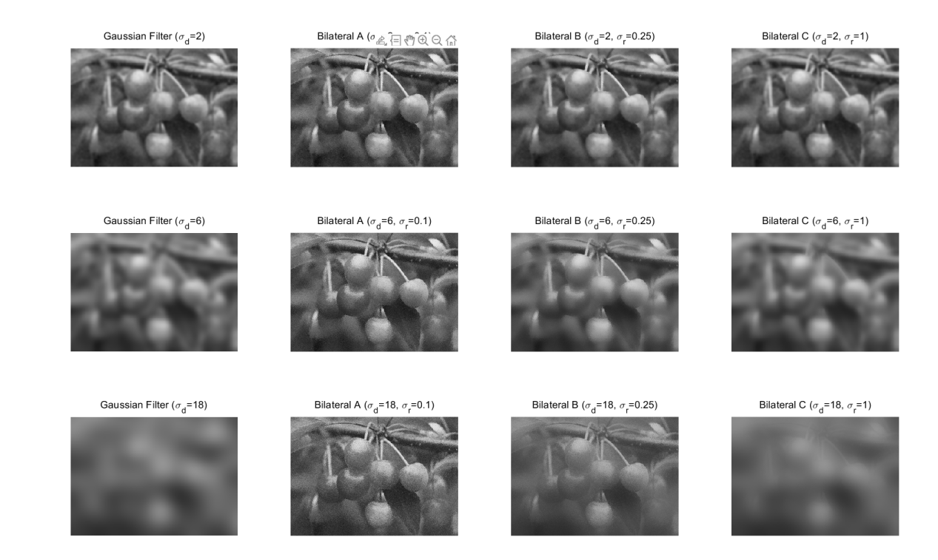
The experimental results are shown above. The experiment compares the performance of the Gaussian Filter and the Bilateral Filter under 12 different parameter configurations.
According the results, we can know that how parameters sigma_d and sigma_r influence the behavior of the bilateral filter and differences between the gaussian filter and the bilateral filter.
The parameter sigma_d controls the size of the neighborhood in terms of spatial distance. It determines how far the filter looks for neighboring pixels. Increasing sigma_d increases the spatial extent of the filter and decreasing sigma_d limits the filter to a small local area.
The parameter sigma_r controls how much the filter penalizes differences in intensity. It determines what constitutes an edge. Increasing sigma_r makes the filter mor tolerant of intensity differences and decreasing sigma_r enforces strict edge preservation.
Gaussian filter smooths the image based only on spatial distance while bilateral filter based on both spatial distance and intensity difference. Gaussian filter blurs edges but bilateral filter preserves shape edges. As sigma_r approaches infinity, the lateral filter loses its sensitivity differences and behaves exactly like a standard gaussian filter.

