Computer Vision
Spring 2026
Experiment #2
Harris Corner Detection

Write a program (Matlab) to implement Harris corner detection algorithm.
The Harris corner detection algorithm:
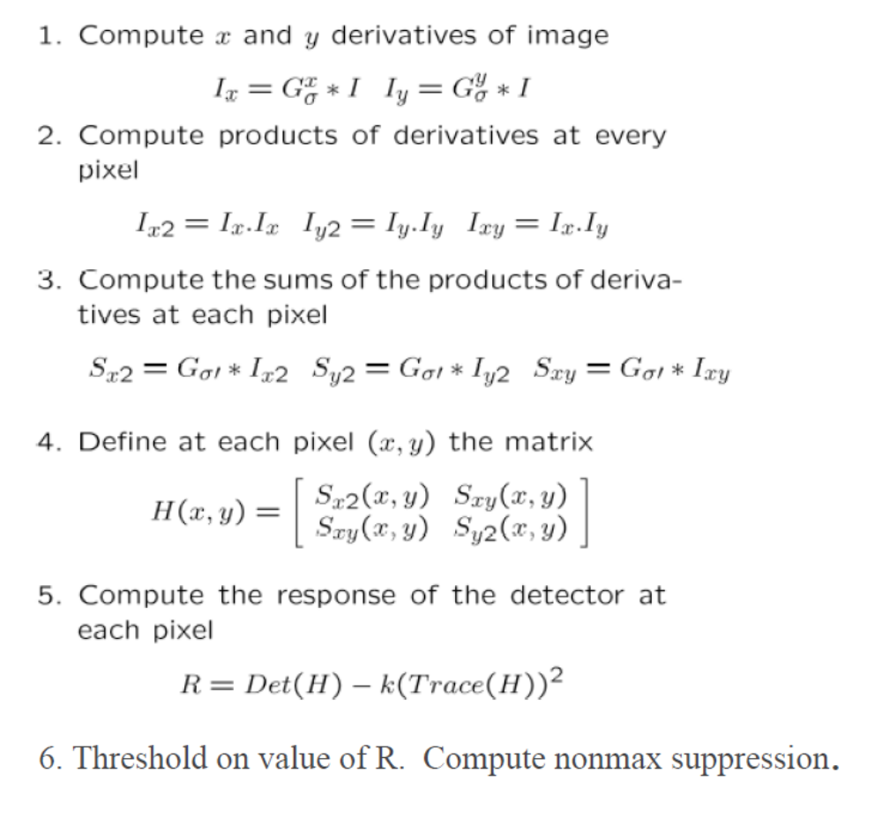

Use Sobel operator to compute Ix and Iy. The windowing function is Gaussian, and the typical values for sigma might be 1-3. The parameter k is an empirically determined constant (0.04-0.06).
Your program should take an image (building.jpg) as input and output corner locations

Submission instructions:
(1) your source code (.m file); (2) a report in a PDF file including input image, response R image and output image with detected corners overlayed on the original image (mark corner locations by red "+"), followed by discussions.
Upload a single zip file containing your source code and report to FTP, and the file name should be exp02_name.zip.

Due date: 2026/03/31

