Experiment #3
Blob Detection
When input is ‘butterfly.jpg’, outputs are as below:
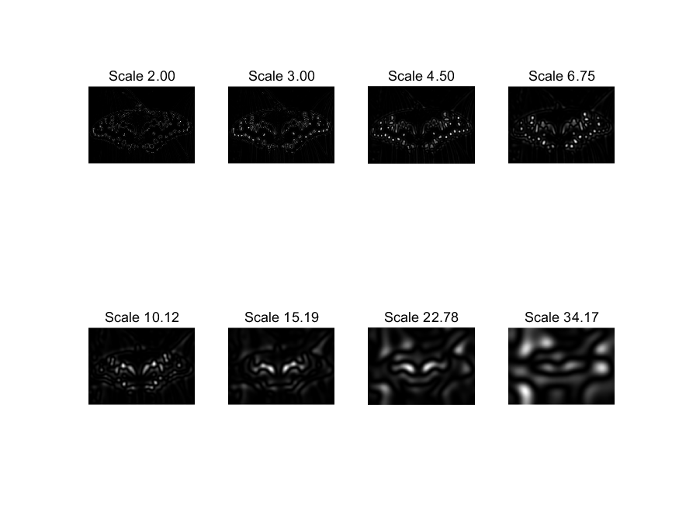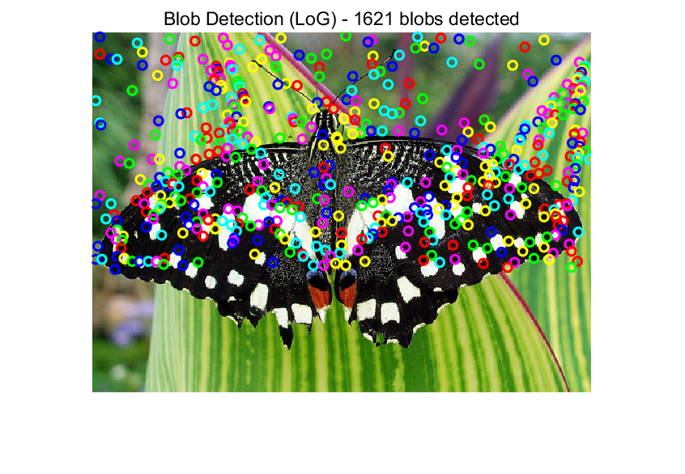
When input is ‘sunflower.jpg’, outputs are as below:
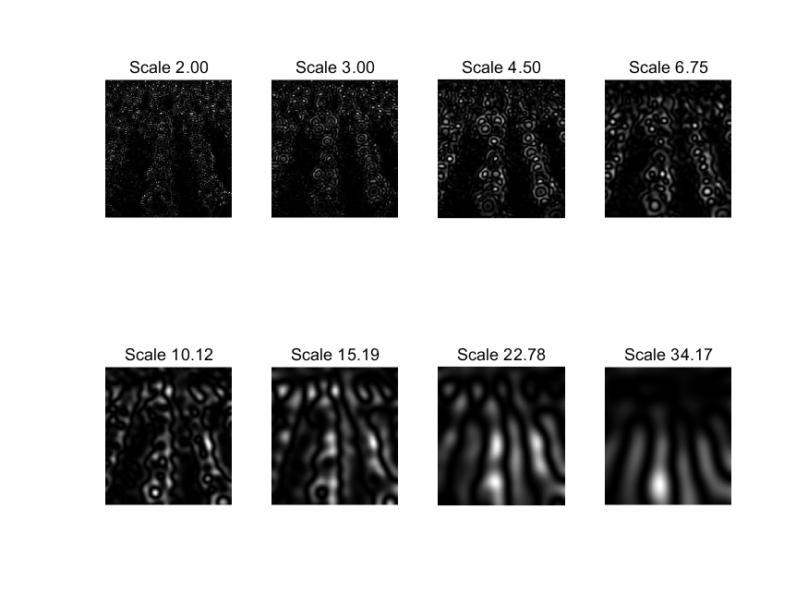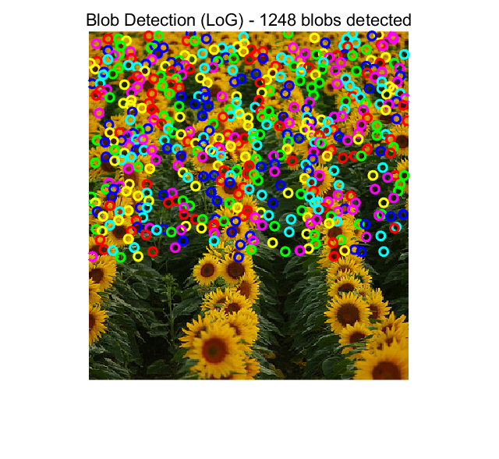
Evaluating the two scale space visualizations, they reveal critical insights about the algorithm’s multi-scale nature:
Small Scales(2.00-6.75):The response maps are highly detailed, with sharp, localized bright spots corresponding to fine textures. This is because small sigma filters capture micro-level intensity variations.
Medium Scales(10.12-15.19): The responses become more generalized, smoothing out fine details and highlighting larger structual elements.
Large Scales(22.78-34.17): The images are heavily blurred, with large, diffuse bright resions representing the coarsest scale features. This demonstrates the Gaussian smothing effect of increasing sigma.

In this experiment, I fixed 3 parameters, initial_sigma=2.0, k=1.5 and threshold =0.03. Their influence are:
Initial sigma: Sets the starting scale for detection. A larger initial sigma would detect larger blobs first, potentially missing fine details.
Scale Factor k: Controls the geometric progression of scales. A smaller k results in more scales, enabling finer detection of blob sizes; a larger k leads to coarser scale sampling.
Threshold: Balances detection recall and precision. A lower threshold would detect more blobs, while a higher threshold would reduce false detections but may miss weak blobs.

