Experiment #4
Image Quilting for Texture Synthesis & Transfer
Proposed by Efros and Freeman and published in the classic SIGGRAPH 2001 paper, the Image Quilting algorithm aims to generate large-scale visually seamless texture images from a small texture sample image.
The algorithm is implemented in three progressive stages with performance optimized step by step:
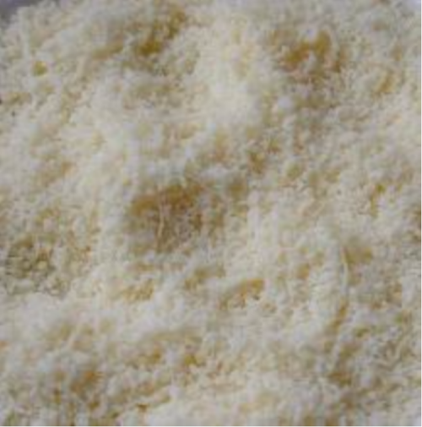
Two input images
Stage 1: Random Patch Placement
All image patches are randomly sampled and placed independently. Obvious grid artifacts can be observed in the synthesized result, which are caused by distinct color discrepancies in the overlapping regions between adjacent patches.
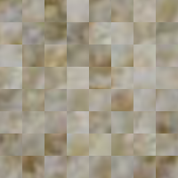
Stage 2: Optimal Patch Selection via SSD
When placing a new patch at coordinate (x, y), its left and top overlapping regions will overlap with previously placed adjacent patches. The Sum of Squared Differences (SSD) is calculated by computing the squared pixel-wise intensity difference between the left/top overlapping region of each candidate patch and the corresponding region on the output canvas. This SSD computation is performed for all valid starting positions of candidate patches in the source texture image to construct a complete 2D error matrix.
Stage 3: Seam Stitching via Minimum Cut
Within overlapping regions, the SSD value between pixels of existing patches and newly inserted patches is calculated to establish a 2D error matrix. Dynamic programming forward propagation is adopted: the cumulative cost of each pixel in the current row equals its intrinsic pixel error plus the minimum transition cost derived from three adjacent pixels in the previous row. Starting from the pixel with the minimum cumulative cost in the last row, backtracking is executed to trace upward and select pixels with the smallest dynamic programming values to obtain the minimum-cost stitching path. Pixels on the left side of the path retain values from the original patch, while pixels on the right side adopt pixel values from the new patch.
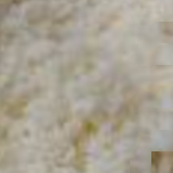
Finally, texture transfer is realized by introducing appearance matching error constraints, and iterative optimization is adopted to enrich and refine image detailed features.
