Experiment #2
Harris Corner Detection
The results are shown below.
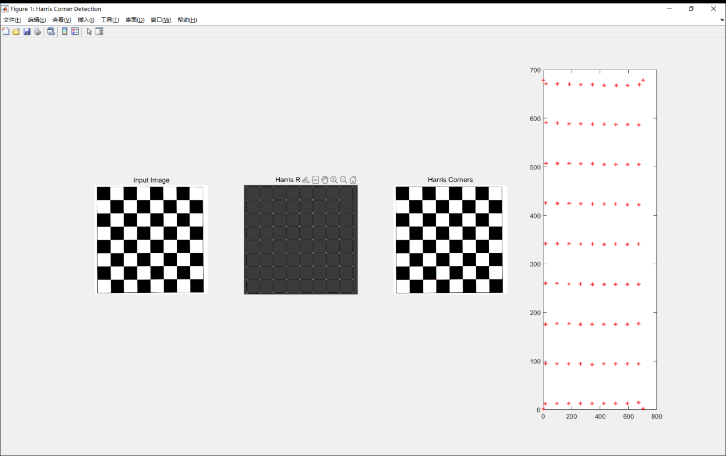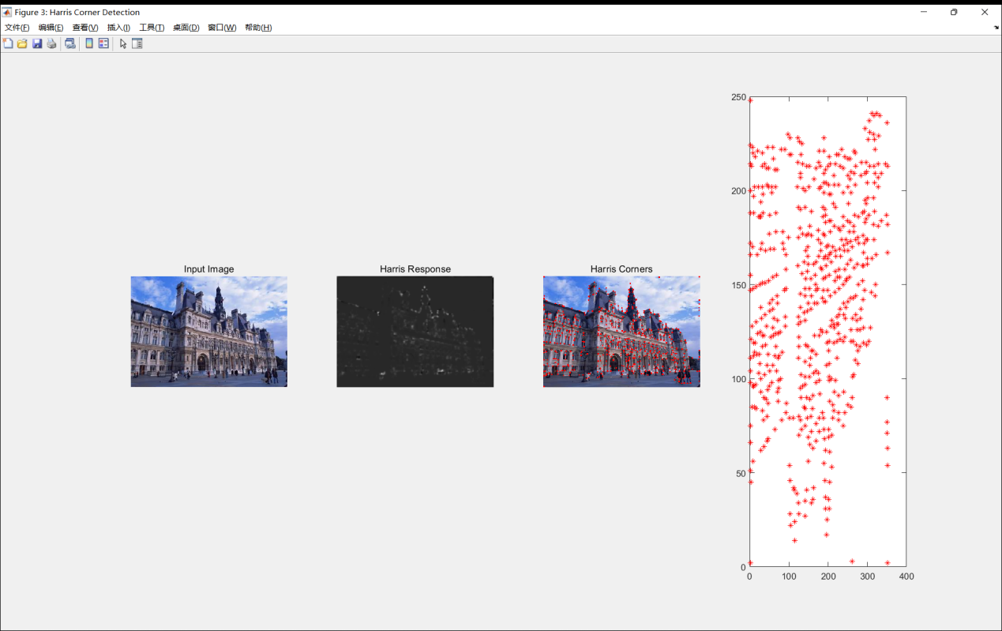
The top one is a standard 8x8 black-and-white checkboard pattern. It is a structured test case with well-defined, grid-aligned corners, ideal for validating algorithm correctness.
The building image represents a complex, unstructured real-world scenario with varied textures, edges, and lighting conditions.
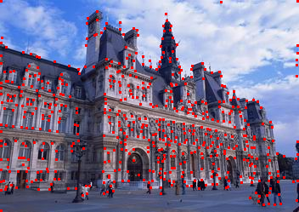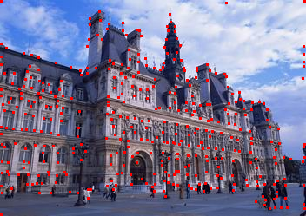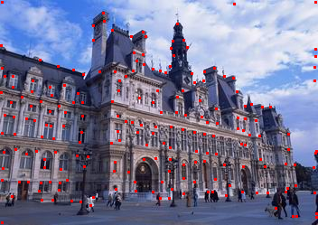
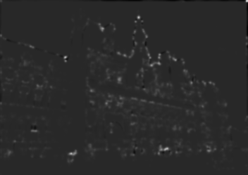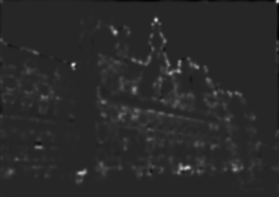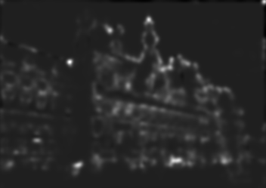
sigma = 1.5 / 2 / 3
The three groups of picture are different in sigma while other parameters are same. As they show, sigma determines the spatial smoothing range of the Gaussian filter applied to the gradient products. A small sigma means small filtering window, reains detailed texture information, sensitive to noise and fine corners.A large sigma means large filtering window, enhances noise robustness, but blurs gradient detailes and reduces positiong accuracy.
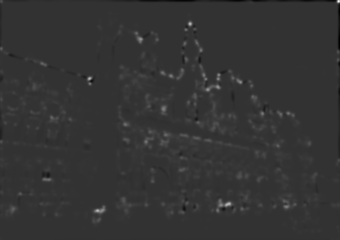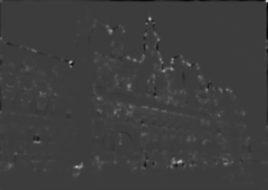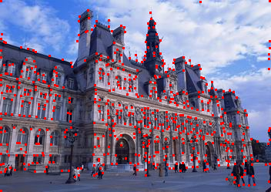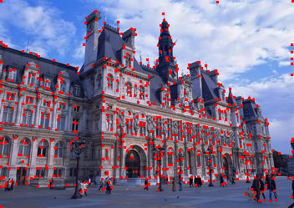
k = 0.04 / 0.05 / 0.06
The three groups of picture are different in Empirical Coefficient k while other parameters are same. As they show, k controls the discrimination ability of the response function between corners and edges. A small k increase the response value R, detects more corners, but easily misidentifies edges as corners. A large reduces the response value R, suppresses edge false detections, but may miss real corners.

