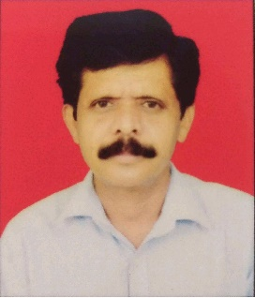
CURRICULUM VITAE
ULHAS NAGAPPA KOSHTI

MHADA ADGAON NASHIK-422003

Mobile : 9325271528

Email : koshtiulhas@gmail.com

CAREER OBJECTIVE
Secure a responsible career opportunity to fully utilize my training and skills, while making a significant contribution to the success of the company.

PROFESSIONAL EXPERIENCE

- Marketing from 25 years

ACADEMIC / EDUCATIONAL QUALIFICATION

- 8th pass

PERSONAL INFORMATION

Father’s Name : NAGAPPA KOSHTI
Date of Birth : 23th APRIL 1972.
Marital Status : married
Gender : Male
Nationality : Indian
Language Known : Hindi, Marathi
Address : FNO D207 DWING MHADA ADGAON , NASHIK

BEHAVIOURAL CHARACTERISTICS

Ability to take challenges, work under pressure & achieve targets.
- Self motivation, Confidence, Responsibility.
- Ability to work continuously with a high energy level.

DECLARATION
I hereby affirm the information given in their document is correct to the best of my knowledge.

(ULHAS KOSHTI)

