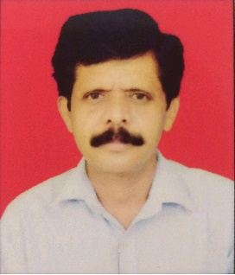

**CURRICULUM VITAE**

**ULHAS NAGAPPA KOSHTI**

MHADA ADGAON NASHIK-422003

**Mobile** : 9325271528

**Email** : koshtiulhas@gmail.com

***CAREER OBJECTIVE***

Secure a responsible career opportunity to fully utilize my training and skills, while making a significant contribution to the success of the company.

***PROFESSIONAL EXPERIENCE*** 

* **Marketing from 25 years**

***ACADEMIC / EDUCATIONAL QUALIFICATION***

* 8th pass

***PERSONAL INFORMATION***



Father’s Name : NAGAPPA KOSHTI

Date of Birth : 23th APRIL 1972.

Marital Status : married

Gender : Male

Nationality : Indian

Language Known : Hindi, Marathi

Address : FNO D207 DWING MHADA ADGAON , NASHIK

***BEHAVIOURAL CHARACTERISTICS*** 

Ability to take challenges, work under pressure & achieve targets.

* Self motivation, Confidence, Responsibility.
* Ability to work continuously with a high energy level.

***DECLARATION***

I hereby affirm the information given in their document is correct to the best of my knowledge.

**(ULHAS KOSHTI)**