1. Create a local git repository and move the entire code base to it

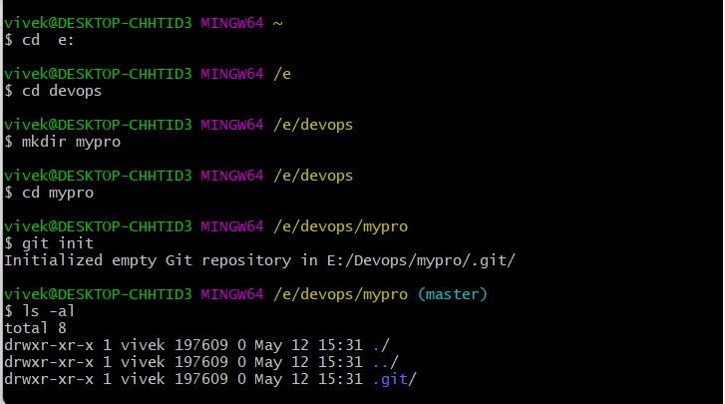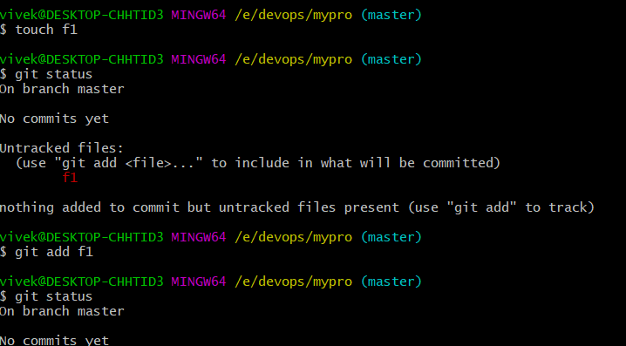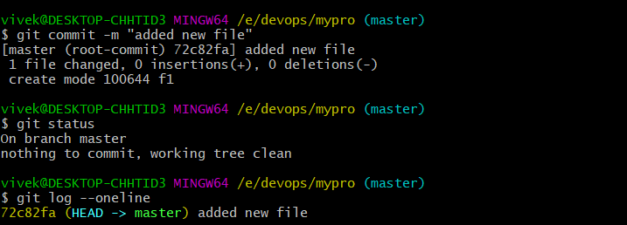

1. Create a new branch for a new feature you want to add to the application

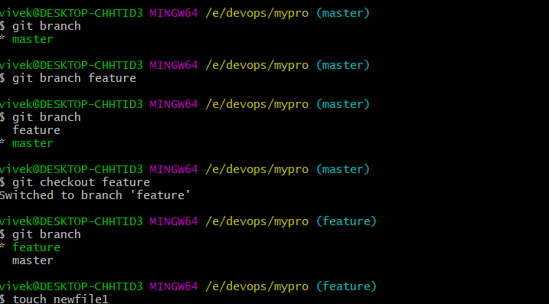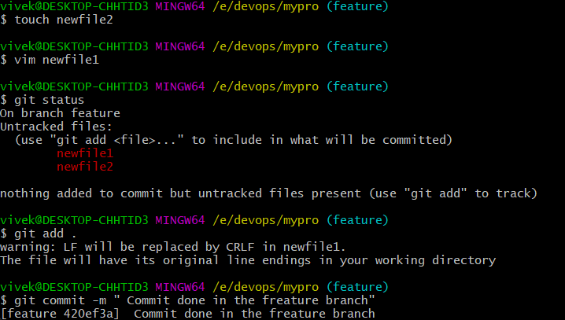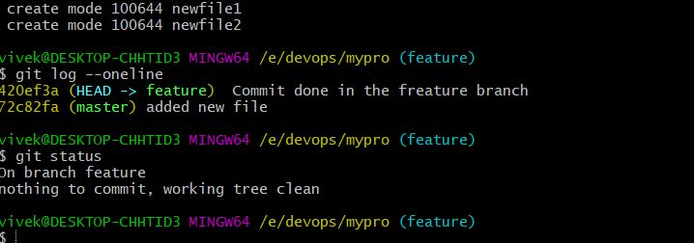

1. Merge back the created branch with the master branch

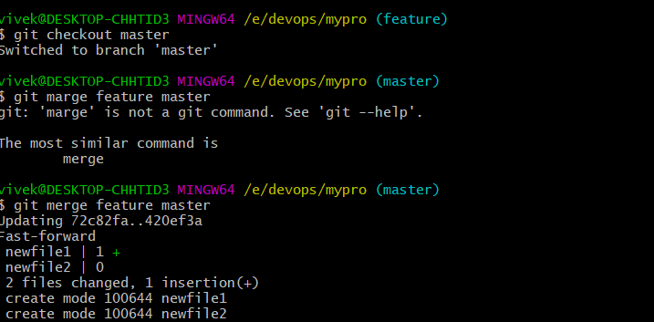

1. Create a remote repository
   1. Create a personal access token to connect with remote repository to local repository settings->developer settings->personal access token-> classic

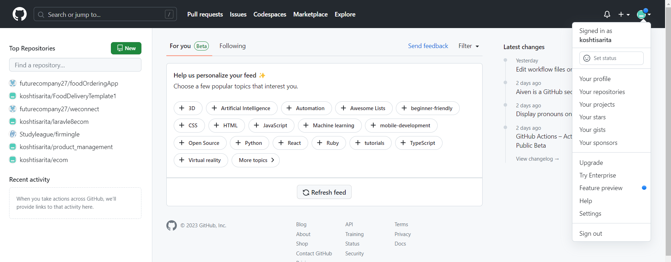

* 1. Save the token generated in any secure file
  2. Create a remote repository and copy the http URL
  3. Connect with the local repository to remote repository

git remote add origin  [“HTTP URL OF remote repository”](https://github.com/Sonal0409/myproject19Apr.git)

* 1. Then authenticate with the personal access token
  2. Now we are connected with remote repository
  3. push the local repository content to the remote repository

1. Push the local repository to company’s remote repository

