Problem Statement

Hooli Co. has put Harry and Kane to implement a new set of features in their feature software. Both started working separately, making their own copies of the same source code. Now, it has become difficult for them to track the changes they’ve made in the original code, and they are finding it difficult to merge their code together.

Action Items

1. Create two separate branches from master

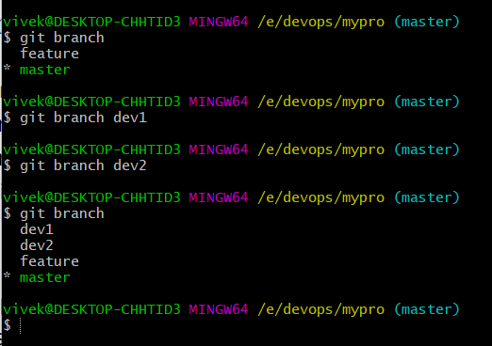

1. Make changes in the same function of the source code in both the branches

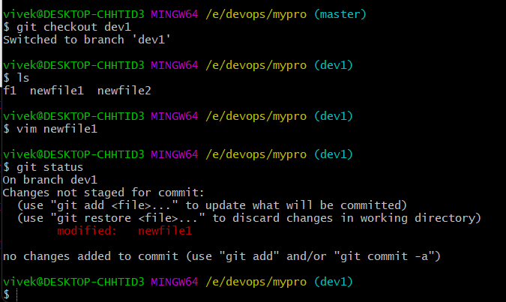 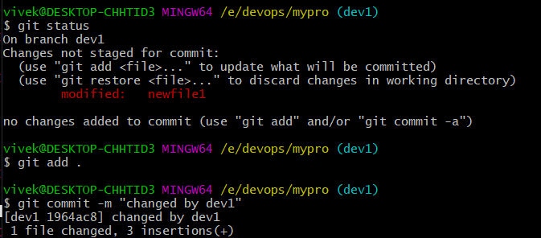

Checkout to other branch dev2

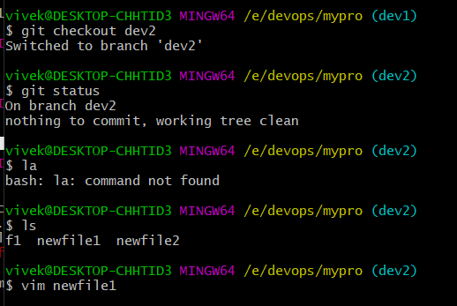

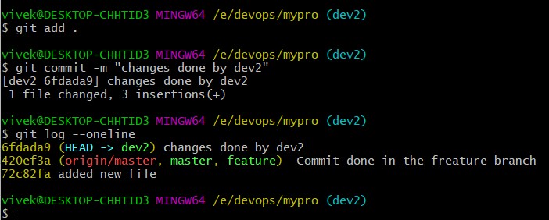

1. Merge branch1 into the master

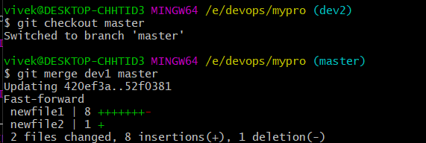

1. Try and merge branch2 into the master

(merge conflict should arise)

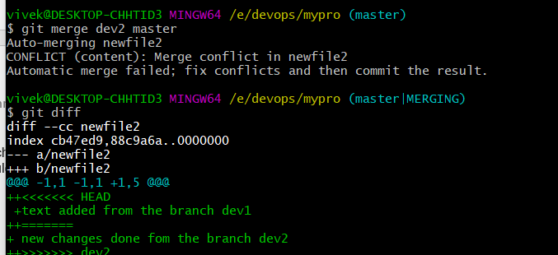

Now we check the newfile2, accept the dev2 branch changes and verify with the person who did the change on the file.

Then we complete the final file code then add this file to the staging and local repository

