Rules - VISE

On your turn you must either:

1. Take one piece from your store, and place it on the board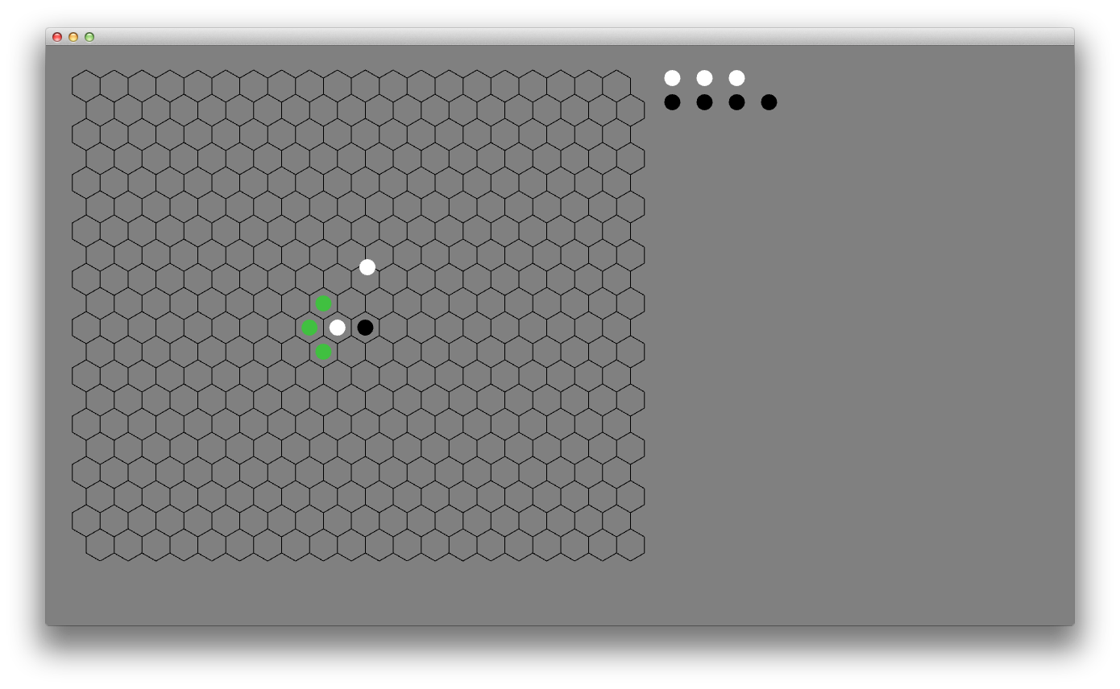
   1. Must be placed adjacent to one of existing pieces
   2. Cannot be adjacent to any enemy piece
2. Take one of your pieces that is already on the board, and move it to a new place on the board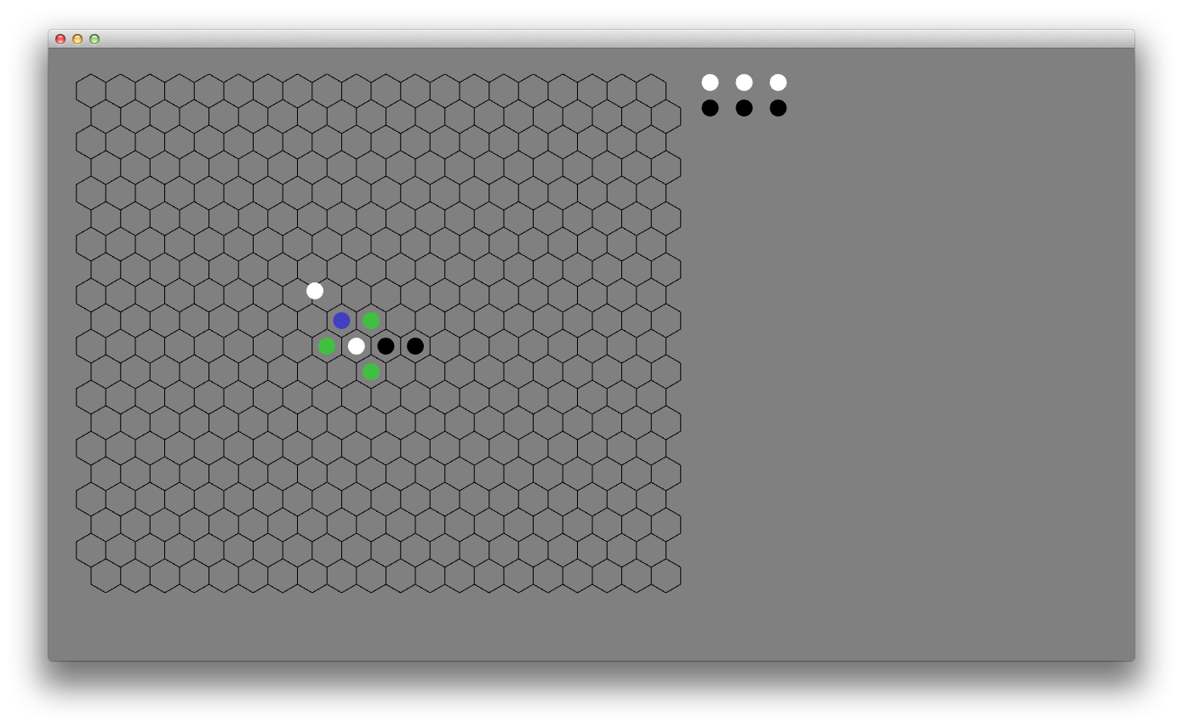
   1. May move to any empty adjacent hex
   2. May hop over one piece into the empty hex on the other side
   3. You cannot move a piece in such a way that causes the board to be disconnected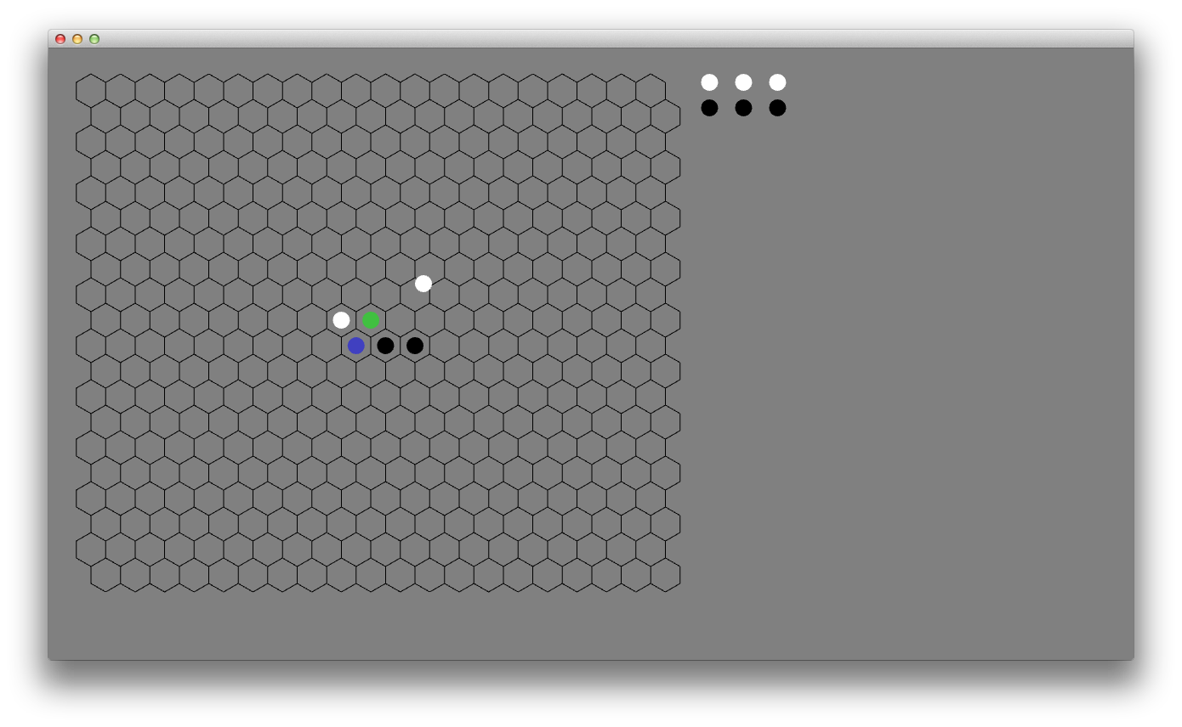

After you move:

1. Check for any piece that is “caught in a vise.” This means the piece is caught in a line between two enemy pieces. Remove all such pieces from play.
   1. The following examples are NOT caught in a vise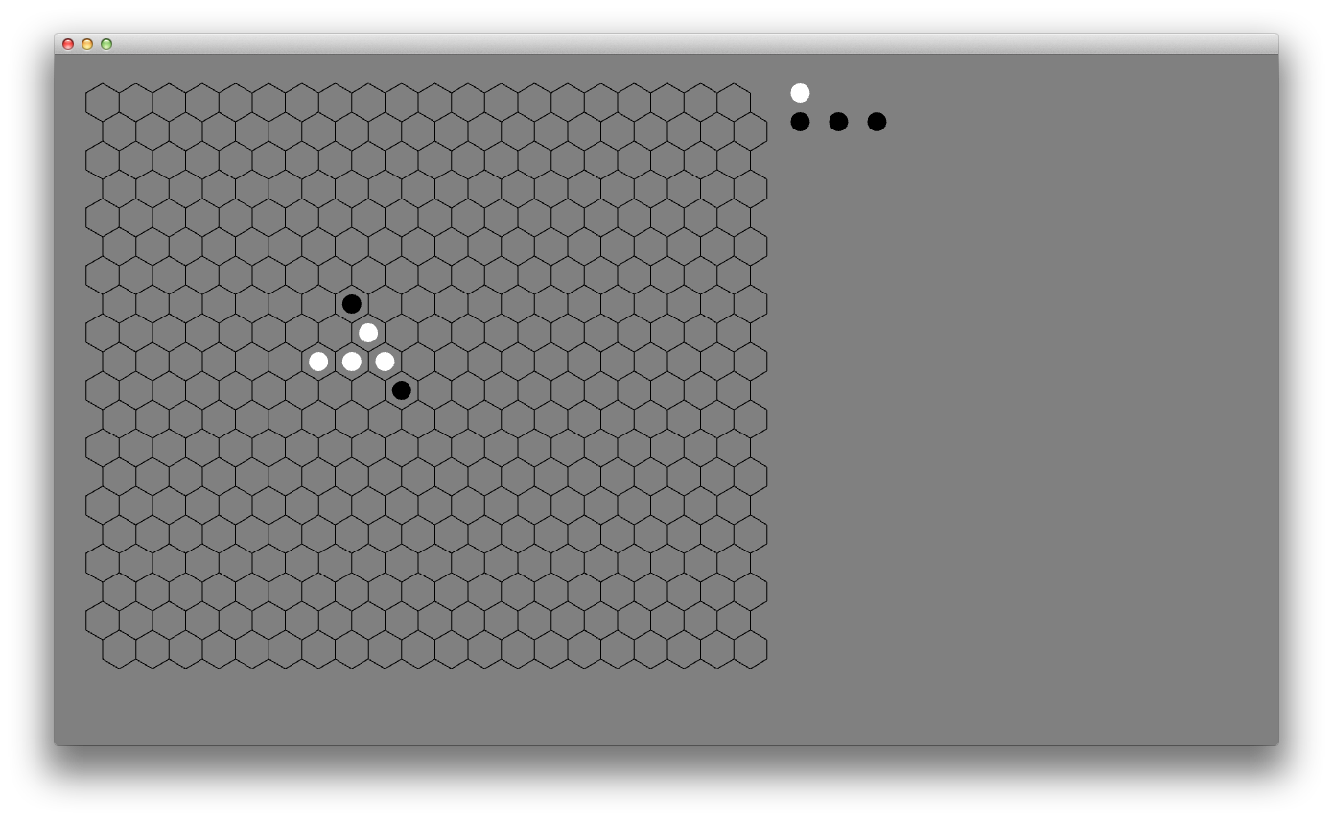To be “in a vise” the piece must be immediately adjacent to the two enemy pieces. So these white pieces are safe.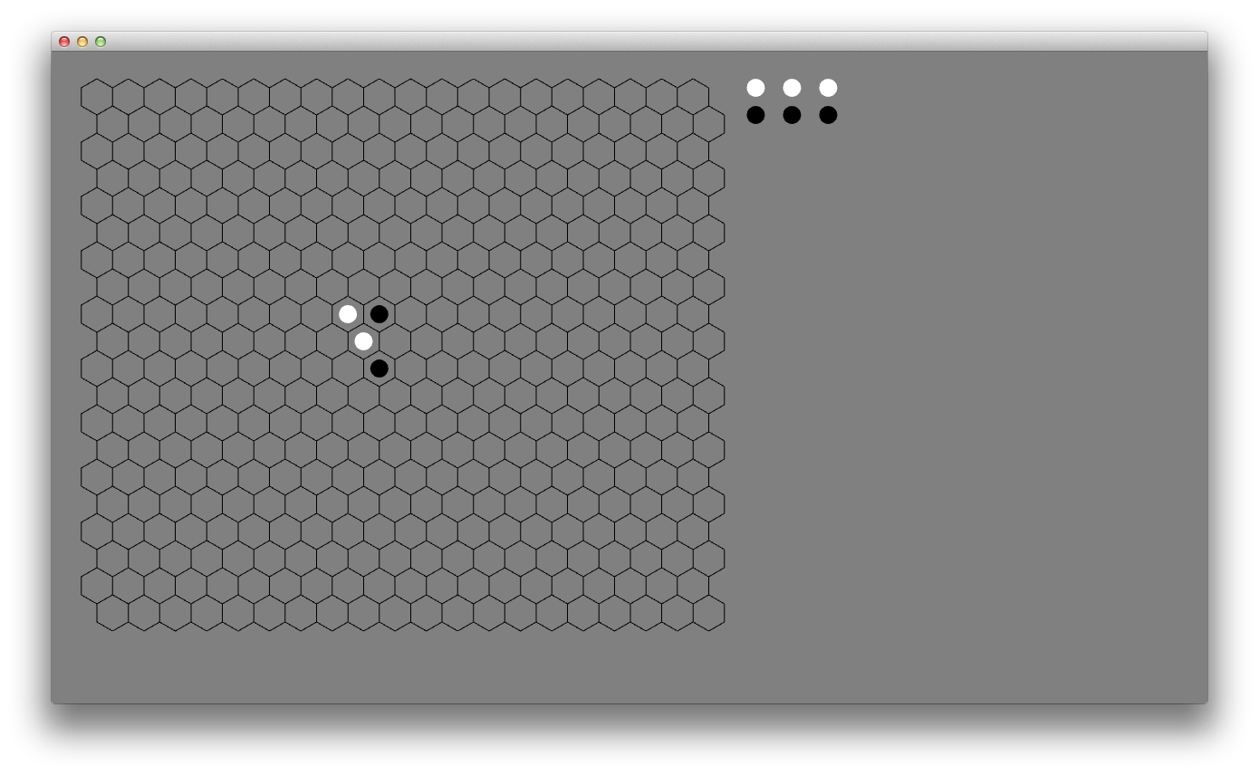The white piece is safe because the two black pieces are not in a line.
   2. The white player is catching a black piece in a vise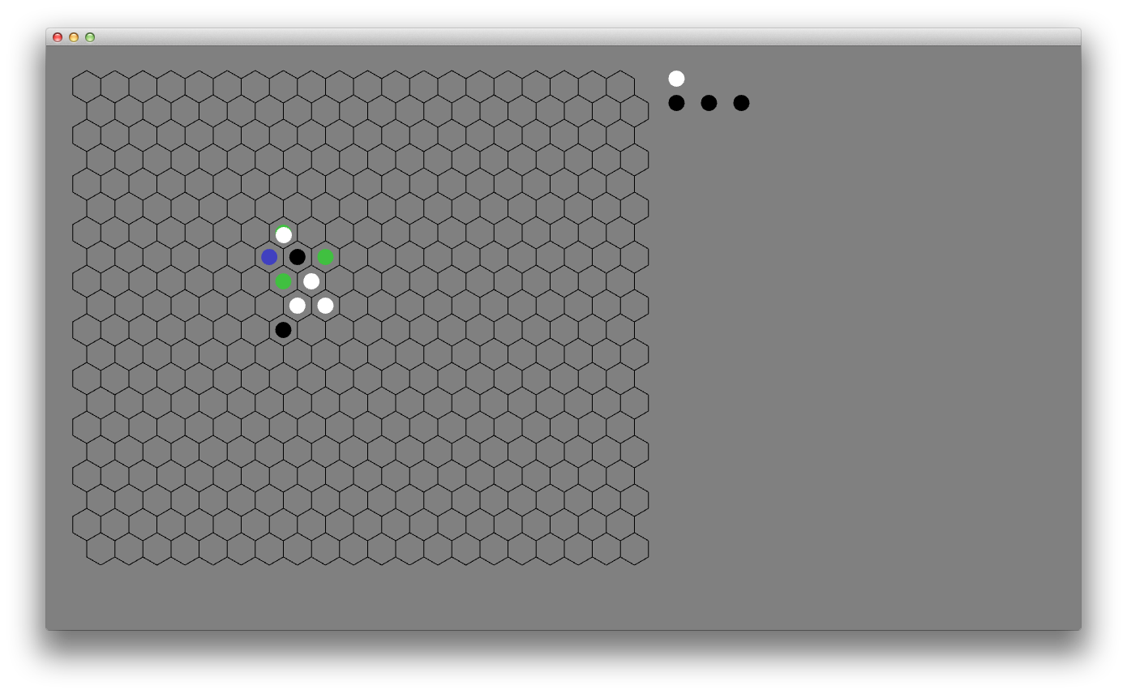
2. If this results in a disconnected board, keep the largest group of pieces that contains pieces for both players. The remaining pieces should be placed back into the store to be re-used.
   1. Deleting the black piece (in the previous example) disconnected the board. The lonely white piece is moved back to the white player’s supply.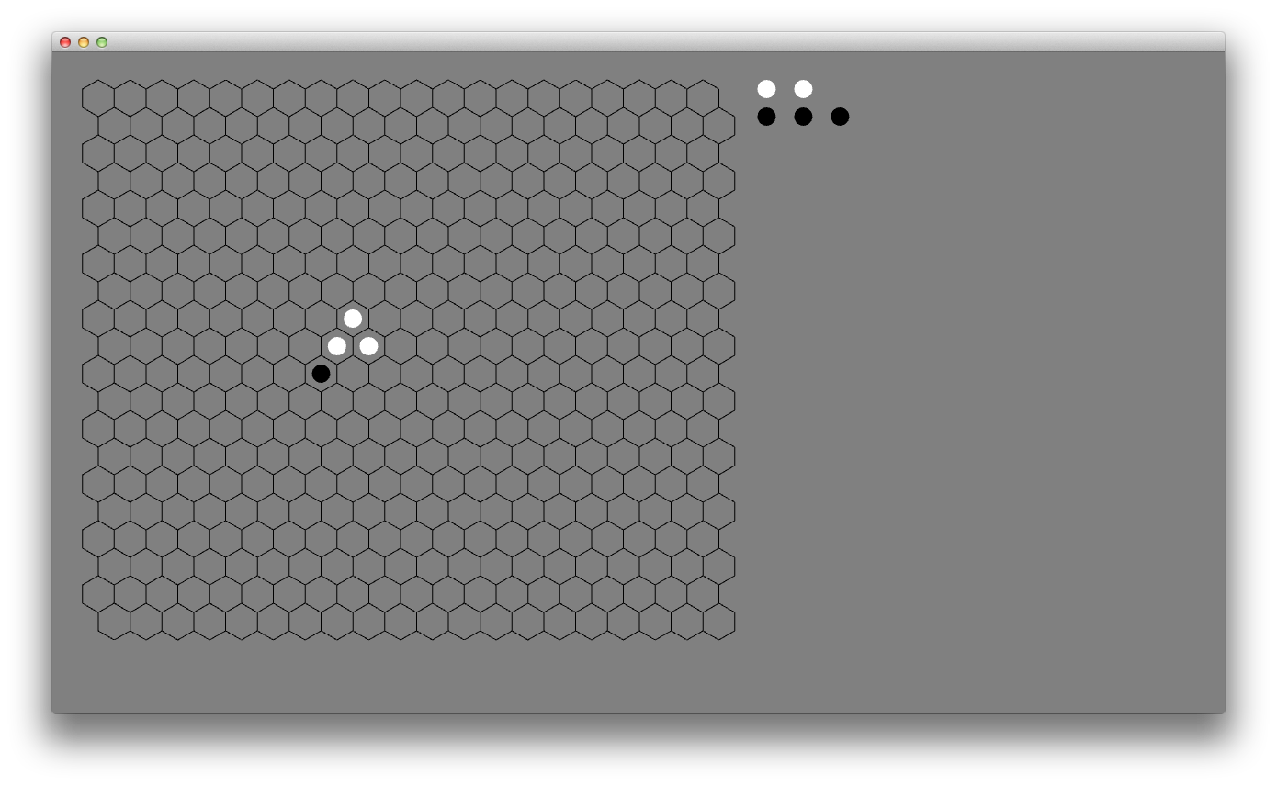
   2. If there is not any group of pieces that contains both players, then someone has won the game – If there are any pieces left on the board belonging to the player that just moved, she wins. If not, she loses.

Ways to win/lose:

1. If you have only one piece left between the board and the supply, you lose.
2. If it is your turn, and you have no valid moves, you lose.
3. If you have no pieces left on the board, you lose.