Hello Ms. Sherman,

Thank you for your warm welcome. You asked me to look at customer transaction data collected from recent online and in-store sales to see if I could infer any insights about customer purchasing behavior.

Specifically,

1. Do customers in different regions spend more per transaction? Which regions spend the most/least?

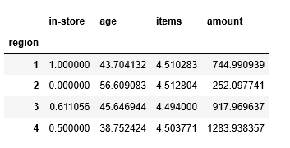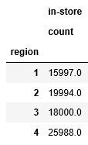

Yes. Different regions do spend different amounts per transaction. I found that all the regions purchased between 1 and 8 items per transaction and all 4 regions had a mean number of items purchased of 4.5 items/transaction. No region was buying more in quantity than other regions.

Region 4 did have a significantly higher number of transactions with 25, 988. Region 2 - 19,994, Region 3 – 18,000, and Region 1 -15,997.

Overall, Region 4 spends the most per transaction. Region 4’s average customer spends a mean $ amount of $1283.94 while Region 2 spends the least with mean of $252.10. Region 1 had a mean amount spent of $744.99 and Region 3 had a mean amount spent of $917.97.

I also noticed that Region 1 is comprised of all in-store sales, Region 2 has all on-line sales, Region 4 is 50% online and 50% in-store and Region 3 has both in-store and on-line with more in-store sales.

1. Is there a relationship between number of items purchased and amount spent?

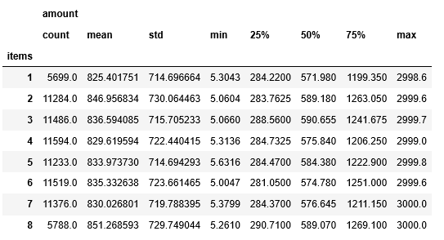

As you can see in the above table, it appears the amount spent does not matter how many items a customer purchased. If the average customer bought 1 item, they spent a total of $825. If they bought 3 items, they spent an average total of $837. Customers spend an average of $825-$851. The minimum, maximum, quartiles and standard deviation are all about the same.

Thank you. Please let me know if you have further questions.

Sherri Koski