Danielle,

Good afternoon. Thank you once again for your business. Blackwell Electronics is considering the purchase of Electronidex. Here are some basic facts about the Electonidex’s transactions from the past 30 days.

* 30 days of online sales transactions
* 9835 total transactions
* 327.83 transactions/day
* 43,104 items purchase
* Average items purchased/transaction is 4.383

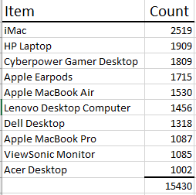

This is the top 10 items sold by Electonidex during this month of sales. The top 10 items accounted for 36% of all items purchased this past month. Blackwell would benefit from selling all of these products. Many of these products are bought together in one transaction. Electonidex sells almost 84 iMac computers each day. After examining the transactions, it was curious to see that iMacs were such a popular purchase even in combination with PC’s. In 227 instances (7.5 times each day), customers who bought a Lenovo Desktop and a HP Laptop also purchased an iMac.

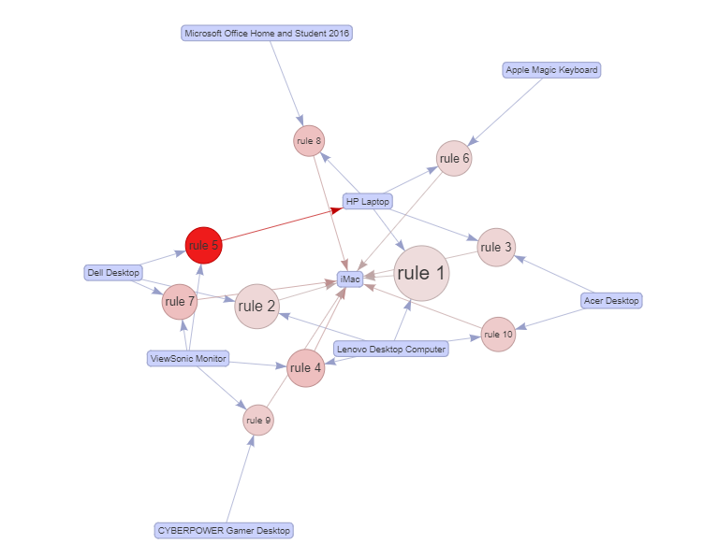This is a diagram of the 10 most common combinations. 9 of the 10 arrows end at iMac. That means that customers are often buying an iMac in addition to other purchases.

I would recommend the purchase of this company. If I were to only add certain items to my inventory, I would include all of these combinations plus the MacBook Air, MacBook Pro, and the Apple Earpods since these are often bought as well.

Thank you,

Sherri Koski