MSP432 Launchpad Demo

Scope
This document provides a description of the Software Distribution and a user guide. It shows how to setup the HW environment and how to build and run the MSP432-ZLS Demo projects.

HW Requirements
  - TI MSP432P401R Launchpad
  - NL2020 smart battery
  - EVAL-AD9838SDZ
  - Oscilloscope
  - PC with Window7 or Window8 OS

SW Requirements
  - CCS v6.1. This version was used for development:
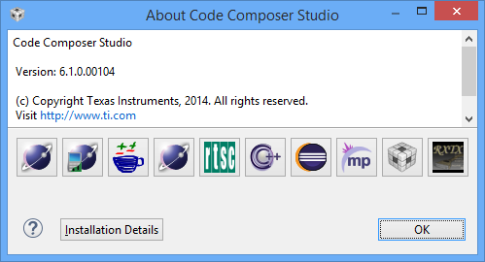

- MSPWare_2_21_00_39
- TeraTerm or other Serial Terminal

HW Setup
Please follow the connection of MSP432, AD9838, NL2020, Oscilloscope, and PC as describe in Figure 4.1 below

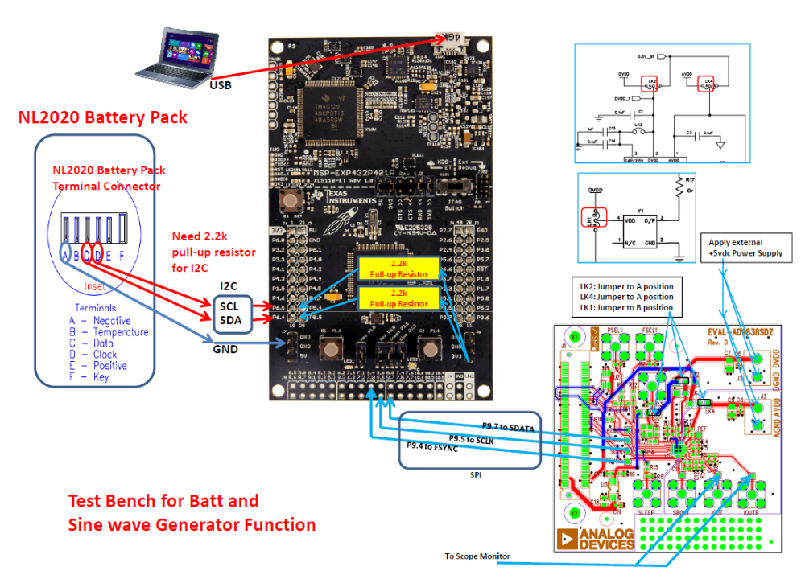
Figure 4.1

SW Setup
  - Install CCS v6.1 and MSPWare_2_21_00_39
  - Install TeraTerm or other Serial Terminal
  - Extract the attached package MSP432-ZLS.rar to dedicate folder
  - Open TeraTem and setup as:
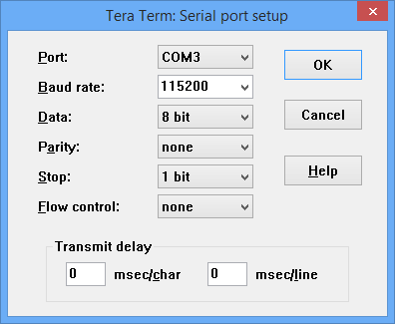
Please note, the Port should be the COMx User/Data from MSP432 board

  - Open CCS and Import the MSP432-ZLS to CCS
    - Right click on the MSP432-ZLS project then Build Project
    - Right click on the MSP432-ZLS project -> Debug As -> Code Composer Debug Session and Run

  - After the code run, the messages will print in the TeraTerm. It should like the screen below.
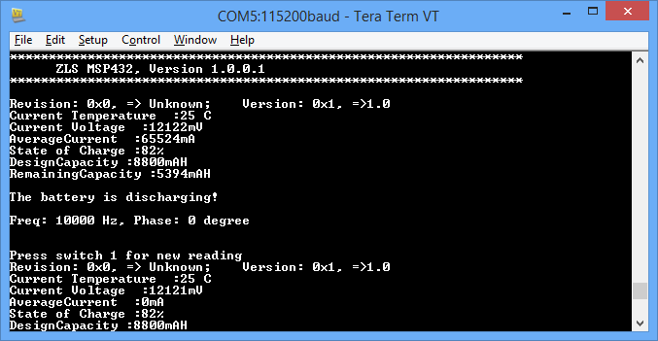
- User can press Switch 1 on MSP432 board to read the new data from NL2020 and new frequency setting for AD9838. Each switch increment 10KHz.

Trouble Shooting
- If no battery data display,
  - Double check the connection between NL2020 to MSP430.
  - Make sure there are 2.2K pullup resistor on SDA and SCL on MPS430 board
- If no correct frequency display on scope,
  - Double check the connection between AD9838 to MSP430.
  - Make sure all jumpers on AD9838 are corrected

