Design document

This document describes the software design project work of the Panssarinyrkki group. The purpose of the program is to implement an application for environment behavior monitoring and visualizations. Initially weather data from Finnish Meteorological Institute and electricity data from Fingrid are used as the main data providers.
The program is developed using a C++ framework Qt that provides all necessary features and libraries for building the entire application. Mainly the program consists of two parts: the C++ backend and QML frontend. This design document primarily focuses on the C++ backend since there is almost direct connection from the view module to the QML frontend. Also, all data processing and user interaction is handled inside the C++ part of the application.

High-level description

The high-level description contains module level description of the implementation. It is mainly intended for understanding the rough operating principles and relationships between the different components.

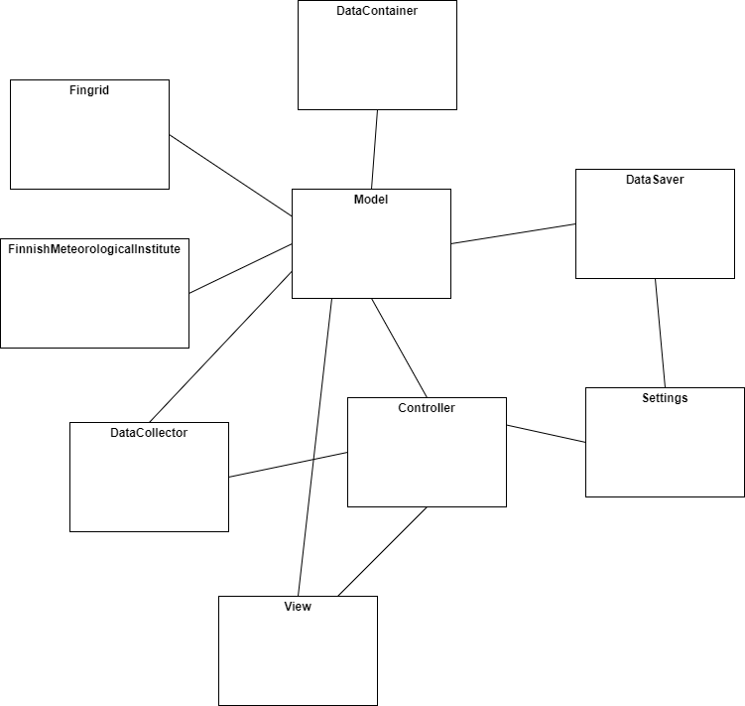
Figure 1 High level diagram

The Figure 1 shows the high-level architecture of the program. In practice, there are the main Model, View and Controller modules in the core of the application. Also, different internet APIs that produce the data handled in the application have their own modules. In addition, there are few utility modules that help other classes to implement the required functionality. Utility classes in this case are the DataCollector, Settings, DataSaver that for example handle saving the application settings between different sessions.

Internal interfaces

According to the general MVC architecture the most important interfaces are between the Model, View and Controller classes. Every on of them has a general interface that they implement, and other classes depend on that only. The Controller reacts to the user actions and controls the Model, which in turn will notify the view for changed content.
Another important internal interface is between the internet data source classes and the model. All data sources implement an interface which the model will use to interact with the actual implementation. This way there are not any direct dependencies to specific data sources.
In general, most of the components operate and communicate with each other in the interface level. This gives flexibility and extendibility to the overall design. It also makes sure that good programming conventions (e.g., SOLID) are followed throughout the application implementation.

Design choices

Main drivers for these design choices come from common design patters that aim to make software maintainable and easy to develop. For example, the separation of Model, View and Controller follows the common and well tested MVC design pattern. Also, aspects of the SOLID principles are considered already at this design document. All components in this software are designed to operate at high abstraction level. This reduces the dependencies between components and keep the modules as general as possible.

