# Windows:

# PostgreSQL installation

1. Go to <https://www.enterprisedb.com/downloads/postgres-postgresql-downloads>
2. Download the package of version 12.9 and higher for your OS. Execute the downloaded file. Package can install some additional components like MS C++ 2015-2019, proceed with it.
3. Install PostgreSQL from downloaded package:

* Leave installation path default or change to your convenience
* Deselect pgAdmin4 (we’ll use better tools than it)

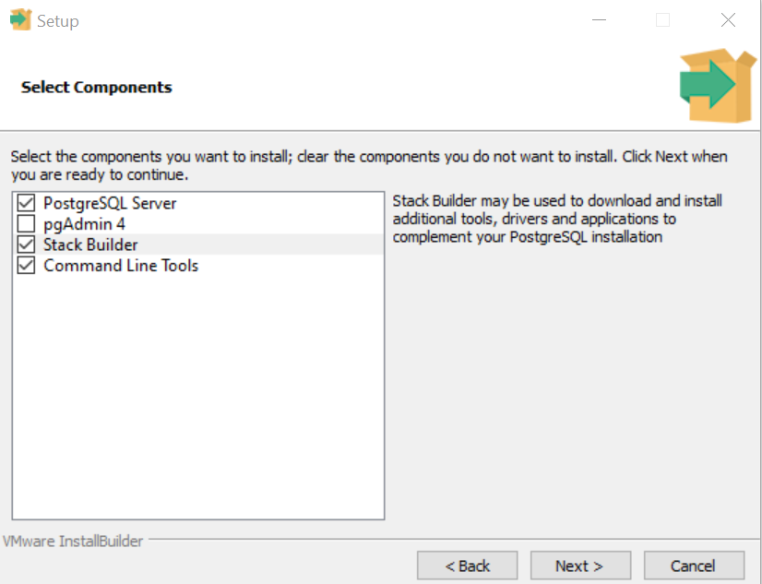

* Leave installation data path default or change to your convenience
* Set a password. Since it’s local installation and to simplify our work, do not use special characters (it’s not a general recommendation). So you can use **postgres** for example. Please don’t forget your password!
* Leave the port equal to default value **5432**
* Set locale equal to **English, United States**
* 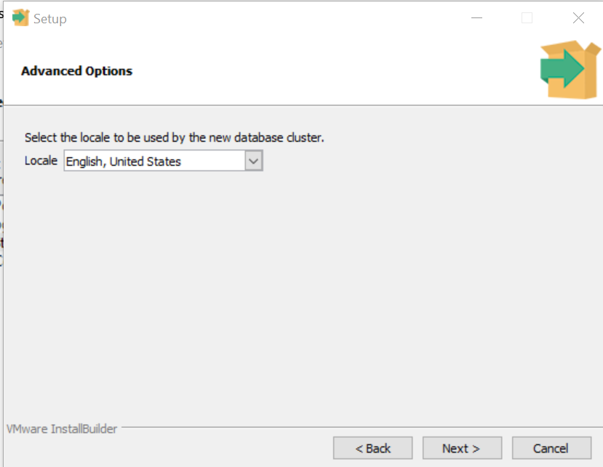

It’s nice to see a database engine speaking Ukrainian to you, but let’s stick to English.

- Next – Next and wait for PostgreSQL to be installed on your PC.

- Unselect “Launch Stack Builder” option and press Finish

- Check in Windows Task Manager if PostgreSQL is up and running.

Scroll down to Background Processes and see Postgres there:

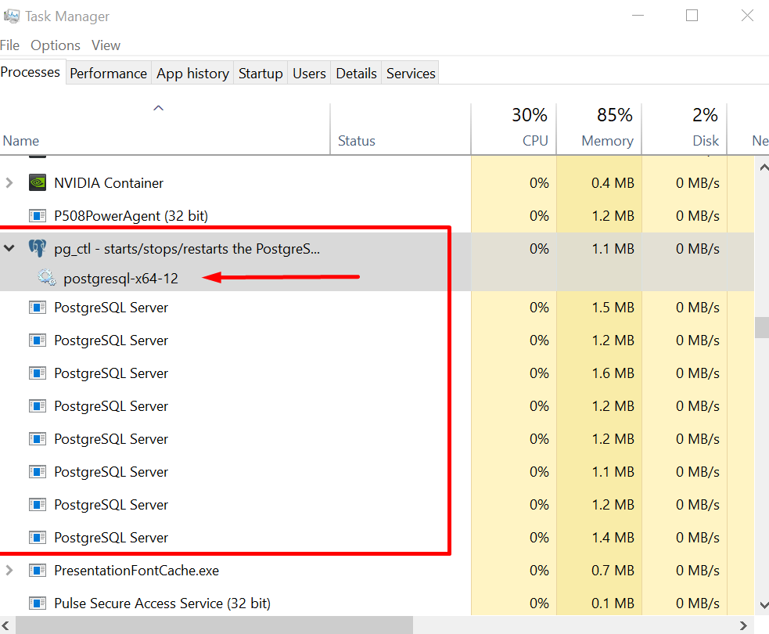

**!!! OPTIONAL !!!**

P.S. In case you don’t want to have PostgreSQL up and running always (your computer is slow etc), you can change its launch type in Windows Services to Manual:

Find postgresql-x64-12 in list of services, double-click on it:

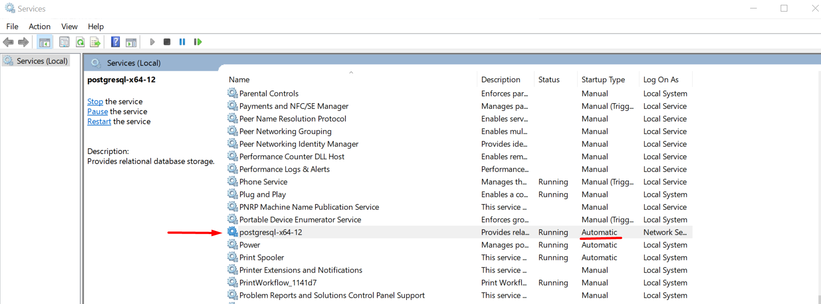

Change Startup Type to **Manual,** press Apply and OK.

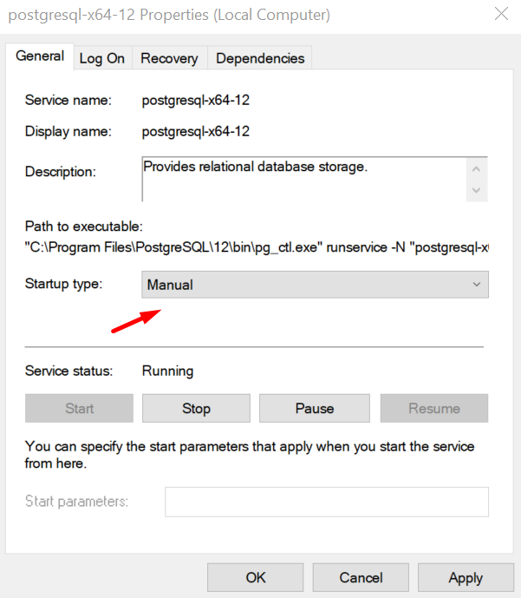

However, every time you need Postgres to work with, you have to go to Windows Services and launch it manually by choosing it and pressing Start button.

# 2. DBeaver installation and configuration for local PostgreSQL

1. Open link <https://dbeaver.io/files/dbeaver-ce-latest-x86_64-setup.exe> and download the installer
2. Launch the installer, click Next-Next-Next-I Agree-Next – just keep the defaults and don’t change any options, except “Create desktop shortcut”
3. Launch installed DBeaver. In case it asks to download missing drivers – accept, download and install.

## Configuring DBeaver connection to local PostgreSQL instance

* Click on the very left icon and choose PostgreSQL from the list:

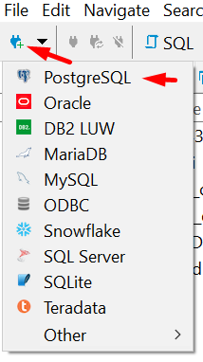

* In the next window, set Host = **localhost,** Database = **postgres,** username and password – set values from your PostgreSQL installation from above.

Keep port equal to **5432**, and other options default.

Press “Test Connection” button. If you’ve done everything right, you’ll see a message like this:

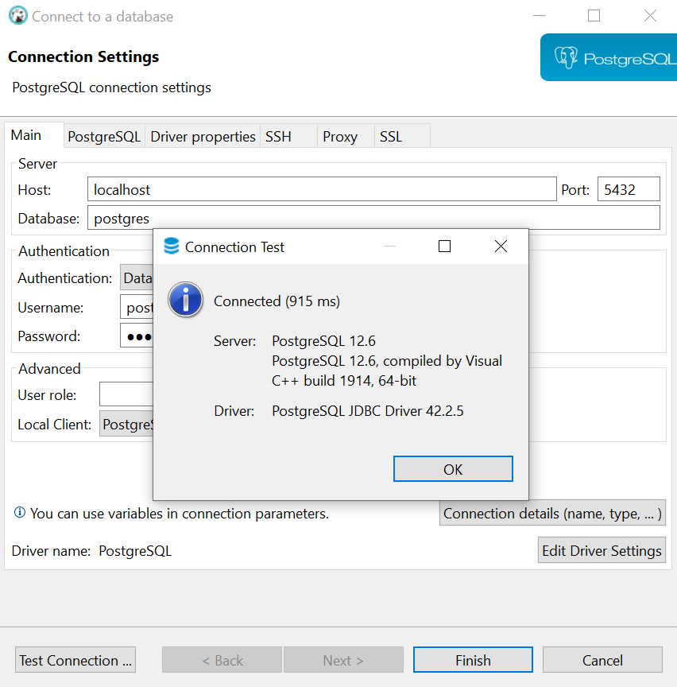

Press OK, then Finish.

Now your PostgreSQL instance will appear in the left panel:

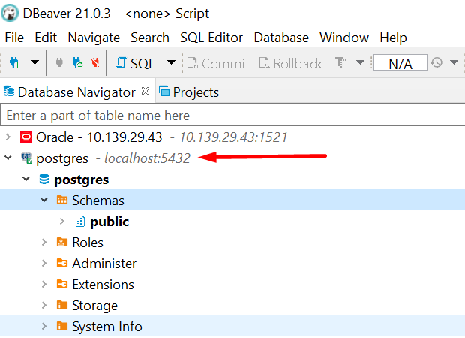

You can click on it and expand server content.

## Run the queries against your Postgres installation

* Right click on your **postgres**, SQL Editor -> New SQL Script
* Type (with semicolon!)

SELECT 1;

And run it by pressing Ctrl+Enter or clicking orange Play button

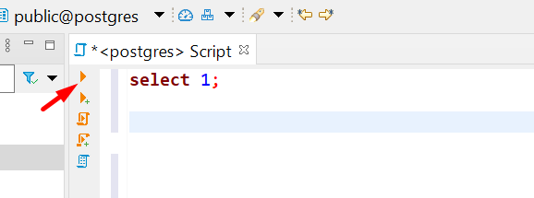

You’ll see the result in the panel below:

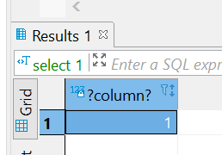

* Clear the script window, type (or copy-past from here)

SELECT 'I have installed Postgres locally! Woohoo!' AS important_message;

And run it as before, observe the result.

Also you can check you current date/time by executing following: SELECT now();

# 3. Installing **bookings** schema – sample DB for training purposes

1. Ensure your PostgresSQL instance is up and running: connect via DBeaver, run a sample query from previous block.
2. Download file from this link: <https://drive.google.com/file/d/1Sx55xZgR-2iko1UzmOOxjvb4F5B_rgmj/view?usp=sharing>
3. Unzip dump.sql from archive and save it to convenient location
4. Open Windows Command Prompt (Run - cmd)
5. Type and run

cd C:\Program Files\PostgreSQL\12\bin

C:\Program Files\PostgreSQL\12\ -- default path for Postgres, works in case you haven’t changed it whilst installing PG

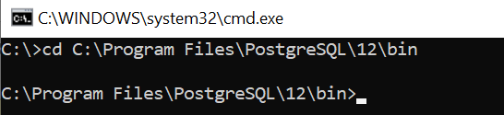

1. Type and run

psql -U postgres -h localhost -d postgres -a -f "D:\ST\pg_pro_airports_medium\dump.sql"

(this is the single line!)

where D:\ST\pg_pro_airports_medium\dump.sql – full path to the file you unzipped and saved in #3

You will be prompted to enter your DB password:

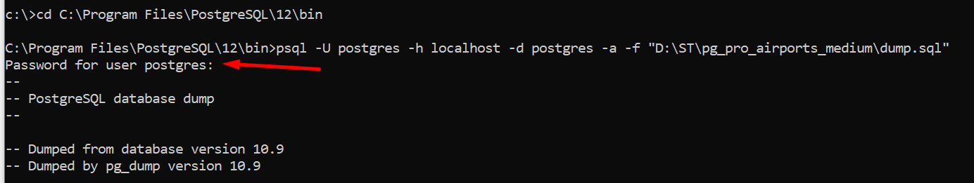

Enter it and hit Enter. Please note, console don’t show your progress of input (no “stars” or any other activity)

In case you’re mistaken with password, you’ll get such error message:



Proceed from the beginning of #6.

1. In case you did everything right, console will be filled with running messages, just wait the process to be completed (couple of minutes) and cursor re-appear in command prompt.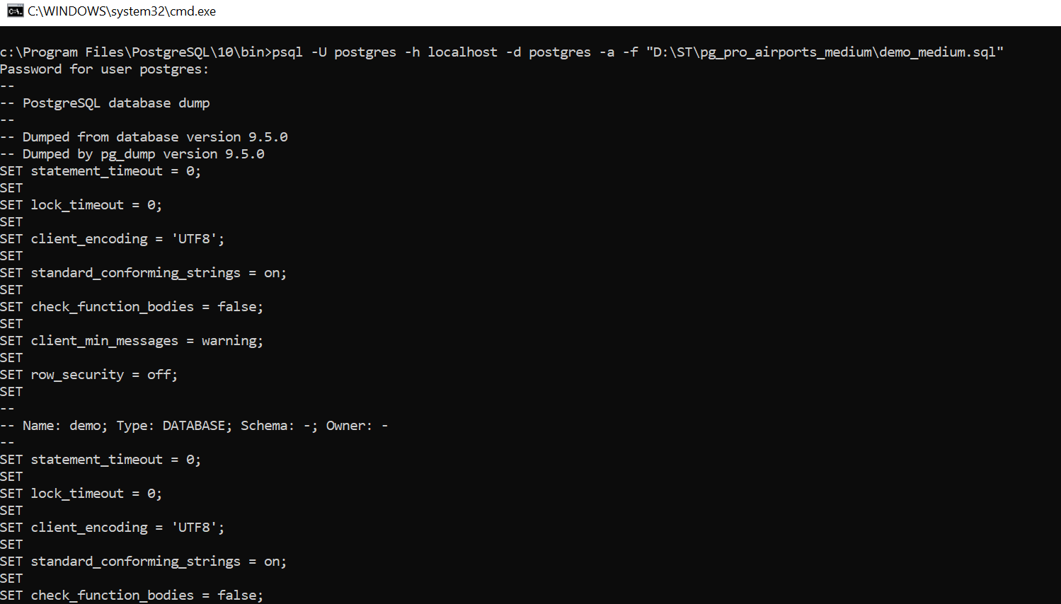
2. Connect to your local Postgres instance using DBeaver, expand **Schemas.** In case you don’t see **bookings** schema, right-click on Schemas -> Refresh (or F5).

You should see the content of schema:

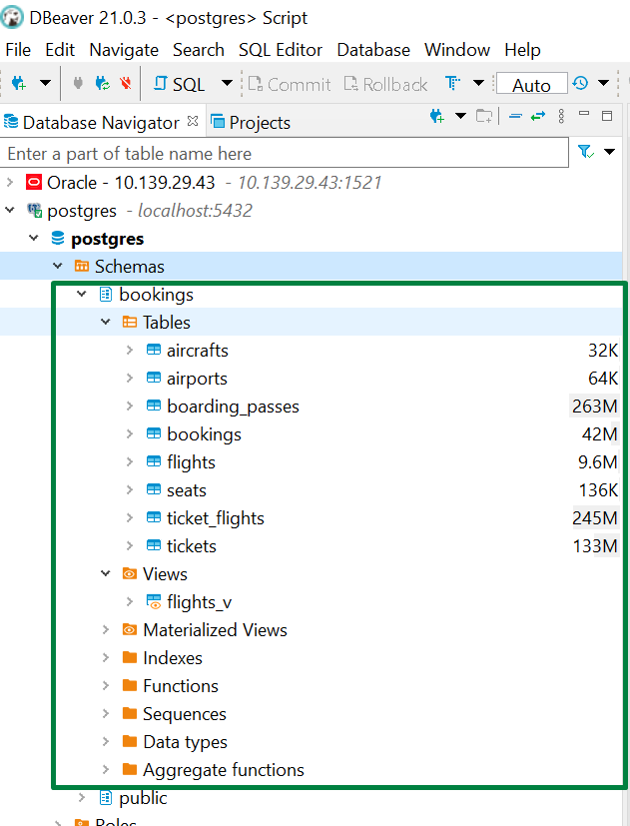

1. Right click on your **bookings**, SQL Editor -> New SQL Script

Then type

SELECT * FROM bookings.aircrafts;

And run it by pressing Ctrl+Enter or clicking orange Play button – like you did before. Observe the results.

MacOS:

Depending on how you installed Postgres, *psql* utility might be already available to you.

* Open Bash terminal and type **psql**.

In case you’ll see psql prompt - then proceed from #6 of Windows instruction, just change D:\ST\pg_pro_airports_medium\dump.sql to actual path - where you saved unzipped file, like /home/user/dump.sql

* In case you get the error “-bash: psql: command not found”, try to run in bash:

*cd /Applications/Postgres.app/Contents/Versions/latest/bin/*

then proceed with #6 from Windows instruction, don’t forget to change the file path to the actual one.