# Angular Application – Movie DB (part 1)

## Create new application

Using the CLI create new angular app typing in console “**ng new movie-finder**”. That will create a new angular app. To make sure everything is up and tuning, navigate in console to the project “src” directory and there type “ng serve –open” → that will start the app on **localhost: 4200** and will open it in browser for you.

## Create components and add style

Type in the console “**ng g c movies**” (that is short command for ng generate component movies). Make sure that the new component is added in “**app.module**”. Go to [*https://bootswatch.com/*](https://bootswatch.com/) and search for “Slate” (if you want you could choose different). Click on it and copy this link from URL [**https://bootswatch.com/4/slate/bootstrap.min.css**](https://bootswatch.com/4/slate/bootstrap.min.css). After that go to **index.html** and post this in the head part <link rel="stylesheet" href="<https://bootswatch.com/4/slate/bootstrap.min.css>">. After that go to **app.component.html** delete everything and type **<app-movies></app-movies>**. Save the whole project and you should see this on the browser:

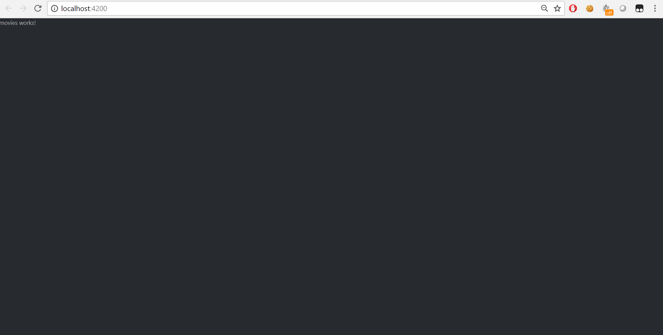

Go to <http://getbootstrap.com/docs/4.1/examples/starter-template/> and click right button on the mouse and select “**View page source**”. Copy the code inside the **<nav>**.

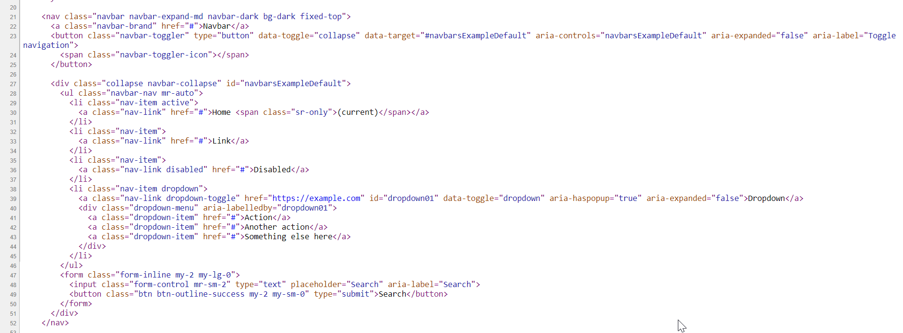

After that use the resources to achieve the **following**:

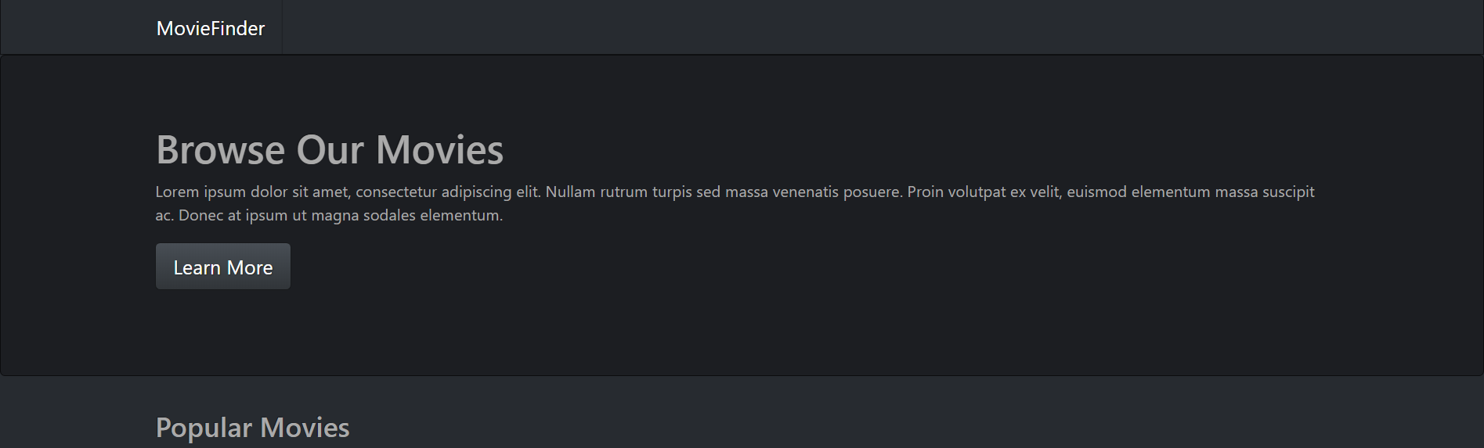

## Sign up

Now go to [moviedb](https://www.themoviedb.org/) and create an account. Go to your account in **settings** and navigate to **API**. From there you will see your details for **API Key**, **API Read Access Token (v3 auth)** and **Example API Request**. We will use them in the following steps.

## Create a service and connect to the API

We will create a **service** in terminal which will be responsible for **fetching the data** from the API.

From the terminal in “src/app” type “**mkdir service”**, after that “**cd service”** and then type “**ng g s movies”**. That will create a service.

*Reminder: Do not forget to import the service and register it as a provider in* ***app.module****. In order to make requests to the API we should add to our project* ***HttpClientModule****. After that we should import* ***HttpClient*** *in our service and* ***inject*** *it through the constructor.*

In the service make constant which will hold our API key from MovieDb.

**const apiKey = '{your api key}’;**

After that go to out movies component and inject as a dependency (through the constructor) the movies service we just created.

Ok, now let’s make our first call to the API. Go to <https://www.themoviedb.org/documentation/api/discover> and see which API call is responsible for getting the **most popular** films and copy it.

Let’s go to the service and create a **function** which will be responsible for calling the API for the most popular movies.

Create **3** variable **fields**

1. **path** = 'https://api.themoviedb.org/3/';

2. **popular** = 'discover/movie?sort_by=popularity.desc';

3. **authentication** = '&api_key=';

The function should look like this:

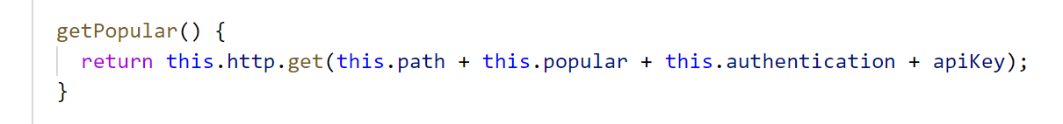

Where the **apiKey** is our **const** which holds the key from our **MovieDb** profile. Notice that after calling the server we **RETURN** the result, because we are about to call this function from another place (in our case movies component) and there we will **subscribe** to the result.

Go to our movie component and in **ngOnInit** call our service with the new function and subscribe to it:

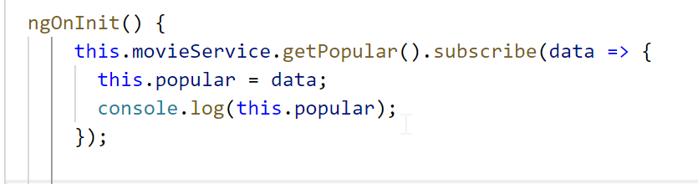

Check the **browser** **console** to see how the information is structured:

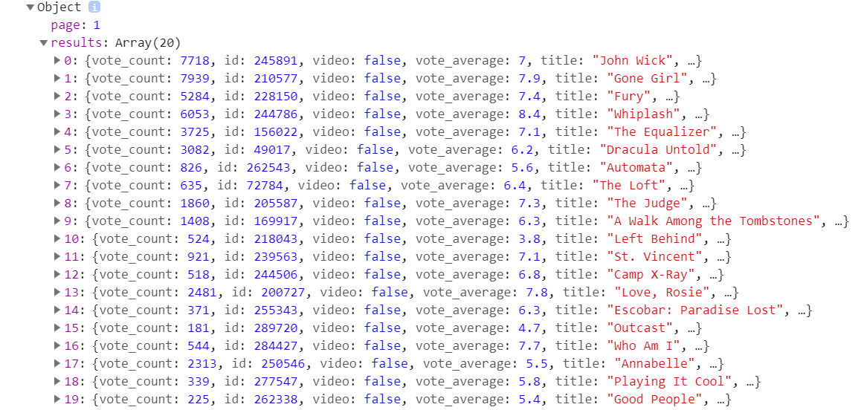

The same logic we will apply in order to get the movies in theaters.

## List the results in the view

Let’s go to our movies component and get rid of the html. Instead of this add this **html** code:

|  |
| --- |
| <div class="panel panel-default">  <div class="panel-heading">  <h3 class="panel-title">Popular Movies</h3>  </div>  <div class="panel-body">  <div class="row">  <div *ngFor="let movie of popular.results;let i=index" class="col-md-2">  <div *ngIf="i < 6">  <img *ngIf="movie.poster_path" class="thumbnail" src="http://image.tmdb.org/t/p/w500/{{movie.poster_path}}">  <h4>{{movie.title}}</h4>  <p>{{movie.release_date}}</p>  <p><a class="btn btn-default" href="#">View Details</a></p>  </div>  </div>  </div>  </div>  </div>  <div class="panel panel-default">  <div class="panel-heading">  <h3 class="panel-title">In Theaters</h3>  </div>  <div class="panel-body">  <div class="row">  <div *ngFor="let movie of theaters.results;let i=index" class="col-md-2">  <div *ngIf="i < 6">  <img *ngIf="movie.poster_path" class="thumbnail" src="http://image.tmdb.org/t/p/w500/{{movie.poster_path}}">  <h4>{{movie.title}}</h4>  <p>{{movie.release_date}}</p>  <p><a class="btn btn-default" href="#">View Details</a></p>  </div>  </div>  </div>  </div>  </div> |

Notice how we use **\*ngIf** for our variables (instead of popular.results, use your created previous variable in which you have saved the results).

In **movies.component.css** (or .scss) file set the rule that the img should be with width of 100%

Your end result should look like this:

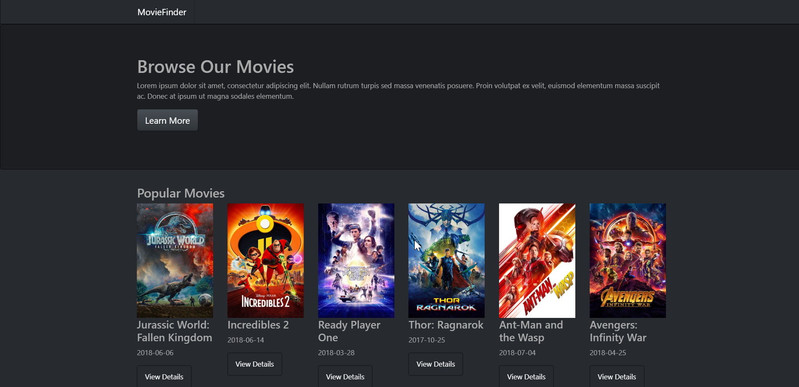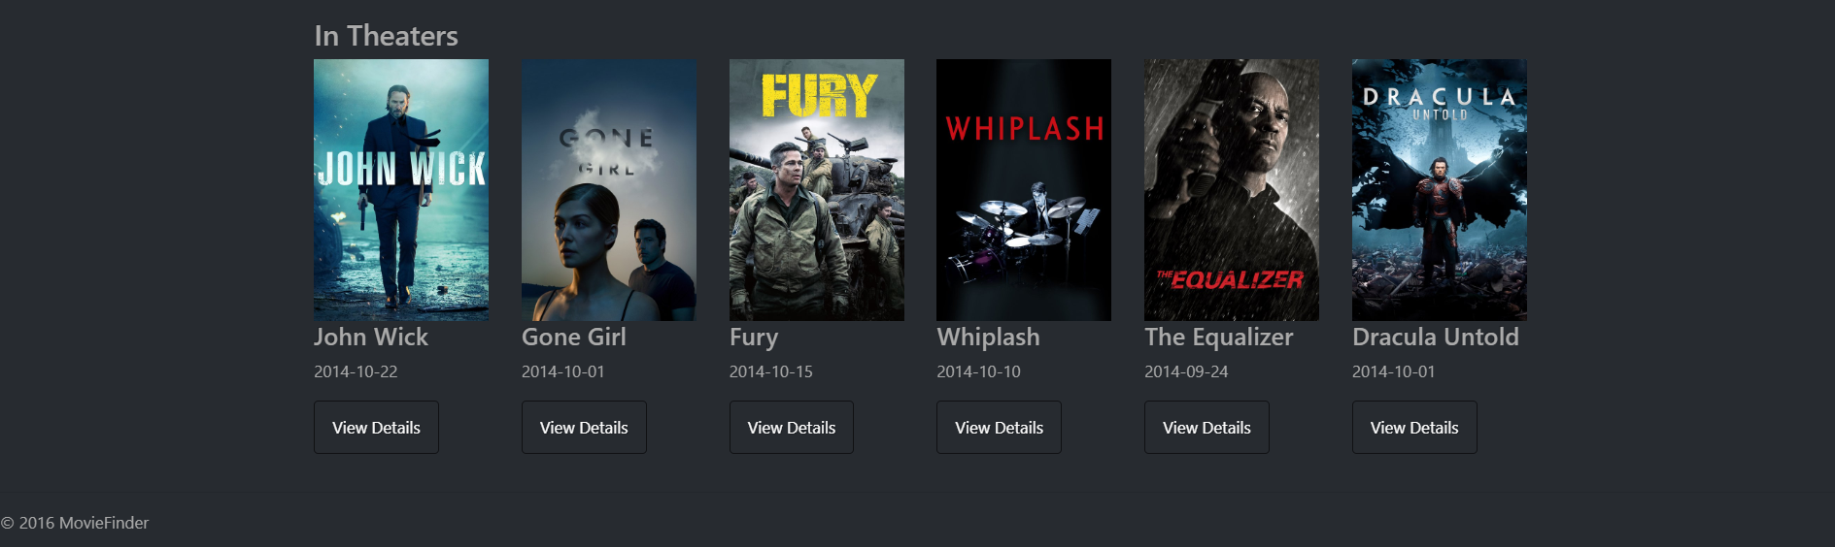

In the next part we will add **routing** to our website to create an actual **Single-Page Application**.