# Angular Application – Movie DB (part 2)

We will continue working on our previous project.

## Implement search logic

Go to **app.component.html** and copy the jumbotron section. Remove it from there and paste it in **movies.component.html.** Make changes to see the component look like this:

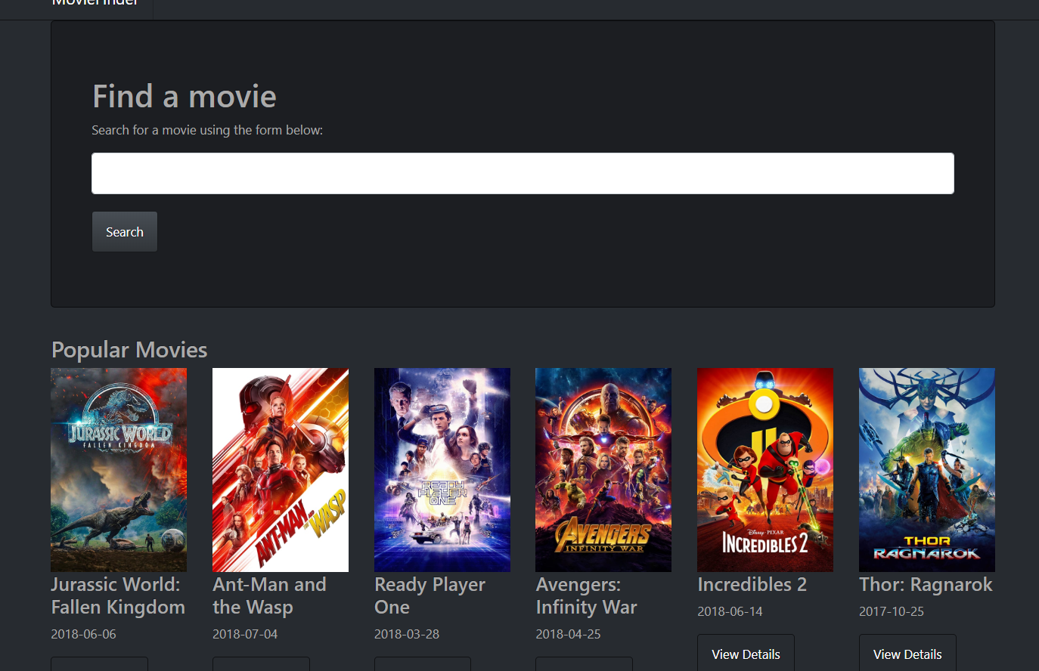

The whole html:

|  |
| --- |
| <div class="jumbotron">  <div class="container">  <h1>Find a movie</h1>  <p>Search for a movie using the form below:</p>  <form action="">  <input type="text" class="form-control">  <button >Search</button>  </form>  </div>  </div>  <div class="panel panel-default">  <div class="panel-heading">  <h3 class="panel-title">Popular Movies</h3>  </div>  <div class="panel-body">  <div class="row">  <div *ngFor="let movie of popular.results;let i=index" class="col-md-2">  <div *ngIf="i < 6">  <img *ngIf="movie.poster_path" class="thumbnail" src="http://image.tmdb.org/t/p/w500/{{movie.poster_path}}">  <h4>{{movie.title}}</h4>  <p>{{movie.release_date}}</p>  <p><a class="btn btn-default" href="#">View Details</a></p>  </div>  </div>  </div>  </div>  </div>  <div class="panel panel-default">  <div class="panel-heading">  <h3 class="panel-title">In Theaters</h3>  </div>  <div class="panel-body">  <div class="row">  <div *ngFor="let movie of theaters.results;let i=index" class="col-md-2">  <div *ngIf="i < 6">  <img *ngIf="movie.poster_path" class="thumbnail" src="http://image.tmdb.org/t/p/w500/{{movie.poster_path}}">  <h4>{{movie.title}}</h4>  <p>{{movie.release_date}}</p>  <p><a class="btn btn-default" href="#">View Details</a></p>  </div>  </div>  </div>  </div>  </div> |

## List more categories

Using your knowledge from previous exercise list **two more** section. One for **popular kids movies** and one for the **best drama movies**.

Your project should look like this:

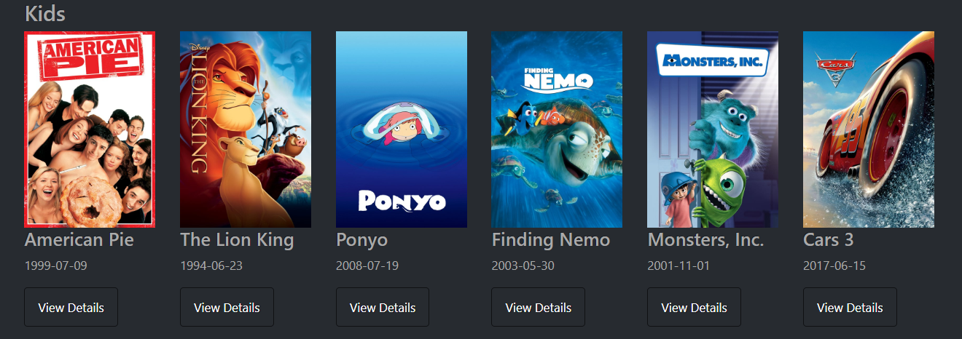

and for drama:

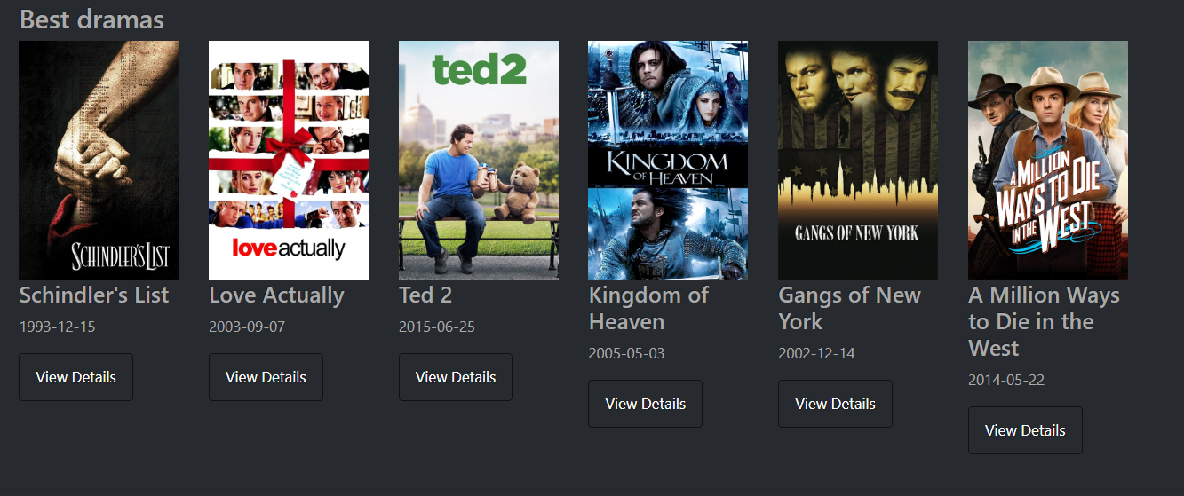

## Prepare for navigation

When we click on “**view details**” button we should be **redirected** to another page and be able to see the details for the selected movie.

To achieve that we will need navigation. Go to the directory where the **app.module** is and create new file **app.routing.ts**

and import

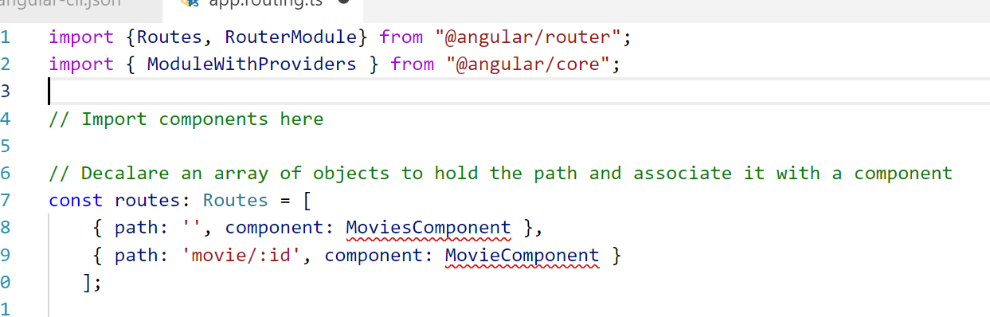

Note that you should import your **MoviesComponent** and create a **new component** called MovieComponent which will be responsible to list the details for a single movie.

After that export a varriable of type **ModuleWithProviders** and assigned to be: **RouterModule.forRoot({***here place the array you just created***})**

Go to app module and add to imports the routing varriable we have just exported form the **app.routing file**.

## Set up the movie component

We should **import** in our component the service and **ActivatedRoute** from **“@angular/router”** and **inject** them through the constructor:

Go to our service and create **new function** called **getMovie(id)** which will take a parameter (id of the movie) and return the call from the **API** for the movie.

Return to the **movie component** and in the **OnInit** method **subscribe** to the router’s parameters and take the id. Below call the service with the new function and give the **id** as an argument

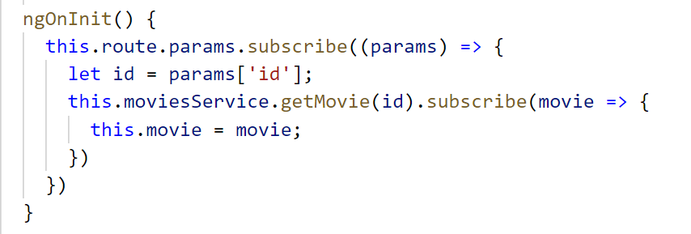

Now we should implement the link. Go to **movies.component.html** and replace the **href** links in “view details” buttons with **routerLink=”/movie/{{movie.id}}”**

Do not forget to replace all in **app.component.html** in container with **<router-outlet></router-outlet>**

When we click on some of the “view details” buttons the page should like this:

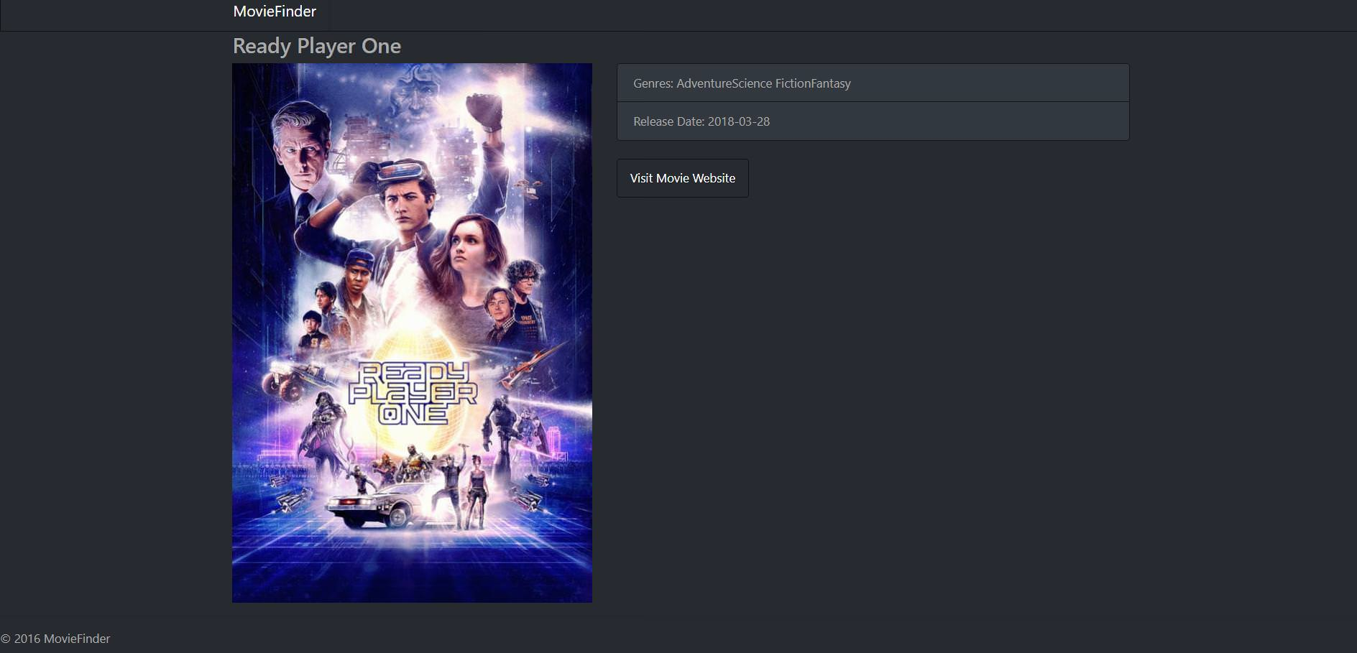

In order to finish this part of application we should add **HTML template** for our **MovieComponent**

|  |
| --- |
| <div \\ensure that there is a movie in order to render this div>  <div class="panel panel-default">  <div class="panel-heading">  <h3 class="panel-title">{{place movie title here}}</h3>  </div>  <div class="panel-body">  <div class="row">  <div class="col-md-5">  <img class="thumbnail" src="<http://image.tmdb.org/t/p/w500/>{{place poster path here}}">  </div>  <div class="col-md-7">  <ul class="list-group">  <li class="list-group-item">Genres: <span *ngFor="let genre of movie.genres">{{list all genres for this movie}}</span></li>  <li class="list-group-item">Release Date: {{show the release date of the movie}}</li>  </ul>  <br>  <a *ngIf="movie.homepage" href="{{place movie's home here}}" target="_blank" class="btn btn-default">Visit Movie Website</a>  </div>  </div>  </div>  </div>  </div> |

## * Working search form (optional)

We make our **UI** for our **search form** but it does **not** include any functionality. So we are going to use **forms** here.

In **app.module** import **FormsModule** from **'@angular/forms'** and add FormsModule to the **imports**

Our HTML should look like this:

*<form #form="ngForm" (submit)="search(form.value)">*

*<input type="text" class="form-control" name="search" ngModel>*

*<button type="sumbit" class="btn btn-primary">Search</button>*

*</form>*

Next steps:

1. Go to our service and create a function **findAMovie(name)**

2. After that go to **movies.component.ts** and create a function which will take the **string** from user input and will call the **new service function**. **Subscribe** to it and list the results in the view.

3. Render the results **only** if the user has **clicked** search button.

The results should look like this

