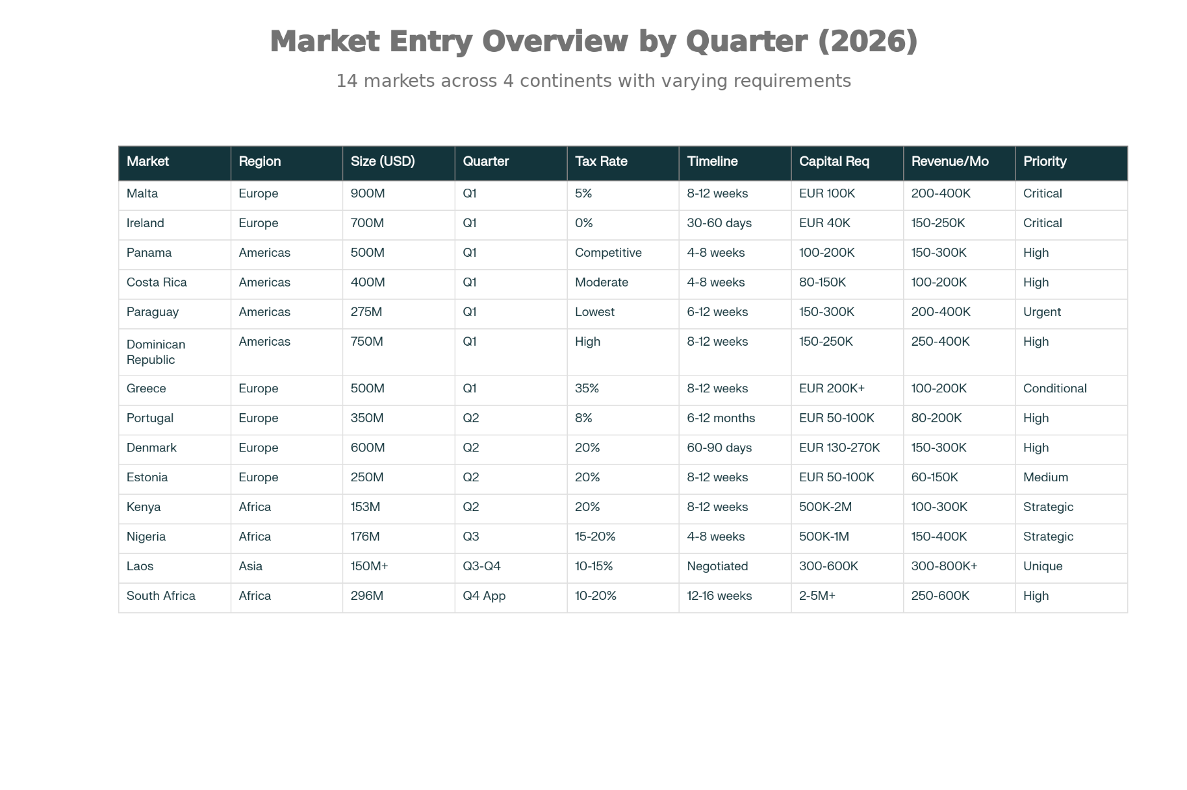
14-Market Strategic Summary: Entry Timeline, Economics & Revenue Potential

Key Highlights
Q1 2026 – Foundation Launch (7 Simultaneous Applications)
ACTION REQUIRED THIS WEEK:
Market | Market Size | Tax | Capital | Revenue Target | Status
🔴 Malta | USD 800M-1.0B | 5% | EUR 100K | USD 200-400K/mo | EU Foundation – CRITICAL
🔴 Ireland | USD 600M-800M | 0% | EUR 40K | USD 150-250K/mo | Fastest Entry – CRITICAL
🔴 Paraguay | USD 200M-350M | LOWEST | USD 150-300K | USD 200-400K/mo | De-Monopolization – URGENT
🟠 Panama | USD 400M-600M | Competitive | USD 100-200K | USD 150-300K/mo | Americas Hub
🟠 Costa Rica | USD 300M-500M | Moderate | USD 80-150K | USD 100-200K/mo | Central America
🟠 Dominican Republic | USD 600M-900M | High | USD 150-250K | USD 250-400K/mo | Closing Window Q4
🟡 Greece | USD 400M-600M | 35% ⚠️ | EUR 200K+ | USD 100-200K/mo | Conditional on 35% Tax Viability
Total Q1 Capital: USD 1.275M | Total Q1 Monthly Revenue Target: USD 1.05M-1.95M

Q2 2026 – Secondary Markets (4 Markets + Q1 Approvals Ramping)
Market | Market Size | Tax | Capital | Revenue Target | Launch Timeline
Portugal | USD 300M-400M | 8% | EUR 50-100K | USD 80-200K/mo | Application Q2; Approval Oct 2026
Denmark | USD 500M-700M | 20% | EUR 130-270K | USD 150-300K/mo | Approval Aug-Sept 2026
Estonia | USD 200M-300M | 20% | EUR 50-100K | USD 60-150K/mo | Approval Jul-Aug 2026
Kenya | USD 153M | 20% | USD 500K-2M | USD 100-300K/mo | Approval May 2026; Launch June
Total Q2 Capital: USD 1.45M | Operating Markets by June: 8 | Monthly Revenue Run-Rate: USD 1.0M-2.0M

Q3 2026 – Growth & Regional Expansion (2 Markets)
Market | Market Size | Tax | Capital | Revenue Target | Launch Timeline
Nigeria | USD 176M | 15-20% | USD 500K-1M | USD 150-400K/mo | Multi-state; Approval May-June 2026
Laos POGO | USD 150M+ | 10-15% | USD 300-600K | USD 300-800K+/mo | Application Q3; Approval Dec 2026
Total Q3 Capital: USD 1.7M | Operating Markets by Sept: 11+ | Monthly Revenue Run-Rate: USD 1.5M-3.0M

Q4 2026 – Consolidation & Positioning (1 Application + Laos Award)
Market | Market Size | Tax | Capital | Revenue Target | Launch Timeline
South Africa | USD 296M | 10-20% | USD 2-5M+ | USD 250-600K/mo (Q2 2027) | Application Q4; Approval Q1 2027; Launch Q2-Q3 2027
Total Q4 Capital: USD 1.5M | Operating Markets by Dec: 13 | Monthly Revenue Run-Rate: USD 3.5M-4.5M

Full Year 2026 Financial Snapshot
Metric | Q1 | Q2 | Q3 | Q4 | Full Year
Capital Investment | USD 1.275M | USD 1.45M | USD 1.7M | USD 1.5M | USD 5.925M
Operating Markets | 2-3 | 8 | 11+ | 13+ | —
Monthly Revenue | USD 500-800K | USD 1.0-2.0M | USD 1.5-3.0M | USD 3.5-4.5M | —
Quarterly Revenue | USD 1.5-2.4M | USD 3.0-6.0M | USD 4.5-9.0M | USD 7.5-13.5M | USD 16.5-31M
Year-End Run-Rate | — | — | — | USD 3.5-4.5M/mo | USD 42-54M+ annualized

Regional Breakdown
Europe (4 Markets) – USD 3.2B Market
- Q1: Malta (5% tax, 8-12 weeks) + Ireland (0% tax, 30-60 days)
- Q2: Denmark (20% tax), Estonia (20% tax), Portugal (8% tax, longer timeline)
- Result: Multi-country EU coverage; maximum tax optimization; EU passporting rights
Americas (4 Markets) – USD 1.8B-3.2B Market
- Q1: Panama + Costa Rica (Central America) + Paraguay (de-monopolization) + Dominican Republic (closing window)
- Result: Central, South, and Caribbean Americas presence; lowest Latin American taxes
Africa (3 Markets) – USD 625M Market
- Q2: Kenya (entry, 6.9% CAGR, lowest capital USD 500K-2M)
- Q3: Nigeria (expansion, 7.4% CAGR, multi-state licensing)
- Q4 App / 2027 Launch: South Africa (premium hub, 4.6% CAGR, highest capital USD 2-5M+)
- Result: Sequential learning curve; optimized capital deployment; 50-100M+ addressable player base
Southeast Asia (3 Markets) – Unique Regional Hub
- Q3-Q4: Laos POGO (offshore foreign-player licensing serving Thailand, Vietnam, Myanmar, Cambodia)
- Result: Multi-country player base (240M+ population); differentiated POGO model; USD 300-800K+/mo revenue potential

Critical Success Factors – Action Items This Week
Priority | Action | Deadline | Owner
🔴 URGENT | Engage Paraguayan counsel; request Conajzar licensing details | Jan 13, 2026 | CCO/Legal
🔴 URGENT | Engage Dominican Republic counsel; prepare licensing application | Jan 15, 2026 | CCO/Legal
🔴 CRITICAL | Engage Malta, Ireland, Panama, Costa Rica counsel (parallel) | Jan 19, 2026 | Legal Team
🟠 HIGH | Complete Greece financial modeling (35% tax viability) | Jan 22, 2026 | CFO
🟠 HIGH | Final Greece decision (proceed OR replace with Denmark/Estonia Q2) | Jan 22, 2026 | CEO
🟢 SUBMIT | Submit all 7 Q1 applications (Malta, Ireland, Panama, Costa Rica, Paraguay, DR, Greece) | Jan 31, 2026 | Legal Team

Why Direct B2C Licensing
Factor | Direct B2C
2026 Capital | USD 5.925M ✅
Timeline Predictability | HIGH ✅
Execution Risk | LOW ✅
Regulatory Window Capture | YES ✅
Operational Complexity | 14 separate P&Ls ✅
2026 Revenue Timing | Q1-Q4 phased ✅

Bottom Line
By executing 7 simultaneous Q1 2026 applications, followed by phased Q2-Q4 expansions, you establish a globally diversified portfolio:
✅ 14 direct B2C licenses across Europe, Americas, Africa, Southeast Asia
✅ USD 5.925M total investment (capital-efficient vs. M&A alternatives)
✅ USD 16.5M-31M 2026 revenue (USD 42-54M+ annualized by year-end)
✅ Multiple regional hubs (EU foundation, Americas portfolio, Africa scaling, Southeast Asia POGO)
✅ Regulatory window capture (Paraguay de-monopolization, Dominican Republic closure, Thailand transformation)

