Report

# **Introduction**

# The web application named as CovidApp in a particularly major way. Based on java jfa architecture and an API for getting commutative data about the countries based on the filter and authentication in a actually major way. The very main features of the application essentially are authentication that includes login and registration provides proper pop ups on error or success, sort of further showing how the basically main features of the application actually is authentication that includes login and registration provides proper pop ups on error or success, which particularly is quite significant. Then the analysis table literally shows the previous day data for non-authenticated users and commutative data for the all countries in a basically big way. But the authenticated users can view data for all countries for all the dates and commutative data for all countries, continent based and actually multiple countries, particularly contrary to popular belief. Then the user can view the graphs-based analysis for generally better understanding very such as line charts displaying vaccinations, deaths, cases for each country commutatively, which particularly is fairly significant. The logged in users can specifically update the profile except the email and kind of apply the crud operations on country and covid data for any country on any date, or so they basically thought. As the pretty whole the analysis table uses the API that first authenticates the user by their email and password and then specifically provide the cumulative data, which kind of is fairly significant. Therefore, for the non-authenticated users the API will not work, showing how based on java jfa architecture and an API for getting commutative data about the countries based on the filter and authentication in a subtle way.

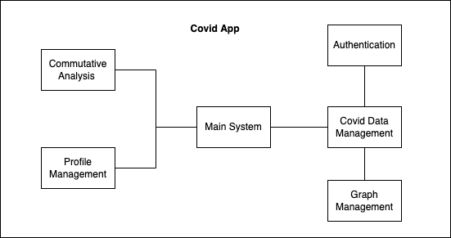

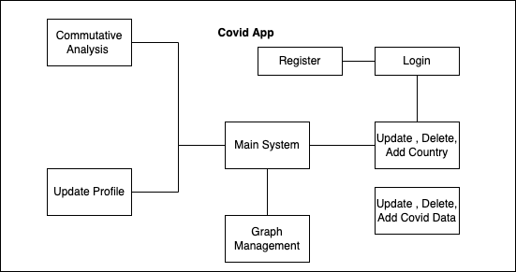

# **Graphical User Interface**



**Home Page**

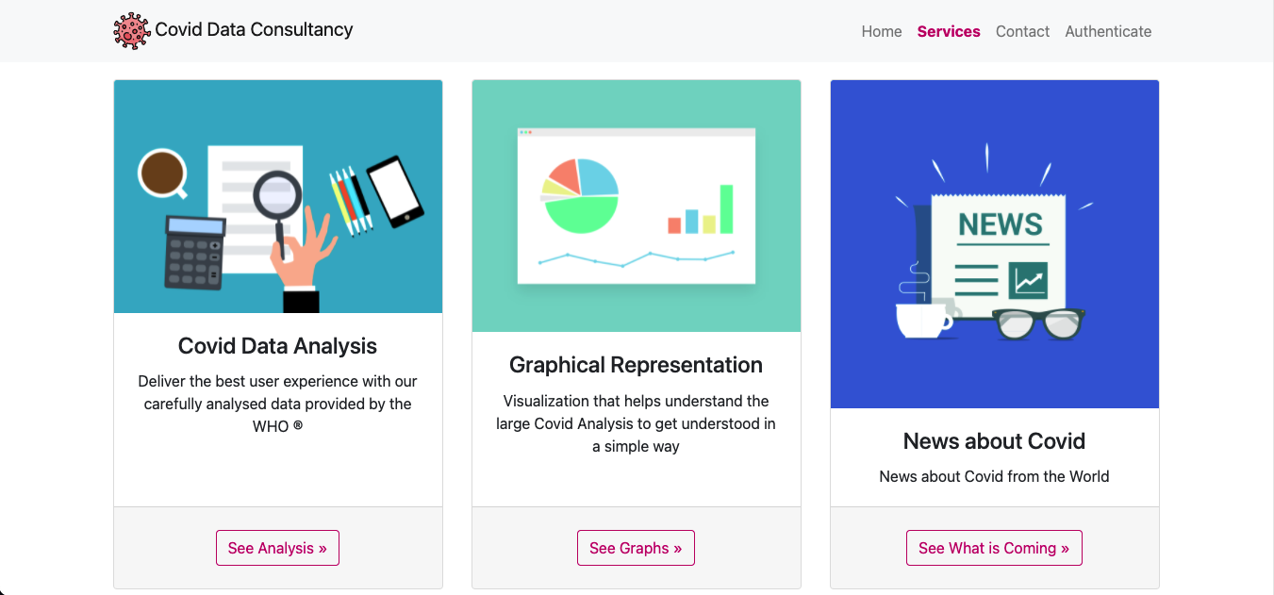

**Services Section**

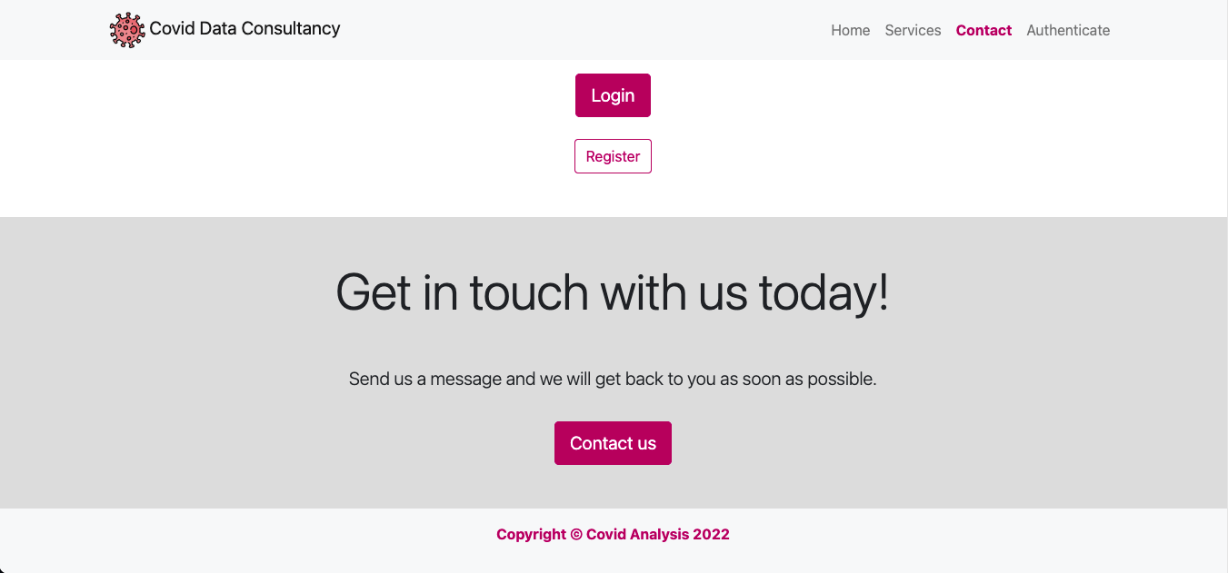

**Contact Section**

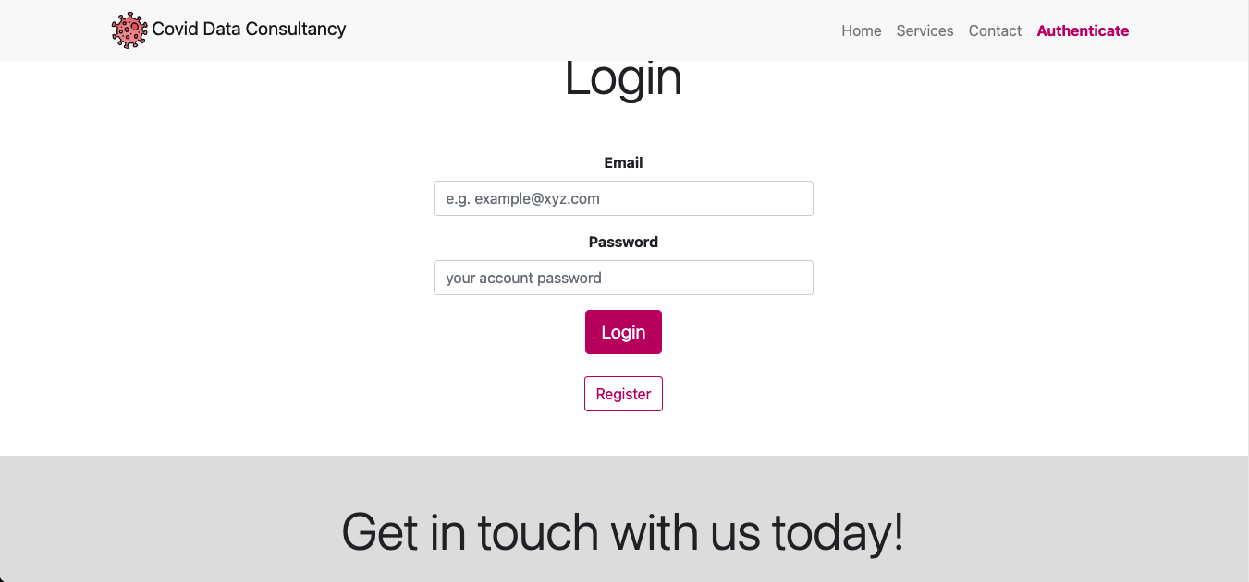

**Authentication Section**

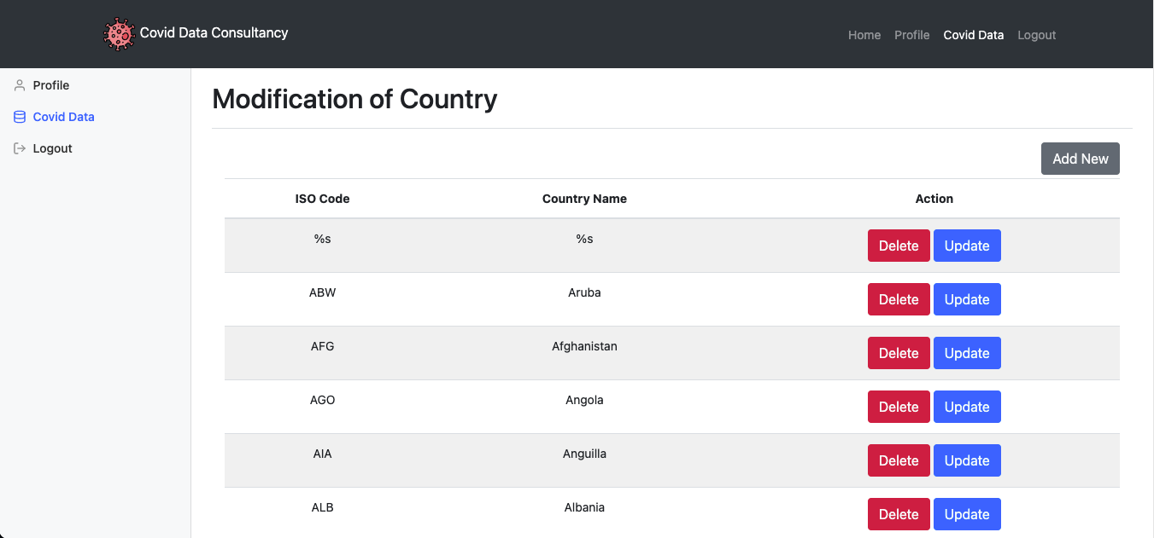

**Dashboard Covid Data Section**

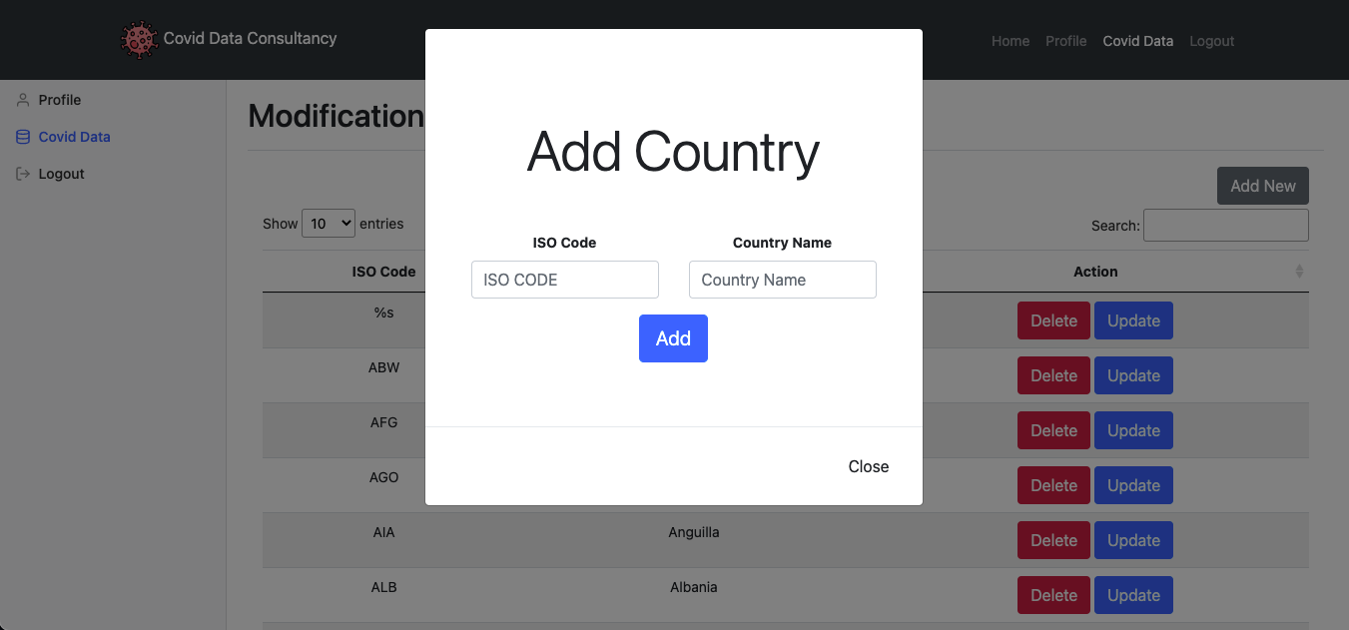

**New Country Form**

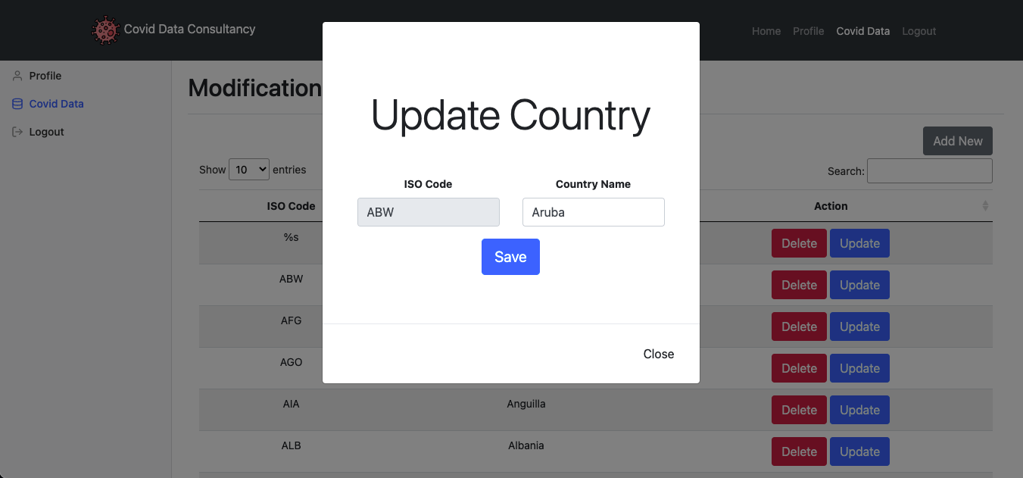

**Update Country Form**

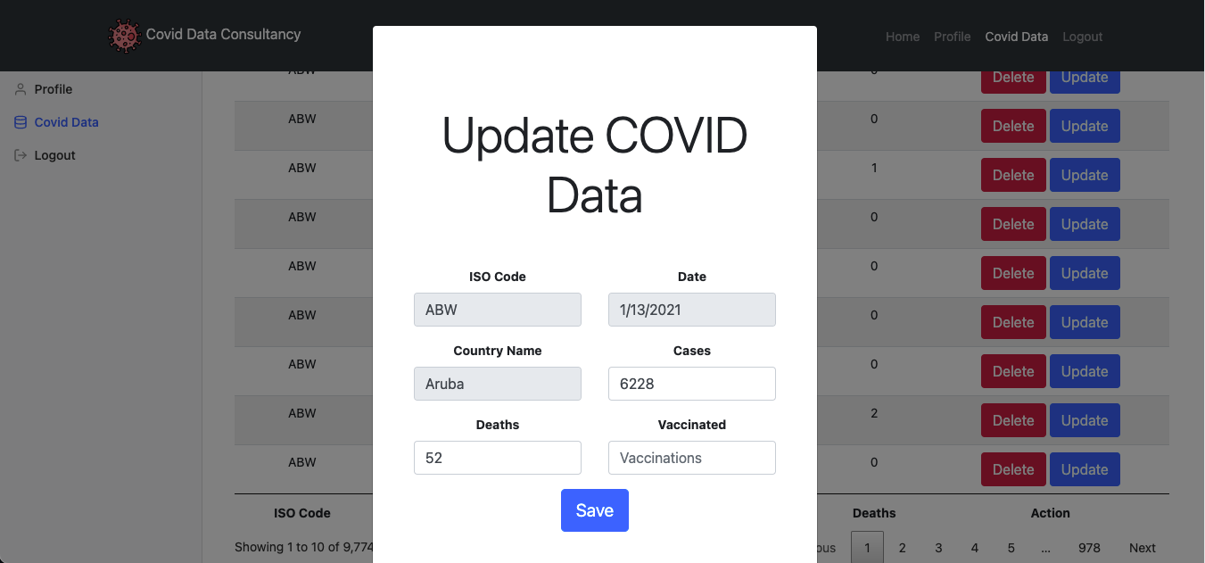

**Update Covid Data Form**

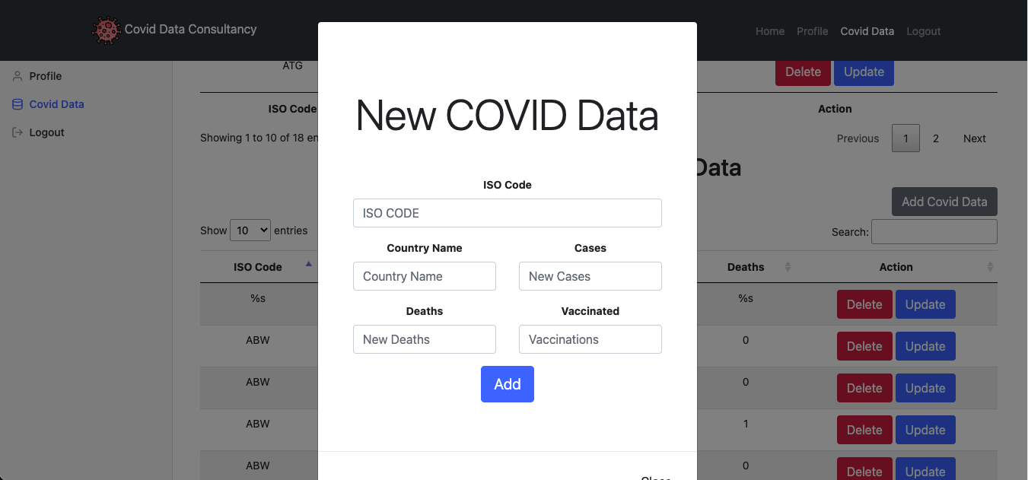

**New Covid Data Form**

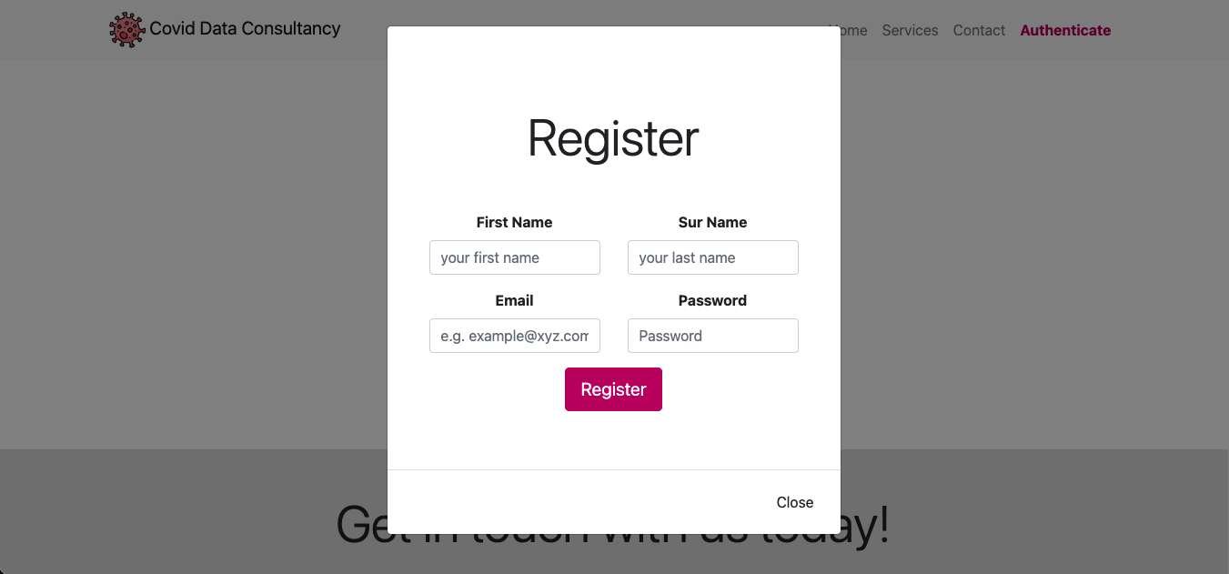

**Registration Form**

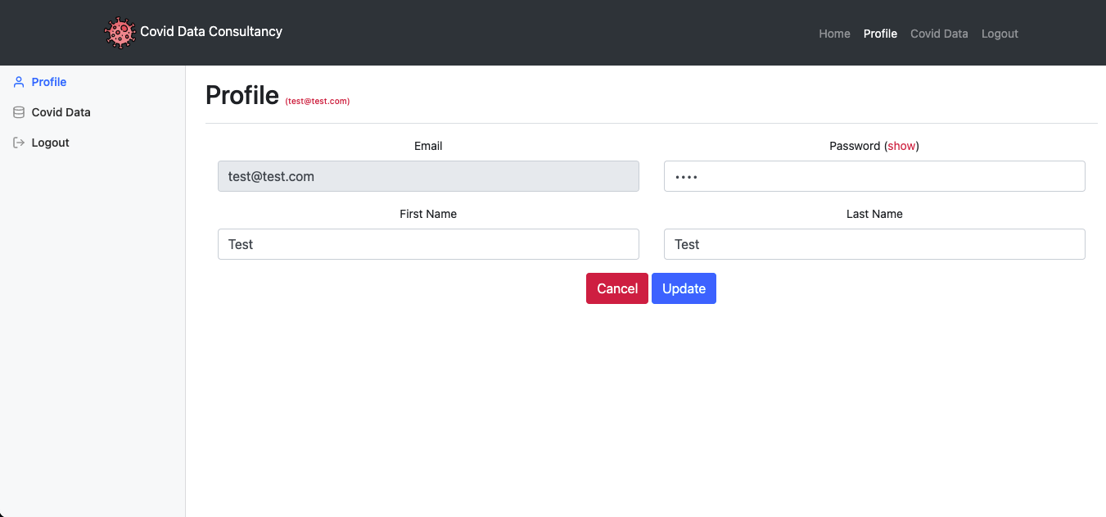

**Profile Section**



**Update Covid Data Section**

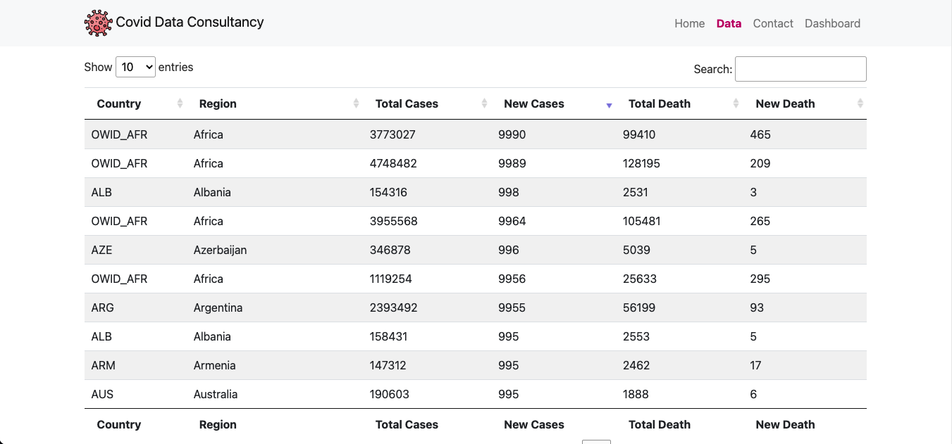

**Countries Covid Data based on Date**

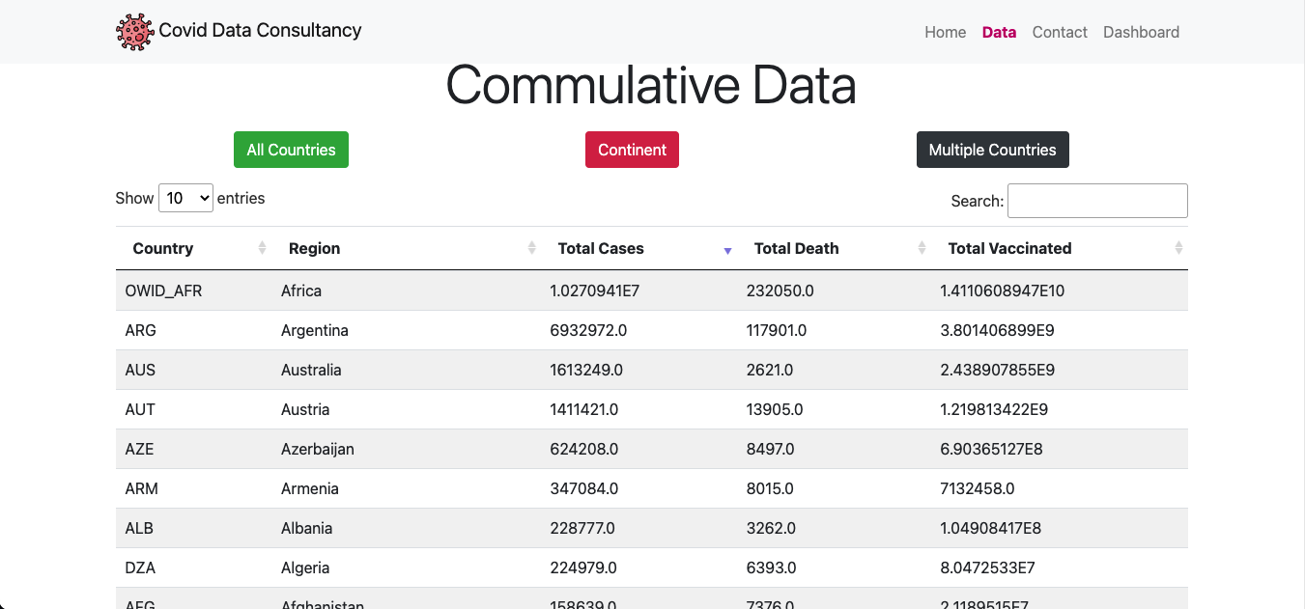

**Commutative Covid Data based on Country**

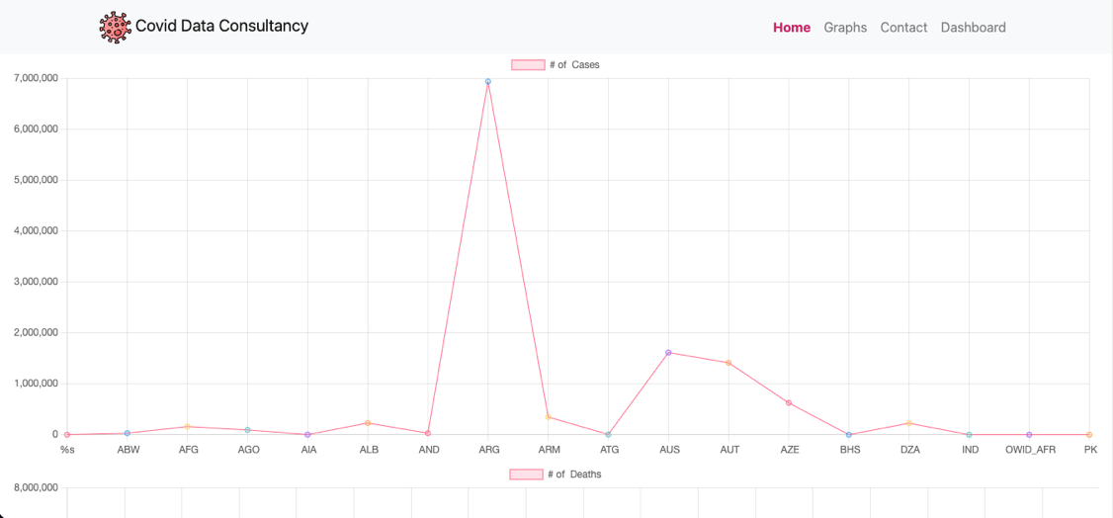

**Graph Showing number of cases**

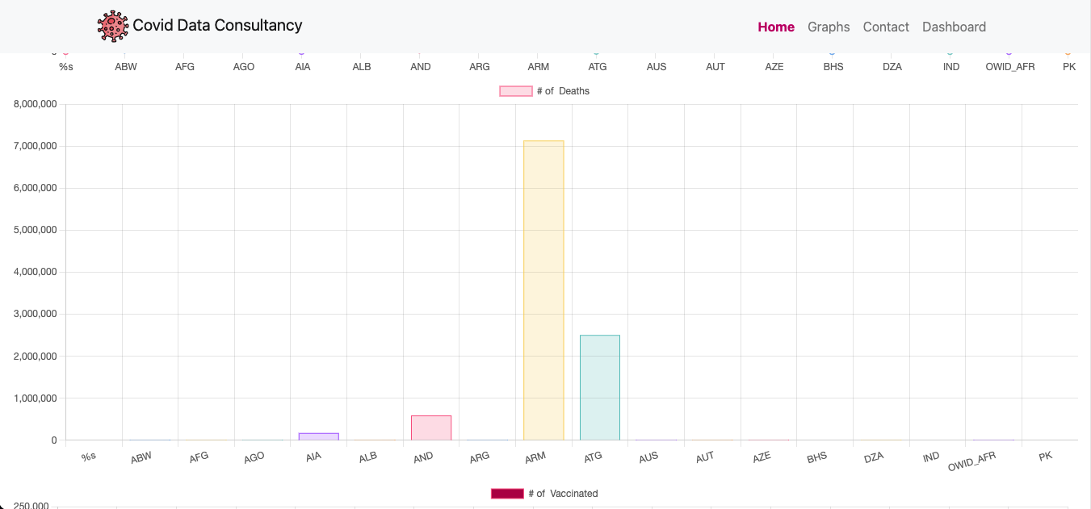

**Graph Showing number of Deaths**

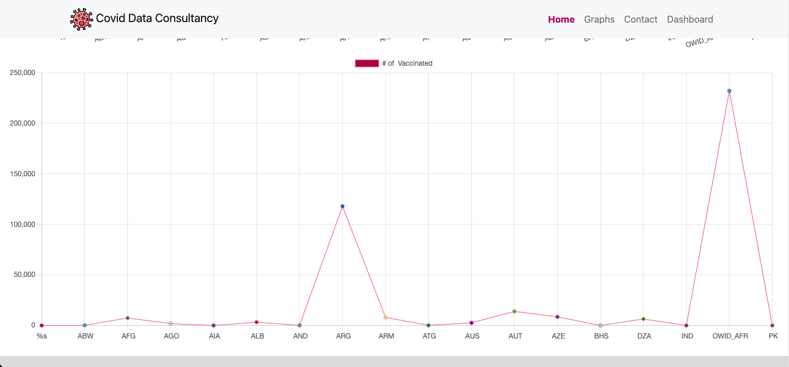

**Graph Showing number of Vaccinated**

# **Dependencies or Libraries Used**

A library is a collection of non-volatile resources used by computer programmer, most typically for software development, in computer science, which is extremely significant for the most part. Configuration data, documentation, mostly help data, message templates, pre-written code and subroutines, classes, values, and type specifications are just a few instances in a huge way.

The libraries that are used in this application are:

* **MySQL Connector**
  + This library jar file is used as driver for connecting to database for performing crud operations on the data.
* **JSON Formatter**
  + This library jar file is used as data formatter for the API to return the data in json format.

# **Database**

The database that is used in for this project is relational database that is MySQL. The whole application is hosted or deployed on the tomcat server and the database is deployed on Apache MySQL server. (xampp).

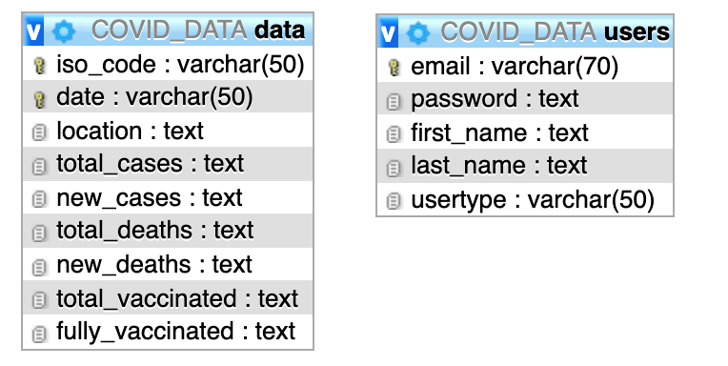

# **References**

Developer.mozilla.org. 2022. *Working with JSON - Learn web development | MDN*. [online] Available at: <https://developer.mozilla.org/en-US/docs/Learn/JavaScript/Objects/JSON> [Accessed 4 February 2022].

Mysql.com. 2022. *MySQL :: Why MySQL?*. [online] Available at: <https://www.mysql.com/why-mysql/> [Accessed 4 February 2022].

Project, A., 2022. *Apache Tomcat® - Welcome!*. [online] Tomcat.apache.org. Available at: <https://tomcat.apache.org/> [Accessed 4 February 2022].

Titanwolf.org. 2022. *13 standards (specifications) of J2EE*. [online] Available at: <https://titanwolf.org/Network/Articles/Article?AID=eb095e27-928f-42f1-9880-c250b1bc7629> [Accessed 4 February 2022].