ΠΑΝΕΠΙΣΤΗΜΙΟ ΙΩΑΝΝΙΝΩΝ
ΤΜΗΜΑ ΜΗΧ. Η/Υ & ΠΛΗΡΟΦΟΡΙΚΗΣ

ΑΝΑΠΤΥΞΗ ΛΟΓΙΣΜΙΚΟΥ

ΠΡΟΓΡΑΜΜΑΤΙΣΤΙΚΗ ΕΡΓΑΣΙΑ για το ακαδημαϊκο έτος 2019-2020

ΟΜΑΔΑ 4387-4508-4523

κικιδης κωνσταντινος, ΑΜ:4387

τσαμπιρας κωνσταντινοσ, ΑΜ:4508

ΤΕΛΙΚΗ ΑΝΑΦΟΡΑ

ΔΕΚΕΜΒΡΙΟΣ 2019

ΙΣΤΟΡΙΚΟ ΕΚΔΟΣΕΩΝ ΤΗΣ ΠΑΡΟΥΣΑΣ ΑΝΑΦΟΡΑΣ
Ημερομηνία | Έκδοση | Περιγραφή | Συγγραφείς
2019/11/03 | v.01 | Οργάνωση απαιτήσεων σε use cases | 4387-4508
2019/11/24 | v.02 | Αρχική σχεδίαση κλάσεων και ελέγχων | 4387-4508
2019/12/13 | v.03 | Διορθώσεις στις uses cases, επεκτάσεις στη σχεδίαση κλάσεων και ελέγχων | 4387-4508
2019/12/14 | v.04 | ΤΕΛΙΚΗ ΑΝΑΦΟΡΑ | 4387-4508

Ανάλυση Απαιτήσεων – Use Cases
Στην παρούσα ενότητα, παρατίθενται οι περιγραφές των use cases με βάση τις καταγεγραμμένες απαιτήσεις.
LoadData
- ID: UC1
- Description and Goal
The UC LoadData, reads the data from the given file and stores them.
- Actors (esp. primary actor)
Analyst
- Preconditions
-
- Basic Flow
- The UC starts when the actor selects the 1st option from the menu.
- The system asks for the file path, the delimiter used and if the file has a header line.
- Extensions / Variations
2a. In case of wrong file path, the system asks for a valid file path.
2b. In case of wrong delimiter, the system asks for a valid delimiter.
- Post conditions
The system returns the number of valid lines that have been loaded.
- Special Requirements, Issues, Risks and other Comments
The input file must have the correct format, with 9 columns.

AggregateByTimeUnit
- ID: UC2
- Description and Goal
The UC AggregateByTimeUnit, aggregates measurements by a time unit, e.g., month, day of week, period of day etc.
- Actors (esp. primary actor)
Analyst
- Preconditions
Data must have been loaded first.
- Basic Flow
- The UC starts when the actor selects the 2nd option from the menu.
- The system asks the actor for a description of the data, in order to show it on the final report, the type of aggregation (season/month/day of week/period of day), the aggregate function (avg/sum).
- Extensions / Variations
2a. In case of wrong type of aggregation, the system asks for a valid one.
2b. In case of wrong aggregate function, the system asks for a valid one.
- Post conditions
The data is have been aggregated correctly.
- Special Requirements, Issues, Risks and other Comments
-

ReportResultsInFile
- ID: UC3
- Description and Goal
The UC ReportResultInFile, reports the contents of an aggregate result to a file.
- Actors (esp. primary actor)
Analyst
- Preconditions
Data must have been loaded and aggregated first.
- Basic Flow
- The UC starts when the actor selects the 3rd option from the menu.
- The system asks the actor for the file format of the output file (html/txt/md) and for the output directory path.
- Extensions / Variations
2a. In case of wrong file format, the system asks for a valid one.
2b. In case of wrong output directory, the system asks for a valid one.
- Post conditions
The system returns 0 and the place where the report has been saved, with filename FinalReport.
- Special Requirements, Issues, Risks and other Comments
After a completed export, the system saves all the metadata on a list for future reference (lost if the application terminates).

ShowHistory
- ID: UC4
- Description and Goal
The UC ShowHistory, shows the types of the reports requested previously from the actor.
- Actors (esp. primary actor)
Analyst
- Preconditions
There’s already at least one completed report.
- Basic Flow
- The UC starts when the actor selects the 4th option from the menu.
- The system returns a list with the metadata of previously requested reports.
- Extensions / Variations
2a. If there’s no report, the system returns an error message.
- Post conditions
-
- Special Requirements, Issues, Risks and other Comments
The history will be deleted when the application terminates.

Exit
- ID: UC5
- Description and Goal
The UC Exit, terminates the application.
- Actors (esp. primary actor)
Analyst
- Preconditions
-
- Basic Flow
- The UC starts when the actor selects the 5th option.
- The system terminates.
- Extensions / Variations
-
- Post conditions
-
- Special Requirements, Issues, Risks and other Comments
-

Σχεδίαση Ελέγχων
Οι έλεγχοι που σχεδιάσθηκαν και εντάχθηκαν στην υλοποίηση περιγράφονται παρακάτω.

Ελεγχος use cases via system tests

Traceability Matrix
Η αντιστοίχιση use cases σε id’s φαίνεται στον Πίνακα 1:
UC1 | Load data
UC2 | Aggregate by time unit
UC3 | Report results in file
UC4 | Show history
UC5 | Exit
Πίνακας 1 Σύνοψη use cases και των id’s τους
Ο Πίνακας 2 είναι ο traceability matrix για τους ελέγχους μας. Στη συνέχεια, οι έλεγχοι επεξηγούνται πιο αναλυτικά.
 | UC1 | UC2 | UC3 | UC4 | UC5
T1_V0_01 | X
T2_V0_01 |  | X
T3_V0_01 |  |  | X
Πίνακας 2 Traceability matrix between use cases and tests

Use case UC1: Load Data
Involved methods
Loader.load(), MainEngine.loadData(), (MainApplication, switch case1)
Test cases
ID | T1_V0_01 | HappyDayScenario for load()
Description | ON | any context
 | RECEIVING | The file path of a file with the data
 | ENSURE | That the System
 | OUTPUTS | The correct formatting of the file
 | SUCH THAT | The state is intact.
Pre-cond. |  | No specific precondition
Input |  | The file path of the file
Output |  | The organized data in collection
Post-cond. |  | The data has been loaded correctly
Method To test |  | load(), loadData()

Use case UC2: AGGREGATE BY TIME UNIT
Involved methods
Aggregator.aggregateByTimeUnit(), MainEngine.aggregateByTimeUnit(), (MainApplication, switch case2)
Test cases
ID | T2_V0_01 | HappyDayScenario for aggregateByTimeUnit()
Description | ON | Any context
 | RECEIVING | The loaded data and the aggregation type
 | ENSURE | That the System
 | OUTPUTS | The aggregated data on an IResult object
 | SUCH THAT | The state is intact.
Pre-cond. |  | Data must have been loaded first.
Input |  | The loaded data and the aggregation function
Output |  | The IResult object
Post-cond. |  | The data has been aggregated correctly
Method To test |  | aggregateByTimeUnit()

Use case UC3: REPORT RESULTS IN FILE
Involved methods
ResultReporter.reportResultInFile(), MainEngine.reportResultInFile(), (MainApplication,switch case3)
Test cases
ID | T3_V0_01 | HappyDayScenario for reportResultInFile()
Description | ON | A collection of records having being aggregated
 | RECEIVING | The IResult object and the output location
 | ENSURE | That the System
 | OUTPUTS | The Final Report file
 | SUCH THAT | The state is intact
Pre-cond. |  | Data must have been loaded and aggregated first
Input |  | The output directory
Output |  | The Final Report
Post-cond. |  | Return 0 and the file output location
Method To test |  | reportResultInFile()

Unit tests
Class Loader
ON any context RECEIVING The file path of a file with the data ENSURE That the System OUTPUTS The correct formatting of the file SUCH THAT The state is intact.
Class Aggregator
ON Any context RECEIVING The loaded data and the aggregation type ENSURE That the System OUTPUTS The aggregated data on an IResult object SUCH THAT The state is intact.

Class ResultReporter
ON A collection of records having being aggregated RECEIVING The IResult object and the output location ENSURE That the System OUTPUTS The Final Report file SUCH THAT The state is intact.

ΕΚΚΡΕΜΟΤΗΤΕΣ (ToDo)
-

Σχεδίαση Λογισμικού

Διαγράμματα ΠΑΚΕΤΩΝ / υποσυστημάτων
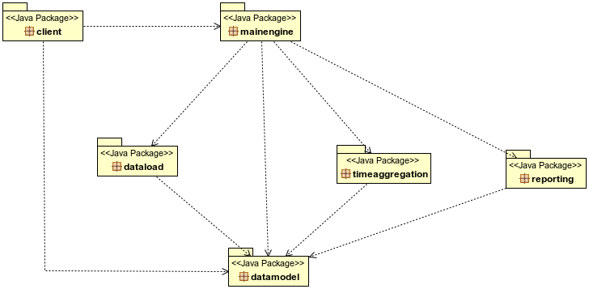

Διαγράμματα Κλάσεων
Στην παρούσα υποενότητα, παρατίθενται τα διαγράμματα κλάσεων και ακολουθιών.
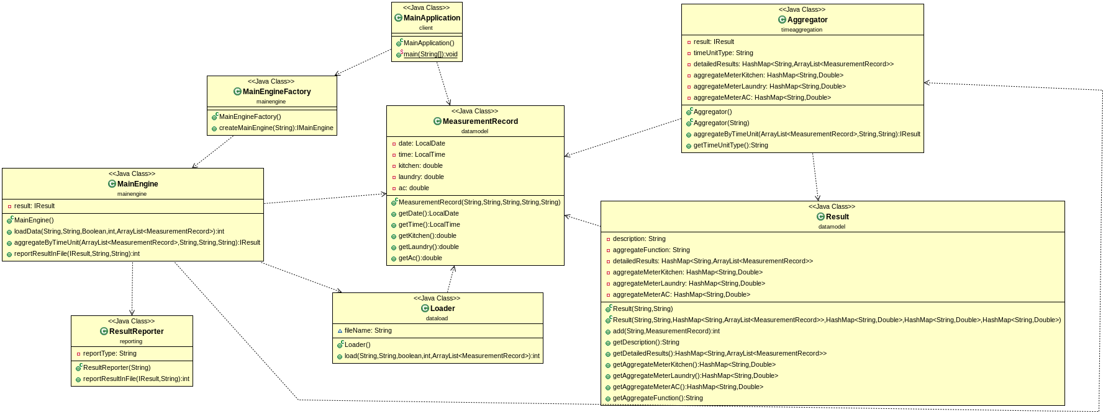
Σχήμα 1. Διάγραμμα κλάσεων για όλα τα πακέτα (παρατίθεται ευκρινέστερο διάγραμμα στην επόμενη σελίδα)

