Product Management System

Konstantinos Tsampiras

# Introduction

This is a simple product management system written in Java using the Spring framework. Admin users can retrieve all the products, add new products, update existing products, and delete products from the database. Simple users can only see existing products and add new ones. The running app has 2 users who can execute commands after proper authorization.

|  |  |  |
| --- | --- | --- |
| Role | ADMIN | USER |
| Username | admin | user |
| Password | Admin | password |

# API Documentation

* GET /api/v1/products

Returns all the products from the database, requires authorization from either an admin or a user.

Using Postman, Select the **GET** action, enter the URL **http://localhost:8080/api/products/** and in the Authorization tab, on Type, select **Basic Auth** and enter the **user** and **password** for the user you want to use, and press **Send**.

A list with the products will appear, each product has a product ID, a name, a description, and a price.

* POST /api/v1/products

Adds a new product to the database, requires authorization from either an admin or a user.

Using Postman, Select the **POST** action, enter the URL **http://localhost:8080/api/products/** and in the Authorization tab, on Type, select **Basic Auth** and enter the **user** and **password** for the user you want to use, in the Body tab, select the raw formatting and select the JSON format, paste the snippet below, and press **Send**.

The product will be returned with a new product ID.

|  |
| --- |
| {  "name": "Laptop",  "description": "A Laptop",  "price": 999.99  } |

* PUT /api/v1/products/*{product ID}*

Updates the product with the specified product ID, requires authorization from an admin.

Using Postman, Select the **PUT** action, enter the URL **http://localhost:8080/api/products/1**, in the Authorization tab, on Type, select **Basic Auth** and enter the **user** and **password** for the user you want to use, in the Body tab, select the raw formatting and select the JSON format, paste the snippet below, and press **Send**.

|  |
| --- |
| {  "name": "Peach",  "price": 1.99  } |

* DELETE /api/v1/products/*{product ID}*

Deletes the product with the specified product ID, requires authorization from an admin.

Using Postman, Select the **DELETE** action, enter the URL **http://localhost:8080/api/products/1**, in the Authorization tab, on Type, select **Basic Auth** and enter the **user** and **password** for the user you want to use, and press **Send**.

# Running the commands

## A screenshot of a computer Description automatically generatedAs an admin

**GET /api/v1/products**

**POST /api/v1/products**

**PUT /api/v1/products/{productid}**

**DELETE /api/v1/products/{product ID}**

## A black rectangle with white text Description automatically generatedAs a user

**GET /api/v1/products**

Same as admin

**POST /api/v1/products**

Same as admin

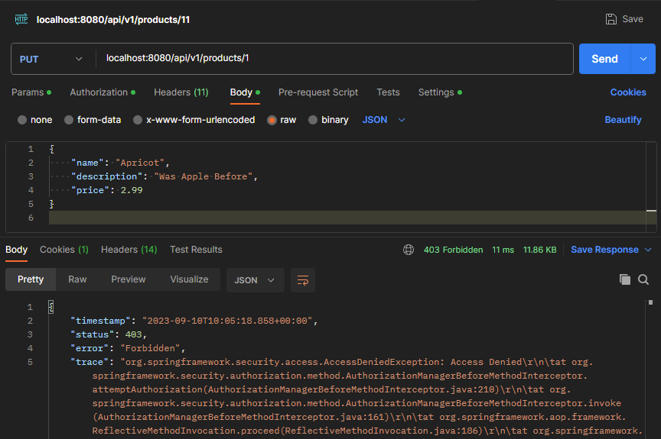**PUT /api/v1/products/{productid}**

**DELETE /api/v1/products/{productid}**

