FEDTRUST
FedTrust Trustworthiness Assessment
Trustworthiness Assessment for Federated Learning Systems
OVERALL ASSESSMENT: CRITICAL

Executive Summary
Overall assessment: CRITICAL. The evaluation identified 2 findings requiring attention. The most significant findings are: Critical membership leakage.

Overall Assessment
Severity | CRITICAL

Classification Performance
The classification evaluation completed successfully.

Metrics
Metric | Value | Unit
Accuracy | 0.800 | Ratio

Findings
- Moderate model performance [MEDIUM]
The model achieves acceptable but improvable predictive performance.
- Evidence: Accuracy = 0.800

Recommendations
- Improve model performance [MEDIUM]
Review model performance before production deployment.

Membership Inference Privacy
The membership_inference evaluation completed successfully.

Metrics
Metric | Value | Unit
MIA ROC-AUC | 1.000 | ROC-AUC

Findings
- Critical membership leakage [CRITICAL]
The evaluation indicates that membership status can be distinguished with high effectiveness.
- Evidence: MIA AUC = 1.000

Recommendations
- Improve privacy protection [CRITICAL]
Prioritize privacy mitigation before deployment.
Interpretation: The ROC curve illustrates how effectively the membership inference attack separates members from non-members. A curve closer to the upper-left region indicates stronger attack discrimination.

Visual Evidence
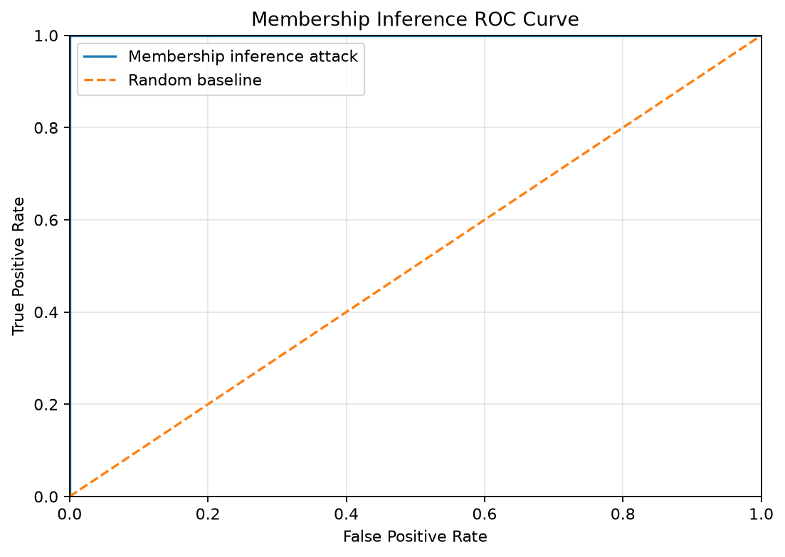
Figure — Membership Inference Privacy evaluation evidence

