Remember to change the password and your setting for your PostgreSQL in the .env file
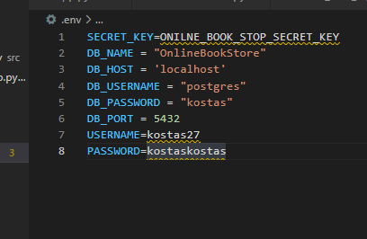

Endpoints:
1)Sign Up
http://127.0.0.1:5000/api/sign_up:
Args:
Json : email, first_name, password1, password2

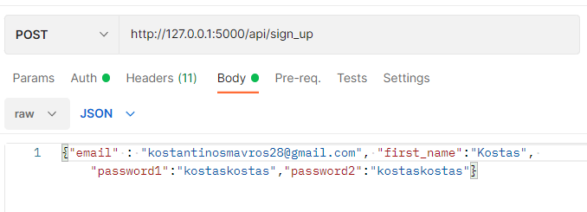
2) Login
http://127.0.0.1:5000/api/login:
Only login endpoint will have basic authentication.
Token will expire in 30 minutes.
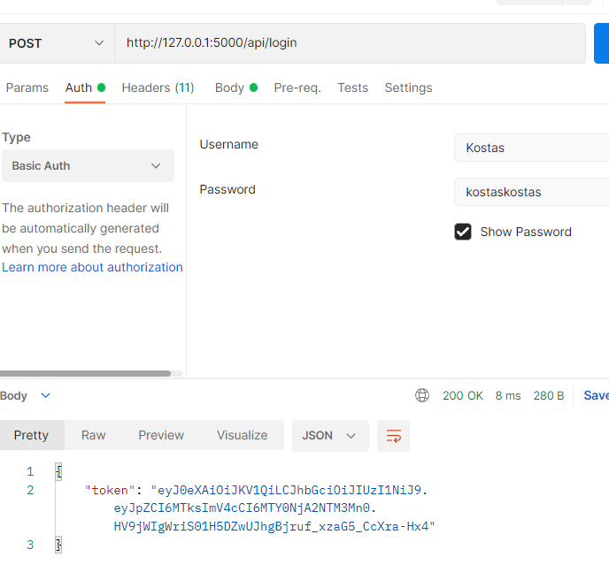
Copy and paste the token value to headers as x-access-token key
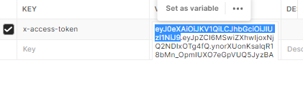

3) Available books without criteria:
http://127.0.0.1:5000/api/books:
if database is empty movies will be imported at your request.
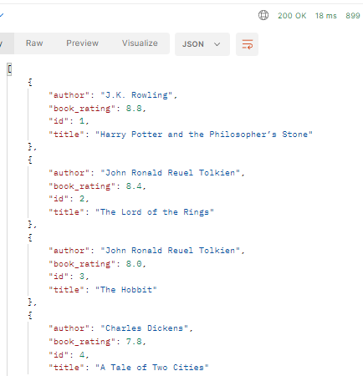

4) Available books with criteria:
http://127.0.0.1:5000/api/books:
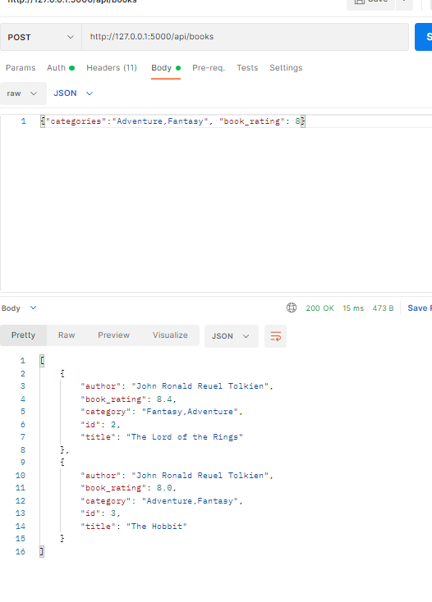

5)Details of a specific book:
http://127.0.0.1:5000/api/books/Harry Potter and the Philosopher’s Stone
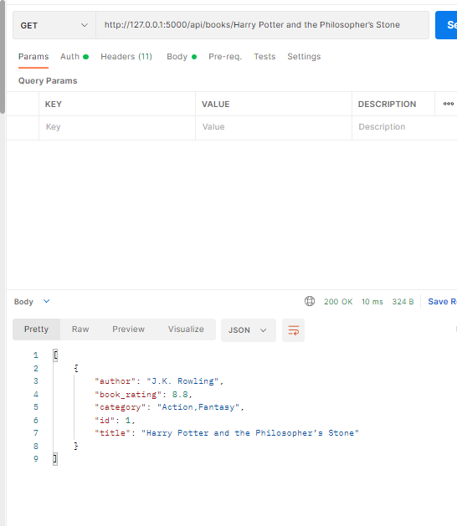

6) Rented books of the current_user:
http://127.0.0.1:5000/api/books/user/rented-books

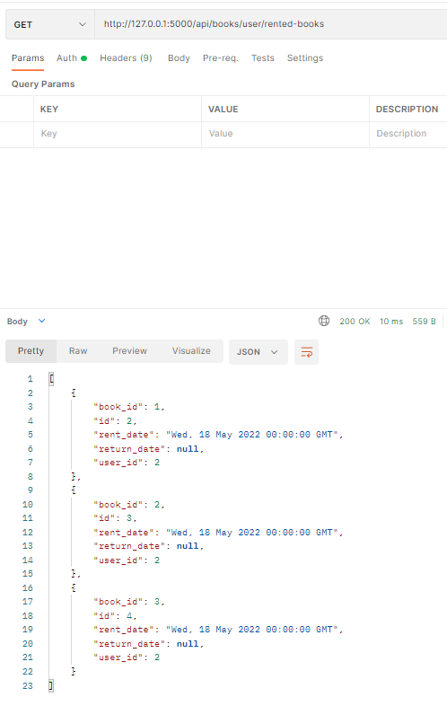

7)Rent a book:
http://127.0.0.1:5000/api/books/book_id/rent:
Requires login.
Token from login will be in header as “x-access-token”.

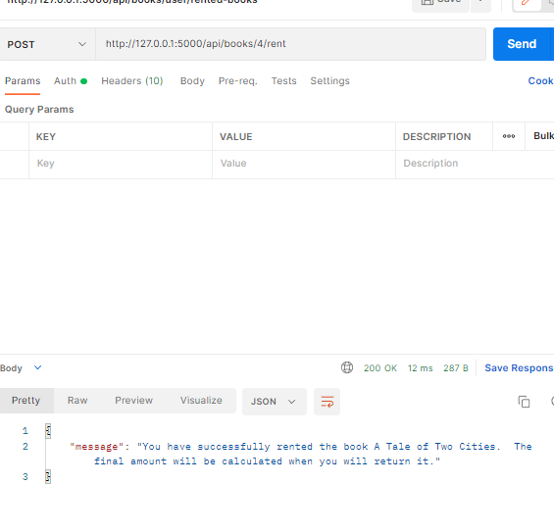

8)Return a book:
http://127.0.0.1:5000/api/books/book_id/return:
Requires login.
Token from login will be in header as “x-access-token”.

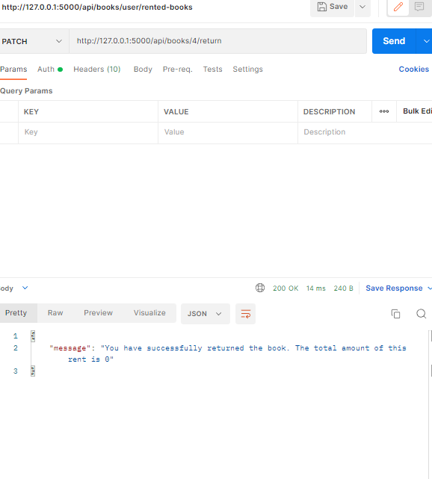

9)Total charge for x days:
http://127.0.0.1:5000/api/books/amount/<int:days>:
