Endpoints:
1)Sign Up
http://127.0.0.1:5000/api/sign_up:
Args:
Json : email, first_name, password1, password2

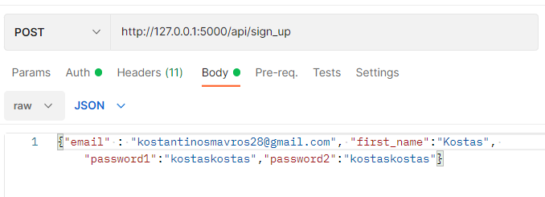
2) Login
http://127.0.0.1:5000/api/login:
Only login endpoint will have basic authentication.
Token will expire in 30 minutes.
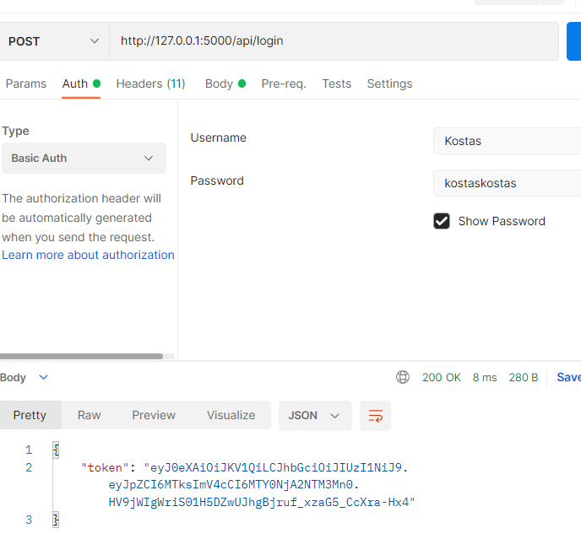

3) Available movies without criteria:
http://127.0.0.1:5000/api/movies:
if database is empty movies will be imported at your request.
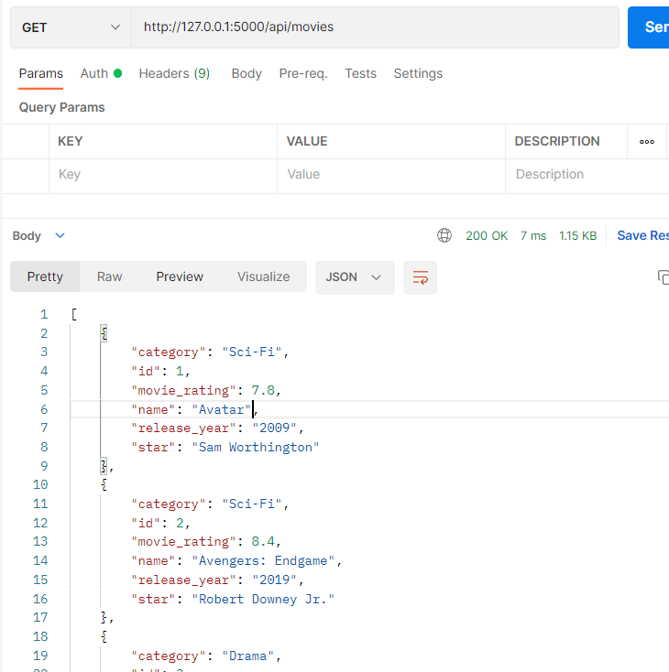

4) Available movies with criteria:
http://127.0.0.1:5000/api/movies:
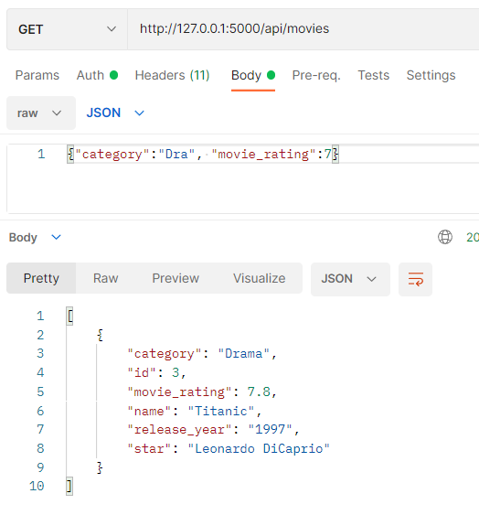

5)Details of a specific movie:
http://127.0.0.1:5000/api/movies/Avengers:
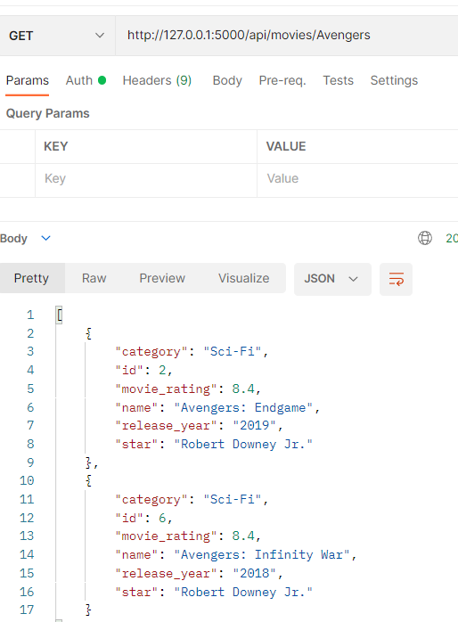

6)Rent a movie:
http://127.0.0.1:5000/api/movies/movie_id/rent:
Requires login.
Token from login will be in header as “x-access-token”.

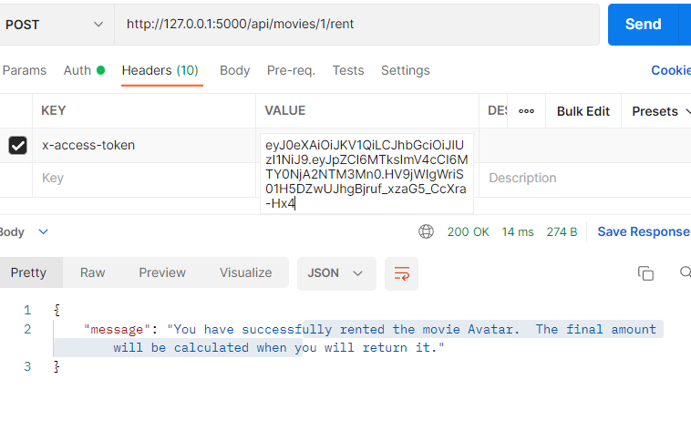

7)Return a movie:
http://127.0.0.1:5000/api/movies/movie_id/return:
Requires login.
Token from login will be in header as “x-access-token”.

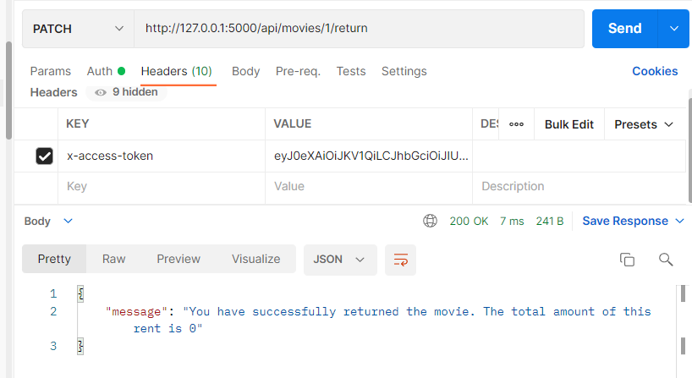

8)Total charge for x days:
http://127.0.0.1:5000/api/movies/amount/days:
