**MDM Lab Assignment 1  
Neural Network Implementation from Scratch**

Name: Kaustubh Wagh  
PRN: 202201070021  
Batch: T1

**Screenshots of results:**

1. **Predicted vs True Median House Value**

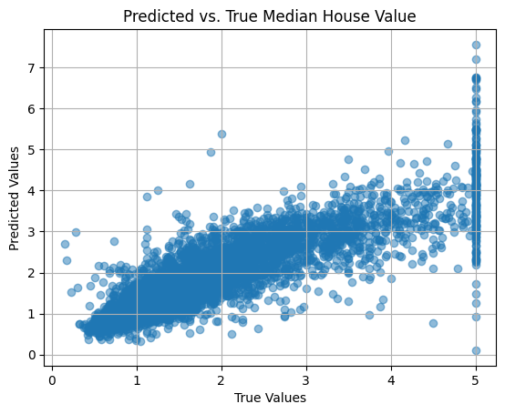

1. **Performance Metrics**

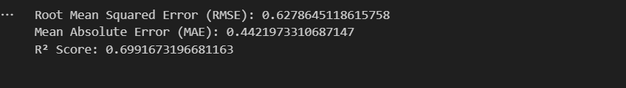

1. **Training Lost Curve**

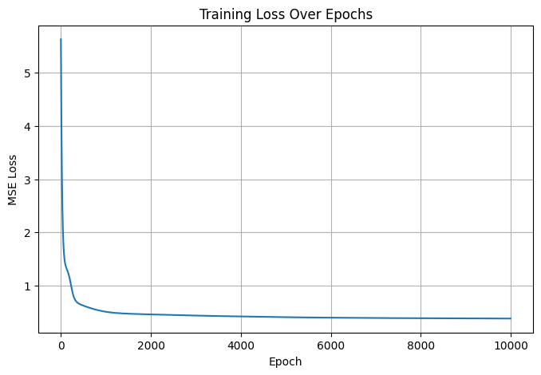

1. **True vs Predicted Values**

