VMware Pro Cloud Service for Private Cloud Infrastructure
Component: VMware Cloud Foundation Low-Level Design and Architecture

  - VMware Cloud Foundation 5.2.x
You can find the most up-to-date technical documentation on the VMware website at:
https://docs.vmware.com/
VMware, Inc.
3401 Hillview Ave.
Palo Alto, CA 94304
www.vmware.com
Copyright© 2023 VMware, Inc. All rights reserved. Copyright and trademark information.
Contents
1. Version History 4
2. Document Overview 5
Executive Summary 5
Document Focus 5
Physical Design 5
Sizing Workbook 6
Naming Convention Document 6
Solution Specification Workbook(s) 6
Solution Verification Workbook(s) 6
3. VMware Pro Cloud Service for Private Cloud Infrastructure Design 8
VMware Cloud Foundation Detailed Design 8
About VMware Cloud Foundation Design Guide 8
External Environmental configurations 10
vSphere Design for VMware Cloud Foundation 23
NSX Design for VMware Cloud Foundation 71
SDDC Manager Design for VMware Cloud Foundation 121
Lifecycle Management Design for VMware Cloud Foundation 124
Logging and Monitoring Design for VMware Cloud Foundation 127
Information Security Design for VMware Cloud Foundation 127
Identity and Access Management for VMware Cloud Foundation Detailed Design 135
Design Objectives of Identity and Access Management 135
Detailed Design of Identity and Access Management 136
4. References 169

Version History
Date | Ver. | Author | Contributors | Description | Reviewers
Architect Note Amend the text as needed and address the consultant and or architect notes. After completion, the notes can be removed. This text provides either sample guidance information, configuration recommendations for specific services, or customer-specific configurations.

Document Overview
This solution design document is created by VMware by Broadcom Professional Services to support the deployment of the Solution for Customer.
This document may be accompanied by other documents that focus on the implementation and operation aspects of the engagement, such as installation guides, solution specification and verification workbooks if implementation services are being performed.

Executive Summary
This executive summary aims to provide a short and comprehensive overview of the technical design, making it easier for decision-makers to understand the project's importance, benefits, and requirements without diving into the technical details.
Architect Note Fill out this with the high-level business language in the below for the customer environment.
This design document outlines the plan for Customer <purpose of the engagement> by VMware by Broadcom Professional Services. The aim is to improve scalability, operational efficiency, and cost-effectiveness while ensuring a high level of security and compliance. The scope of this engagement includes <list main scope items>.
Developed using the VMware by Broadcom design methodology, the architecture aims to address <customers main problems and issues>. Some of the key features of the proposed design includes <technical capabilities that will be an output of the design>.
Upon approval, the next steps include extending the design to the implementation teams, initiating the integrations, and providing the teams with the necessary operational support as part of the handover.

Document Focus
This document, the Low-Level Design Document, is one of five main documents that which will collectively form the Low-Level design documents for the solution.
This includes the following content, which may be presented as one or more technical documents as required by the solution.

Physical Design
The physical design serves as the final, implementable blueprint that translates the high-level objectives and architectural outlines of the conceptual and logical designs into specific, actionable details. The physical design details the exact hardware, including server models, storage arrays, and network devices, as well as their configurations.
It provides intricate network topologies, complete with IP schemes and VLAN settings, specifies storage layouts down to RAID levels and disk types, and outlines concrete security mechanisms such as firewall configurations and encryption protocols. The physical design also covers specifics on availability and disaster recovery solutions like failover clusters and backup schedules.
The physical design incorporates the management and monitoring tools to be used and how they will be configured. Essentially, the physical design is the comprehensive guide that the implementation team will follow to build the system, ensuring that it meets both functional and non-functional requirements and aligns closely with the organizational objectives.

Sizing Workbook
The sizing workbook is a vital tool that systematically outlines the resource requirements such as CPU, memory, storage, and networking that are needed for a specific architecture.
The sizing workbook is a living document which incorporates various elements, including detailed calculations guided by formulas to ensure that the architecture can meet the calculated sizing which ideally would align with the organization's objectives and constraints.
The sizing document incorporates the licensing which will be consumed by the solution and if any design decision violates the licensing constraints or if additional licenses need to be procured part the scalability exercise.

Naming Convention Document
The naming convention document serves as a critical blueprint for organizing and managing elements within a cloud infrastructure. This document delineates a standardized naming scheme, covering elements of the VMware by Broadcom solution to ensure uniformity, easier management, and streamlined troubleshooting.
The naming convention outlines specific syntax rules including permitted characters, name length, and capitalization guidelines, as well as semantic conventions to imbue names with functional, environmental, or locational significance.
Additionally, the document addresses rules for prefixes or suffixes. The <component> naming convention document is considered a structured approach to achieve communication among team members and stakeholders, and it aids significantly in the complex task of managing the solution.

Solution Specification Workbook(s)
The solution specification workbook(s) serve as a set of guides that outline the specific settings required to implement a VMware by Broadcom solution. These detailed documents the precise configurations for each solution, aligning closely with the earlier conceptual, logical, and physical design phases.
Solution specification workbooks cover a wide range of elements, from exact hardware settings for servers, storage, and network devices to software versions and patches, as well as configurations like VM sizes and resource allocation. The workbooks also incorporate network settings, including VLANs and IP schemes, layout storage configurations, and detail mechanisms for high availability, disaster recovery, and security.
The solution specification workbooks ensures that deployment consultants and cloud administrators have a consistent, accurate roadmap for successfully realizing the architectural design and meeting business objectives.

Solution Verification Workbook(s)
The solution verification workbook(s) act as structured guides for the comprehensive testing and validation of the VMware by Broadcom solution prescribed within the architecture. These workbooks are pivotal for quality assurance, defining test objectives aligned with the solution's functional and non-functional requirements, outlining specific test scenarios and procedures.
The solution verification workbooks provide detailed step-by-step instructions for executing each test, including the setup requirements, and expected outcomes, and feature explicit pass/fail criteria to quantify success or failure. The workbooks also have designated sections for recording actual test results, documenting anomalies or issues encountered.
The solution verification workbooks are an anchor for ensuring the implemented VMware solution is ready for production, meeting both technical specifications and organizational goals.

VMware Pro Cloud Service for Private Cloud Infrastructure Design
This section describes the product design used for Customer for the Private Cloud Infrastructure.
VMware Cloud Foundation is a prescriptive design construct that has a fixed design for many design considerations. This document describes this the design as created for the VMware Pro Cloud Services for Private Cloud Infrastructure implementation, which is based off of the VMware Cloud Foundation design with modifications to support the service.
This design also uses the VMware Validated Solution for Identity and Access Management to help secure the environment.

VMware Cloud Foundation Detailed Design
This section describes the detailed design for the VMware Cloud Foundation deployment.
This includes the Detailed design for the following components:
- ESXi Hosts
- vSAN
- vCenter Server and supplemental features
- NSX and supplemental features
- SDDC Manager
See the the VMware Pro Cloud Service for Private Cloud Infrastructure High Level design document, for further details on the conceptual and logical architectures and rack layout for this design.

About VMware Cloud Foundation Design Guide
The VMware Cloud Foundation Design Guide contains a design model for VMware Cloud Foundation (also called VCF) that is based on industry best practices for SDDC implementation.
The VMware Cloud Foundation Design Guide provides the supported design options for VMware Cloud Foundation, and a set of decision points, justifications, implications, and considerations for building each component.

Intended Audience
This VMware Cloud Foundation Design Guide is intended for cloud architects who are familiar with and want to use VMware Cloud Foundation to deploy and manage an SDDC that meets the requirements for capacity, scalability, backup and restore, and extensibility for disaster recovery support.

Before You Apply This Guidance
The sequence of the VMware Cloud Foundation documentation follows the stages for implementing and maintaining an SDDC.
To apply this VMware Cloud Foundation Design Guide, you must be acquainted with the Getting Started with VMware Cloud Foundation documentation and with the VMware Cloud Foundation Release Notes. See VMware Cloud Foundation documentation.
For performance best practices for vSphere, see Performance Best Practices for VMware vSphere 8.0 Update 1.

Design Elements
This VMware Cloud Foundation Design Guide contains requirements and recommendations for the design of each component of the SDDC. In situations where a configuration choice exists, requirements and recommendations are available for each choice. Implement only those that are relevant to your target configuration.
Design Element | Description
Requirement | Required for the operation of VMware Cloud Foundation. Deviations are not permitted.
Recommendation | Recommended as a best practice. Deviations are permitted.

VMware Cloud Foundation Deployment Options in This Design
This design guidance is for all architecture models of VMware Cloud Foundation. By following the guidance, you can examine the design for these deployment options:
- Single VMware Cloud Foundation instance.
- Single VMware Cloud Foundation instance with multiple availability zones (also known as stretched deployment). The default vSphere cluster of the workload domain is stretched between two availability zones by using vSAN Design for VMware Cloud Foundation and configuring vSphere Cluster Design Requirements and Recommendations for VMware Cloud Foundation and BGP Routing Design for VMware Cloud Foundation accordingly.
- Multiple VMware Cloud Foundation instances. You deploy several instances of VMware Cloud Foundation to address requirements for scale and co-location of users and resources.
For disaster recovery, workload mobility, or propagation of common configuration to multiple VMware Cloud Foundation instances, you can deploy NSX Design for VMware Cloud Foundation for the SDDC management and workload components.
- Multiple VMware Cloud Foundation instances with multiple availability zones. You apply the configuration for stretched clusters for a single VMware Cloud Foundation instance to one or more additional VMware Cloud Foundation instances in your environment.

vCenter Single Sign-On Options in This Design
This design guidance covers the topology with a single vCenter Single Sign-On domain in a VMware Cloud Foundation instance and the topology with several isolated vCenter Single Sign-On domains in a single instance. See vCenter Single Sign-On Design Requirements for VMware Cloud Foundation.

VMware Cloud Foundation Design Blueprints
You can follow design blueprints for selected architecture models and topologies that list the applicable design elements. See VMware Cloud Foundation Topology Design Blueprints.

VMware Cloud Foundation Design Patterns
A design pattern is a collection of design requirements and recommendations based on a specific component design, such as the design for vSphere clusters or NSX Edge clusters. A design pattern covers a particular aspect of the design rather than all design decisions for a full topology. See VMware Cloud Foundation vSphere Cluster Design Patterns and VMware Cloud Foundation NSX Edge Cluster Design Patterns.

Information about Environment Configurations that Can be Converted or Imported into VMware Cloud Foundation
In VMware Cloud Foundation 5.2, by using the VCF Import Tool, you can convert or import infrastructure into your VMware Cloud Foundation in the following way:
- If you do not already have SDDC Manager deployed, you can deploy it on an existing vSphere environment and use the VCF Import Tool to convert that environment to the VMware Cloud Foundation management domain.
- If SDDC Manager is already deployed, you can use the VCF Import Tool to import existing vSphere environments as VI workload domains.
For more information, see Converting or Importing Existing vSphere Environments into VMware Cloud Foundationin the VMware Cloud Foundation Administration Guide.

VMware Cloud Foundation Glossary
See the VMware Cloud Foundation Glossary for constructs, operations, and other terms specific to VMware Cloud Foundation. It is important to understand these constructs before continuing with this design guidance.

External Environmental configurations
This section describes external environmental configuration details which are required for implementation of the solution.

External Services Design for VMware Cloud Foundation
IP addressing scheme, name resolution, and time synchronization must support the requirements for VMware Cloud Foundation deployments.
Table 3-1. External Services Design Requirements for VMware Cloud Foundation
Requirement ID | Design Requirement | Justification | Implication
VCF-EXT-REQD-NET-001 | Allocate statically assigned IP addresses and host names for all workload domain components. | Ensures stability across the VMware Cloud Foundation instance, and makes it simpler to maintain, track, and implement a DNS configuration. | You must provide precise IP address management.
VCF-EXT-REQD-NET-002 | Configure forward and reverse DNS records for all workload domain components. | Ensures that all components are accessible by using a fully qualified domain name instead of by using IP addresses only. It is easier to remember and connect to components across the VMware Cloud Foundation instance. | You must provide DNS records for each component.
VCF-EXT-REQD-NET-003 | Configure time synchronization by using an internal NTP time source for all workload domain components. | Ensures that all components are synchronized with a valid time source. | An operational NTP service must be available in the environment.
VCF-EXT-REQD-NET-004 | Set the NTP service for all workload domain components to start automatically. | Ensures that the NTP service remains synchronized after you restart a component. | None.

Physical Network Infrastructure Design for VMware Cloud Foundation
Design of the physical data center network includes defining the network topology for connecting physical switches and ESXi hosts, determining switch port settings for VLANs and link aggregation, and designing routing.
A software-defined network (SDN) both integrates with and uses components of the physical data center. SDN integrates with your physical network to support east-west transit in the data center and north-south transit to and from the SDDC networks.
Several typical data center network deployment topologies exist:
- Core-Aggregation-Access
- Leaf-Spine
- Hardware SDN
Note Leaf-Spine is the default data center network deployment topology used for VMware Cloud Foundation.

VLANs and Subnets for VMware Cloud Foundation
Configure your VLANs and subnets according to the guidelines and requirements for VMware Cloud Foundation.
When designing the VLAN and subnet configuration for your VMware Cloud Foundation deployment, consider the following guidelines:
Table 3-2. VLAN and Subnet Guidelines for VMware Cloud Foundation
All Deployment Topologies | Multiple Availability Zones | NSX Federation Between Multiple VMware Cloud Foundation Instances | Multi-Rack Compute VI Workload Domain Cluster
- Ensure your subnets are scaled appropriately to allow for expansion as expanding at a later time can be disruptive.  - Use the IP address of the floating interface for Virtual Router Redundancy Protocol (VRPP) or Hot Standby Routing Protocol (HSRP) as the gateway.  - Use the RFC 1918 IPv4 address space for these subnets and allocate one octet by VMware Cloud Foundation instance and another octet by function. | - For network segments which are stretched between availability zones, the VLAN ID must meet the following requirements:  - Be the same in both availability zones with the same Layer 3 network segments.  - Have a Layer 3 gateway at the first hop that is highly available such that it tolerates the failure of an entire availability zone.  - For network segments of the same type which are not stretched between availability zones, the VLAN ID can be the same or different between the zones. | - An RTEP network segment should have a VLAN ID and Layer 3 range that is specific to the VMware Cloud Foundation instance.  - In a VMware Cloud Foundation instance with multiple availability zones, the RTEP network segment must be stretched between the zones and assigned the same VLAN ID and IP range.  - All Edge RTEP networks must reach each other. | Use the RFC 1918 IPv4 address space for these subnets and allocate one octet by rack and another by network function.
When deploying VLANs and subnets for VMware Cloud Foundation, they must conform to the following requirements according to the VMware Cloud Foundation topology:
Figure 3-1. Choosing a VLAN Model for Host and Management VM Traffic
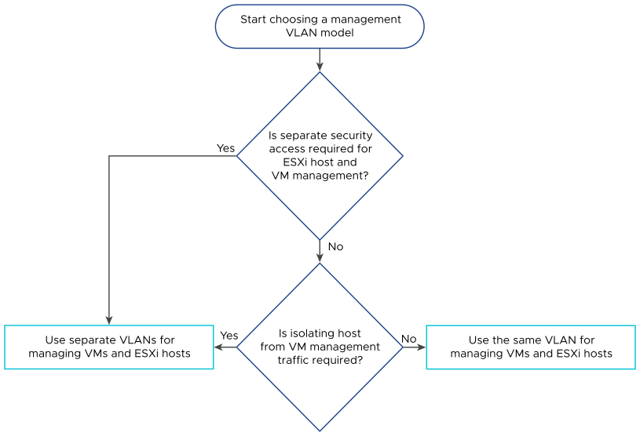
Table 3-3. VLANs and Subnets for Availability Zones and Instances for VMware Cloud Foundation
Function | VMware Cloud Foundation Instances with a Single Availability Zone | VMware Cloud Foundation Instances with Multiple Availability Zones
VM management | - Required when separate from host management  - Highly available gateway within the instance | - Required when separate from host management  - Must be stretched within the instance  - Highly available gateway across availability zones within the instance
Host management - first availability zone | - Required  - Highly available gateway within the instance | - Required  - Highly available gateway across availability zones within the instance
vSphere vMotion - first availability zone | - Required  - Highly available gateway within the instance | - Required  - Highly available gateway in first availability zone within the instance
vSAN - first availability zone | - Required for the default cluster of the management domain  - Highly available gateway within the instance | - Required  - Highly available gateway in first availability zone within the instance
Host overlay - first availability zone | - Required  - Highly available gateway within the instance | - Required  - Highly available gateway in first availability zone within the instance
NFS | - Required if using NFS as principal storage in the VI workload domain | - Not Supported
Uplink01 | - Required  - Gateway optional | - Required  - Gateway optional  - Must be stretched within the instance
Uplink02 | - Required  - Gateway optional | - Required  - Gateway optional  - Must be stretched within the instance
Edge overlay | - Required  - Highly available gateway within the instance | - Required  - Must be stretched within the instance  - Highly available gateway across availability zones within the instance
Host management - second availability zone | - Not required | - Required  - Highly available gateway in second availability zone within the instance
vSphere vMotion - second availability zone | - Not required | - Required  - Highly available gateway in second availability zone within the instance
vSAN - second availability zone | - Not required | - Required  - Highly available gateway in second availability zone within the instance
Host overlay - second availability zone | - Not required | - Required  - Highly available gateway in second availability zone within the instance
Edge RTEP | - Required for NSX Federation only  - Highly available gateway within the instance | - Required for NSX Federation only  - Must be stretched within the instance  - Highly available gateway across availability zones within the instance
Management and Witness - witness appliance at a third location | - Not required | - Required  - Highly available gateway at the witness location
Table 3-4. VLANs and Subnets for Multi-Rack Deployments with VMware Cloud Foundation
Function | VMware Cloud Foundation Instances With Multi-Rack Compute VI Workload Domain Cluster | VMware Cloud Foundation Instances with Multi-Rack NSX Edge Availability
VM management | - Not required as compute-only | - Required when separate from host management  - Highly available gateway at the ToR switched or leaf nodes in the rack
Host management | - Required per rack  - Highly available gateway at the ToR switched or leaf nodes in the rack | - Required per rack  - Highly available gateway at the ToR switched or leaf nodes in the rack
vSphere vMotion | - Required per rack  - Highly available gateway at the ToR switched or leaf nodes in the rack | - Required per rack  - Highly available gateway at the ToR switched or leaf nodes in the rack
vSAN | - Required per rack  - Highly available gateway at the ToR switched or leaf nodes in the rack | - Required per rack if using vSAN  - Highly available gateway at the ToR switched or leaf nodes in the rack
Host overlay | - Required per rack  - Highly available gateway at the ToR switched or leaf nodes in the rack | - Required per rack  - Highly available gateway at the ToR switched or leaf nodes in the rack
NFS | - Not supported | - Required if using NFS as principal storage for the clusters with the NSX Edge nodes.
Uplink01 | - Not required | - Required per rack
Uplink02 | - Not required | - Required per rack
Edge overlay | - Not required | - Required per rack  - Highly available gateway at the ToR switched or leaf nodes in the rack

Leaf-Spine Physical Network Design Requirements and Recommendations for VMware Cloud Foundation
Leaf-Spine is the default data center network deployment topology used for VMware Cloud Foundation. Consider network bandwidth, trunk port configuration, jumbo frames and routing configuration for NSX in a deployment with a single or multiple VMware Cloud Foundation instances.

Leaf-Spine Physical Network Logical Design
Each ESXi host has redundant connectivity to the top-of-rack (ToR) switches of the SDDC network fabric by two or more ports with a recommended speed of 25-GbE or higher. The ToR switches are configured to provide all necessary VLANs using an 802.1Q trunk. These redundant connections use features in vSphere Distributed Switch and NSX to guarantee that no physical interface is overrun and available redundant paths are used.
Figure 3-2. Leaf-Spine Physical Network Logical Design
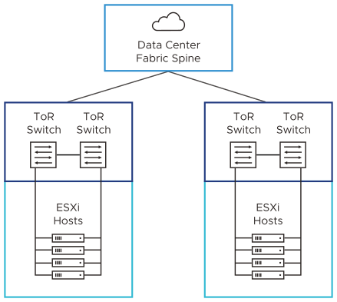

Leaf-Spine Physical Network Design Requirements and Recommendations
The requirements and recommendations for the leaf-spine network configuration determine the physical layout and use of VLANs. They also include requirements and recommendations on jumbo frames, and on network-related requirements such as DNS, NTP and routing.
Table 3-5. Leaf-Spine Physical Network Design Requirements for VMware Cloud Foundation
Requirement ID | Design Requirement | Justification | Implication
VCF-NET-REQD-CFG-001 | Do not use EtherChannel (LAG, LACP, or vPC) configuration for ESXi host uplinks. | - Simplifies configuration of top-of-rack switches.  - Teaming options available with vSphere Distributed Switch provide load balancing and failover.  - EtherChannel implementations might have vendor-specific limitations. | None.
VCF-NET-REQD-CFG-002 | Use VLANs to separate physical network functions. | - Supports physical network connectivity without requiring many NICs.  - Isolates the different network functions in the SDDC so that you can have differentiated services and prioritized traffic as needed. | Requires uniform configuration and presentation on all the trunks that are made available to the ESXi hosts.
VCF-NET-REQD-CFG-003 | Configure the VLANs as members of a 802.1Q trunk. | All VLANs become available on the same physical network adapters on the ESXi hosts. | Optionally, the management VLAN can act as the native VLAN.
VCF-NET-REQD-CFG-004 | Set the MTU size to at least 1,700 bytes (recommended 9,000 bytes for jumbo frames) on the physical switch ports, vSphere Distributed Switches, vSphere Distributed Switch port groups, and N-VDS switches that support the following traffic types:  - Overlay (Geneve)  - vSAN  - vSphere vMotion | - Improves traffic throughput.  - Supports Geneve by increasing the MTU size to a minimum of 1,600 bytes.  - Geneve is an extensible protocol. The MTU size might increase with future capabilities. While 1,600 bytes is sufficient, an MTU size of 1,700 bytes provides more room for increasing the Geneve MTU size without the need to change the MTU size of the physical infrastructure. | When adjusting the MTU packet size, you must also configure the entire network path (VMkernel network adapters, virtual switches, physical switches, and routers) to support the same MTU packet size.  In an environment with multiple availability zones, the MTU must be configured on the entire network path between the zones.
Table 3-6. Leaf-Spine Physical Network Design Requirements for Multi-Rack Compute VI Workload Domain Cluster for VMware Cloud Foundation
Requirement ID | Design Requirement | Justification | Implication
VCF-NET-L3MR-REQD-CFG-001 | For a multi-rack compute VI workload domain cluster, provide separate VLANs per rack for each network function.  - Host management  - vSAN  - vSphere vMotion  - Host overlay | A Layer 3 leaf-spine fabric has a Layer 3 boundary at the leaf switches in each rack creating a Layer 3 boundary between racks. | Requires additional VLANs for each rack.
VCF-NET-L3MR-REQD-CFG-002 | For a multi-rack compute VI workload domain cluster, the subnets for each network per rack must be routable and reachable to the leaf switches in the other racks.  - Host management  - vSAN  - vSphere vMotion  - Host overlay | Ensures the traffic for each network can flow between racks. | Requires additional physical network configuration to make networks routable between racks.
Table 3-7. Leaf-Spine Physical Network Design Requirements for NSX Federation in VMware Cloud Foundation
Requirement ID | Design Requirement | Justification | Implication
VCF-NET-REQD-CFG-005 | Set the MTU size to at least 1,500 bytes (1,700 bytes preferred; 9,000 bytes recommended for jumbo frames) on the components of the physical network between the VMware Cloud Foundation instances for the following traffic types.  - NSX Edge RTEP | - Jumbo frames are not required between VMware Cloud Foundation instances. However, increased MTU improves traffic throughput.  - Increasing the RTEP MTU to 1,700 bytes minimizes fragmentation for standard-size workload packets between VMware Cloud Foundation instances. | When adjusting the MTU packet size, you must also configure the entire network path, that is, virtual interfaces, virtual switches, physical switches, and routers to support the same MTU packet size.
VCF-NET-REQD-CFG-006 | Ensure that the latency between VMware Cloud Foundation instances that are connected in an NSX Federation is less than 500 ms. | A latency lower than 500 ms is required for NSX Federation. | None.
VCF-NET-REQD-CFG-007 | Provide a routed connection between the NSX Manager clusters in VMware Cloud Foundation instances that are connected in an NSX Federation. | Configuring NSX Federation requires connectivity between the NSX Global Manager instances, NSX Local Manager instances, and NSX Edge clusters. | You must assign unique routable IP addresses for each fault domain.
Table 3-8. Leaf-Spine Physical Network Design Recommendations for VMware Cloud Foundation
Recommendation ID | Design Recommendation | Justification | Implication
VCF-NET-RCMD-CFG-001 | Use two ToR switches for each rack. | Supports the use of two 10-GbE (25-GbE or greater recommended) links to each server, provides redundancy and reduces the overall design complexity. | Requires two ToR switches per rack which might increase costs.
VCF-NET-RCMD-CFG-002 | Implement the following physical network architecture:  - At least one 25-GbE (10-GbE minimum) port on each ToR switch for ESXi host uplinks (Host to ToR).  - Layer 3 device that supports BGP. | - Provides availability during a switch failure.  - Provides support for BGP dynamic routing protocol | - Might limit the hardware choices.  - Requires dynamic routing protocol configuration in the physical network.
VCF-NET-RCMD-CFG-003 | Use a physical network that is configured for BGP routing adjacency. | - Supports design flexibility for routing multi-site and multi-tenancy workloads.  - BGP is the only dynamic routing protocol that is supported for NSX Federation.  - Supports failover between ECMP Edge uplinks. | Requires BGP configuration in the physical network.
VCF-NET-RCMD-CFG-004 | Assign persistent IP configurations for NSX tunnel endpoints (TEPs) that use static IP pools instead of dynamic IP pool addressing. | - Ensures that endpoints have a persistent TEP IP address.  - In VMware Cloud Foundation, TEP IP assignment by using static IP pools is recommended for all topologies.  - This configuration removes any requirement for external DHCP services. | Adding more hosts to the cluster may require the static IP pools to be increased..
VCF-NET-RCMD-CFG-005 | Configure the trunk ports connected to ESXi NICs as trunk PortFast. | Reduces the time to transition ports over to the forwarding state. | Although this design does not use the STP, switches usually have STP configured by default.
VCF-NET-RCMD-CFG-006 | Configure VRRP, HSRP, or another Layer 3 gateway availability method for these networks.  - Management  - Edge overlay | Ensures that the VLANs that are stretched between availability zones are connected to a highly- available gateway. Otherwise, a failure in the Layer 3 gateway will cause disruption in the traffic in the SDN setup. | Requires configuration of a high availability technology for the Layer 3 gateways in the data center.
VCF-NET-RCMD-CFG-007 | Use separate VLANs for the network functions for each cluster. | Reduces the size of the Layer 2 broadcast domain to a single vSphere cluster. | Increases the overall number of VLANs that are required for a VMware Cloud Foundation instance.
Table 3-9. Leaf-Spine Physical Network Design Recommendations for Dedicated Edge Scale and Performance for VMware Cloud Foundation
Recommendation ID | Design Recommendation | Justification | Implication
VCF-NET-DES-RCMD-CFG-001 | Implement the following physical network architecture:  - Two 100-GbE ports on each ToR switch for ESXi host uplinks (Host to ToR).  - Layer 3 device that supports BGP. | Supports the requirements for high bandwidth and packets per second for large-scale deployments. | Requires 100-GbE network switches.
Table 3-10. Leaf-Spine Physical Network Design Recommendations for NSX Federation in VMware Cloud Foundation
Recommendation ID | Design Recommendation | Justification | Implication
VCF-NET-RCMD-CFG-008 | Provide BGP routing between all VMware Cloud Foundation instances that are connected in an NSX Federation setup. | BGP is the supported routing protocol for NSX Federation. | None.
VCF-NET-RCMD-CFG-009 | Ensure that the latency between VMware Cloud Foundation instances that are connected in an NSX Federation is less than 150 ms for workload mobility. | A latency lower than 150 ms is required for the following features:  - Cross vCenter Server vMotion | None.

Supported Storage Types for VMware Cloud Foundation
Storage design for VMware Cloud Foundation includes the design for principal and supplemental storage.
Principal storage is used during the creation of a workload domain and is capable of running workloads. Supplemental storage can be added after the creation of a workload domain and can be capable of running workloads or be used for data at rest storage such as virtual machine templates, backup data, and ISO images.
Special considerations apply if you plan to add clusters to the management domain, for example, to separate additional management components that require specific hardware resources or might impact the performance of the main management components in the default cluster.
VMware Cloud Foundation supports the following principal and supplemental storage combinations for clean deployments of VMware Cloud Foundation.
Note For information about the supported storage types for vSphere environments converted or imported into VMware Cloud Foundation, see Converting or Importing Existing vSphere Environments into VMware Cloud Foundationin the VMware Cloud Foundation Administration Guide.
Table 3-11. Supported Storage Types in VMware Cloud Foundation
Storage Type | Management Domain - Default Cluster | Management Domain - Additional Clusters | VI Workload Domain
vSAN Original Storage Architecture (OSA) | Principal | Principal | Principal
vSAN Express Storage Architecture (ESA) | Principal | Principal | Principal
VMware vSAN Max | Not supported | Principal | Principal
Cross-cluster capacity sharing (HCI Mesh) | Supplemental | - Principal (additional compute-only clusters)  - Supplemental | - Principal (additional compute-only clusters)  - Supplemental
VMware vSphere Virtual Volumes (FC, iSCSI, or NFS) | Supplemental | Supplemental | - Principal  - Supplemental
VMFS on FC | Supplemental | Supplemental | - Principal  - Supplemental
NFS | Supplemental (NFS 3 and NFS 4.1) | Supplemental (NFS 3 and NFS 4.1) | - Principal (NFS 3)  - Supplemental (NFS 3 and NFS 4.1)
iSCSI | Supplemental | Supplemental | Supplemental
NVMe/TCP | Supplemental | Supplemental | Supplemental
NVMe-FC | Supplemental | Supplemental | Supplemental
NVMe-RDMA | Supplemental | Supplemental | Supplemental
Note For a consolidated VMware Cloud Foundation architecture model, the storage types that are supported for the management domain apply.

vSphere Design for VMware Cloud Foundation
The vSphere design includes determining the configuration of the vCenter Server instances, ESXi hosts, vSphere clusters,and vSphere networking for a VMware Cloud Foundation instance.

ESXi Design for VMware Cloud Foundation
In the design of the ESXi host configuration for your VMware Cloud Foundation environment, consider the resources, networking, and security policies that are required to support the virtual machines in each workload domain cluster.

Logical Design for ESXi for VMware Cloud Foundation
In the logical design for ESXi, you determine the high-level integration of the ESXi hosts with the other components of the VMware Cloud Foundation instance for providing virtual infrastructure to management and workload components.
To provide the resources required to run the management and workload components of the VMware Cloud Foundation instance, each ESXi host consists of the following elements:
- CPU and memory
- Storage devices
- Out of band management interface
- Network interfaces
Figure 3-3. ESXi Logical Design for VMware Cloud Foundation
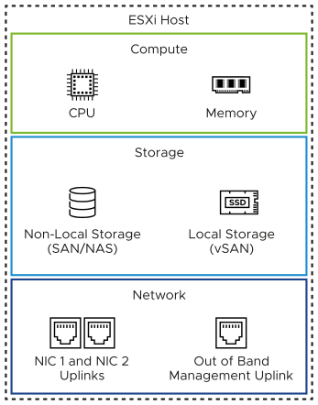

Sizing Considerations for ESXi for VMware Cloud Foundation
You decide on the number of ESXi hosts per cluster and the number of physical disks per ESXi host.
For detailed sizing based on the overall profile of the VMware Cloud Foundation instance you plan to deploy, see VMware Cloud Foundation Planning and Preparation Workbook.
The configuration and assembly process for each system should be standardized, with all components installed in the same manner on each ESXi host. Because standardization of the physical configuration of the ESXi hosts removes variability, the infrastructure is easily managed and supported. ESXi hosts are deployed with identical configuration across all cluster members, including storage and networking configurations. For example, consistent PCIe card slot placement, especially for network interface controllers, is essential for accurate mapping of physical network interface controllers to virtual network resources. By using identical configurations, you have an even balance of virtual machine storage components across storage and compute resources.
Table 3-12. ESXi Server Sizing Considerations by Hardware Element
Hardware Element | Considerations
CPU | - Total CPU requirements for the workloads that are running in the cluster.  - Host failure and maintenance scenarios.  Keep the overcommitment ratio vCPU-to-pCPU less than or equal to 2:1 for the management domain and less than or equal to 8:1 for VI workload domains.  - Additional third-party management components.  - Number of physical cores, not logical cores. Simultaneous multithreading (SMT) technologies in CPUs, such as hyper-threading in Intel CPUs, improve CPU performance by allowing multiple threads to run in parallel on the same CPU core. Although a single CPU core can be viewed as two logical cores, the performance enhancement will not be equivalent to 100% more CPU power. It will also differ from one environment to another.
Memory | - Total memory requirements for the workloads that are running in the cluster.  - When sizing memory for the ESXi hosts in a cluster, to reserve the resources of one host for failover or maintenance, set the admission control setting to N+1, which reserves the resources of one host for failover or maintenance.  - vSAN OSA. Number of vSAN disk groups and disks on an ESXi host.  To support the maximum number of disk groups, you must provide 32 GB of RAM. For more information about disk groups, including design and sizing guidance, see Administering VMware vSAN in the vSphere documentation.  - vSAN ESA. You must provide 512 GB of RAM.
Storage | - Use high-endurance device such as a hard drive or SSD for boot device  - Use 128-GB boot device to maximize the space available for ESX-OS Data  - vSAN OSA  - Provide at least one 600-GB cache disk.  - Use a minimum of two capacity disks.  - vSAN ESA. Use a minimum of two NVME devices.  - Use hosts with homogeneous configuration.

ESXi Design Requirements and Recommendations for VMware Cloud Foundation
The requirements for the ESXi hosts in a workload domain in VMware Cloud Foundation are related to the system requirements of the workloads hosted in the domain. The ESXi requirements include number, server configuration, amount of hardware resources, networking, and certificate management. Similar best practices help you design optimal environment operation.

ESXi Server Design Requirements
You must meet the following design requirements for the ESXi hosts in a workload domain in a VMware Cloud Foundation deployment.
Table 3-13. Design Requirements for ESXi Server
Requirement ID | Design Requirement | Requirement Justification | Requirement Implication
VCF-ESX-REQD-CFG-001 | Install no less than the minimum number of ESXi hosts required for the cluster type being deployed. | - Ensures availability requirements are met.  - If one of the hosts is not available because of a failure or maintenance event, the CPU overcommitment ratio becomes 2:1. | None.
VCF-ESX-REQD-CFG-002 | Ensure each ESXi host matches the required CPU, memory and storage specification. | - Ensures workloads will run without contention, even during failure and maintenance conditions. | Assemble the server specification and number according to the sizing in VMware Cloud Foundation Planning and Preparation Workbook which is based on the projected deployment size.
VCF-ESX-REQD-SEC-001 | Regenerate the certificate of each ESXi host after assigning the host an FQDN. | Establishes a secure connection with VMware Cloud Builder during the deployment of a workload domain and prevents man-in-the-middle (MiTM) attacks. | You must manually regenerate the certificates of the ESXi hosts before the deployment of a workload domain.

ESXi Server Design Recommendations
In your ESXi host design for VMware Cloud Foundation, you can apply certain best practices.
Table 3-14. Design Recommendations for ESXi Server
Recommendation ID | Recommendation | Justification | Implication
VCF-ESX-RCMD-CFG-001 | Use vSAN ReadyNodes with vSAN storage for each ESXi host in the management domain. | Your management domain is fully compatible with vSAN at deployment.  For information about the models of physical servers that are vSAN-ready, see vSAN Compatibility Guide for vSAN ReadyNodes. | Hardware choices might be limited.  If you plan to use a server configuration that is not a vSAN ReadyNode, your CPU, disks and I/O modules must be listed on the VMware Compatibility Guide under CPU Series and vSAN Compatibility List aligned to the ESXi version specified in VMware Cloud Foundation 5.2 Release Notes.
VCF-ESX-RCMD-CFG-002 | Allocate hosts with uniform configuration across the default management vSphere cluster. | A balanced cluster has these advantages:  - Predictable performance even during hardware failures  - Minimal impact of resynchronization or rebuild operations on performance | You must apply vendor sourcing, budgeting, and procurement considerations for uniform server nodes on a per cluster basis.
VCF-ESX-RCMD-CFG-003 | When sizing CPU, do not consider multithreading technology and associated performance gains. | Although multithreading technologies increase CPU performance, the performance gain depends on running workloads and differs from one case to another. | Because you must provide more physical CPU cores, costs increase and hardware choices become limited.
VCF-ESX-RCMD-CFG-004 | Install and configure all ESXi hosts in the default management cluster to boot using a 128-GB device or larger. | Provides hosts that have large memory, that is, greater than 512 GB, with enough space for the scratch partition when using vSAN. | None.
VCF-ESX-RCMD-CFG-005 | Use the default configuration for the scratch partition on all ESXi hosts in the default management cluster. | - If a failure in the vSAN cluster occurs, the ESXi hosts remain responsive and log information is still accessible.  - It is not possible to use vSAN datastore for the scratch partition. | None.
VCF-ESX-RCMD-CFG-006 | For workloads running in the default management cluster, save the virtual machine swap file at the default location. | Simplifies the configuration process. | Increases the amount of replication traffic for management workloads that are recovered as part of the disaster recovery process.
VCF-ESX-RCMD-NET-001 | Place the ESXi hosts in each management domain cluster on a host management network that is separate from the VM management network. | Enables the separation of the physical VLAN between ESXi hosts and the other management components for security reasons.  The VM management network is not required for a multi-rack compute-only cluster in a VI workload domain. | Increases the number of VLANs required.
VCF-ESX-RCMD-NET-002 | Place the ESXi hosts in each VI workload domain on a separate host management VLAN-backed network. | Enables the separation of the physical VLAN between the ESXi hosts in different VI workload domains for security reasons. | Increases the number of VLANs required. For each VI workload domain, you must allocate a separate management subnet.
VCF-ESX-RCMD-SEC-001 | Deactivate SSH access on all ESXi hosts in the management domain by having the SSH service stopped and using the default SSH service policy Start and stop manually . | Ensures compliance with the vSphere Security Configuration Guide and with security best practices.  Disabling SSH access reduces the risk of security attacks on the ESXi hosts through the SSH interface. | You must activate SSH access manually for troubleshooting or support activities as VMware Cloud Foundation deactivates SSH on ESXi hosts after workload domain deployment.
VCF-ESX-RCMD-SEC-002 | Set the advanced setting UserVars.SuppressShellWarning to 0 across all ESXi hosts in the management domain. | - Ensures compliance with the vSphere Security Configuration Guide and with security best practices  - Enables the warning message that appears in the vSphere Client every time SSH access is activated on an ESXi host. | You must turn off SSH enablement warning messages manually when performing troubleshooting or support activities.

vSAN Design for VMware Cloud Foundation
VMware Cloud Foundation uses VMware vSAN as the principal storage type for the management domain and is recommended for use as principal storage in VI workload domains. You must determine the size of the compute and storage resources for the vSAN storage, and the configuration of the network carrying vSAN traffic. For multiple availability zones, you extend the resource size and determine the configuration of the vSAN witness host.

Logical Design for vSAN for VMware Cloud Foundation
vSAN is a cost-efficient storage technology that provides a simple storage management user experience, and permits a fully automated initial deployment of VMware Cloud Foundation. It also provides support for future storage expansion and implementation of vSAN stretched clusters in a workload domain.
Figure 3-4. vSAN Logical Design for VMware Cloud Foundation
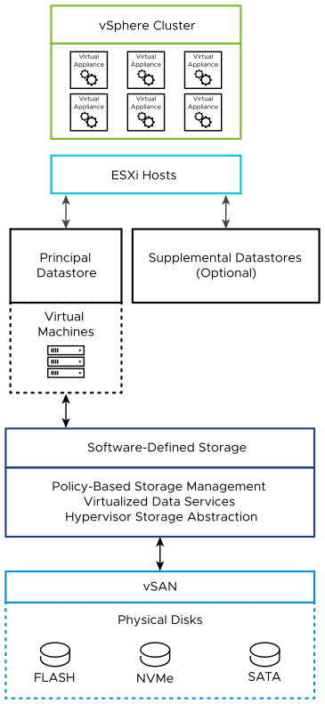
Table 3-15. vSAN Logical Design
Workload Domain Type | VMware Cloud Foundation Instances with a Single Availability Zone | VMware Cloud FoundationInstances with Multiple Availability Zones
Management domain (default cluster) | - Four nodes minimum  - In the vSAN default storage policy, failures to tolerate is set to 1 failure - RAID-1 (mirroring) | - Must be stretched first before the VI workload domain clusters  - Eight node minimum, equally distributed across availability zones  - vSAN witness appliance in a third fault domain  - In the vSAN default storage policy, site disaster tolerance is set to Site-mirroring - stretched cluster
Management domain (additional clusters) | - Three nodes minimum  - Four nodes minimum is recommended for higher availability | - Six nodes minimum, equally distributed across availability zones  - Eight nodes minimum is recommended for higher availability  - vSAN witness appliance in a third fault domain  - In the vSAN default storage policy, site disaster tolerance is set to Site-mirroring - stretched cluster
VI workload domain (all clusters) | - Three nodes minimum  - Four nodes minimum is recommended for higher availability | - Six nodes minimum, equally distributed across availability zones  - Eight nodes minimum is recommended for higher availability  - vSAN witness appliance in a third fault domain  - In the vSAN default storage policy, site disaster tolerance is set to Site-mirroring - stretched cluster

Hardware Configuration for vSAN for VMware Cloud Foundation
Determine the vSAN architecture and the storage controllers for performance and stability according to the requirements of the management components of VMware Cloud Foundation.
Figure 3-5. Choosing a vSAN Architecture Model
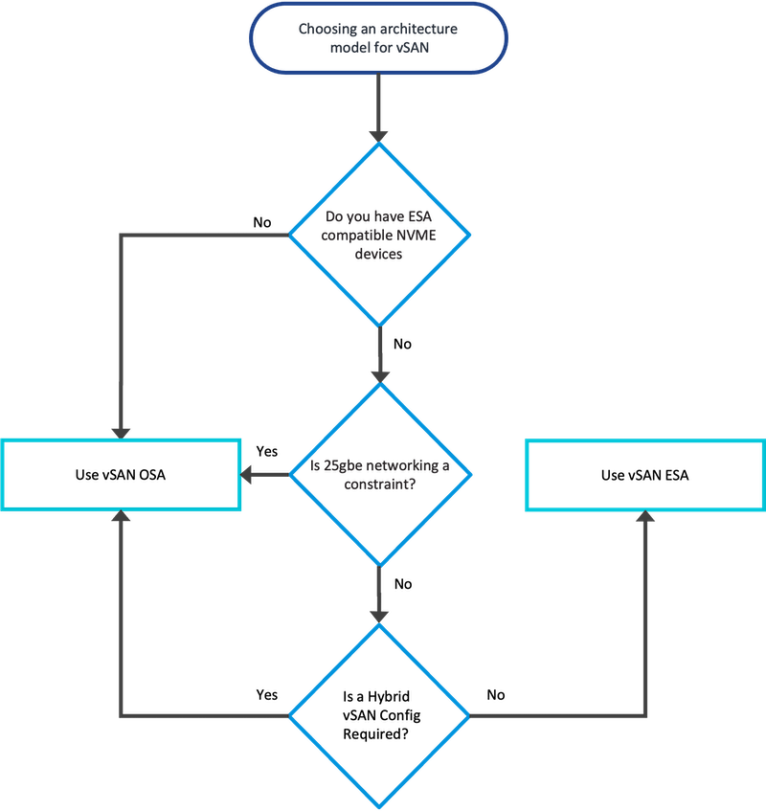

vSAN Physical Requirements and Dependencies
vSAN has the following requirements and options:
- vSAN Express Storage Architecture (ESA)
  - All storage devices claimed by vSAN contribute to capacity and performance. Each host's storage devices claimed by vSAN form a storage pool. The storage pool represents the amount of caching and capacity provided by the host to the vSAN datastore.
  - ESA requires compatible NVMe devices.
  - ESXi hosts must be on the vSAN ESA Ready Node HCL with a minimum of 512 GB RAM per host.
- vSAN Original Storage Architecture (OSA) as hybrid storage or all-flash storage.
  - A vSAN hybrid storage configuration requires both magnetic devices and flash caching devices. The cache tier must be at least 10% of the size of the capacity tier.
  - An all-flash vSAN configuration requires flash devices for both the caching and capacity tiers.
  - VMware vSAN ReadyNodes or hardware from the VMware Compatibility Guide to build your own.
For best practices, capacity considerations, and general recommendations about designing and sizing a vSAN cluster, see the VMware vSAN Design and Sizing Guide.

Network Design for vSAN for VMware Cloud Foundation
In the network design for vSAN in VMware Cloud Foundation, you determine the network configuration for vSAN traffic.
Consider the overall traffic bandwidth and decide how to isolate storage traffic.
- Consider how much vSAN data traffic is running between ESXi hosts.
- The amount of storage traffic depends on the number of VMs that are running in the cluster, and on how write-intensive the I/O process is for the applications running in the VMs.
For information on the physical network setup for vSAN traffic, and other system traffic, see Physical Network Infrastructure Design for VMware Cloud Foundation.
For information on the virtual network setup for vSAN traffic, and other system traffic, see Logical vSphere Networking Design for VMware Cloud Foundation.
The vSAN network design includes these components.
Table 3-16. Components of vSAN Network Design
Design Component | Description
Physical NIC speed | For best and predictable performance (IOPS) of the environment, this design uses a minimum of a 10-GbE connection, with 25-GbE recommended, for use with vSAN OSA all-flash configurations.  For vSAN ESA, 25-GbE connection is recommended.
VMkernel network adapters for vSAN | The vSAN VMkernel network adapter on each ESXi host is created when you enable vSAN on the cluster. Connect the vSAN VMkernel network adapters on all ESXi hosts in a cluster to a dedicated distributed port group, including ESXi hosts that are not contributing storage resources to the cluster.
VLAN | All storage traffic should be isolated on its own VLAN. When a design uses multiple vSAN clusters, each cluster should use a dedicated VLAN or segment for its traffic. This approach increases security, prevents interference between clusters, and helps with troubleshooting cluster configuration. If a cluster spans a rack, the vSAN VLAN must be allocated per rack to enable Layer 3 multi-rack deployments.
Jumbo frames | vSAN traffic can be handled by using jumbo frames. Use jumbo frames for vSAN traffic only if the physical environment is already configured to support them, they are part of the existing design, or if the underlying configuration does not create a significant amount of added complexity to the design.

vSAN Witness Design for VMware Cloud Foundation
The vSAN witness appliance is a specialized ESXi installation that provides quorum and tiebreaker services for stretched clusters in VMware Cloud Foundation.

vSAN Witness Deployment Specification
You must deploy a witness ESXi host when using vSAN in a stretched cluster configuration. This appliance must be deployed in a third location that is not local to the ESXi hosts on either side of the stretched cluster.
Table 3-17. vSAN Witness Appliance Sizing Considerations
Appliance Size | Number of Supported Virtual Machines | Maximum Number of Supported Witness Components
Tiny | 10 | 750
Medium | 500 | 21,833
Large | More than 500 | 45,000
Extra Large | More than 500 | 64,000

vSAN Witness Network Design
When using two availability zones, connect the vSAN witness appliance to the workload domain vCenter Server so that you can perform the initial setup of the stretched cluster and have workloads failover between the zones.
VMware Cloud Foundation uses vSAN witness traffic separation where you can use a VMkernel adapter for vSAN witness traffic that is different from the adapter for vSAN data traffic. In this design, you configure vSAN witness traffic in the following way:
- On each ESXi host in both availability zones, place the vSAN witness traffic on the management VMkernel adapter.
- On the vSAN witness appliance, use the same VMkernel adapter for both management and witness traffic.
For information about vSAN witness traffic separation, see vSAN Stretched Cluster Guide on VMware Cloud Platform Tech Zone.
Management network
Routed to the management networks in both availability zones. Connect the first VMkernel adapter of the vSAN witness appliance to this network. The second VMkernel adapter on the vSAN witness appliance is not used.
Place the following traffic on this network:
- Management traffic
- vSAN traffic
Figure 3-6. vSAN Witness Network Design
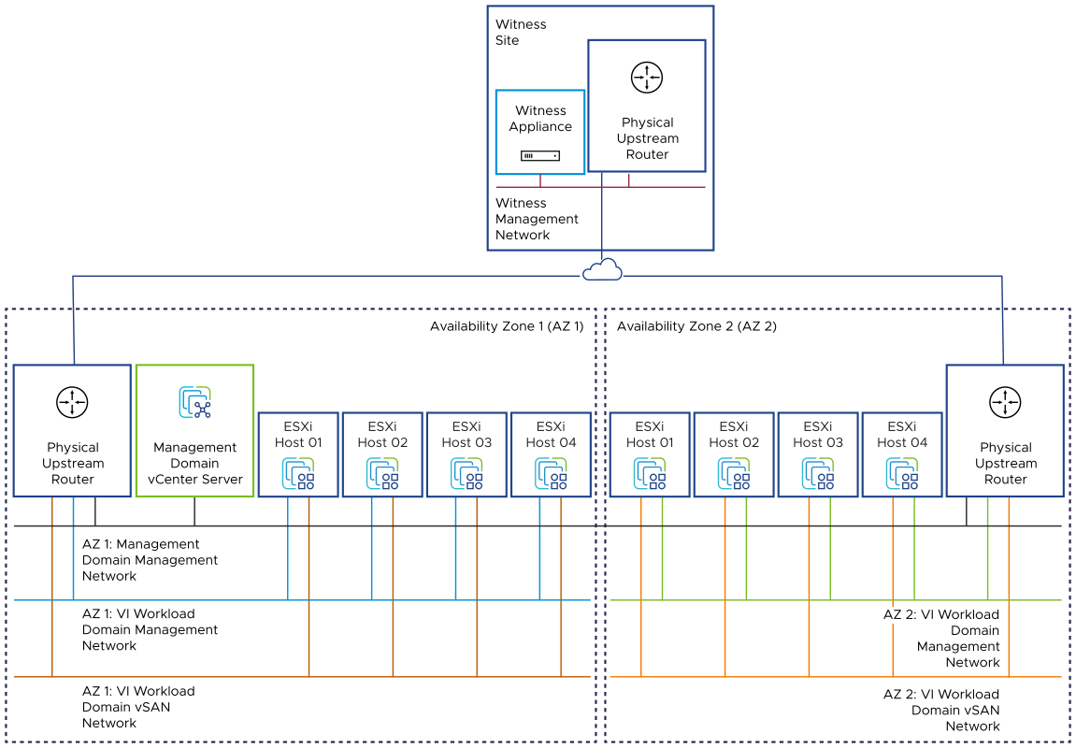

vSAN Design Requirements and Recommendations for VMware Cloud Foundation
Consider the requirements for using vSAN storage for standard and stretched clusters in VMware Cloud Foundation, such as required capacity, number of hosts, storage policies, and the similar best practices for having vSAN operate in an optimal way.
For related vSphere cluster requirements and recommendations, see vSphere Cluster Design Requirements and Recommendations for VMware Cloud Foundation.

vSAN Design Requirements
You must meet the following design requirements for standard and stretched clusters in your vSAN design for VMware Cloud Foundation.
Table 3-18. vSAN Design Requirements for VMware Cloud Foundation
Requirement ID | Design Requirement | Justification | Implication
VCF-VSAN-REQD-CFG-001 | Provide sufficient raw capacity to meet the initial needs of the workload domain cluster. | Ensures that sufficient resources are present to create the workload domain cluster. | None.
VCF-VSAN-REQD-CFG-002 | Provide at least the required minimum number of hosts according to the cluster type. | Satisfies the requirements for storage availability. | None.
Table 3-19. vSAN ESA Design Requirements for VMware Cloud Foundation
Requirement ID | Design Requirement | Justification | Implication
VCF-VSAN-REQD-CFG-003 | Verify the hardware components used in your vSAN deployment are on the vSAN Hardware Compatibility List. | Prevents hardware-related failures during workload deployment | Limits the number of compatible hardware configurations that can be used.
Table 3-20. vSAN Design Requirements for Stretched Clusters with VMware Cloud Foundation
Requirement ID | Design Requirement | Justification | Implication
VCF-VSAN-REQD-CFG-004 | Add the following setting to the default vSAN storage policy:  Site disaster tolerance = Site mirroring - stretched cluster | Provides the necessary protection for virtual machines in each availability zone, with the ability to recover from an availability zone outage. | You might need additional policies if third-party virtual machines are to be hosted in these clusters because their performance or availability requirements might differ from what the default VMware vSAN policy supports.
VCF-VSAN-REQD-CFG-005 | Configure two fault domains, one for each availability zone. Assign each host to their respective availability zone fault domain. | Fault domains are mapped to availability zones to provide logical host separation and ensure a copy of vSAN data is always available even when an availability zone goes offline. | You must provide additional raw storage when the site mirroring - stretched cluster option is selected, and fault domains are enabled.
VCF-VSAN-REQD-CFG-006 | Configure an individual vSAN storage policy for each stretched cluster. | The vSAN storage policy of a stretched cluster cannot be shared with other clusters. | You must configure additional vSAN storage policies.
VCF-VSAN-WTN-REQD-CFG-001 | Deploy a vSAN witness appliance in a location that is not local to the ESXi hosts in any of the availability zones. | Ensures availability of vSAN witness components in the event of a failure of one of the availability zones. | You must provide a third physically separate location that runs a vSphere environment. You might use a VMware Cloud Foundation instance in a separate physical location.
VCF-VSAN-WTN-REQD-CFG-002 | Deploy a witness appliance that corresponds to the required cluster capacity. | Ensures the witness appliance is sized to support the projected workload storage consumption. | The vSphere environment at the witness location must satisfy the resource requirements of the witness appliance.
VCF-VSAN-WTN-REQD-CFG-003 | Connect the first VMkernel adapter of the vSAN witness appliance to the management network in the witness site. | Enables connecting the witness appliance to the workload domain vCenter Server. | The management networks in both availability zones must be routed to the management network in the witness site.
VCF-VSAN-WTN-REQD-CFG-004 | Allocate a statically assigned IP address and hostname to the management adapter of the vSAN witness appliance. | Simplifies maintenance and tracking, and implements a DNS configuration. | Requires precise IP address management.
VCF-VSAN-WTN-REQD-CFG-005 | Configure forward and reverse DNS records for the vSAN witness appliance for the VMware Cloud Foundation instance. | Enables connecting the vSAN witness appliance to the workload domain vCenter Server by FQDN instead of IP address. | You must provide DNS records for the vSAN witness appliance.
VCF-VSAN-WTN-REQD-CFG-006 | Configure time synchronization by using an internal NTP time for the vSAN witness appliance. | Prevents any failures in the stretched cluster configuration that are caused by time mismatch between the vSAN witness appliance and the ESXi hosts in both availability zones and workload domain vCenter Server. | - An operational NTP service must be available in the environment.  - All firewalls between the vSAN witness appliance and the NTP servers must allow NTP traffic on the required network ports.
Table 3-21. vSAN Design Requirements for a Multi-Rack Compute VI Workload Domain Cluster with VMware Cloud Foundation
Requirement ID | Design Requirement | Justification | Implication
VCF-VSAN-L3MR-REQD-CFG-001 | Configure vSAN fault domains and place each rack's nodes into their fault domain. | Allows workload VMs to tolerate a rack failure by distributing copies of the data and witness components on nodes in separate racks. | You must make the fault domain configuration manually vCenter Server after deployment and after cluster expansion.

vSAN Design Recommendations
In your vSAN design for VMware Cloud Foundation, you can apply certain best practices for standard and stretched clusters.
Table 3-22. vSAN Design Recommendations for VMware Cloud Foundation
Recommendation ID | Design Recommendation | Justification | Implication
VCF-VSAN-RCMD-CFG-001 | Provide sufficient raw capacity to meet the planned needs of the workload domain cluster. | Ensures that sufficient resources are present in the workload domain cluster, preventing the need to expand the vSAN datastore in the future. | None.
VCF-VSAN-RCMD-CFG-002 | Ensure that at least 30% of free space is always available on the vSAN datastore. | This reserved capacity is set aside for host maintenance mode data evacuation, component rebuilds, rebalancing operations, and VM snapshots. | Increases the amount of available storage needed.
VCF-VSAN-RCMD-CFG-003 | Use the default VMware vSAN storage policy. | - Provides the level of redundancy that is needed in the workload domain cluster.  - Provides the level of performance that is enough for the individual workloads. | You might need additional policies for third-party virtual machines hosted in these clusters because their performance or availability requirements might differ from what the default VMware vSAN policy supports.
VCF-VSAN-RCMD-CFG-004 | Leave the default virtual machine swap file as a sparse object on vSAN. | Sparse virtual swap files consume capacity on vSAN only as they are accessed. As a result, you can reduce the consumption on the vSAN datastore if virtual machines do not experience memory over-commitment, which would require the use of the virtual swap file. | None.
VCF-VSAN-RCMD-CFG-005 | Use the existing vSphere Distributed Switch instance for the workload domain cluster. | - Reduces the complexity of the network design.  - Reduces the number of physical NICs required. | All traffic types can be shared over common uplinks.
VCF-VSAN-RCMD-CFG-006 | Configure jumbo frames on the VLAN for vSAN traffic. | - Simplifies configuration because jumbo frames are also used to improve the performance of vSphere vMotion and NFS storage traffic.  - Reduces the CPU overhead, resulting in high network usage. | Every device in the network must support jumbo frames.
VCF-VSAN-RCMD-CFG-007 | Use a dedicated VLAN for vSAN traffic for each vSAN cluster. | - Isolates the vSAN traffic only to the hosts in the cluster.  - Reduces the amount of vSAN broadcast traffic that reaches a host to only the hosts in the cluster. | Increases the number of VLANs required.
VCF-VSAN-RCMD-CFG-008 | Configure vSAN in an all-flash configuration in the default workload domain cluster. | Meets the performance needs of the default workload domain cluster. | All vSAN disks must be flash disks, which might cost more than magnetic disks.
Table 3-23. vSAN OSA Design Recommendations for with VMware Cloud Foundation
Recommendation ID | Design Recommendation | Justification | Implication
VCF-VSAN-RCMD-CFG-008 | Ensure that the storage I/O controller has a minimum queue depth of 256 set. | Storage controllers with lower queue depths can cause performance and stability problems when running vSAN.  vSAN ReadyNode servers are configured with the correct queue depths for vSAN. | Limits the number of compatible I/O controllers that can be used for storage.
VCF-VSAN-RCMD-CFG-009 | Do not use the storage I/O controllers that are running vSAN disk groups for another purpose. | Running non-vSAN disks, for example, VMFS, on a storage I/O controller that is running a vSAN disk group can impact vSAN performance. | If non-vSAN disks are required in ESXi hosts, you must have an additional storage I/O controller in the host.
VCF-VSAN-RCMD-CFG-010 | Configure vSAN with a minimum of two disk groups per ESXi host. | Reduces the size of the fault domain and spreads the I/O load over more disks for better performance. | Using multiple disk groups requires more disks in each ESXi host.
VCF-VSAN-RCMD-CFG-011 | For the cache tier in each disk group, use a flash-based drive that is at least 600 GB large. | Provides enough cache for both hybrid or all-flash vSAN configurations to buffer I/O and ensure disk group performance.  Additional space in the cache tier does not increase performance. | Using larger flash disks can increase the initial host cost.
Table 3-24. vSAN ESA Design Recommendations for with VMware Cloud Foundation
Recommendation ID | Design Recommendation | Justification | Implication
VCF-VSAN-RCMD-CFG-012 | Activate auto-policy management. | Configures optimized storage policies based on the cluster type and the number of hosts in the cluster inventory. On changes to the number of hosts in the cluster or to host rebuild reserve, vSAN prompts you to make a suggested adjustment to the optimized storage policy. | None.
VCF-VSAN-RCMD-CFG-013 | Activate vSAN ESA compression. | Improves performance. | PostgreSQL databases and other applications might use their own compression capabilities. In these cases, using a storage policy with the compression capability turned off will save CPU cycles.  You can disable vSAN ESA compressions for such workloads through the use of the Storage Policy Based Management (SPBM) framework.
VCF-VSAN-RCMD-CFG-014 | Use NICs with a minimum 25-GbE capacity. | 10-GbE NICs will limit the scale and performance of a vSAN ESA cluster because, usually, performance requirements increase over the lifespan of the cluster. | Requires 25-GbE or faster network fabric.
Table 3-25. vSAN Design Recommendations for Stretched Clusters with VMware Cloud Foundation
Recommendation ID | Design Recommendation | Justification | Implication
VCF-VSAN-WTN-RCMD-CFG-001 | Configure the vSAN witness appliance to use the first VMkernel adapter, that is the management interface, for vSAN traffic. | Removes the requirement to have static routes on the witness appliance as vSAN traffic from the witness is routed over the management network. | The management networks in both availability zones must be routed to the management network in the witness site.
VCF-VSAN-WTN-RCMD-CFG-002 | Place witness traffic on the management VMkernel adapter of all the ESXi hosts in the workload domain. | Separates the witness traffic from the vSAN data traffic. Witness traffic separation provides the following benefits:  - Removes the requirement to have static routes from the vSAN networks in both availability zones to the witness site.  - Removes the requirement to enable jumbo frames on the path between each availability zone and the witness site because witness traffic can use a regular MTU size of 1500 bytes. | The management networks in both availability zones must be routed to the management network in the witness site.

vCenter Server Design for VMware Cloud Foundation
vCenter Server design considers the location, size, high availability, and identity domain isolation of the vCenter Server instances for the workload domains in a VMware Cloud Foundation environment.

Logical Design for vCenter Server for VMware Cloud Foundation
Each workload domain has a dedicated vCenter Server that manages the ESXi hosts running NSX Edge nodes and customer workloads. All vCenter Server instances run in the management domain.
Figure 3-7. Design of vCenter Server for VMware Cloud Foundation
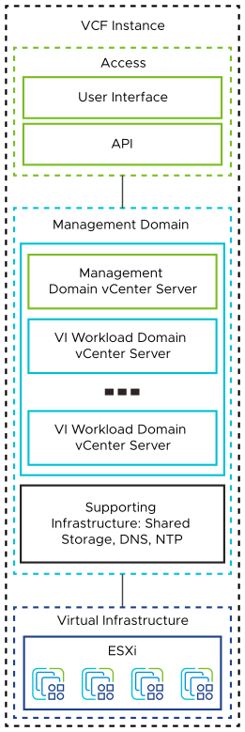
Table 3-26. vCenter Server Layout
VMware Cloud Foundation Instances with a Single Availability Zone | VMware Cloud Foundation Instances with Multiple Availability Zones
- One vCenter Server instance for the management domain that manages the management components of the SDDC, such as the vCenter Server instances for the VI workload domains, NSX Manager cluster nodes, SDDC Manager, and other solutions.  - Optionally, additional vCenter Server instances for the VI workload domains to support customer workloads.  - vSphere HA protecting all vCenter Server appliances. | - One vCenter Server instance for the management domain that manages the management components of the SDDC, such as vCenter Server instances for the VI workload domains, NSX Manager cluster nodes, SDDC Manager, and other solutions.  - Optionally, additional vCenter Server instances for the VI workload domains to support customer workloads.  - vSphere HA protecting all vCenter Server appliances.  - A should-run-on-host-in-group VM-Host affinity rule in vSphere DRS specifying that the vCenter Server appliances should run in the primary availability zone unless an outage in this zone occurs.

Sizing Considerations for vCenter Server for VMware Cloud Foundation
You select an appropriate vCenter Server appliance size according to the scale of your environment.
When you deploy a workload domain, you select a vCenter Server appliance size that is suitable for the scale of your environment. The option that you select determines the number of CPUs and the amount of memory of the appliance. For detailed sizing according to a collective profile of the VMware Cloud Foundation instance you plan to deploy, refer to the VMware Cloud Foundation Planning and Preparation Workbook .
Table 3-27. Sizing Considerations for vCenter Server
vCenter Server Appliance Size | Management Capacity
Tiny | Up to 10 hosts or 100 virtual machines
Small * | Up to 100 hosts or 1,000 virtual machines
Medium ** | Up to 400 hosts or 4,000 virtual machines
Large | Up to 800 hosts or 10,000 virtual machines
X-Large | Up to 800 hosts or 45,000 virtual machines
* Default for the management domain vCenter Server
** Default for VI workload domain vCenter Server instances

High Availability Design for vCenter Server for VMware Cloud Foundation
Protecting vCenter Server is important because it is the central point of management and monitoring for each workload domain.
VMware Cloud Foundation supports only vSphere HA as a high availability method for vCenter Server.
Table 3-28. Methods for Protecting the vCenter Server Appliance
High Availability Method | Supported in VMware Cloud Foundation | Considerations
vSphere High Availability | Yes | -
vCenter High Availability (vCenter HA) | No | - vCenter Server services must fail over to the passive node so there is no continuous availability.  - Recovery time can be up to 15 mins.  - You must meet additional networking requirements for the private network.  - vCenter HA requires additional resources for the Passive and Witness nodes.  - Life cycle management is complicated because you must manually delete and recreate the standby virtual machines during a life cycle management operation.
vSphere Fault Tolerance (vSphere FT) | No | - The vCPU limit of vSphere FT vCPU would limit vCenter Server appliance size to medium.  - You must provide a dedicated network.

vCenter Server Design Requirements and Recommendations for VMware Cloud Foundation
Each workload domain in VMware Cloud Foundation is managed by a single vCenter Server instance. You determine the size of this vCenter Server instance and its storage requirements according to the number of ESXi hosts per cluster and the number of virtual machines you plan to run on these clusters.

vCenter Server Design Requirements for VMware Cloud Foundation
You allocate vCenter Server appliances according to the requirements for workload isolation, scalability, and resilience to failures.
Table 3-29. vCenter Server Design Requirements for VMware Cloud Foundation
Requirement ID | Design Requirement | Justification | Implication
VCF-VCS-REQD-CFG-001 | Deploy a dedicated vCenter Server appliance for the management domain of the VMware Cloud Foundation instance. | - Isolates vCenter Server failures to management or customer workloads.  - Isolates vCenter Server operations between management and customers.  - Supports a scalable cluster design where you can reuse the management components as more customer workloads are added to the SDDC.  - Simplifies capacity planning for customer workloads because you do not consider management workloads for the VI workload domain vCenter Server.  - Improves the ability to upgrade the vSphere environment and related components by enabling for explicit separation of maintenance windows:  - Management workloads remain available while you are upgrading the tenant workloads  - Customer workloads remain available while you are upgrading the management nodes  - Supports clear separation of roles and responsibilities to ensure that only administrators with granted authorization can control the management workloads.  - Facilitates quicker troubleshooting and problem resolution.  - Simplifies disaster recovery operations by supporting a clear separation between recovery of the management components and tenant workloads.  - Provides isolation of potential network issues by introducing network separation of the clusters in the SDDC. | Requires a separate license for the vCenter Server instance in the management domain
VCF-VCS-REQD-NET-001 | Place all workload domain vCenters Server appliances on the VM management network in the management domain. | - Simplifies IP addressing for management VMs by using the same VLAN and subnet.  - Provides simplified secure access to management VMs in the same VLAN network. | None.

vCenter Server Design Recommendations
In your vCenter Server design for VMware Cloud Foundation, you can apply certain best practices for sizing and high availability.
Table 3-30. vCenter Server Design Recommendations for VMware Cloud Foundation
Recommendation ID | Design Recommendation | Justification | Implication
VCF-VCS-RCMD-CFG-001 | Deploy an appropriately sized vCenter Server appliance for each workload domain. | Ensures resource availability and usage efficiency per workload domain. | The default size for a management domain is Small and for VI workload domains is Medium. To override these values, you must use the Cloud Builder API and the SDDC Manager API.
VCF-VCS-RCMD-CFG-002 | Deploy a vCenter Server appliance with the appropriate storage size. | Ensures resource availability and usage efficiency per workload domain. | The default size for a management domain is Small and for VI Workload Domains is Medium. To override these values, you must use the API.
VCF-VCS-RCMD-CFG-003 | Protect workload domain vCenter Server appliances by using vSphere HA. | vSphere HA is the only supported method to protect vCenter Server availability in VMware Cloud Foundation. | vCenter Server becomes unavailable during a vSphere HA failover.
VCF-VCS-RCMD-CFG-004 | In vSphere HA, set the restart priority policy for the vCenter Server appliance to high. | vCenter Server is the management and control plane for physical and virtual infrastructure. In a vSphere HA event, to ensure the rest of the SDDC management stack comes up faultlessly, the workload domain vCenter Server must be available first, before the other management components come online. | If the restart priority for another virtual machine is set to highest, the connectivity delay for the management components will be longer.

vCenter Server Design Recommendations for Stretched Clusters with VMware Cloud Foundation
The following additional design recommendations apply when using stretched clusters.
Table 3-31. vCenter Server Design Recommendations for vSAN Stretched Clusters with VMware Cloud Foundation
Recommendation ID | Design Recommendation | Justification | Implication
VCF-VCS-RCMD-CFG-005 | Add the vCenter Server appliance to the virtual machine group for the first availability zone. | Ensures that, by default, the vCenter Server appliance is powered on a host in the first availability zone. | None.

vCenter Single Sign-On Design Requirements for VMware Cloud Foundation
vCenter Server instances for the VI workload domains in a VMware Cloud Foundation instance can be either joined to the vCenter Single Sign-On domain of the vCenter Server instance for the management domain or deployed in isolated vCenter Single Sign-On domains.
You select the vCenter Single Sign-On topology according to the needs and design objectives of your deployment.
Table 3-32. vCenter Single Sign-On Topologies for VMware Cloud Foundation
VMware Cloud Foundation Topology | vCenter Single Sign-On Domain Topology | Benefits | Drawbacks
Single vCenter Server Instance - Single vCenter Single Sign-On Domain | One vCenter Single Sign-On domain with the management domain vCenter Server instance only. | Enables a small environment where customer workloads run in the same cluster as the management domain components. | -
Multiple vCenter Server Instances - Single vCenter Single Sign-On Domain | One vCenter Single Sign-On domain with the management domain and all VI workload domain vCenter Server instances in enhanced linked mode (ELM) using a ring topology. | Enables sharing of vCenter Server roles, tags and licenses between all workload domain instances. | Limited to 15 workload domains per VMware Cloud Foundation instance including the management domain.
Multiple vCenter Server Instances - Multiple vCenter Single Sign-On Domains | - One vCenter Single Sign-On domain with at least the management domain vCenter Server instance  - Additional VI workload domains, each with their own isolated vCenter Single Sign-On domain. | - Enables isolation at the vCenter Single Sign-On domain layer for increased security separation.  - Supports up to 25 workload domains per VMware Cloud Foundation instance. | Additional password management overhead per vCenter Single Sign-On domain.
Figure 3-8. Single vCenter Server Instance - Single vCenter Single Sign-On Domain
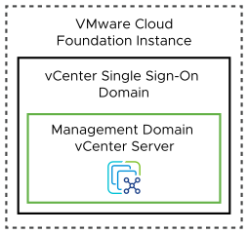
Because the Single vCenter Server Instance - Single vCenter Single Sign-On Domain topology contains a single vCenter Server instance by definition, no relevant design requirements or recommendations for vCenter Single Sign-On are needed.
Figure 3-9. Multiple vCenter Server Instances - Single vCenter Single Sign-On Domain
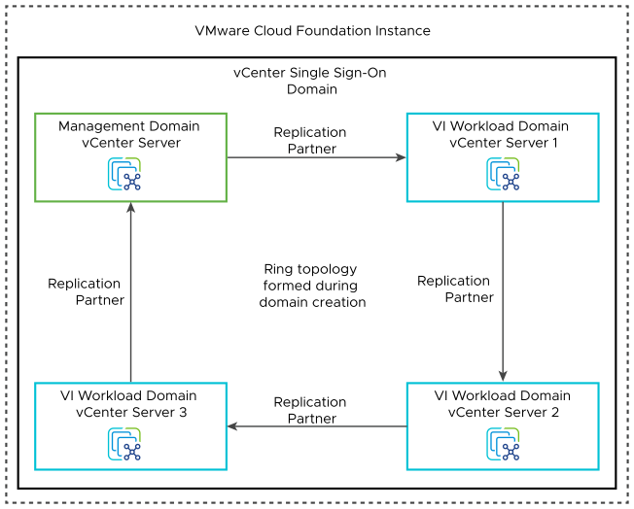
Table 3-33. Design Requirements for the Multiple vCenter Server Instance - Single vCenter Single Sign-on Domain Topology for VMware Cloud Foundation
Requirement ID | Design Requirement | Justification | Implication
VCF-VCS-REQD-SSO-STD-001 | Join all vCenter Server instances within aVMware Cloud Foundation instance to a single vCenter Single Sign-On domain. | When all vCenter Server instances are in the same vCenter Single Sign-On domain, they can share authentication and license data across all components. | - Only one vCenter Single Sign-On domain exists.  - The number of linked vCenter Server instances in the same vCenter Single Sign-On domain is limited to 15 instances. Because each workload domain uses a dedicated vCenter Server instance, you can deploy up to 15 domains within each VMware Cloud Foundation instance.
VCF-VCS-REQD-SSO-STD-002 | Create a ring topology between the vCenter Server instances within the VMware Cloud Foundation instance. | By default, one vCenter Server instance replicates only with another vCenter Server instance. This setup creates a single point of failure for replication. A ring topology ensures that each vCenter Server instance has two replication partners and removes any single point of failure. | None.
Figure 3-10. Multiple vCenter Server Instances - Multiple vCenter Single Sign-On Domain
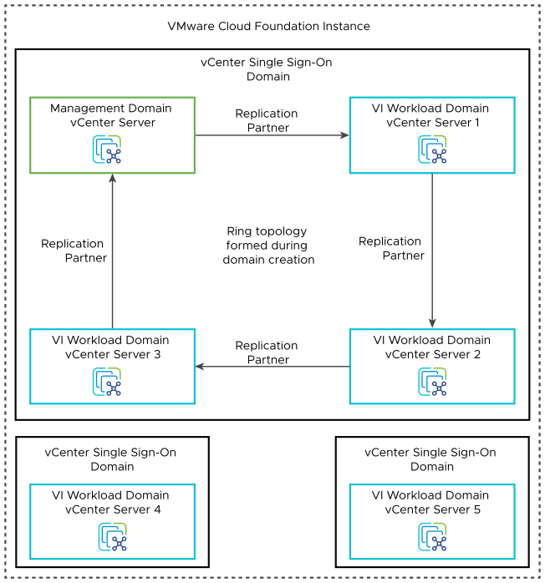
Table 3-34. Design Requirements for Multiple vCenter Server Instance - Multiple vCenter Single Sign-On Domain Topology for VMware Cloud Foundation
Requirement ID | Design Requirement | Justification | Implication
VCF-VCS-REQD-SSO-ISO-001 | Create all vCenter Server instances within a VMware Cloud Foundation instance in their own unique vCenter Single Sign-On domains. | - Enables isolation at the vCenter Single Sign-On domain layer for increased security separation.  - Supports up to 25 workload domains. | - Each vCenter server instance is managed through its own pane of glass using a different set of administrative credentials.  - You must manage password rotation for each vCenter Single Sign-On domain separately.

vSphere Cluster Design for VMware Cloud Foundation
vSphere cluster design must consider the requirements for standard, stretched and remote clusters and for the life cycle management of the ESXi hosts in the clusters according to the characteristics of the workloads.

Logical vSphere Cluster Design for VMware Cloud Foundation
The cluster design must consider the characteristics of the workloads that are deployed in the cluster.
When you design the cluster layout in vSphere, consider the following guidelines:
- Compare the capital costs of purchasing fewer, larger ESXi hosts with the costs of purchasing more, smaller ESXi hosts. Costs vary between vendors and models. Evaluate the risk of losing one larger host in a scaled-up cluster and the impact on the business with the higher chance of losing one or more smaller hosts in a scale-out cluster.
- Evaluate the operational costs of managing a few ESXi hosts with the costs of managing more ESXi hosts.
- Consider the purpose of the cluster - management, compute only, edge and compute or edge only clusters.
- For NSX Edge-only clusters, consider the number of physical NICs for the ESXi nodes in the vSphere cluster.
- Consider the total number of ESXi hosts and cluster limits.
Figure 3-11. Logical vSphere Cluster Layout with a Single Availability Zone for VMware Cloud Foundation
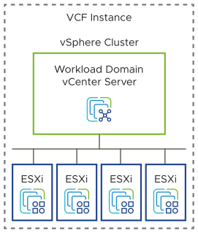
Figure 3-12. Logical vSphere Cluster Layout for Multiple Availability Zones for VMware Cloud Foundation
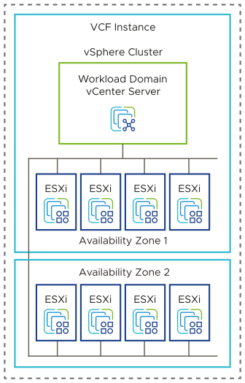

Remote Cluster Design Considerations
Remote clusters are managed by the management infrastructure at the central site.
Table 3-35. Remote Cluster Design Considerations
Remote Cluster Attribute | Consideration
Number of hosts per remote cluster | - Minimum: 2 (with external storage)  - Maximum: 16
VI Workload domains having Remote Clusters in a VMware Cloud Foundation instance. | - Maximum: 24
Number of remote clusters per VI workload domain | 1 with NSX Networking
 | 30 with vSphere Networking
Cluster types per VI workload domain | A VI workload domain can include either local clusters or a remote cluster.
Latency between the central site and the remote site | - Maximum: 100 ms
Bandwidth between the central site and the remote site | - Minimum: 10 Mbps

vSphere Cluster Lifecycle Method Design for VMware Cloud Foundation
vSphere Lifecycle Manager is used to manage the vSphere clusters in each workload domain.
When you deploy a workload domain, you choose a vSphere cluster lifecycle management method according to the requirements of your organization.
Note You can apply only one vSphere cluster lifecycle management method across a workload domain. You cannot mix the lifecycle management methods in the same workload domain.
Table 3-36. vSphere Lifecycle Manager Choices
Cluster Lifecycle Management Method | Description | Benefits | Drawbacks
vSphere Lifecycle Manager images | vSphere Lifecycle Manager images contain base images, vendor add-ons, firmware, and drivers. | - Supports NVIDIA GPU-enabled clusters.  - Supports 2-node NFS, FC, or vVols clusters.  - Supports vSAN ESA and vSAN OSA clusters. | - An initial cluster image is required during workload domain or cluster deployment.
vSphere Lifecycle Manager baselines | An upgrade baseline contains the ESXi image and a patch baseline contains the respective patches for ESXi host. | - None | - Not supported for NVIDIA GPU-enabled clusters.  - Not supported for 2-node NFS, FC, or vVols clusters.  - Not supported for vSAN ESA clusters.  - Deprecated.

vSphere Cluster Design Requirements and Recommendations for VMware Cloud Foundation
The design of a vSphere cluster is a subject to a minimum number of hosts, design requirements, and design recommendations.
For vSAN design requirements and recommendations, see vSAN Design Requirements and Recommendations for VMware Cloud Foundation.
The requirements for the ESXi hosts in a workload domain in VMware Cloud Foundation are related to the system requirements of the workloads hosted in the domain. The ESXi requirements include number, server configuration, amount of hardware resources, networking, and certificate management. Similar best practices help you design optimal environment operation

vSphere Cluster Design Considerations
You consider different number of hosts per cluster according to the storage type and specific resource requirements for standard and stretched vSAN clusters.
Table 3-37. Host-Related Design Considerations per Cluster
Attribute | Specification | Management Domain (Default Cluster) | Management Domain (Additional Clusters) or VI Workload Domain (All Clusters)
Minimum number of ESXi hosts | vSAN (single availability zone) | 4 | 3
 | vSAN (two availability zones) | 8 | 6
 | NFS, FC, or vVols | Not supported | - 2  - VI workload domain only  - Requires vSphere Lifecycle Manager images  - 3  - Additional management clusters
Reserved capacity for handling ESXi host failures per cluster | Single availability zone | - 25% CPU and memory  - Tolerates one host failure | - 33% CPU and memory  - Tolerates one host failure
 | Two availability zones | - 50% CPU and memory  - Tolerates one availability zone failure | - 50% CPU and memory  - Tolerates one availability zone failure

vSphere Cluster Design Requirements VMware Cloud Foundation
You must meet the following design requirements for standard and stretched clusters in your vSphere cluster design for VMware Cloud Foundation. The cluster design considers the storage type for the cluster, the architecture model of the environment, and the lifecycle management method.
Table 3-38. vSphere Cluster Design Requirements for VMware Cloud Foundation
Requirement ID | Design Requirement | Justification | Implication
VCF-CLS-REQD-CFG-001 | Create a cluster in each workload domain for the initial set of ESXi hosts. | - Simplifies configuration by isolating management from customer workloads.  - Ensures that customer workloads have no impact on the management stack. | Management of multiple clusters and vCenter Server instances increases operational overhead.
VCF-CLS-REQD-CFG-002 | Allocate a minimum number of ESXi hosts according to the cluster type being deployed. | - Ensures correct level of redundancy to protect against host failure in the cluster. | To support redundancy, you must allocate additional ESXi host resources.
VCF-CLS-REQD-CFG-003 | If using a consolidated workload domain, configure the following vSphere resource pools to control resource usage by management and customer workloads.  - cluster-name-rp-sddc-mgmt  - cluster-name-rp-sddc-edge  - cluster-name-rp-user-edge  - cluster-name-rp-user-vm | - Ensures sufficient resources for the management components. | You must manage the vSphere resource pool settings over time.
VCF-CLS-REQD-CFG-004 | For vSAN clusters, configure the vSAN network gateway IP address as the isolation address for the cluster. | Allows vSphere HA to validate if a host is isolated from the vSAN network. | None.
VCF-CLS-REQD-CFG-005 | For vSAN clusters, set the advanced cluster setting das.usedefaultisolationaddress to false. | Ensures that vSphere HA uses the manual isolation addresses instead of the default management network gateway address. | None.
Table 3-39. vSphere Cluster Design Requirements for vSAN Stretched Clusters with VMware Cloud Foundation
Requirement ID | Design Requirement | Justification | Implication
VCF-CLS-REQD-CFG-006 | Configure the IP address of the vSAN network for the second availability zone as an additional isolation addresses for the cluster. | Enables vSphere HA to validate if a host is isolated from the vSAN network for hosts in both availability zones. | The IP address of the vSAN network gateway must be highly available and reply to ICMP requests.
VCF-CLS-REQD-CFG-007 | Enable the Override default gateway for this adapter setting on the vSAN VMkernel adapters on all ESXi hosts. | Enables routing the vSAN data traffic through the vSAN network gateway rather than through the management gateway. | vSAN networks across availability zones must have a route to each other.
VCF-CLS-REQD-CFG-008 | Create a host group for each availability zone and add the ESXi hosts in the zone to the respective group. | Makes it easier to manage which virtual machines run in which availability zone. | You must create and maintain VM-Host DRS group rules.

vSphere Cluster Design Recommendations for VMware Cloud Foundation
In your vSphere cluster design, you can apply certain best practices for standard and stretched clusters.
Table 3-40. vSphere Cluster Design Recommendations for VMware Cloud Foundation
Recommendation ID | Design Recommendation | Justification | Implication
VCF-CLS-RCMD-CFG-001 | Use vSphere HA to protect all virtual machines against failures. | vSphere HA supports a robust level of protection for both ESXi host and virtual machine availability. | You must provide sufficient resources on the remaining hosts so that virtual machines can be restarted on those hosts in the event of a host outage.
VCF-CLS-RCMD-CFG-002 | For vSAN clusters, set host isolation response to Power Off and restart VMs in vSphere HA. | vSAN requires that the host isolation response be set to Power Off and to restart virtual machines on available ESXi hosts. | If a false positive event occurs, virtual machines are powered off and an ESXi host is declared isolated incorrectly.
VCF-CLS-RCMD-CFG-003 | Configure admission control for 1 ESXi host failure and percentage-based failover capacity. | Using the percentage-based reservation works well in situations where virtual machines have varying and sometimes significant CPU or memory reservations.  vSphere automatically calculates the reserved percentage according to the number of ESXi host failures to tolerate and the number of ESXi hosts in the cluster. | In a cluster of 4 ESXi hosts, the resources of only 3 ESXi hosts are available for use.
VCF-CLS-RCMD-CFG-004 | Enable VM Monitoring for each cluster. | VM Monitoring provides in-guest protection for most VM workloads. The application or service running on the virtual machine must be capable of restarting successfully after a reboot or the virtual machine restart is not sufficient. | None.
VCF-CLS-RCMD-CFG-005 | Set the advanced cluster setting das.iostatsinterval to 0 to deactivate monitoring the storage and network I/O activities of the management appliances. | Enables triggering a restart of a management appliance when an OS failure occurs and heartbeats are not received from VMware Tools instead of waiting additionally for the I/O check to complete. | If you want to specifically enable I/O monitoring, you must configure the das.iostatsinterval advanced setting.
VCF-CLS-RCMD-CFG-006 | Enable vSphere DRS on all clusters, using the default fully automated mode with medium threshold. | Provides the best trade-off between load balancing and unnecessary migrations with vSphere vMotion. | If a vCenter Server outage occurs, the mapping from virtual machines to ESXi hosts might be difficult to determine.
VCF-CLS-RCMD-CFG-007 | Enable Enhanced vMotion Compatibility (EVC) on all clusters in the management domain. | Supports cluster upgrades without virtual machine downtime. | You must enable EVC only if the clusters contain hosts with CPUs from the same vendor.  You must enable EVC on the default management domain cluster during bringup.
VCF-CLS-RCMD-CFG-008 | Set the cluster EVC mode to the highest available baseline that is supported for the lowest CPU architecture on the hosts in the cluster. | Supports cluster upgrades without virtual machine downtime. | None.
VCF-CLS-RCMD-LCM-001 | Use images as the life cycle management method for all workload domains. | - vSphere Lifecycle Manager images simplify the management of firmware and vendor add-ons manually.  - Supports vSAN ESA clusters. | - A cluster image is required during VI workload domain or cluster deployment.  - A cluster image is required when you add a cluster to the management domain.
Table 3-41. vSphere Cluster Design Recommendations for vSAN Stretched Clusters with VMware Cloud Foundation
Recommendation ID | Design Recommendation | Justification | Implication
VCF-CLS-RCMD-CFG-009 | Increase admission control percentage to half of the ESXi hosts in the cluster. | Allocating only half of a stretched cluster ensures that all VMs have enough resources if an availability zone outage occurs. | In a cluster of 8 ESXi hosts, the resources of only 4 ESXi hosts are available for use.  If you add more ESXi hosts to the default management cluster, add them in pairs, one per availability zone.
VCF-CLS-RCMD-CFG-010 | Create a virtual machine group for each availability zone and add the VMs in the zone to the respective group. | Ensures that virtual machines are located only in the assigned availability zone to avoid unnecessary vSphere vMotion migrations. | You must add virtual machines to the allocated group manually.
VCF-CLS-RCMD-CFG-011 | Create a should-run-on-hosts-in-group VM-Host affinity rule to run each group of virtual machines on the respective group of hosts in the same availability zone. | Ensures that virtual machines are located only in the assigned availability zone to avoid unnecessary vSphere vMotion migrations. | You must manually create the rules.

vSphere Networking Design for VMware Cloud Foundation
VMware Cloud Foundation uses vSphere Distributed Switch for virtual networking.

Logical vSphere Networking Design for VMware Cloud Foundation
When you design vSphere networking, consider the configuration of the vSphere Distributed Switches, distributed port groups, and VMkernel adapters in the VMware Cloud Foundation environment.

vSphere Distributed Switch Design
The default cluster in a workload domain uses a single vSphere Distributed Switch with a configuration for system traffic types, NIC teaming, and MTU size.
VMware Cloud Foundation supports NSX Overlay traffic over a single vSphere Distributed Switch per cluster. Additional distributed switches are supported for other traffic types.
When using vSAN ReadyNodes, you must define the number of vSphere Distributed Switches at workload domain deployment time. You cannot add additional vSphere Distributed Switches post deployment.
Table 3-42. Configuration Options for vSphere Distributed Switch for VMware Cloud Foundation
vSphere Distributed Switch Configuration | Management Domain Options | VI Workload Domain Options | Benefits | Drawbacks
Single vSphere Distributed Switch for hosts with two physical NICs | - One vSphere Distributed Switch for each cluster with all traffic using two uplinks. | - One vSphere Distributed Switch for each cluster with all traffic using two uplinks. | Requires the least number of physical NICs and switch ports. | All traffic shares the same two uplinks.
Single vSphere Distributed Switch for hosts with four or six physical NICs | - One vSphere Distributed Switch for each cluster with four uplinks by using the predefined profiles in the Deployment Parameters Workbook in VMware Cloud Builder to deploy the default management cluster.  - One vSphere Distributed Switch for each cluster with four or six uplinks by using the VMware Cloud Builder API to deploy the default management cluster. | - One vSphere Distributed Switch for each cluster with four or six uplinks. | - Provides support for traffic separation across different uplinks. | - You must provide additional physical NICs and switch ports.
Multiple vSphere Distributed Switches | - Maximum two vSphere Distributed Switches by using the predefined profiles in the Deployment Parameters Workbook in VMware Cloud Builder to deploy the default management cluster.  - Maximum 16 vSphere Distributed Switches per cluster. You use the VMware Cloud Builder API to deploy the default management cluster using combinations of vSphere Distributed Switches and physical NIC configurations that are not available as predefined profiles in the Deployment Parameters Workbook  - You can use only one of the vSphere Distributed Switches for NSX overlay traffic. | - Maximum 16 vSphere Distributed Switches per cluster.  - You can use only one of the vSphere Distributed Switches for NSX overlay traffic. | - Provides support for traffic separation across different uplinks or vSphere Distributed Switches.  - Provides support for traffic separation onto different physical network fabrics. | - You must provide additional physical NICs and switch ports.  - More complex with additional configuration and management overhead.

Distributed Port Group Design
VMware Cloud Foundation requires several port groups on the vSphere Distributed Switch for a workload domain. The VMkernel adapters for the NSX host TEPs are connected to the host overlay network, but do not require a dedicated port group on the distributed switch. The VMkernel network adapter for NSX host TEP is automatically created when VMware Cloud Foundation configures the ESXi host as an NSX transport node.
Table 3-43. Distributed Port Group Configuration for VMware Cloud Foundation
Function | Teaming Policy | Configuration
- VM management  - Host management  - vSphere vMotion  - vSAN  - NFS (not applicable for the default cluster of the management Domain) | Route based on physical NIC load. | Recommended.
 | - Failover Detection: Link status only  - Failback: Yes  Occurs only on saturation of the active uplink.  - Notify Switches: Yes | Recommended.
- Host overlay | Not applicable. | Not applicable.
- Edge uplinks and overlay | Use explicit failover order. | Required.
- Edge RTEP (NSX Federation only) | Not applicable. | Not applicable.

VMkernel Network Adapter Design
The VMkernel networking layer provides connectivity to hosts and handles the system traffic for management, vSphere vMotion, vSphere HA, vSAN, NFS and others.
Table 3-44. VMkernel Adapters for Workload Domain Hosts
VMkernel Adapter Service | Connected Port Group | Activated Services | Recommended MTU Size (Bytes)
Management | Management Port Group | Management Traffic | 1500 (Default)
vMotion | vMotion Port Group | vMotion Traffic | 9000
vSAN | vSAN Port Group | vSAN | 9000
NFS | NFS Port Group | NFS | 9000
Host TEPs | Not applicable | Not applicable | 9000

vSphere Distributed Switch Data Path Modes
vSphere Distributed Switch supports three data path modes - Standard Datapath, Enhanced Datapath Interrupt, and Enhanced Datapath. Data path is a networking stack mode that is configured on a vSphere Distributed Switch when an NSX Transport Node Profile is applied during the installation of NSX on an ESXi cluster. Each data path mode has performance characteristics that are suitable for a particular workload running on the cluster. The following table provides details of the various modes available in VMware Cloud Foundation, along with recommended cluster workload types for each mode.
Table 3-45. Data Path Modes for VMware Cloud Foundation
Data Path Mode Name | Description | Use Cases | Requirements
Standard | - Standard data path is installed by default. It is designed to address applications with large flows.  - CPU usage in Standard Datapath is on demand. For applications with high packet processing requirements, such as NSX Edge, Standard Datapath requires significant tuning. | Compute workload domains or clusters | The driver-firmware combination must be on VMware Compatibility Guide for I/O Devices and must support the following features:  - Geneve Offload  - Geneve Rx/Tx Filters or RSS
Enhanced Datapath Interrupt  (Referred to as Enhanced Datapath - Standard in NSX Manager UI) | - Enhanced Datapath Interrupt is a performance-oriented data path that combines the flexibility of on-demand CPU usage of the existing standard data path and Data Plane Development Kit (DPDK) like features for performance.  - This mode auto-scales up and down core usage for packet processing, based on need.  - Enhanced Datapath Interrupt has proven performance characteristics, especially for smaller flows that primarily focus on packet processing such as NSX Edge, with no additional tuning required. | vSphere clusters running NSX Edge nodes | The driver-firmware combination must be on VMware Compatibility Guide for I/O Devices with Enhanced Data Path - Interrupt mode support
Enhanced Datapath  (Referred to Enhanced Datapath - Performance in NSX Manager UI) | - Enhanced Datapath mode is a performance-oriented data path that leverages DPDK-like performance features, including dedicated CPU cores for networking data path processing.  - This mode is best suited for workloads where the traffic patterns and the performance requirements are well defined.  - This mode is fixed from a core allocation point of view and does not auto-scale up or down based on need. The cores assigned to the data path will not be available for workloads, even when there is no network traffic.  - There is a possibility of not having enough cores for packet processing unless the cores are pre-assigned accurately sizing the workload. | Telco or NFV workloads | The driver-firmware combination must be on the VMware Compatibility Guide for I/O Devices with Enhanced data path - Poll mode support.

vSphere Networking Design Requirements and Recommendations for VMware Cloud Foundation
Consider the requirements and recommendations for vSphere networking in VMware Cloud Foundation, such as distributed port group configuration, MTU size, port binding, teaming policy, and traffic-specific network shares.

vSphere Networking Design Requirements for VMware Cloud Foundation
You must meet the following design requirements in your vSphere networking design for VMware Cloud Foundation.
Table 3-46. vSphere Networking Design Requirements for a Multi-Rack Compute VI Workload Domain Cluster for VMware Cloud Foundation
Requirement ID | Design Requirement | Justification | Implication
VCF-VDS-L3MR-REQD-CFG-001 | For each rack, create a port group on the vSphere Distributed Switch for the cluster for for the following traffic types:  - Host management  - vSAN  - vSphere vMotion | Required for using separate VLANs per rack. | None.

vSphere Networking Design Recommendations for VMware Cloud Foundation
In your vSphere networking design for VMware Cloud Foundation, you can apply certain best practices for vSphere Distributed Switch and distributed port groups.
Table 3-47. vSphere Networking Design Recommendations for VMware Cloud Foundation
Recommendation ID | Design Recommendation | Justification | Implication
VCF-VDS-RCMD-CFG-001 | Use a single vSphere Distributed Switch per cluster. | - Reduces the complexity of the network design. | Reduces the number of vSphere Distributed Switches that must be managed per cluster.
VCF-VDS-RCMD-CFG-002 | Do not share a vSphere Distributed Switch across clusters. | - Enables independent lifecycle management of vSphere Distributed Switch per cluster.  - Reduces the size of the fault domain. | For multiple clusters, you manage more vSphere Distributed Switches .
VCF-VDS-RCMD-CFG-003 | Configure the MTU size of the vSphere Distributed Switch to 9000 for jumbo frames. | - Supports the MTU size required by system traffic types.  - Improves traffic throughput. | When adjusting the MTU packet size, you must also configure the entire network path (VMkernel ports, virtual switches, physical switches, and routers) to support the same MTU packet size.
VCF-VDS-RCMD-DPG-001 | Use ephemeral port binding for the VM management port group. | Using ephemeral port binding provides the option for recovery of the vCenter Server instance that is managing the distributed switch.  The VM management network is not required for a multi-rack compute-only cluster in a VI workload domain. | Port-level permissions and controls are lost across power cycles, and no historical context is saved.
VCF-VDS-RCMD-DPG-002 | Use static port binding for all non-management port groups. | Static binding ensures a virtual machine connects to the same port on the vSphere Distributed Switch. This configuration provides support for historical data and port-level monitoring. | None.
VCF-VDS-RCMD-DPG-003 | - Use the Route based on physical NIC load teaming algorithm for the VM management port group.  - VM management network is not required for a compute only L3 multi-rack deployment. | Reduces the complexity of the network design, increases resiliency, and can adjust to fluctuating workloads. | None.
VCF-VDS-RCMD-DPG-004 | Use the Route based on physical NIC load teaming algorithm for the ESXi management port group. | Reduces the complexity of the network design, increases resiliency, and can adjust to fluctuating workloads. | None.
VCF-VDS-RCMD-DPG-005 | Use the Route based on physical NIC load teaming algorithm for the vSphere vMotion port group. | Reduces the complexity of the network design, increases resiliency, and can adjust to fluctuating workloads. | None.
VCF-VDS-RCMD-DPG-006 | Use the Route based on physical NIC load teaming algorithm for the vSAN port group. | Reduces the complexity of the network design, increases resiliency, and can adjust to fluctuating workloads. | None.
VCF-VDS-RCMD-NIO-001 | Enable Network I/O Control on the vSphere Distributed Switch of the management domain cluster.  Do not enable Network I/O Control on dedicated vSphere clusters for NSX Edge nodes. | Increases resiliency and performance of the network. | Network I/O Control might impact network performance for critical traffic types if misconfigured.
VCF-VDS-RCMD-NIO-002 | Set the share value for management traffic to Normal. | By keeping the default setting of Normal, management traffic is prioritized higher than vSphere vMotion but lower than vSAN traffic. Management traffic is important because it ensures that the hosts can still be managed during times of network contention. | None.
VCF-VDS-RCMD-NIO-003 | Set the share value for vSphere vMotion traffic to Low. | During times of network contention, vSphere vMotion traffic is not as important as virtual machine or storage traffic. | During times of network contention, vMotion takes longer than usual to complete.
VCF-VDS-RCMD-NIO-004 | Set the share value for virtual machines to High. | Virtual machines are the most important asset in the SDDC. Leaving the default setting of High ensures that they always have access to the network resources they need. | None.
VCF-VDS-RCMD-NIO-005 | Set the share value for vSAN traffic to High. | During times of network contention, vSAN traffic needs guaranteed bandwidth to support virtual machine performance. | None.
VCF-VDS-RCMD-NIO-006 | Set the share value for other traffic types to Low. | By default, VMware Cloud Foundation does not use other traffic types, like vSphere FT traffic. Hence, these traffic types can be set the lowest priority. | None.

NSX Design for VMware Cloud Foundation
In VMware Cloud Foundation, you use NSX to implement virtualization for networks, routing and load balancing. It provides support for an automated approach to the creation of virtual network segments and routing objects used to connect management and customer virtual machines to the physical network.
You also create constructs for solutions that are deployed for a single VMware Cloud Foundation instance or are available across multiple VMware Cloud Foundation instances. These constructs provide routing to the data center and load balancing.
Table 3-48. NSX Logical Concepts and Components
Component | Description
NSX Manager | - Provides the user interface and the REST API for creating, configuring, and monitoring NSX components, such as segments, and Tier-0 and Tier-1 gateways.  - In a deployment with NSX Federation, NSX Manager is called NSX Local Manager.
NSX Edge nodes | - A special type of transport node that contains service router components.  - Provides north-south traffic connectivity between the physical data center networks and the NSX SDN networks. Each NSX Edge node has multiple interfaces where traffic flows.  - Provides east-west traffic flow between virtualized workloads. Provides stateful services such as load balancing and DHCP. In a deployment with multiple VMware Cloud Foundation instances, east-west traffic between the VMware Cloud Foundation instances flows through the NSX Edge nodes.
NSX Federation (optional design extension) | - Propagates configurations that span multiple NSX instances in a single VMware Cloud Foundation instance or across multiple VMware Cloud Foundation instances. You can stretch overlay segments, activate failover of segment ingress and egress traffic between VMware Cloud Foundation instances, and implement a unified firewall configuration.  - In a deployment with multiple VMware Cloud Foundation instances, you use NSX to provide cross-instance services to SDDC management components that do not have native support for availability at several locations, such as VMware Aria Automation and VMware Aria Operations.  - Connect only workload domains of matching types (management domain to management domain or VI workload domain to VI workload domain).
NSX Global Manager (Federation only) | - Is part of deployments with multiple VMware Cloud Foundation instances where NSX Federation is required. NSX Global Manager can connect multiple NSX Local Manager instances under a single global management plane.  - Provides the user interface and the REST API for creating, configuring, and monitoring NSX global objects, such as global virtual network segments, and global Tier-0 and Tier-1 gateways.  - Connected NSX Local Manager instances create the global objects on the underlying software-defined network that you define from NSX Global Manager. An NSX Local Manager instance directly communicates with other NSX Local Manager instances to synchronize configuration and state needed to implement a global policy.  - NSX Global Manager is a deployment-time role that you assign to an NSX Manager appliance.
NSX Manager instance shared between VI workload domains | - An NSX Manager instance can be shared between up to 14 VI workload domains that are part of the same vCenter Single Sign-On domain  - An NSX Manager instance can be shared between up to 24 isolated VI workload domains.  - VI workload domains sharing an NSX Manager instance must use the same vSphere cluster life cycle method.  - Using a shared NSX Manager instance reduces resource requirements for the management domain.  - A single transport zone is shared across all clusters in all VI workload domains that share the NSX Manager instance.  - The management domain NSX Manager instance cannot be shared.

Logical Design for NSX for VMware Cloud Foundation
NSX provides networking services to workloads in VMware Cloud Foundation such as load balancing, routing and virtual networking.
Table 3-49. NSX Logical Design
Component | VMware Cloud Foundation Instances with a Single Availability Zone | VMware Cloud Foundation Instances with Multiple Availability Zones
NSX Manager Cluster | - Three appropriately sized nodes with a virtual IP (VIP) address with an anti-affinity rule to keep them on different hosts.  - vSphere HA protects the cluster nodes applying high restart priority | - Three appropriately sized nodes with a VIP address with an anti-affinity rule to keep them on different hosts.  - vSphere HA protects the cluster nodes by applying high restart priority  - vSphere DRS rule should-run-on-hosts-in-group keeps the NSX Manager VMs in the first availability zone.
NSX Global Manager Cluster (Conditional) | - Manually deployed three appropriately sized nodes with a VIP address with an anti-affinity rule to run them on different hosts.  - One active and one standby cluster.  - vSphere HA protects the cluster nodes applying high restart priority. | - Manually deployed three appropriately sized nodes with a VIP address with an anti-affinity rule to run them on different hosts.  - One active and one standby cluster.  - vSphere HA protects the cluster nodes by applying high restart priority.  - vSphere DRS rule should-run-on-hosts-in-group keeps the NSX Global Manager VMs in the first availability zone.
NSX Edge Cluster | - Two appropriately sized NSX Edge nodes with an anti-affinity rule to separate them on different hosts.  - vSphere HA protects the cluster nodes applying high restart priority. | - Two appropriately sized NSX Edge nodes in the first availability zone with an anti-affinity rule to separate them on different hosts.  - vSphere HA protects the cluster nodes by applying high restart priority.  - vSphere DRS rule should-run-on-hosts-in-group keeps the NSX Edge VMs in the first availability zone.
Transport Nodes | - Each ESXi host acts as a host transport node.  - Minimum two edge transport nodes. | - Each ESXi host acts as a host transport node.  - Minimum two transport nodes in the first availability zone.
Transport zones | - One VLAN transport zone for north-south traffic.  - Maximum one overlay transport zone for overlay segments per NSX instance.  - One VLAN transport zone for VLAN-backed segments. | - One VLAN transport zone for north-south traffic.  - Maximum one overlay transport zone for overlay segments per NSX instance.  - One or more VLAN transport zones for VLAN-backed segments.
VLANs and IP subnets allocated to NSX  For information about the networks for virtual infrastructure management, see Distributed Port Group Design. | See VLANs and Subnets for VMware Cloud Foundation. | See VLANs and Subnets for VMware Cloud Foundation.
Routing configuration | - BGP for a single VMware Cloud Foundation instance.  - In a VMware Cloud Foundation deployment with NSX Federation, BGP with ingress and egress traffic to the first VMware Cloud Foundation instance during normal operating conditions. | - BGP with path prepend to control ingress traffic and local preference to control egress traffic through the first availability zone during normal operating conditions.  - In a VMware Cloud Foundation deployment with NSX Federation, BGP with ingress and egress traffic to the first instance during normal operating conditions.
For a description of the NSX logical component in this design, see Table 3-48. NSX Logical Concepts and Components.

Single Instance - Single Availability Zone
The NSX design for the Single Instance - Single Availability Zone topology consists of the following components:
Figure 3-13. NSX Logical Design for a Single Instance - Single Availability Zone Topology
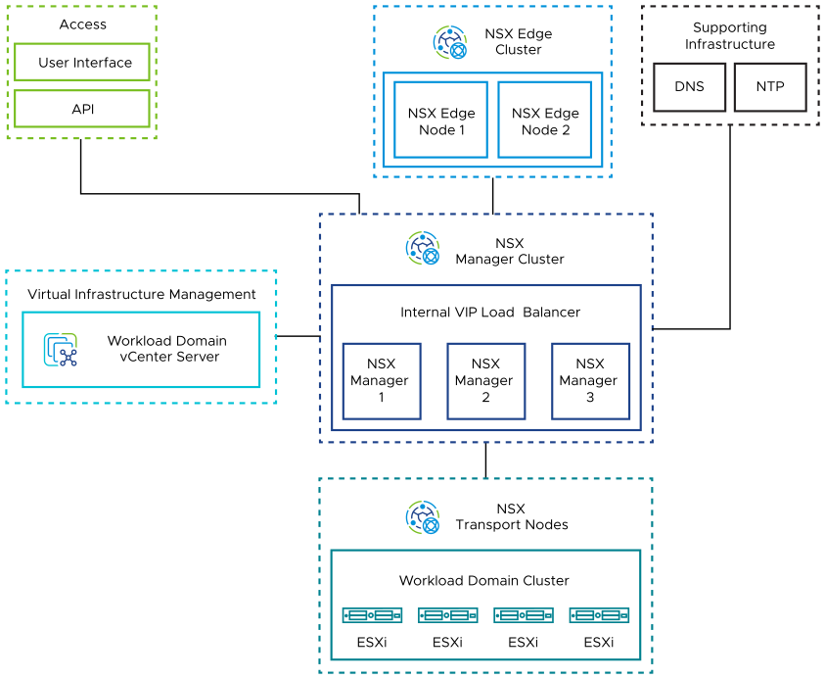
- Unified appliances that have both the NSX Local Manager and NSX Controller roles. They provide management and control plane capabilities.
- NSX Edge nodes in the workload domain that provide advanced services such as load balancing, and north-south connectivity.
- ESXi hosts in the workload domain that are registered as NSX transport nodes to provide distributed routing and firewall services to workloads.

Single Instance - Multiple Availability Zones
The NSX design for a Single Instance - Multiple Availability Zone topology consists of the following components:
Figure 3-14. NSX Logical Design for a Single Instance - Multiple Availability Zone Topology
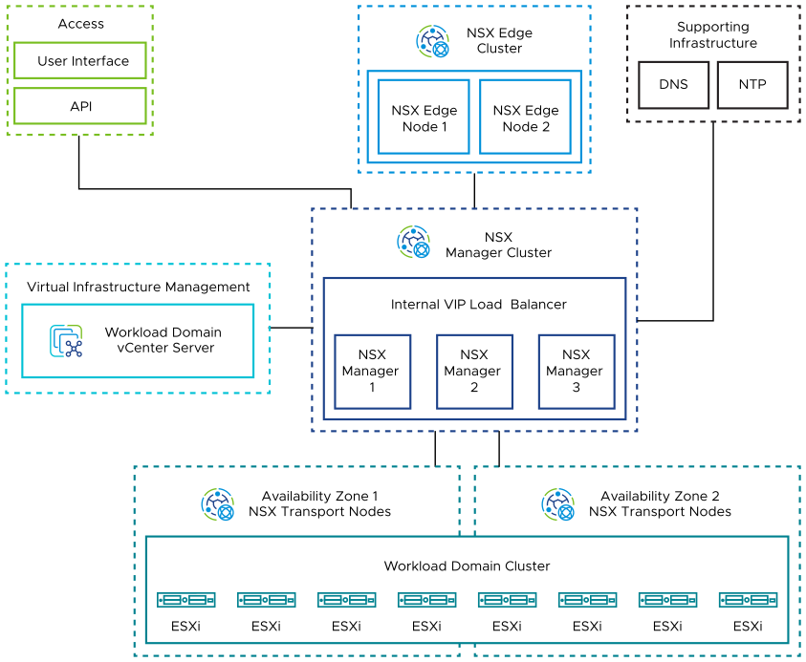
- Unified appliances that have both the NSX Local Manager and NSX Controller roles. They provide management and control plane capabilities.
- NSX Edge nodes that provide advanced services such as load balancing, and north-south connectivity.
- ESXi hosts that are distributed evenly across availability zones in the workload domain and are registered as NSX transport nodes to provide distributed routing and firewall services to workloads.

Multiple Instances - Single Availability Zone
The NSX design for a Multiple Instance - Single Availability Zone topology consists of the following components:
Figure 3-15. NSX Logical Design for a Multiple Instance - Single Availability Zone Topology
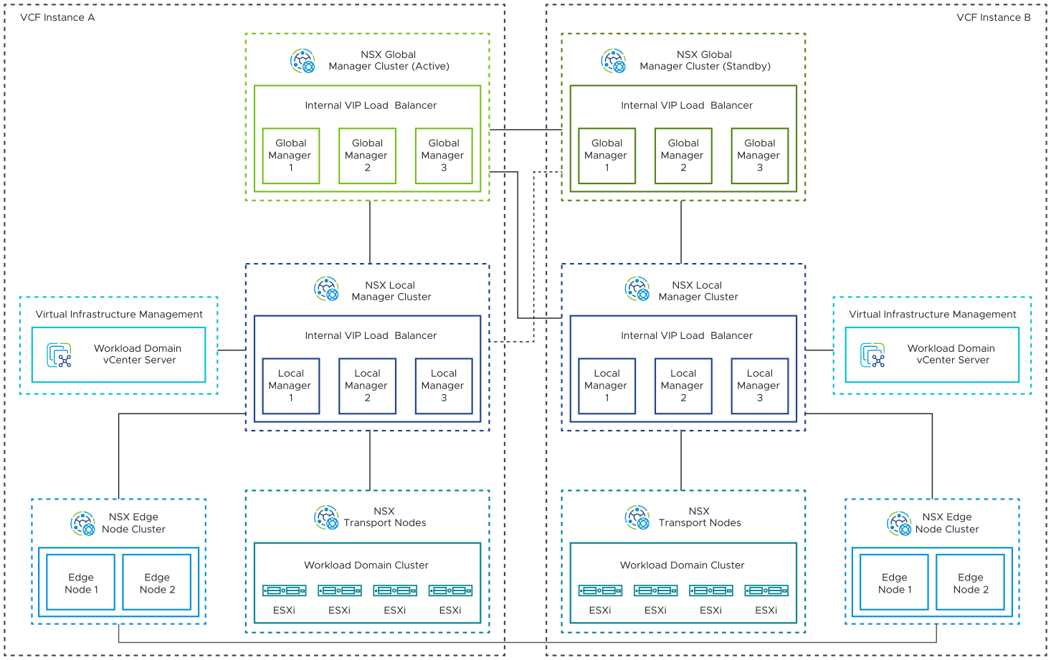
- Unified appliances that have both the NSX Local Manager and NSX Controller roles. They provide management and control plane capabilities.
- NSX Edge nodes that provide advanced services such as load balancing, and north-south connectivity.
- ESXi hosts in the workload domain that are registered as NSX transport nodes to provide distributed routing and firewall services to workloads.
- NSX Global Manager clusters deployed in each of the first two VMware Cloud Foundation instances in an Active/Standby configuration. You deploy the NSX Global Manager clusters so that you can use NSX Federation for global management of networking and security services.
- An additional infrastructure VLAN in each VMware Cloud Foundation instance to carry instance-to-instance traffic (RTEP).

Multiple Instances - Multiple Availability Zones
The NSX design for a Multiple Instance - Multiple Availability Zone topology consists of the following components:
Figure 3-16. NSX Logical Design for Multiple Instance - Multiple Availability Zone Topology
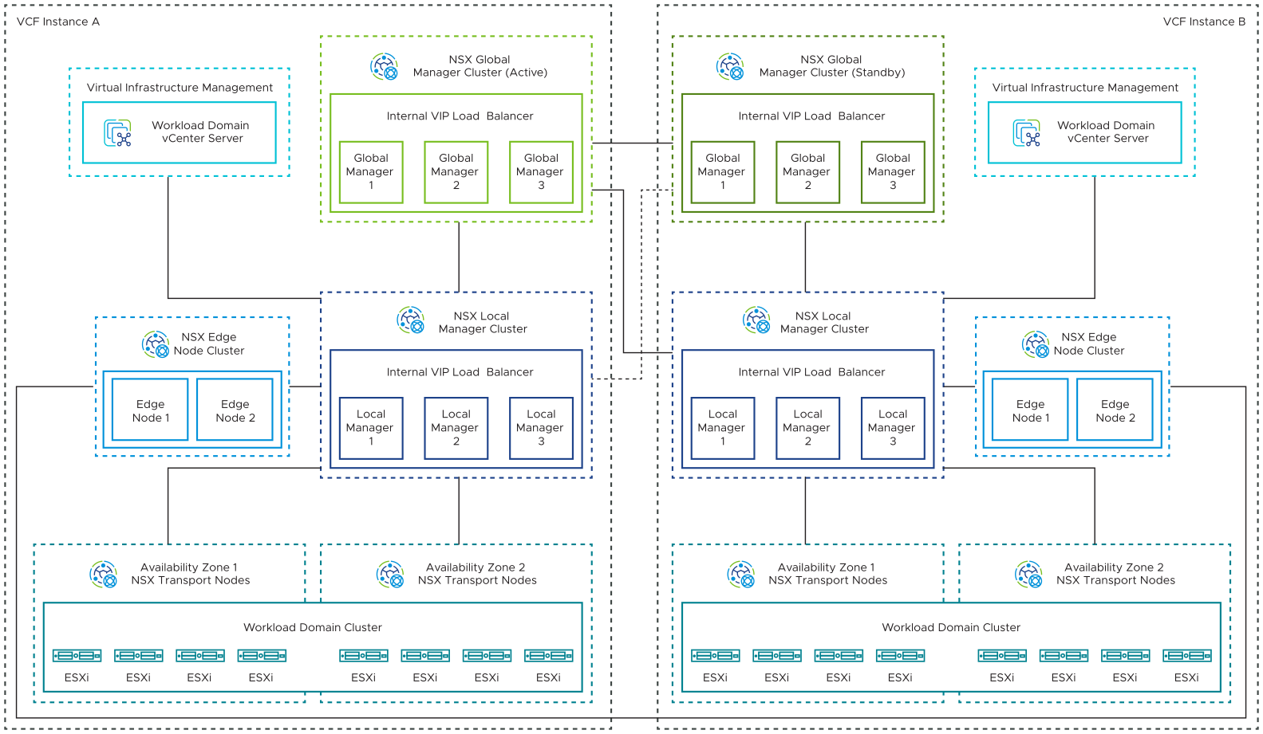
- Unified appliances that have both the NSX Local Manager and NSX Controller roles. They provide management and control plane capabilities.
- NSX Edge nodes that provide advanced services such as load balancing, and north-south connectivity.
- ESXi hosts that are distributed evenly across availability zones in the workload domain in a VMware Cloud Foundation instance, and are registered as NSX transport nodes to provide distributed routing and firewall services to workloads.
- NSX Global Manager cluster in each of the first two VMware Cloud Foundation instances.
You deploy the NSX Global Manager cluster in each VMware Cloud Foundation instance so that you can use NSX Federation for global management of networking and security services.
- An additional infrastructure VLAN in each VMware Cloud Foundation instance to carry instance-to-instance traffic (RTEP).

NSX Manager Design for VMware Cloud Foundation
Following the principles of this design and of each product, you determine the size of, deploy and configure NSX Manager as part of your VMware Cloud Foundation deployment.

Sizing Considerations for NSX Manager for VMware Cloud Foundation
You select an appropriate NSX Manager appliance size that is suitable for the scale of your environment.
When you deploy NSX Manager appliances, either with a local or global scope, you select to deploy the appliance with a size suitable for your environment's scale. The option that you select determines the number of CPUs and the amount of memory of the appliance. For detailed sizing according to the overall profile of the VMware Cloud Foundation instance you plan to deploy, see VMware Cloud Foundation Planning and Preparation Workbook.
Table 3-50. Sizing Considerations for NSX Manager
NSX Manager Appliance Size | Scale
Extra-Small | Cloud Service Manager only
Small | Proof of concept only
Medium  Default for the management domain | Up to 128 ESXi hosts
Large  Default for VI workload domains | Up to 1,024 ESXi hosts
Extra Large | Up to 2048 ESXi Hosts
Note To deploy an NSX Manager appliance in the VI workload domain with a size different from the default one, you must use the API.

NSX Manager Design Requirements and Recommendations for VMware Cloud Foundation
Consider the placement requirements for using NSX Manager in VMware Cloud Foundation, and the best practices for having an NSX Manager cluster operate in an optimal way, such as number and size of the nodes, and high availability, on a standard or stretched management cluster.

NSX Manager Design Requirements for VMware Cloud Foundation
You must meet the following design requirements in your NSX Manager design for VMware Cloud Foundation.
Table 3-51. NSX Manager Design Requirements for VMware Cloud Foundation
Requirement ID | Design Requirement | Justification | Implication
VCF-NSX-LM-REQD-CFG-001 | Place the appliances of the NSX Manager cluster on the VM management network in the management domain. | - Simplifies IP addressing for management VMs by using the same VLAN and subnet.  - Provides simplified secure access to management VMs in the same VLAN network. | None.
VCF-NSX-LM-REQD-CFG-002 | Deploy three NSX Manager nodes in the default vSphere cluster in the management domain for configuring and managing the network services for the workload domain. | Supports high availability of the NSX manager cluster. | You must have sufficient resources in the default cluster of the management domain to run three NSX Manager nodes.

NSX Manager Design Recommendations for VMware Cloud Foundation
In your NSX Manager design for VMware Cloud Foundation, you can apply certain best practices for standard and stretched clusters.
Table 3-52. NSX Manager Design Recommendations for VMware Cloud Foundation
Recommendation ID | Design Recommendation | Justification | Implication
VCF-NSX-LM-RCMD-CFG-001 | Deploy appropriately sized nodes in the NSX Manager cluster for the workload domain. | Ensures resource availability and usage efficiency per workload domain. | The default size for a management domain is Medium, and for VI workload domains is Large.
VCF-NSX-LM-RCMD-CFG-002 | Create a virtual IP (VIP) address for the NSX Manager cluster for the workload domain. | Provides high availability of the user interface and API of NSX Manager. | - The VIP address feature provides high availability only. It does not load-balance requests across the cluster.  - When using the VIP address feature, all NSX Manager nodes must be deployed on the same Layer 2 network.
VCF-NSX-LM-RCMD-CFG-003 | Apply VM-VM anti-affinity rules in vSphere Distributed Resource Scheduler (vSphere DRS) to the NSX Manager appliances. | Keeps the NSX Manager appliances running on different ESXi hosts for high availability. | You must allocate at least four physical hosts so that the three NSX Manager appliances continue running if an ESXi host failure occurs.
VCF-NSX-LM-RCMD-CFG-004 | In vSphere HA, set the restart priority policy for each NSX Manager appliance to high. | - NSX Manager implements the control plane for virtual network segments. vSphere HA restarts the NSX Manager appliances first so that other virtual machines that are being powered on or migrated by using vSphere vMotion while the control plane is offline lose connectivity only until the control plane quorum is re-established.  - Setting the restart priority to high reserves the highest priority for flexibility for adding services that must be started before NSX Manager. | If the restart priority for another management appliance is set to highest, the connectivity delay for management appliances will be longer.
Table 3-53. NSX Manager Design Recommendations for Stretched Clusters in VMware Cloud Foundation
Recommendation ID | Design Recommendation | Justification | Implication
VCF-NSX-LM-RCMD-CFG-006 | Add the NSX Manager appliances to the virtual machine group for the first availability zone. | Ensures that, by default, the NSX Manager appliances are powered on a host in the primary availability zone. | None.

NSX Global Manager Design Requirements and Recommendations for VMware Cloud Foundation
For a deployment with multiple VMware Cloud Foundation instances, you use NSX Federation, which requires the manual deployment of NSX Global Manager nodes in the first two instances. Consider the placement requirements for using NSX Global Manager in VMware Cloud Foundation, and the best practices for having an NSX Global Manager cluster operate in an optimal way, such as the number and size of the nodes and high availability on a standard or stretched management cluster.

NSX Global Manager Design Requirements
You must meet the following design requirements in your NSX Global Manager design for VMware Cloud Foundation.
Table 3-54. NSX Global Manager Design Requirements for VMware Cloud Foundation
Requirement ID | Design Requirement | Justification | Implication
VCF-NSX-GM-REQD-CFG-001 | Place the appliances of the NSX Global Manager cluster on the Management VM network in each VMware Cloud Foundation instance. | - Simplifies IP addressing for management VMs.  - Provides simplified secure access to all management VMs in the same VLAN network. | None.

NSX Global Manager Design Recommendations
In your NSX Global Manager design for VMware Cloud Foundation, you can apply certain best practices for standard and stretched clusters.
Table 3-55. NSX Global Manager Design Recommendations for VMware Cloud Foundation
Recommendation ID | Design Recommendation | Justification | Implication
VCF-NSX-GM-RCMD-CFG-001 | Deploy three NSX Global Manager nodes for the workload domain to support NSX Federation across VMware Cloud Foundation instances. | Provides high availability for the NSX Global Manager cluster. | You must have sufficient resources in the default cluster of the management domain to run three NSX Global Manager nodes.
VCF-NSX-GM-RCMD-CFG-002 | Deploy appropriately sized nodes in the NSX Global Manager cluster for the workload domain.  Check VMware Configuration Maximums to select the right NSX Global Managers form factor for your scale needs. | Ensures resource availability and usage efficiency per workload domain. | Incorrectly sized NSX Global Managers might impact the ability to scale according to the requirements.
VCF-NSX-GM-RCMD-CFG-003 | Create a virtual IP (VIP) address for the NSX Global Manager cluster for the workload domain. | Provides high availability of the user interface and API of NSX Global Manager. | - The VIP address feature provides high availability only. It does not load-balance requests across the cluster.  - When using the VIP address feature, all NSX Global Manager nodes must be deployed on the same Layer 2 network.
VCF-NSX-GM-RCMD-CFG-004 | Apply VM-VM anti-affinity rules in vSphere DRS to the NSX Global Manager appliances. | Keeps the NSX Global Manager appliances running on different ESXi hosts for high availability. | You must allocate at least four physical hosts so that the three NSX Manager appliances continue running if an ESXi host failure occurs.
VCF-NSX-GM-RCMD-CFG-005 | In vSphere HA, set the restart priority policy for each NSX Global Manager appliance to medium. | - NSX Global Manager implements the management plane for global segments and firewalls.  NSX Global Manager is not required for control plane and data plane connectivity.  - Setting the restart priority to medium reserves the high priority for services that impact the NSX control or data planes. | - Management of NSX global components will be unavailable until the NSX Global Manager virtual machines restart.  - The NSX Global Manager cluster is deployed in the management domain, where the total number of virtual machines is limited and where it competes with other management components for restart priority.
VCF-NSX-GM-RCMD-CFG-006 | Deploy an additional NSX Global Manager Cluster in the second VMware Cloud Foundation instance. | Enables recoverability of NSX Global Manager in the second VMware Cloud Foundation instance if a failure in the first VMware Cloud Foundation instance occurs. | Requires additional NSX Global Manager nodes in the second VMware Cloud Foundation instance.
VCF-NSX-GM-RCMD-CFG-007 | Set the NSX Global Manager cluster in the second VMware Cloud Foundation instance as standby for the workload domain. | Enables recoverability of NSX Global Manager in the second VMware Cloud Foundation instance if a failure in the first instance occurs. | Must be done manually.
VCF-NSX-GM-RCMD-SEC-001 | Establish an operational practice to capture and update the thumbprint of the NSX Local Manager certificate on NSX Global Manager every time the certificate is updated by using SDDC Manager. | Ensures secured connectivity between the NSX Manager instances.  Each certificate has its own unique thumbprint. NSX Global Manager stores the unique thumbprint of the NSX Local Manager instances for enhanced security.  If an authentication failure between NSX Global Manager and NSX Local Manager occurs, objects that are created from NSX Global Manager will not be propagated on to the SDN. | The administrator must establish and follow an operational practice by using a runbook or automated process to ensure that the thumbprint is up-to-date.
Table 3-56. NSX Global Manager Design Recommendations for Stretched Clusters in VMware Cloud Foundation
Recommendation ID | Design Recommendation | Justification | Implication
VCF-NSX-GM-RCMD-CFG-008 | Add the NSX Global Manager appliances to the virtual machine group for the first availability zone. | Ensures that, by default, the NSX Global Manager appliances are powered on a host in the primary availability zone. | Done automatically by VMware Cloud Foundation when stretching a cluster.

NSX Edge Node Design for VMware Cloud Foundation
Following the principles of this design and of each product, you deploy, configure, and connect the NSX Edge nodes to support networks in the NSX instances in your VMware Cloud Foundation deployment.

Deployment Model for the NSX Edge Nodes for VMware Cloud Foundation
For NSX Edge nodes, you determine the form factor, number of nodes and placement according to the requirements for network services in a VMware Cloud Foundation workload domain.
An NSX Edge node is an appliance that provides centralized networking services which cannot be distributed to hypervisors, such as load balancing, NAT, VPN, and physical network uplinks. Some services, such as Tier-0 gateways, are limited to a single instance per NSX Edge node. However, most services can coexist in these nodes.
NSX Edge nodes are grouped in one or more edge clusters, representing a pool of capacity for NSX services.
An NSX Edge node can be deployed as a virtual appliance, or installed on bare-metal hardware. The edge node on bare-metal hardware can have better performance capabilities at the expense of more difficult deployment and limited deployment topology use cases. For details on the trade-offs of using virtual or bare-metal NSX Edges, see the NSX documentation.
Table 3-57. NSX Edge Deployment Model Considerations
Deployment Model | Benefits | Drawbacks
NSX Edge virtual appliance deployed by using SDDC Manager | - Deployment and life cycle management by using SDDC Manager workflows that call NSX Manager  - Automated password management by using SDDC Manager  - Benefits from vSphere HA recovery  - Can be used across availability zones  - Easy to scale up by modifying the specification of the virtual appliance  - Provides sufficient performance for most scenarios | - Workloads with small packet size might not have the best performance.
NSX Edge virtual appliance deployed by using NSX Manager | - Benefits from vSphere HA recovery  - Can be used across availability zones  - Easy to scale up by modifying the specification of the virtual appliance | - Workloads with small packet size might not have the best performance.  - Manually deployed by using NSX Manager.  - Manual password management by using NSX Manager.  - Cannot be used to support Application Virtual Networks (AVNs) in the management domain.
Bare-metal NSX Edge appliance | - Workloads with small packet size might have better performance. | - Has hardware compatibility requirements  - Requires individual hardware life cycle management and monitoring of failures, firmware and drivers  - Manual password management  - Must be manually deployed and connected to the environment  - Requires manual recovery after hardware failure  - Requires deploying a bare-metal NSX Edge appliance in each availability zone for network failover  - Deploying a bare-metal edge in each availability zone requires considering asymmetric routing  - Requires edge fault domains if more than one edge is deployed in each availability zone for Active/Standby Tier-0 or Tier-1 gateways  - Requires redeployment to new host to achieve scale-up  - Cannot be used to support AVNs in the management domain

Sizing Considerations for NSX Edges for VMware Cloud Foundation
When you deploy NSX Edge appliances, you select a size according to the scale of your environment. The option that you select determines the number of CPUs and the amount of memory of the appliance.
For detailed sizing according to the overall profile of the VMware Cloud Foundation instance you plan to deploy, see VMware Cloud Foundation Planning and Preparation Workbook.
Table 3-58. Sizing Considerations for NSX Edges
NSX Edge Appliance Size | Scale
Small | Proof of concept
Medium | Suitable when only Layer 2 through Layer 4 features such as NAT, routing, Layer 4 firewall, Layer 4 load balancer are required and the total throughput requirement is less than 2 Gbps.
Large | Suitable when only Layer 2 through Layer 4 features such as NAT, routing, Layer 4 firewall, Layer 4 load balancer are required and the total throughput is 2 ~ 10 Gbps. It is also suitable when a Layer 7 load balancer, for example, SSL offload, is required.
Extra Large | Suitable when the total throughput required is multiple Gbps for Layer 7 load balancer and VPN.

Network Design for the NSX Edge Nodes for VMware Cloud Foundation
In each VMware Cloud Foundation instance, you implement an NSX Edge configuration with a single N-VDS. You connect the uplink network interfaces of the edge appliance to VLAN trunk port groups that are connected to particular physical NICs on the host.

NSX Edge Network Configuration
The NSX Edge node contains a virtual switch, called an N-VDS, that is managed by NSX. This internal N-VDS is used to define traffic flow through the interfaces of the edge node. An N-VDS can be connected to one or more interfaces. Interfaces cannot be shared between N-VDS instances.
If you plan to deploy multiple VMware Cloud Foundation instances, apply the same network design to the NSX Edge cluster in the second and other additional VMware Cloud Foundation instances.
Figure 3-17. NSX Edge Network Configuration
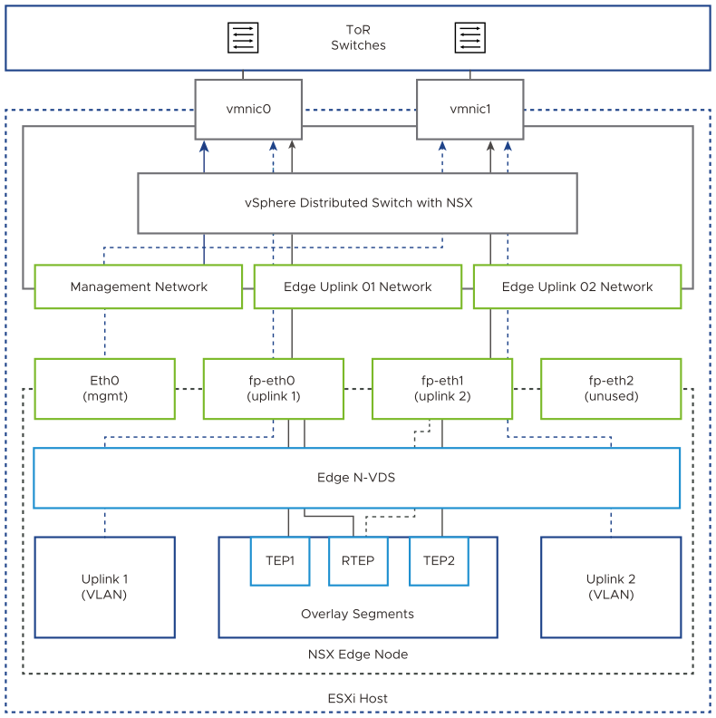

Uplink Policy Design for the NSX Edge Nodes for VMware Cloud Foundation
A transport node can participate in an overlay and VLAN network. Uplink profiles define policies for the links from the NSX Edge transport nodes to top of rack switches. Uplink profiles are containers for the properties or capabilities for the network adapters. Uplink profiles are applied to the N-VDS of the edge node.
Uplink profiles can use either load balance source or failover order teaming. If using load balance source, multiple uplinks can be active. If using failover order, only a single uplink can be active.
Teaming can be configured by using the default teaming policy or a user-defined named teaming policy. You can use named teaming policies to pin traffic segments to designated edge uplinks.

NSX Edge Node Requirements and Recommendations for VMware Cloud Foundation
Consider the network, N-VDS configuration and uplink policy requirements for using NSX Edge nodes in VMware Cloud Foundation, and the best practices for having NSX Edge nodes operate in an optimal way, such as number and size of the nodes, high availability, and N-VDS architecture, on a standard or stretched cluster.

NSX Edge Design Requirements
You must meet the following design requirements for standard and stretched clusters in your NSX Edge design for VMware Cloud Foundation.
Table 3-59. NSX Edge Design Requirements for VMware Cloud Foundation
Requirement ID | Design Requirement | Justification | Implication
VCF-NSX-EDGE-REQD-CFG-001 | Connect the management interface of each NSX Edge node to the VM management network. | Provides connection from the NSX Manager cluster to the NSX Edge. | None.
VCF-NSX-EDGE-REQD-CFG-002 | - Use two physical NICs as uplinks for the NSX Edge appliances, for example, vmnic0 and vmnic1.  - Connect the fp-eth0 interface of each NSX Edge appliance to a VLAN trunk port group pinned to the one physical NIC (vmnic0) of the host, with the ability to failover to another physical NIC (vmnic1).  - Connect the fp-eth1 interface of each NSX Edge appliance to a VLAN trunk port group pinned to a physical NIC of the host (vmnic1), with the ability to failover to first physical NIC (vmnic0).  - Leave the additional fp-eth2 and fp-eth3 interfaces of each NSX Edge appliance unused. | - Because VLAN trunk port groups pass traffic for all VLANs, VLAN tagging can occur in the NSX Edge node itself for easy post-deployment configuration.  - By using two separate VLAN trunk port groups, you can direct traffic from the edge node to a particular host network interface and top of rack switch as needed.  - In the event of failure of the top of rack switch, the VLAN trunk port group will failover to the other physical NIC and to ensure both fp-eth0 and fp-eth1 are available. | None.
VCF-NSX-EDGE-REQD-CFG-003 | Use a dedicated VLAN for edge overlay that is different from the host overlay VLAN. | A dedicated edge overlay network provides support for edge mobility in support of advanced deployments such as multiple availability zones or multi-rack clusters. | - You must have routing between the VLANs for edge overlay and host overlay.  - You must allocate another VLAN in the data center infrastructure for edge overlay.
VCF-NSX-EDGE-REQD-CFG-004 | Create one uplink profile for the edge nodes with three teaming policies.  - Default teaming policy of load balance source with both active uplinks uplink1 and uplink2.  - Named teaming policy of failover order with a single active uplink uplink1 without standby uplinks.  - Named teaming policy of failover order with a single active uplink uplink2 without standby uplinks. | - An NSX Edge node that uses a single N-VDS can have only one uplink profile.  - For increased resiliency and performance, supports the concurrent use of both edge uplinks through both physical NICs on the ESXi hosts.  - The default teaming policy increases overlay performance and availability by using multiple TEPs, and balancing of overlay traffic.  - By using named teaming policies, you can connect an edge uplink to a specific host uplink and from there to a specific top of rack switch in the data center.  - Enables ECMP because the NSX Edge nodes can uplink to the physical network over two different VLANs. | None.
Table 3-60. NSX Multi-Rack Edge Availability Design Requirements for VMware Cloud Foundation
Requirement ID | Design Requirement | Justification | Implication
VCF-NSX-MR-EDGE-REQD-ENV-001 | Place at least one edge VM per edge cluster onto each vSphere cluster, that is in a separate rack. | Provides availability if a failure of a rack or a vSphere cluster occurs. | Additional compute resources required.
VCF-NSX-MR-EDGE-REQD-CFG-001 | Connect the management interface of each NSX Edge node in each rack to the VM management network that rack. | Provides connection from the NSX Manager cluster to the NSX Edge. | None.
VCF-NSX-MR-EDGE-REQD-CFG-002 | Use a dedicated IP pool for the edge overlay network for each rack used for the deployment of a multi-rack NSX Edge cluster. | A dedicated edge overlay network and subnet per rack provides support for a Layer 3 leaf-and-spine physical network design with the Layer 2 boundary at the leaf nodes. | You must manage additional IP pools for each additional rack.
VCF-NSX-MR-EDGE-REQD-CFG-003 | Create an edge uplink profile for each rack. | Enables having a dedicated edge overlay VLAN per rack to provide support for a Layer 3 leaf-and-spine physical network design with the Layer 2 boundary at the leaf nodes. | None.
Table 3-61. NSX Edge Design Requirements for NSX Federation in VMware Cloud Foundation
Requirement ID | Design Requirement | Justification | Implication
VCF-NSX-EDGE-REQD-CFG-005 | Allocate a separate VLAN for edge RTEP overlay that is different from the edge overlay VLAN. | The RTEP network must be on a VLAN that is different from the edge overlay VLAN. This is an NSX requirement that provides support for configuring different MTU size per network. | You must allocate another VLAN in the data center infrastructure.

NSX Edge Design Recommendations
In your NSX Edge design for VMware Cloud Foundation, you can apply certain best practices for standard and stretched clusters.
Table 3-62. NSX Edge Design Recommendations for VMware Cloud Foundation
Recommendation ID | Design Recommendation | Justification | Implications
VCF-NSX-EDGE-RCMD-CFG-001 | Use appropriately sized NSX Edge virtual appliances. | Ensures resource availability and usage efficiency per workload domain. | You must provide sufficient compute resources to support the chosen appliance size.
VCF-NSX-EDGE-RCMD-CFG-002 | Deploy the NSX Edge virtual appliances to the default vSphere cluster of the workload domain, sharing the cluster between the workloads and the edge appliances. | Simplifies the configuration and minimizes the number of ESXi hosts required for initial deployment. | Workloads and NSX Edges share the same compute resources.
VCF-NSX-EDGE-RCMD-CFG-003 | Deploy two NSX Edge appliances in an edge cluster in the default vSphere cluster of the workload domain. | Creates the minimum size NSX Edge cluster while satisfying the requirements for availability. | For a VI workload domain, additional edge appliances might be required to satisfy increased bandwidth requirements.
VCF-NSX-EDGE-RCMD-CFG-004 | Apply VM-VM anti-affinity rules for vSphere DRS to the virtual machines of the NSX Edge cluster. | Keeps the NSX Edge nodes running on different ESXi hosts for high availability. | None.
VCF-NSX-EDGE-RCMD-CFG-005 | In vSphere HA, set the restart priority policy for each NSX Edge appliance to high. | - The NSX Edge nodes are part of the north-south data path for overlay segments. vSphere HA restarts the NSX Edge appliances first to minimise the time an edge VM is offline.  - Setting the restart priority to high reserves highest for future needs. | If the restart priority for another VM in the cluster is set to highest, the connectivity delays for edge appliances will be longer.
VCF-NSX-EDGE-RCMD-CFG-006 | Create an NSX Edge cluster with the default Bidirectional Forwarding Detection (BFD) configuration between the NSX Edge nodes in the cluster. | - Satisfies the availability requirements by default.  - Edge nodes must remain available to create services such as NAT, routing to physical networks, and load balancing. | None.
VCF-NSX-EDGE-RCMD-CFG-007 | Use a single N-VDS in the NSX Edge nodes. | - Simplifies deployment of the edge nodes.  - The same N-VDS switch design can be used regardless of edge form factor.  - Supports multiple TEP interfaces in the edge node.  - vSphere Distributed Switch is not supported in the edge node. | None.
Table 3-63. NSX Edge Design Recommendations for Stretched Clusters in VMware Cloud Foundation
Recommendation ID | Design Recommendation | Justification | Implications
VCF-NSX-EDGE-RCMD-CFG-008 | Add the NSX Edge appliances to the virtual machine group for the first availability zone. | Ensures that, by default, the NSX Edge appliances are powered on upon a host in the primary availability zone. | None.

Routing Design for VMware Cloud Foundation
NSX Edge clusters in VMware Cloud Foundation provide pools of capacity for service router functions in NSX.

Routing Options for VMware Cloud Foundation
VMware Cloud Foundation supports the following routing options:
Routing Type | Description | Benefits | Drawbacks
Static routing | - The network administrator manages the routing information, adding routing information to the routing table.  - If any change occurs in the network, the administrator has to update the related information in the routing table. | - No dynamic routing protocol is required on the ToR switches.  - Might reduce ToR switch license costs. | - You must manually create static routes in NSX Manager on the Tier-0 gateway.  - If required, you must manually create an HA VIP in the NSX Manager on the Tier-0 gateway to provide redundancy across ToR switches.  - Not supported with vSAN stretched clusters.
OSPF | - The routing protocol automatically adds and manages the routing information in the routing table. If any change occurs in the network, the routing protocol automatically updates the related information in the routing table. If any new segments or subnets are added in NSX, they are automatically added to the routing table. | - If the physical fabric is running OSPF routing protocol, using OSPF at the virtual layer might be a simpler approach for the network administrator. | - Needs additional manual configuration. See VMware Knowledge Base article 85916.  - Not supported with vSAN stretched clusters.  - Not supported with NSX Federation.  - Combined use of BGP and OSPF on a single Tier-0 gateway not supported.
BGP | - BGP is known as an exterior gateway protocol. It is designed to share routing information between disparate networks, known as autonomous systems (ASes).  - When multiple BGP-derived paths exist, the protocol chooses a path to send traffic based on certain criteria.  - The routing protocol automatically adds and manages the routing information in the routing table. If any new segments or subnets are added in NSX, they are automatically added to the routing table. | - Fully supported by the automated edge workflows in VMware Cloud Foundation.  - Fully supported for all VMware Cloud Foundation topologies. | - None.
BGP routing is the routing option recommended for VMware Cloud Foundation.

BGP Routing Design for VMware Cloud Foundation
Determine the number, networking, and high-availability configuration of the Tier-0 and Tier-1 gateways in NSX for VMware Cloud Foundation workload domains. Identify the BGP configuration for a single availability zone and two availability zones in the environment.
Table 3-64. Routing Direction Definitions
Routing Direction | Description
North-south | Traffic leaving or entering the NSX domain, for example, a virtual machine on an overlay network communicating with an end-user device on the corporate network.
East-west | Traffic that remains in the NSX domain, for example, two virtual machines on the same or different segments communicating with each other.

North-South Routing
The routing design considers different levels of routing in the environment, such as number and type of gateways in NSX, dynamic routing protocol, and others.
The following models for north-south traffic exist:
Table 3-65. Considerations for the Operating Model for North-South Service Routers
North-South Service Router Operating Model | Description | Benefits | Drawbacks
Active-Active | - Bandwidth independent of the Tier-0 gateway failover model.  - Configured in active-active equal-cost multi-path (ECMP) mode.  - Failover takes approximately 2 seconds for virtual edges and is sub-second for bare-metal edges. | - Active-active mode can support up to 8 NSX Edge nodes per northbound service router (SR).  - Availability can be as high as N+7, with up to 8 active-active NSX Edge nodes.  - Supports ECMP north-south routing on all nodes in the NSX Edge cluster. | - Cannot provide some stateful services, such as SNAT or DNAT.
Active-Standby | - Bandwidth independent of the Tier-0 gateway failover model.  - Failover takes approximately 2 seconds for virtual edges and is sub-second for bare-metal edges. | - Can provide stateful services such as NAT. | - Active-standby mode is limited to a single node.  - Availability is limited to N+1.

BGP North-South Routing for a Single or Multiple Availability Zones
For multiple availability zones, plan for failover of the NSX Edge nodes by configuring BGP so that traffic from the top of rack switches is directed to the first availability zone unless a failure in this zone occurs.
Figure 3-18. BGP North-South Routing for VMware Cloud Foundation Instances with a Single Availability Zone
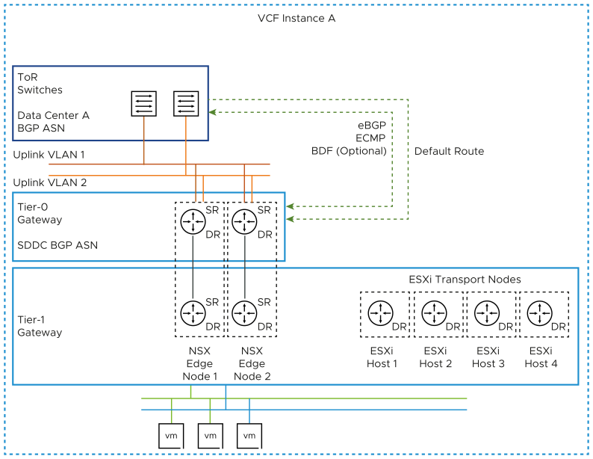
Figure 3-19. BGP North-South Routing for VMware Cloud Foundation Instances with Multiple Availability Zones
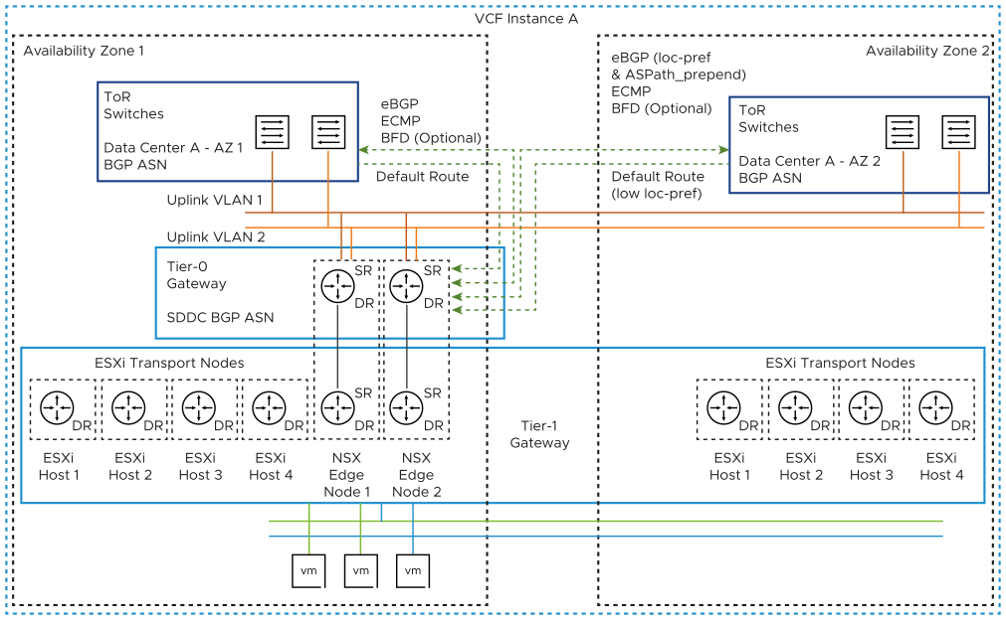

BGP North-South Routing Design for NSX Federation
In a routing design for an environment with VMware Cloud Foundation instances that use NSX Federation, you identify the instances that an SDN network must span and at which physical location ingress and egress traffic should occur.
Local egress allows traffic to leave any location which the network spans. The use of local-egress would require controlling local-ingress to prevent asymmetrical routing. This design does not use local-egress. Instead, this design uses a preferred and failover VMware Cloud Foundation instances for all networks.
Figure 3-20. BGP North-South Routing for VMware Cloud Foundation Instances with NSX Federation
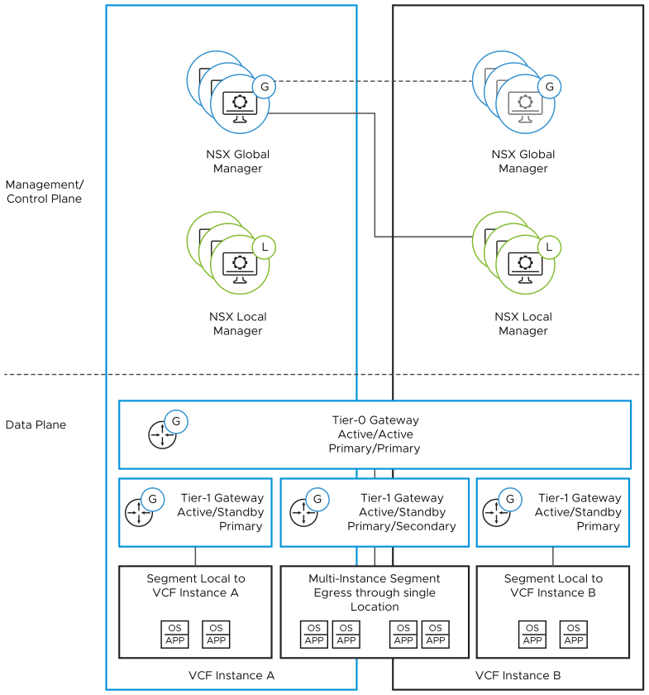

Tier-0 Gateways with NSX Federation
In NSX Federation, a Tier-0 gateway can span multiple VMware Cloud Foundation instances.
Each VMware Cloud Foundation instance that is in the scope of a Tier-0 gateway can be configured as primary or secondary. A primary instance passes traffic for any other SDN service such as Tier-0 logical segments or Tier-1 gateways. A secondary instance routes traffic locally but does not egress traffic outside the SDN or advertise networks in the data center.
When deploying an additional VMware Cloud Foundation instance, the Tier-0 gateway in the first instance is extended to the new instance.
In this design, the Tier-0 gateway in each VMware Cloud Foundation instance is configured as primary. Although the Tier-0 gateway technically supports local-egress, the design does not recommend the use of local-egress. Ingress and egress traffic is controlled at the Tier-1 gateway level.
Each VMware Cloud Foundation instance has its own NSX Edge cluster with associated uplink VLANs for north-south traffic flow for that instance. The Tier-0 gateway in each instance peers with the top of rack switches over eBGP.
Figure 3-21. BGP Peering to Top of Rack Switches for VMware Cloud Foundation Instances with NSX Federation
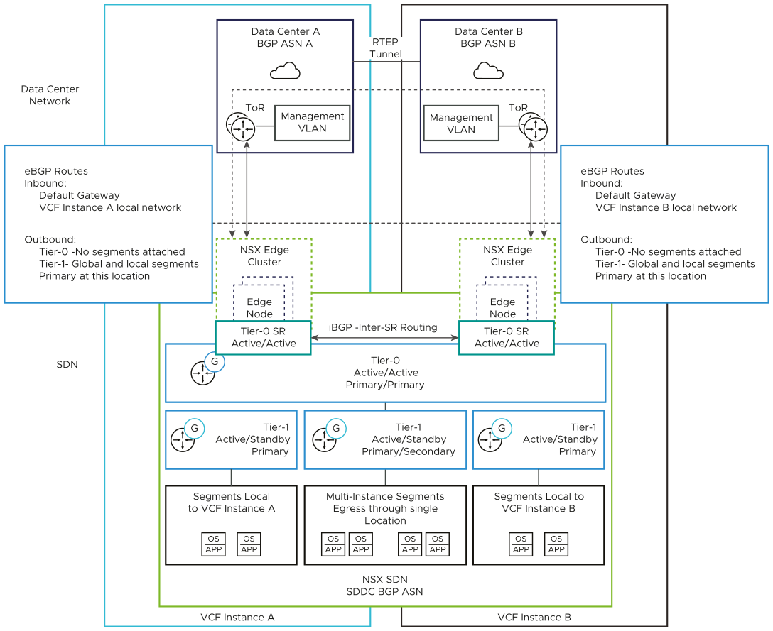

Tier-1 Gateways with NSX Federation
A Tier-1 gateway can span several VMware Cloud Foundation instances. As with a Tier-0 gateway, you can configure an instance's location as primary or secondary for the Tier-1 gateway. The gateway then passes ingress and egress traffic for the logical segments connected to it.
Any logical segments connected to the Tier-1 gateway follow the span of the Tier-1 gateway. If the Tier-1 gateway spans several VMware Cloud Foundation instances, any segments connected to that gateway become available in both instances.
Using a Tier-1 gateway enables more granular control on logical segments in the first and second VVMware Cloud Foundation instances. You use three Tier-1 gateways - one in each VMware Cloud Foundation instance for segments that are local to the instance, and one for segments which span the two instances.
Table 3-66. Location Configuration of the Tier-1 Gateways for Multiple VMware Cloud Foundation Instances
Tier-1 Gateway | First VMware Cloud Foundation Instance | Second VMware Cloud Foundation Instance | Ingress and Egress Traffic
Connected to both VMware Cloud Foundation instances | Primary | Secondary | First VMware Cloud Foundation instance  Second VMware Cloud Foundation instance
Local to the firstVMware Cloud Foundation instance | Primary | - | First VMware Cloud Foundation instance only
Local to the second VMware Cloud Foundation instance | - | Primary | Second VMware Cloud Foundation instance only
The Tier-1 gateway advertises its networks to the connected local-instance unit of the Tier-0 gateway. In the case of primary-secondary location configuration, the Tier-1 gateway advertises its networks only to the Tier-0 gateway unit in the location where the Tier-1 gateway is primary. The Tier-0 gateway unit then re-advertises those networks to the data center in the sites where that Tier-1 gateway is primary. During failover of the components in the first VMware Cloud Foundation instance, an administrator must manually set the Tier-1 gateway in the second VMware Cloud Foundation instance as primary. Then, networks become advertised through the Tier-1 gateway unit in the second instance.
In a Multiple Instance-Multiple Availability Zone topology, the same Tier-0 and Tier-1 gateway architecture applies. The ESXi transport nodes from the second availability zone are also attached to the Tier-1 gateway as per the Figure 3-19. BGP North-South Routing for VMware Cloud Foundation Instances with Multiple Availability Zones design.

BGP Routing Design Requirements and Recommendations for VMware Cloud Foundation
Consider the requirements for the configuration of Tier-0 and Tier-1 gateways for implementing BGP routing in VMware Cloud Foundation, and the best practices for having optimal traffic routing on a standard or stretched cluster in a environment with a single or multiple VMware Cloud Foundation instances.

BGP Routing
The BGP routing design has the following characteristics:
- Enables dynamic routing by using NSX.
- Offers increased scale and flexibility.
- Is a proven protocol that is designed for peering between networks under independent administrative control - data center networks and the NSX SDN.
Note These design recommendations do not include BFD. However, if faster convergence than BGP timers is required, you must enable BFD on the physical network and also on the NSX Tier-0 gateway.

BGP Routing Design Requirements
You must meet the following design requirements for standard and stretched clusters in your routing design for a single VMware Cloud Foundation instance. For NSX Federation, additional requirements exist.
Table 3-67. BGP Routing Design Requirements for VMware Cloud Foundation
Requirement ID | Design Requirement | Justification | Implication
VCF-NSX-BGP-REQD-CFG-001 | To enable ECMP between the Tier-0 gateway and the Layer 3 devices (ToR switches or upstream devices), create two VLANs.  The ToR switches or upstream Layer 3 devices have an SVI on one of the two VLANS, and each Edge node in the cluster has an interface on each VLAN. | Supports multiple equal-cost routes on the Tier-0 gateway and provides more resiliency and better bandwidth use in the network. | Additional VLANs are required.
VCF-NSX-BGP-REQD-CFG-002 | Assign a named teaming policy to the VLAN segments to the Layer 3 device pair. | Pins the VLAN traffic on each segment to its target edge node interface. From there, the traffic is directed to the host physical NIC that is connected to the target top of rack switch. | None.
VCF-NSX-BGP-REQD-CFG-003 | Create a VLAN transport zone for edge uplink traffic. | Enables the configuration of VLAN segments on the N-VDS in the edge nodes. | Additional VLAN transport zones might be required if the edge nodes are not connected to the same top of rack switch pair.
VCF-NSX-BGP-REQD-CFG-004 | Deploy a Tier-1 gateway and connect it to the Tier-0 gateway. | Creates a two-tier routing architecture.  Abstracts the NSX logical components which interact with the physical data center from the logical components which provide SDN services. | A Tier-1 gateway can only be connected to a single Tier-0 gateway.  In cases where multiple Tier-0 gateways are required, you must create multiple Tier-1 gateways.
VCF-NSX-BGP-REQD-CFG-005 | Deploy a Tier-1 gateway to the NSX Edge cluster. | Enables stateful services, such as load balancers and NAT, for SDDC management components.  Because a Tier-1 gateway always works in active-standby mode, the gateway supports stateful services. | None.
Table 3-68. BGP Routing Design Requirements for Stretched Clusters in VMware Cloud Foundation
Requirement ID | Design Requirement | Justification | Implication
VCF-NSX-BGP-REQD-CFG-006 | Extend the uplink VLANs to the top of rack switches so that the VLANs are stretched between both availability zones. | Because the NSX Edge nodes will fail over between the availability zones, ensures uplink connectivity to the top of rack switches in both availability zones regardless of the zone the NSX Edge nodes are presently in. | You must configure a stretched Layer 2 network between the availability zones by using physical network infrastructure.
VCF-NSX-BGP-REQD-CFG-007 | Provide this SVI configuration on the top of the rack switches.  - In the second availability zone, configure the top of rack switches or upstream Layer 3 devices with an SVI on each of the two uplink VLANs.  - Make the top of rack switch SVI in both availability zones part of a common stretched Layer 2 network between the availability zones. | Enables the communication of the NSX Edge nodes to the top of rack switches in both availability zones over the same uplink VLANs. | You must configure a stretched Layer 2 network between the availability zones by using the physical network infrastructure.
VCF-NSX-BGP-REQD-CFG-008 | Provide this VLAN configuration:  - Use two VLANs to enable ECMP between the Tier-0 gateway and the Layer 3 devices (top of rack switches or Leaf switches).  - The ToR switches or upstream Layer 3 devices have an SVI to one of the two VLANS and each NSX Edge node has an interface to each VLAN. | Supports multiple equal-cost routes on the Tier-0 gateway, and provides more resiliency and better bandwidth use in the network. | - Extra VLANs are required.  - Requires stretching uplink VLANs between availability zones
VCF-NSX-BGP-REQD-CFG-009 | Create an IP prefix list that permits access to route advertisement by any network instead of using the default IP prefix list. | Used in a route map to prepend a path to one or more autonomous system (AS-path prepend) for BGP neighbors in the second availability zone. | You must manually create an IP prefix list that is identical to the default one.
VCF-NSX-BGP-REQD-CFG-010 | Create a route map-out that contains the custom IP prefix list and an AS-path prepend value set to the Tier-0 local AS added twice. | - Used for configuring neighbor relationships with the Layer 3 devices in the second availability zone.  - Ensures that all ingress traffic passes through the first availability zone. | You must manually create the route map.  The two NSX Edge nodes will route north-south traffic through the second availability zone only if the connection to their BGP neighbors in the first availability zone is lost, for example, if a failure of the top of the rack switch pair or in the availability zone occurs.
VCF-NSX-BGP-REQD-CFG-011 | Create an IP prefix list that permits access to route advertisement by network 0.0.0.0/0 instead of using the default IP prefix list. | Used in a route map to configure local-reference on learned default-route for BGP neighbors in the second availability zone. | You must manually create an IP prefix list that is identical to the default one.
VCF-NSX-BGP-REQD-CFG-012 | Apply a route map-in that contains the IP prefix list for the default route 0.0.0.0/0 and assign a lower local-preference , for example, 80, to the learned default route and a lower local-preference, for example, 90 any routes learned. | - Used for configuring neighbor relationships with the Layer 3 devices in the second availability zone.  - Ensures that all egress traffic passes through the first availability zone. | You must manually create the route map.  The two NSX Edge nodes will route north-south traffic through the second availability zone only if the connection to their BGP neighbors in the first availability zone is lost, for example, if a failure of the top of the rack switch pair or in the availability zone occurs.
VCF-NSX-BGP-REQD-CFG-013 | Configure the neighbors of the second availability zone to use the route maps as In and Out filters respectively. | Makes the path in and out of the second availability zone less preferred because the AS path is longer and the local preference is lower. As a result, all traffic passes through the first zone. | The two NSX Edge nodes will route north-south traffic through the second availability zone only if the connection to their BGP neighbors in the first availability zone is lost, for example, if a failure of the top of the rack switch pair or in the availability zone occurs.
Table 3-69. BGP Routing Design Requirements for NSX Federation in VMware Cloud Foundation
Requirement ID | Design Requirement | Justification | Implication
VCF-NSX-BGP-REQD-CFG-014 | Extend the Tier-0 gateway to the second VMware Cloud Foundation instance. | - Supports ECMP north-south routing on all nodes in the NSX Edge cluster.  - Enables support for cross-instance Tier-1 gateways and cross-instance network segments. | The Tier-0 gateway deployed in the second instance is removed.
VCF-NSX-BGP-REQD-CFG-015 | Set the Tier-0 gateway as primary for all VMware Cloud Foundation instances. | - In NSX Federation, a Tier-0 gateway lets egress traffic from connected Tier-1 gateways only in its primary locations.  - Local ingress and egress traffic is controlled independently at the Tier-1 level. No segments are provisioned directly to the Tier-0 gateway.  - A mixture of network spans (local to a VMware Cloud Foundation instance or spanning multiple instances) is enabled without requiring additional Tier-0 gateways and hence edge nodes.  - If a failure in a VMware Cloud Foundation instance occurs, the local-instance networking in the other instance remains available without manual intervention. | None.
VCF-NSX-BGP-REQD-CFG-016 | From the global Tier-0 gateway, establish BGP neighbor peering to the ToR switches connected to the second VMware Cloud Foundation instance. | - Enables the learning and advertising of routes in the second VMware Cloud Foundation instance.  - Facilitates a potential automated failover of networks from the first to the second VMware Cloud Foundation instance. | None.
VCF-NSX-BGP-REQD-CFG-017 | Use a stretched Tier-1 gateway and connect it to the Tier-0 gateway for cross-instance networking. | - Enables network span between the VMware Cloud Foundation instances because NSX network segments follow the span of the gateway they are attached to.  - Creates a two-tier routing architecture. | None.
VCF-NSX-BGP-REQD-CFG-018 | Assign the NSX Edge cluster in each VMware Cloud Foundation instance to the stretched Tier-1 gateway. Set the first VMware Cloud Foundation instance as primary and the second instance as secondary. | - Enables cross-instance network span between the first and second VMware Cloud Foundation instances.  - Enables deterministic ingress and egress traffic for the cross-instance network.  - If a VMware Cloud Foundation instance failure occurs, enables deterministic failover of the Tier-1 traffic flow.  - During the recovery of the inaccessible VMware Cloud Foundation instance, enables deterministic failback of the Tier-1 traffic flow, preventing unintended asymmetrical routing.  - Eliminates the need to use BGP attributes in the first and second VMware Cloud Foundation instances to influence location preference and failover. | You must manually fail over and fail back the cross-instance network from the standby NSX Global Manager.
VCF-NSX-BGP-REQD-CFG-019 | Assign the NSX Edge cluster in each VMware Cloud Foundation instance to the local Tier-1 gateway for that VMware Cloud Foundation instance. | - Enables instance-specific networks to be isolated to their specific instances.  - Enables deterministic flow of ingress and egress traffic for the instance-specific networks. | You can use the service router that is created for the Tier-1 gateway for networking services. However, such configuration is not required for network connectivity.
VCF-NSX-BGP-REQD-CFG-020 | Set each local Tier-1 gateway only as primary in that instance. Avoid setting the gateway as secondary in the other instances. | Prevents the need to use BGP attributes in primary and secondary instances to influence the instance ingress-egress preference. | None.
Table 3-70. BGP Routing Design Requirements for NSX Multi-Rack Edge Availability for VMware Cloud Foundation
Requirement ID | Design Requirement | Justification | Implication
VCF-NSX-MRE-BGP-REQD-CFG-001 | To enable ECMP between the Tier-0 gateway and the Layer 3 devices, such as leaf switches or upstream devices, create two separate uplink VLANs for the edge nodes in each rack.  The leaf switches or Layer 3 upstream devices have an SVI on one of the two VLANS for each rack, and each edge node in the rack has an interface on each VLAN. | Supports multiple equal-cost routes on the Tier-0 gateway and improves resiliency and bandwidth use in the network across multiple racks with a pair of leaf switches in each rack. | Additional VLANs are required.
VCF-NSX-MRE-BGP-REQD-CFG-002 | Assign a named teaming policy to the VLAN segments to the Layer 3 device pair for each rack. | Pins the VLAN traffic on each segment to its target edge node interface. From there, the traffic is directed to the host physical NIC that is connected to the target leaf switch in the rack. | None.

BGP Routing Design Recommendations
In your routing design for a single VMware Cloud Foundation instance, you can apply certain best practices for standard and stretched clusters. For NSX Federation, additional recommendations are available.
Table 3-71. BGP Routing Design Recommendations for VMware Cloud Foundation
Recommendation ID | Design Recommendation | Recommendation Justification | Recommendation Implication
VCF-NSX-BGP-RCMD-CFG-001 | Deploy an active-active Tier-0 gateway. | Supports ECMP north-south routing on all Edge nodes in the NSX Edge cluster. | Active-active Tier-0 gateways cannot provide stateful services such as NAT.
VCF-NSX-BGP-RCMD-CFG-002 | Configure the BGP Keep Alive Timer to 4 and Hold Down Timer to 12 or lower between the top of tack switches and the Tier-0 gateway. | Provides a balance between failure detection between the top of rack switches and the Tier-0 gateway, and overburdening the top of rack switches with keep-alive traffic. | By using longer timers to detect if a router is not responding, the data about such a router remains in the routing table longer. As a result, the active router continues to send traffic to a router that is down.  These timers must be aligned with the data center fabric design of your organization.
VCF-NSX-BGP-RCMD-CFG-003 | Do not enable Graceful Restart between BGP neighbors. | Avoids loss of traffic.  On the Tier-0 gateway, BGP peers from all the gateways are always active. On a failover, the Graceful Restart capability increases the time a remote neighbor takes to select an alternate Tier-0 gateway. As a result, BFD-based convergence is delayed. | None.
VCF-NSX-BGP-RCMD-CFG-004 | Enable helper mode for Graceful Restart mode between BGP neighbors. | Avoids loss of traffic.  During a router restart, helper mode works with the graceful restart capability of upstream routers to maintain the forwarding table which in turn will forward packets to a down neighbor even after the BGP timers have expired causing loss of traffic. | None.
VCF-NSX-BGP-RCMD-CFG-005 | Enable Inter-SR iBGP routing. | In the event that an edge node has all of its northbound eBGP sessions down, north-south traffic will continue to flow by routing traffic to a different edge node. | None.
VCF-NSX-BGP-RCMD-CFG-006 | Deploy a Tier-1 gateway in non-preemptive failover mode. | Ensures that after a failed NSX Edge transport node is back online, it does not take over the gateway services thus preventing a short service outage. | None.
VCF-NSX-BGP-RCMD-CFG-007 | Enable standby relocation of the Tier-1 gateway. | Ensures that if an edge failure occurs, a standby Tier-1 gateway is created on another edge node. | None.
Table 3-72. BGP Routing Design Recommendations for NSX Federation in VMware Cloud Foundation
Recommendation ID | Design Recommendation | Justification | Implication
VCF-NSX-BGP-RCMD-CFG-008 | Use Tier-1 gateways to control the span of networks and ingress and egress traffic in the VMware Cloud Foundation instances. | Enables a mixture of network spans (isolated to a VMware Cloud Foundation instance or spanning multiple instances) without requiring additional Tier-0 gateways and hence edge nodes. | To control location span, a Tier-1 gateway must be assigned to an edge cluster and hence has the Tier-1 SR component. East-west traffic between Tier-1 gateways with SRs need to physically traverse an edge node.
VCF-NSX-BGP-RCMD-CFG-009 | Allocate a Tier-1 gateway in each instance for instance-specific networks and connect it to the stretched Tier-0 gateway. | - Creates a two-tier routing architecture.  - Enables local-instance networks that are not to span between the VMware Cloud Foundation instances.  - Guarantees that local-instance networks remain available if a failure occurs in another VMware Cloud Foundation instance. | None.

Overlay Design for VMware Cloud Foundation
As part of the overlay design, you determine the NSX configuration for handling traffic between workloads, management or customer, in VMware Cloud Foundation. You determine the NSX segments and the transport zones.

Logical Overlay Design for VMware Cloud Foundation
This logical design provides the network virtualization design of the logical components that handle the data to and from the workloads in the environment. For an environment with multiple VMware Cloud Foundation instances, you replicate the design of the first VMware Cloud Foundation instance to the additional VMware Cloud Foundation instances.

ESXi Host Transport Nodes
A transport node in NSX is a node that is capable of participating in an NSX data plane. The workload domains contain multiple ESXi hosts in a vSphere cluster to support management or customer workloads. You register these ESXi hosts as transport nodes so that networks and workloads on that host can use the capabilities of NSX. During the preparation process, the native vSphere Distributed Switch for the workload domain is extended with NSX capabilities.

Virtual Segments
Geneve provides the overlay capability to create isolated, multi-tenant broadcast domains in NSX across data center fabrics, and enables customers to create elastic, logical networks that span physical network boundaries, and physical locations.

Transport Zones
A transport zone identifies the type of traffic, VLAN or overlay, and the vSphere Distributed Switch name. You can configure one or more VLAN transport zones and a single overlay transport zone per virtual switch. A transport zone does not represent a security boundary. VMware Cloud Foundation supports a single overlay transport zone per NSX Instance. All vSphere clusters, within and across workload domains that share the same NSX instance subsequently share the same overlay transport zone.
Figure 3-22. Transport Zone Design
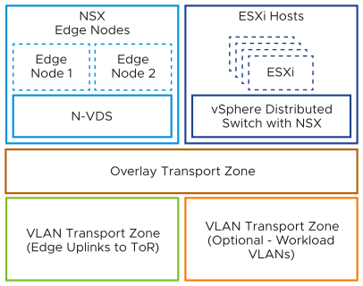

Host Transport Node Profiles
A transport node profile (TNP) is a template to define networking configuration that is applied to a host cluster. It contains an uplink profile, transport zones, and an IP assignment method together with vSphere Distributed Switch-to-NSX uplink mappings. After you create a TNP, you attach it to a cluster. As a result, the NSX configurations defined in the profile are applied to the nodes in the cluster.

Uplink Policy for ESXi Host Transport Nodes
Uplink profiles define policies for the links from ESXi hosts to NSX segments or from NSX Edge appliances to top of rack switches. By using uplink profiles, you can apply consistent configuration of capabilities for network adapters across multiple ESXi hosts or NSX Edge nodes.
Uplink profiles can use either load balance source or failover order teaming. If using load balance source, multiple uplinks can be active. If using failover order, only a single uplink can be active.

Sub-Transport Node Profiles
A sub-transport node profile (TNP) is a template to define networking for a subset of hosts in a cluster, also known as sub-cluster. This construct is useful for stretched clusters or multi-rack clusters with Layer 3 networking so that the nodes in each availability zone or each rack in a multi-rack configuration can have different network configuration for host TEP VLANs and subnets.

Replication Mode of Segments
The control plane decouples NSX from the physical network. The control plane handles the broadcast, unknown unicast, and multicast (BUM) traffic in the virtual segments.
The following options are available for BUM replication on segments.
Table 3-73. BUM Replication Modes of NSX Segments
BUM Replication Mode | Description
Hierarchical Two-Tier | The ESXi host transport nodes are grouped according to their TEP IP subnet. One ESXi host in each subnet is responsible for replication to an ESXi host in another subnet. The receiving ESXi host replicates the traffic to the ESXi hosts in its local subnet.  The source ESXi host transport node knows about the groups based on information it has received from the control plane. The system can select an arbitrary ESXi host transport node as the mediator for the source subnet if the remote mediator ESXi host node is available.
Head-End | The ESXi host transport node at the origin of the frame to be flooded on a segment sends a copy to every other ESXi host transport node that is connected to this segment.

Overlay Design Requirements and Recommendations for VMware Cloud Foundation
Consider the requirements for the configuration of the ESXi hosts in a workload domain as NSX transport nodes, transport zone layout, uplink teaming policies, and the best practices for IP allocation and BUM replication mode in a VMware Cloud Foundation deployment.

Overlay Design Requirements
You must meet the following design requirements in your overlay design.
Table 3-74. Overlay Design Requirements for VMware Cloud Foundation
Requirement ID | Design Requirement | Justification | Implication
VCF-NSX-OVERLAY-REQD-CFG-001 | Configure all ESXi hosts in the workload domain as transport nodes in NSX. | Enables distributed routing, logical segments, and distributed firewall. | None.
VCF-NSX-OVERLAY-REQD-CFG-002 | Configure each ESXi host as a transport node using transport node profiles. | - Enables the participation of ESXi hosts and the virtual machines running on them in NSX overlay and VLAN networks.  - Transport node profiles can only be applied at the cluster level. | None.
VCF-NSX-OVERLAY-REQD-CFG-003 | To provide virtualized network capabilities to workloads, use overlay networks with NSX Edge nodes and distributed routing. | - Creates isolated, multi-tenant broadcast domains across data center fabrics to deploy elastic, logical networks that span physical network boundaries.  - Enables advanced deployment topologies by introducing Layer 2 abstraction from the data center networks. | Requires configuring transport networks with an MTU size of at least 1,600 bytes.
VCF-NSX-OVERLAY-REQD-CFG-004 | Create a single overlay transport zone in the NSX instance for all overlay traffic across the host and NSX Edge transport nodes of the workload domain or multiple workload domains using a shared NSX instance. | - Ensures that overlay segments are connected to an NSX Edge node for services and north-south routing.  - Ensures that all segments are available to all ESXi hosts and NSX Edge nodes configured as transport nodes. | All clusters in all workload domains that share the same NSX Manager share the same overlay transport zone.
VCF-NSX-OVERLAY-REQD-CFG-005 | Create an uplink profile with a load balance source teaming policy with two active uplinks for ESXi hosts. | For increased resiliency and performance, supports the concurrent use of both physical NICs on the ESXi hosts that are configured as transport nodes. | None.
Table 3-75. Overlay Design Requirements for a Multi-Rack Compute VI Workload Domain Cluster for VMware Cloud Foundation
Requirement ID | Design Requirement | Justification | Implication
VCF-NSX-L3MR-OVERLAY-REQD-CFG-001 | Create an uplink profile for each rack with a separate host TEP transport VLAN ID per rack. | Enables a Layer 3 boundary at the top-of-rack switches for host TEP traffic. | Requires additional host TEP VLAN ID per rack.
VCF-NSX-L3MR-OVERLAY-REQD-CFG-002 | Create a host TEP IP pool for each rack with a subnet allocated per rack and a gateway for the subnet. | - Provides the host TEP IP addressing for each rack  - Enables a Layer 3 boundary at the top-of-rack switches for host TEP traffic.  - Provides routing capabilities for the host TEPs between racks. | Requires additional subnet per rack.
VCF-NSX-L3MR-OVERLAY-REQD-CFG-003 | Create NSX host sub transport node profiles for additional racks. | - Enables NSX host transport node configuration per rack. | None

Overlay Design Recommendations
In your overlay design for VMware Cloud Foundation, you can apply certain best practices.
Table 3-76. Overlay Design Recommendations for VMware Cloud Foundation
Recommendation ID | Design Recommendation | Justification | Implication
VCF-NSX-OVERLAY-RCMD-CFG-001 | Use static IP pools to assign IP addresses to the host TEP interfaces. | - Removes the need for an external DHCP server for the host overlay VLANs.  - You can use NSX Manager to verify static IP pool configurations. | None.
VCF-NSX-OVERLAY-RCMD-CFG-002 | Use hierarchical two-tier replication on all overlay segments. | Hierarchical two-tier replication is more efficient because it reduced the number of ESXi hosts the source ESXi host must replicate traffic to if hosts have different TEP subnets. This is typically the case with more than one cluster and will improve performance in that scenario. | None.
Table 3-77. Overlay Design Recommendations for Stretched Clusters inVMware Cloud Foundation
Recommendation ID | Design Recommendation | Justification | Implication
VCF-NSX-OVERLAY-RCMD-CFG-003 | Configure an NSX sub-transport node profile. | - You can use static IP pools for the host TEPs in each availability zone.  - The NSX transport node profile can remain attached when using two separate VLANs for host TEPs at each availability zone as required for clusters that are based on vSphere Lifecycle Manager images.  - Using an external DHCP server for the host overlay VLANs in both availability zones is not required. | Changes to the host transport node configuration are done at the vSphere cluster level.

Application Virtual Network Design for VMware Cloud Foundation
In VMware Cloud Foundation, you place VMware Aria Suite components on a pre-defined configuration of NSX segments (known as application virtual networks or AVNs) for dynamic routing and load balancing.

Logical Application Virtual Network Design VMware Cloud Foundation
NSX segments provide flexibility for workload placement by removing the dependence on traditional physical data center networks. This approach also improves security and mobility of the management applications, and reduces the integration effort with existing customer network.
Table 3-78. Comparing Application Virtual Network Types
Design Component | Overlay-Based NSX Segments | VLAN-Backed NSX Segments
Benefits | - Supports IP mobility with dynamic routing.  - Limits the number of VLANs needed in the data center fabric.  - In an environment with multiple availability zones, limits the number of VLANs needed to expand from an architecture with one availability zone to an architecture with two availability zones. | Uses the data center fabric for the network segment and the next-hop gateway.
Requirement | Requires routing between the data center fabric and the NSX Edge nodes.
Figure 3-23. Application Virtual Networks in VMware Cloud Foundation
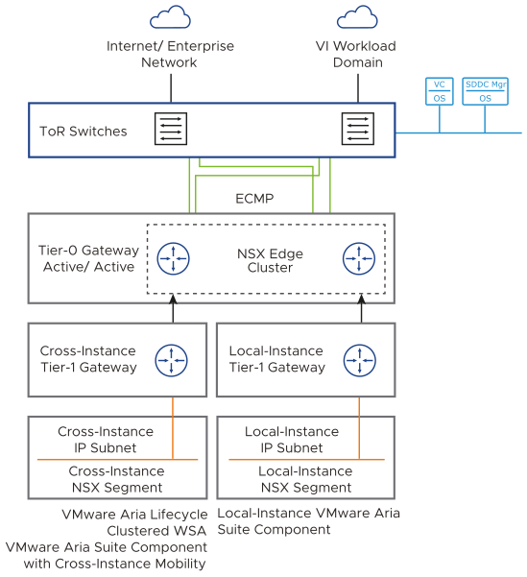
For the design for specific VMware Aria Suite components, see this design and VMware Validated Solutions. For identity and access management design for NSX, see Identity and Access Management for VMware Cloud Foundation.
Important If you plan to use NSX Federation in the management domain, create the AVNs before you enable federation. Creating AVNs in an environment where NSX Federation is already active is not supported.
With NSX Federation, an NSX segment can span multiple instances of NSX and VMware Cloud Foundation. A single network segment can be available in different physical locations over the NSX SDN. In an environment with multiple VMware Cloud Foundation instances, the cross-instance NSX network in the management domain is extended between the first two instances. This configuration provides IP mobility for management components which fail over from the first to the second instance.

Application Virtual Network Design Requirements and Recommendations forVMware Cloud Foundation
Consider the requirements and best practices for the configuration of the NSX segments for using the Application Virtual Networks in VMware Cloud Foundation for a single VMware Cloud Foundation or multiple VMware Cloud Foundation instances.

Application Virtual Network Design Requirements
You must meet the following design requirements in your Application Virtual Network design for a single VMware Cloud Foundation instance and for multiple VMware Cloud Foundation instances.
Table 3-79. Application Virtual Network Design Requirements for VMware Cloud Foundation
Requirement ID | Design Requirement | Justification | Implication
VCF-NSX-AVN-REQD-CFG-001 | Create one cross-instance NSX segment for the components of a VMware Aria Suite application or another solution that requires mobility between VMware Cloud Foundation instances. | Prepares the environment for the deployment of solutions on top of VMware Cloud Foundation, such as VMware Aria Suite, without a complex physical network configuration.  The components of the VMware Aria Suite application must be easily portable between VMware Cloud Foundation instances without requiring reconfiguration. | Each NSX segment requires a unique IP address space.
VCF-NSX-AVN-REQD-CFG-002 | Create one or more local-instance NSX segments for the components of a VMware Aria Suite application or another solution that are assigned to a specific VMware Cloud Foundation instance. | Prepares the environment for the deployment of solutions on top of VMware Cloud Foundation, such as VMware Aria Suite, without a complex physical network configuration. | Each NSX segment requires a unique IP address space.
Table 3-80. Application Virtual Network Design Requirements for NSX Federation in VMware Cloud Foundation
Requirement ID | Design Requirement | Justification | Implication
VCF-NSX-AVN-REQD-CFG-003 | Extend the cross-instance NSX segment to the second VMware Cloud Foundation instance. | Enables workload mobility without a complex physical network configuration.  The components of a VMware Aria Suite application must be easily portable between VMware Cloud Foundation instances without requiring reconfiguration. | Each NSX segment requires a unique IP address space.
VCF-NSX-AVN-REQD-CFG-004 | In each VMware Cloud Foundation instance, create additional local-instance NSX segments. | Enables workload mobility within a VMware Cloud Foundation instance without complex physical network configuration.  Each VMware Cloud Foundation instance should have network segments to support workloads which are isolated to that VMware Cloud Foundation instance. | Each NSX segment requires a unique IP address space.
VCF-NSX-AVN-REQD-CFG-005 | In each VMware Cloud Foundation instance, connect or migrate the local-instance NSX segments to the corresponding local-instance Tier-1 gateway. | Configures local-instance NSX segments at required sites only. | Requires an individual Tier-1 gateway for local-instance segments.

Application Virtual Network Design Recommendations
In your Application Virual Network design for VMware Cloud Foundation, you can apply certain best practices.
Table 3-81. Application Virtual Network Design Recommendations for VMware Cloud Foundation
Recommendation ID | Design Recommendation | Justification | Implication
VCF-NSX-AVN-RCMD-CFG-001 | Use overlay-backed NSX segments. | - Supports expansion to deployment topologies for multiple VMware Cloud Foundation instances.  - Limits the number of VLANs required for the data center fabric. | Using overlay-backed NSX segments requires routing, eBGP recommended, between the data center fabric and edge nodes.

Load Balancing Design for VMware Cloud Foundation
Following the principles of this design and of each product, you deploy and configure NSX load balancing services to support VMware Aria Suite and Workspace ONE Access components.

Logical Load Balancing Design for VMware Cloud Foundation
The logical load balancer capability in NSX offers a high-availability service for applications in VMware Cloud Foundation and distributes the network traffic load among multiple servers.
A standalone Tier-1 gateway is created to provide load balancing services with a service interface on the cross-instance application virtual network.
Figure 3-24. NSX Logical Load Balancing Design for VMware Cloud Foundation
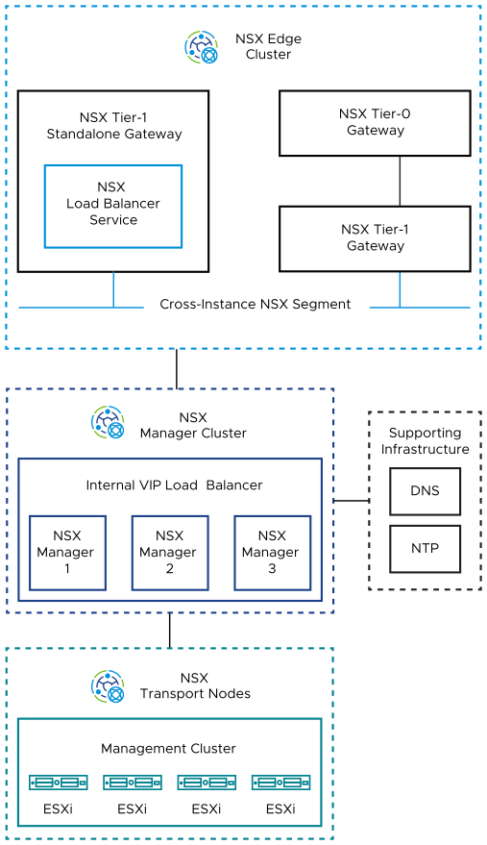

Load Balancing Design Requirements for VMware Cloud Foundation
Consider the requirements for running a load balancing service including creating a standalone Tier-1 gateway and connecting it to the client applications. Separate requirements exist for a single VMware Cloud Foundation instance and for multiple VMware Cloud Foundation instances.
Table 3-82. Load Balancing Design Requirements for VMware Cloud Foundation
Requirement ID | Design Requirement | Justification | Implication
VCF-NSX-LB-REQD-CFG-001 | Deploy a standalone Tier-1 gateway to support advanced stateful services such as load balancing for other management components. | Provides independence between north-south Tier-1 gateways to support advanced deployment scenarios. | You must add a separate Tier-1 gateway.
VCF-NSX-LB-REQD-CFG-002 | When creating load balancing services for Application Virtual Networks, connect the standalone Tier-1 gateway to the cross-instance NSX segments. | Provides load balancing to applications connected to the cross-instance network. | You must connect the gateway to each network that requires load balancing.
VCF-NSX-LB-REQD-CFG-003 | Configure a default static route on the standalone Tier-1 gateway with a next hop the Tier-1 gateway for the segment to provide connectivity to the load balancer. | Because the Tier-1 gateway is standalone, it does not auto-configure its routes. | None.
Table 3-83. Load Balancing Design Requirements for NSX Federation in VMware Cloud Foundation
Requirement ID | Design Requirement | Justification | Implication
VCF-NSX-LB-REQD-CFG-004 | Deploy a standalone Tier-1 gateway in the second VMware Cloud Foundation instance. | Provides a cold-standby non-global service router instance for the second VMware Cloud Foundation instance to support services on the cross-instance network which require advanced services not currently supported as NSX global objects. | - You must add a separate Tier-1 gateway.  - You must manually configure any services and synchronize them between the non-global service router instances in the first and second VMware Cloud Foundation instances.  - To avoid a network conflict between the two VMware Cloud Foundation instances, make sure that the primary and standby networking services are not both active at the same time.
VCF-NSX-LB-REQD-CFG-005 | Connect the standalone Tier-1 gateway in the second VMware Cloud Foundationinstance to the cross-instance NSX segment. | Provides load balancing to applications connected to the cross-instance network in the second VMware Cloud Foundation instance. | You must connect the gateway to each network that requires load balancing.
VCF-NSX-LB-REQD-CFG-006 | Configure a default static route on the standalone Tier-1 gateway in the second VMware Cloud Foundation instance with a next hop as the Tier-1 gateway for the segment it connects with to provide connectivity to the load balancers. | Because the Tier-1 gateway is standalone, it does not autoconfigure its routes. | None.
VCF-NSX-LB-REQD-CFG-007 | Establish a process to ensure any changes made on to the load balancer instance in the first VMware Cloud Foundationinstance are manually applied to the disconnected load balancer in the second instance. | Keeps the network service in the failover load balancer instance ready for activation if a failure in the first VMware Cloud Foundation instance occurs.  Because network services are not supported as global objects, you must configure them manually in each VMware Cloud Foundation instance. The load balancer service in one instance must be connected and active, while the service in the other instance must be disconnected and inactive. | - Because of incorrect configuration between the VMware Cloud Foundation instances, the load balancer service in the second instance might come online with an invalid or incomplete configuration.  - If both VMware Cloud Foundation instances are online and active at the same time, a conflict between services could occur resulting in a potential outage.  - The administrator must establish and follow an operational practice by using a runbook or automated process to ensure that configuration changes are reproduced in each VMware Cloud Foundation instance.

SDDC Manager Design for VMware Cloud Foundation
In VMware Cloud Foundation, operational day-to-day efficiencies are delivered through SDDC Manager. These efficiencies include full life cycle management tasks such as deployment, configuration, patching and upgrades.

Logical Design for SDDC Manager
You deploy an SDDC Manager appliance in the management domain for creating VI workload domains, provisioning additional virtual infrastructure, and life cycle management of the SDDC management components.
Figure 3-25. Logical Design of SDDC Manager
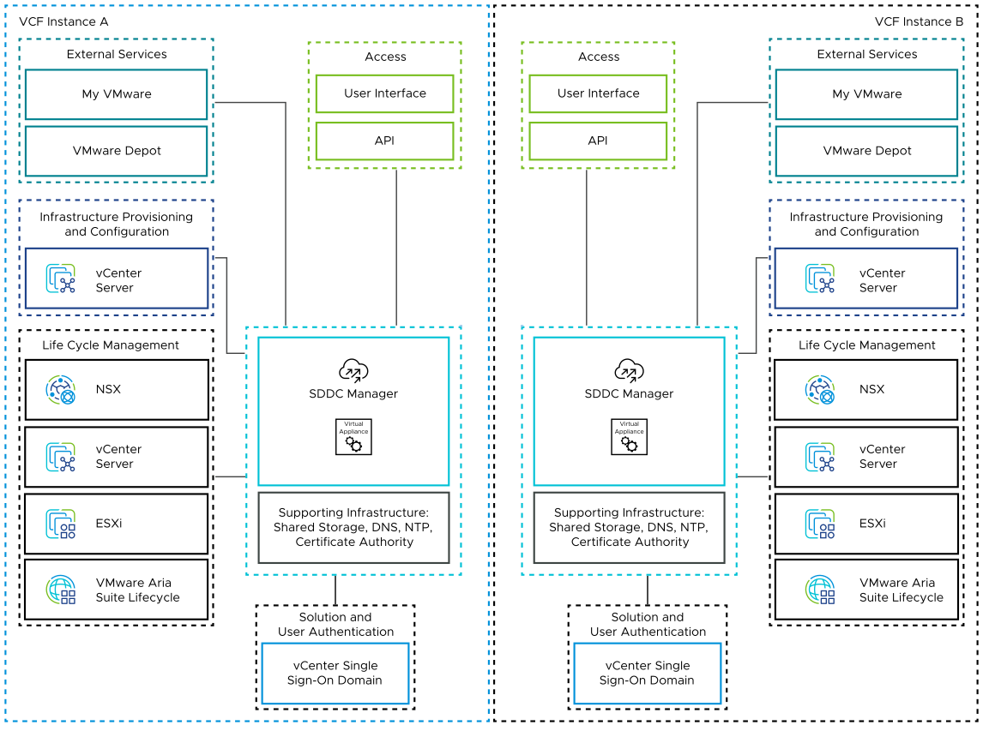
You use SDDC Manager to perform the following operations:
- Commissioning or decommissioning ESXi hosts
- Deployment of VI workload domains
- Deployment of VMware Aria Suite Lifecycle
- Deployment of NSX Edge clusters in workload domains
- Adding and extending clusters in workload domains
- Life cycle management of the virtual infrastructure components in all workload domains and of VMware Aria Suite Lifecycle
- Storage management for vVOL VASA providers
- Identity provider management
- Composable infrastructure management
- Creation of network pools for host configuration workload domains
- Product licenses storage
- Certificate management
- Password management and rotation
- Backup configuration
Table 3-84. SDDC Manager Logical Components
VMware Cloud Foundation Instances with a Single Availability Zone | VMware Cloud Foundation Instances with Multiple Availability Zones
- A single SDDC Manager appliance is deployed on the management network.  - vSphere HA protects the SDDC Manager appliance. | - A single SDDC Manager appliance is deployed on the management network.  - vSphere HA protects the SDDC Manager appliance.  - A vSphere DRS rule specifies that the SDDC Manager appliance should run on an ESXi host in the first availability zone.

SDDC Manager Design Requirements and Recommendations for VMware Cloud Foundation
Consider the placement and network design requirements for SDDC Manager, and the best practices for configuring the access to install and upgrade software bundles.

SDDC Manager Design Requirements
You must meet the following design requirements for in your SDDC Manager design.
Table 3-85. SDDC Manager Design Requirements for VMware Cloud Foundation
Requirement ID | Design Requirement | Justification | Implication
VCF-SDDCMGR-REQD-CFG-001 | Deploy an SDDC Manager system in the first availability zone of the management domain. | SDDC Manager is required to perform VMware Cloud Foundation capabilities, such as provisioning VI workload domains, deploying solutions, patching, upgrading, and others. | None.
VCF-SDDCMGR-REQD-CFG-002 | Deploy SDDC Manager with its default configuration. | The configuration of SDDC Manager is not configurable and should not be changed from its defaults. | None.
VCF-SDDCMGR-REQD-CFG-003 | Place the SDDC Manager appliance on the VM management network. | - Simplifies IP addressing for management VMs by using the same VLAN and subnet.  - Provides simplified secure access to management VMs in the same VLAN network. | None.

SDDC Manager Design Recommendations
In your SDDC Manager design, you can apply certain best practices.
Table 3-86. SDDC Manager Design Recommendations for VMware Cloud Foundation
Recommendation ID | Design Recommendation | Justification | Implication
VCF-SDDCMGR-RCMD-CFG-001 | Connect SDDC Manager to the Internet for downloading software bundles. | SDDC Manager must be able to download install and upgrade software bundles for deployment of VI workload domains and solutions, and for upgrade from a repository. | The rules of your organization might not permit direct access to the Internet. In this case, you must either download software bundles for SDDC Manager manually, or configure an offline depot.
VCF-SDDCMGR-RCMD-CFG-002 | Configure an authenticated network proxy to connect SDDC Manager to the Internet. | To protect SDDC Manager against external attacks from the Internet. | You must managed the proxy settings and security manually.
VCF-SDDCMGR-RCMD-CFG-003 | Configure SDDC Manager with a VMware Customer Connect account with VMware Cloud Foundation entitlement to check for and download software bundles. | Software bundles for VMware Cloud Foundation are stored in a repository that is secured with access controls. | Requires the use of a VMware Customer Connect user account with access to VMware Cloud Foundation licensing.  Sites without an internet connection can use local upload or offline depot option instead.
VCF-SDDCMGR-RCMD-CFG-004 | Configure SDDC Manager with an external certificate authority that is responsible for providing signed certificates. | Provides increased security by implementing signed certificate generation and replacement across the management components. | An external certificate authority, such as Microsoft CA, must be locally available.

Lifecycle Management Design for VMware Cloud Foundation
In a VMware Cloud Foundation instance, you use SDDC Manager for lifecycle management of the management components in the entire instance except for NSX Global Manager and VMware Aria Suite Lifecycle. VMware Aria Suite Lifecycle manages the lifecycle of the components that it deploys.
Lifecycle management of a VMware Cloud Foundation instance is the process of performing patch updates or upgrades to the underlying management components.
Table 3-87. Lifecycle Management for VMware Cloud Foundation
Component | Management Domain | VI Workload Domain
SDDC Manager | SDDC Manager performs its own life cycle management. | Not applicable
NSX Local Manager | SDDC Manager uses the NSX upgrade coordinator service in the NSX Local Manager.
NSX Edges | SDDC Manager uses the NSX upgrade coordinator service in NSX Manager.
NSX Global Manager | You manually use the NSX upgrade coordinator service in the NSX Global Manager.
vCenter Server | You use SDDC Manager for life cycle management of all vCenter Server instances.
ESXi | - SDDC Manager uses vSphere Lifecycle Manager baselines or vSphere Lifecycle Manager images to update and upgrade the ESXi hosts.  - Custom vendor ISOs are supported and might be required according to the ESXi hardware in use.
VMware Aria Suite Lifecycle | VMware Aria Suite Lifecycle performs its own life cycle management. | Not applicable

VMware Cloud Foundation Lifecycle Management Requirements
Consider the design requirements for automated and centralized lifecycle management in the context of the entire VMware Cloud Foundation environment.
Table 3-88. Lifecycle Management Design Requirements for VMware Cloud Foundation
Requirement ID | Design Requirement | Justification | Implication
VCF-LCM-REQD-001 | Use SDDC Manager to perform the life cycle management of the following components:  - SDDC Manager  - NSX Manager  - NSX Edges  - vCenter Server  - ESXi | Because the deployment scope of SDDC Manager covers the full VMware Cloud Foundation stack, SDDC Manager performs patching, update, or upgrade of these components across all workload domains. | The operations team must understand and be aware of the impact of a patch, update, or upgrade operation by using SDDC Manager.
VCF-LCM-REQD-002 | Use VMware Aria Suite Lifecycle to manage the life cycle of the following components:  - VMware Aria Suite Lifecycle  - Workspace ONE Access | VMware Aria Suite Lifecycle automates the life cycle of VMware Aria Suite Lifecycle and Workspace ONE Access. | - You must deploy VMware Aria Suite Lifecycle by using SDDC Manager.  - You must manually apply Workspace ONE Access patches, updates, and hotfixes. Patches, updates, and hotfixes for Workspace ONE Access are not generally managed by VMware Aria Suite Lifecycle.
Table 3-89. Lifecycle Management Design Requirements for NSX Federation in VMware Cloud Foundation
Requirement ID | Design Requirement | Justification | Implication
VCF-LCM-REQD-003 | Use the upgrade coordinator in NSX to perform life cycle management on the NSX Global Manager appliances. | The version of SDDC Manager in this design is not currently capable of life cycle operations (patching, update, or upgrade) for NSX Global Manager. | - You must explicitly plan upgrades of the NSX Global Manager nodes. An upgrade of the NSX Global Manager nodes might require a cascading upgrade of the NSX Local Manager nodes and underlying SDDC Manager infrastructure before upgrading the NSX Global Manager nodes.  - You must always align the version of the NSX Global Manager nodes with the rest of the SDDC stack in VMware Cloud Foundation.
VCF-LCM-REQD-004 | Establish an operations practice to ensure that prior to the upgrade of any workload domain, the impact of any version upgrades is evaluated in relation to the need to upgrade NSX Global Manager. | The versions of NSX Global Manager and NSX Local Manager nodes must be compatible with each other.  Because SDDC Manager does not provide life cycle operations (patching, update, or upgrade) for the NSX Global Manager nodes, upgrade to an unsupported version cannot be prevented. | The administrator must establish and follow an operations practice by using a runbook or automated process to ensure a fully supported and compliant bill of materials prior to any upgrade operation.
VCF-LCM-REQD-005 | Establish an operations practice to ensure that prior to the upgrade of the NSX Global Manager, the impact of any version change is evaluated against the existing NSX Local Manager nodes and workload domains. | The versions of NSX Global Manager and NSX Local Manager nodes must be compatible with each other.  Because SDDC Manager does not provide life cycle operations (patching, update, or upgrade) for the NSX Global Manager nodes, upgrade to an unsupported version cannot be prevented. | The administrator must establish and follow an operations practice by using a runbook or automated process to ensure a fully supported and compliant bill of materials prior to any upgrade operation.

Logging and Monitoring Design for VMware Cloud Foundation
By using VMware or third-party components, collect log data from all SDDC management components in your VMware Cloud Foundation environment in a central place. You can use VMware Aria Operations for Logs as the central platform because of its native integration with VMware Aria Suite Lifecycle.
After you deploy VMware Aria Operations for Logs by using VMware Aria Suite Lifecycle in VMware Cloud Foundation mode, SDDC Manager configures VMware Aria Suite Lifecycle logging to VMware Aria Operations for Logs over the log ingestion API. For information about on-premises VMware Aria Operations for Logs in VMware Cloud Foundation, see Intelligent Logging and Analytics for VMware Clod Foundation.

Information Security Design for VMware Cloud Foundation
You design management of access controls, certificates and accounts for VMware Cloud Foundation according to the requirements of your organization.

Access Management for VMware Cloud Foundation
You design access management for VMware Cloud Foundation according to industry standards and the requirements of your organization.
Component | Access Method | Additional Information
SDDC Manager | - UI  - API  - SSH | SSH is active by default. root user access is not permitted.
NSX Local Manager | - UI  - API  - SSH | SSH is deactivated by default.
NSX Edges | - API  - SSH | SSH is deactivated by default.
NSX Global Manager | - UI  - API  - SSH | SSH setting is defined during deployment.
vCenter Server | - UI  - API  - SSH  - VAMI | SSH is active by default.
ESXi | - Direct Console User Interface (DCUI)  - ESXi Shell  - SSH  - VMware Host Client | SSH and ESXi shell are deactivated by default.
VMware Aria Suite Lifecycle | - UI  - API  - SSH | SSH is active by default.
Workspace ONE Access | - UI  - API  - SSH | SSH is active by default.

Account Management Design for VMware Cloud Foundation
You design account management for VMware Cloud Foundation according to industry standards and the requirements of your organization.

Password Management Methods
SDDC Manager manages the life cycle of passwords for the components that are part of the VMware Cloud Foundation instance. Multiple methods for managing password life cycle are supported.
Table 3-90. Password Management Methods in VMware Cloud Foundation
Method | Description
Rotate | Update one or more accounts with an auto-generated password
Update | Update password for a single account with a manually entered password
Remediate | Reconcile a single account with a password that has been set manually at the component.
Schedule | Schedule auto-rotation for one or more selected accounts.
Manual | Update a password manually directly in the component.

Account and Password Management
VMware Cloud Foundation comprises multiple types of interactive, local, and service accounts. Each account has different attributes and can be managed in the following ways:
For more information on password complexity, account lockout or integration with additional Identity Providers, refer to the Identity and Access Management for VMware Cloud Foundation.
Table 3-91. Account and Password Management in VMware Cloud Foundation
Component | User Account | Password Management | Additional Information
SDDC Manager | admin@local | - Manual by using the SDDC Manager API  - Default Expiry: Never | - Local appliance account  - API access (break-glass account)
 | vcf | - Manual by using the OS  - Default Expiry: 365 days | - Local appliance account  - OS level access
 | root | - Manual by using the OS  - Default Expiry: 90 days | - Local appliance account  - OS level access
 | backup | - Rotate, update,remediate or schedule by using the SDDC Manager UI or API  - Default Expiry: 365 days | - Local appliance account  - OS level access
 | administrator@vsphere.local | - Rotate, update,remediate or schedule by using the SDDC Manager UI or API  - Default Expiry: 90 days | - vCenter Single Sign-On account.  - Application and API access.  - Additional VMware Cloud FoundationAdmin account required to perform manual password rotation.
NSX Local Manager | admin | - Rotate, update,remediate or schedule by using the SDDC Manager UI or API  - Default Expiry: 90 days | - Local appliance account  - OS level, API, and application access
 | root | - Rotate, update,remediate or schedule by using the SDDC Manager UI or API  - Default Expiry: 90 days | - Local appliance account  - OS level access
 | audit | - Rotate, update,remediate or schedule by using the SDDC Manager UI or API  - Default Expiry: 90 days | - Local appliance account  - OS level access  - Read-only application level access
NSX Edges | admin | - Rotate, update,remediate or schedule by using the SDDC Manager UI or API  - Default Expiry: 90 days | - Local appliance account  - OS level, API, and application access
 | root | - Rotate, update,remediate or schedule by using the SDDC Manager UI or API  - Default Expiry: 90 days | - Local appliance account  - OS level access
 | audit | - Rotate, update,remediate or schedule by using the SDDC Manager UI or API  - Default Expiry: 90 days | - Local appliance account  - OS level access  - Read-only application level access
NSX Global Manager | admin | - Manual by using the NSX Global Manager UI or API  - Default Expiry: 90 days | - Local appliance account  - OS level, API, and application access
 | root | - Manual by using each NSX Global Manager appliance  - Default Expiry: 90 days | - Local appliance account  - OS level access
 | audit | - Manual by using the NSX Global Manager UI or API  - Default Expiry: 90 days | - Local appliance account  - OS level access  - Read-only application level access
vCenter Server | root | - Rotate, update,remediate or schedule by using the SDDC Manager UI or API  - Default Expiry: 90 days | - Local appliance account  - OS level access  - VAMI access
 | administrator@isolatedsso.local | - Rotate, update,remediate or schedule by using the SDDC Manager UI or API  - Default Expiry: 90 days | - vCenter Single Sign-On account.  - Application and API access.  - Relevant to isolated workload domain
 | svc-sddc-manager-hostname-vcenter-server-hostname@vsphere.local | - System managed.  - Automatically rotated every 30 days by default  - Default Expiry: None | Service account between SDDC Manager and vCenter Server
 | svc-nsx-manager-hostname-vcenter-server-hostname@vsphere.local | - System managed.  - Automatically rotated every 30 days by default  - Default Expiry: None | Service account between NSX Manager and vCenter Server
 | svc-vrslcm-hostname-vcenter-server-hostname@vsphere.local | - System managed  - Automatically rotated every 30 days by default  - Default Expiry: None | Service account between VMware Aria Suite Lifecycle and vCenter Server
ESXi | root | - Rotate, update,remediate or schedule by using the SDDC Manager UI or API  - Default Expiry: 99999 (never) | Manual
 | svc-vcf-esxi-hostname | - Rotate, update,remediate or schedule by using the SDDC Manager UI or API  - Default Expiry: 99999 (never) | Service account between SDDC Manager and the ESXi host
VMware Aria Suite Lifecycle | vcfadmin@local | - Rotate, update,remediate or schedule by using the SDDC Manager UI or API  - Default Expiry: Never | API and application access
 | root | - Rotate, update,remediate or schedule by using the SDDC Manager UI or API  - Default Expiry: 365 days | - Local appliance account  - OS level access
Workspace ONE Access | root | - Rotate, update,remediate or schedule by using the SDDC Manager UI or API  - Default Expiry: 60 days | - Local appliance account  - OS level access
 | sshuser | - Managed by VMware Aria Suite Lifecycle  - Default Expiry: 60 days | - Local appliance account  - OS level access
 | admin (port 8443) | Managed by VMware Aria Suite Lifecycle | System Admin
 | Admin (port 443) | - Rotate, update,remediate or schedule by using the SDDC Manager UI or API  - Default Expiry: Never | Default application administrator
 | configadmin | - You must use both Workspace ONE Access and VMware Aria Suite Lifecycle to manage the password rotation schedule of the configadmin user.  - Default Expiry: Never | Application configuration administrator

Account Management Design Recommendations
In your account management design, you can apply certain best practices.
Table 3-92. Design Requirements for Account and Password Management for VMware Cloud Foundation
Recommendation ID | Design Recommendation | Justification | Implication
VCF-ACTMGT-REQD-SEC-001 | Enable scheduled password rotation in SDDC Manager for all accounts supporting scheduled rotation. | - Increases the security posture of your SDDC.  - Simplifies password management across your SDDC management components. | You must retrieve new passwords by using the API if you must use accounts interactively.
VCF-ACTMGT-REQD-SEC-003 | Establish operational practice to rotate passwords using SDDC Manager on components that do not support scheduled rotation in SDDC Manager. | Rotates passwords and automatically remediates SDDC Manager databases for those user accounts. | None.
VCF-ACTMGT-REQD-SEC-003 | Establish operational practice to manually rotate passwords on components that cannot be rotated by SDDC Manager. | Maintains password policies across components not handled by SDDC Manager password management. | None.

Certificate Management for VMware Cloud Foundation
You design certificate management for VMware Cloud Foundation according to industry standards and the requirements of your organization.
Access to all management component interfaces must be over a Secure Socket Layer (SSL) connection. During deployment, each component is assigned a certificate from a default signing CA. To provide secure access to each component, replace the default certificate with a trusted enterprise CA-signed certificate.
Table 3-93. Certificate Management in VMware Cloud Foundation
Component | Default Signing CA | Life cycle for Enterprise CA-Signed Certificates
SDDC Manager | Management domain VMCA | Using SDDC Manager
NSX Local Manager | Management domain VMCA | Using SDDC Manager
NSX Edges | Not applicable | Not applicable
NSX Global Manager | Self Signed | Manual
vCenter Server | Local workload domain VMCA | Using SDDC Manager
ESXi | Local workload domain VMCA | Manual*
VMware Aria Suite Lifecycle | Management domain VMCA | Using SDDC Manager
Note * To use enterprise CA-Signed certificates with ESXi, the initial deployment of VMware Cloud Foundation must be done using the API providing the Trusted Root certificate.
Table 3-94. Certificate Management Design Recommendations for VMware Cloud Foundation
Recommendation ID | Design Recommendation | Justification | Implication
VCF-SDDC-RCMD-SEC-001 | Replace the default VMCA or signed certificates on all management virtual appliances with a certificate that is signed by an internal certificate authority. | Ensures that the communication to all management components is secure. | Replacing the default certificates with trusted CA-signed certificates from a certificate authority might increase the deployment preparation time because you must generate and submit certificate requests.
VCF-SDDC-RCMD-SEC-002 | Use a SHA-2 algorithm or higher for signed certificates. | The SHA-1 algorithm is considered less secure and has been deprecated. | Not all certificate authorities support SHA-2 or higher.
VCF-SDDC-RCMD-SEC-003 | Perform SSL certificate life cycle management for all management appliances by using SDDC Manager. | SDDC Manager supports automated SSL certificate lifecycle management rather than requiring a series of manual steps. | Certificate management for NSX Global Manager instances must be done manually.

Identity and Access Management for VMware Cloud Foundation Detailed Design
This section describes the Identity and Access Management design considerations for VMware Cloud Foundation based on the VMware Validated Solution.

Design Objectives of Identity and Access Management
The Identity and Access Management for VMware Cloud Foundation validated solution has objectives to deliver prescriptive content about the solution so that it is fast to deploy and is suitable for use in production environments.
Objective | Description
Main objective | Provide role-based access control for VMware Cloud Foundation infrastructure components through an organization's directory services as the authentication source.
VMware Cloud Foundation architecture support | - vSAN ReadyNodes  - Consolidated  - Standard  - Dell VxRail Nodes  - Consolidated  - Standard
Workload domain type support | - Management Workload domain  - VI Workload domain
Scope of implementation | - Configuration of role based access control for VMware Cloud Foundation components:  - ESXi  - vCenter Server  - NSX  - SDDC Manager
Scope of guidance | - Deployment and initial configuration of identity access and management components for management and VI workload domains.  - Operational guidance for the identity access and management components such as operational and post-maintenance validation.  - Solution interoperability with solution components, such as monitoring and alerting, logging, and life cycle management.
Cloud type | Private cloud
Availability | 99%
Authentication, authorization, and access control | - Use of Microsoft Active Directory over LDAP as the identity provider.  - Use of security groups and roles for least-privilege access control.  - Use of service accounts and least-privilege access control for solution integration.  Support for other external identity providers is not in included in this solution.
Certificate signing | Certificates are signed by a certificate authority (CA) that consists of a root and intermediate certificate authority layers.

Detailed Design of Identity and Access Management
The design considers the components of the Identity and Access Management for VMware Cloud Foundation validated solution. It includes numbered design decisions, and the justification and implications of each decision.

Logical Design of Identity and Access Management
The logical design provides a high-level overview of the Identity and Access Management for VMware Cloud Foundation solution design.
Figure 3-26. Logical Design of Identity and Access Management for VMware Cloud Foundation
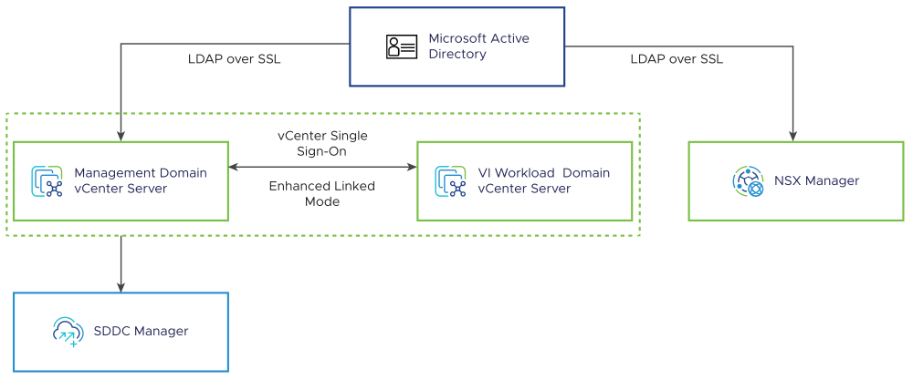

vCenter Server
By default, the vCenter Single Sign-On built-in identity provider uses an embedded vsphere.local domain and supports local accounts. The vCenter Server instances in a VMware Cloud Foundation system are joined to the built-in identity provider and are required to participate in an enhanced linked-mode configuration. Additional VMware Cloud Foundation instances may be joined to the same vCenter Single Sign-On identity provider during bring-up or brought online with a dedicated identity provider.
vSphere configuration limits apply to linked vCenter Server instances:
- The number of linked vCenter Servers
- The number of hosts in linked vCenter Servers
- The number of powered-on virtual machines in linked vCenter Servers
- The number of registered virtual machines in linked vCenter Servers
See VMware Configuration Maximums.
The vCenter Single Sign-On built-in identity provider can be configured to use Microsoft Active Directory as its identity source using LDAP over SSL (LDAPS). The configuration is applicable to all vCenter Server instances configured in enhanced linked mode. Active Directory security groups and/or users can be assigned to default or custom roles in vSphere with the scope of provisioned and managed permissions.

ESXi
This solution does not require ESXi hosts in a VMware Cloud Foundation system to join Active Directory. SDDC Manager manages the commissioning, configuration, and life cycle of the ESXi hosts.
If supplemental storage uses NFS version 4.1 with Kerberos authentication, you must join each ESXi host to an Active Directory domain. To ensure the default security group is not used, the default esxAdminsGroup group on each ESXi host can be configured to use a custom Active Directory security group.

NSX
To provide identity management services to NSX, NSX Manager instances in a VMware Cloud Foundation system are configured to use Microsoft Active Directory as its identity source using LDAP over SSL (LDAPS). Active Directory security groups and/or users can be assigned to default or custom roles in NSX.

SDDC Manager
SDDC Manager inherits the identity provider configuration from all vCenter Server instances in enhanced linked-mode. Active Directory security groups and/or users can be assigned to default roles in SDDC Manager.

Information Security and Access of Identity and Access Management
Information security and access design details the design decisions covering authentication and access controls for ESXi, vCenter Server, NSX, and SDDC Manager.
Table 3-95. Design Decisions on Information Security
Decision ID | Design Decision | Design Justification | Design Implication
IAM-VCF-SEC-001 | Limit the use of local accounts for both interactive or API access and solution integration. | Local accounts are not specific to user identity and do not offer complete auditing from an endpoint back to the user identity. | You must define and manage service accounts, security groups, group membership, and security controls in Active Directory.
IAM-VCF-SEC-002 | Limit the scope and privileges for accounts used for both interactive or API access and solution integration. | The principle of least privilege is a critical aspect of access management and must be part of a comprehensive defense-in-depth security strategy. | You must define and manage custom roles and security controls to limit the scope and privileges used for interactive access or solution integration.
IAM-VCF-SEC-003 | Assign Active Directory user accounts to security groups following your organization's access policies. | Allows Active Directory security groups to be assigned to roles in SDDC components for streamlined management of access and administrative privileges. | You must define and manage security groups, group membership, and security controls in Active Directory.
IAM-VCF-SEC-004 | Assign Active Directory security groups to default or custom roles, as applicable, for interactive or API access to solution components based on your organization's business and security requirements.  - SDDC Manager  - ESXi (as applicable)  - vCenter Servers  - NSX Managers | - Using Active Directory security group membership provides greater flexibility in granting access to roles across solution components.  - Ensuring that users log in with a unique Active Directory user account provides greater visibility for auditing.  - Evaluate the needs for additional role separation in your organization and implement mapping from Active Directory users to Active Directory security groups and default or custom roles. | - You must manage privileges assigned to custom roles.  - You must manage the assignment and scope of custom roles based on the business and security requirements.  - Additional Active Directory security groups must be created in advance to assigning roles.  - You must maintain the life cycle and availability of Active Directory security groups outside of the SDDC stack.  - The principle of least privilege is only one aspect of access management and must be part of a comprehensive defense-in-depth security strategy aligned with organization personas.

Information Security and Access for ESXi for Identity and Access Management
Information security and access details the design decisions covering authentication and access controls for ESXi in VMware Cloud Foundation.
By default, you can log in to an ESXi host using only the root account. Direct access to an ESXi host is available and most commonly used for troubleshooting purposes. You can access an ESXi host using one of the following methods.
Access Method | Description
Direct Console User Interface (DCUI) | A text-based interface on the ESXi host console. Provides basic administrative controls and troubleshooting options.
ESXi Shell | A local Linux-style shell accessed by using Alt+F1 on the ESXi host console.
Secure Shell (SSH) | A remote command-line access to the ESXi Shell using SSH.
Host Client | An HTML5-based client for managing ESXi hosts individually. You use the Host Client for emergency management when vCenter Server is temporarily unavailable.
vSphere Client | An HTML5-based client included with vCenter Server. You use the vSphere Client is the primary interface for connecting to and managing vCenter Server instances.

Active Directory Integration for ESXi Hosts
Generally, it is not required to join ESXi hosts in a VMware Cloud Foundation system to Active Directory. SDDC Manager manages the commissioning, configuration, and life cycle of the ESXi hosts. In the event that direct access to an ESXi host is required, the Cloud Administrator can obtain the root or SERVICE account credentials to troubleshoot any issues with the ESXi host. However, there are circumstances when you must add Active Directory as the identity provider by joining each ESXi host to an Active Directory domain.
VMware Cloud Foundation supports the use of NFS version 4.1 as supplemental storage. With NFS version 4.1, ESXi supports the RPCSEC_GSS Kerberos authentication service. It allows the built-in NFS 4.1 client for ESXi to prove its identity to an NFS server before mounting an NFS share. The Kerberos security uses cryptography to work across an insecure network connection. To use Kerberos authentication, each ESXi host, that mounts an NFS 4.1 datastore, must join the required Active Directory domain and the NFS Kerberos credentials must be set on each host.
The ESXi implementation of Kerberos for NFS 4.1 provides two security models, krb5 and krb5i, that offer different levels of security.
- Kerberos for authentication only (krb5) supports identity verification.
- Kerberos for authentication and data integrity (krb5i), in addition to identity verification, provides data integrity services.
When you use Kerberos authentication, the following considerations apply:
- You must add Active Directory as the authentication system by joining each ESXi host to an Active Directory domain.
- You must specify the Active Directory credentials to provide access to NFS version 4.1 Kerberos datastores. A single set of credentials is used to access all Kerberos datastores mounted on an ESXi host.
- You must use the same Active Directory credentials for all ESXi hosts that access the shared datastore.
- You cannot use two security mechanisms, AUTH_SYS and Kerberos, for the same NFS version 4.1 datastore shared by multiple hosts.
When an ESXi host is added to an Active Directory domain to support NFS version 4.1 with Kerberos authentication, you must configure the administrative access by defining a non-default Active Directory security group for privileged access to the ESXi host. Thus, you ensure that only the designated Active Directory security group membership has administrative access to the ESXi host.
Table 3-96. Design Considerations on the Integration of ESXi Hosts with Active Directory
Design Consideration | Justification | Implications
If NFS version 4.1 with Kerberos authentication is used for supplemental storage, add Active Directory as the authentication service by joining each ESXi host to the Active Directory domain. | Ensures greater visibility for auditing by enforcing that users log in with user accounts in the Active Directory domain. | - Adding ESXi hosts to the domain adds administrative overhead, which can be automated.  - You must manage the placement of the computer object for each ESXi host in the Active Directory domain.  - You must maintain the access, life cycle, and availability for the associated Active Directory objects outside of the SDDC stack.
If NFS version 4.1 with Kerberos authentication is used for supplemental storage, change the default esxAdminsGroup configuration on each ESXi host to use a custom Active Directory security group in the Active Directory domain. | - Changing the Active Directory security group removes the use of a default security group membership.  - Using an Active Directory security group name allows you to use a designated security group across management and workload domains, if required. | - An Active Directory security group must be created in advance of changing the assignment.  - You must maintain the life cycle and availability of an Active Directory security group outside of the SDDC stack.  - You must make changes to the ESXi hosts' advanced settings.
If NFS version 4.1 with Kerberos authentication is used for supplemental storage, use an Active Directory user account with the minimum privileges to join a ESXi host to the Active Directory domain. | ESXi hosts are joined to the Active Directory domain using an account with the minimum set of required directory permissions.  - Account Operators group  - Join Computers to Domain delegation. | - You must maintain the life cycle and availability of the service account in your directory services.  - If the computer objects in Active Directory are not created in advance, you must ensure that the user account has permissions to create objects in the default or the target organizational unit.

Password Policies for ESXi Hosts
For an ESXi host, you can enforce password policies for access to the DCUI, the ESXi Shell, SSH, or the Host Client. You can configure these password policies by using the advanced system settings for each ESXi host. The password policies apply only to local user accounts.

Password Expiration Policy for ESXi Hosts
You manage the password expiration policy on a per-host basis by using the advanced system settings in the vSphere Client or the Host Client. You can modify the configuration settings on each ESXi host to refine the settings and adhere to the policies and regulatory standards of your organization. The default configuration is shown in the following table.
Table 3-97. Default Password Expiration Policy for ESXi Hosts
Setting | Default | Description
Security.PasswordMaxDays | 99999 (never) | Maximum number of days before password expiration

Password Complexity Policy for ESXi Hosts
You manage the password complexity policy on a per-host basis by using the advanced system settings in the vSphere Client or the Host Client. You can edit and modify the configuration to refine the settings and adhere to the policies of your organization and regulatory standards. The default configuration is shown in the following table.
Table 3-98. Default Password Complexity Policy for ESXi Hosts
Setting | Default | Description
Security.PasswordQualityControl | retry=3 min=disabled,disabled,disabled,7,7 | - Maximum number of retries  - Required character classes  - Minimum password length (characters)
Security.PasswordHistory | 0 | Maximum number of passwords that the system remembers
For more detailed information, see the ESXi Passwords and Account Lockout documentation for VMware vSphere.

Account Lockout Policy for ESXi Hosts
ESXi account lockout is supported for SSH and API. If a user attempts to log in with incorrect local account credentials using SSH or API, the account is locked. The DCUI and the ESXi Shell do not support account lockout.
You manage the account lockout policy on a per-host basis by using the advanced system settings in the vSphere Client or the Host Client. You can edit and modify the configuration to refine the settings and adhere to the policies of your organization and regulatory standards. The default configuration is shown in the following table.
Table 3-99. Default Account Lockout Policy for ESXi Hosts
Setting | Default | Description
Security.AccountLockFailures | 5 | Maximum number of authentication failures before the account is locked
Security.AccountUnlockTime | 900 | Amount of time in seconds that the account remains locked
For more detailed information, see the ESXi Passwords and Account Lockout documentation for VMware vSphere.

Design Decisions on Password Policies for ESXi Hosts
Table 3-100. Design Decisions on Password Policies for ESXi Hosts
Decision ID | Design Decision | Design Justification | Design Implication
IAM-ESXI-SEC-001 | Configure the password expiration policy for each ESXi host. | - You configure the password expiration for ESXi hosts to align with the requirements of your organization which might be based on industry compliance standards.  - The password expiration policy is applicable to the following default accounts for a commissioned ESXi host:  - root account  - SERVICE account  - The policy is applicable only to the local ESXi host users. | You must manage the local user password expiration policy on each ESXi host by using the advanced system settings in the vSphere Client or the Host Client.
IAM-ESXI-SEC-002 | Configure the password complexity policy for each ESXi host. | - You configure the password complexity policy for ESXi hosts to align with the requirements of your organization which might be based on industry compliance standards.  - The password complexity policy is applicable only to the local ESXi host users. | You must manage the local user password complexity policy on each ESXi host by using the advanced system settings in the vSphere Client or the Host Client.
IAM-ESXI-SEC-003 | Configure the account lockout policy for each ESXi host. | - You configure the account lockout policy for ESXi hosts to align with the requirements of your organization which might be based on industry compliance standards.  - The policy is applicable only to the local ESXi host users. | You must manage the local user account lockout policy on each ESXi host by using the advanced system settings in the vSphere Client or the Host Client.

ESXi Host Password Management
SDDC Manager provides the ability to perform life cycle management for the local accounts used by each ESXi host. Changing the passwords periodically or when certain events occur, such as an administrator leaving your organization, increases the security posture and health of the system. SDDC Manager provides the ability to rotate, update, and remediate most of these component passwords. Unlike password rotation, which generates a randomized password, updates allow you provide the desired password for the selected account.
For more information, see the Password Management documentation for VMware Cloud Foundation.
You can activate or deactivate normal lock down mode on an ESXi host to increase the security of the hosts. To activate or deactivate normal lock down mode, you must perform the operation through the vSphere Client. SDDC Manager creates service accounts that can be used to access the ESXi hosts over SSH. The service accounts are added to the Exception Users list during the bring-up process or host commissioning workflow. You can rotate the passwords for the service accounts using the password management functionality in SDDC Manager.
For more information, see the Host Management documentation for VMware Cloud Foundation.
Table 3-101. Design Decisions on Password Management for ESXi Hosts
Decision ID | Design Decision | Design Justification | Design Implication
IAM-ESXI-SEC-004 | Change the root user password for each ESXi host on a recurring or event-initiated schedule by using SDDC Manager. | - The password for the ESXi host's root user does not expire based on the default password expiration policy.  - SDDC Manager manages each ESXi host in the system. The ESXi root user password must be known and managed by SDDC Manager. | - You must manage the password update or password rotation for the root account by using SDCC Manager.  - An automated password rotation schedule can not be activated for ESXi hosts in SDDC Manager.
IAM-ESXI-SEC-005 | Rotate the SERVICE account password for each ESXi host on a recurring or event-initiated schedule by using SDDC Manager. | - SDDC Manager creates a SERVICE account on each ESXi host to provide the access to the ESXi host over SSH in the context of an exception user in normal lock down mode.  - The password for the ESXi host's SERVICE account does not expire based on the default password expiration policy.  - SDDC Manager manages each ESXi host in the system. The ESXi root user password must be known and managed by SDDC Manager. | - You must manage the password rotation for the SERVICE account by using SDDC Manager.  - An automated password rotation schedule can not be activated for ESXi hosts in SDDC Manager.

Information Security and Access for vCenter Server for Identity and Access Management
Information security and access design details the design decisions covering authentication and access controls for vCenter Server in VMware Cloud Foundation.
You can log in to a vCenter Server instance based on the configuration of vCenter Single Sign-On. vCenter Single Sign-On allows vSphere components to communicate with each other through a secure token mechanism.
vCenter Single Sign-On uses the following services.
- Authentication of users through the vCenter Server built-in identity provider or external identity provider federation.
- Authentication of solution users through certificates.
- Security Token Service (STS).
- SSL for secure traffic.
vCenter Server includes a built-in identity provider. By default, the vCenter Server built-in identity provider uses an embedded vsphere.local domain and supports local accounts. You can configure the vCenter Server built-in identity provider to use Microsoft Active Directory as its identity source using LDAP(S) or use OpenLDAP. These configurations allow you to log in to vCenter Server using Active Directory user accounts assigned to vCenter Server roles.
You can also configure vCenter Server to use an external identity provider. Using federated authentication, you replace vCenter Server as the identity provider with an external identity provider.
The configuration of an external identity provider is not in scope of this solution.

Active Directory Integration for vCenter Server
This solution provides design and implementation guidance on configuring the vCenter Server built-in identity provider to use Microsoft Active Directory over LDAP.
Table 3-102. Design Decisions on the Identity Provider for vCenter Server
Decision ID | Design Decision | Design Justification | Design Implication
IAM-VCS-SEC-001 | Configure the vCenter Server instances to use Active Directory over LDAP with SSL (LDAPS) as the identity source. | - Provides the ability for vCenter Server to connect to an Active Directory using LDAP.  - Ensures that LDAP traffic between a vCenter Server instance and the Active Directory is encrypted.  Microsoft recommends a hardened configuration for LDAP channel binding and LDAP signing on Active Directory domain controllers. For more information, see Microsoft Security Advisory ADV190023. | - In a multi-domain forest, where the vCenter Server instance connects to a child domain, Active Directory security groups must have global scope. Therefore members added to the Active Directory global security group and user accounts for solution integration must reside within the same Active Directory domain.  - If multiple VMware Cloud Foundation instances are deployed to separate Active Directory domains (for example, child domains in a multi-domain forest), the instances can not be in enhanced linked-mode.  - A certificate is required to establish trust for the Active Directory LDAPS endpoints. You must obtain a CA-signed certificate that can be used for server authentication.  - You must remove and reconfigure the integration between the identity provider and vCenter Server when replacing the certificates used by Active Directory over LDAP with SSL.
IAM-VCS-SEC-002 | Use an Active Directory user account with minimum read-only access as Base DN for users and groups to server as the service account for the Active Directory bind. | Provides the following access control features:  - Each vCenter Server instance connects to the Active Directory domain with the minimum permissions to bind and query the directory.  - Improves the visibility in tracking request-response interactions between the vCenter Server instances and Active Directory. | You must manage the password life cycle of this Active Directory use account.
vCenter Server provides precise control over authorization by using permissions and roles. Each object in the vCenter Server object hierarchy has associated permissions. When you assign permissions to an object in the vCenter Server object hierarchy, you specify the privileges and access for each user or group on that object.
You can assign privileges only to authenticated users or groups of authenticated users. Users are authenticated through vCenter Single Sign-On. Users and groups must be defined in the identity source that vCenter Single Sign-On uses. Define users and groups using the tools in your identity source, for example, Active Directory.
To specify the privileges for users or groups, you use roles, which are sets of privileges. Roles allow you to assign permissions on an object based on a typical set of tasks that users perform. Default roles, such as Administrator, are predefined in vCenter Server and cannot be changed. Other roles, such as Resource Pool Administrator, are predefined sample roles. vCenter Server offers predefined roles, which combine frequently used privilege sets. You can create custom roles either from scratch or by cloning and modifying sample roles.
vSphere supports several models with control for determining whether a user is allowed to perform a task. A user's role on an object or the user's global permission determines whether that user is allowed to perform other tasks in vSphere.
For more information, see the vSphere Permissions and User Management Tasks documentation for VMware vSphere.
Table 3-103. Design Decisions on Identity and Access Management for vCenter Server
Decision ID | Design Decision | Design Justification | Design Implication
IAM-VCS-SEC-003 | Assign the default Administrator role in vCenter Server to an Active Directory security group. | By assigning the Administrator role to an Active Directory security group, you can simplify and manage user access with administrative rights in vCenter Server based on your organization's personas. | - An Active Directory security group must be created in advance to assigning a role.  - You must maintain the life cycle and availability of the security group in Active Directory.
IAM-VCS-SEC-004 | Assign vCenter Server global permissions for the Active Directory security groups assigned the Administrator role. | By assigning the global permissions to an Active Directory security group with the Administrator role , you can manage user access with administrative rights across all management and workload domain vCenter Servers instances which participate in enhanced linked-mode and use the same identity provider. | None.
IAM-VCS-SEC-005 | Assign the default Read-Only role in vCenter Server to an Active Directory security group. | By assigning the Read-only role to an Active Directory security group, you can simplify and manage user access with read-only rights in vCenter Server based on your organization's personas. | - An Active Directory security group must be created in advance to assigning a role.  - You must maintain the life cycle and availability of the security group in Active Directory.
IAM-VCS-SEC-006 | Assign vCenter Server global permissions for the Active Directory security groups assigned the Read-Only role. | By assigning global permissions to an Active Directory security group with the Read-only role, you can manage user access with read-only privileges across all management and workload domain vCenter Servers instances which participate in enhanced linked-mode and use the same identity provider. | None.
IAM-VCS-SEC-007 | Add an Active Directory security group as a member of the vCenter Single Sign-On Administrators group. | By adding an Active Directory security group as a member of the Administrators group, you can manage user access with administrative rights to the vCenter Single Sign-On built-in identity provider based on your organization's personas. | - An Active Directory security group must be created in advance to assigning a role.  - You must maintain the life cycle and availability of the security group in Active Directory.

Password Policies for vCenter Server
For a vCenter Server instance, you can enforce password policies for access to the virtual appliance by using the DCUI, SSH, or the vCenter Server Management Interface. The password policies apply only to local user accounts.

Password Expiration Policy for vCenter Server
You manage the password expiration policies on a per-instance basis. You can modify the configuration settings on each vCenter Server instance to refine the settings and adhere to the policies and regulatory standards of your organization. The default configurations are shown in the following table.
Table 3-104. Default Global Password Expiration Policy for vCenter Server
Setting | Default | Description
Maximum (days) | 90 | Maximum number of days between password change
Minimum (days) | 0 | Minimum number of days between password change
Warning | 7 | Number of days of warning before a password expires
Table 3-105. Default Local User Password Expiration Policy for vCenter Server
Setting | Default | Description
Password Expires | Yes | The virtual appliance root password is set to expire
Password validity | 90 | Maximum number of days before password expiration
Email for expiration warning | - | Email for password expiration warnings
Warning (days) | 7 | Number of days of warning before a password expires

Password Complexity Policy for vCenter Server for Local Users
You manage the local user password complexity policy by using the /etc/pam.d/system-password file on a per-instance basis. You can modify the configuration settings on each vCenter Server instance to refine the settings and adhere to the policies and regulatory standards of your organization. The default configuration is shown in the following table.
Table 3-106. Default Local User Password Complexity Policy for vCenter Server
Setting | Default | Description
dcredit | -1 | Maximum number of digits that generate a credit
ucredit | -1 | Maximum number of uppercase characters that generate a credit
lcredit | -1 | Maximum number of lowercase characters that generate a credit
ocredit | -1 | Maximum number of other characters that generate a credit
minlen | 6 | Minimum password length (number of characters)
difok | 4 | Minimum number of characters that must be different from the old password
remember | 5 | Maximum number of passwords that the system remembers

Account Lockout Policy for vCenter Server for Local Users
You manage the local user account lockout policy by using the /etc/pam.d/system-auth file on a per-instance basis. You can modify the configuration settings on each vCenter Server instance to refine the settings and adhere to the policies and regulatory standards of your organization. The default configuration is shown in the following table.
Table 3-107. Default Account Lockout Policy for vCenter Server
Setting | Default | Description
deny | 3 | Maximum number of authentication failures before account is locked
unlock_time | 900 | Amount of time in seconds that the account remains locked
root_unlock_time | 300 | Amount of time in seconds that the root account remains locked

Password Expiration Policy for vCenter Single Sign-On
You manage the vCenter Single Sign-On password expiration policy per built-in identity provider domain. The password expiration policy applies only to user accounts in the vCenter Single Sign-On built-in identity provider domain (for example, vsphere.local). The policy does not apply to local system accounts or the domain’s default Administrator account (for example, administrator@vsphere.local). You can modify the configuration settings for the vCenter Single Sign-On identity provider domain to refine the settings and adhere to the policies and regulatory standards of your organization. The default configuration is shown in the following table.
Table 3-108. Default Password Expiration Policy for vCenter Single Sign-On
Setting | Default | Description
Maximum lifetime | 90 | Maximum number of days before expiration

Password Complexity Policy for vCenter Single Sign-On
You manage the vCenter Single Sign-On password expiration policy per built-in identity provider domain. The password complexity policy applies only to user accounts in the vCenter Single Sign-On built-in identity provider domain (for example, vsphere.local). The policy does not apply to local system accounts or the built-in identity provider’s default Administrator account (for example, administrator@vsphere.local). You can modify the configuration to refine the settings and adhere to the policies and regulatory standards of your organization.
The vCenter Single Sign-On password complexity policy determines the password format requirements for the vCenter Single Sign-On built-in identity provider. The default configuration is shown in the following table.
Table 3-109. Default Password Complexity Policy for vCenter Single Sign-On
Setting | Default | Description
Restrict reuse | 5 | Number of previous passwords that cannot be reused
Maximum length | 20 | Maximum password length (number of characters)
Minimum length | 8 | Minimum password length (number of characters)
Special characters | 1 | Minimum number of special characters
Alphabetic characters | 2 | Minimum number of alphabetic characters
Uppercase characters | 1 | Minimum number of uppercase characters
Lowercase characters | 1 | Minimum number of lowercase characters
Numeric characters | 1 | Minimum number of numeric characters
Identical adjacent characters | 1 | Maximum number of identical adjacent characters

Account Lockout Policy for vCenter Single Sign-On
You manage the vCenter Single Sign-On account lockout policy per built-in identity provider domain. You can edit and modify the configuration to refine the settings and adhere to the policies of your organization and regulatory standards. The default configuration is shown in the following table.
Table 3-110. Default Account Lockout Policy for vCenter Single Sign-On
Setting | Default | Description
Maximum number of failed login attempts | 5 | Maximum number of authentication failures before the account is locked
Time interval between failures | 180 | Amount of time in seconds within which failed login attempts must occur to trigger a lockout
Unlock time | 900 | Amount of time in seconds that the account remains locked. If you set it to 0, the administrator must unlock the account explicitly.
For more information, see the vCenter Password Requirements and Lockout Behavior documentation for VMware vSphere.

Design Decisions on Password Policies for vCenter Server
Table 3-111. Design Decisions on Password Policies for vCenter Server
Decision ID | Design Decision | Design Justification | Design Implication
IAM-VCS-SEC-008 | Configure the global password expiration policy for each vCenter Server instance. | You configure the global password expiration policy for each vCenter Server instance to align with the requirements of your organization which might be based on industry compliance standards. | You must manage the password expiration policy on each vCenter Server instance by using the vCenter Server Management Interface.
IAM-VCS-SEC-009 | Configure the local user password expiration policy for each vCenter Server instance. | - You configure the local user password expiration policy for each vCenter Server instance to align with the requirements of your organization which might be based on industry compliance standards.  - The local user password expiration policy is applicable to the root account for the vCenter Server virtual appliance. | You must manage the local user password expiration settings on each vCenter Server instance by using both the vCenter Server Management Interface and the virtual appliance console.
IAM-VCS-SEC-010 | Configure the local user password complexity policy for each vCenter Server instance. | - You configure the local user password complexity policy for each vCenter Server instance to align with the requirements of your organization which might be based on industry compliance standards.  - The local user password complexity policy is applicable only to the local vCenter Server virtual appliance users. | - You must manage the local user password complexity settings on each vCenter Server instance by using the virtual appliance console.  - If the password complexity policy sets the minimum password length to a value greater than 20, password rotation in SDDC Manager cannot be performed for a managed account. Passwords must be updated or remediated.
IAM-VCS-SEC-011 | Configure the local user account lockout policy for each vCenter Server instance. | - You configure the local user account lockout policy for each vCenter Server instance to align with the requirements of your organization which might be based on industry compliance standards.  - The local user account lockout policy is applicable only to the local vCenter Server virtual appliance users. | You must manage the local user account lockout settings on each vCenter Server instance by using the virtual appliance console.
IAM-VCS-SEC-012 | Configure the password expiration policy for the vCenter Single Sign-On built-in identity provider. | - You configure the password expiration policy for the vCenter Single Sign-On built-in identity provider to align with the requirements of your organization which might be based on industry compliance standards.  - The password expiration policy is applicable to the built-in identity provider users only and does not impact your organization's directory services or the root account for the vCenter Server virtual appliance.  - The password for the Administrator account of the vCenter Single Sign-On built-in identity provider does not expire based on the default vCenter Server Single-Sign-On password expiration policy configuration. | You must manage the password expiration policy for the vCenter Single Sign-On built-in identity provider by using the vSphere Client.
IAM-VCS-SEC-013 | Configure the password complexity policy for the vCenter Single Sign-On built-in identity provider. | - You configure the password complexity policy for the vCenter Single Sign-On built-in identity provider to align with the requirements of your organization which might be based on industry compliance standards.  - The password complexity policy is applicable to the built-in identity provider users only and does not impact your organization's directory services or the root account for the vCenter Server virtual appliance. | - You must manage the password expiration policy for the vCenter Single Sign-On built-in identity provider using the vSphere Client.  - If the password complexity policy sets the minimum password length to a value greater than 20, password rotation in SDDC Manager cannot be performed for a managed account. Passwords must be updated or remediated.
IAM-VCS-SEC-014 | Configure the account lockout policy for the vCenter Single Sign-On built-in identity provider. | - You configure the account lockout policy for the vCenter Single Sign-On domain to align with the requirements of your organization which might be based on industry compliance standards.  - The account lockout policy is applicable to the built-in identity provider users only and does not impact your organization's directory services or the root account for the vCenter Server virtual appliance.  - The password for the vCenter Single Sign-On built-in identity provider Administrator account does not lock out based on the vCenter Server Single-Sign-On account lockout policy configuration. | You must manage the password expiration policy for the vCenter Single Sign-On built-in identity provider by using the vSphere Client.

vCenter Server Password Management
In VMware Cloud Foundation, SDDC Manager manages the life cycle of critical accounts in the system. Changing the passwords periodically or when certain events occur, such as an administrator leaving your organization, increases the security posture of the system. SDDC Manager provides the ability to rotate, update, and remediate component passwords. Unlike password rotation, which generates a randomized password, password updates allow you to provide the desired password for the selected account. You can rotate passwords manually or set up an automated rotation schedule. By default, the scheduled rotation for vCenter Server managed accounts is 90 days.
When an error occurs, for example, after a password expires, you must reset the password. After you reset the password, you must remediate the password. Password remediation synchronizes the password of the component account stored in SDDC Manager with the updated password. To resolve any errors that might occur during password rotation or updates, you must use password remediation.
- For USER and SYSTEM account types, you must provide the password set in the component. SDDC Manager updates the stored password with the new password.
- For the SERVICE account type, you must provide the password set in the component. SDDC Manager updates the service account password with the new password. After password remediation, the password is rotated to a new password.
SERVICE type accounts have a defined set of privileges and are created for communication between system components. SERVICE account passwords are randomly generated by SDDC Manager with a 20 character length and cannot be manually set. You can update the password of a SERVICE account type by rotating the password.
For more information, see the Password Management documentation for VMware Cloud Foundation.
Table 3-112. Design Decisions on Password Management for vCenter Server
Decision ID | Design Decision | Design Justification | Design Implication
IAM-VCS-SEC-015 | For each vCenter Server instance, change the vCenter Server virtual appliance root account password on a recurring or event-initiated schedule by using SDDC Manager. | - The password for the vCenter Server root user account expires based on the default password expiration settings. By default, SDDC Manager is configured to automate a password rotation for the root account every 90 days.  - SDDC Manager manages each vCenter Server instance in the system. The vCenter Server virtual appliance root account password must be known and managed by SDDC Manager. | You must manage the password update or an automated password rotation schedule (default) for the root account by using SDDC Manager.
IAM-VCS-SEC-016 | Change the vCenter Single Sign-On domain administrator SYSTEM account (for example, administrator@vsphere.local) password in the vCenter Single Sign-On built-in identity provider on a recurring or event-initiated schedule by using SDDC Manager. | - The password for the vCenter Single Sign-On domain administrator SYSTEM account does not expire based on the default vCenter Server Single Sign-On password expiration settings.  - SDDC Manager manages each vCenter Server instance in the system. The vCenter Single Sign-On domain administrator SYSTEM account password must be known and managed by SDDC Manager. | You must manage the password update or an automated password rotation schedule for the SYSTEM account by using SDDC Manager.
IAM-VCS-SEC-017 | Rotate the passwords for SDDC Manager SERVICE account types in the vCenter Single Sign-On built-in identity provider on a recurring or event-initiated schedule by using SDDC Manager. | - The password for each vCenter Single Sign-On SERVICE account expires based on the vCenter Server Single Sign-On password expiration settings. By default, SDDC Manager is configured to automate a password rotation for the account every 90 days.  - A vCenter Server instance is registered as a compute manager with its NSX Local Manager cluster during workload domain creation. This SERVICE account password must be known and managed by SDDC Manager.The passwords for the SERVICE accounts are randomly generated by SDDC Manager and cannot be manually set. | You must manage the password rotation or an automated password rotation schedule for the SERVICE account by using SDDC Manager.

Information Security and Access for NSX for Identity and Access Management
Information security and access design details the design decisions covering authentication and access controls for NSX in VMware Cloud Foundation.
Note NSX Federation is not within the scope of the Identity and Access Management for VMware Cloud Foundation validated solution. SDDC Manager does not manage NSX Global Managers. However, similar design decisions can apply.
Users can authenticate to NSX Manager from several sources. Role-based access control is not available with local user accounts.
- Default local user accounts
- Microsoft Active Directory or OpenLDAP using native LDAP integration.
- Microsoft Active Directory or OpenLDAP using Workspace ONE Access
- Third-party Identity Provider using Workspace ONE Access (for example, Microsoft Active Directory Federation Services)
- Principal identity
In addition to the default roles, custom roles can be created in NSX to fulfill your organization's personas and operational requirements. You can add a new role or clone and customize an existing role. For example, you can implement mapping for Active Directory users to Active Directory security groups and then assign access based on default or custom roles in NSX.
In this solution, the following NSX Manager built-in roles are used based on the target personas.
Table 3-113. Default NSX Manager Roles
Role | Description
Enterprise Admin | A role with full access permissions for NSX Manager networking, security, inventory, troubleshooting, and system elements using the UI or API.
Network Admin | A role with full access permissions for NSX Manager networking, troubleshooting, and system elements using the UI and API, but read-only for security features.
Auditor | A role with the read-only permissions for NSX Manager networking, security, inventory, troubleshooting, and system elements using the UI and API.

Active Directory Integration for NSX
This solution provides design and implementation guidance on configuring NSX with Microsoft Active Directory using the native LDAP integration as the authentication source.
Table 3-114. Design Decisions on Identity Management in NSX
Decision ID | Design Decision | Design Justification | Design Implication
IAM-NSX-SEC-001 | Configure Active Directory over LDAP as the authentication source for the NSX Local Managers. | Provides integration with Active Directory for role-based access control. You can introduce authorization policies by assigning roles to Active Directory security groups. | None.
IAM-NSX-SEC-002 | Assign the default Enterprise Admin role in NSX Manager to an Active Directory security group. | By assigning the Enterprise Admin role to an Active Directory security group, you can simplify and manage user access to NSX by using the enterprise administrative access controls in Active Directory. | - An Active Directory security group must be created before assigning a role.  - You must maintain the life cycle and availability of the security group in Active Directory.
IAM-NSX-SEC-003 | Assign the default Network Admin role in NSX Manager to an Active Directory security group. | By assigning the Network Admin role to an Active Directory security group, you can simplify and manage user access to NSX by using the enterprise administrative access controls in Active Directory. | - An Active Directory security group must be created before assigning a role.  - You must maintain the life cycle and availability of the security group in Active Directory.
IAM-NSX-SEC-004 | Assign the default Auditor role in NSX Manager to an Active Directory security group. | By assigning the Auditor role to an Active Directory security group, you can simplify and manage user access to NSX by using the enterprise administrative access controls in Active Directory. | - An Active Directory security group must be created before assigning a role.  - You must maintain the life cycle and availability of the security group in Active Directory.

Password Policies for NSX
For NSX, you can enforce password policies for access to both the NSX Manager clusters and NSX Edge nodes.

Password Expiration Policy for NSX
You manage the NSX password expiration policy on a per-user basis by using the API for the built-in NSX accounts on both NSX Local Manager clusters and NSX Edge nodes. You can modify the configuration on each NSX Local Manager cluster and each NSX Edge node to refine the settings and adhere to the policies and regulatory standards of your organization. The default configuration is shown in the following table.
Table 3-115. Default Password Expiration Policy for NSX Local Manager Clusters and NSX Edge Nodes
Setting | Default | Description
maxdays | 90 | Maximum number of days between password change

Password Complexity Policy for NSX
You manage the password complexity policy by using the /etc/pam.d/common-password file on a per-node basis for the built-in NSX accounts on both NSX Manager clusters and the NSX Edge nodes. You can modify the configuration on each NSX Manager node and each NSX Edge node to refine the settings and adhere to the policies and regulatory standards of your organization. The default configuration is shown in the following table.
Table 3-116. Default Password Complexity Policy for NSX Local Manager Clusters and NSX Edge Nodes
Setting | Default | Description
dcredit | -1 | Maximum number of digits that generate a credit
ucredit | -1 | Maximum number of uppercase characters that generate a credit
lcredit | -1 | Maximum number of lowercase characters that generate a credit
ocredit | -1 | Maximum number of other characters that generate a credit
minlen | 15 | Minimum password length (number of characters)
difok | 0 | Minimum number of characters that must be different from the old password
retry | 3 | Maximum number of retries

Account Lockout Policy for NSX
You manage the account lockout policies on a per-cluster basis for NSX Local Manager clusters and on a per-node basis for NSX Edge nodes by using authentication policies. You can configure account lockout policies for the NSX Manager user interface and API as well as the command line interface (CLI) for both NSX Local Manager clusters and NSX Edge nodes. You can modify the configuration on each NSX Local Manager cluster and each NSX Edge node to refine the settings and adhere to the policies and regulatory standards of your organization. The default configuration is shown in the following table.
Table 3-117. Default Account Lockout Policy for NSX
Method | Scope | Setting | Default | Description
API | NSX Local Manager | max-auth-failures | 5 | Maximum number of authentication failures before the account is locked
 |  | lockout-reset-period | 180 | Amount of time in seconds within which failed login attempts must occur to trigger a lockout
 |  | lockout-period | 900 | Amount of time in seconds that the account remains locked
CLI | - NSX Local Manager  - NSX Edge | max-auth-failures | 5 | Maximum number of authentication failures before the account is locked
 |  | lockout-period | 900 | Amount of time in seconds that the account remains locked
For more detailed information, see the Authentication Policy Settings documentation for NSX.

Design Decisions on Password Policies for NSX
Table 3-118. Design Decisions on Password Policies for NSX
Decision ID | Design Decision | Design Justification | Design Implication
IAM-NSX-SEC-005 | Configure the password expiration policy for each NSX Local Manager cluster. | - You configure the password expiration policy for NSX Local Manager cluster to align with the requirements of your organization which might be based on industry compliance standards.  - The password expiration policy is applicable to the following default active accounts for the NSX Local Manager cluster nodes:  - root account  - admin account  - audit account | You must manage the password expiration policy on each NSX Local Manager cluster using the CLI or an API.
IAM-NSX-SEC-006 | Configure the password complexity policy for each NSX Local Manager cluster node. | You configure the password complexity policy for each NSX Local Manager cluster node to align with the requirements of your organization which might be based on industry compliance standards. | - You must manage the password complexity policy on each NSX Local Manager cluster node using the virtual appliance console.  - If the password complexity policy sets the minimum password length to a value greater than 20, automatic password rotation in SDDC Manager cannot be performed. Passwords must be updated or remediated.
IAM-NSX-SEC-007 | Configure the account lockout policy on each NSX Local Manager cluster to configure the account lockout policy and set the lockout behavior for the API, CLI, and user interface. | You configure the account lockout policy for each NSX Local Manager cluster to align with the requirements of your organization which might be based on industry compliance standards. | You must manage the account lockout policy on each NSX Local Manager cluster by using the virtual appliance console.
IAM-NSX-SEC-008 | Configure the password expiration policy for each NSX Edge node. | - You configure the password expiration policy for NSX Edge nodes to align with the requirements of your organization which might be based on industry compliance standards.  - The password expiration policy is applicable to the following default active accounts for the NSX Edge nodes:  - root account  - admin account  - audit account | You must manage the password expiration policy on each NSX Edge node by using the virtual appliance console.
IAM-NSX-SEC-009 | Configure the password complexity policy for each NSX Edge node. | You configure the password complexity policy for NSX Edge nodes to align with the requirements of your organization which might be based on industry compliance standards. | - You must manage the password complexity policy on each NSX Edge node by using the virtual appliance console.  - If the password complexity policy sets the minimum password length to a value greater than 20, automatic password rotation in SDDC Manager cannot be performed. Passwords must be updated or remediated.
IAM-NSX-SEC-010 | Configure the account lockout policy on each NSX Edge node to configure the account lockout policy and set the lockout behavior for the CLI. | You configure the account lockout policy for NSX Edge nodes to align with the requirements of your organization which might be based on industry compliance standards. | You must manage the account lockout policy on each NSX Edge node by using the virtual appliance console.

NSX Password Management
SDDC Manager provides the ability to perform life cycle management for all local accounts used by each NSX Local Manager cluster and each NSX Edge node in a system. Changing the passwords periodically or when certain events occur, such as an administrator leaving your organization, increases the security posture and health of the system. SDDC Manager provides the ability to rotate, update, or remediate the local accounts passwords for most of the components.
Unlike password rotation, which generates a randomized complex password, with an update, you provide the desired password for the selected account. You can initiate a password rotation or set up automated rotation schedule.
For more information, see the Password Management documentation for VMware Cloud Foundation.
Table 3-119. Design Decisions on Password Management for NSX
Decision ID | Design Decision | Design Justification | Design Implication
IAM-NSX-SEC-011 | - For VMware Cloud Foundation 5.1 and later, for each NSX Local Manager cluster, change the root, admin, and audit account passwords on a recurring or event-initiated schedule by using SDDC Manager.  - For VMware Cloud Foundation 5.0 and earlier, for the management domain NSX Local Manager cluster, change the root, admin, and audit account passwords on a recurring or event-initiated schedule by using SDDC Manager. | - The passwords for the accounts for the management domain NSX Local Manager cluster expire based on the password expiration settings for each account.  - SDDC Manager manages the management domain NSX Local Manager cluster in the system. The accounts passwords must be known and managed by SDDC Manager. | - For VMware Cloud Foundation 5.1 and later, SDDC Manager supports the rotation of the audit account for each NSX Local Manager cluster, regardless of the domain type.  - You must manage the password change or an automated password rotation schedule for the root, admin, and audit accounts by using SDDC Manager.
IAM-NSX-SEC-012 | - For VMware Cloud Foundation 5.0 and earlier, for each VI workload domain NSX Local Manager cluster, change the root and the admin account passwords on a recurring or event-initiated schedule by using SDDC Manager. | - The passwords for the accounts for each VI workload domain NSX Local Manager cluster expire based on the password expiration settings for each account.  - SDDC Manager manages each VI workload domain NSX Local Manager cluster in the system. The accounts passwords must be known and managed by SDDC Manager. | - You must manage the password change or an automated password rotation schedule for the accounts by using SDDC Manager  - If the authentication policy sets the minimum password length to a value greater than 20, automatic password rotation in SDDC Manager cannot be performed. Passwords must be updated or remediated.
IAM-NSX-SEC-013 | For VMware Cloud Foundation 5.0 and earlier, for each VI workload domain NSX Local Manager cluster, change the audit account password on a recurring or event-initiated schedule by using the API or CLI. | - The password for the account for each VI workload domain NSX Local Manager cluster expires based on the password expiration settings the account.  - SDDC Manager does not manage the workload domain NSX Local Manager cluster audit account password. | - You must manage the password change for the account by using the API or CLI.  - You must monitor the password expiration of the account.
IAM-NSX-SEC-014 | For each NSX Edge cluster deployed and managed by SDDC Manager, change the root, admin, and audit account passwords for each NSX Edge node on a recurring or event-initiated schedule by using SDDC Manager. | - The passwords for the accounts for each NSX Edge node in an NSX Edge cluster managed by SDDC Manager expire based on the password expiration settings for each account.  - For each NSX Edge node in an NSX Edge cluster managed by SDDC Manager, the accounts passwords must be known and managed by SDDC Manager. | - You must manage the password change for the accounts by using SDDC Manager.  - If the authentication policy sets the minimum password length to a value greater than 20, automatic password rotation in SDDC Manager cannot be performed. Passwords must be updated or remediated.

Information Security and Access for SDDC Manager for Identity and Access Management
Information security and access design details the design decisions covering authentication and access controls for SDDC Manager in VMware Cloud Foundation.
Authentication to the SDDC Manager user interface uses the vCenter Single Sign-On authentication service. During the VMware Cloud Foundation bring-up, SDDC Manager uses the built-in or federated identity provider for the system. For example, once the vCenter Single Sign-On is configured to use Active Directory over LDAP as the identity source, SDDC Manager inherits the identity source configuration from the management domain vCenter Server instance. Users and groups from the identity source can then be assigned to roles in SDDC Manager.
In addition, SDDC Manager has the following local accounts:
- A local account for accessing SDDC Manager APIs when the management domain vCenter Server is unavailable.
- A local account used for the default backup configuration.
For more information, see the User and Group Management documentation for VMware Cloud Foundation.

Active Directory Integration for SDDC Manager
SDDC Manager provides delegation of permissions through the use of roles. Roles allow you to assign pre-defined set of permissions on a typical set of tasks that users perform.
This solution provides design and implementation guidance on configuring the SDDC Manager built-in roles to Microsoft Active Directory security groups.
In this solution, the following SDDC Manager built-in roles are used based on the target personas.
Table 3-120. Default SDDC Manager Roles and Example Security Group Assignments
Role | Description
Admins | A role with privileges to administer all SDDC Manager functionality through the UI and API.
Operators | A role with privileges to all SDDC Manager functionality through the UI and API with the exception of user management, password management, or backup configuration settings.
Viewers | A role with privileges to view SDDC Manager configuration with the exception of user management and password management.
Table 3-121. Design Decisions on Active Directory Integration for SDDC Manager
Decision ID | Design Decision | Design Justification | Design Implication
IAM-SDDC-SEC-001 | Assign the Admin role in SDDC Manager to an Active Directory security group. | By assigning the Admin role to an Active Directory security group, you can simplify and manager user access with administrative rights to SDDC Manager. | - An Active Directory security group must be created before assigning a role.  - You must maintain the life cycle and availability of the security group in Active Directory.
IAM-SDDC-SEC-002 | Assign the Operator role in SDDC Manager to an Active Directory security group. | By assigning the Operator role to an Active Directory security group, you can simplify and manage user access with operative rights to SDDC Manager. | - An Active Directory security group must be created before assigning a role.  - You must maintain the life cycle and availability of the security group in Active Directory.
IAM-SDDC-SEC-003 | Assign the Viewer role in SDDC Manager to an Active Directory security group. | By assigning the Viewer role to an Active Directory security group, you can create user accounts that have read-only rights in SDDC Manager. | - An Active Directory security group must be created before assigning a role.  - You must maintain the life cycle and availability of the security group in Active Directory.

Password Policies for SDDC Manager
Within SDDC Manager, you can enforce password polices for access via the virtual appliance console and SSH. You can configure these password policies by using the pluggable authentication module (PAM) that is part of the operating system of the virtual appliance. The password policies apply only to local user accounts.

Password Expiration Policy for SDDC Manager
You manage the password expiration policy on a user basis. You can modify the configuration for a user to refine the settings and adhere to the policies and regulatory standards of your organization. The default configuration is shown in the following table.
Table 3-122. Default Password Expiration Policy for SDDC Manager
Setting | Default | Description | Notes
maxdays | 90 | Maximum number of days between password change | VMware Cloud Foundation 4.5 and later
 | 365 |  | VMware Cloud Foundation 4.4 and later
mindays | 0 | Minimum number of days between password change. | -
warndays | 7 | Number of days of warning before a password expires | -

Password Complexity Policy for SDDC Manager
You manage the password complexity policy by using the /etc/pam.d/system-password file. You can edit and modify the configuration to refine the settings and adhere to the policies of your organization and regulatory standards. The default configuration is shown in the following table.
Table 3-123. Default Password Complexity Policy for SDDC Manager
Setting | Default | Description
dcredit | -1 | Maximum number of digits that generate a credit
ucredit | -1 | Maximum number of uppercase characters that generate a credit
lcredit | -1 | Maximum number of lowercase characters that generate a credit
ocredit | -1 | Maximum number of other characters that generate a credit
minlen | 8 | Minimum password length (number of characters)
minclass | 4 | Minimum number of character types that must be used (for example, uppercase, lowercase, digits, and so on)
difok | 4 | Minimum number of characters that must be different from the old password
retry | 3 | Maximum number of reties
maxsequence | 0 | Maximum number of times a single character can be repeated
remember | 5 | Maximum number of passwords the system remembers

Account Lockout Policy for SDDC Manager
You manage the account lockout policy by using the /etc/pam.d/system-auth file. You can edit and modify the configuration to refine the settings and adhere to the policies of your organization and regulatory standards. The default configuration is shown in the following table.
Table 3-124. Default Account Lockout Policy for SDDC Manager
Setting | Default | Description
deny | 3 | Maximum number of authentication failures before the account is locked
unlock_time | 86400 | Amount of time in seconds that the account remains locked
root_unlock_time | 300 | Amount of time in seconds that the root account remains locked
Table 3-125. Design Decisions on Password Policies for SDDC Manager
Decision ID | Design Decision | Design Justification | Design Implication
IAM-SDDC-SEC-004 | Configure the password expiration policy for the SDDC Manager appliance. | - You configure the password expiration policy for the SDDC Manager appliance to align with the requirements of your organization which might be based on industry compliance standards.  - The password expiration policy is applicable only to the following accounts for the SDDC Manager appliance:  - root account  - vcf account  - backup account | You must manage the password expiration policy on the SDDC Manager appliance by using the virtual appliance console.
IAM-SDDC-SEC-005 | Configure the password complexity policy for the SDDC Manager appliance. | - You configure the password complexity policy for SDDC Manager to align with the requirements of your organization which might be based on industry compliance standards.  - The policy is applicable only to the local SDDC Manager users. | You must manage the password complexity policy on the SDDC Manager appliance by using the virtual appliance console.
IAM-SDDC-SEC-006 | Configure the account lockout policy for the SDDC Manager appliance. | - You configure the account lockout policy for SDDC Manager to align with the requirements of your organization which might be based on industry compliance standards.  - The policy is applicable only to the local SDDC Manager users. | You must manage the account lockout policy on the SDDC Manager appliance by using the virtual appliance console.

SDDC Manager Password Management
Changing the passwords periodically or when certain events occur, such as an administrator leaving your organization, increases the security posture and health of the system. You cannot update SDDC Manager appliance passwords through the SDDC Manager user interface or API. You use the appliance shell of SDDC Manager to update local account passwords. The process for updating the SDDC Manager passwords varies, depending on the account.
For more information, see the Password Management documentation for VMware Cloud Foundation.
Table 3-126. Design Decisions on Password Management for SDDC Manager
Decision ID | Design Decision | Design Justification | Design Implication
IAM-SDDC-SEC-007 | Change the SDDC Manager virtual appliance root, vcf, and backup account passwords on a recurring or event-initiated schedule by using the appliance shell. | - The passwords for the root, vcf, and backup accounts for the SDDC Manager virtual appliance expire based on the password expiration settings for each account.  - You cannot update the SDDC Manager virtual appliance account passwords through the SDDC Manager user interface or API. | - You must manage the password change for the virtual appliance root, vcf, and backup accounts by using the SDDC Manager virtual appliance console.  - You must monitor the password expiration of the accounts.
IAM-SDDC-SEC-008 | Change the SDDC Manager local administrative admin@local account password on a recurring or event-initiated schedule by using the API. | The password for the SDDC Manager local administrative admin@local account does not expire. | - You must routinely perform the password change for the admin@local account by using API.

References
For more information, see the following supplemental configuration and administration guides, white papers and best practices documents.

VMware Pro Cloud Services for Private Cloud Solution References
Architect Note Refine or add any additional links to product documentation
See the VMware Cloud Foundation Documentation (https://docs.vmware.com/en/VMware-Cloud-Foundation/index.html) for product documentation for Cloud Foundation.
The information is arranged by topics that include the following:
- VMware Cloud Foundation 5.2 Release Notes
- VMware Cloud Foundation Planning and Preparation Workbook
- VMware Cloud Foundation Design Guide
- VMware Cloud Foundation Deployment Guide
- VMware Cloud Foundation Administration Guide
- VMware Cloud Foundation Operations Guide
- VMware Cloud Foundation Lifecycle Management Guide
- VMware Cloud Foundation API Reference Guide
VMware Validated Solutions Guides:
- Identity and Access Management for VMware Cloud Foundation
- Developer Ready Infrastructure for VMware Cloud Foundation
- Private Cloud Automation for VMware Cloud Foundation
- Intelligent Operations Management for VMware Cloud Foundation
- Intelligent Logging and Analytics for VMware Cloud Foundation
- Intelligent Network Visibility for VMware Cloud Foundation
- Site Protection and Disaster Recovery for VMware Cloud Foundation

