VMware Cloud Foundation 9.1.1 · KB 441333
VCF Automation 正常移除
Step-by-Step 實作手冊
使用官方腳本 cleanup_component.py · 全程實測截圖與指令輸出
實測環境:home.lab 巢狀實驗室 · 2026-10-07

目錄
一、摘要
二、三條指令各碰到哪裡(流程圖)
三、環境與前提
四、Step 0 — 移除前狀態
五、Step 1 — 把腳本傳到 SDDC Manager
六、Step 2 — 確認 VSP 認證帳號
七、Step 3 — 列出要刪的元件 ID
八、Step 4 — ① 刪除 VCF Automation 元件
九、Step 5 — ② 刪除 Migration service engine 元件
十、Step 6 — 在 SDDC Manager 取得 root
十一、Step 7 — ③ 刪除 VCFA services runtime
十二、Step 8 — 移除後驗證
十三、注意事項與坑
附錄 A:可直接複製的完整指令
附錄 B:腳本參數一覽

一、摘要
KB 441333 提供官方腳本 cleanup_component.py,用來把 VCF Automation(VCFA)從 VCF fleet 中正常移除。本文在一套全新部署的 VCF 9.1.1(greenfield,含 VCFA)上完整執行一次,逐步記錄每條指令的輸出、UI 畫面與前後狀態。
步驟 | 指令 | 執行身分 | 實測耗時 | 結果
① | delete vsp-component(VCF Automation) | vcf | 23 分 03 秒 | ✅
② | delete vsp-component(Migration service engine) | vcf | 12 分 02 秒 | ✅
③ | delete vsp-cluster(VCFA services runtime) | root | 3 分 10 秒 | ✅

結果:Fleet 元件由 10 個變 9 個,VCFA runtime VM(vcf-m03-auto-platform-lmh4w)已關機並刪除,SDDC Manager platform DB 的 vsp_cluster 紀錄已清除,VCFA console 連線逾時。Identity broker、VCF Operations、NSX、vCenter、SDDC Manager 完全不受影響。

三個最重要的注意事項
- VSP 認證帳號必須用 admin,不是 administrator@vsphere.local(後者回 HTTP 401 access_denied)。
- 是「三步」不是兩步:VCFA runtime 上還住著 Migration service engine(VCD_MIGRATOR),必須在刪 runtime 之前單獨刪掉。腳本不會幫你檢查。
- 刪 runtime(③)必須在 SDDC Manager 上以 root 執行;vcf 帳號不在 sudoers,su 又需要 TTY。

二、三條指令各碰到哪裡
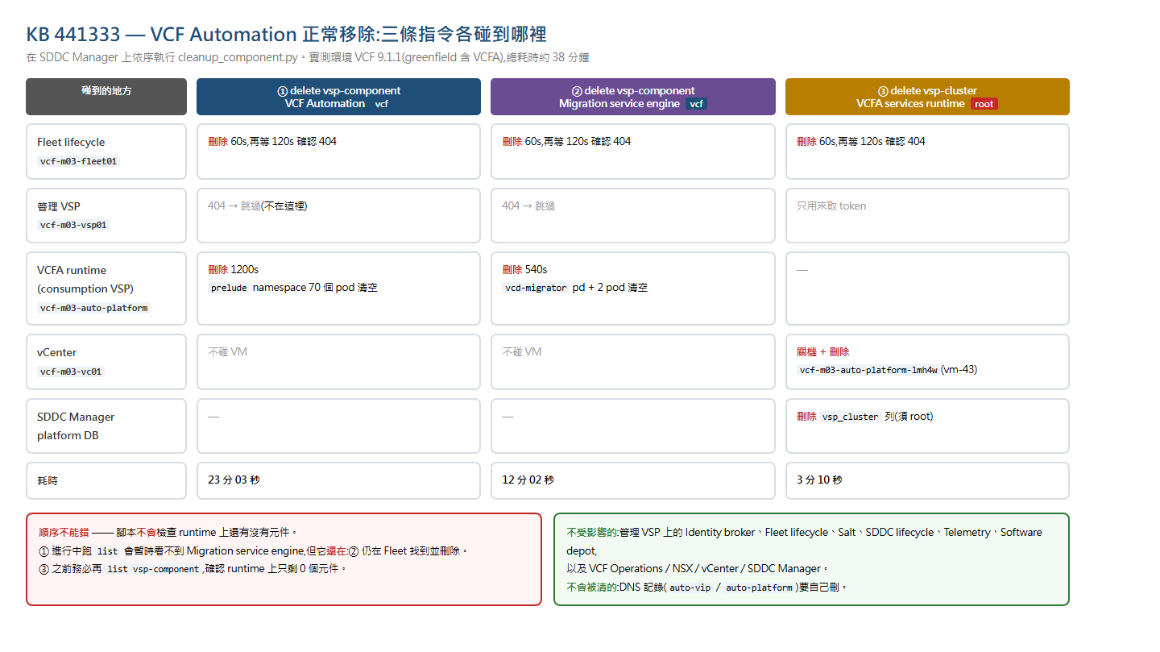
圖 1 三條指令分別作用在 Fleet、管理 VSP、VCFA runtime、vCenter、SDDC Manager DB 的情形

三、環境與前提
角色 | FQDN | IP
SDDC Manager(執行腳本的地方) | vcf-m03-sddcm01.home.lab | 10.0.1.65
Fleet lifecycle | vcf-m03-fleet01.home.lab | 10.0.1.67
VCF services runtime(管理 VSP) | vcf-m03-vsp01.home.lab | VIP .69,節點 .82/.83/.84
VCFA services runtime(consumption VSP) | vcf-m03-auto-platform.home.lab | VIP .73,節點 .98
VCF Automation console | vcf-m03-auto-vip.home.lab | 10.0.1.72
vCenter | vcf-m03-vc01.home.lab | 10.0.1.60

前提
- VCF 9.1.1,VCFA 版本 9.1.1.0.25714559(≥ 9.1 才會真的刪除實體;< 9.1 只會清 Fleet 帳面)。
- 能以 vcf 帳號 SSH 進 SDDC Manager,並知道 root 密碼。
- 知道兩個 VSP 的 admin 密碼,以及 vCenter 的 administrator@vsphere.local 密碼。
- 本次 VCFA 尚未啟用 Supervisor(provider 首頁顯示 Pre-requisites for setup are missing)。

四、Step 0 — 移除前狀態
先把移除前的狀態完整記下來,事後才有東西對照。
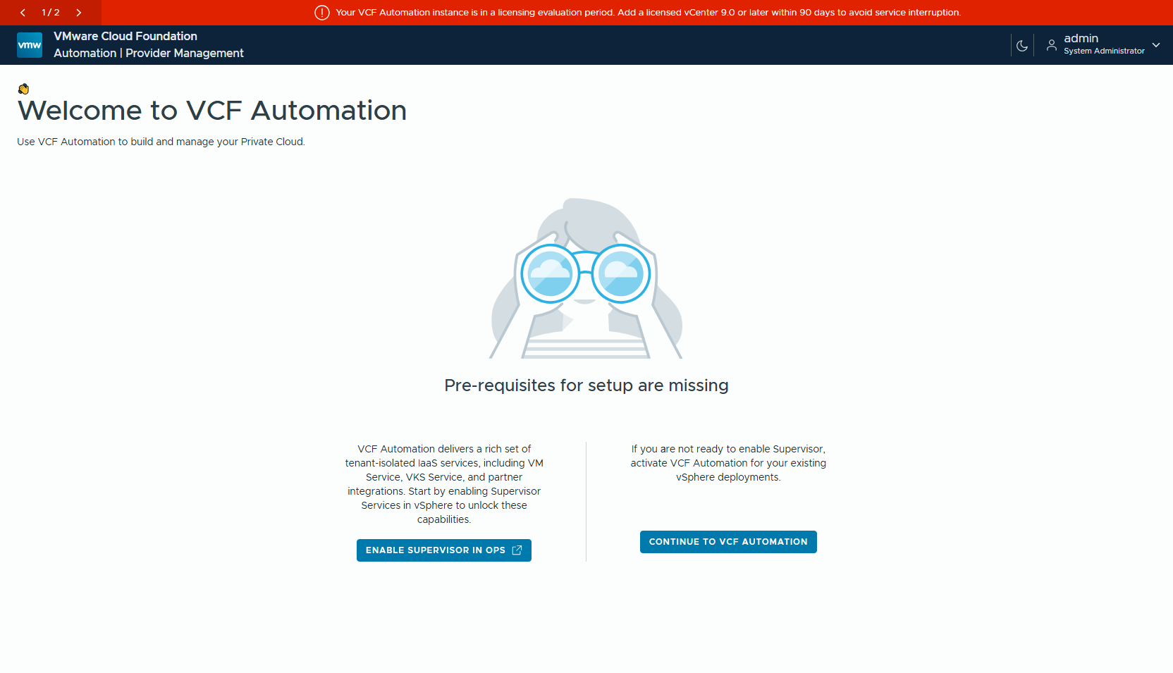
圖 2 移除前:VCFA provider 可正常登入(admin / System Administrator)
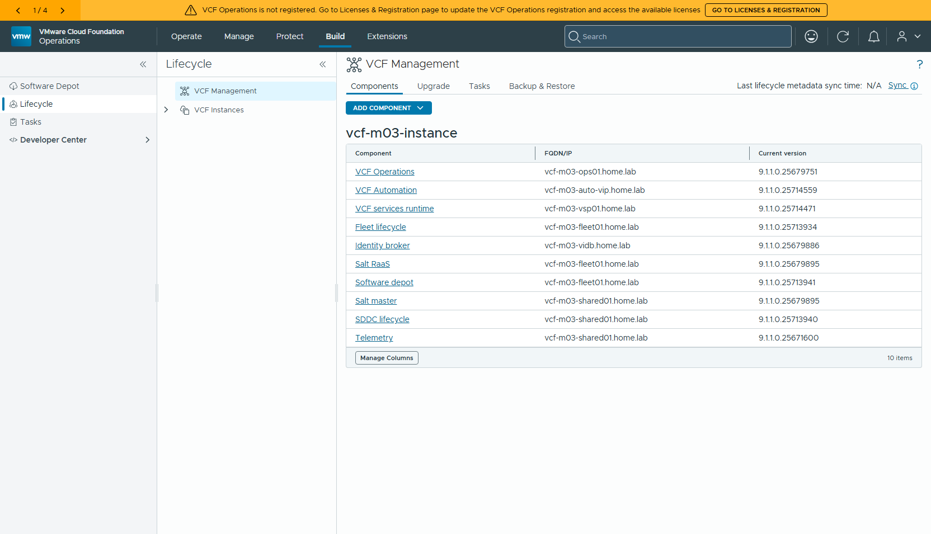
圖 3 移除前:VCF Operations → Build → Lifecycle → Components,共 10 個元件,VCF Automation 9.1.1.0.25714559 在列
# 移除前狀態 — 2026-10-07 11:34:32
## vCenter(vcf-m03-vc01)上的 VM
vcf-m03-auto-platform-lmh4w 24 vCPU 96 GB 10.0.1.98 poweredOn
vcf-m03-lic01 2 vCPU 4 GB 10.0.1.62 poweredOn
vcf-m03-nsx01a 6 vCPU 24 GB 10.0.1.64 poweredOn
vcf-m03-ops01 4 vCPU 16 GB 10.0.1.61 poweredOn
vcf-m03-opsc01 4 vCPU 16 GB 10.0.1.66 poweredOn
vcf-m03-sddcm01 4 vCPU 16 GB 10.0.1.65 poweredOn
vcf-m03-vc01 4 vCPU 21 GB 10.0.1.60 poweredOn
vcf-m03-vsp01-fz8hf 4 vCPU 10 GB 10.0.1.82 poweredOn
vcf-m03-vsp01-g7m86 12 vCPU 24 GB 10.0.1.83 poweredOn
vcf-m03-vsp01-kdwcz 12 vCPU 24 GB 10.0.1.84 poweredOn
vcf-services-runtime-template-9.1.1.0.25714471 6 vCPU 24 GB - poweredOff
## 端點
https://vcf-m03-auto-vip.home.lab/automation/ 200
https://vcf-m03-auto-vip.home.lab/provider 301
https://vcf-m03-auto-platform.home.lab/ 404
https://vcf-m03-vsp01.home.lab/ 404
https://vcf-m03-fleet01.home.lab/ 404
## DNS
vcf-m03-auto-vip 10.0.1.72
vcf-m03-auto-platform 10.0.1.73
vcf-m03-vsp01 10.0.1.69
vcf-m03-fleet01 10.0.1.67

五、Step 1 — 把腳本傳到 SDDC Manager
腳本要在 SDDC Manager 上執行(③ 會直接操作 SDDC Manager 的本機資料庫)。傳完比對 sha256。
# Step 1 — 把 cleanup_component.py 傳到 SDDC Manager
# 本機 sha256:
253bf30d0b33e0c6640aa6cbdf96de41a4a6d75d0265db269b1f44099308ca4c */e/9.1/cleanup_component.py
$ pscp cleanup_component.py vcf@vcf-m03-sddcm01.home.lab:/home/vcf/
cleanup_component.py | 4 kB | 4.0 kB/s | ETA: 00:00:09 | 9%cleanup_component.py | 40 kB | 40.6 kB/s | ETA: 00:00:00 | 100%
$ ls -l /home/vcf/cleanup_component.py ; sha256sum /home/vcf/cleanup_component.py
-rw-r--r-- 1 vcf vcf 41591 Oct 7 03:33 /home/vcf/cleanup_component.py
253bf30d0b33e0c6640aa6cbdf96de41a4a6d75d0265db269b1f44099308ca4c /home/vcf/cleanup_component.py

六、Step 2 — 確認 VSP 認證帳號
腳本對 VSP 的認證是 POST https://<vsp>/api/v1/identity/token(form-urlencoded,grant_type=password)。直接打一次,確認哪個帳號拿得到 token:
# Step 2 — 驗 VSP 認證帳號(從 SDDC Manager 打 /api/v1/identity/token)
vcf-m03-vsp01.home.lab admin HTTP 200 ✅ 拿到 access_token
vcf-m03-vsp01.home.lab administrator@vsphere.local HTTP 401 ❌ {"error":"access_denied","error_description":"invalid credentials. incorrect credentials"}
vcf-m03-auto-platform.home.lab admin HTTP 200 ✅ 拿到 access_token
vcf-m03-auto-platform.home.lab administrator@vsphere.local HTTP 401 ❌ {"error":"access_denied","error_description":"invalid credentials. incorrect credentials"}
只有 admin 拿得到 token;administrator@vsphere.local 兩個 VSP 都回 401 access_denied。之前曾因此誤判「官方腳本需要 VSP 認證、無法執行」,其實只是帳號用錯。
腳本會在任何刪除動作之前先驗證帳密(validate_vsp_credentials),帳號錯不會刪到一半。

七、Step 3 — 列出要刪的元件 ID
list 是唯讀操作,用 vcf 帳號即可。
$ python3 cleanup_component.py list vsp-component \
-ff vcf-m03-fleet01.home.lab -vsrf vcf-m03-vsp01.home.lab -vsru admin -vsrp ********
Authenticating with VSP platform (vcf-m03-vsp01.home.lab)...
Authentication successful.
Fetching VSP components from Fleet...
Available VSP Components:
------------------------------------------------------------------------------------------------
ID | Type | Deployment | Version | FQDN | VCF Services Runtime FQDN
------------------------------------------------------------------------------------------------
12f80ada-c354-4b4d-9a19-6318ce58fe49 | VCF Automation | VSP | 9.1.1.0.25714559 | vcf-m03-auto-vip.home.lab | vcf-m03-auto-platform.home.lab
fe04c14c-4c68-4db4-b91b-05006adf5139 | Identity broker | VSP | 9.1.1.0.25679886 | vcf-m03-vidb.home.lab | vcf-m03-vsp01.home.lab
9c064f80-f259-4c50-98a8-97fbccf26cdc | VCD_MIGRATOR | VSP | 9.1.1.0.25714559 | N/A | vcf-m03-auto-platform.home.lab
------------------------------------------------------------------------------------------------
$ python3 cleanup_component.py list vsp-cluster \
-ff vcf-m03-fleet01.home.lab -vsrf vcf-m03-vsp01.home.lab -vsru admin -vsrp ********
Authenticating with VSP platform (vcf-m03-vsp01.home.lab)...
Authentication successful.
Fetching VSP components from Fleet...
Available VSP Components:
------------------------------------------------------------------------------------------------
ID | Type | Deployment | Version | FQDN | VCF Services Runtime FQDN
------------------------------------------------------------------------------------------------
4fde9186-f3d4-48d6-ab64-a06664dad047 | VCF services runtime | VSP | 9.1.1.0.25714471 | vcf-m03-auto-platform.home.lab | vcf-m03-auto-platform.home.lab
------------------------------------------------------------------------------------------------
ID | 類型 | 跑在哪個 runtime | 處理
12f80ada-…-6318ce58fe49 | VCF Automation | vcf-m03-auto-platform | ① 刪除
9c064f80-…-97fbccf26cdc | VCD_MIGRATOR(Migration service engine) | vcf-m03-auto-platform | ② 刪除
4fde9186-…-a06664dad047 | VCF services runtime(VCFA 用) | — | ③ 刪除
fe04c14c-…-05006adf5139 | Identity broker | vcf-m03-vsp01(管理 VSP) | ⛔ 不能碰

VCD_MIGRATOR 也住在 VCFA runtime 上。它是 VCFA 部署時一起裝的 Migration service engine,必須在刪 runtime 之前另外刪掉。

八、Step 4 — ① 刪除 VCF Automation 元件
要同時給管理 VSP(-vsrf)與 VCFA runtime(-varf)的帳密,腳本才會連 VCFA runtime 上的元件一起處理。
# Step ① — 刪除 VCF Automation 元件 2026-10-07 11:37:29
$ python3 cleanup_component.py delete vsp-component \
-c 12f80ada-c354-4b4d-9a19-6318ce58fe49 \
-ff vcf-m03-fleet01.home.lab \
-vsrf vcf-m03-vsp01.home.lab -vsru admin -vsrp ******** \
-varf vcf-m03-auto-platform.home.lab -varu admin -varp ******** \
-fd
Authenticating with VSP platform (vcf-m03-vsp01.home.lab)...
Authentication successful.
Authenticating with VSP platform (vcf-m03-auto-platform.home.lab)...
Authentication successful.
Deleting component '12f80ada-c354-4b4d-9a19-6318ce58fe49' from Fleet...
Delete task initiated (ID: 01a1146d-a9ae-75ae-ad6d-c4bcf0904371)
Waiting for task 01a1146d-a9ae-75ae-ad6d-c4bcf0904371 to complete (timeout: 7200 seconds)...
Task status: RUNNING | Elapsed time: 0s
Task status: RUNNING | Elapsed time: 30s
Task status: SUCCEEDED | Elapsed time: 60s
Successfully deleted component '12f80ada-c354-4b4d-9a19-6318ce58fe49' from Fleet.
Waiting 120 seconds before checking if component 12f80ada-c354-4b4d-9a19-6318ce58fe49 has been successfully deleted from Fleet...
Component '12f80ada-c354-4b4d-9a19-6318ce58fe49' does not exist in Fleet (HTTP 404).
Component '12f80ada-c354-4b4d-9a19-6318ce58fe49' does not exist in VSP (HTTP 404).
Checking Consumption VSP (vcf-m03-auto-platform.home.lab) for component...
Authenticating with VSP platform (vcf-m03-auto-platform.home.lab)...
Authentication successful.
Deleting component '12f80ada-c354-4b4d-9a19-6318ce58fe49' from VSP...
Delete task initiated (ID: ybtawneti5c5zecrovul22l42u)
Waiting for task ybtawneti5c5zecrovul22l42u to complete (timeout: 7200 seconds)...
Task status: PENDING | Elapsed time: 0s
Task status: RUNNING | Elapsed time: 30s
…(中間 37 次 RUNNING 省略)…
Task status: RUNNING | Elapsed time: 1170s
Task status: SUCCEEDED | Elapsed time: 1200s
Successfully deleted component '12f80ada-c354-4b4d-9a19-6318ce58fe49' from VSP.
real 23m3.064s
user 0m0.381s
sys 0m0.159s
流程:先刪 Fleet(60 秒)→ 等 120 秒回頭確認 404 → 查管理 VSP(不在,跳過)→ 到 VCFA runtime 刪除(1200 秒)。

VCFA runtime 上的刪除任務
從 VCFA runtime 的 /api/v1/tasks 查到的任務,三個 stage:
{
"cancellable": false,
"createTime": "2026-10-07T03:37:54Z",
"createdBy": "admin@vsp.local",
"endTime": null,
"id": "ybtawneti5c5zecrovul22l42u",
"messages": [],
"output": null,
"phase": "Running",
"precheckGroups": [],
"resource": {
"componentId": "12f80ada-c354-4b4d-9a19-6318ce58fe49"
},
"result": null,
"retryable": true,
"stages": [
{
"description": "Running Delete Component Prechecks",
"name": "delete-component",
"stageType": "Precheck",
"status": "Succeeded"
},
{
"description": "VCF Component Delete Initialization",
"name": "delete-component-initialization",
"stageType": "Workflow",
"status": "Succeeded"
},
{
"description": "Delete VCF Component",
"name": "delete-component",
"stageType": "Workflow",
"status": "Running"
}
],
"startTime": "2026-10-07T03:37:55Z",
"status": "Running",
"type": "com.vmware.vcfms.task.DeleteComponent"
}

卸載過程
每分鐘記一次 VCFA runtime 上 prelude(VCFA 本體)namespace 的 pod 狀態,可以看到 pod 逐步進入 CreateContainerConfigError / ContainerCreating 後被清空:
# VCFA 卸載時間軸(每 60 秒)
# 時間 任務狀態 stage3 prelude(R/C/其他) vcd-migrator cleanup 程序
11:49:09 Running Running 8 Completed 2 CreateContainerConfigError 60 Running | 2 running
11:50:18 Running Running 8 Completed 1 CreateContainerConfigError 46 Running 15 Terminating | 2 running
11:51:25 Running Running 8 Completed 2 Running 3 Terminating | 2 running
11:52:30 Running Running 2 ContainerCreating | 2 running
11:53:35 Running Running | 2 running
11:54:40 Running Running | 2 running
11:55:46 Running Running | 2 running
11:56:50 Running Running | 2 running
11:57:55 Running Running | 2 running
11:59:00 Running Running | 2 running
12:00:06 ? ? | 2 running
12:01:11 ? ? | 2 running
12:02:16 ? ? | 2 running
12:03:21 ? ? | 2 running
12:04:27 ? ? | 2 running
12:05:33 ? ? | 2 running
12:06:39 ? ? | 2 running
12:07:44 ? ? | 2 running
12:08:49 ? ? | 1 running
12:09:54 ? ? | 0 running
12:10:59 ? ? | 0 running
12:12:04 ? ? | 0 running
12:13:09 ? ? | 0 running
12:14:14 ? ? | 0 running
12:15:18 ? ? | 0 running
12:16:23 ? ? | 0 running
12:18:08 ? ? ? running
12:19:37 ? ? ? running
12:21:06 ? ? ? running
12:22:35 ? ? ? running
12:24:04 ? ? ? running
12:25:33 ? ? ? running
12:27:02 ? ? ? running
12:28:31 ? ? ? running
12:30:00 ? ? ? running
12:31:29 ? ? ? running
透過 ssh 執行 python 沒有 TTY,stdout 會被緩衝,刪除期間畫面完全沒輸出。建議改用 python3 -u。

九、Step 5 — ② 刪除 Migration service engine 元件
① 進行中如果跑 list vsp-component,會暫時看不到 VCD_MIGRATOR —— 但它並沒有被刪掉。下面的輸出顯示 ② 仍在 Fleet 中找到它並執行刪除(Deleting component ... from Fleet → SUCCEEDED)。不要因為 list 看不到就跳過這一步。
# Step ② — 刪除 VCD_MIGRATOR(Migration service engine)元件 2026-10-07 12:01:09
$ python3 -u cleanup_component.py delete vsp-component \
-c 9c064f80-f259-4c50-98a8-97fbccf26cdc \
-ff vcf-m03-fleet01.home.lab \
-vsrf vcf-m03-vsp01.home.lab -vsru admin -vsrp ******** \
-varf vcf-m03-auto-platform.home.lab -varu admin -varp ******** \
-fd
Authenticating with VSP platform (vcf-m03-vsp01.home.lab)...
Authentication successful.
Authenticating with VSP platform (vcf-m03-auto-platform.home.lab)...
Authentication successful.
Deleting component '9c064f80-f259-4c50-98a8-97fbccf26cdc' from Fleet...
Delete task initiated (ID: 01a11483-5498-7572-9d10-21a29d8cf4c5)
Waiting for task 01a11483-5498-7572-9d10-21a29d8cf4c5 to complete (timeout: 7200 seconds)...
Task status: RUNNING | Elapsed time: 0s
Task status: RUNNING | Elapsed time: 30s
Task status: SUCCEEDED | Elapsed time: 60s
Successfully deleted component '9c064f80-f259-4c50-98a8-97fbccf26cdc' from Fleet.
Waiting 120 seconds before checking if component 9c064f80-f259-4c50-98a8-97fbccf26cdc has been successfully deleted from Fleet...
Component '9c064f80-f259-4c50-98a8-97fbccf26cdc' does not exist in Fleet (HTTP 404).
Component '9c064f80-f259-4c50-98a8-97fbccf26cdc' does not exist in VSP (HTTP 404).
Checking Consumption VSP (vcf-m03-auto-platform.home.lab) for component...
Authenticating with VSP platform (vcf-m03-auto-platform.home.lab)...
Authentication successful.
Deleting component '9c064f80-f259-4c50-98a8-97fbccf26cdc' from VSP...
Delete task initiated (ID: mndfw6dezbf5lcbnrfcouytlgi)
Waiting for task mndfw6dezbf5lcbnrfcouytlgi to complete (timeout: 7200 seconds)...
Task status: PENDING | Elapsed time: 0s
Task status: RUNNING | Elapsed time: 30s
…(中間 15 次 RUNNING 省略)…
Task status: RUNNING | Elapsed time: 510s
Task status: SUCCEEDED | Elapsed time: 540s
Successfully deleted component '9c064f80-f259-4c50-98a8-97fbccf26cdc' from VSP.
real 12m1.873s
user 0m0.258s
sys 0m0.135s
刪除後再 list 一次,VCFA runtime 上已經沒有任何元件,只剩管理 VSP 上的 Identity broker:
# Step ③ 之前 — 確認 VCFA runtime 上已經沒有元件 12:13:29
$ python3 -u cleanup_component.py list vsp-component ...
Authenticating with VSP platform (vcf-m03-vsp01.home.lab)...
Authentication successful.
Fetching VSP components from Fleet...
Available VSP Components:
------------------------------------------------------------------------------------------------
ID | Type | Deployment | Version | FQDN | VCF Services Runtime FQDN
------------------------------------------------------------------------------------------------
fe04c14c-4c68-4db4-b91b-05006adf5139 | Identity broker | VSP | 9.1.1.0.25679886 | vcf-m03-vidb.home.lab | vcf-m03-vsp01.home.lab
------------------------------------------------------------------------------------------------
$ python3 -u cleanup_component.py list vsp-cluster ...
Authenticating with VSP platform (vcf-m03-vsp01.home.lab)...
Authentication successful.
Fetching VSP components from Fleet...
Available VSP Components:
------------------------------------------------------------------------------------------------
ID | Type | Deployment | Version | FQDN | VCF Services Runtime FQDN
------------------------------------------------------------------------------------------------
4fde9186-f3d4-48d6-ab64-a06664dad047 | VCF services runtime | VSP | 9.1.1.0.25714471 | vcf-m03-auto-platform.home.lab | vcf-m03-auto-platform.home.lab
------------------------------------------------------------------------------------------------

十、Step 6 — 在 SDDC Manager 取得 root
③ 會直接改 SDDC Manager 的 platform 資料庫,腳本會檢查兩件事:os.geteuid() == 0,以及 http://localhost/commonsvcs/about 回傳 name=COMMON_SERVICES。
vcf 帳號不在 sudoers,su 又必須在終端機裡執行。用 python 的 pty 模組開虛擬終端、看到密碼提示就送出密碼:
# Step ③-準備 — 在 SDDC Manager 取得 root
$ sudo -n id # vcf 不在 sudoers
sudo: a password is required
$ su - root -c id # 沒有 TTY 會失敗
su: must be run from a terminal
$ ROOTPW=******** python3 asroot.py "id; curl -s http://localhost/commonsvcs/about"
uid=0(root) gid=0(root) groups=0(root)
{"id":"59279484-a78b-4269-8f84-3b4919d5d533","name":"COMMON_SERVICES","version":"9.1.1.0.25713929","status":"ACTIVE","serviceUrl":"http://localhost/commonsvcs","description":"Platform services"}
# asroot.py(核心邏輯)
pid, fd = pty.fork()
if pid == 0:
os.execvp("su", ["su", "-", "root", "-c", cmd])
# 父程序:讀到 "assword" 就寫入 root 密碼 + 換行,其餘輸出照印

十一、Step 7 — ③ 刪除 VCFA services runtime
這一步要給 vCenter 帳密(-vu / -vp),腳本會從 Fleet 取得 runtime 的 VM 清單與所在 vCenter,然後關機刪除。
# Step ③ — 刪除 VCFA VCF services runtime(必須 root) 2026-10-07 12:13:50
# python3 -u cleanup_component.py delete vsp-cluster \
-c 4fde9186-f3d4-48d6-ab64-a06664dad047 \
-ff vcf-m03-fleet01.home.lab \
-vsrf vcf-m03-vsp01.home.lab -vsru admin -vsrp ******** \
-vu administrator@vsphere.local -vp ******** \
-fd
whoami: root time: 2026-10-07 04:11:13
Verifying this script is running as root on the SDDC Manager VM...
Verified: running as root on the SDDC Manager VM.
Authenticating with VSP platform (vcf-m03-vsp01.home.lab)...
Authentication successful.
Fetching component '4fde9186-f3d4-48d6-ab64-a06664dad047' details from Fleet...
Component has 1 VM node(s): vcf-m03-auto-platform-lmh4w
Hosting vCenter: vcf-m03-vc01.home.lab
Authenticating with vCenter (vcf-m03-vc01.home.lab)...
vCenter authentication successful.
Deleting component '4fde9186-f3d4-48d6-ab64-a06664dad047' from Fleet...
Delete task initiated (ID: 01a1148e-eff4-7648-84ba-92d0faa51ee9)
Waiting for task 01a1148e-eff4-7648-84ba-92d0faa51ee9 to complete (timeout: 7200 seconds)...
Task status: RUNNING | Elapsed time: 0s
Task status: RUNNING | Elapsed time: 30s
Task status: SUCCEEDED | Elapsed time: 60s
Successfully deleted component '4fde9186-f3d4-48d6-ab64-a06664dad047' from Fleet.
Waiting 120 seconds before checking if component 4fde9186-f3d4-48d6-ab64-a06664dad047 has been successfully deleted from Fleet...
Component '4fde9186-f3d4-48d6-ab64-a06664dad047' does not exist in Fleet (HTTP 404).
Authenticating with vCenter (vcf-m03-vc01.home.lab)...
vCenter authentication successful.
Looking up VM 'vcf-m03-auto-platform-lmh4w' in vCenter...
Found VM 'vcf-m03-auto-platform-lmh4w' with identifier 'vm-43'.
Checking power state for VM 'vcf-m03-auto-platform-lmh4w' (vm-43)...
Powering off VM 'vcf-m03-auto-platform-lmh4w'...
Successfully powered off VM 'vcf-m03-auto-platform-lmh4w'.
Deleting VM 'vcf-m03-auto-platform-lmh4w' (vm-43) from vCenter...
Successfully deleted VM 'vcf-m03-auto-platform-lmh4w' (vm-43) from vCenter.
Deleting VSP cluster '4fde9186-f3d4-48d6-ab64-a06664dad047' from the platform database...
Successfully deleted VSP cluster '4fde9186-f3d4-48d6-ab64-a06664dad047' from the platform database.
psql output: DO
real 3m10.212s
user 0m0.265s
sys 0m0.211s
動作 | 結果
驗證 root | Verified: running as root on the SDDC Manager VM
Fleet 刪除 | task 01a1148e… SUCCEEDED(60 秒),120 秒後確認 404
vCenter | vm-43 vcf-m03-auto-platform-lmh4w 關機 → 刪除
SDDC Manager platform DB | vsp_cluster 紀錄刪除(psql: DO)

十二、Step 8 — 移除後驗證
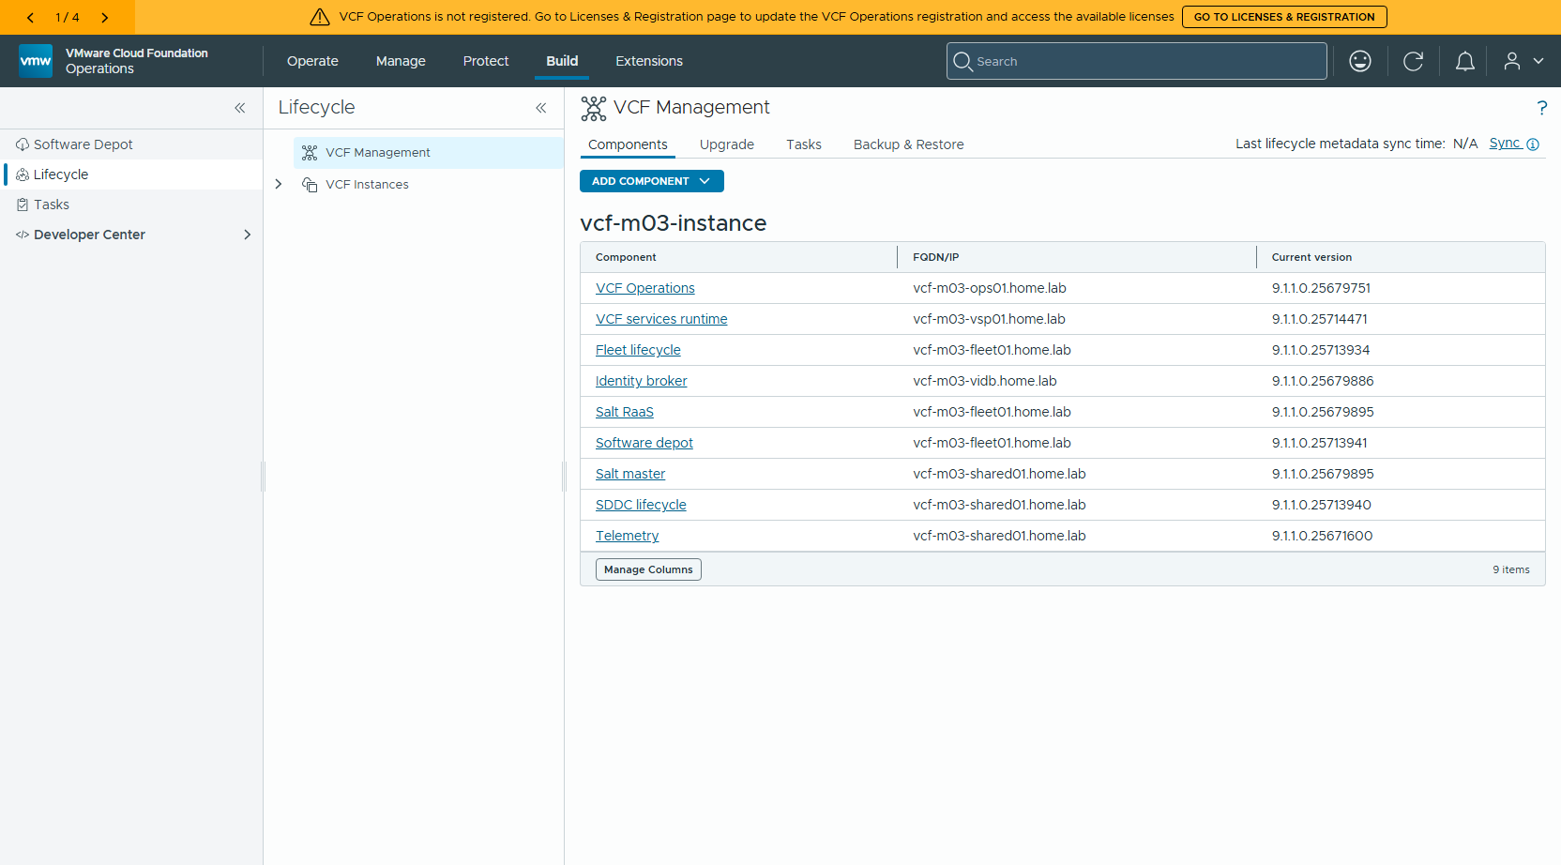
圖 4 移除後:Fleet 元件剩 9 個,VCF Automation 已不在清單
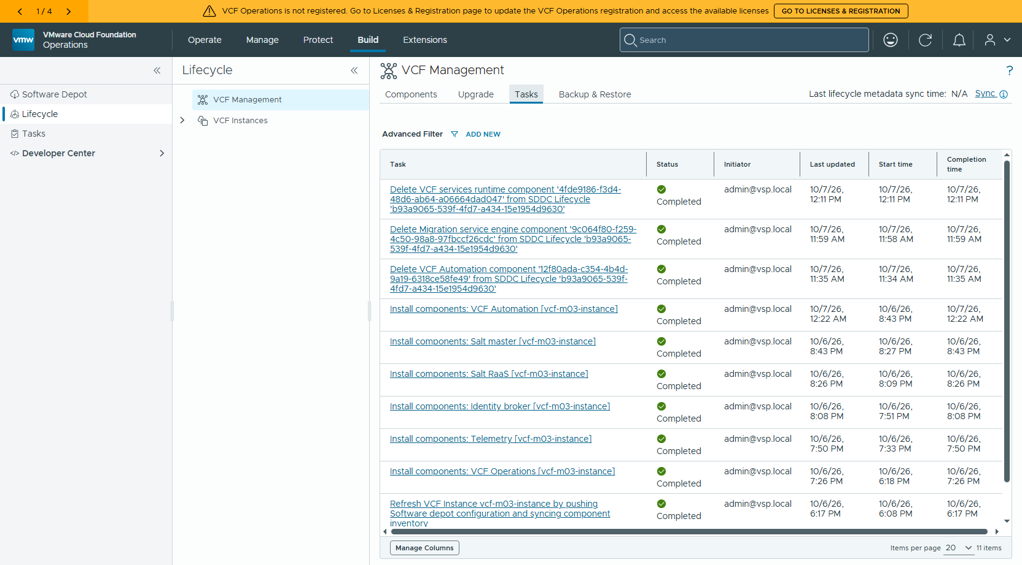
圖 5 移除後:Fleet → Tasks 留有三筆刪除紀錄,狀態皆為 Completed
Delete VCF Automation component 12f80ada… Completed
Delete Migration service engine component 9c064f80… Completed
Delete VCF services runtime component 4fde9186… Completed
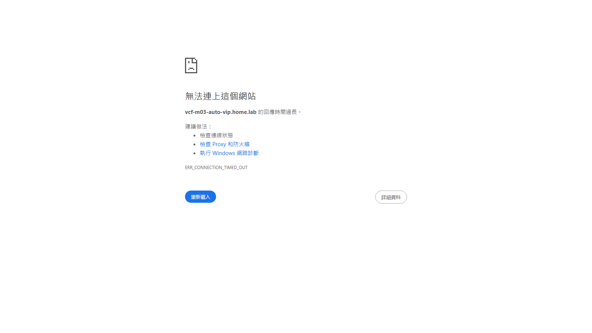
圖 6 移除後:VCFA console 連線逾時(net::ERR_CONNECTION_TIMED_OUT)
# 移除後狀態 — 2026-10-07 12:17:18
## vCenter(vcf-m03-vc01)上的 VM
vcf-m03-lic01 2 vCPU 4 GB 10.0.1.62 poweredOn
vcf-m03-nsx01a 6 vCPU 24 GB 10.0.1.64 poweredOn
vcf-m03-ops01 4 vCPU 16 GB 10.0.1.61 poweredOn
vcf-m03-opsc01 4 vCPU 16 GB 10.0.1.66 poweredOn
vcf-m03-sddcm01 4 vCPU 16 GB 10.0.1.65 poweredOn
vcf-m03-vc01 4 vCPU 21 GB 10.0.1.60 poweredOn
vcf-m03-vsp01-fz8hf 4 vCPU 10 GB 10.0.1.82 poweredOn
vcf-m03-vsp01-g7m86 12 vCPU 24 GB 10.0.1.83 poweredOn
vcf-m03-vsp01-kdwcz 12 vCPU 24 GB 10.0.1.84 poweredOn
vcf-services-runtime-template-9.1.1.0.25714471 6 vCPU 24 GB - poweredOff
## 端點
https://vcf-m03-auto-vip.home.lab/automation/ 000
https://vcf-m03-auto-vip.home.lab/provider 000
https://vcf-m03-vidb.home.lab/ 404
https://vcf-m03-ops01.home.lab/ 200
(000 = 連不上)
## DNS(腳本不會動 DNS)
vcf-m03-auto-vip 10.0.1.72
vcf-m03-auto-platform 10.0.1.73
## SDDC Manager platform DB:vsp_cluster
1
16fbc3aa-0413-4df2-adc0-a8534bbe01f4
↑ 第一行=筆數,之後=剩下的 vsp_cluster_id(4fde9186… 應該不在)
## Identity broker 是否受影響(管理 VSP 上的 vidb pod)
NAMESPACE NAME AGE PHASE STATUS
salt-raas salt-raas 15h Successful successful package deployment
salt salt 15h Successful successful package deployment
telemetry telemetry-acceptor 16h Successful successful package deployment
vcf-fleet-depot vcf-fleet-depot 18h Successful successful package deployment
vcf-fleet-lcm vcf-fleet-lcm 18h Successful successful package deployment
vcf-sddc-lcm vcf-sddc-lcm 18h Successful successful package deployment
vidb-external vidb 16h Successful successful package deployment
vmsp-platform vmsp-platform 19h Successful successful package deployment
2 Running
## ping 10.0.1.98 判讀
Reply from 10.0.0.200: Destination host unreachable. ← 本機自己回的,不是目標
Test-Connection 3 次全 TimedOut ← 10.0.1.98 確實已不存在
⚠ Windows ping 會把「Destination host unreachable」算進 Received,不能只看收到幾個
檢查項目 | 移除前 | 移除後
Fleet 元件數 | 10 | 9(VCF Automation 消失)
vCenter VM | 11(含 auto-platform-lmh4w) | 10(auto-platform-lmh4w 已刪)
VCFA /automation/ | 200 | 000(連不上)
10.0.1.98(runtime 節點) | 有回應 | Test-Connection 全 TimedOut
platform DB vsp_cluster | 含 4fde9186…(移除前未直接查;③ 刪除時腳本確認它存在並刪除) | 1 筆,只剩管理 VSP 的 16fbc3aa…
Identity broker(管理 VSP) | pd Successful | pd Successful、2 pod Running(未受影響)
DNS auto-vip / auto-platform | 存在 | 仍存在(腳本不處理 DNS)

十三、注意事項與坑
症狀 / 情境 | 原因 | 做法
Failed to obtain VSP token (HTTP 401) | 用了 administrator@vsphere.local | VSP 帳號一律用 admin
① 進行中 list 看不到 VCD_MIGRATOR | Fleet 清單暫時性的狀態 | 不要跳過 ②;③ 之前再 list 確認
直接跑 ③ 會留下孤兒 | 腳本不檢查 runtime 上是否還有元件 | 嚴守 ① → ② → ③ 順序
③ 報 must be root | vsp-cluster 刪除要改本機 DB | 用 pty 執行 su(見 Step 6)
刪除期間畫面沒輸出 | ssh 無 TTY,python stdout 緩衝 | python3 -u
元件版本 < 9.1 | should_skip_infra_deletion 會跳過實體刪除 | 只會清 Fleet 帳面,VM 要另外處理
ping 看起來有回應 | Windows 把 Destination host unreachable 算成 Received | 看回應來源,或用 Test-Connection
DNS 記錄還在 | 腳本不處理 DNS | 自行刪除 auto-vip / auto-platform 的 A 與 PTR

已知後續問題(KB 441127):VCFA 元件移除後若要再加回,可能因 infrastructure properties 為 NULL 而無法 import。移除前請確認之後不會需要原地加回同一套。

附錄 A:可直接複製的完整指令
以下在 SDDC Manager 上執行;密碼以變數代替。
# 0) 準備
cd /home/vcf
export VSPPW='<VSP admin 密碼>' VCPW='<vCenter administrator@vsphere.local 密碼>'
FLEET=vcf-m03-fleet01.home.lab
MGMT_VSP=vcf-m03-vsp01.home.lab
VCFA_VSP=vcf-m03-auto-platform.home.lab
# 1) 列出 ID(唯讀)
python3 -u cleanup_component.py list vsp-component -ff $FLEET -vsrf $MGMT_VSP -vsru admin -vsrp "$VSPPW"
python3 -u cleanup_component.py list vsp-cluster -ff $FLEET -vsrf $MGMT_VSP -vsru admin -vsrp "$VSPPW"
# 2) ① 刪 VCF Automation(vcf 帳號即可)
python3 -u cleanup_component.py delete vsp-component -c <VCFA_ID> \
-ff $FLEET -vsrf $MGMT_VSP -vsru admin -vsrp "$VSPPW" \
-varf $VCFA_VSP -varu admin -varp "$VSPPW" -fd
# 3) ② 刪 Migration service engine(VCD_MIGRATOR)
python3 -u cleanup_component.py delete vsp-component -c <VCD_MIGRATOR_ID> \
-ff $FLEET -vsrf $MGMT_VSP -vsru admin -vsrp "$VSPPW" \
-varf $VCFA_VSP -varu admin -varp "$VSPPW" -fd
# 4) 再 list 一次,確認 VCFA runtime 上已經沒有元件
python3 -u cleanup_component.py list vsp-component -ff $FLEET -vsrf $MGMT_VSP -vsru admin -vsrp "$VSPPW"
# 5) ③ 刪 VCFA services runtime(必須 root)
python3 -u cleanup_component.py delete vsp-cluster -c <VSP_CLUSTER_ID> \
-ff $FLEET -vsrf $MGMT_VSP -vsru admin -vsrp "$VSPPW" \
-vu administrator@vsphere.local -vp "$VCPW" -fd

附錄 B:腳本參數一覽
參數 | 長名稱 | 用在 | 說明
-ff | --fleet-fqdn | 全部 | Fleet lifecycle 的 FQDN
-vsrf | --vcf-services-runtime-fqdn | 全部 | 管理 VSP 的 FQDN
-vsru / -vsrp | --vcf-services-runtime-username/password | 全部 | 管理 VSP 帳密(帳號用 admin)
-c | --component-id | delete | 要刪的元件或 runtime ID
-fd | --force-delete | delete | 不詢問直接刪
-varf | --vcfa-vcf-services-runtime-fqdn | delete vsp-component | VCFA runtime FQDN(刪 VCFA / Migration service engine 必填)
-varu / -varp | --vcfa-vcf-services-runtime-username/password | delete vsp-component | VCFA runtime 帳密(帳號用 admin)
-vu / -vp | --vcenter-username/password | delete vsp-cluster | vCenter 帳密,用來關機刪 VM

常數 | 值 | 意義
POLL_INTERVAL_IN_SECONDS | 30 | 每 30 秒查一次任務狀態
MAX_POLL_TIME_IN_SECONDS | 7200 | 單一任務最多等 2 小時
FLEET_DELETE_RETRY_DELAY_IN_SECONDS | 120 | Fleet 刪完後等 2 分鐘回頭確認

