ESXi 9.1.1 Installation Step-by-Step
Physical server installation: from ISO boot to Host Client initial configuration
2026-10-27 · VMware ESXi 9.1.1.0 build 25714478

Contents
1. About This Document and Planning Values
2. Preparation
3. Booting from the ISO
4. Installation Wizard
5. Configuring the Management Network in the DCUI
6. Initial Configuration in the Host Client
7. Post-Installation Verification
8. Troubleshooting and Notes

1. About This Document and Planning Values
This document describes how to install VMware ESXi 9.1.1 (build 25714478) on a physical server from the original ISO — from booting the installer, through the installation wizard and DCUI management network configuration, to the initial configuration in the ESXi Host Client and post-installation verification. All screenshots were captured during an actual installation.
- Installer and DCUI screens: operated on the server's local console or the BMC remote console (iDRAC / iLO / XCC)
- Host Client screens: operated in a web browser at https://<host FQDN>/ui/
The example values used in this document are listed below. Replace them with the customer's planned values for an actual installation; all other steps stay the same.
Item | Example value | Notes
Installation media | VMware-VMvisor-Installer-9.1.1.0.25714478.x86_64.iso | Original ISO downloaded from the Broadcom Support Portal (699.5 MB)
Host FQDN | esx911-demo.home.lab | Lowercase, including the domain; create both forward and reverse DNS records in advance
Management IP / mask | 10.0.0.88 / 255.255.254.0 (/23) | Static IP for vmk0
Default gateway | 10.0.0.1
DNS server | 10.0.0.200
DNS suffix | home.lab
NTP server | 10.0.1.254 | Same time source as vCenter / other VCF components
VLAN | None (access port) | A VLAN ID is only needed in the DCUI for a trunk port
Datastore name | esx911-demo-ds01 | Created on a local disk or SAN LUN other than the boot device
root password | Provided separately | Not listed in this document

2. Preparation

Hardware and compatibility
- The server, CPU, NICs, and HBA / RAID controllers must be listed as supported for ESXi 9.1.1 in the Broadcom Compatibility Guide.
- Boot device: 32 GB minimum; a persistent device of 128 GB or larger is recommended (M.2 / BOSS card / local SSD). Using an SD card or USB flash drive as the only boot device is not recommended.
- Memory: refer to the 9.1 documentation for the official minimum; hosts for a VCF management domain need far more than the minimum in practice.
- For OEM servers, use the vendor's custom ISO (Dell / HPE / Lenovo), which includes the vendor's drivers and management tools.

BIOS / UEFI settings
- Boot mode: UEFI
- Intel VT-x / AMD-V and VT-d / AMD-Vi (IOMMU): enabled
- Power management: OS Controlled is recommended (lets ESXi manage power)
- Secure Boot and TPM 2.0: according to the customer's security requirements; Secure Boot requires a signed ISO

Network and name resolution
- Confirm with the network team whether the management switch port is an access or trunk port; for a trunk port, obtain the management VLAN ID.
- Create the A and PTR records in DNS first, and check both nslookup <FQDN> and nslookup <IP> — the results must match each other.
- The NTP source must be the same as for vCenter / other VCF components.

Mounting the installation media
- Remote: mount the ISO with the Virtual Media feature of iDRAC / iLO / XCC and boot from Virtual CD
- Local: write the ISO to a bootable USB drive with a tool such as Rufus
- Mass deployment: PXE + kickstart (not covered in this document)
When using the HTML5 remote console of a BMC, F11 is often captured by the browser as "full screen". Send F11 using the virtual keyboard or key macros on the remote console toolbar instead.

3. Booting from the ISO
- After mounting the ISO, reboot the server and open the one-time boot menu during POST (common keys: Dell F11 Boot Manager, HPE F11 One-Time Boot, Lenovo F12; you can also set "next boot from Virtual CD" in the BMC web interface). Select Virtual CD / USB.
- When the ESXi boot loader appears, there is a 5-second countdown. Press Enter or let it boot automatically.
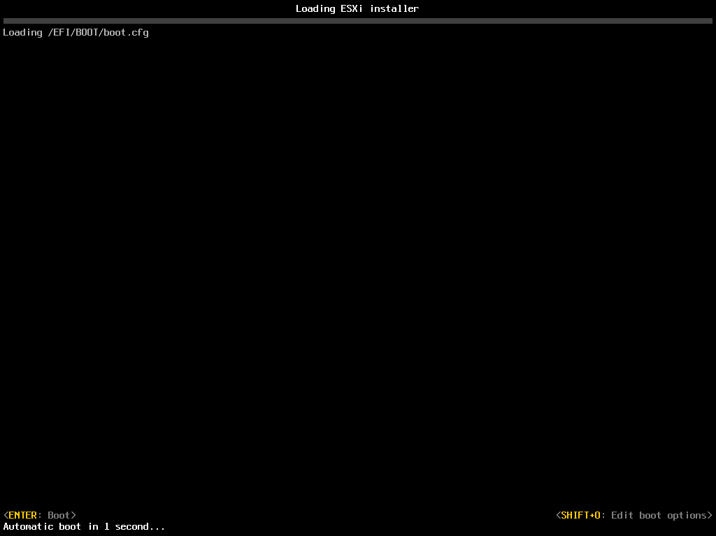
Figure 1 Boot loader countdown
Press Shift+O on this screen to edit the boot options — for example, to specify a kickstart file, or to use systemMediaSize=min|small|default|max to control how large the system partition (OSDATA) will be. This is useful when the boot device is large and you want to keep the remaining space for a datastore.
- The installer loads its modules. Wait for the progress bar to finish; no action is needed.
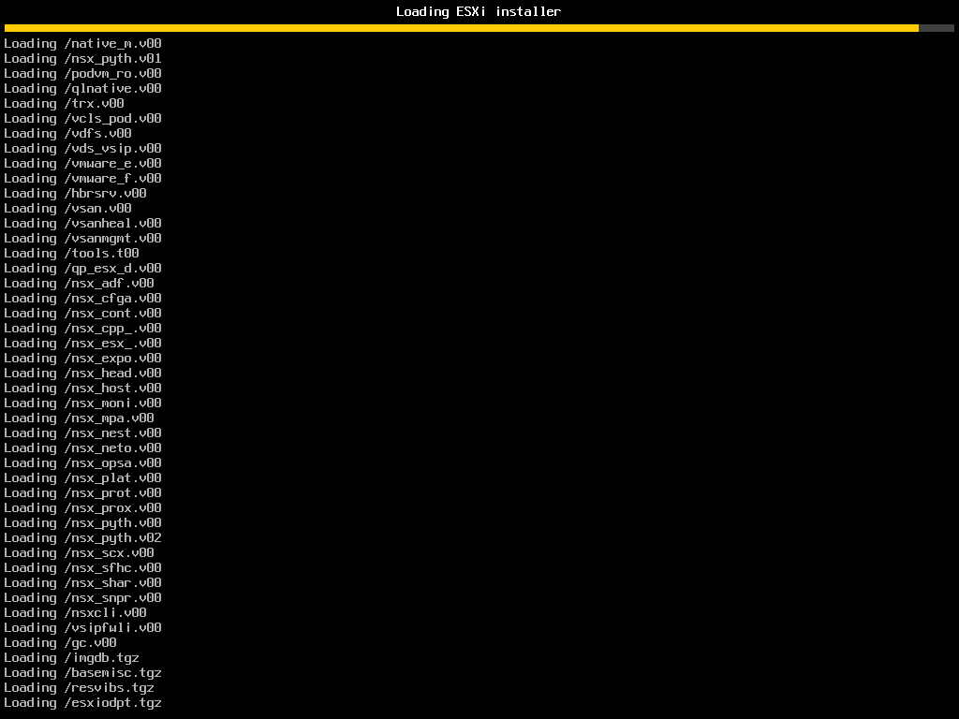
Figure 2 Loading the ESXi installer

4. Installation Wizard

4.1 Welcome
- When the Welcome screen appears, press Enter to continue.
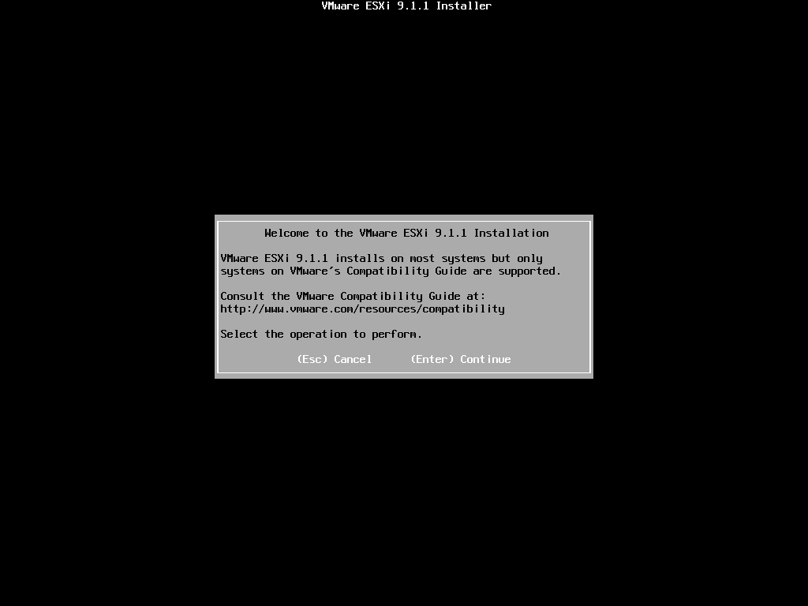
Figure 3 Welcome screen

4.2 End User License Agreement (EULA)
- Read the license agreement and press F11 (Accept and Continue).
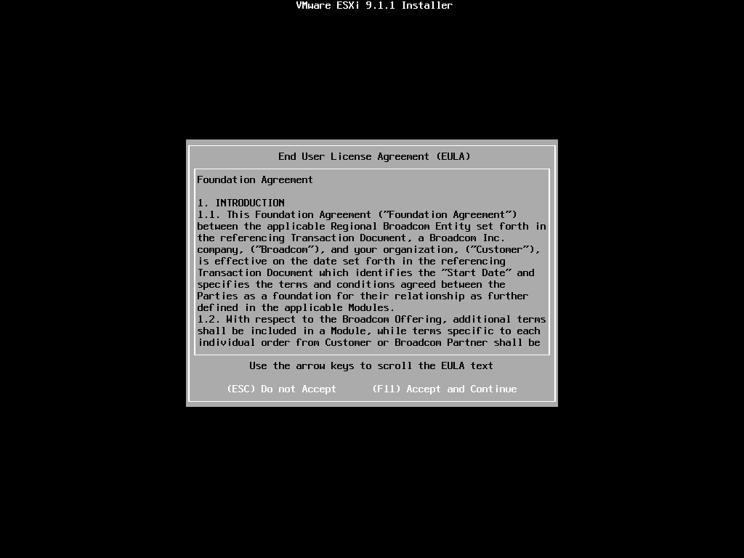
Figure 4 EULA
- The installer scans for available storage devices. Wait a few seconds.
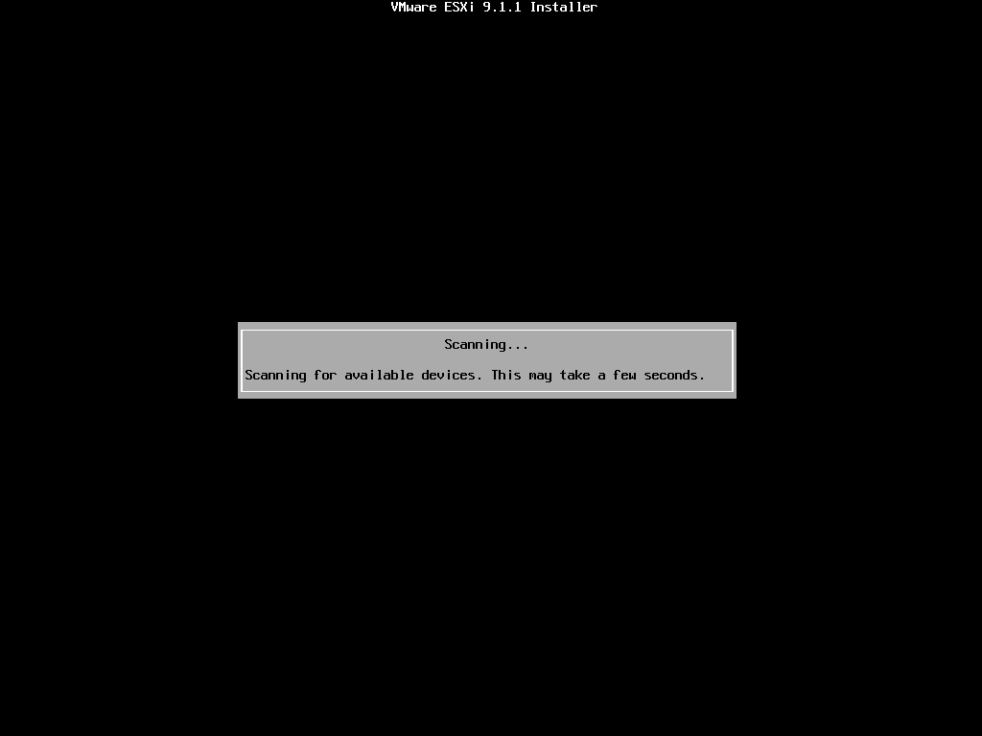
Figure 5 Scanning for devices

4.3 Select the installation disk
- Use the arrow keys to select the disk to install ESXi on (the BOSS / M.2 / RAID 1 virtual disk used for booting). The list shows each device's name, model, and capacity, grouped by Local / Remote.
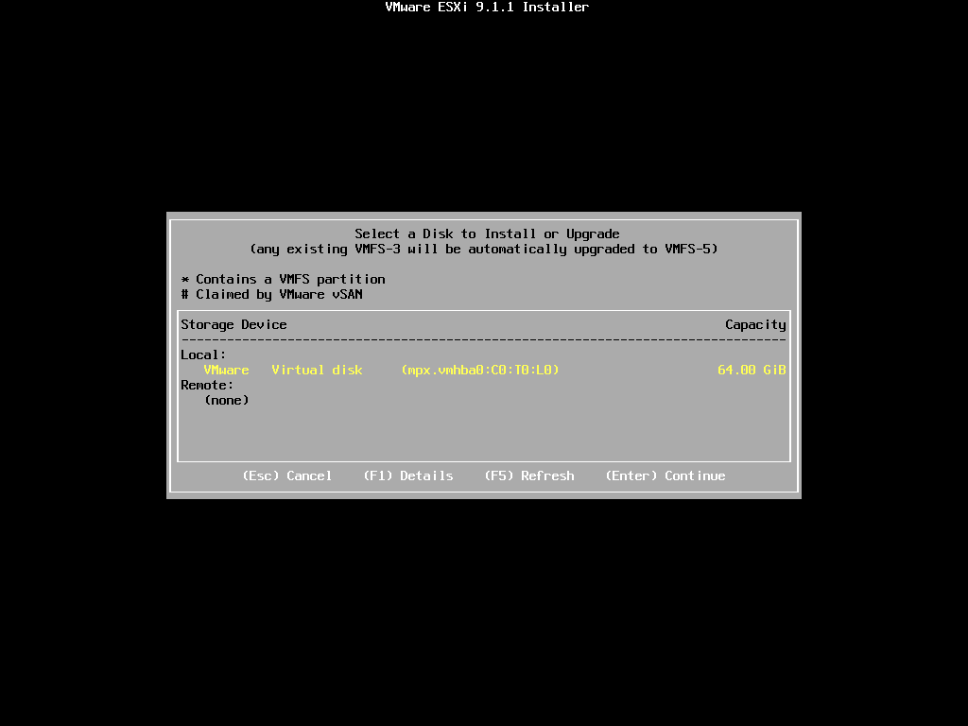
Figure 6 Select a disk
A disk marked * already contains a VMFS partition, and a disk marked # is claimed by vSAN. Selecting either type overwrites its data — double-check before continuing. On hosts connected to a SAN, consider suspending the FC / iSCSI zoning or unplugging the HBA cables before installing, so that ESXi is not accidentally installed on a remote LUN.
- If you are not sure which disk is which, highlight it and press F1 to view its details (model, capacity, path, whether ESXi is already installed, and which datastores it holds). Press Enter to close the details.
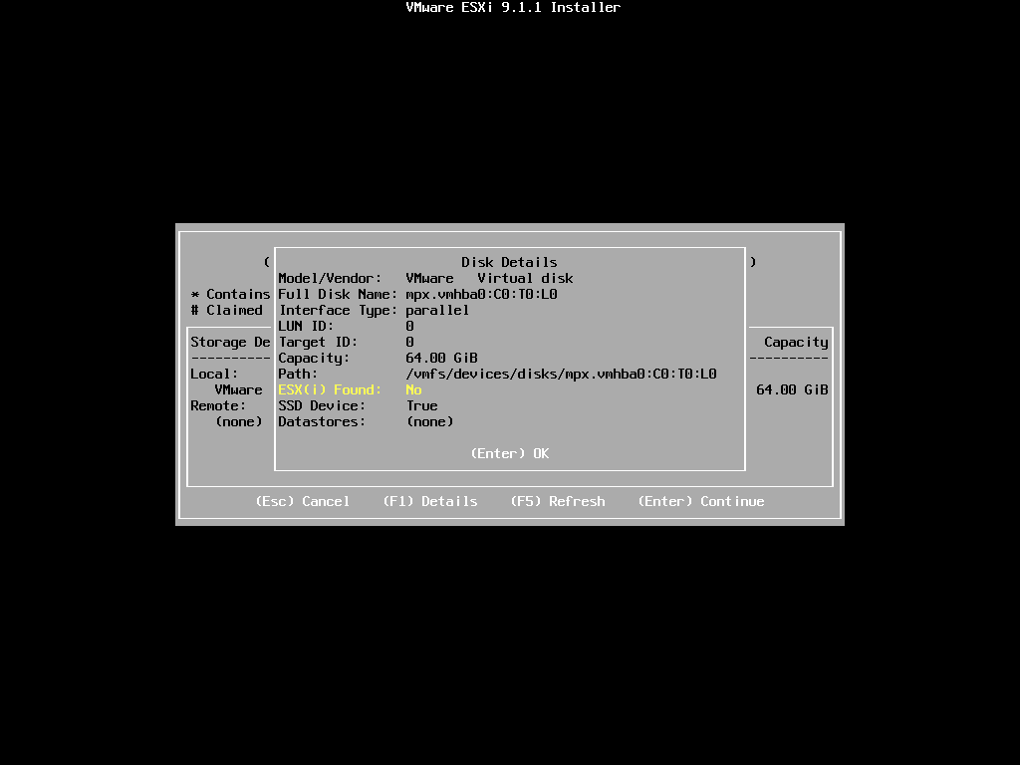
Figure 7 Disk details (F1)
- Back in the list, press Enter to select the disk.

4.4 Keyboard layout
- Select the keyboard layout (usually the default US Default) and press Enter.
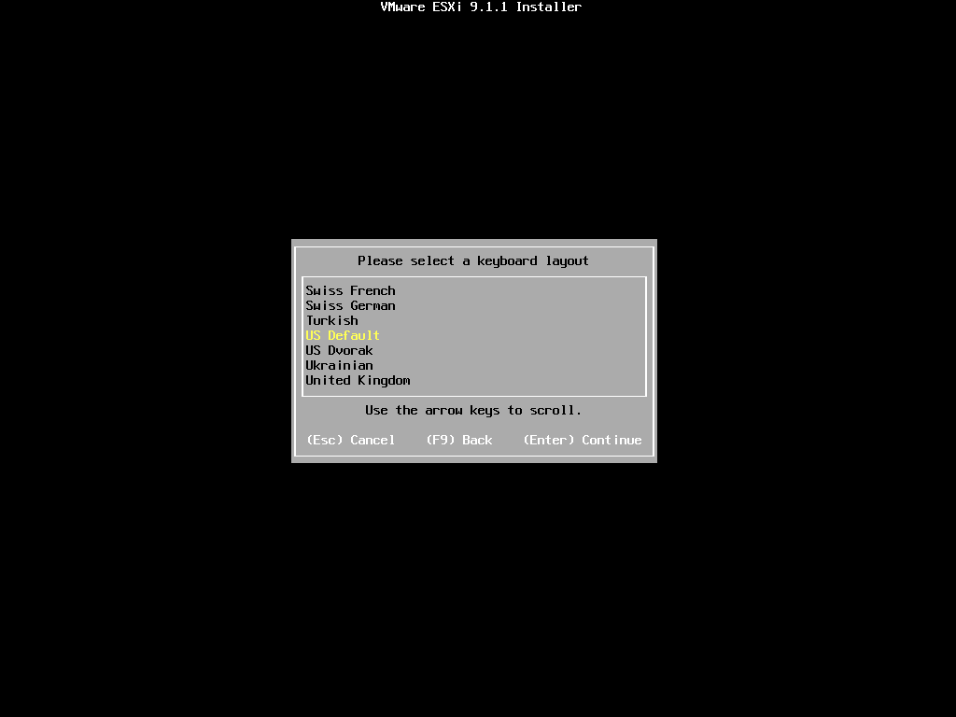
Figure 8 Keyboard layout

4.5 Set the root password
- Enter the root password, press the ↓ key to move to Confirm password, and enter it again.
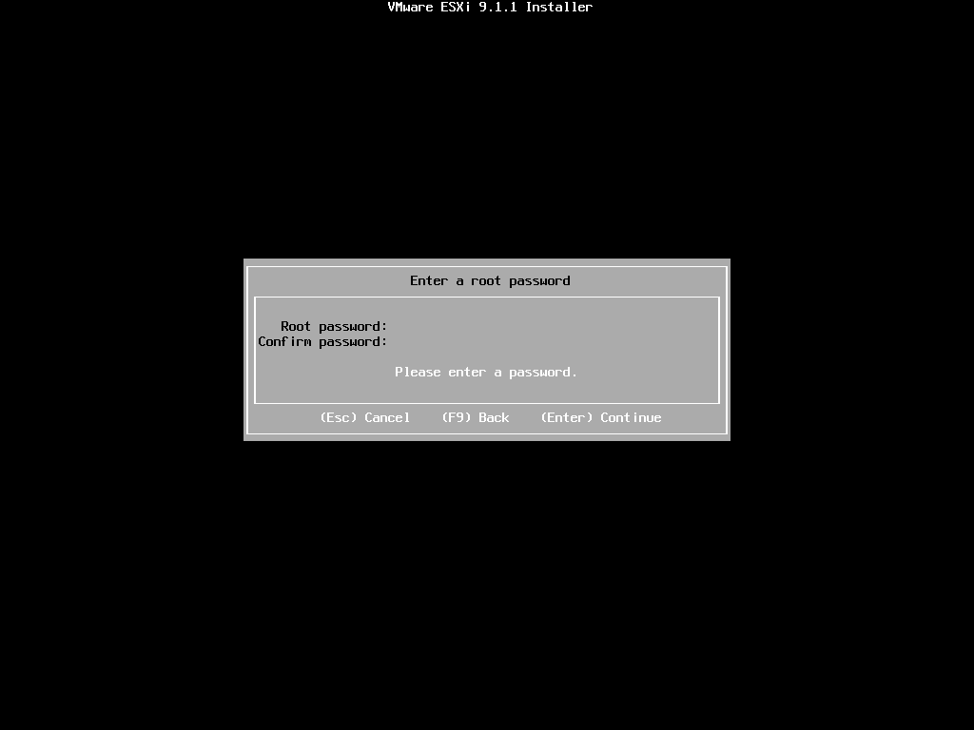
Figure 9 Enter a root password
- When both entries match, "Passwords match." appears below. Press Enter to continue.
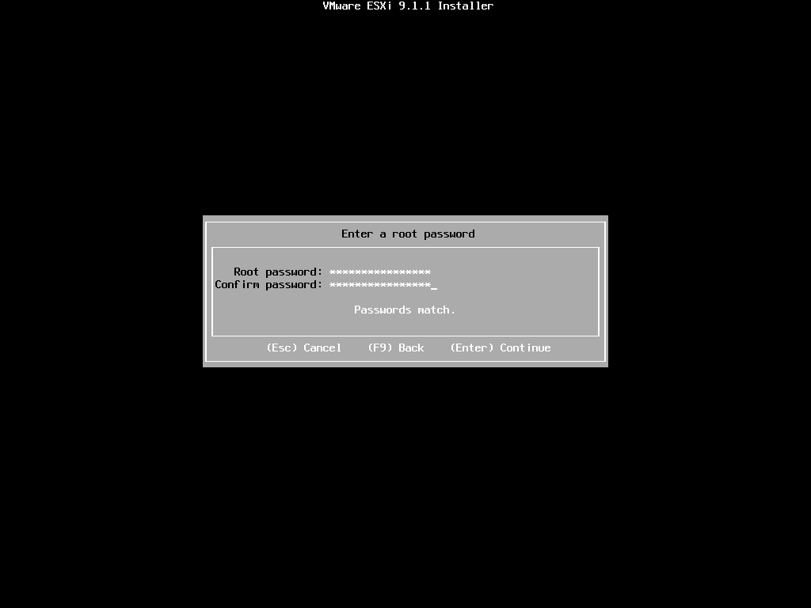
Figure 10 Passwords match
The default password policy requires sufficient length and a mix of uppercase, lowercase, digits, and symbols. If the host will be used for VCF, set a password that already meets the VCF password requirements to avoid changing it later.

4.6 System scan warnings (only on hardware that is not on the compatibility list)
After the password is entered, the installer checks whether the hardware meets the requirements. If all hardware is on the compatibility list, the screens in this section do not appear and the installer goes straight to 4.7 "Confirm Install".
If the CPU is not supported by ESXi 9.1.1 (for example, on an older server generation), the following two screens appear:
- CPU_SUPPORT OVERRIDEWARNING: the CPU is not supported by ESXi 9.1.1. You can force the installation, but it is not officially supported (see KB 82794). In a production environment, press Esc to stop the installation and replace the hardware with supported hardware; press Enter to continue only in a test environment.
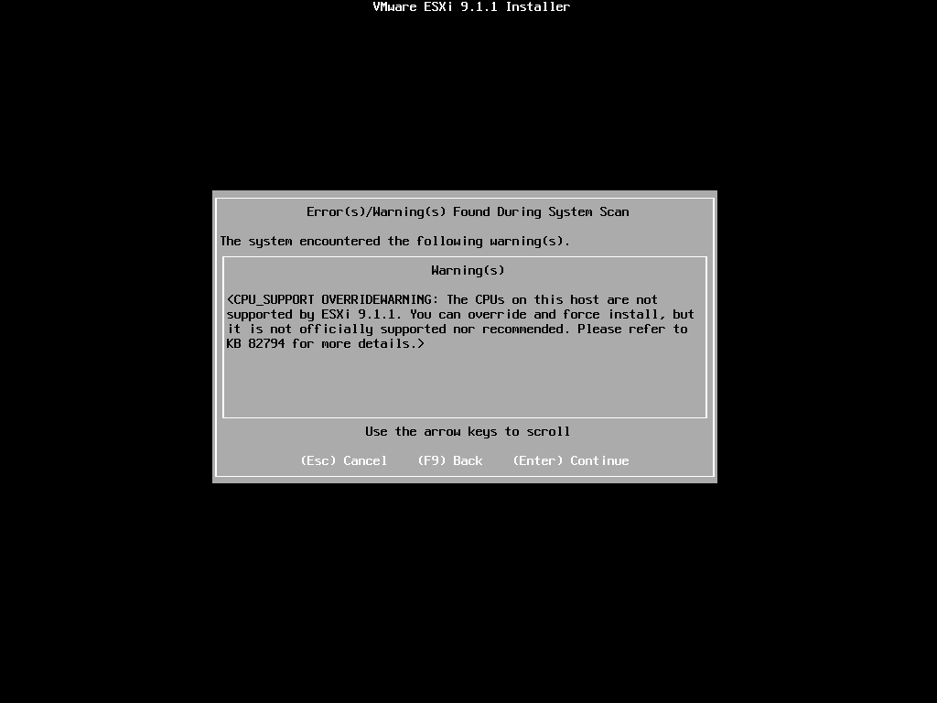
Figure 11 CPU support warning
- Confirm again whether to force the installation (Force Installation).
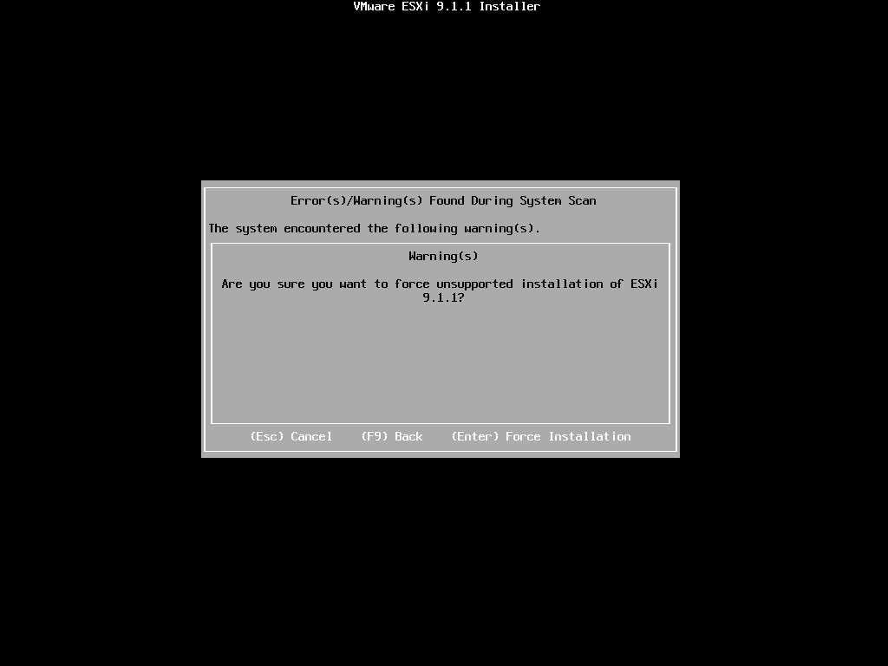
Figure 12 Force installation confirmation
If a different warning appears (for example, VT or NX/XD is not enabled), it is usually a BIOS setting issue: press Esc to cancel, fix the setting in the BIOS, and run the installation again.

4.7 Confirm the installation
- The final confirmation screen shows the target disk and warns that the disk will be repartitioned. If everything is correct, press F11 (Install).
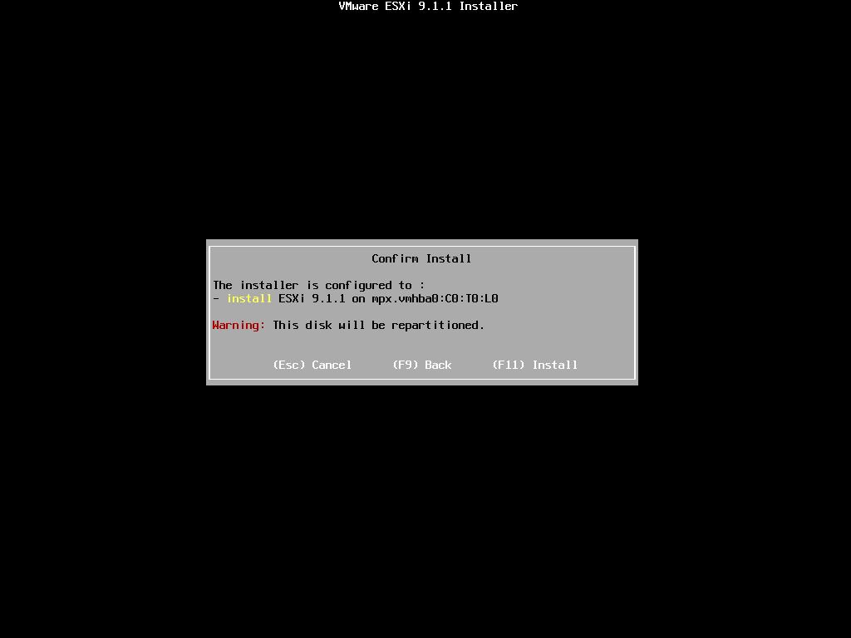
Figure 13 Confirm Install
- The installation starts and is complete when the progress reaches 100%. It normally takes only a few minutes (when the ISO is mounted remotely through BMC Virtual Media, the speed depends on the network bandwidth).
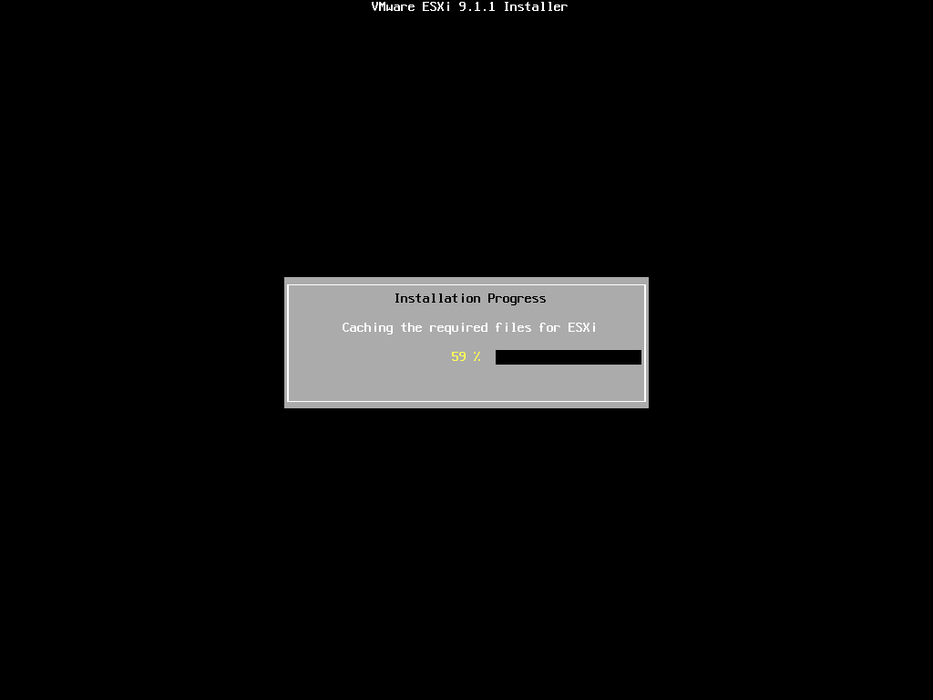
Figure 14 Installation progress

4.8 Installation complete and reboot
- When "Installation Complete" appears, unmount the installation media first (unmount the ISO from BMC Virtual Media, or remove the USB drive), then press Enter to reboot.
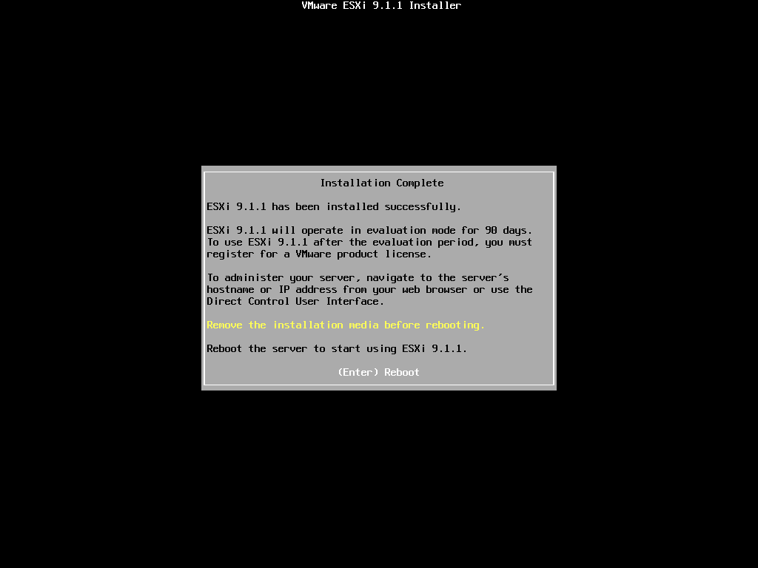
Figure 15 Installation Complete
The screen also notes that without a license, ESXi runs in 90-day evaluation mode.
- After the reboot, the screen title reads "Loading VMware ESXi" (not "Loading ESXi installer"), which means the host is booting from its disk.
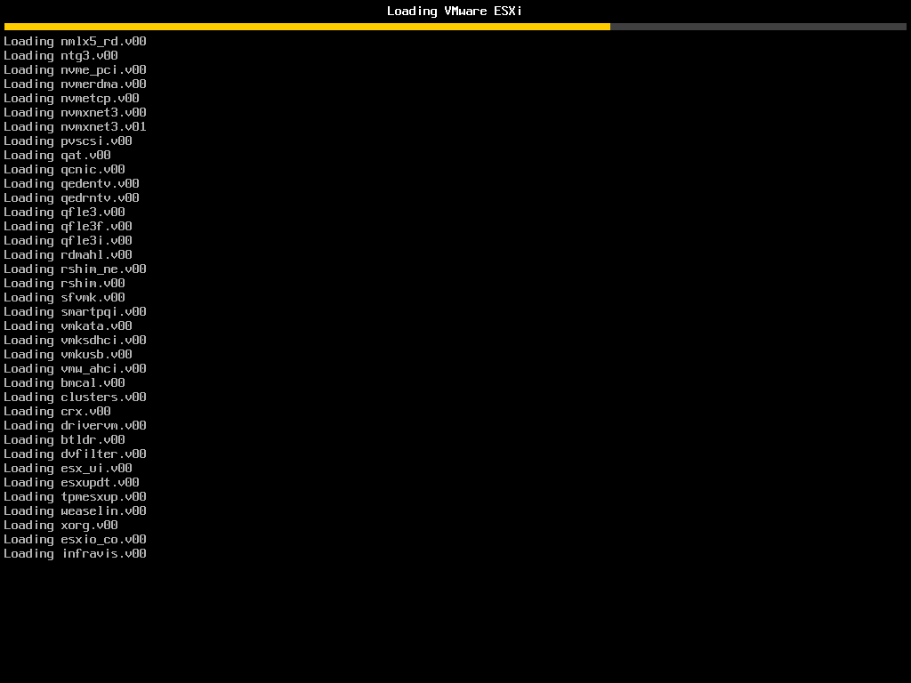
Figure 16 Booting ESXi from disk

5. Configuring the Management Network in the DCUI

5.1 DCUI main screen
- When the boot finishes, the DCUI (Direct Console User Interface) appears. The management network uses DHCP by default; if the network has no DHCP server, "Waiting for DHCP" and a DHCP lookup failed warning are shown. This is expected — the next steps configure a static IP.
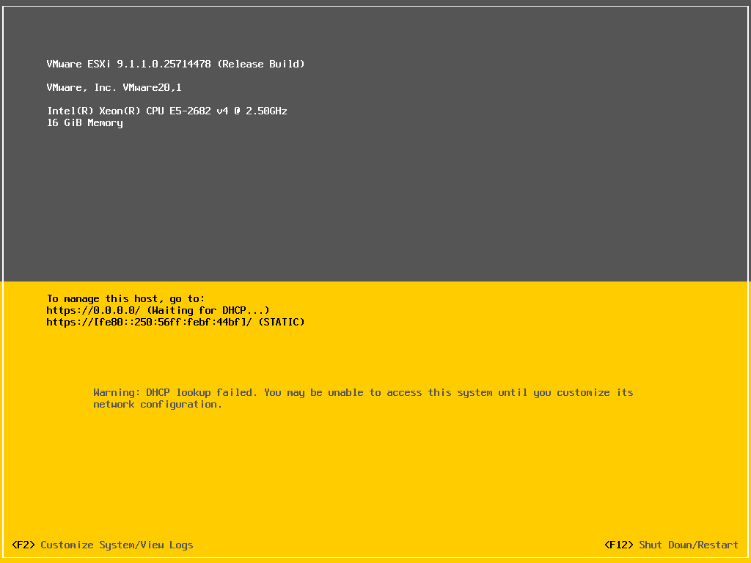
Figure 17 DCUI main screen (DHCP)

5.2 Log in
- Press F2 (Customize System/View Logs). Login Name defaults to root; press ↓ to move to Password, enter the password set during installation, and press Enter.
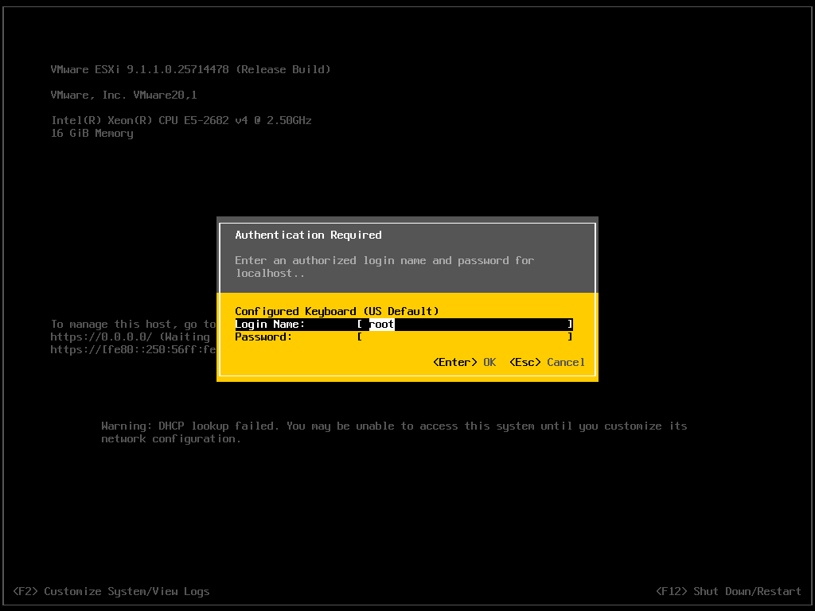
Figure 18 DCUI login
- After logging in, the System Customization menu appears.
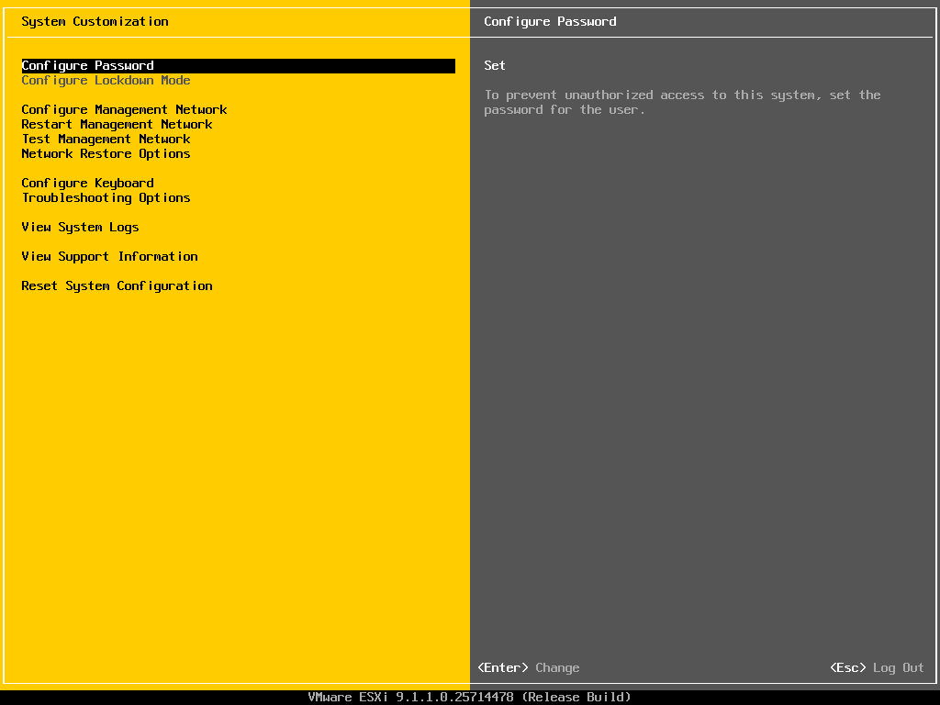
Figure 19 System Customization

5.3 Configure Management Network
- Use the arrow keys to select Configure Management Network. The right pane shows the current hostname and IP (still localhost and 169.254.x.x at this point). Press Enter.
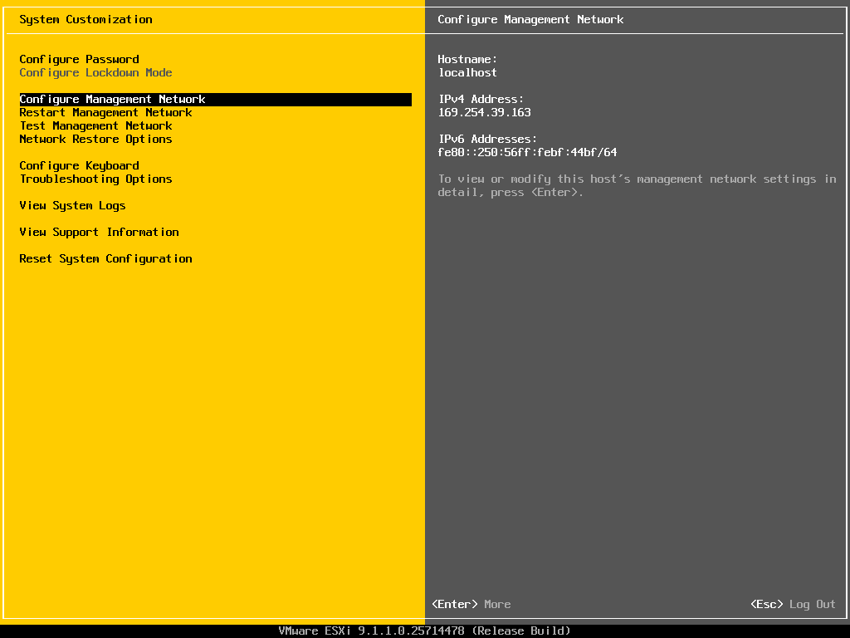
Figure 20 Select Configure Management Network
"Configure Lockdown Mode" is grayed out and skipped by the arrow keys — pressing ↓ twice from Configure Password lands on Restart Management Network, so watch the highlight.
- The management network submenu opens.
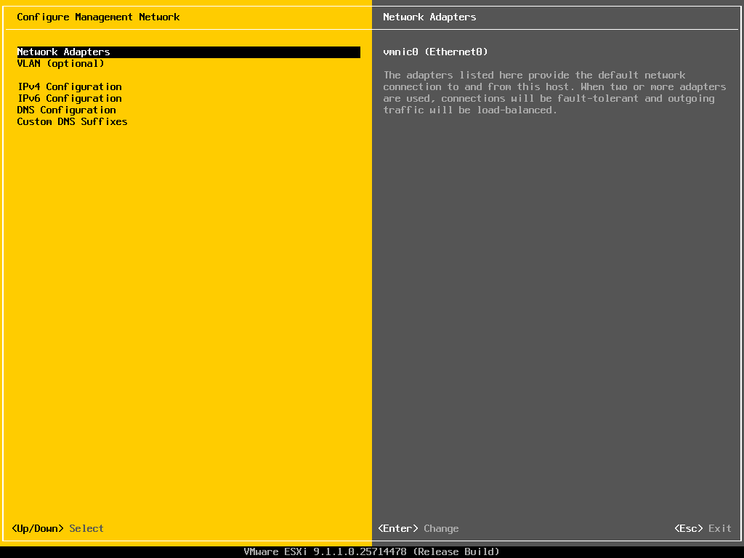
Figure 21 Configure Management Network menu

5.4 Network Adapters
- Select Network Adapters and press Enter to confirm which physical NICs the management network uses ([X] means selected). If two or more NICs are connected to the management network, select them with Space for redundancy, then press Enter.
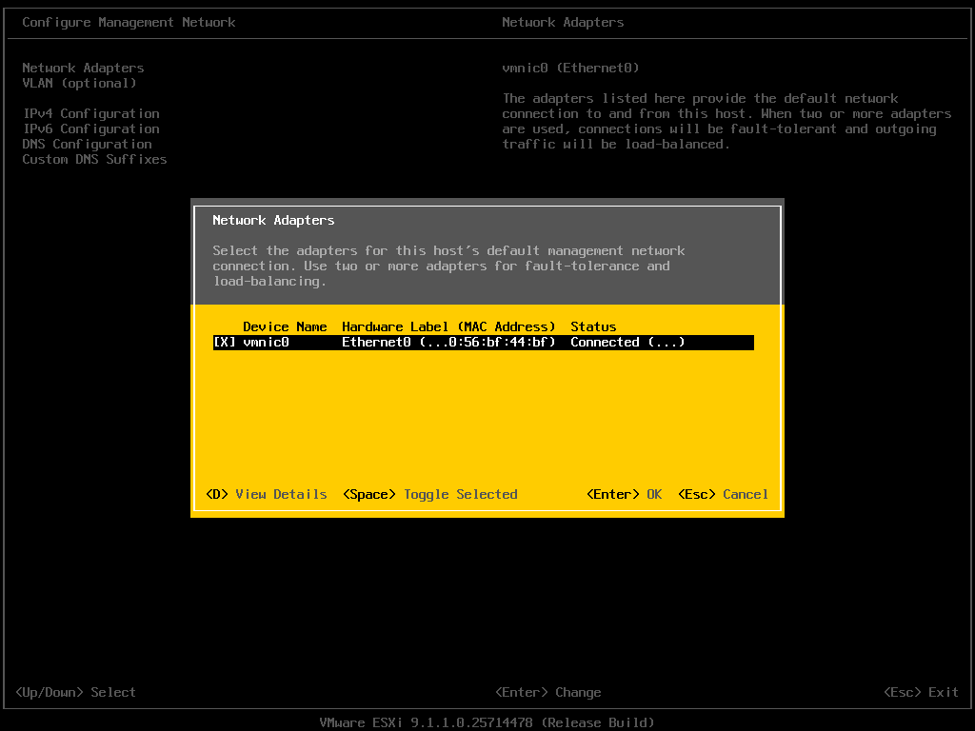
Figure 22 Network Adapters
On a physical server, press D (View Details) and compare the MAC address with the switch cabling to make sure the selected NIC is the one connected to the management network.

5.5 VLAN (optional)
- Select VLAN (optional) and press Enter. If the switch port is a trunk port, enter the management VLAN ID here; for an access port, leave it empty and press Esc. The example environment uses an access port, so no VLAN is set.
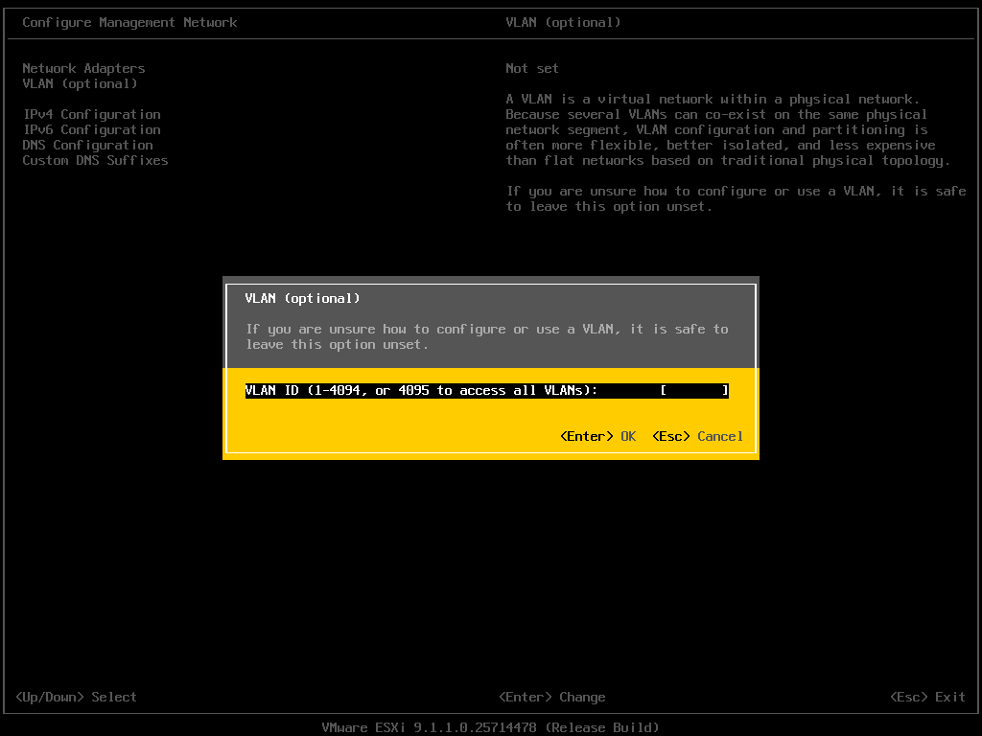
Figure 23 VLAN (optional)

5.6 IPv4 Configuration
- Select IPv4 Configuration and press Enter. The default is "Use dynamic IPv4 address" (DHCP).
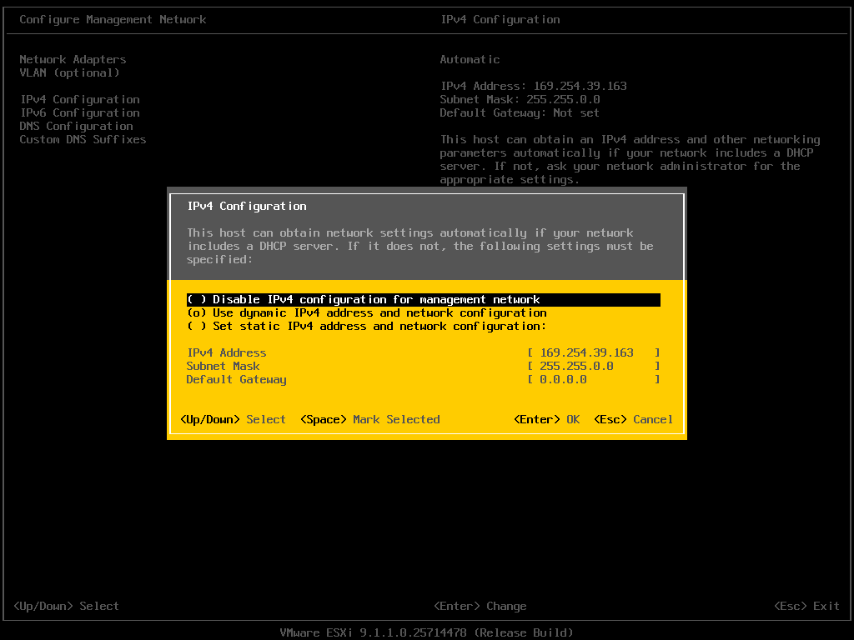
Figure 24 IPv4 Configuration (default DHCP)
- Use the arrow keys to move to Set static IPv4 address and network configuration, press Space to select it, then fill in IPv4 Address, Subnet Mask, and Default Gateway (delete the existing values in each field with Backspace first). Press Enter.
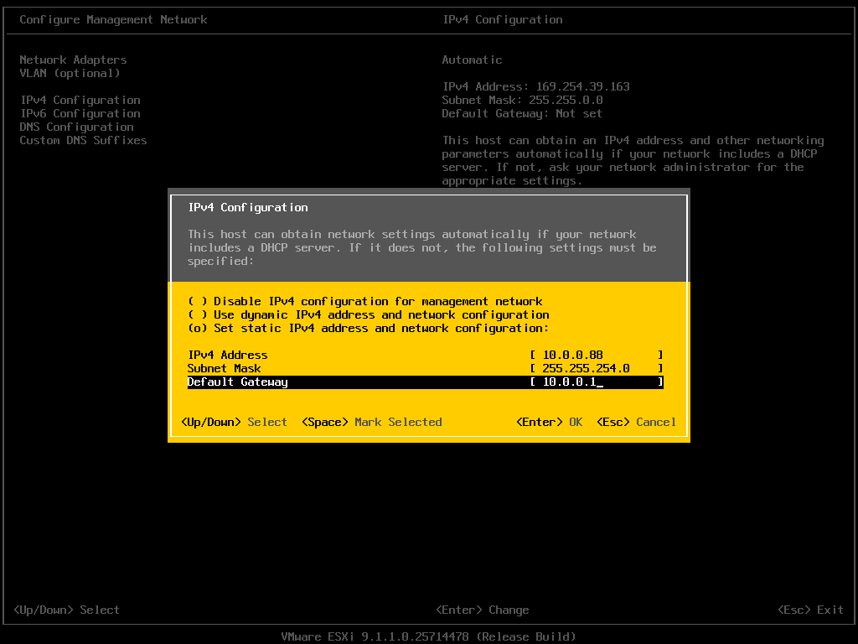
Figure 25 Static IPv4 configuration

5.7 DNS Configuration
- Select DNS Configuration and press Enter. The default is to obtain the settings automatically.
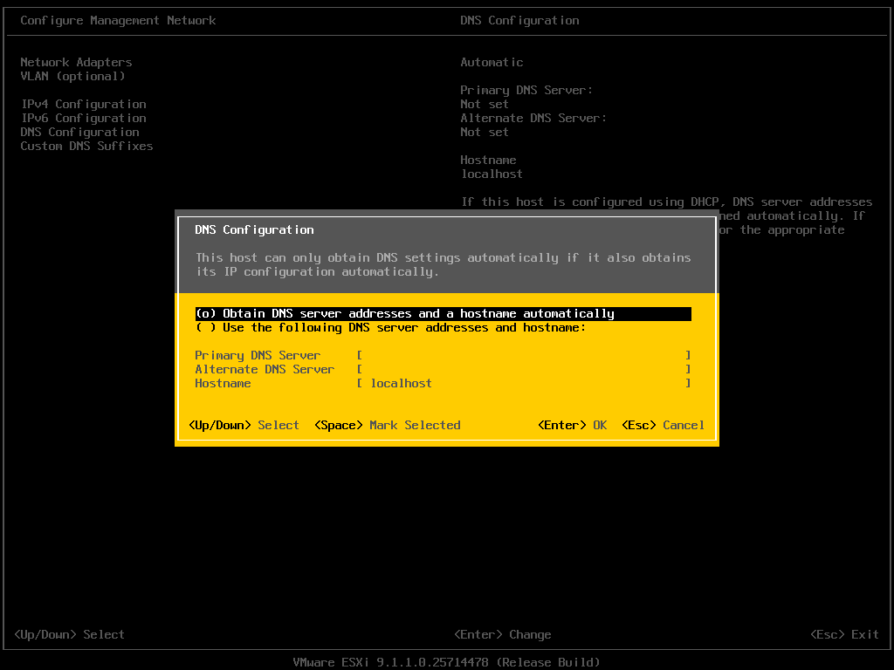
Figure 26 DNS Configuration (default)
- Move to Use the following DNS server addresses and hostname, press Space to select it, enter the Primary DNS Server, enter the FQDN as the Hostname (for example esx911-demo.home.lab), and press Enter.
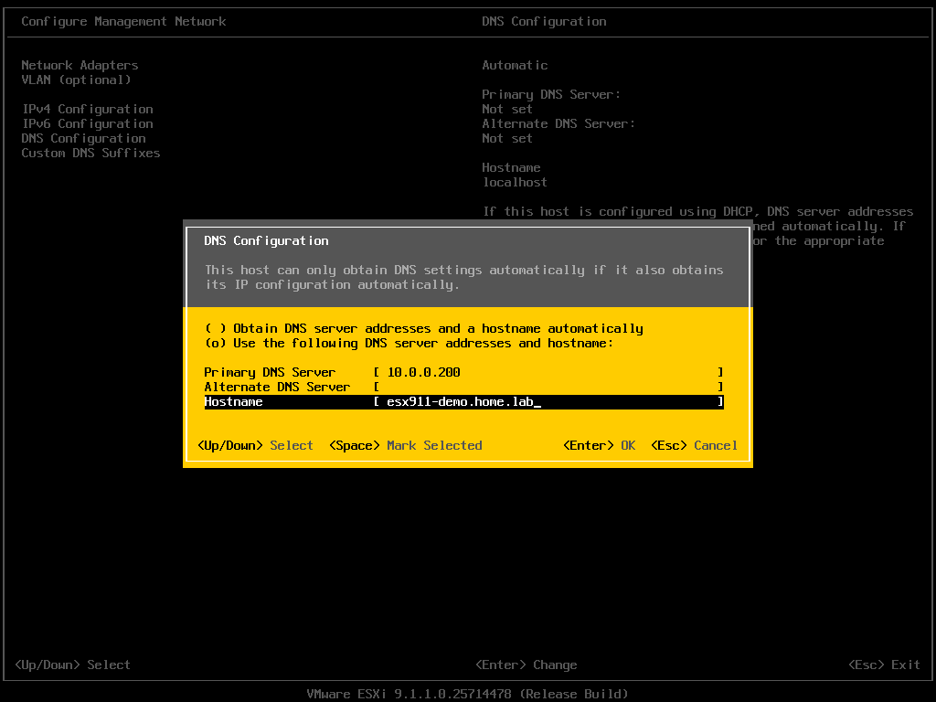
Figure 27 Static DNS and hostname

5.8 Custom DNS Suffixes
- Select Custom DNS Suffixes and press Enter. Enter the search domain(s) (separate multiple entries with spaces or commas) and press Enter.
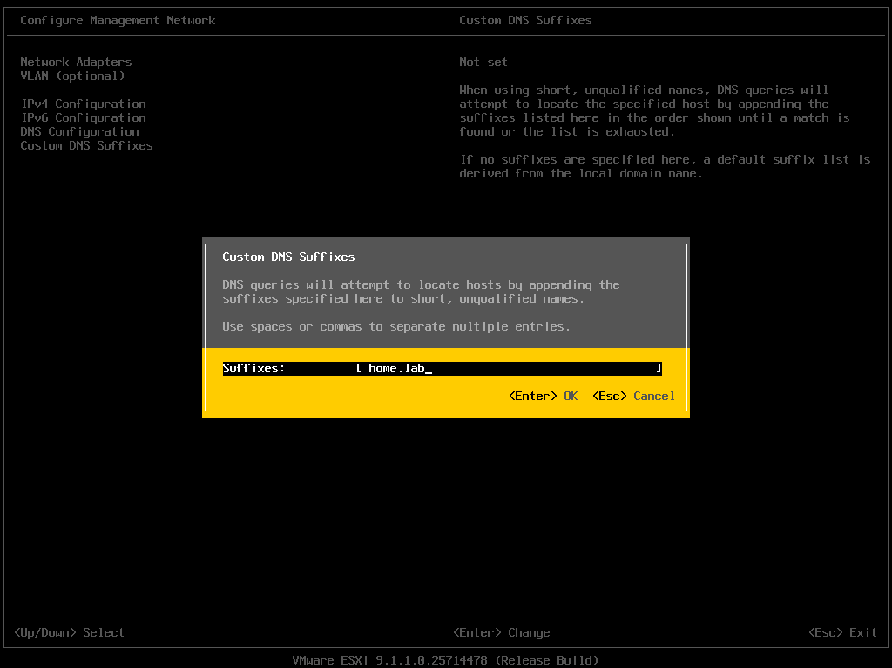
Figure 28 Custom DNS Suffixes

5.9 Apply the changes
- Press Esc to leave the management network submenu. When asked whether to apply the changes and restart the management network, press Y.
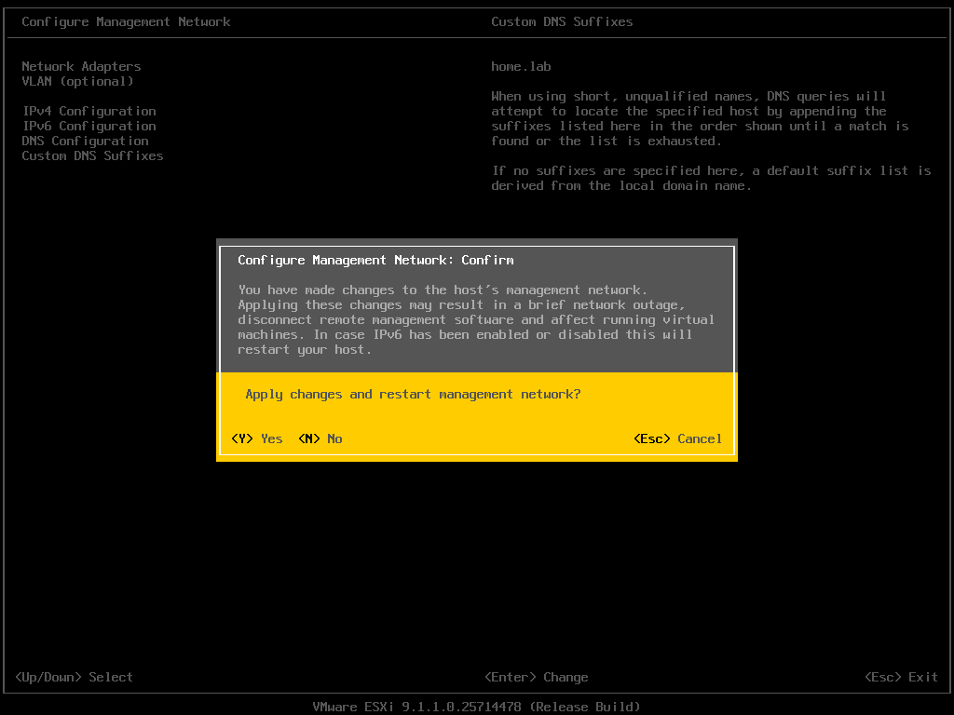
Figure 29 Apply changes and restart management network
Changing only IPv4 / DNS does not require a reboot; enabling or disabling IPv6 does require a host reboot.
- Back in System Customization, the right pane shows the new hostname and IPv4 address.
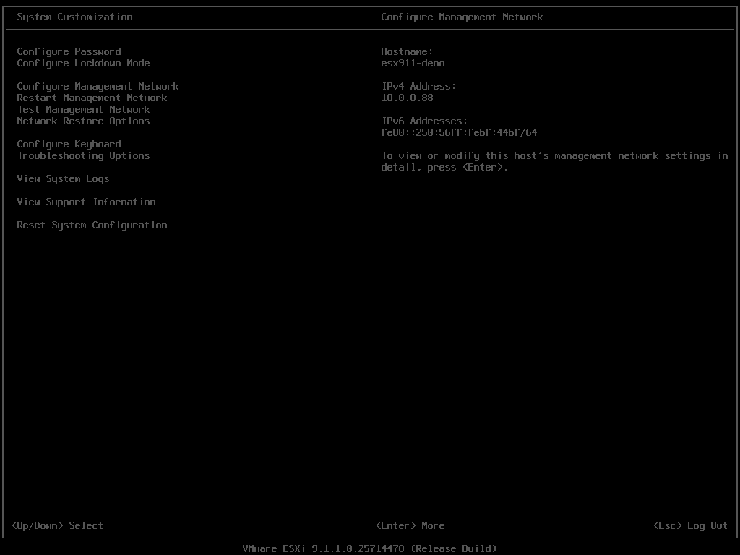
Figure 30 Management network after configuration

5.10 Test Management Network
- Select Test Management Network and press Enter. By default it pings the gateway and DNS servers and resolves the host's own FQDN. Press Enter to run the test.
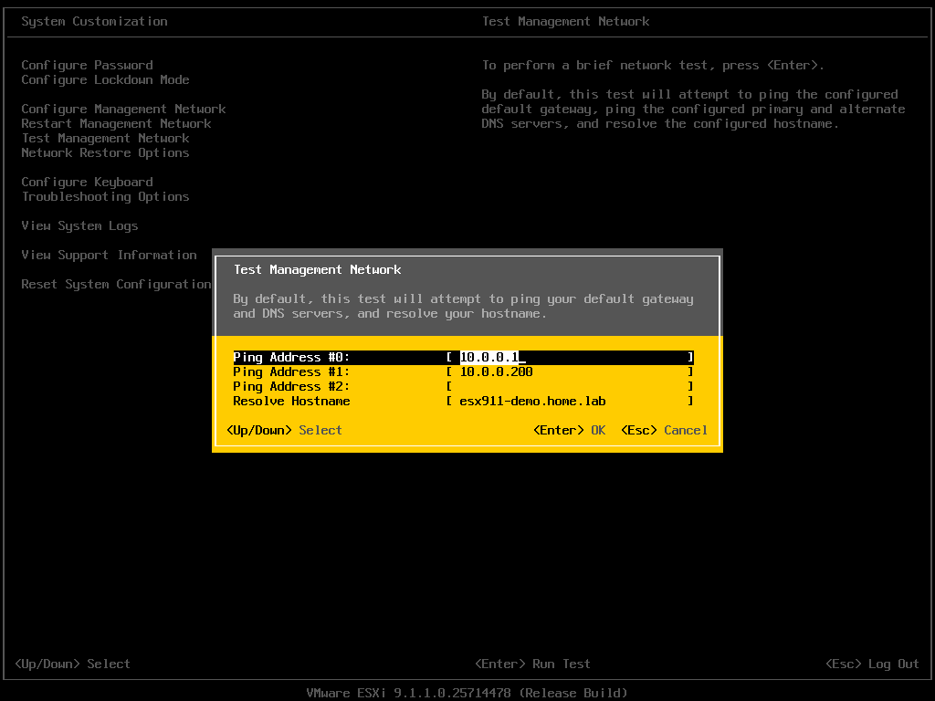
Figure 31 Test Management Network
- All three items must show OK. If any item fails, fix it before continuing.
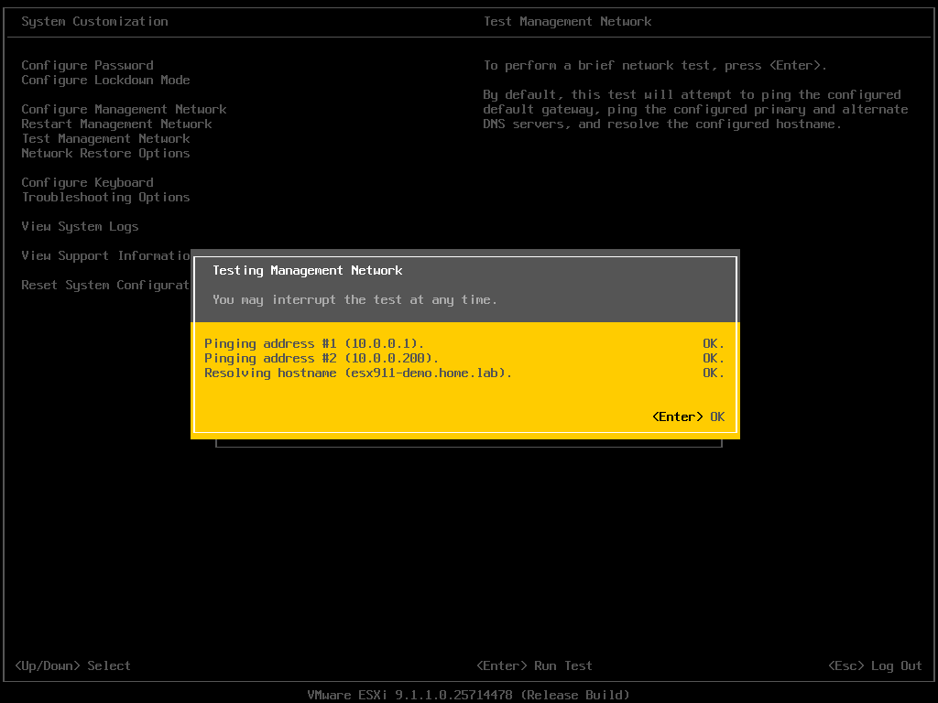
Figure 32 Test results
If even the gateway cannot be pinged, the most common cause is that the switch port VLAN configuration does not match the DCUI (the switch port is a trunk but no VLAN ID is set in the DCUI, or the port is an access port but a VLAN ID is set), followed by a selected NIC that is not cabled or is connected to the wrong switch. Have the network team check the port configuration, and compare MAC addresses using View Details in section 5.4.

5.11 Enable SSH (optional)
- Select Troubleshooting Options and press Enter.
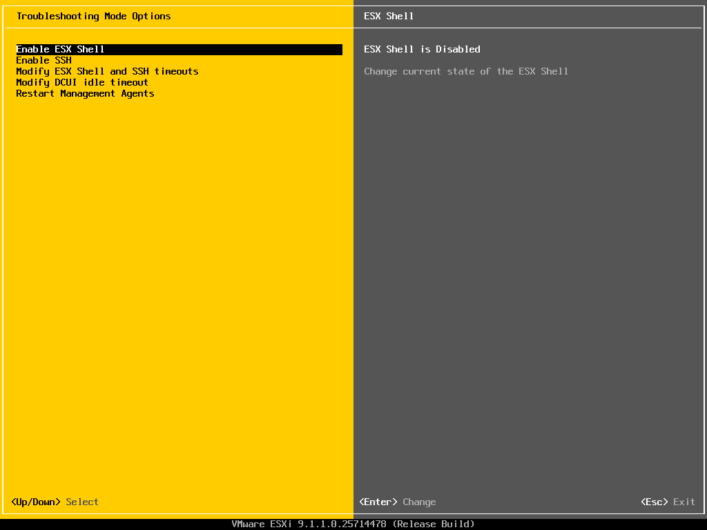
Figure 33 Troubleshooting Options
- Select Enable SSH and press Enter. When the right pane shows "SSH is Enabled" and the option changes to "Disable SSH", it is done. Hosts that will be added to VCF (commission / bring-up) need SSH enabled; in other environments, disabling it after use is recommended.
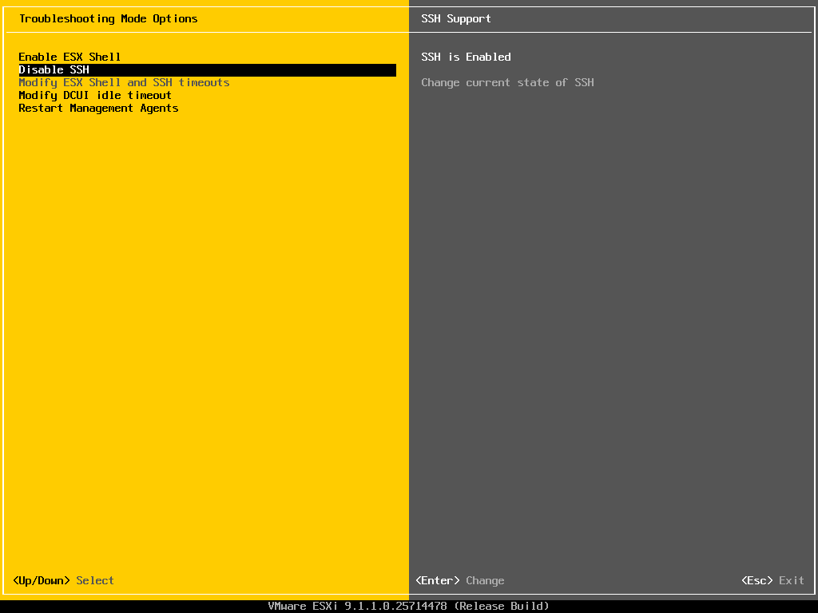
Figure 34 SSH enabled

5.12 Log out
- Press Esc twice to log out and return to the DCUI main screen. Confirm that the management URLs now show the FQDN and the IP marked (STATIC).
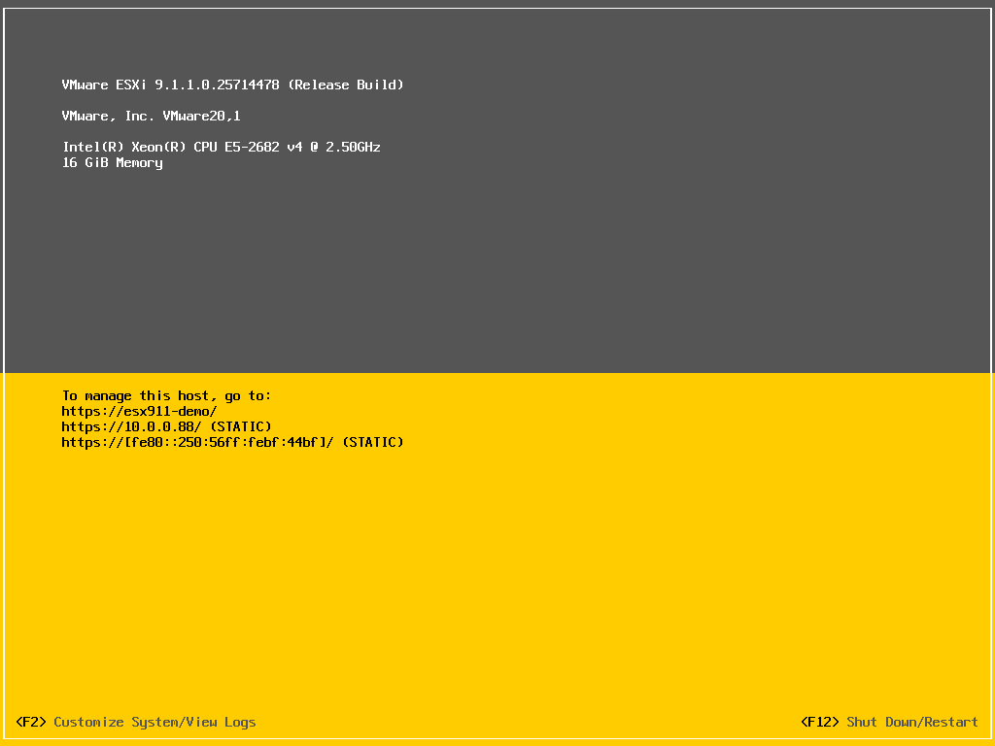
Figure 35 DCUI main screen (static IP)

6. Initial Configuration in the Host Client

6.1 Log in to the Host Client
- Open https://<host FQDN>/ui/ in a browser (the first connection shows a self-signed certificate warning; continue after confirming it is your host).
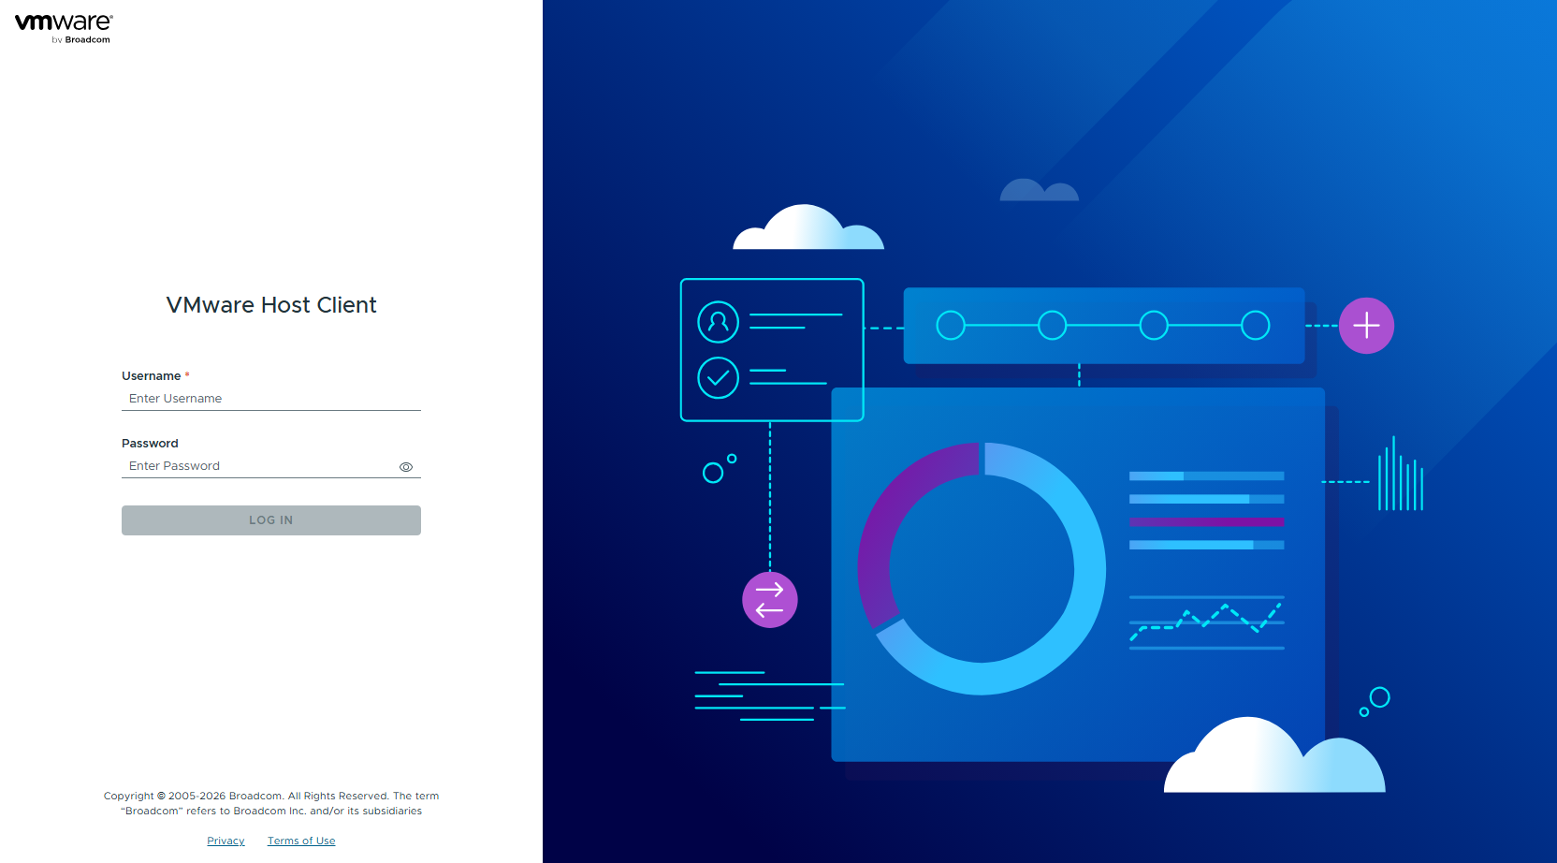
Figure 36 Host Client login page
- Enter root and the password, then click LOG IN.
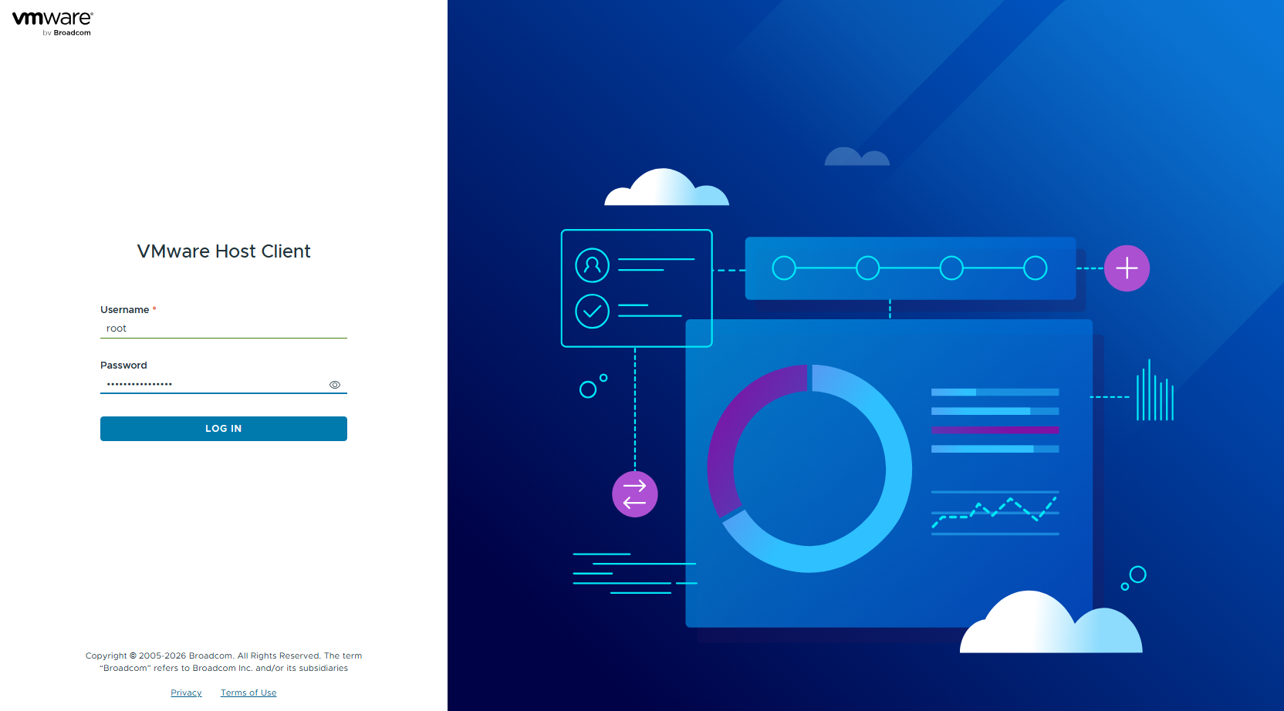
Figure 37 Entering the credentials
- On the first login, you are asked whether to join the CEIP (Customer Experience Improvement Program). Decide according to the customer's policy and click OK. The example does not join.
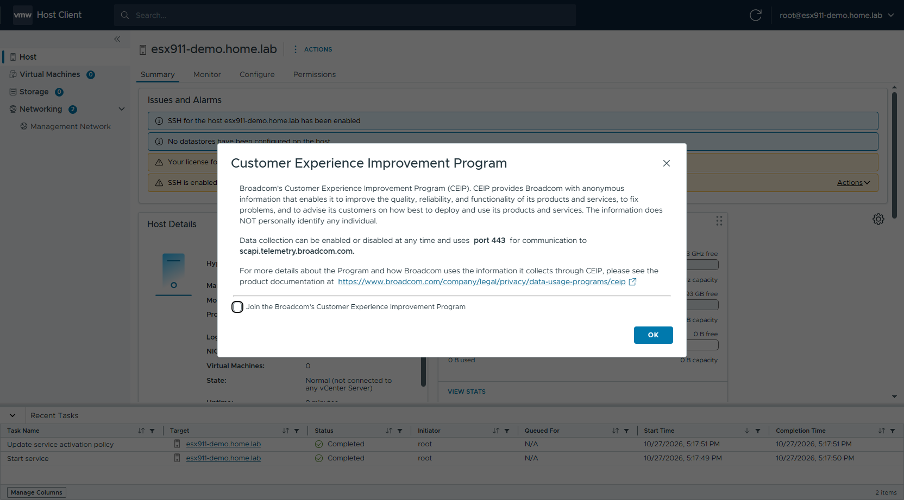
Figure 38 CEIP
- The host Summary page opens. The ESXi 9.1 Host Client uses a new interface: the left pane shows Host / Virtual Machines / Storage / Networking, and the host tabs are Summary / Monitor / Configure / Permissions. At this point, Issues and Alarms shows that SSH is enabled, no datastore exists yet, and the license expires in 90 days.
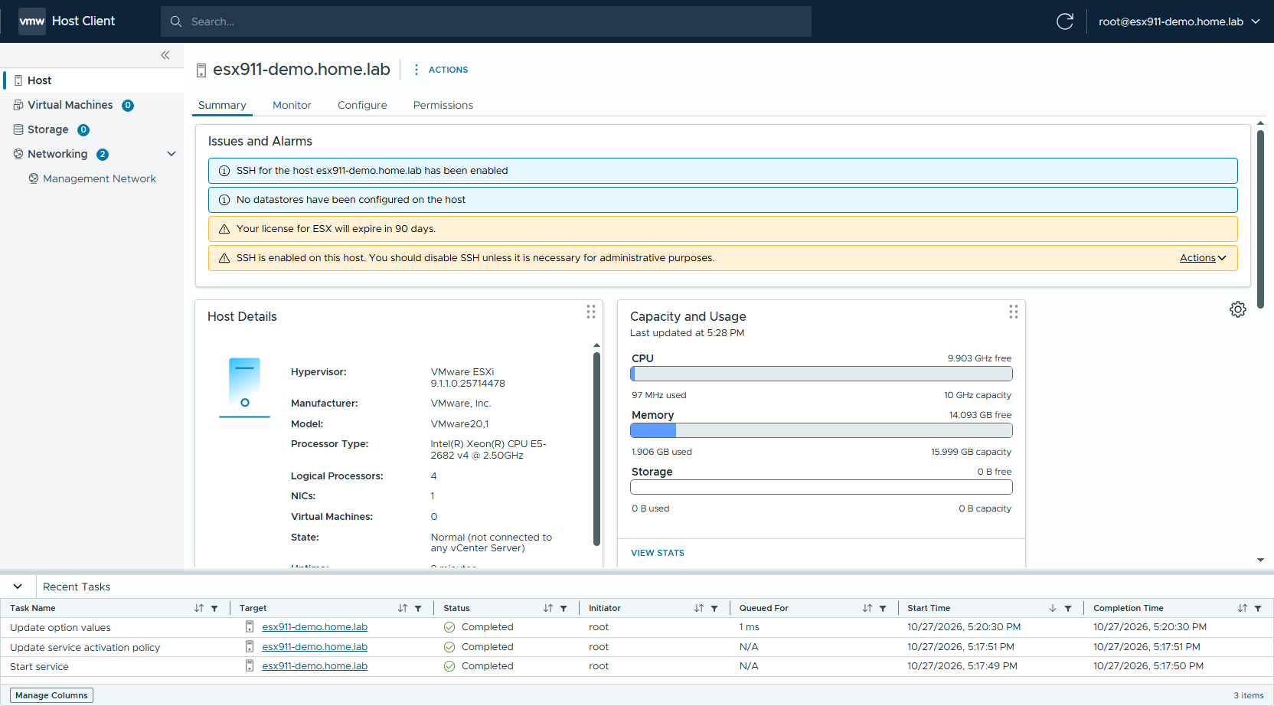
Figure 39 Host Summary

6.2 Configure NTP
- Click Configure → System → Time Configuration. By default, Time Synchronization is Manual and the NTP Client is Disabled. Click EDIT... next to Network Time Protocol.
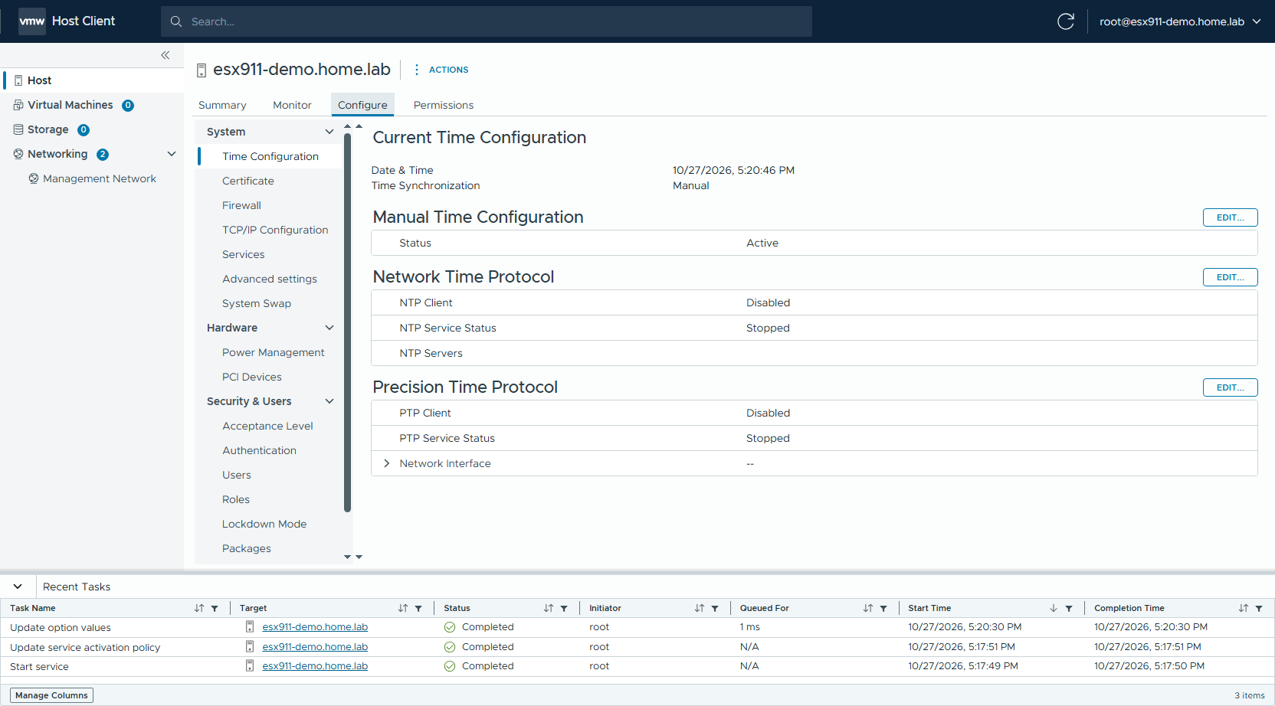
Figure 40 Time Configuration (default)
- The Edit Network Time Protocol dialog opens.
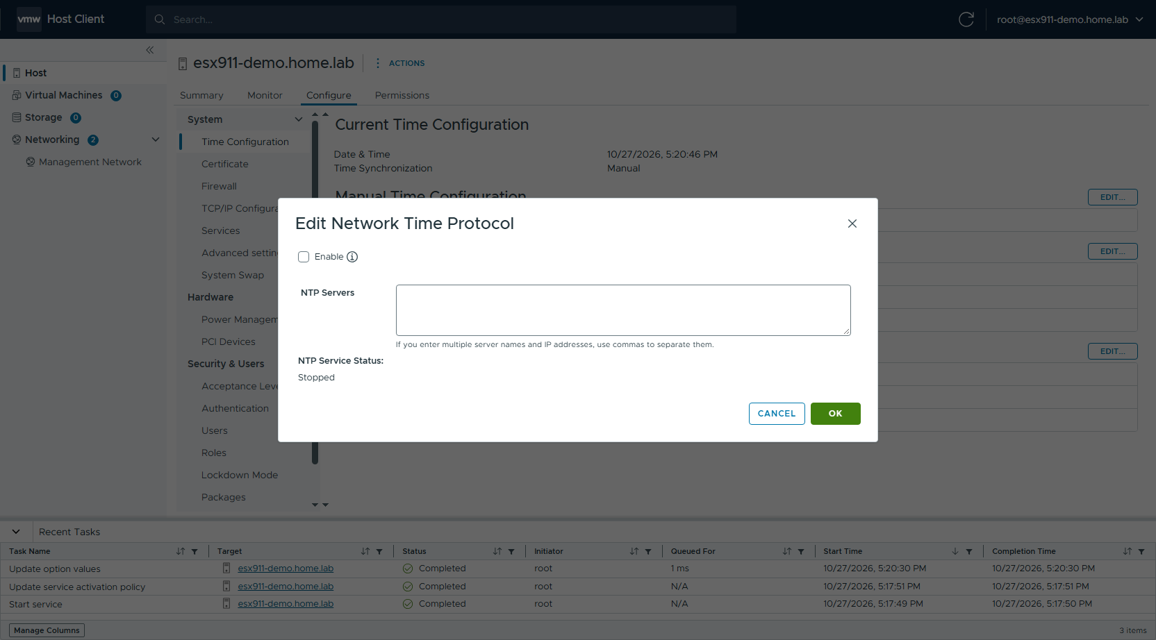
Figure 41 Edit Network Time Protocol
- Select Enable, enter the NTP server(s) in NTP Servers (separate multiple servers with commas), and click OK.
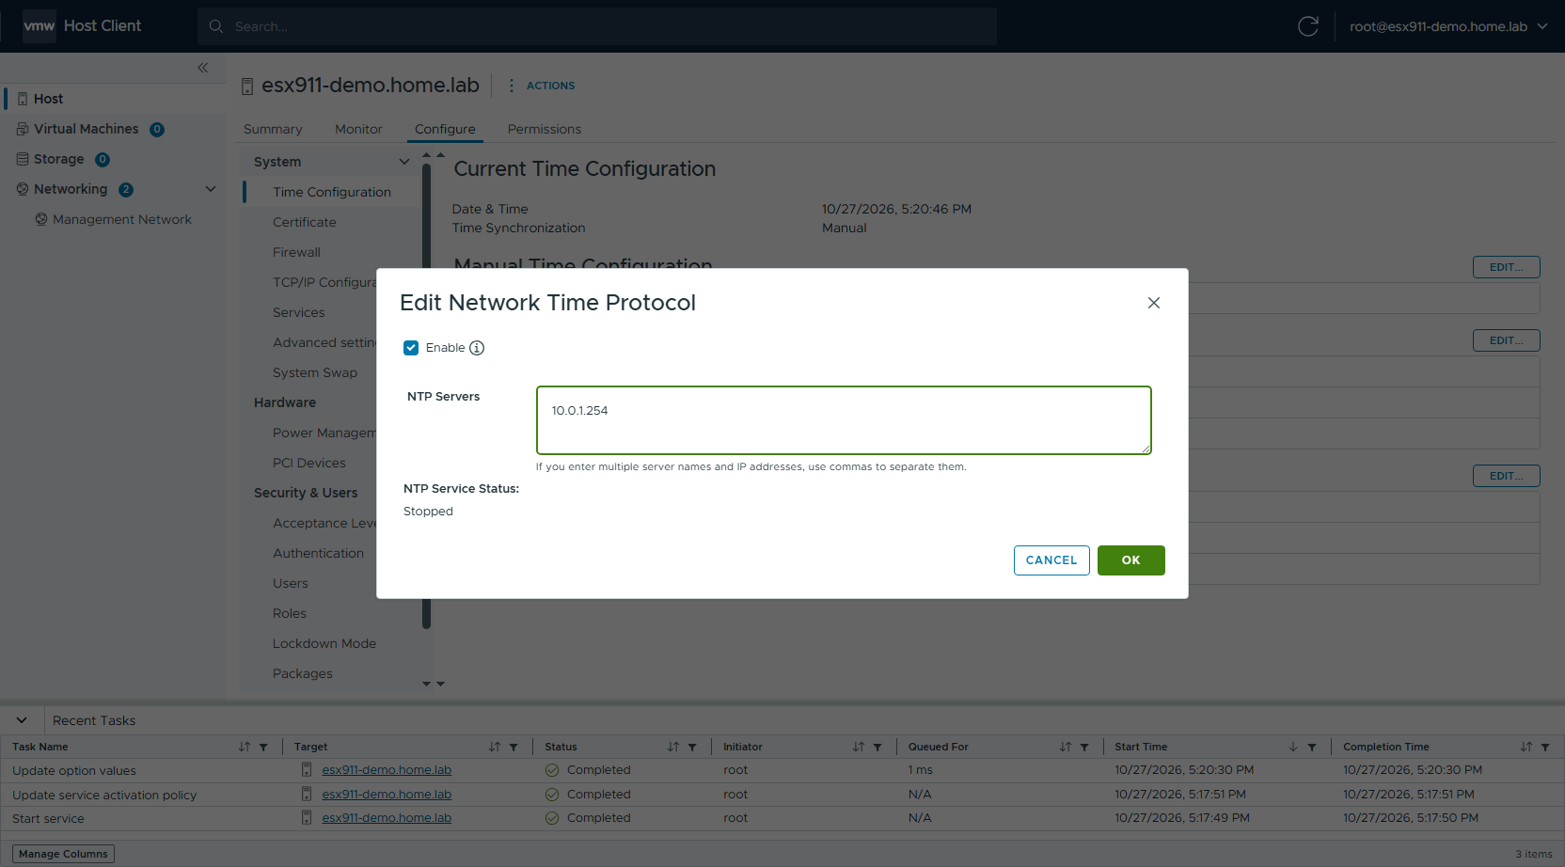
Figure 42 NTP server entered
- Confirm that Time Synchronization is now Network Time Protocol, with NTP Client = Enabled and NTP Service Status = Running.
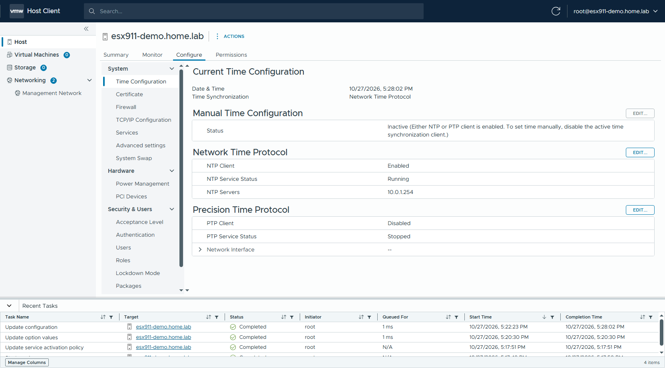
Figure 43 Time Configuration (NTP)

6.3 Set the startup policy of the NTP service
Common pitfall: after enabling NTP in the previous step, the NTP Daemon is running but its startup policy is still "Start and stop manually" — NTP does not start automatically after the host reboots. Always do this step as well.
- Click Configure → System → Services. SSH is Running, and the NTP Daemon is Running but its startup policy is Start and stop manually.
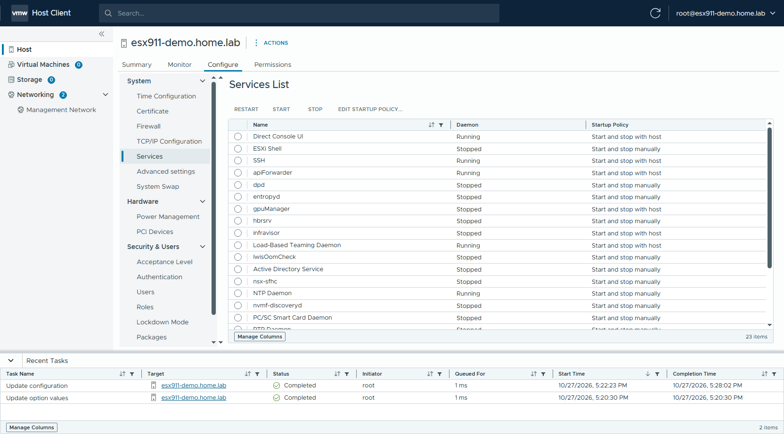
Figure 44 Services list
- Select NTP Daemon, click EDIT STARTUP POLICY..., select Start and stop with host, and click OK.
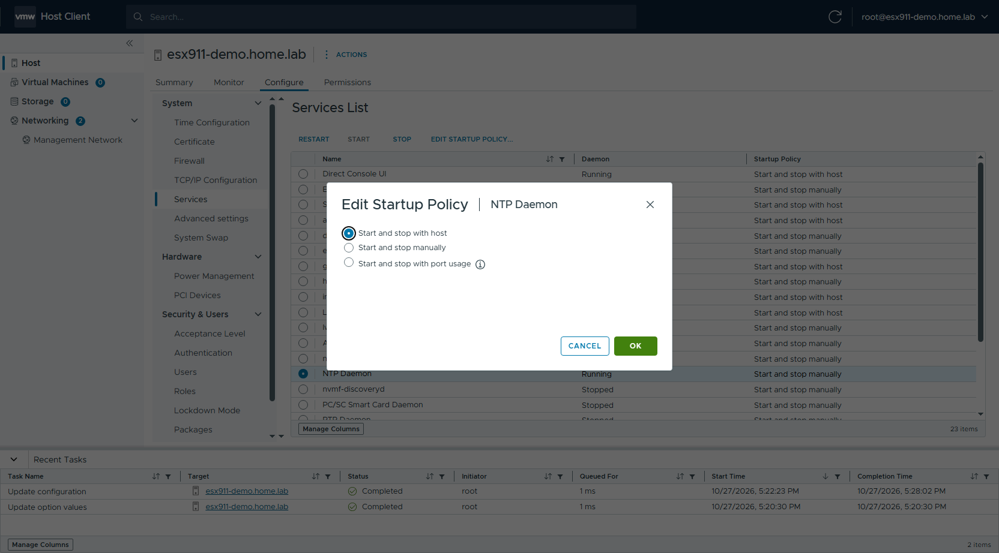
Figure 45 Edit Startup Policy: Start and stop with host
- Confirm that the Startup Policy of the NTP Daemon is now Start and stop with host.
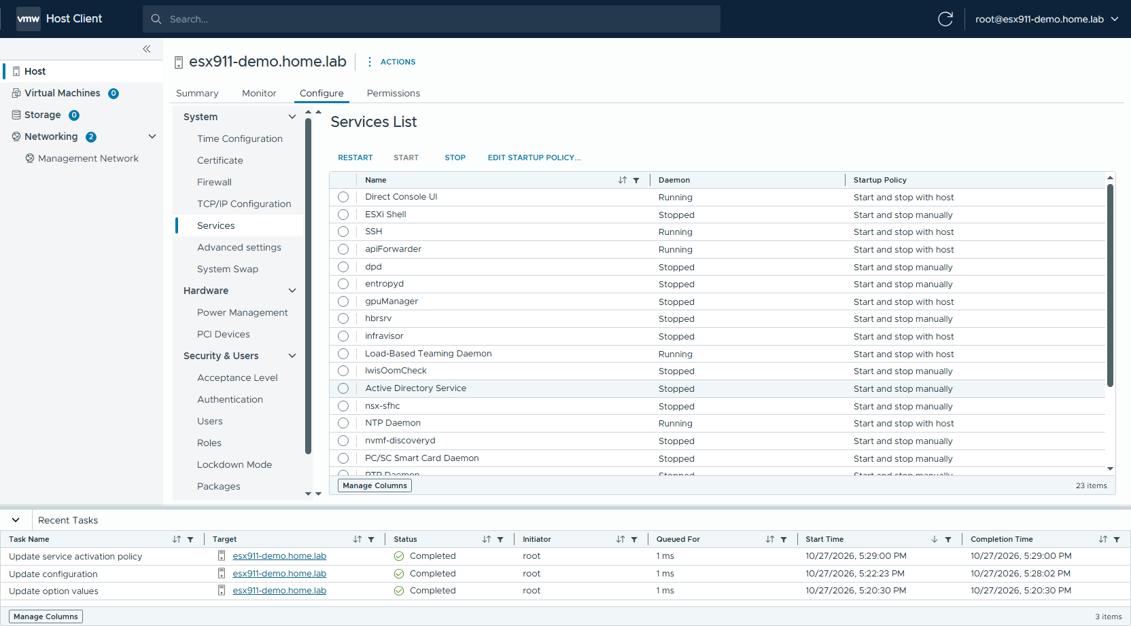
Figure 46 NTP Daemon startup policy updated

6.4 Verify DNS and networking
- Click Configure → System → TCP/IP Configuration and confirm that the IPv4 gateway and preferred DNS server of the Default stack are correct.
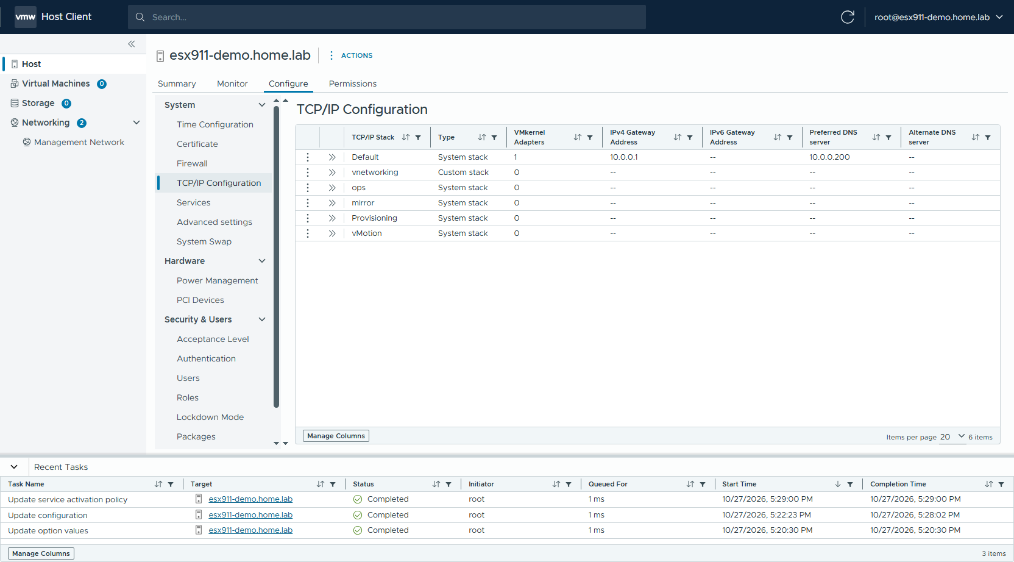
Figure 47 TCP/IP Configuration
- Click Networking → Port Groups in the left pane. By default, vSwitch0 has two port groups: Management Network and VM Network.
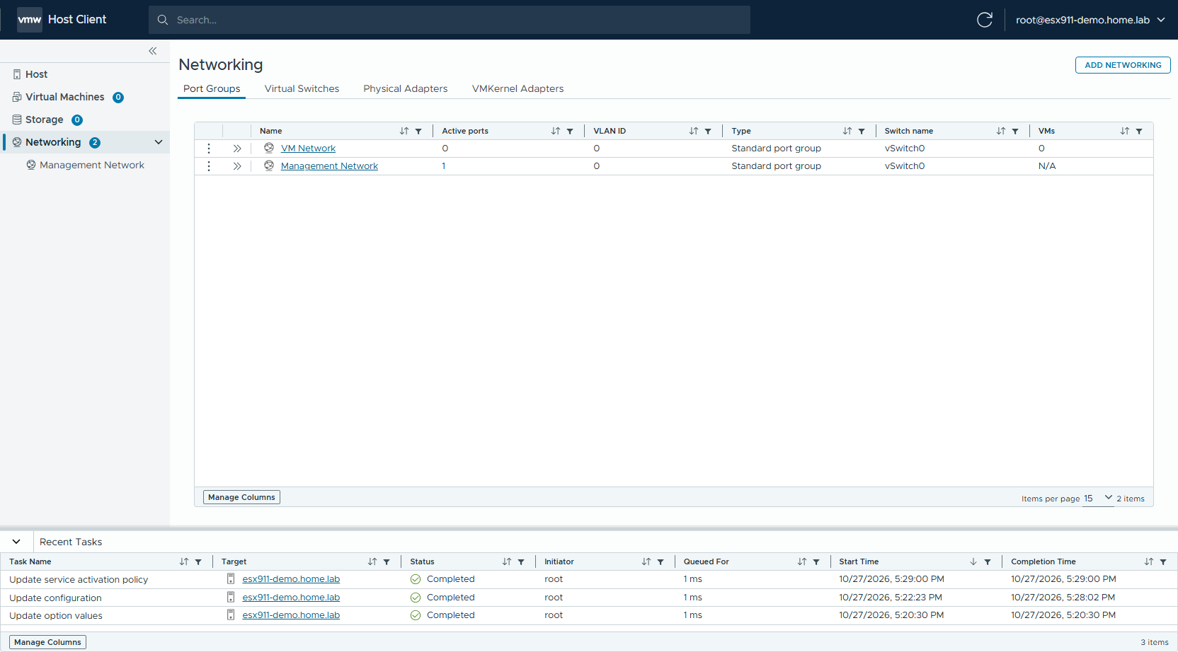
Figure 48 Port Groups
- Switch to the VMKernel Adapters tab and confirm the IP and TCP/IP stack of vmk0.
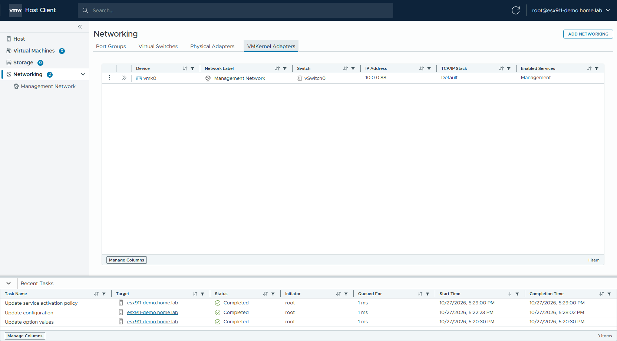
Figure 49 VMkernel Adapters

6.5 Create a VMFS datastore
The boot device is first used by the system partitions: BOOTBANK1 / BOOTBANK2 (about 4 GB each) plus OSDATA. On a small boot device (for example, a small-capacity BOSS / M.2 boot device), the entire device is consumed and the installer does not create datastore1 automatically, so the Summary page shows "No datastores have been configured". The installer creates datastore1 only when space remains after the system partitions. A datastore for virtual machines should be created on a local disk or SAN LUN other than the boot device, as follows.
- Click Storage → Storage Devices → RESCAN STORAGE and click OK in the dialog to rescan (newly inserted disks and SAN LUNs that were just zoned / mapped need a rescan first).
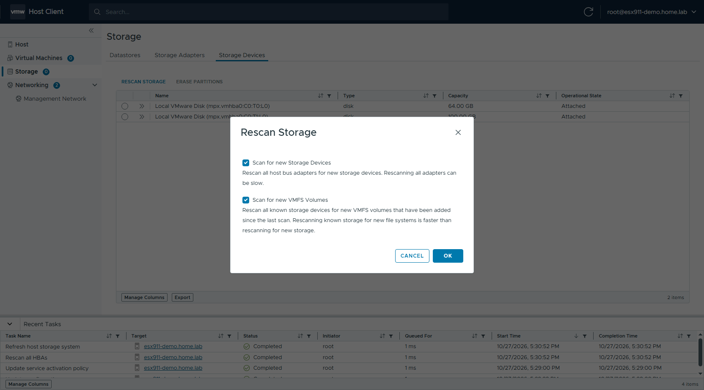
Figure 50 Rescan Storage
- Confirm that the disk for the datastore appears in the list (the 100 GB disk in the example).
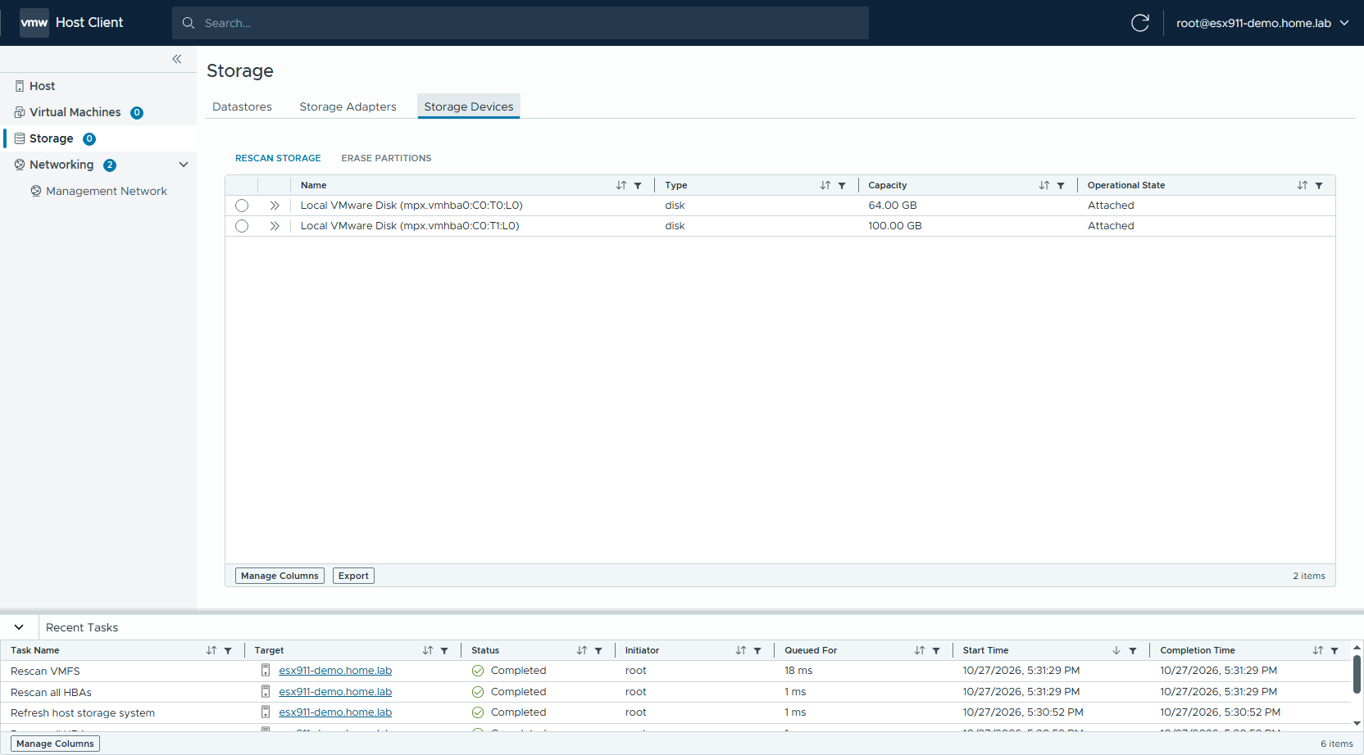
Figure 51 Storage Devices
- Switch to the Datastores tab, click NEW DATASTORE..., select VMFS as the type, and click NEXT.
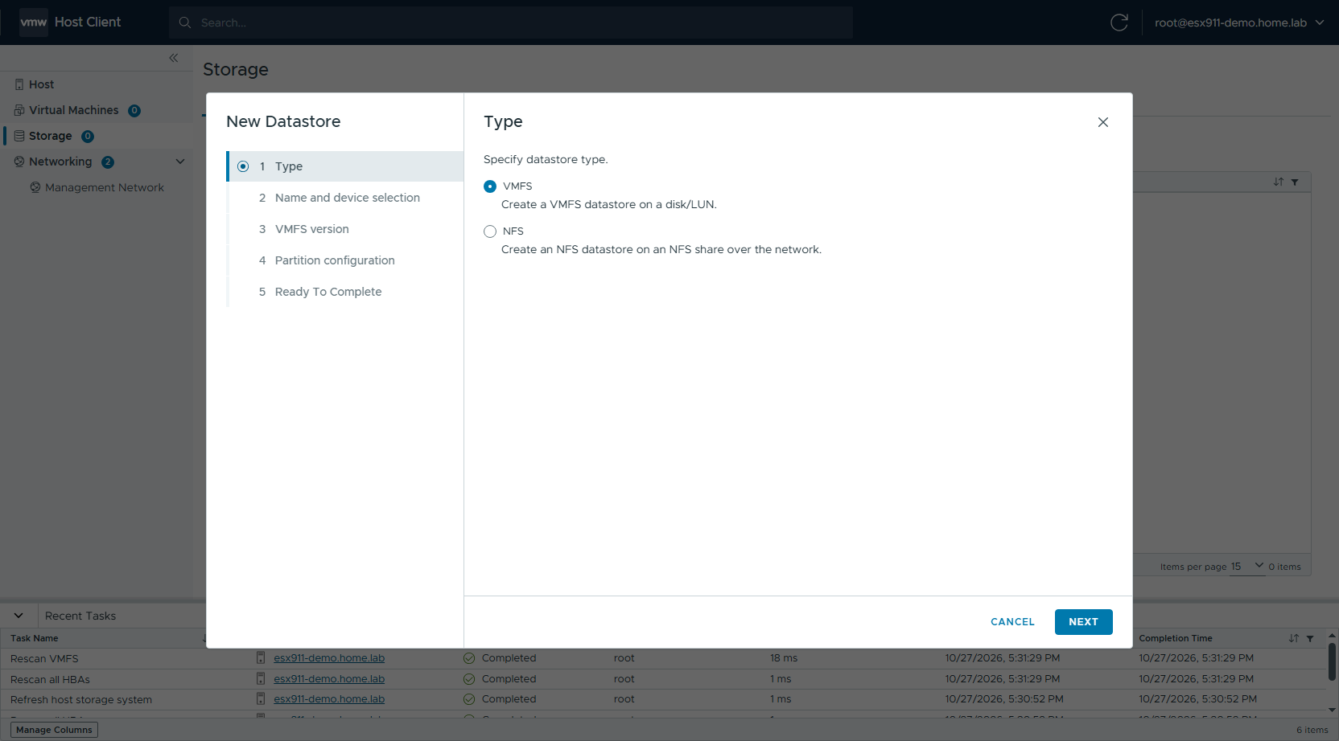
Figure 52 New Datastore: type
- Enter the datastore name, select the target disk (make sure not to select the boot device), and click NEXT.
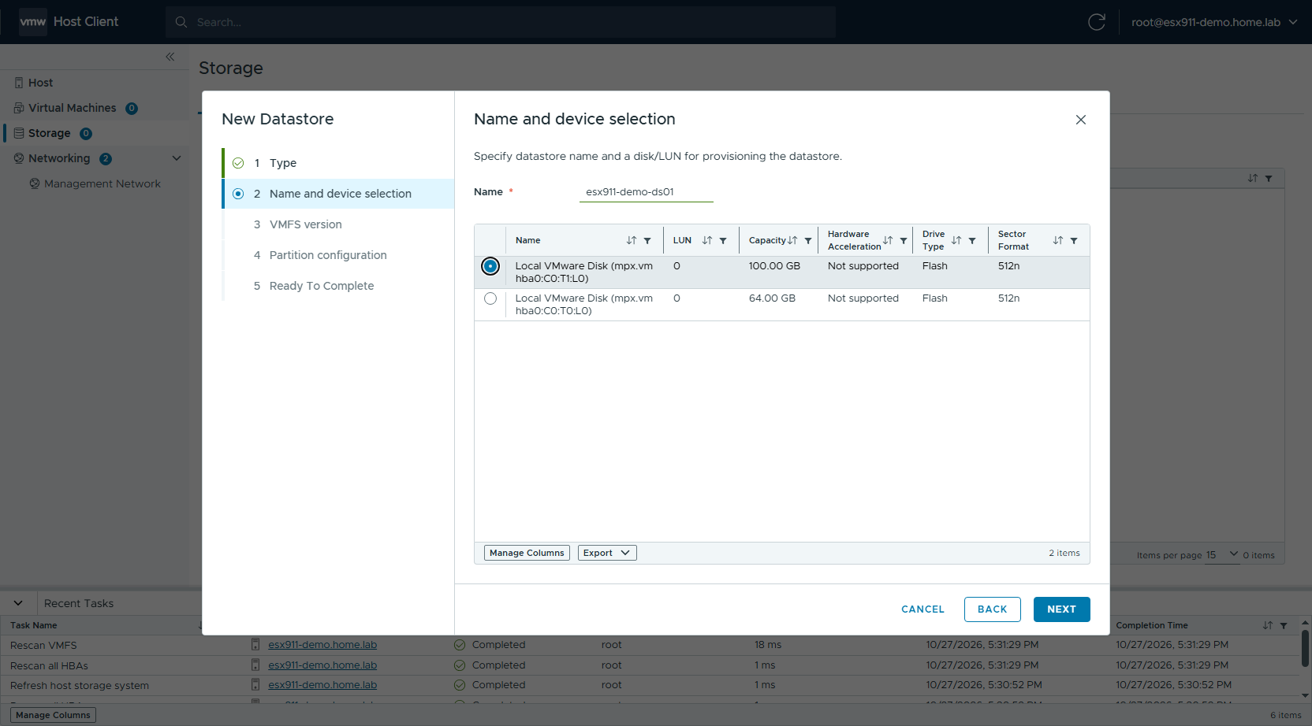
Figure 53 New Datastore: name and device
- Select VMFS 6 as the VMFS version and click NEXT.
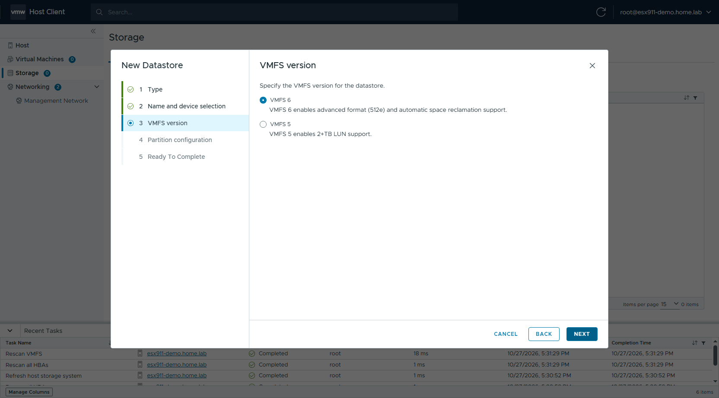
Figure 54 New Datastore: VMFS version
- For Partition Configuration, select Use all available partitions, keep the other defaults (block size 1 MB, Space Reclamation Priority Low), and click NEXT.
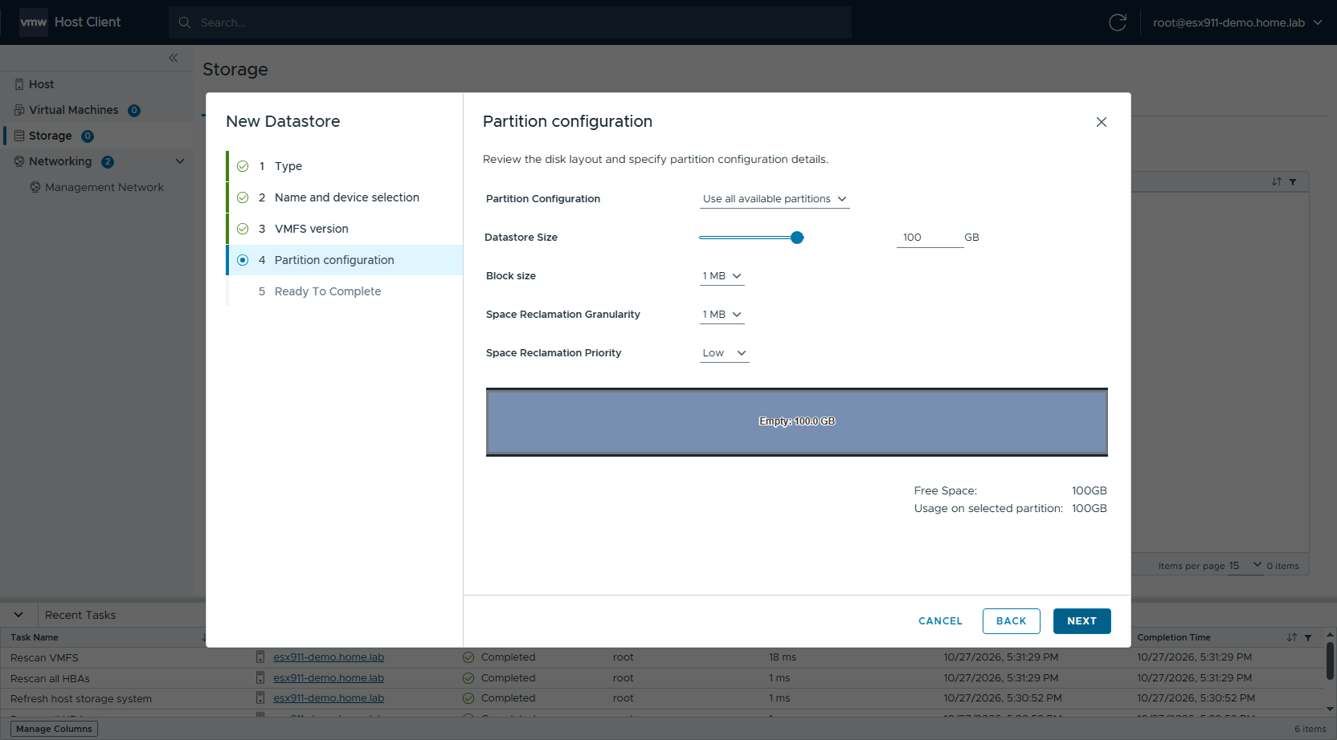
Figure 55 New Datastore: partition configuration
- Review the settings and click FINISH.
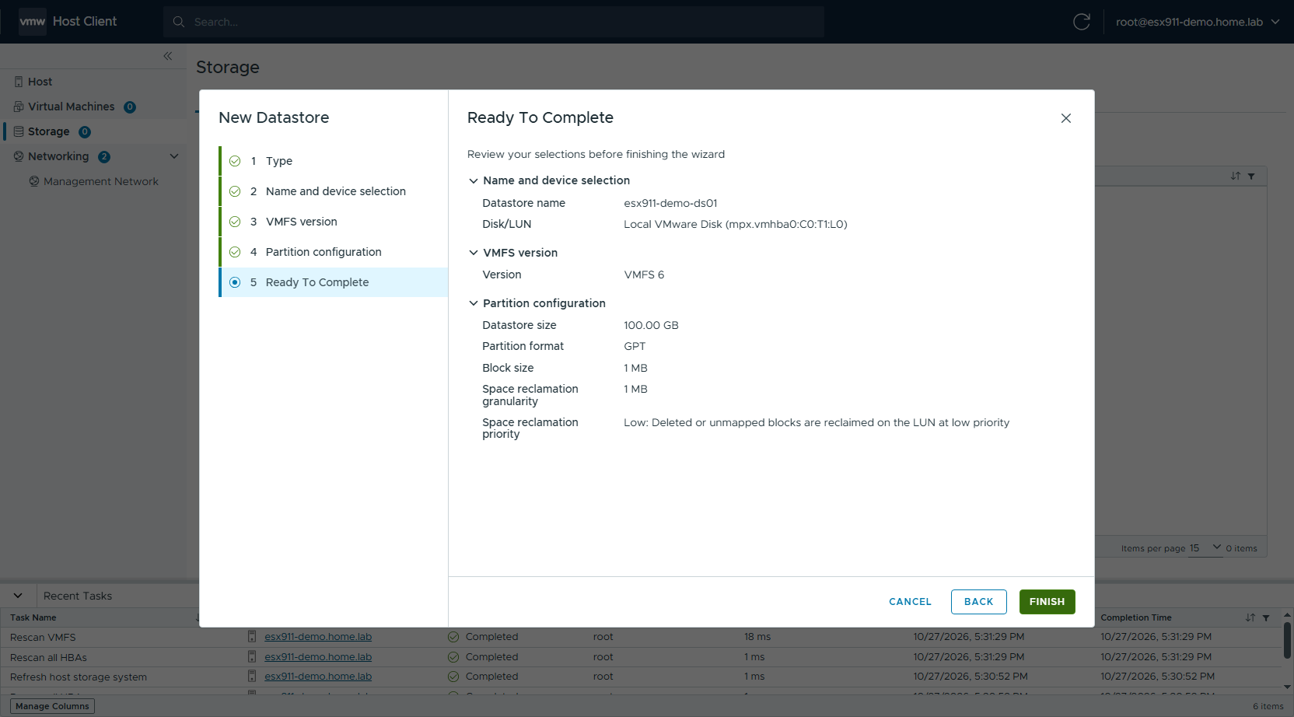
Figure 56 New Datastore: ready to complete
- The new VMFS 6 datastore appears in the Datastores list.
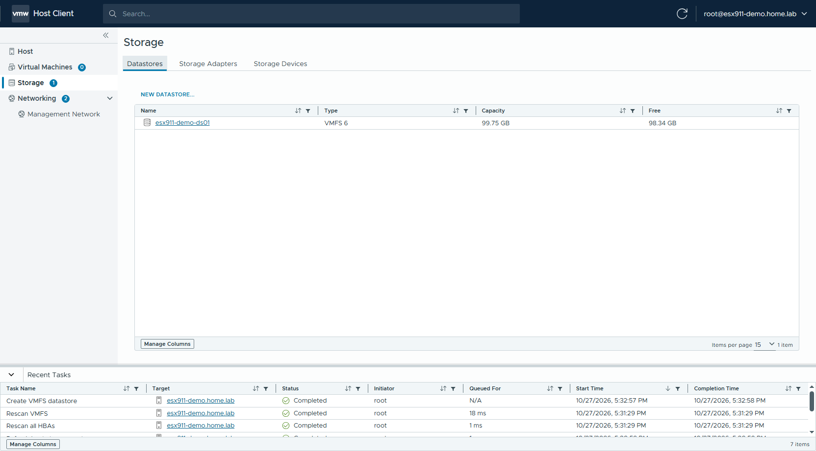
Figure 57 Datastores list
- Back on the host Summary page, the "No datastores" message is gone and the storage capacity is shown.
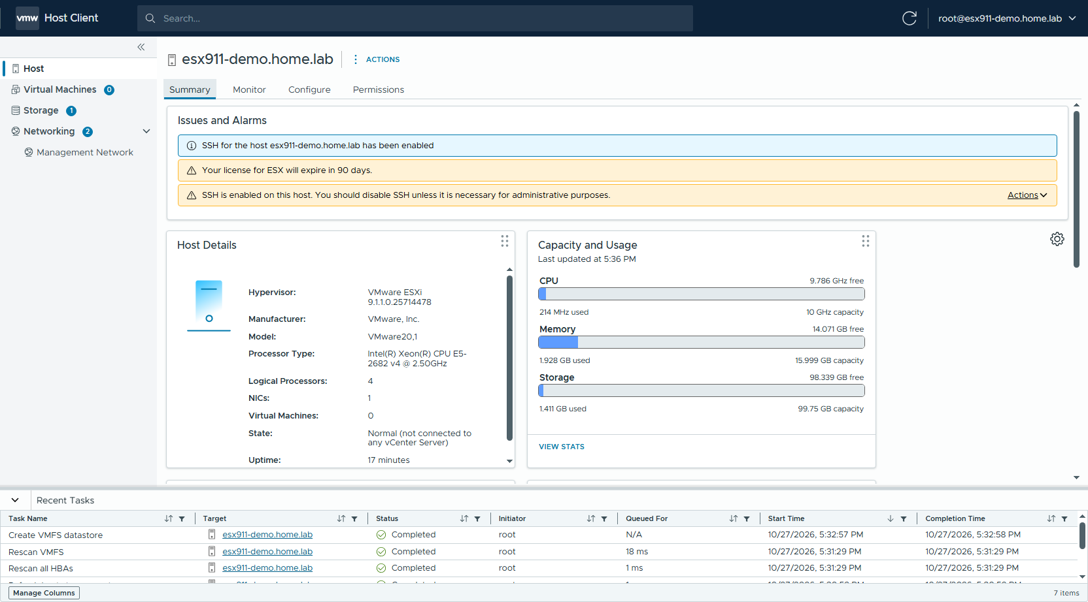
Figure 58 Host Summary after configuration

6.6 Regenerate the host certificate (required before adding the host to VCF / vCenter)
The ESXi self-signed certificate is generated at installation time, when the hostname is still localhost, so its CN / SAN is localhost.localdomain. Changing the FQDN in the DCUI afterwards does not update the certificate. VCF Installer / SDDC Manager checks that the host certificate matches the FQDN and fails validation if it does not.
- Click Configure → System → Certificate. The CN in the Subject is still localhost.localdomain.
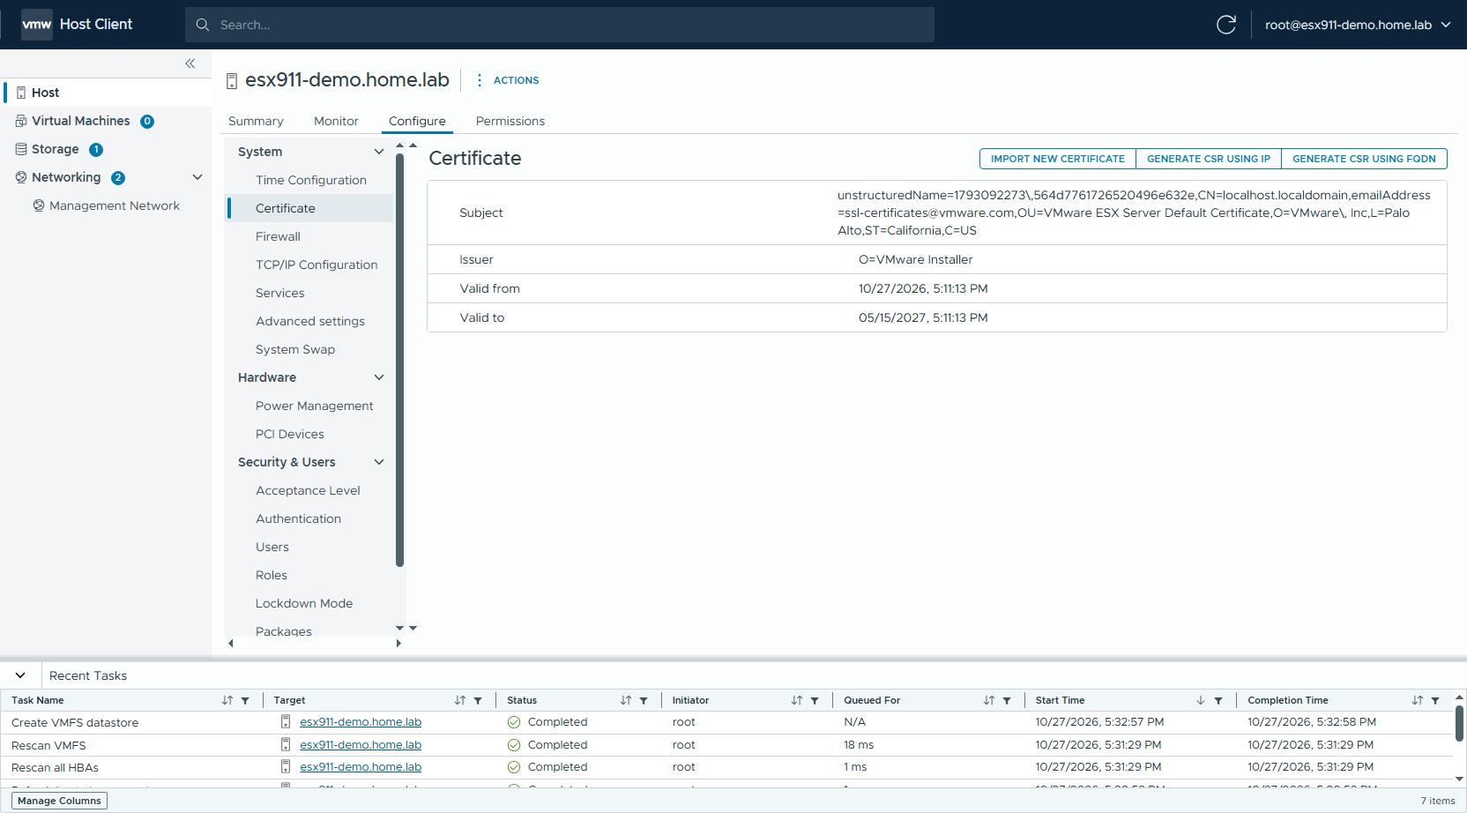
Figure 59 Certificate before regeneration
- Log in to the host over SSH, regenerate the certificate, and restart the related services (on ESXi 9 the rhttpproxy that serves port 443 is Envoy — it must be restarted, otherwise the old certificate is still presented):
[root@esx911-demo:~] /sbin/generate-certificates
[root@esx911-demo:~] /etc/init.d/hostd restart
hostd stopped.
hostd started.
[root@esx911-demo:~] /etc/init.d/vpxa restart
vpxa stopped.
vpxa started.
[root@esx911-demo:~] /etc/init.d/rhttpproxy restart
Envoy proxy Discovery Service stopped.
Envoy proxy Discovery Service started
[root@esx911-demo:~] openssl x509 -in /etc/vmware/ssl/rui.crt -noout -subject -ext subjectAltName
subject=... CN=esx911-demo.home.lab ...
X509v3 Subject Alternative Name:
DNS:esx911-demo.home.lab
If only hostd / vpxa are restarted, rui.crt is already updated but port 443 still presents the old certificate; it changes only after rhttpproxy is restarted. Rebooting the host also works.
- Log in to the Host Client again (restarting hostd invalidates the existing session). The CN on the Certificate page is now the host FQDN.
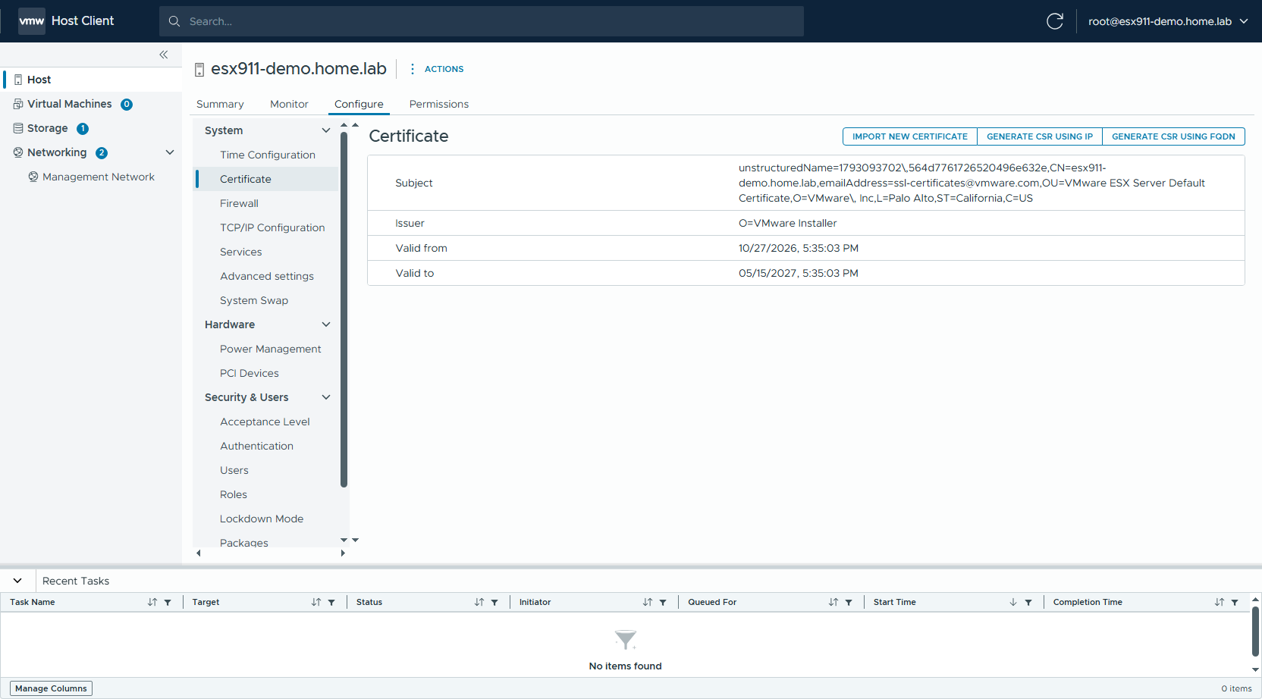
Figure 60 Certificate after regeneration

7. Post-Installation Verification
Log in to the host over SSH and run the following commands to check each item (the output below is from the example host).

Version
[root@esx911-demo:~] esxcli system version get
Product: VMware ESXi
Version: 9.1.1
Build: Releasebuild-25714478
Update: 1
Maintenance: 1
Patch: 0
When adding the host to an existing VCF environment, the ESXi build must match the BOM of that VCF version (9.1.1 = 25714478).

Management network, hostname, DNS
[root@esx911-demo:~] esxcli network ip interface ipv4 get
Name IPv4 Address IPv4 Netmask IPv4 Broadcast Address Type Gateway DHCP DNS
---- ------------ ------------- -------------- ------------ -------- --------
vmk0 10.0.0.88 255.255.254.0 10.0.1.255 STATIC 10.0.0.1 false
[root@esx911-demo:~] esxcli system hostname get
Domain Name: home.lab
Fully Qualified Domain Name: esx911-demo.home.lab
Host Name: esx911-demo
[root@esx911-demo:~] esxcli network ip dns server list
DNSServers: 10.0.0.200

NTP synchronization
[root@esx911-demo:~] esxcli system ntp get
Enabled: true
Loglevel: warning
PID: 264176
Runtime Seconds: 638
Servers: 10.0.1.254
Service Providing Kernel Time: Network Time Protocol
Time Service Enabled: true
Time Synchronized: true
Only Time Synchronized: true means the clock is actually synchronized.

Storage
[root@esx911-demo:~] esxcli storage filesystem list
Volume Name Type Size Free
------------------------------------------- ------ ------------ ------------
esx911-demo-ds01 VMFS-6 107105746944 105590554624
OSDATA-6ae06a2d-3d0de9f4-1679-005056bf44bf VMFSOS 59861106688 57913901056
BOOTBANK1 vfat 4293591040 3939893248
BOOTBANK2 vfat 4293591040 4293525504
(The Mount Point / UUID columns are omitted.)

Acceptance checklist
# | Check | Expected result | Result
1 | ESXi version / build | 9.1.1 / 25714478 | ✅
2 | vmk0 address type | STATIC; IP / mask / gateway correct | ✅
3 | FQDN | Matches the DNS A record; all lowercase | ✅
4 | Forward / reverse DNS | nslookup FQDN and nslookup IP match each other | ✅
5 | Test Management Network | Gateway / DNS / hostname all OK | ✅
6 | NTP | Time Synchronized = true | ✅
7 | NTP Daemon startup policy | Start and stop with host | ✅
8 | Host certificate CN / SAN | = host FQDN | ✅
9 | SSH | As required (needed for VCF commissioning) | ✅
10 | Datastore | Created as required (VMFS 6) | ✅

8. Troubleshooting and Notes
Symptom | Cause | Resolution
CPU_SUPPORT OVERRIDEWARNING during installation | The CPU is not supported by ESXi 9.1.1 | Replace with supported hardware in production; force the installation only in a test environment (KB 82794)
F11 does nothing in the BMC remote console | The browser treats F11 as full screen | Send F11 with the console's virtual keyboard / key macros
The DCUI shows DHCP lookup failed | No DHCP on the management network | Expected; configure a static IP as in chapter 5
Ping fails / Test Management Network fails after setting the IP | Wrong switch port VLAN, wrong NIC selected, or wrong gateway | Check access / trunk and the VLAN ID first, then compare MAC addresses with View Details in Network Adapters
No datastore1 after installation | The boot device is fully used by the system partitions | Create a datastore (section 6.5), or reduce OSDATA with the systemMediaSize boot option during installation
The time drifts again after a reboot | The NTP Daemon startup policy is manual | Change it to Start and stop with host (section 6.3)
VCF host validation reports a certificate / hostname mismatch | The certificate is still the installation-time localhost.localdomain | Regenerate the certificate and restart rhttpproxy (section 6.6)
VMs cannot be powered on after 90 days | The evaluation license has expired | In a VCF 9 environment, the license is applied by vCenter / VCF Operations after the host is added to vCenter

Next steps
- Add to vCenter: use Add Host in the vSphere Client, with the FQDN as the host name.
- Add to VCF: before commissioning the host in VCF Operations / SDDC Manager, make sure items 1–9 in the checklist above all pass.

