VCF 9.1.1 Coverage Lab
把既有 vSphere converge 成管理網域,再把另一套 vSphere 匯入成工作負載網域
工作負載網域只把 vCenter 升到 9.1.1、主機維持 ESXi 8.0 U3b,並與管理網域共用同一套 NSX
從零重建 → converge → 建來源端 → 升 vCenter → 匯入 → 驗收,全程逐步截圖
實作日期:2026-10-01 ~ 10-03

目錄
一、這份 lab 要回答什麼
二、環境與拓樸
三、階段 1:把既有 vSphere converge 成 VCF 管理網域
四、階段 2:建立工作負載網域的來源端
五、階段 3:只把 vCenter 從 8.0.3 升到 9.1.1
六、階段 4:匯入成 VI workload domain 並共用 NSX
七、三個 Error 怎麼修
八、踩坑速查
附錄 A:指令彙整 附錄 B:CLI 輸出

一、這份 lab 要回答什麼
客戶手上常常不是一張白紙:既有的 vSphere 要進 VCF,而且不只一套。這份 lab 把兩件事串起來做完 —— 先用 converge 把一套既有 vSphere 變成 VCF 9.1.1 的管理網域,再把另一套獨立的 vSphere 匯入成 VI workload domain,而且那套只把 vCenter 升到 9.1.1、ESXi 主機刻意留在 8.0 U3b,再讓它跟管理網域共用同一套 NSX。
問題 | 答案 | 依據
既有 vSphere 可以 converge 成 VCF 9.1.1 管理網域嗎? | ✅ 可以 | VCF Installer workflowType=VCF,181/181 子任務成功
工作負載網域可以只升 vCenter、主機留在 8.0U3b 嗎? | ✅ 可以 | 匯入前置條件:vCenter ≥ 8.0 U3a、ESX ≥ 8.0 U3
兩個網域可以共用同一套 NSX 嗎? | ✅ 可以 | 官方:Shared NSX instances are supported across multiple vCenter instances
要共用 NSX,vCenter 一定要升到 9.1 嗎? | ✅ 要 | 官方:NSX 9.1 does not support vCenter 8.0 Update 3a or later
匯入驗證會卡在哪? | 3 個 Error,都可修 | DRS / NSX compute manager / vLCM 映像管理
最關鍵的一句:共用 NSX 本身沒有被擋,擋的是前置條件 —— 那套 NSX 必須先把要匯入的 vCenter 註冊成 Compute Manager。驗證訊息直接把修法寫出來了。

1.1 最後的成績
階段 | 內容 | 結果
1 | converge 既有 vSphere → VCF 9.1.1 管理網域(不部 overlay) | COMPLETED_WITH_SUCCESS 181/181
2 | 建工作負載網域來源端:vCenter 8.0.3 + ESXi 8.0U3b ×3 + vSAN | 1500 GB vSAN,3 台主機
3 | vCenter 8.0.3 → 9.1.1(migration-based),主機不動 | Upgrade finished successfully,50 分鐘
4 | 匯入成 VI workload domain + 共用管理網域 NSX | Validation Succeeded 71 Passed / 0 Errors / 1 Warning

二、環境與拓樸

2.1 管理網域(converge 出來的)
元件 | FQDN / IP | 版本 / 說明
VCF Instance | vcf-m02-converge | VCF 9.1.1.0.25713928
vCenter | vcf-m02-vc01.home.lab / 10.0.1.19 | 9.1.1.0.25712839
NSX Manager (VIP) | vcf-m02-nsx01.home.lab / 10.0.1.20 | 9.1.1.0.25691509,單節點 vcf-m02-nsx01a
SDDC Manager | vcf-m02-sddcm01.home.lab / 10.0.1.18 | —
VCF Operations | vcf-m02-ops01.home.lab / 10.0.1.22 | 主控台,匯入精靈在這裡
VCF Installer | vcf-m02-inst06.home.lab / 10.0.1.54 | 只用於階段 1 的 converge
主機 | vcf-m02-esx01~04.home.lab | ESXi 9.1.1,4 台,vtepless transport node

2.2 工作負載網域來源端(要被匯入的)
元件 | FQDN / IP | 版本 / 說明
vCenter | vcf-w01-vc01.home.lab / 10.0.1.49 | 8.0.3 build-24853646 → 9.1.1.0.25712839
主機 | vcf-w01-esx01~03.home.lab / 10.0.1.46-48 | ESXi 8.0.3 build-24280767(8.0 U3b),全程不動
叢集 | vcf-w01-cl01 | vSAN OSA 1500 GB,DRS fullyAutomated
VDS | vcf-w01-cl01-vds01 | MTU 9000,mgmt portgroup w01-DPortGroup-VM-Mgmt
NTP | 10.0.1.254 | 與管理網域同一台(RouterOS)
nested lab 繞道:這三台 nested ESXi 上除了 vmk0 之外的 dvPort 都收不到 unicast(portgroup / VLAN / MTU / 安全性政策逐項排除後仍然如此),所以 vMotion 與 vSAN 直接開在 vmk0 上。對本文要驗證的題目沒有影響。
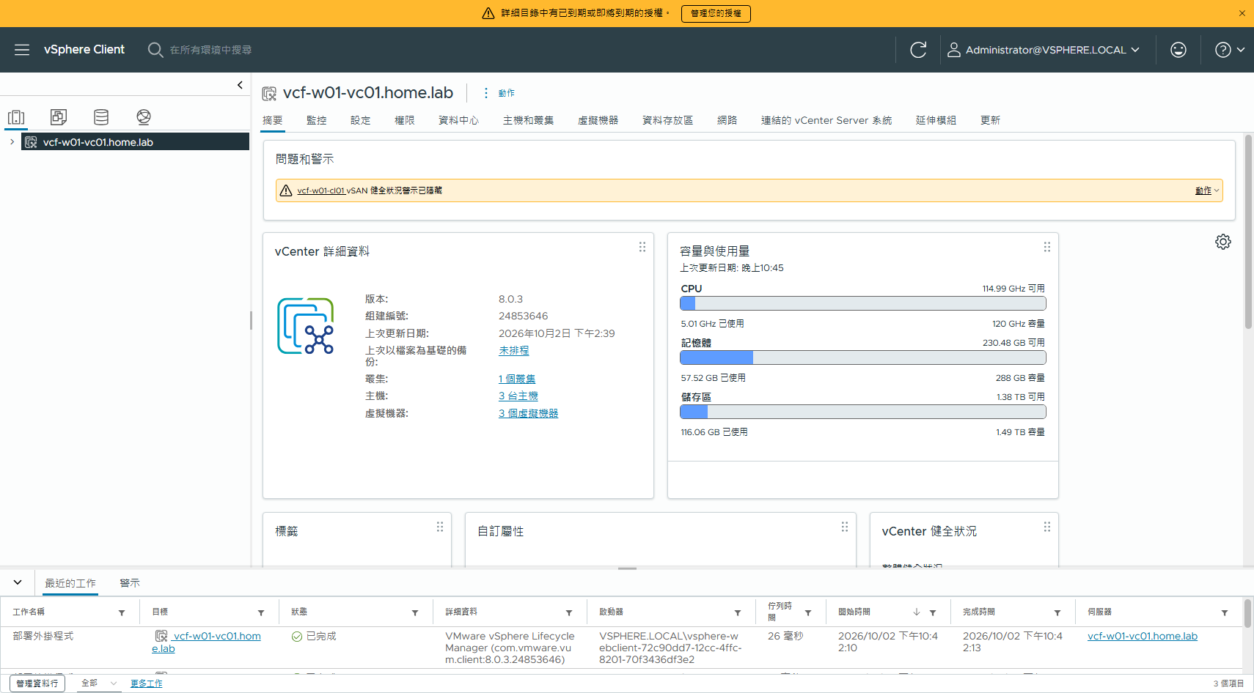
圖 1 升級前的 w01:vCenter 8.0.3 build 24853646、1 個叢集、3 台主機、1.49 TB 儲存

三、階段 1:把既有 vSphere converge 成 VCF 管理網域
這一段沿用另一份文件已經驗過的「不部 overlay」寫法:workflowType = VCF、既有 vCenter 用 useExistingDeployment,NSX 新部但 skipNsxOverlayOverManagementNetwork = true,而且刻意不給 transportVlanId 與 ipAddressPoolSpec,主機會變成 vtepless transport node。
"workflowType": "VCF",
"vcenterSpec": { "useExistingDeployment": true, "vcenterHostname": "vcf-m02-vc01.home.lab", ... },
"nsxtSpec": { "useExistingDeployment": false,
"nsxtManagers": [ { "hostname": "vcf-m02-nsx01a.home.lab" } ],
"vipFqdn": "vcf-m02-nsx01.home.lab",
"skipNsxOverlayOverManagementNetwork": true },
"sddcManagerSpec": { "hostname": "vcf-m02-sddcm01.home.lab", "useExistingDeployment": false, ... }
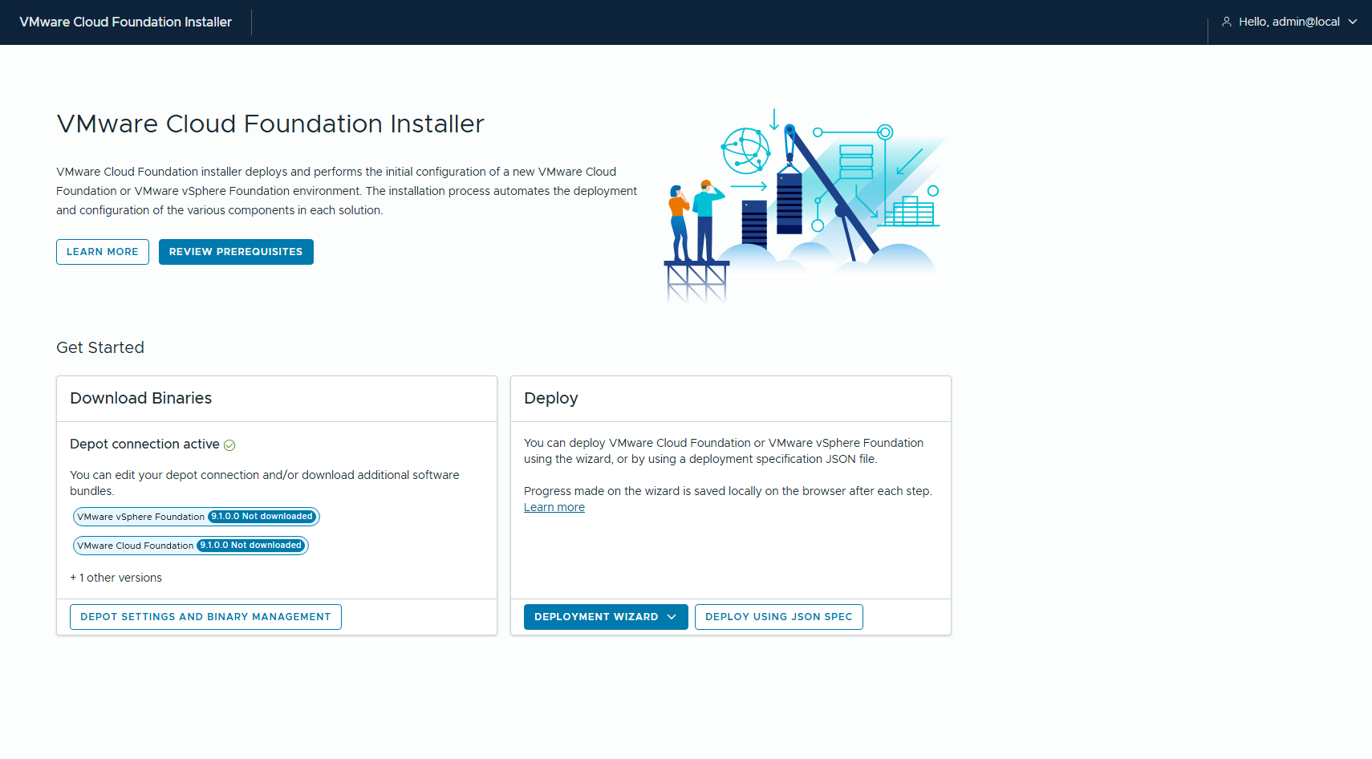
圖 2 VCF Installer 9.1.1,depot 指向離線 depot http://10.0.0.61:8888
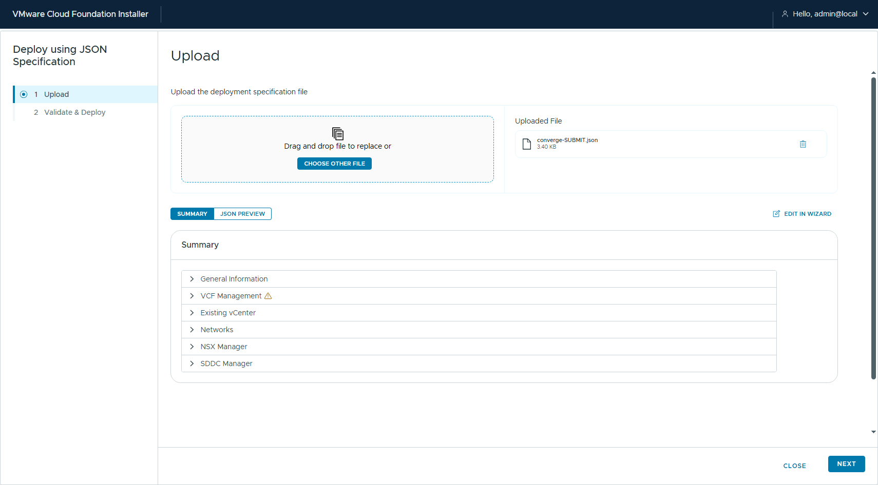
圖 3 DEPLOY USING JSON SPEC → 上傳 converge spec
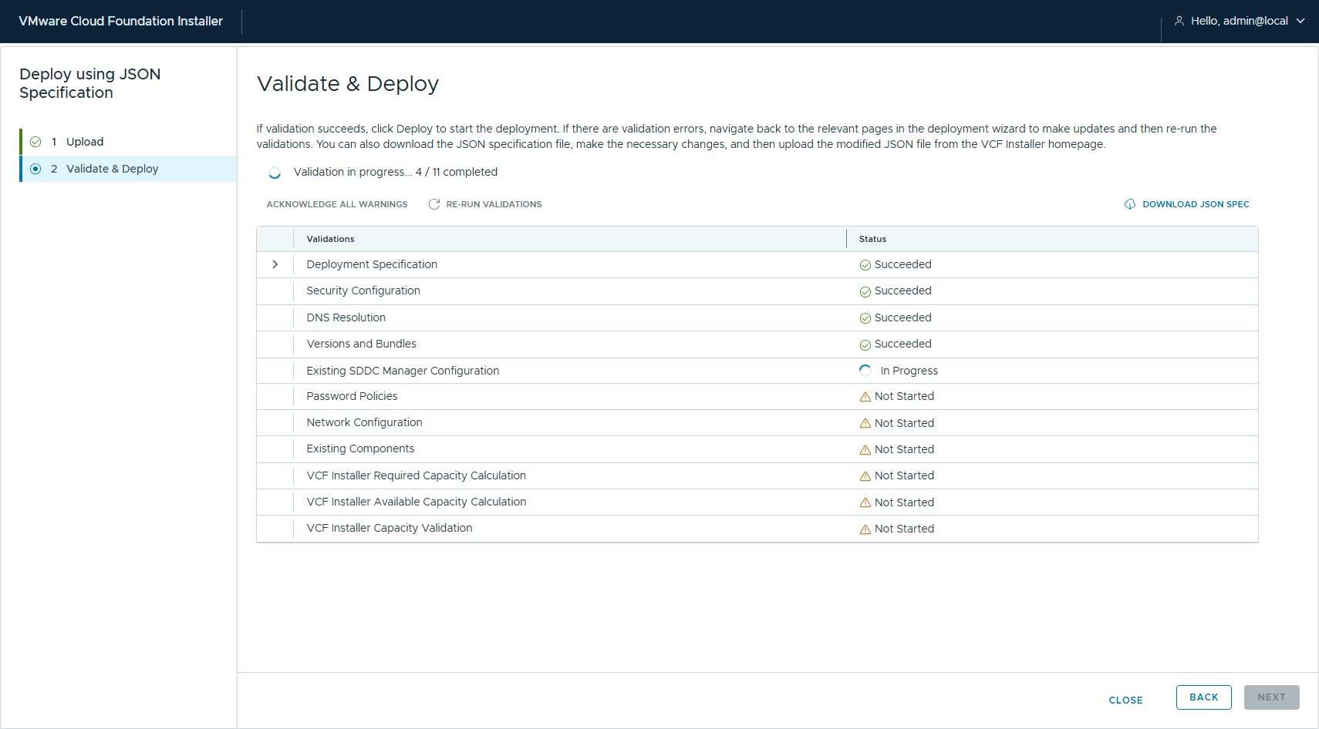
圖 4 驗證 spec
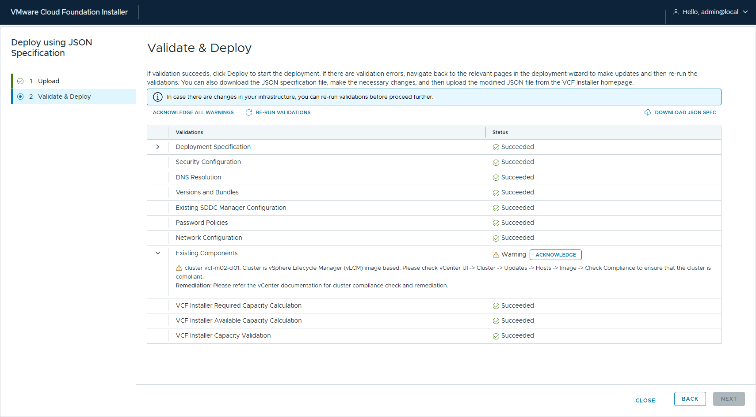
圖 5 確認警告
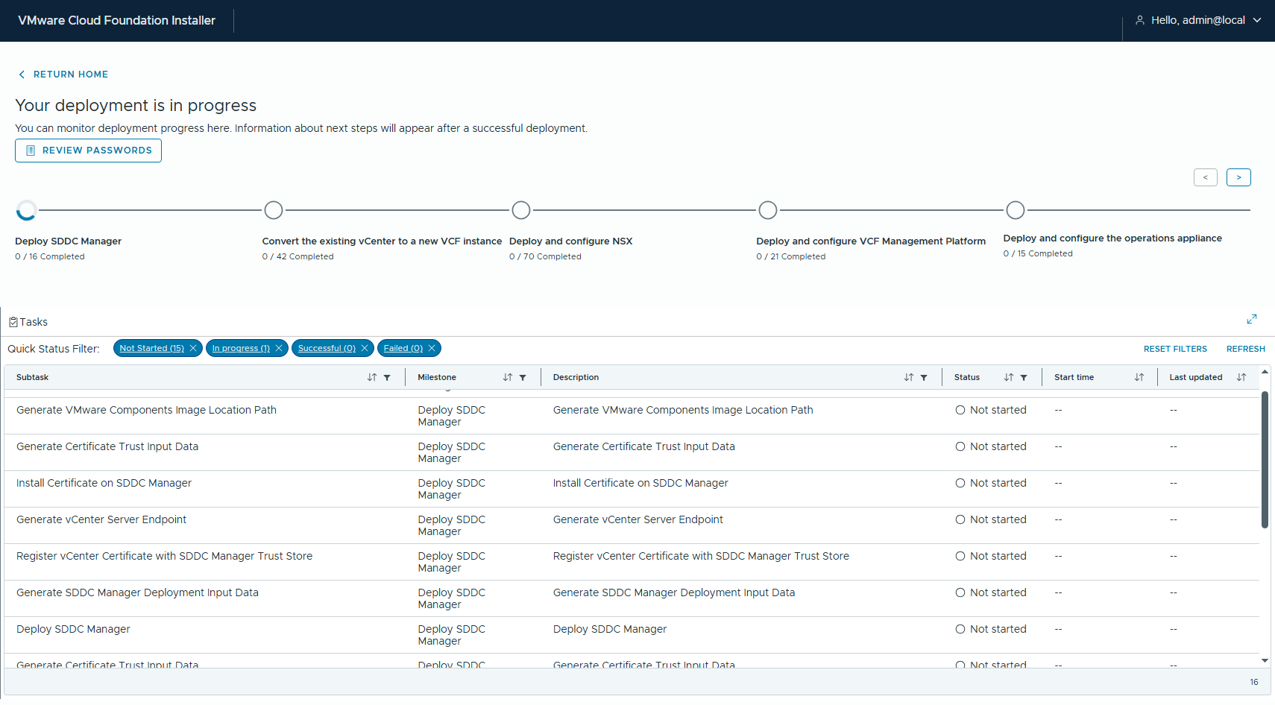
圖 6 送出,開始 converge
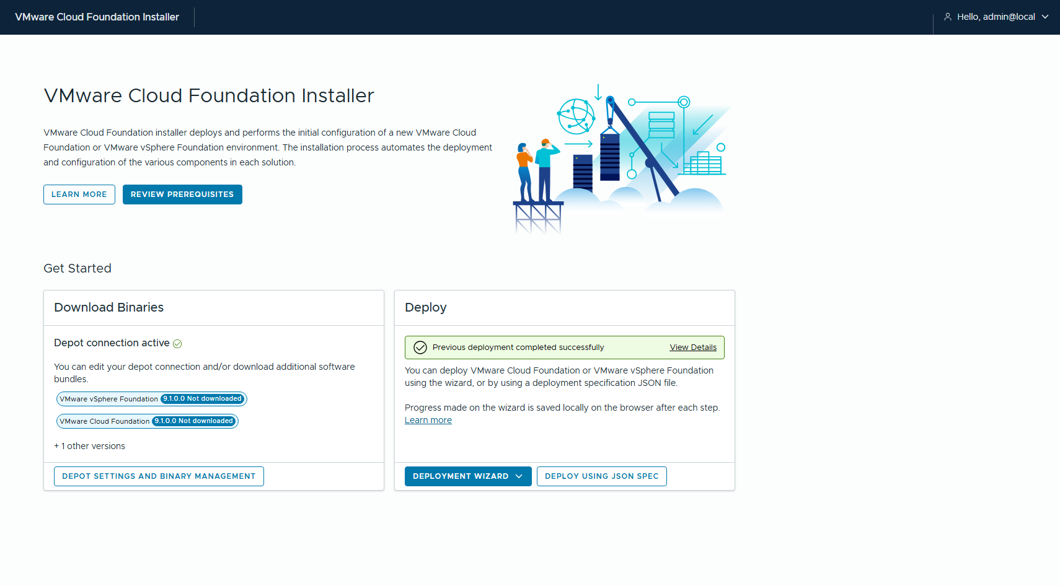
圖 7 Previous deployment completed successfully

3.1 結果
VCF Installer : vcf-m02-inst06.home.lab
vcfInstanceName: vcf-m02-converge
deploymentType : VMware Cloud Foundation Deployment
sddcId : 012a6214-87cc-4a99-824b-bedac64907a6
status : COMPLETED_WITH_SUCCESS
subtasks : 181 / 181 succeeded
--- Milestones ---
Deploy SDDC Manager COMPLETED_WITH_SUCCESS
Convert the existing vCenter to a new VCF instance COMPLETED_WITH_SUCCESS
Deploy and configure NSX COMPLETED_WITH_SUCCESS
Deploy and configure VCF Management Platform COMPLETED_WITH_SUCCESS
Deploy and configure the operations appliance COMPLETED_WITH_SUCCESS
Deploy and configure VCF Management Services COMPLETED_WITH_SUCCESS
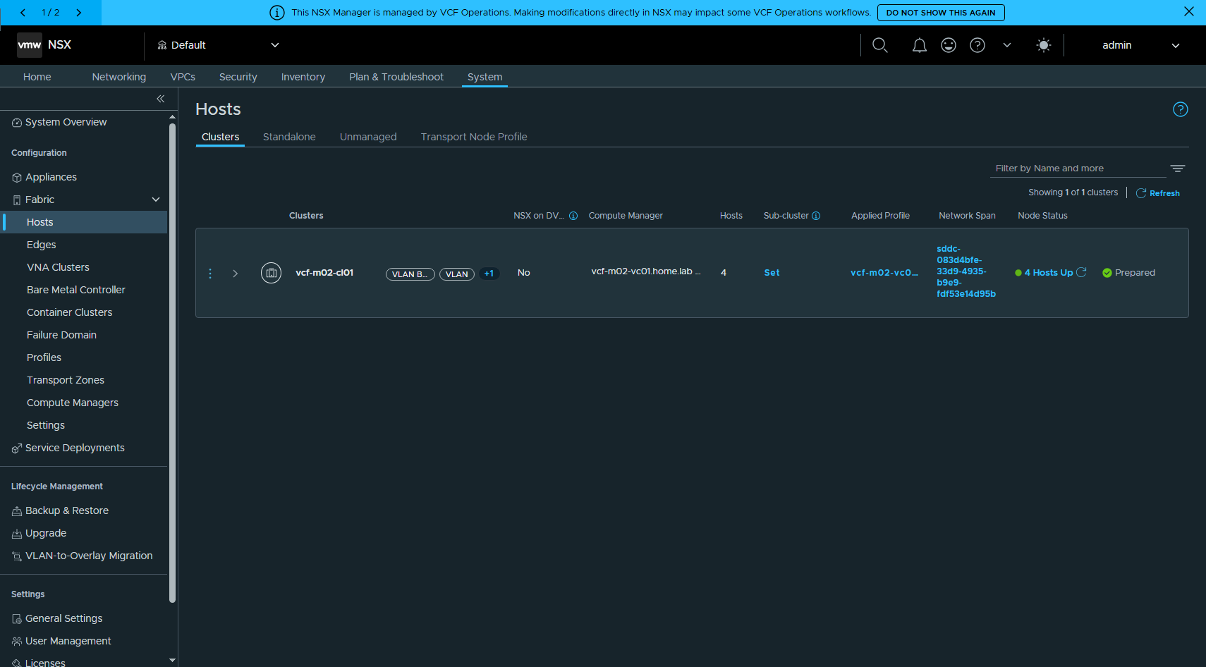
圖 8 converge 完成後的 NSX:System → Fabric → Hosts。上方橫幅提醒「This NSX Manager is managed by VCF Operations」

四、階段 2:建立工作負載網域的來源端
來源端刻意做成「客戶現場的樣子」:一套獨立、沒有被任何 SDDC Manager 納管的 vSphere 8.0.3,底下 3 台 ESXi 8.0 U3b 組 vSAN。

4.1 用 vcsa-deploy 在 nested 主機上引導 vCenter
第一台主機先用 single-node vSAN 把 vCenter 生出來,之後再把另外兩台加進來。
{
"__version": "2.13.0",
"__comments": "Coverage lab 階段 2:workload domain 來源端 vCenter 8.0.3,在 nested vcf-w01-esx01 上以 single-node vSAN 引導。之後只把這台 vCenter 升到 9.1.1,主機維持 8.0U3b。",
"new_vcsa": {
"esxi": {
"hostname": "vcf-w01-esx01.home.lab",
"username": "root",
"password": "<REDACTED>",
"deployment_network": "VM Network",
"VCSA_cluster": {
"datacenter": "vcf-w01-dc01",
"cluster": "vcf-w01-cl01",
"compression_only": false,
"deduplication_and_compression": false,
"enable_vsan_esa": false,
"disks_for_vsan": {
"cache_disk": [
"naa.6000c29960f7a9d9f17a0b6e552b05da"
],
"capacity_disk": [
"naa.6000c2967c56267e91cddea00168847e"
]
}
}
},
"appliance": {
"thin_disk_mode": true,
"deployment_option": "small",
"name": "vcf-w01-vc01"
},
"network": {
"ip_family": "ipv4",
"mode": "stat
🔴 esxi.hostname 一定要填 FQDN。填 IP 的話主機會以 IP 的身分加進 inventory,後面 VCF 匯入會因為「All ESX hosts use FQDNs instead of short names」被擋,要再 object.rename 救回來。

4.2 補齊叢集
[14:44:34] connecting vcf-w01-vc01.home.lab
[14:44:37] cluster vcf-w01-cl01, hosts now: vcf-w01-esx01.home.lab
[14:44:37] adding vcf-w01-esx02.home.lab ...
[14:44:51] adding vcf-w01-esx03.home.lab ...
[14:45:03] hosts: vcf-w01-esx01.home.lab, vcf-w01-esx02.home.lab, vcf-w01-esx03.home.lab
[14:45:03] creating VDS vcf-w01-cl01-vds01 (MTU 9000)
[14:45:04] portgroup w01-DPortGroup-VM-Mgmt (VLAN 0)
[14:45:05] portgroup vcf-w01-cl01-vds01-pg-vmotion (VLAN 15)
[14:45:06] portgroup vcf-w01-cl01-vds01-pg-vsan (VLAN 16)
[14:45:08] adding vcf-w01-esx01.home.lab to VDS
[14:45:11] attaching vmnic1 on vcf-w01-esx01.home.lab
[14:45:11] vcf-w01-esx01.home.lab VDS uplinks: vmnic1
[14:45:11] moving VM vcf-w01-vc01 NIC 'VM Network' -> w01-DPortGroup-VM-Mgmt
[14:45:13] migrating vmk0 + vmnic0 on vcf-w01-esx01.home.lab
[14:45:14] adding vcf-w01-esx02.home.lab to VDS
[14:45:17] attaching vmnic1 on vcf-w01-esx02.home.lab
[14:45:17] vcf-w01-esx02.home.lab VDS uplinks: vmnic1
[14:45:17] migrating vmk0 + vmnic0 on vcf-w01-esx02.home.lab
[14:45:19] adding vcf-w01-esx03.home.lab to VDS
[14:45:24] attaching vmnic1 on vcf-w01-esx03.home.lab
[14:45:24] vcf-w01-esx03.home.lab VDS uplinks: vmnic1
[14:45:24] migrating vmk0 + vmnic0 on vcf-w01-esx03.home.lab
[14:45:25] vcf-w01-esx01.home.lab new vmk vmotion 192.168.25.11
[14:45:27] vcf-w01-esx01.home.lab new vmk vsan 192.168.26.11
[14:45:34] vcf-w01-esx01.home.lab vmk0: 關掉 vmotion/vsan
[14:45:42] vcf-w01-esx02.home.l

4.3 vMotion / vSAN 走 vmk0 的繞道
[22:10:51] remove vcf-w01-esx01.home.lab vmk1
[22:10:52] remove vcf-w01-esx01.home.lab vmk2
[22:10:52] vcf-w01-esx01.home.lab vmk0 (10.0.1.46) -> enable vMotion + vSAN
[22:11:00] remove vcf-w01-esx02.home.lab vmk1
[22:11:00] remove vcf-w01-esx02.home.lab vmk2
[22:11:01] vcf-w01-esx02.home.lab vmk0 (10.0.1.47) -> enable vMotion + vSAN
[22:11:08] remove vcf-w01-esx03.home.lab vmk1
[22:11:09] remove vcf-w01-esx03.home.lab vmk2
[22:11:10] vcf-w01-esx03.home.lab vmk0 (10.0.1.48) -> enable vMotion + vSAN
[22:11:17] === vmk summary ===
[22:11:17]
Host Name PortGroupName IP VMotionEnabled VsanTrafficEnabled
---- ---- ------------- -- -------------- ------------------
vcf-w01-esx01.home.lab vmk0 w01-DPortGroup-VM-Mgmt 10.0.1.46 True True
[22:11:17]
Host Name PortGroupName IP VMotionEnabled VsanTrafficEnabled
---- ---- ------------- --
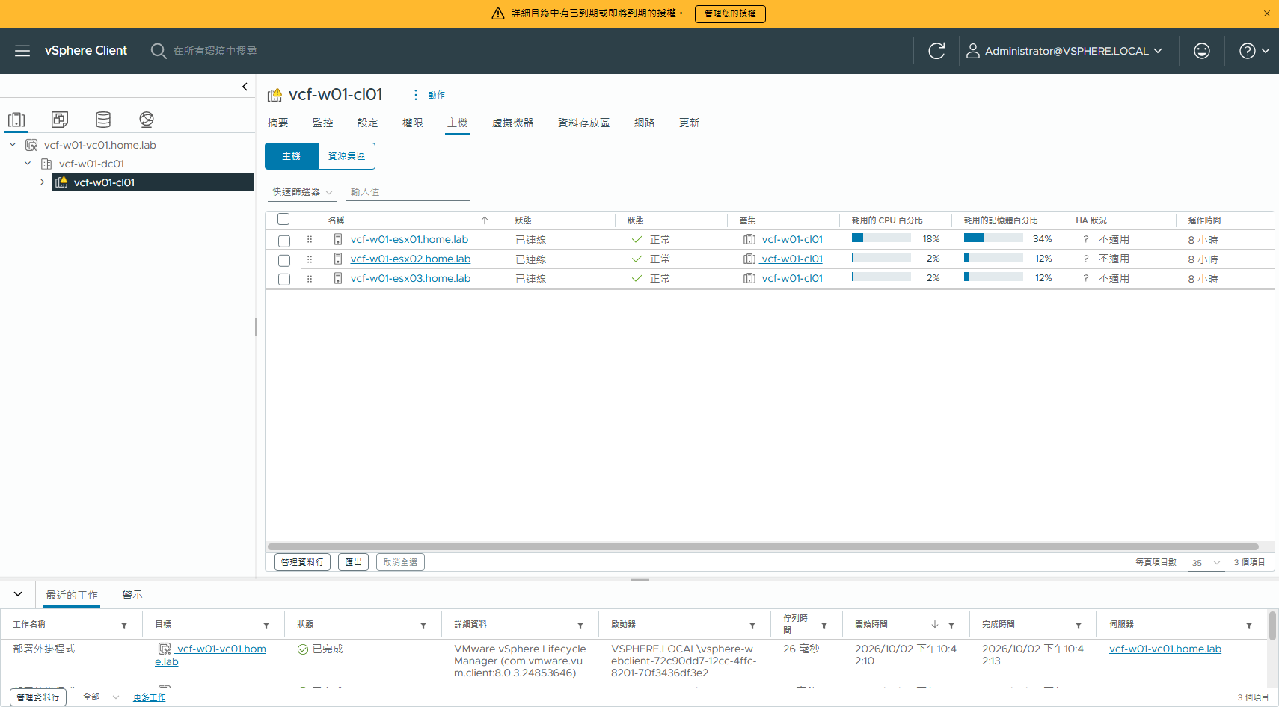
圖 9 3 台 ESXi 8.0.3 全部連線正常
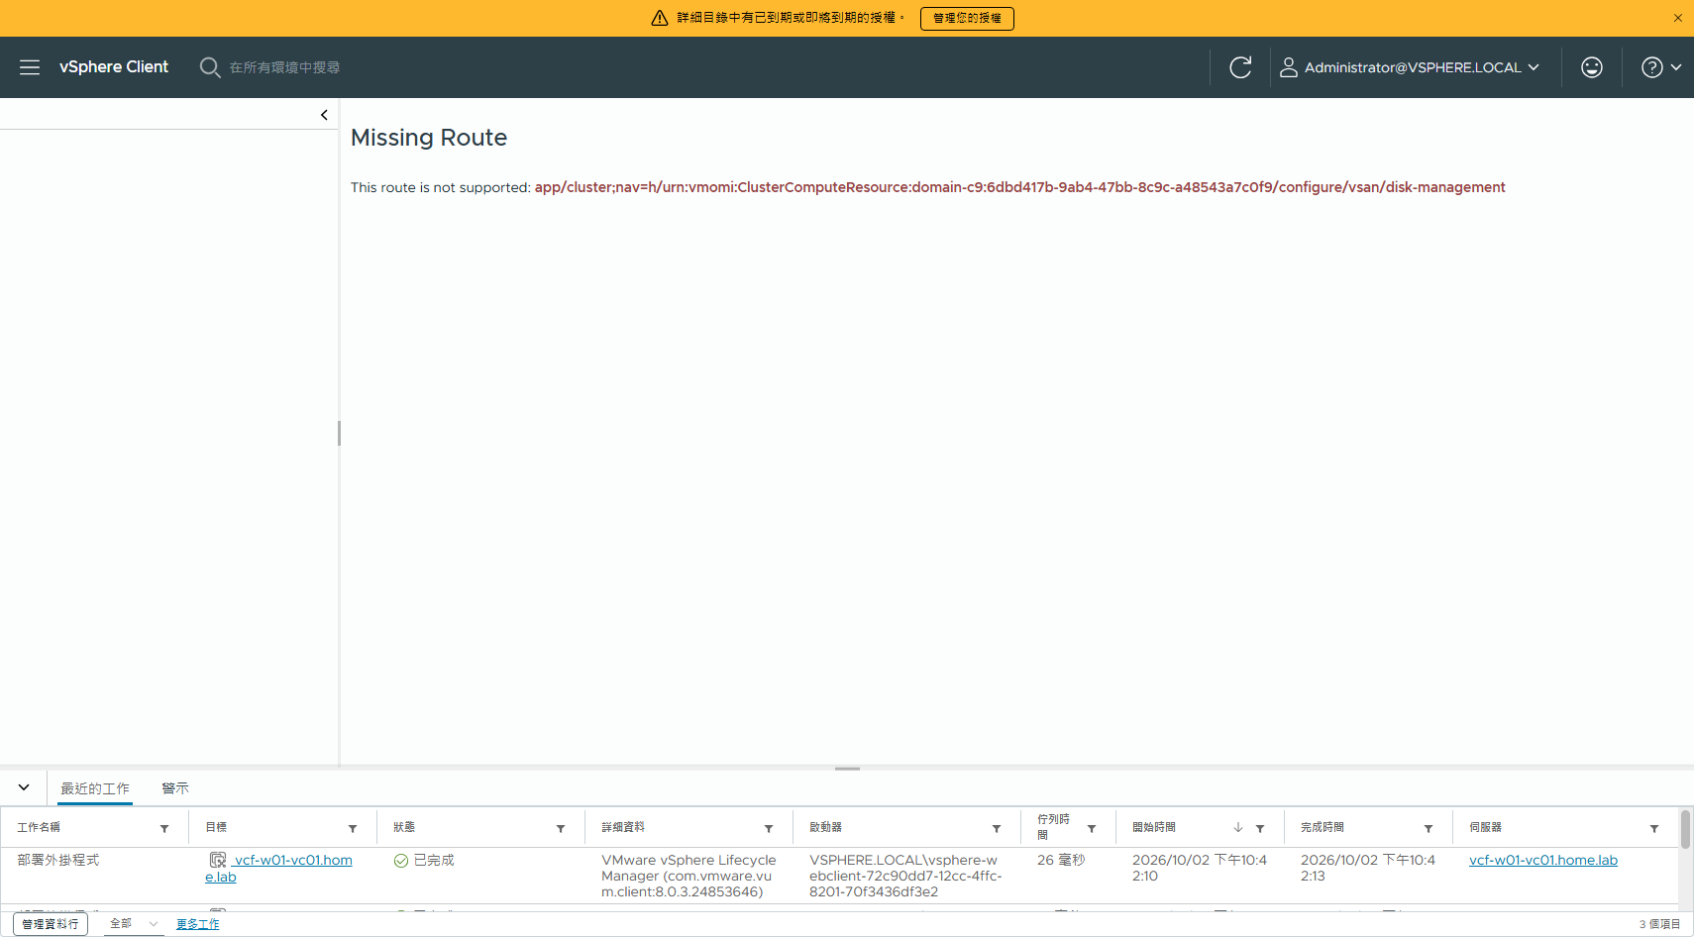
圖 10 vSAN 磁碟管理

五、階段 3:只把 vCenter 從 8.0.3 升到 9.1.1
用 VCSA 9.1.1 ISO 的 migration-based upgrade:部一台新的 appliance、把資料搬過去、再由新的接管原本的 FQDN 與 IP。三台主機完全不動。

5.1 升級範本
用 vcsa-cli-installer/templates/upgrade/vcsa8.0/embedded_vCSA_on_VC.json 當骨架。選 on_VC 而不是 on_ESXi,是因為新 appliance 要接的是 VDS 的 static-binding portgroup —— 直接對 ESXi 部署接不上去。
{
"__version": "2.13.0",
"__comments": "Coverage lab 階段 3:workload domain 的 vCenter 8.0.3 -> 9.1.1(migration-based)。三台主機維持 ESXi 8.0U3b 不動。新 appliance 由來源 vCenter 自己部署進 vcf-w01-cl01,接 VDS portgroup w01-DPortGroup-VM-Mgmt。",
"new_vcsa": {
"vc": {
"hostname": "vcf-w01-vc01.home.lab",
"username": "administrator@vsphere.local",
"password": "<REDACTED>",
"deployment_network": "w01-DPortGroup-VM-Mgmt",
"datacenter": [
"vcf-w01-dc01"
],
"datastore": "vsanDatastore",
"target": [
"vcf-w01-cl01"
]
},
"appliance": {
"thin_disk_mode": true,
"deployment_option": "small",
"name": "vcf-w01-vc01-new"
},
"os": {
"ssh_enable": true
},
"temporary_network": {
"ip_family": "ipv4",
"mode": "static",
"ip": "10.0.1.50",
"prefix": "23",
"gateway": "10.0.0.1",
"dns_servers": [
"10.0.0.200"
]
},
"user_options": {
"vcdb_migrateSet": "core"
}
},
"source_vc": {
"managing_esxi_or_vc": {
"hostname": "vcf-w01-esx01.home.lab",
"username": "root",
"password": "<REDACTED>"

5.2 precheck
vcsa-deploy upgrade --accept-eula --acknowledge-ceip --no-ssl-certificate-verification \n --upgrade-framework legacy --precheck-only \n --log-dir E:9.1converge-targetw01-upgrade-logs vcsa-upgrade-w01-911.json
=== 階段3 precheck(vcsa-deploy upgrade --precheck-only --upgrade-framework legacy)===
source: vcf-w01-vc01.home.lab 8.0.3 build-24853646 target: 9.1.1.0.25712839
Pre-upgrade check warning: 1. Title: Files that cannot be used with Lifecycle
Pre-upgrade check warning: 1. Details: Files that cannot be used with Lifecycle
Pre-upgrade check warning: 1. Suggested Resolution: Please review VMware
Pre-upgrade check warning: 2. Problem ID: upgrade.vpxd.external.extension
Pre-upgrade check warning: 2. Title: This vCenter Server has extensions
Pre-upgrade check warning: 2. Details: vCenter External Extensions
Pre-upgrade check warning: 2. Suggested Resolution: Please ensure extensions are
Estimated disk space required on source VM for export data: 1.97 GB
Estimated total disk space required on target VM: 2.88 GB
[SUCCEEDED] Successfully executed Task 'Running precheck: Appliance Health
[SUCCEEDED] Successfully executed Task 'Running precheck:
[SUCCEEDED] Successfully executed Task 'Running precheck: TargetCredentials' in
[SUCCEEDED] Successfully executed Task 'Running precheck: HostConfigs' in
[SUCCEEDED] Successfully executed Task 'Running precheck: TargetHostType' in
[SUCCEEDED] Successfully executed Task 'Running precheck: TargetVersion' in
[SUCCEEDED] Successfully executed Task 'Running precheck: OVAProperties.' in
[SUCCEEDED] Successfully executed Task 'Running precheck: IpFqdnInUse' in
[SUCCEEDED] Successfully executed Task 'Running precheck:
[SUCCEEDED] Successfully executed Task 'Running precheck: DNSResolveTask' in
[SUCCEEDED] Successfully executed Task 'Running precheck: ESX

5.3 執行與結果
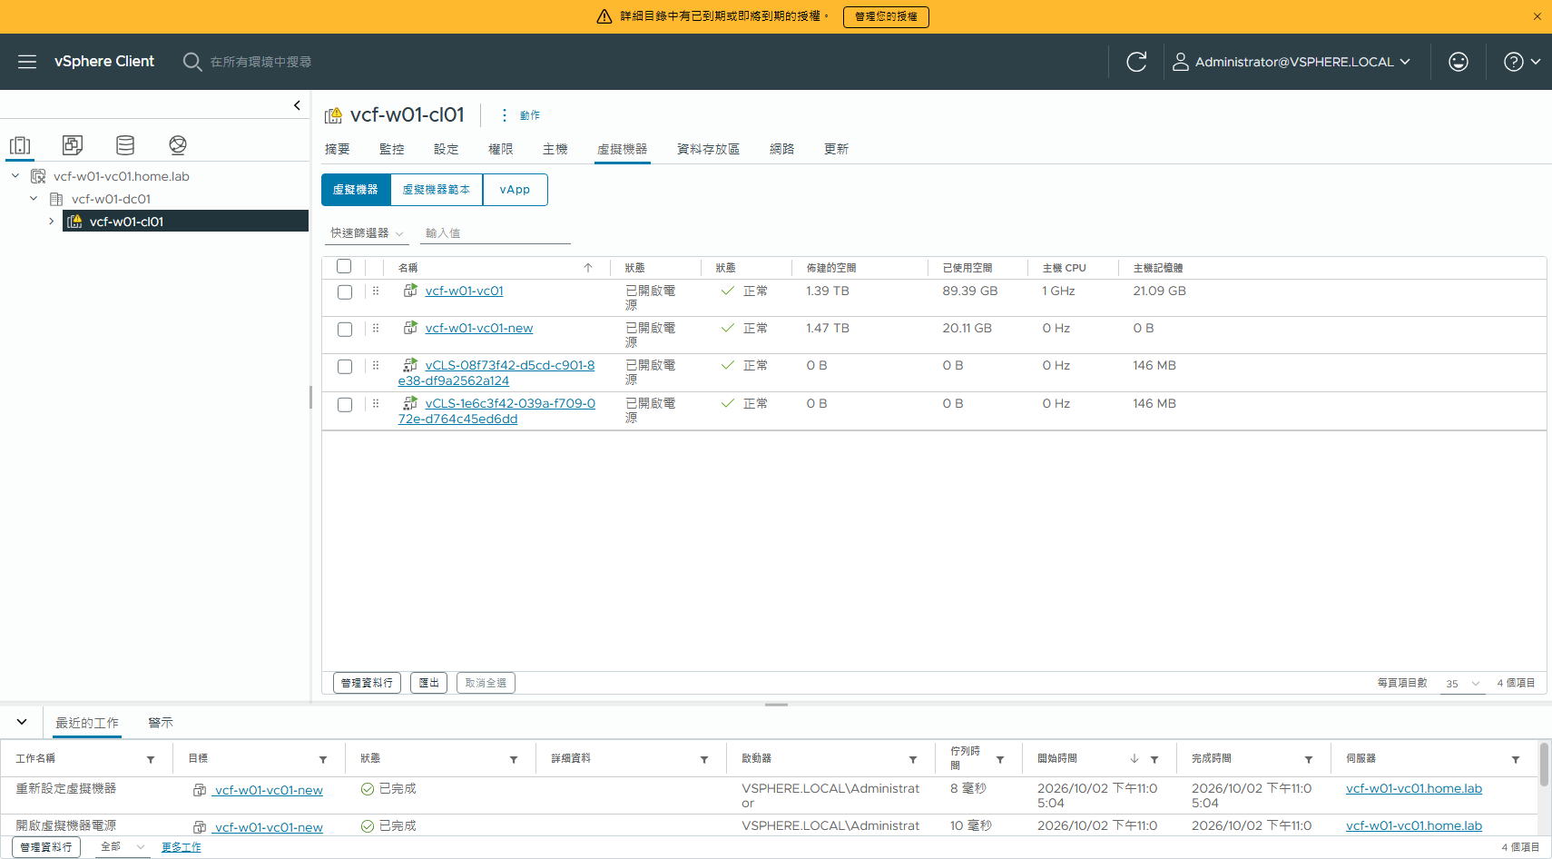
圖 11 搬移期間兩台 appliance 並存:舊的 vcf-w01-vc01 與新的 vcf-w01-vc01-new
=== 階段 3 結果:vcsa-deploy upgrade(migration-based)===
來源 vcf-w01-vc01.home.lab 8.0.3 build-24853646 → 目標 9.1.1.0.25712839
Successfully completed VCSA deployment. VCSA Deployment Start Time:
2026-10-02T15:05:43.245Z VCSA Deployment End Time: 2026-10-02T15:55:55.390Z
Appliance Name: vcf-w01-vc01-new
System Name: vcf-w01-vc01.home.lab
System IP: 10.0.1.49
Log in as: Administrator@vsphere.local
The vCenter Server will currently be in the evaluation-mode
RESULT: success | Upgrade finished successfully.
--- 各階段
Task: Run appliance precheck.(SUCCEEDED 100/100)
Task: Import data into appliance.(SUCCEEDED 100/100)

5.4 升級前後對照
項目 | 升級前 | 升級後
vCenter | 8.0.3 build-24853646 | 9.1.1.0 build-25712839
ESXi ×3 | 8.0.3 build-24280767 | 8.0.3 build-24280767(不動)
主機連線 | connected | connected
vSAN | 1500 GB | 1500 GB,正常
=== w01 升級後 2026-10-03 00:00:18 ===
FullName: VMware vCenter Server 9.1.1.0.25712839
Version: 9.1.1
Build: 25712839
--- hosts
vcf-w01-esx01.home.lab : VMware ESXi 8.0.3 build-24280767 connected
vcf-w01-esx02.home.lab : VMware ESXi 8.0.3 build-24280767 connected
vcf-w01-esx03.home.lab : VMware ESXi 8.0.3 build-24280767 connected
--- datastore
Name: vsanDatastore
Capacity: 1500.0 GB
Free: 1312.1 GB
--- VMs
vcf-w01-vc01
vcf-w01-vc01-new
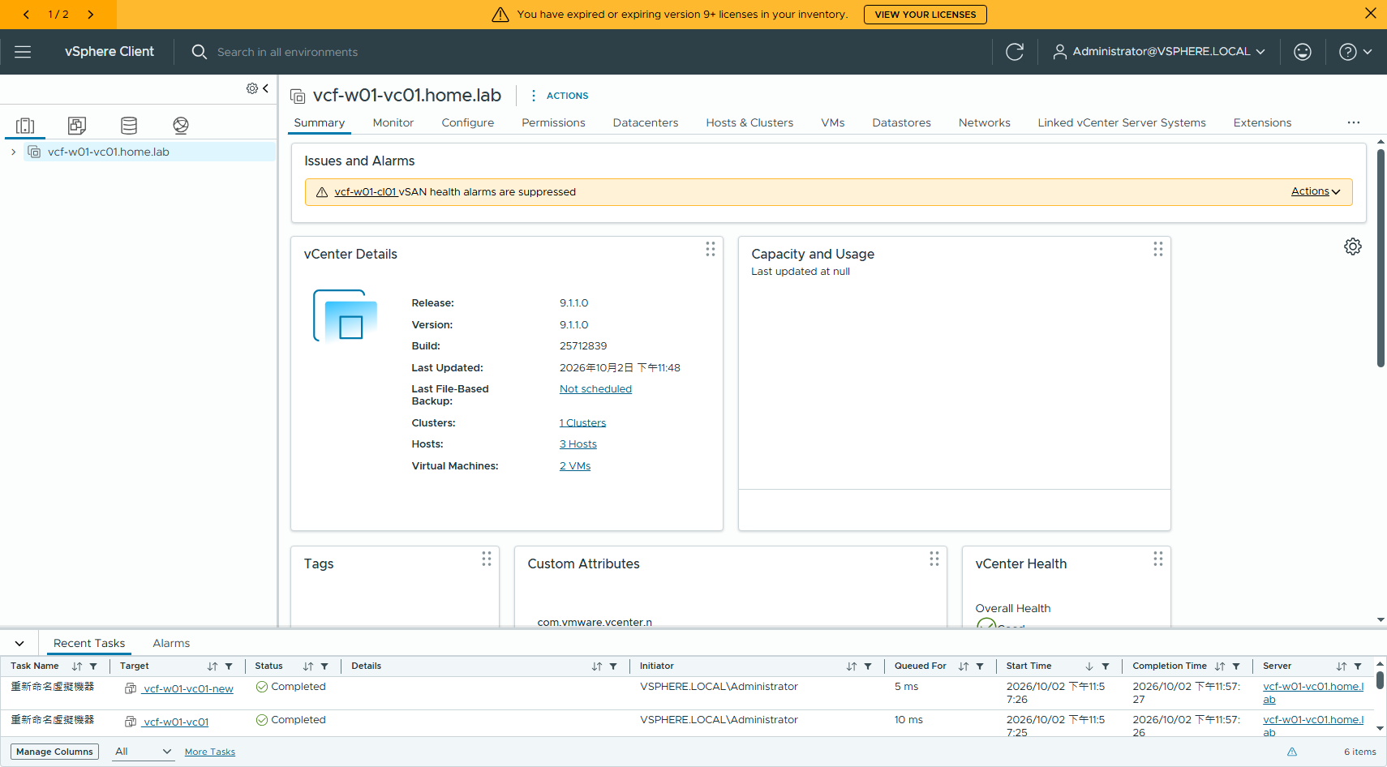
圖 12 升級後的 w01 vCenter
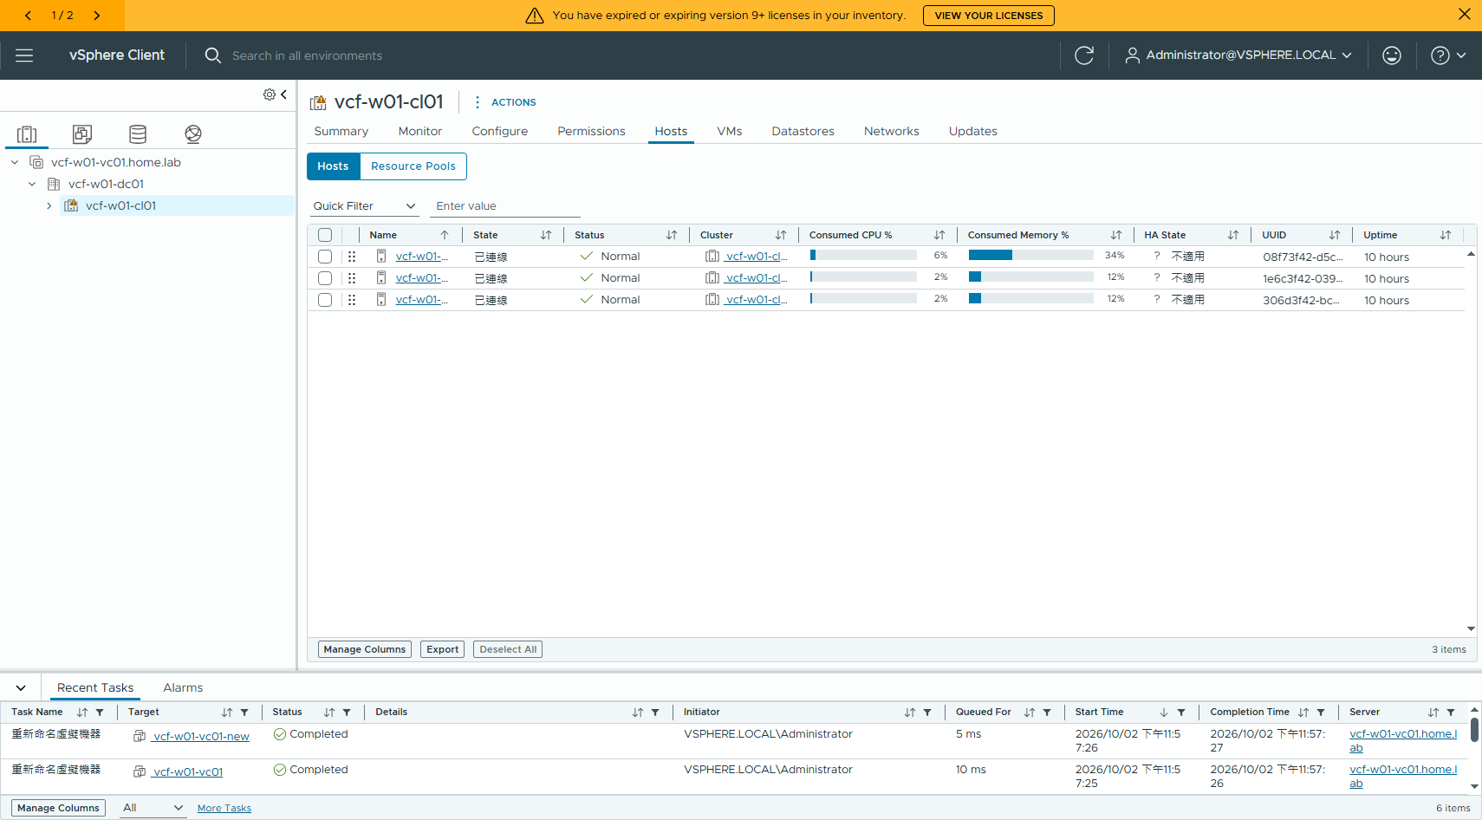
圖 13 主機仍是 ESXi 8.0.3 build-24280767
🔴 兩階段之間不要重開機。vcsa-deploy upgrade 一次跑完 stage 1 + stage 2 就不會有這個問題;中間重開會讓 vmdird / vmafdd 卡在 stale 狀態,firstboot 失敗。

六、階段 4:匯入成 VI workload domain 並共用 NSX

6.1 入口在哪(先踩了一個坑)
VI workload domain 的匯入不在 VCF Installer。我先試過 VCF Installer 的 workflowType = VCF_EXTEND,一路把 spec 餵到六項驗證全綠,最後卡在 sddcManagerSpec 的語意上 —— 那個 useExistingDeployment 指的是「把 VCF Installer 本體轉成 SDDC Manager」,不是「接上既有的 SDDC Manager」。
=== 繞路紀錄:VCF Installer 的 workflowType = VCF_EXTEND 不是 workload domain import ===
POST https://<installer>/v1/sddcs/validations
試法 1 sddcManagerSpec.useExistingDeployment=true, hostname=vcf-m02-sddcm01.home.lab
→ EXISTING_SDDC_HOSTNAME_VALIDATION_ERROR.error
"Incorrect SDDC Manager hostname 'vcf-m02-sddcm01.home.lab' provided whilst using
the option to reuse VCF Installer, expected hostname 'vcf-m02-inst06.home.lab'"
試法 2 sddcManagerSpec.hostname 改成 installer 自己
→ EXISTING_SDDC_VALIDATION_FLIP_ERROR.error
"Existing SDDC Manager scenario is selected, but VCF Installer is not located on
any of the given ESX hosts"
結論:sddcManagerSpec.useExistingDeployment=true 的語意是「把這台 VCF Installer 本體
轉成 SDDC Manager」,不是「接上既有的 SDDC Manager」。VCF_EXTEND 是把既有的
VVF 補成 VCF(補管理元件),不是把既有 vSphere 併成 VI workload domain。
workload domain 的 import 要走 VCF Operations UI。
附帶收穫(VCF_EXTEND 驗證通過的欄位,仍可留做參考):
vspClusterSpec.useExistingDeployment = true
vspClusterSpec.systemUserPassword = <VSP vmware-system-user 密碼> ← 欄位名不好猜
以上兩個補齊後,Deployment Specification / Security Configuration /
DNS Resolution / Versions and Bundles / Password Policies / Network Configuration 全部 SUCCEEDED。

6.2 官方路徑
=== 官方依據:把既有 vCenter 匯入成 VI workload domain(VCF 9.1)===
techdocs 9.1 / Building Your Private Cloud Infrastructure / Working with Workload Domains
"Import an Existing vCenter to Create a Workload Domain"
UI 路徑(VCF Operations):
Operate → Overview/Inventory → Detailed View → 展開 VCF Instances → 選目標 VCF Instance
→ 「Add workload domain」下拉 → 「Import a vCenter」
前置條件(節錄):
- vCenter 最低 8.0 Update 3a;ESX 最低 8.0 Update 3
- inventory 內所有 ESX 主機要用 FQDN,不可用短名
- 既有 vCenter 要開 SSH
NSX:
- 可有可無;既有的 NSX Manager 可以一起匯入
- 「Shared NSX instances are supported across multiple vCenter instances」
→ 多個 vCenter 共用同一套 NSX 是支援的
- 🔴 "NSX 9.1 does not support vCenter 8.0 Update 3a or later"
→ 若要用 NSX 9.1,vCenter 必須先升到 9.1
★ 這就是本 lab「只升 vCenter 到 9.1.1、主機維持 8.0U3b」的理由
精靈頁面:
1 General Information —— workload domain 名稱
2 Specify a vCenter —— 選既有 vCenter / 填外部憑證;可選 NSX Manager
3 Certificate Confirmation—— 確認 vCenter / NSX 憑證指紋
4 NSX Configuration —— vCenter 沒有 NSX 時:新建 或 join 既有 NSX instance ★
5 Prechecks —— 驗證
6 Review & Finish
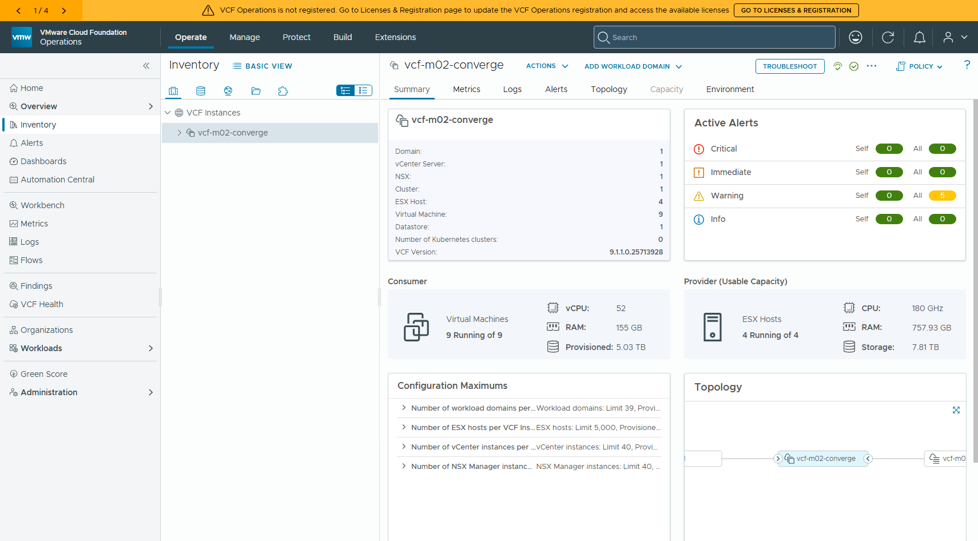
圖 14 VCF Operations → Operate → Inventory → VCF Instances → vcf-m02-converge。右上角有 ADD WORKLOAD DOMAIN

6.3 精靈逐頁
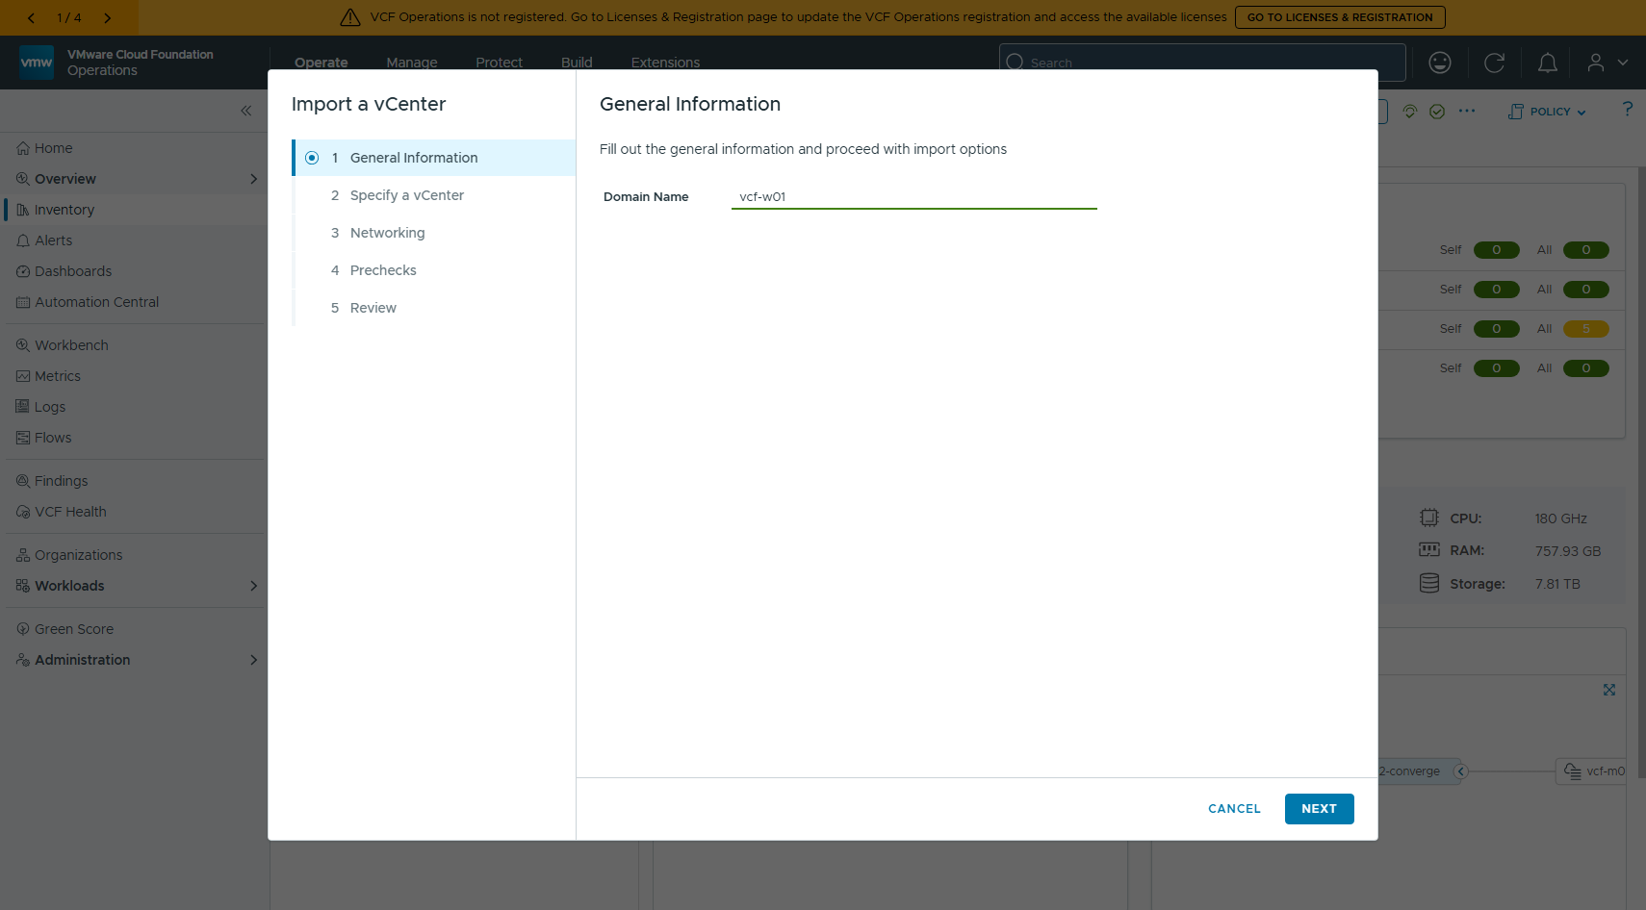
圖 15 第 1 頁 General Information:Domain Name 填 vcf-w01
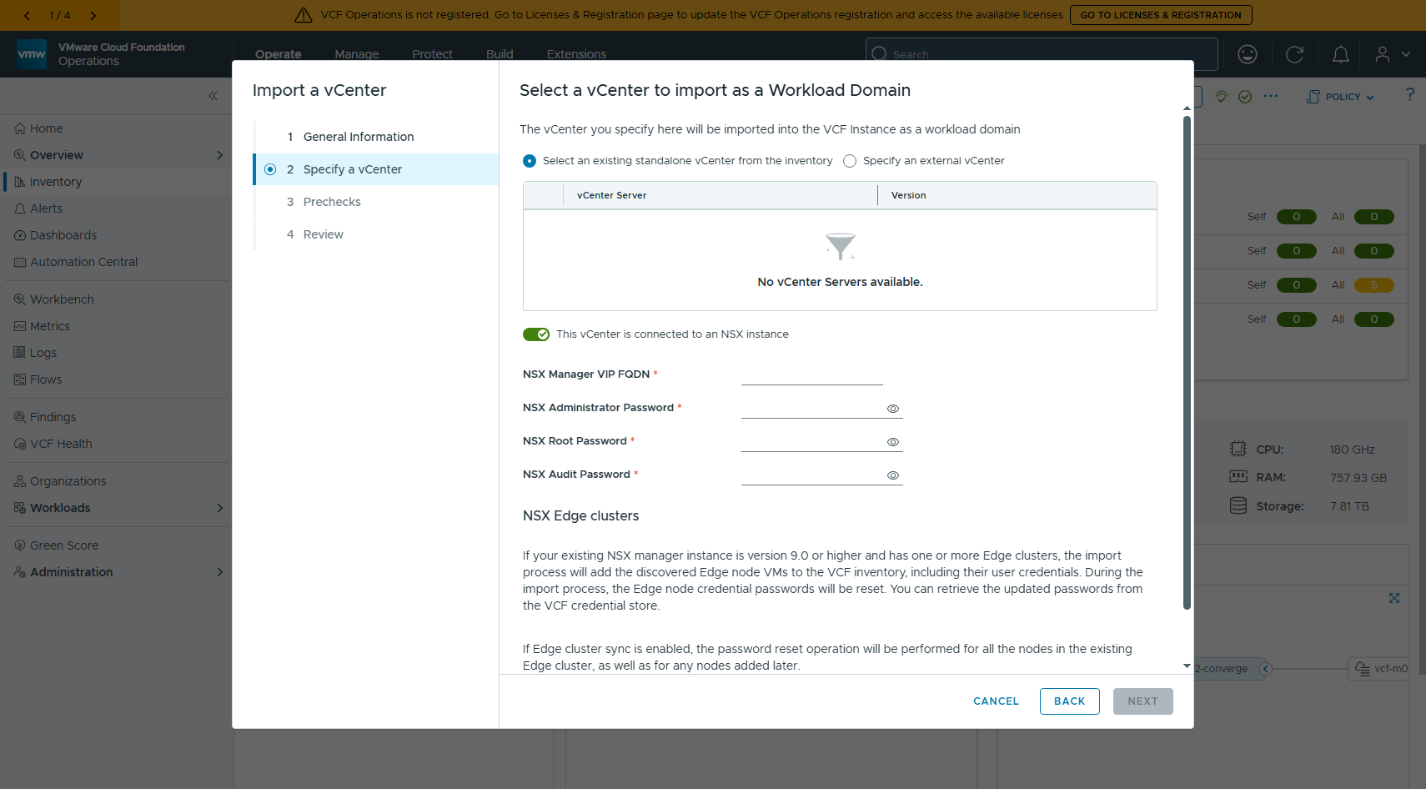
圖 16 第 2 頁 Specify a vCenter。預設是從 inventory 選既有 standalone vCenter(本 lab 沒有),要改選 Specify an external vCenter
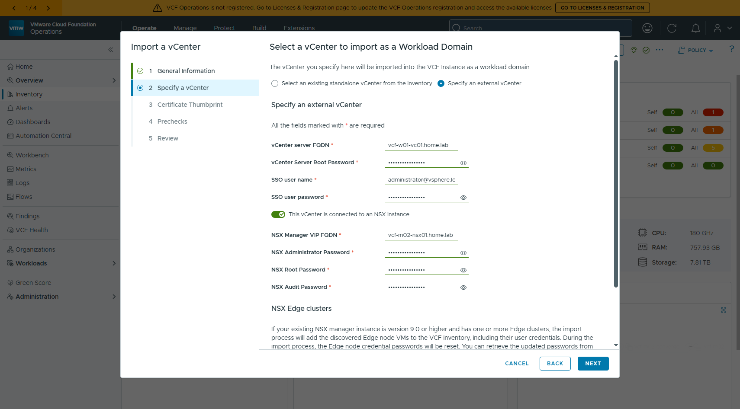
圖 17 填完:vCenter 指 vcf-w01-vc01.home.lab,NSX Manager VIP FQDN 指管理網域正在用的 vcf-m02-nsx01.home.lab
「This vCenter is connected to an NSX instance」這個開關預設就是開的。把 NSX VIP 填成管理網域那一套,就是本文要測的「共用 NSX」。
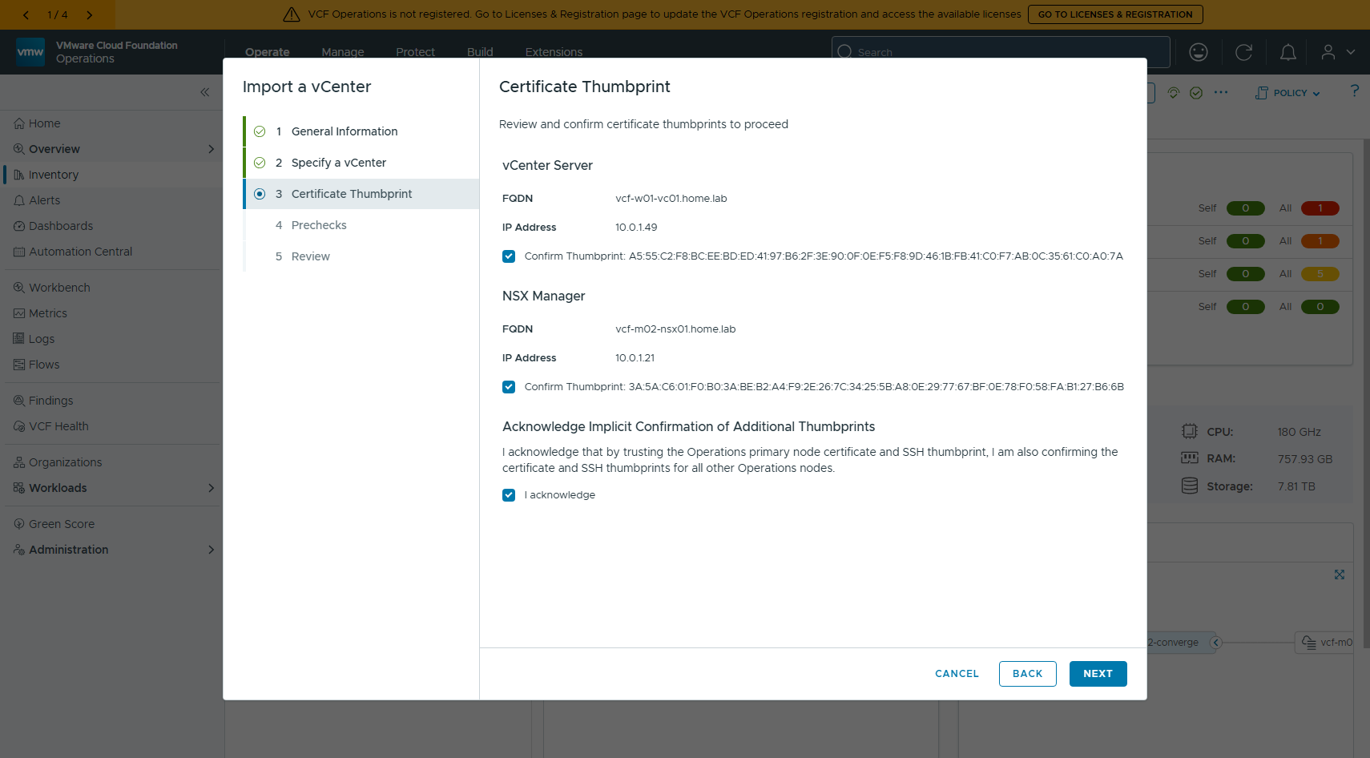
圖 18 第 3 頁 Certificate Thumbprint:vCenter 與 NSX 的指紋各自確認,再加一個 I acknowledge
指紋可以先用 openssl 獨立抓來對:
echo | openssl s_client -connect vcf-w01-vc01.home.lab:443 -servername vcf-w01-vc01.home.lab 2>/dev/null \n | openssl x509 -noout -fingerprint -sha256
# vcf-w01-vc01 : A5:55:C2:F8:BC:EE:BD:ED:41:97:B6:2F:3E:90:0F:0E:F5:F8:9D:46:1B:FB:41:C0:F7:AB:0C:35:61:C0:A0:7A
# vcf-m02-nsx01: 3A:5A:C6:01:F0:B0:3A:BE:B2:A4:F9:2E:26:7C:34:25:5B:A8:0E:29:77:67:BF:0E:78:F0:58:FA:B1:27:B6:6B

6.4 第一輪 precheck:68 Passed / 3 Errors / 4 Warnings
[ 缺圖:48-import-prechecks-failed.png ]
圖 19 第 4 頁 Prechecks:Validation Failed
=== 匯入 precheck 第一輪(2026-10-03 00:24)===
68 Passed / 3 Errors / 4 Warnings
Compatibility validation :: Success
Cluster Distributed Resource Scheduler (DRS) :: Error
Cluster DVS presence :: Success
Conforming cluster present :: Success
DVS version :: Success
ESXi vmotion IP address family :: Success
ESXi upgrade policy validation across vCenter and SDDC Manager :: Warning
Host certificate CN/SAN :: Success
Host name :: Success
NTP service :: Success
Host connectivity :: Success
Host minimum version :: Success
Verify cluster-host topology :: Success
Host stateless check :: Success
ESXi VMKernel adapter traffic type check :: Success
vCenter Server SDDC Manager extension presence :: Success
No unsupported Legacy VxRail extension in vCenter Server :: Success
Import NSX-vCenter compute manager :: Error
Check NSX Manager host scale support :: Success
Compatibility validation for vCenter and NSX :: Success
Cluster common datastore check. :: Success
SDDC Manager DNS server :: Success
SDDC Manager NTP server :: Success
vCenter VM co-located :: Success
vCenter IP address family :: Success
vCenter Server is above 9.2.0.0 with VxRail Next extension present :: Success
vCenter root password :: Success
vCenter SSH Login enabled :: Success
vCenter to SDDC Manager time difference :: Success
vCenter Server virtual machine distributed virtual port group and traf :: Success
:: Success
Lookup service availability :: Success
Vpxd service availability :: Success
vCenter Server appliance update status validator :: Success
Check if Customer Experience Improvement Program is configured on vCen :: Success
vCenter Server Connection Latency :: Success
vCenter FQDN is resolvable check :: Success
vCenter Server is in ELM :: Success
vCenter FQDN DNS aliases check :: Success
vCenter HA disabled check :: Success
vCenter Server minimum version :: Success
vCenter NTP configured check :: Success
Scale limits validation :: Success
Cl

七、三個 Error 怎麼修

7.1 Import NSX-vCenter compute manager —— 共用 NSX 的關鍵
驗證訊息已經把答案寫出來了:要共用的那套 NSX,必須先把要匯入的 vCenter 註冊成 Compute Manager。這不是「不准共用」,是前置條件。
=== 修正 #2:在管理網域的 NSX 註冊 w01 vCenter 為 Compute Manager ===
POST https://vcf-m02-nsx01.home.lab/api/v1/fabric/compute-managers
{ "display_name":"vcf-w01-vc01", "server":"vcf-w01-vc01.home.lab", "origin_type":"vCenter",
"create_service_account":true, "set_as_oidc_provider":true, "access_level_for_oidc":"FULL",
"multi_nsx":false, "reverse_proxy_https_port":443,
"credential":{"credential_type":"UsernamePasswordLoginCredential",
"username":"administrator@vsphere.local","password":"<REDACTED>",
"thumbprint":"A5:55:C2:F8:...:A0:7A"} }
→ HTTP 201, id = b88e27f5-5a00-4658-908e-8764de6bf2a4
--- 狀態
registration_status = REGISTERED
connection_status = UP
--- 這套 NSX 現在管了兩個 vCenter
vcf-m02-vc01.home.lab | VMware vCenter Server 9.1.1.0.25712839
vcf-w01-vc01.home.lab | VMware vCenter Server 9.1.1.0.25712839
同一頁的 Check NSX Manager host scale support 與 Compatibility validation for vCenter and NSX 兩項第一輪就是 Success —— 共用 NSX 這件事本身 VCF 沒有意見。

7.2 Cluster DRS
第一輪報「Cluster does not have DRS fully automated」,但查下來叢集本來就是 enabled = true、defaultVmBehavior = fullyAutomated。推測是 vCenter 剛升級完、服務還在穩定時被驗到,重跑就過。

7.3 Cluster is vSphere Lifecycle Manager (vLCM) image based
w01 叢集原本是 baseline 管理。要轉成映像管理,又不想動主機版本,正解是用「沿用現行映像」:vLCM 會去主機上抽出目前跑的映像,直接拿它當 desired image。離線 depot 裡沒有 ESXi 8.0U3b 的 depot zip 也不受影響。
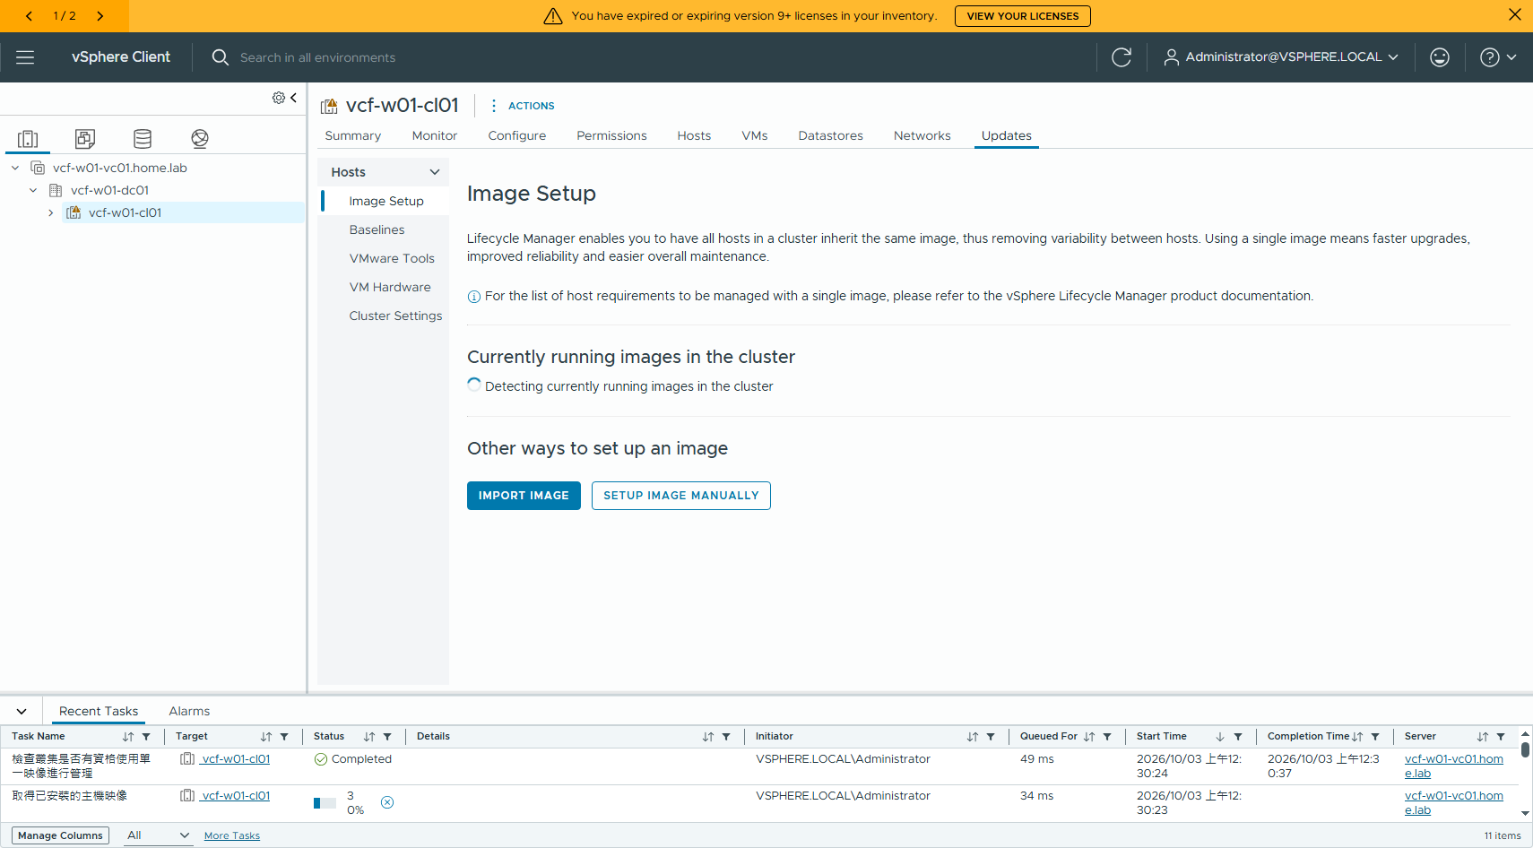
圖 20 Cluster → Updates → Image Setup,尚未啟用映像管理
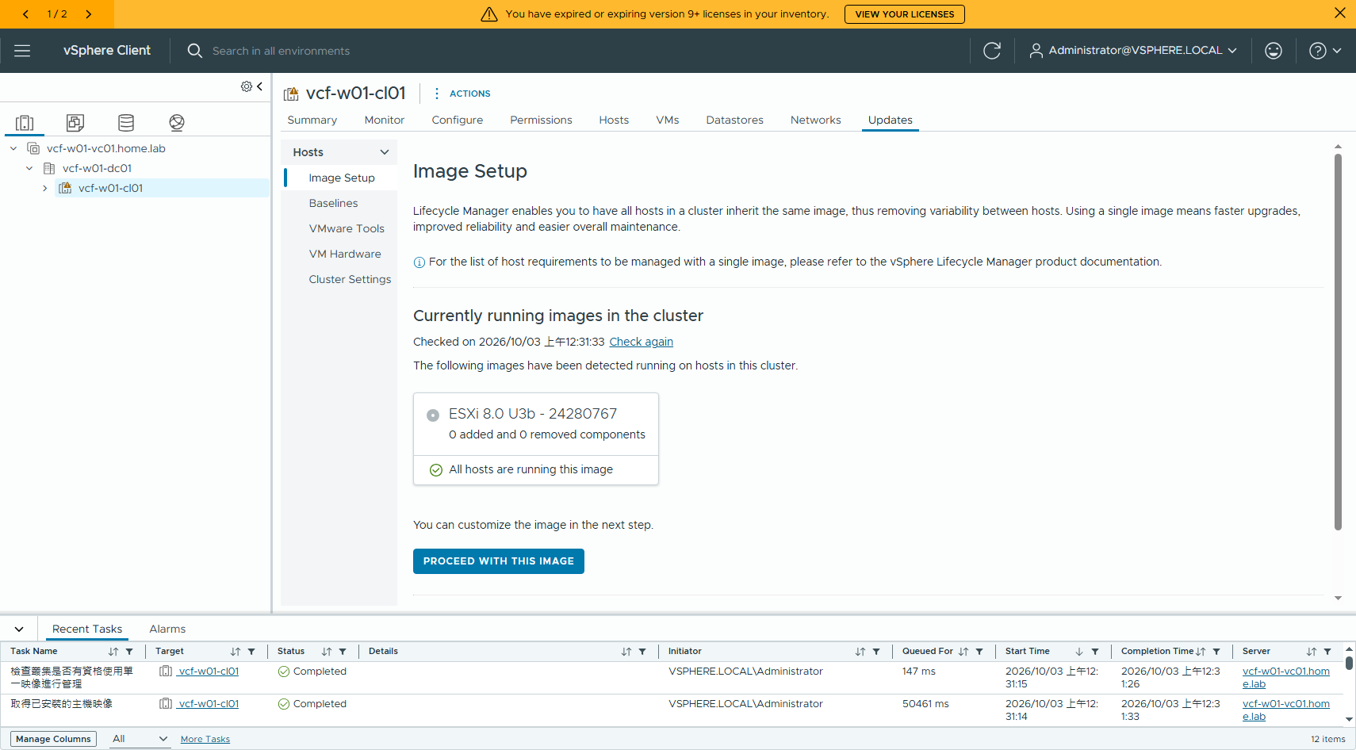
圖 21 偵測結果:ESXi 8.0 U3b - 24280767、0 added and 0 removed components、All hosts are running this image
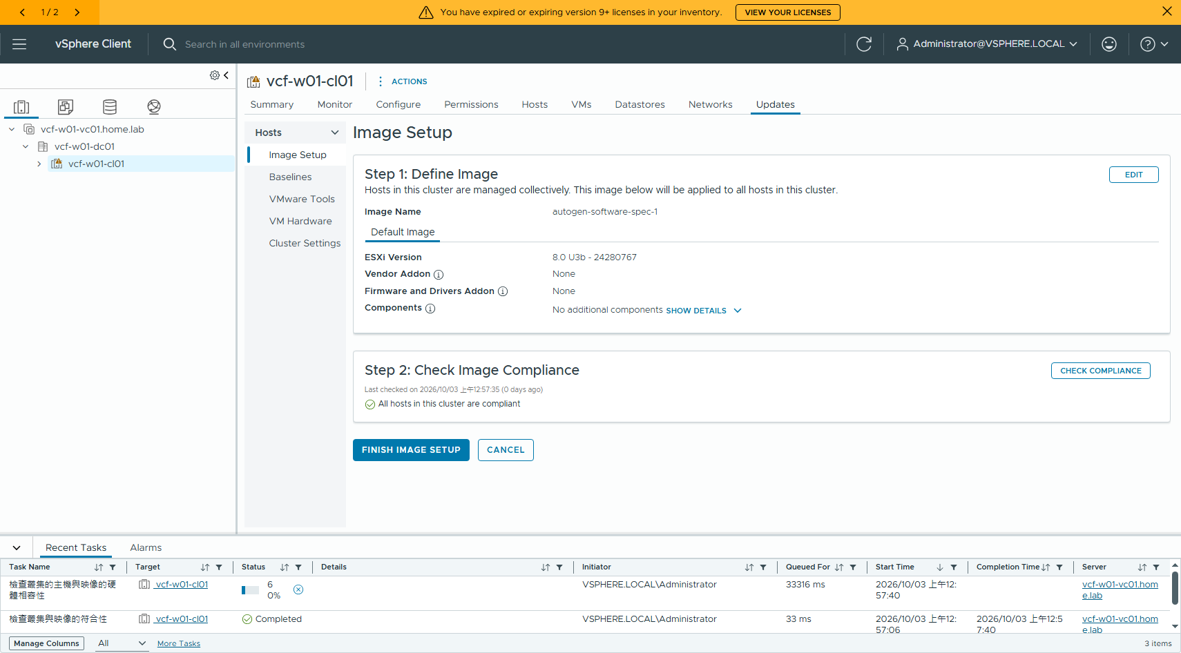
圖 22 Save → Validate(映像有效)→ Check compliance:All hosts in this cluster are compliant
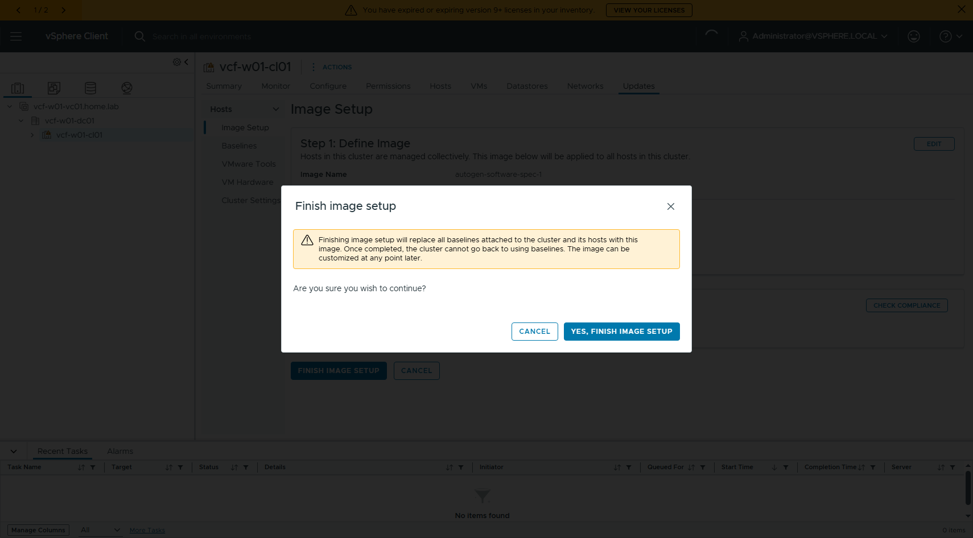
圖 23 確認框:完成後叢集無法再退回 baseline 管理
=== 修正 #1 / #3 ===
[#1] Cluster DRS
查下來本來就是 enabled=true / defaultVmBehavior=fullyAutomated,
推測是升級期間 vCenter 剛起來、驗證時讀到不穩的狀態。重跑驗證即可。
[{"drs_enabled":true,"cluster":"domain-c9","name":"vcf-w01-cl01","ha_enabled":false}]
[#3] Cluster is vSphere Lifecycle Manager (vLCM) image based
原本 w01 叢集是 baseline 管理。做法:vSphere Client → Cluster → Updates →
Image Setup →「Currently running images in the cluster」偵測到
ESXi 8.0 U3b - 24280767,0 added and 0 removed components
All hosts are running this image
→ PROCEED WITH THIS IMAGE → Save → Validate(映像有效)→ Check compliance
(All hosts in this cluster are compliant)→ FINISH IMAGE SETUP
🔑 用「沿用現行映像」這條路,主機版本完全不動,不會被拉去升級;
離線 depot 裡沒有 8.0U3b 的 ESXi depot zip 也不影響。
⚠ 確認框明寫:完成後叢集無法再退回 baseline 管理。
--- 驗收
enablement/software : {"enabled":true}
desired base image : 8.0.3-0.35.24280767 ( 8.0 U3b - 24280767 )

7.4 第二輪 precheck:71 Passed / 0 Errors / 1 Warning
[ 缺圖:56-import-prechecks-passed.png ]
圖 24 Validation Succeeded
=== 匯入 precheck 第二輪(2026-10-03 01:27)=== Validation Succeeded
71 Passed / 0 Errors / 1 Warning
Compatibility validation :: Success
Cluster Distributed Resource Scheduler (DRS) :: Success
Cluster DVS presence :: Success
Conforming cluster present :: Success
DVS version :: Success
ESXi vmotion IP address family :: Success
ESXi upgrade policy validation across vCenter and SDDC Manager :: Warning
Host certificate CN/SAN :: Success
Host name :: Success
NTP service :: Success
唯一的 Warning 仍是 ESXi upgrade policy 與 SDDC Manager 預設值不同,不擋匯入。
第一輪 3 個 Error 的修法:
DRS → 本來就是 fullyAutomated,重跑即過
NSX compute mgr→ 在 vcf-m02-nsx01 註冊 vcf-w01-vc01 為 Compute Manager
vLCM image → 叢集沿用現行映像(ESXi 8.0 U3b - 24280767)轉成映像管理

九、匯入結果與驗收
匯入任務「Import vCenter vcf-w01-vc01.home.lab as a VI Domain」57 / 57 子任務成功,約 15 分鐘。
[ 缺圖:57-import-review.png ]
圖 25 第 5 頁 Review:vCenter = vcf-w01-vc01.home.lab,NSX Manager VIP = vcf-m02-nsx01.home.lab
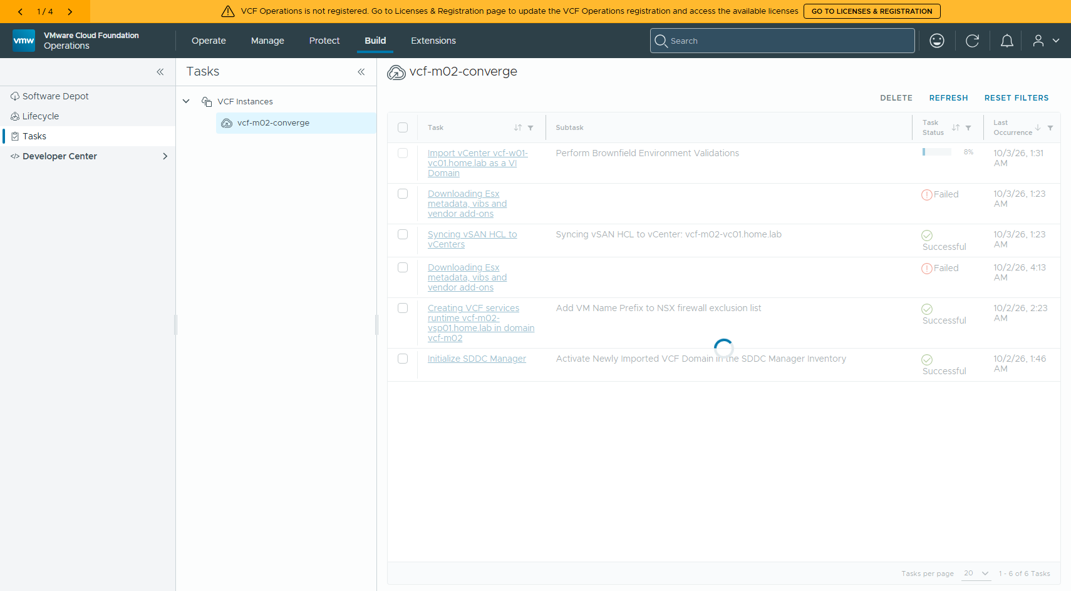
圖 26 匯入執行中,第一個階段是 Perform Brownfield Environment Validations
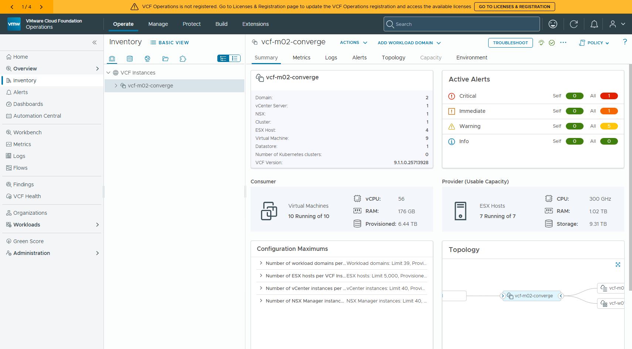
圖 27 匯入完成:同一個 VCF 執行個體底下兩個網域

9.1 兩個網域共用同一套 NSX —— 證據
=== 階段 4 結果:Import vCenter vcf-w01-vc01.home.lab as a VI Domain ===
task 1e507ca4-abfd-4e7a-ad23-635f51cbd36f
01:34:51 Pending|0/1|
01:35:22 In Progress|5/60|Perform Brownfield Environment Validations
01:35:52 In Progress|5/60|Perform Brownfield Environment Validations
01:45:57 In Progress|48/60|Add VMs to NSX Distributed Firewall Exclusion List
01:46:28 Successful|57/57|
IMPORT-TERMINAL
建立 2026-10-02T17:31:31Z,完成 01:46:28(本地)→ 約 15 分鐘,57/57 子任務成功
--- /v1/domains
vcf-m02 MANAGEMENT ACTIVE vCenter=vcf-m02-vc01.home.lab NSX=vcf-m02-nsx01.home.lab (03321675-7b16-40c5-a45a-50121217aea4)
vcf-w01 VI ACTIVE vCenter=vcf-w01-vc01.home.lab NSX=vcf-m02-nsx01.home.lab (03321675-7b16-40c5-a45a-50121217aea4)
--- /v1/clusters
vcf-w01-cl01 ACTIVE hosts=3 isImported=True isDefault=True
vcf-m02-cl01 ACTIVE hosts=4 isImported=True isDefault=True
--- /v1/hosts
vcf-m02-esx01.home.lab ASSIGNED esxi=9.1.1.0.25714478 domain=083d4bfe
vcf-m02-esx02.home.lab ASSIGNED esxi=9.1.1.0.25714478 domain=083d4bfe
vcf-m02-esx03.home.lab ASSIGNED esxi=9.1.1.0.25714478 domain=083d4bfe
vcf-m02-esx04.home.lab ASSIGNED esxi=9.1.1.0.25714478 domain=083d4bfe
vcf-w01-esx01.home.lab ASSIGNED esxi=8.0.3-24280767 domain=61bc9cc1
vcf-w01-esx02.home.lab ASSIGNED esxi=8.0.3-24280767 domain=61bc9cc1
vcf-w01-esx03.home.lab ASSIGNED esxi=8.0.3-24280767 domain=61bc9cc1
--- /v1/nsxt-clusters(這套 NSX 現在服務哪些網域)
vcf-m02-nsx01.home.lab | version 9.1.1.0.25691509
domain: vcf-m02 083d4bfe-33d9-4935-b9e9-fdf53e14d95b
domain: vcf-w01 61bc9cc1-7260-4125-a054-5f39f677574b
兩個網域的 nsxtCluster.id 是同一個值 03321675-7b16-40c5-a45a-50121217aea4;從 NSX 那一側看,/v1/nsxt-clusters 的同一筆記錄下面同時列著 vcf-m02 與 vcf-w01 兩個 domain。這不是「各自部一套」,是同一個執行個體。

9.2 版本維持原樣
網域 | 類型 | vCenter | ESXi
vcf-m02 | MANAGEMENT | 9.1.1.0.25712839 | 9.1.1.0.25714478 × 4
vcf-w01 | VI(imported) | 9.1.1.0.25712839 | 8.0.3-24280767 × 3
兩個 cluster 在 SDDC Manager 裡都是 isImported = True。

9.3 一個要講清楚的分界:共用 NSX ≠ 主機自動被 prep
匯入完成後回頭看 NSX,會發現它只建立了「網域 ↔ NSX 執行個體」的歸屬關係,並沒有把 w01 的主機準備成 transport node。
=== 匯入後:同一套 NSX 的 host transport nodes ===
共 4 個 host transport node
vcf-m02-esx01.home.lab vtep ip_assignment=[{}]
vcf-m02-esx02.home.lab vtep ip_assignment=[{}]
vcf-m02-esx03.home.lab vtep ip_assignment=[{}]
vcf-m02-esx04.home.lab vtep ip_assignment=[{}]
=== compute managers ===
vcf-m02-vc01.home.lab
vcf-w01-vc01.home.lab
=== Transport Node Collections(叢集層級的 NSX prep)===
共 1 個
4a5dca86-ab7e-47d0-8d65-28c0122f5610 | compute_collection_id= a227bcbe-22b5-4238-bbac-37602d9fcb40:domain-c9
=== NSX 看得到的 compute collection(叢集)===
Resources origin=a227bcbe-22b5-4238-b id=a227bcbe-22b5-4238-bbac-37602d9fcb40:resgroup-10
Resources origin=b88e27f5-5a00-4658-9 id=b88e27f5-5a00-4658-908e-8764de6bf2a4:resgroup-10
vcf-m02-cl01 origin=a227bcbe-22b5-4238-b id=a227bcbe-22b5-4238-bbac-37602d9fcb40:domain-c9
vcf-m02-cl01-mgmt-001 origin=a227bcbe-22b5-4238-b id=a227bcbe-22b5-4238-bbac-37602d9fcb40:resgroup-35
vcf-w01-cl01 origin=b88e27f5-5a00-4658-9 id=b88e27f5-5a00-4658-908e-8764de6bf2a4:domain-c9
★ 觀察:匯入只是把網域接上同一套 NSX,w01 的 3 台主機並沒有被自動 prep 成
transport node(NSX 的 host transport node 仍然只有管理網域那 4 台)。
要讓 w01 真的用 NSX 網路,得另外做叢集的 NSX 準備。
NSX 物件 | 匯入後狀態
Compute Manager | 兩個 vCenter 都在(vcf-m02-vc01、vcf-w01-vc01)
Compute Collection | 看得到 vcf-m02-cl01 與 vcf-w01-cl01
Host Transport Node | 只有管理網域那 4 台;w01 的 3 台沒有被 prep
Transport Node Collection | 只有 1 個,對應 vcf-m02-cl01
所以「共用 NSX」在匯入這一步的意思是:這個工作負載網域歸屬於那套 NSX、由它統一管理。要讓 w01 真的跑 NSX 網路,叢集的 NSX 準備是另外一個動作。

十、結論
問題 | 結論
既有 vSphere 能 converge 成 VCF 9.1.1 管理網域嗎? | ✅ 能(181/181)
另一套既有 vSphere 能匯入成 VI workload domain 嗎? | ✅ 能(57/57,約 15 分鐘)
匯入的網域能和管理網域共用同一套 NSX 嗎? | ✅ 能,nsxtCluster.id 相同
主機可以留在 ESXi 8.0 U3b 嗎? | ✅ 可以,匯入後仍是 8.0.3-24280767
vCenter 可以不升嗎? | ❌ 要共用 NSX 9.1 就得升到 9.1
匯入會自動把主機 prep 成 NSX transport node 嗎? | ❌ 不會,要另外做

八、踩坑速查
坑 | 症狀 | 處置
VI workload domain 的匯入入口 | VCF Installer 的 workflowType=VCF_EXTEND 看起來很像,實際不是 | 走 VCF Operations → Operate → Inventory → 選 VCF Instance → ADD WORKLOAD DOMAIN → Import a vCenter
共用 NSX 被擋 | Import NSX-vCenter compute manager:Could not find compute manager | 先在那套 NSX 把要匯入的 vCenter 註冊成 Compute Manager(POST /api/v1/fabric/compute-managers)
要共用 NSX 9.1,vCenter 版本 | NSX 9.1 不支援 vCenter 8.0 U3a 以後的版本 | vCenter 先升到 9.1;主機可以留在 8.0 U3b(匯入最低要求 ESX 8.0 U3)
叢集不是 vLCM 映像管理 | Cluster is not vSphere Lifecycle Manager (vLCM) image based | 用「沿用現行映像」轉換,主機版本完全不動;確認框會提醒無法退回 baseline
vcsa-deploy 選錯範本 | 新 appliance 接不上 VDS 的 static-binding portgroup | 用 embedded_vCSA_on_VC.json(透過 vCenter 部署),不要用 on_ESXi
vcsa-deploy esxi.hostname 填 IP | 主機以 IP 身分進 inventory,匯入會因為必須用 FQDN 被擋 | 範本就填 FQDN;已經錯了用 govc object.rename 改回來
兩階段之間重開機 | vmdird / vmafdd stale,firstboot 失敗 | vcsa-deploy upgrade 一次跑完,中間不要碰
VCF Operations session 逾時 | 精靈做到一半被踢回登入頁,整份輸入要重填 | 長時間的步驟(例如先去修 vLCM)做完再重開精靈
離線 depot 沒有 ESX metadata | Downloading Esx metadata, vibs and vendor add-ons FAILED | air-gap 環境的 UMDS 下載本來就會失敗,不影響匯入

附錄 A:指令彙整
### 連線
export GOVC_URL="https://10.0.1.49" GOVC_USERNAME="administrator@vsphere.local" GOVC_INSECURE=1
export MSYS_NO_PATHCONV=1 # Git-Bash 必加
S=$(curl -sk -X POST -u "administrator@vsphere.local:<pw>" https://<vc>/api/session | tr -d '"')
T=$(curl -sk -X POST https://<sddcm>/v1/tokens -H "Content-Type: application/json" \n -d '{"username":"administrator@vsphere.local","password":"<pw>"}' | jq -r .accessToken)
### vCenter 8.0.3 -> 9.1.1(migration-based)
vcsa-deploy upgrade --accept-eula --acknowledge-ceip --no-ssl-certificate-verification \n --upgrade-framework legacy [--precheck-only] --log-dir <dir> <template.json>
### NSX:註冊 compute manager(共用 NSX 的前置)
POST https://<nsx-vip>/api/v1/fabric/compute-managers
GET https://<nsx-vip>/api/v1/fabric/compute-managers/{id}/status
### vLCM:叢集轉成映像管理
GET /api/esx/settings/clusters/{c}/enablement/software # {"enabled": true/false}
GET /api/esx/settings/clusters/{c}/software # desired image
GET /api/esx/settings/depot-content/base-images # depot 內可用的 base image
# 「沿用現行映像」只有 UI 有:Cluster -> Updates -> Image Setup -> PROCEED WITH THIS IMAGE
### 匯入驗收
GET https://<sddcm>/v1/domains
GET https://<sddcm>/v1/clusters
GET https://<sddcm>/v1/nsxt-clusters
GET https://<sddcm>/v1/tasks/{id} # 匯入任務的 subTasks

附錄 B:CLI 輸出

B.1 階段 1 converge 里程碑
VCF Installer : vcf-m02-inst06.home.lab
vcfInstanceName: vcf-m02-converge
deploymentType : VMware Cloud Foundation Deployment
sddcId : 012a6214-87cc-4a99-824b-bedac64907a6
status : COMPLETED_WITH_SUCCESS
subtasks : 181 / 181 succeeded
--- Milestones ---
Deploy SDDC Manager COMPLETED_WITH_SUCCESS
Convert the existing vCenter to a new VCF instance COMPLETED_WITH_SUCCESS
Deploy and configure NSX COMPLETED_WITH_SUCCESS
Deploy and configure VCF Management Platform COMPLETED_WITH_SUCCESS
Deploy and configure the operations appliance COMPLETED_WITH_SUCCESS
Deploy and configure VCF Management Services COMPLETED_WITH_SUCCESS

B.2 升級前
=== w01 workload domain 來源端(升級前)2026-10-02 22:40:27 ===
FullName: VMware vCenter Server 8.0.3 build-24853646
Version: 8.0.3
Build: 24853646
--- hosts
vcf-w01-esx01.home.lab:
vcf-w01-esx02.home.lab:
vcf-w01-esx03.home.lab:
--- datastore
Name: vsanDatastore
Capacity: 1500.0 GB
Free: 1388.5 GB
--- vmk(vMotion/vSAN 走 vmk0)
Device: vmk0 IP address: 10.0.1.46
Device: vmk0 IP address: 10.0.1.47
Device: vmk0 IP address: 10.0.1.48
--- host 版本(正確抓法)
/vcf-w01-dc01/host/vcf-w01-cl01/vcf-w01-esx01.home.lab
/vcf-w01-dc01/host/vcf-w01-cl01/vcf-w01-esx02.home.lab
/vcf-w01-dc01/host/vcf-w01-cl01/vcf-w01-esx03.home.lab
--- cluster
3
--- vsan
vcf-w01-esx01.home.lab : VMware ESXi 8.0.3 build-24280767 connected
vcf-w01-esx02.home.lab : VMware ESXi 8.0.3 build-24280767 connected
vcf-w01-esx03.home.lab : VMware ESXi 8.0.3 build-24280767 connected
--- vSAN disk groups

B.3 升級後
=== w01 升級後 2026-10-03 00:00:18 ===
FullName: VMware vCenter Server 9.1.1.0.25712839
Version: 9.1.1
Build: 25712839
--- hosts
vcf-w01-esx01.home.lab : VMware ESXi 8.0.3 build-24280767 connected
vcf-w01-esx02.home.lab : VMware ESXi 8.0.3 build-24280767 connected
vcf-w01-esx03.home.lab : VMware ESXi 8.0.3 build-24280767 connected
--- datastore
Name: vsanDatastore
Capacity: 1500.0 GB
Free: 1312.1 GB
--- VMs
vcf-w01-vc01
vcf-w01-vc01-new

B.4 匯入 precheck 第二輪(完整清單)
=== 匯入 precheck 第二輪(2026-10-03 01:27)=== Validation Succeeded
71 Passed / 0 Errors / 1 Warning
Compatibility validation :: Success
Cluster Distributed Resource Scheduler (DRS) :: Success
Cluster DVS presence :: Success
Conforming cluster present :: Success
DVS version :: Success
ESXi vmotion IP address family :: Success
ESXi upgrade policy validation across vCenter and SDDC Manager :: Warning
Host certificate CN/SAN :: Success
Host name :: Success
NTP service :: Success
唯一的 Warning 仍是 ESXi upgrade policy 與 SDDC Manager 預設值不同,不擋匯入。
第一輪 3 個 Error 的修法:
DRS → 本來就是 fullyAutomated,重跑即過
NSX compute mgr→ 在 vcf-m02-nsx01 註冊 vcf-w01-vc01 為 Compute Manager
vLCM image → 叢集沿用現行映像(ESXi 8.0 U3b - 24280767)轉成映像管理

