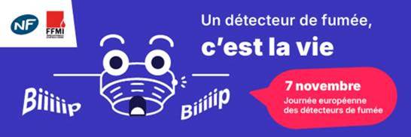
We are pleased to inform you about the launch, on November 7th — on the occasion of the European Smoke Detector Day — of a national awareness campaign co-branded by NF and FFMI: #CheckTonDétecteur.
This initiative, led by AFNOR Certification with the support of the French Federation of Fire Safety Professions (FFMI), aims to remind the general public of the importance of properly maintaining their smoke detector — ten years after the law mandating its installation in all homes came into effect.
This essential safety device has contributed to a 50% reduction in domestic fire-related deaths over the past decade.

Campaign objectives: “Raise awareness and remind people of the right actions”
- Test your smoke detector twice a year
- Replace it every 10 years
- Choose an NF-certified model compliant with standard 17064, ensuring reliability and safety

A comprehensive communication package
Instagram: To deliver the message in a concrete and accessible way, three content creators were involved:
- Daddy Poule: https://www.instagram.com/reel/DQv2pcOiPMn/
A charming and humorous father who shares his daily life with authenticity. In this video, he demonstrates that home safety often starts with small everyday gestures.
- Les Copains Colocs: https://www.instagram.com/reel/DQxB9ayjf6F/
A dynamic duo from Montpellier, known for their quirky and energetic “storytime” videos. They highlight that prevention is not just for families — even housemates must think about safety!
- Brian Iimpact: https://www.instagram.com/reel/DQw1Zssja3O/
A firefighter and dedicated creator who uses his social media to raise awareness about fire safety and share good practices. His professional perspective adds even more weight to the message.
Google: A 15-day series of preventive visual ads.
Spotify: An audio spot broadcast for 10 days (attached).
LinkedIn and Instagram: Shareable content linking to our new page dedicated to smoke detectors:
https://marque-nf.com/nf-detecteur-fumee/

This campaign is still ongoing—feel free to share the various posts with your communities and clients.

