Knowledge is power
Diego J.¹, Doe J.², Ivanov I.I.³
¹Institute for Humic Materials, City, Country, juan_diego@humic.edu
²University of Living Systems, City, Country
³Academy for Humic Design, City, Country

Keywords: knowledge, power

Please place your text here keeping provided styles: AbstractTitle, AbstractAuthors, AbstractAffiliation, AbstractText, AbstractFigure, AbstractTableName, AbstractThanks, and AbstratFerTitle [1].
The abstract can be 1 page strictly.
The file name should be the last name of the first author. For example, diego.doc.
Please submit the abstract in doc/docx-format (Microsoft Word).
The maximum file size is 1 Mb.
All margins should be set to 2 cm.
In case of several authors, please, underline the presenting author.
Formats for Figures and Tables are shown below.
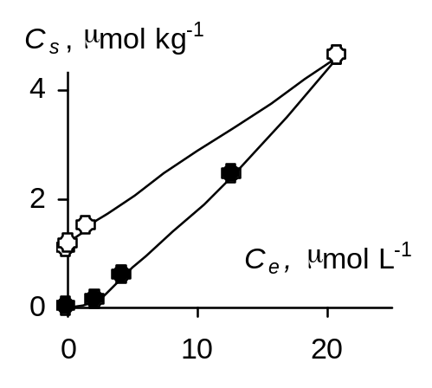
Figure 1. Prepare your figures only in black and white. Keep in mind that it will be reduced to about 75% while publishing.
Table 1. Summary of guidelines
Number of pages | One page strictly
Page size | A4, 210 x 297 mm
Styles | provided in this template
Margin | 2 cm for all margins
File size | Maximum 1 Mb
File name | lastname.doc

The abstracts of all contributions will be published in the Abstract book after peer review.
Acknowledgements. Thank you for submission of your abstract.
References
1. Please do not format your text manually. Instead, use provided styles.

