УО «Белорусский государственный университет информатики и радиоэлектроники»

Кафедра ПОИТ

Отчет по лабораторной работе №1.1

по предмету

Основы алгоритмизации и программирования

Вариант 3

Выполнил:

Бетеня К.С.

Проверила:

Данилова Г.В.

Группа 351005

Минск 2023

Задание:

Составьте программу для определения подходящего возраста кандидатуры для вступления в брак, используя следующее соображение: возраст девушки равен половине возраста мужчины+7, возраст мужчины определяется соответственно как удвоенный возраст девушки-14. В начале выполнения программы на экране должен появиться вопрос МУЖЧИНА или ЖЕНЩИНА? ВВЕДИТЕ М, если Вы мужчина, или Ж, если женщина и свой возраст. В зависимости от ответа выводятся соответствующие рекомендации.

Код программы на **Delphi**:

Program Lab1;

Uses

System.SysUtils;

Const

MINYEAR = 18;

MAXYEAR = 120;

Var

Gender: Char = ' ';

Year: Integer = 0;

IsCorrect: Boolean = True;

Begin

Writeln(' The program will ask the user for their gender and age.', #13#10,

'The age of your significant other will be calculated using the

formulas!!!', #13#10, #13#10, 'Age restrictions: from ', MINYEAR,

' to ', MAXYEAR, '.', #13#10, #13#10);

Repeat

Try

IsCorrect := False;

Writeln('Select your gender. If you are a man, then (M), if you are a

woman, then (W).');

Readln(Gender);

If (Gender <> 'M') And (Gender <> 'm') And (Gender <> 'W') And (Gender

<> 'w') Then

Begin

Raise Exception.Create('Wrong gender selection.');

End;

Writeln('Write your age in years.');

Readln(Year);

If (Year > MAXYEAR) Then

Begin

Raise Exception.Create('The age is great. The permissible maximum

age for the program is 120 years.');

End

Else

If (Year < MINYEAR) Then

Begin

Raise Exception.Create('Age is small. The acceptable minimum

age for the program is 18 years.');

End;

If (Gender = 'M') Or (Gender = 'm') Then

Begin

//checking your significant other's age

If ((Year Div 2) + 7 < MinYear) Then

Begin

Write('The age of your significant other is below the

acceptable norm (18). ', FormatFloat('#', (Year / 2) +

7));

End

Else

Begin

Write('You are a man and you ', Year, ', and to your soulmate

', FormatFloat('#', (Year / 2) + 7), '.');

End;

End

Else

If (Gender = 'W') Or (Gender = 'w') Then

Begin

If ((Year * 2) - 14 > MaxYear) Then

Begin

Write('The age of your significant other has exceeded the

maximum norm (120). ', (Year * 2) - 14);

End

Else

Begin

Write('You are a woman and you ', Year, ', and to your

soulmate ', (Year * 2) - 14, '.');

End;

End;

Readln;

Readln;

IsCorrect := True;

Except

On Error: Exception Do

Begin

Writeln(Error.Message);

End;

End;

Until IsCorrect;

End.

Код программы на **C++**:

#include <iostream>

int main()

{

const int MINYEAR = 18;

const int MAXYEAR = 120;

char gender = '\0';

int year = 0;

bool IsCorrectGender = false, IsCorrectYear = false;

std::cout << " The program will ask the user for their gender and age.\n"

<< "The age of your significant other will be calculated using the

formulas!!!\n\n"

<< "Age restrictions: from " << MINYEAR << " to " << MAXYEAR <<

".\n\n\n";

do

{

IsCorrectGender = false;

std::cout << "Select your gender. If you are a man, then (M), if you are a

woman, then (W).\n";

std::cin >> gender;

if (gender != 'M' && gender != 'w' && gender != 'W' && gender != 'm')

{

std::cout << "Wrong gender selection.\n";

IsCorrectGender = true;

std::cin.clear();

while (std::cin.get() != '\n') {}

}

else if (std::cin.get() != '\n')

{

std::cout << "ERROR\n";

IsCorrectGender = true;

std::cin.clear();

while (std::cin.get() != '\n') {}

}

} while (IsCorrectGender);

do

{

std::cout << "Write your age in years.\n";

std::cin >> year;

IsCorrectYear = false;

if (std::cin.get() != '\n')

{

std::cout << "ERROR.\n";

IsCorrectYear = true;

std::cin.clear();

while (std::cin.get() != '\n') {}

}

else if (year > MAXYEAR)

{

std::cout << "The age is great. The permissible maximum age for the

program is 120 years.\n";

IsCorrectYear = true;

std::cin.clear();

while (std::cin.get() != '\n') {}

}

else if (year < MINYEAR)

{

std::cout << "Age is small. The acceptable minimum age for the

program is 18 years.\n";

IsCorrectYear = true;

std::cin.clear();

while (std::cin.get() != '\n') {}

}

} while (IsCorrectYear);

if (IsCorrect && (gender == 'M' || gender == 'm'))

{

if ((year / 2) + 7 < MINYEAR)

{

std::cout << "The age of your significant other is below the

acceptable norm(18). " << (year / 2) + 7;

}

else

{

std::cout << "You are a man and you " << year << ", and to your

soulmate " << (year / 2) + 7 << ".";

}

}

else if (IsCorrect)

{

if ((year * 2) - 14 > MAXYEAR)

{

std::cout << "The age of your significant other has exceeded the

maximum norm(120). " << (year * 2) - 14;

}

else

{

std::cout << "You are a woman and you " << year << ", and to your

soulmate " << (year * 2) - 14 << ".";

}

}

return 0;

}

Код программы на **Java**:

import java.util.Scanner;  
  
public class lab_1  
{  
public static void main(String[] args)  
 {  
 final int MAXYEAR = 120;  
 final int MINYEAR = 18;  
 boolean IsCorrect = false;   
 int year = MINYEAR;  
 char gender = '\0';  
 System.*out*.println(" The program will ask the user for their gender and

age.\n" +  
 "The age of your significant other will be calculated

using the formulas!!!\n\n" +  
 "Age restrictions: from " + MINYEAR + " to " + MAXYEAR

+ ".\n");  
 do {  
 try  
 {  
 Scanner in = new Scanner(System.*in*);  
 System.*out*.println("Select your gender. If you are a man, then

(M), if you are a woman, then (W).");  
 gender = in.next().charAt(0);  
 if (gender != 'M' && gender != 'w' && gender != 'W' && gender !=

'm')  
 {  
 throw new Exception("Wrong gender selection.");  
 }  
 System.*out*.println("Write your age in years.");  
 year = in.nextInt();  
 if (year > MAXYEAR)  
 {  
 throw new Exception("The age is great. The permissible maximum

age for the program is 120 years.");  
 }  
 else if (year < MINYEAR)  
 {  
 throw new Exception("Age is small. The acceptable minimum age

for the program is 18 years.");  
 }  
 in.close();  
 IsCorrect = false;  
 } catch (Exception error) {  
 if (error.getMessage() == null)  
 {  
 IsCorrect = true;  
 System.*out*.println("You must write the number.");  
 }  
 else  
 {  
 IsCorrect = true;  
 System.*out*.println(error.getMessage());  
 }  
 }  
 } while (IsCorrect);  
  
 if (gender == 'M' || gender == 'm')  
 {  
 if ((year / 2) + 7 < MINYEAR)  
 {  
 System.*out*.println("The age of your significant other is below the

acceptable norm(18). " + ((year / 2) + 7));  
 }  
 else  
 {  
 System.*out*.println("You are a man and you " + year + ", and to

your soulmate " + ((year / 2) + 7) + ".");  
 }  
 }  
 else  
 {  
 if ((year * 2) - 14 > MAXYEAR)  
 {  
 System.*out*.println("The age of your significant other has exceeded

the maximum norm(120). " + ((year * 2) - 14));  
 }  
 else  
 {  
 System.*out*.println("You are a woman and you " + year + ", and to

your soulmate " + ((year * 2) - 14) + ".");  
 }  
 }  
 }  
}

Результат на **Delphi**:

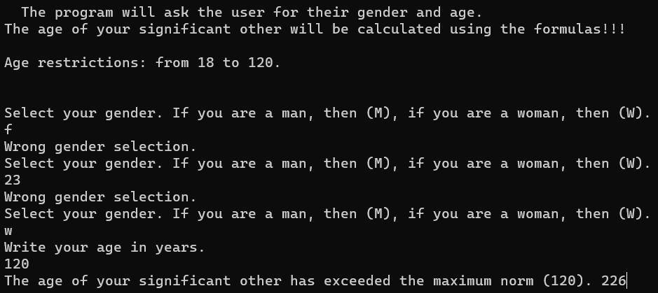

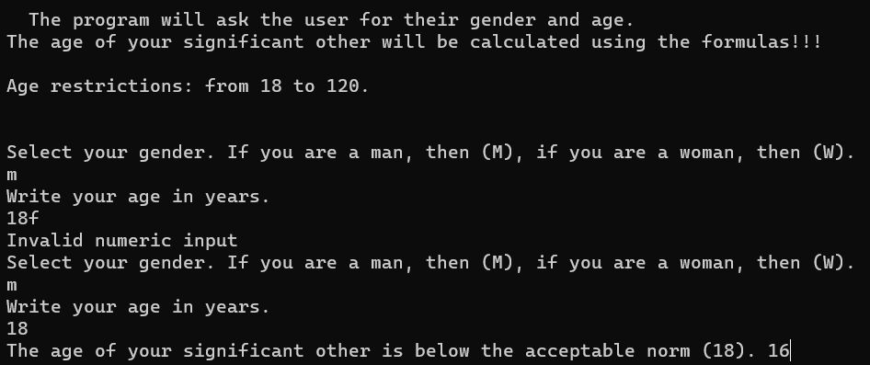

Результат на **C++**:

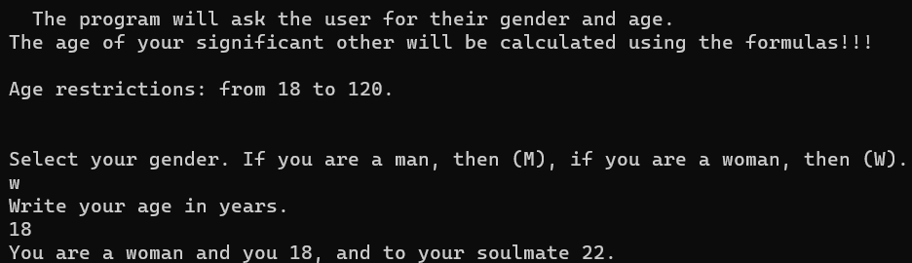

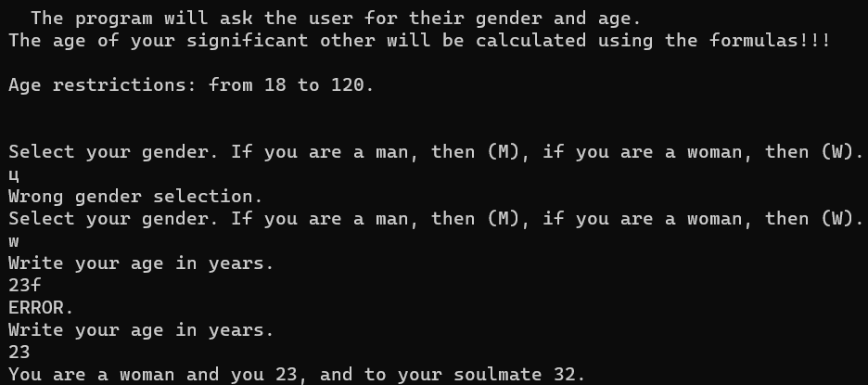

Результат на **Java**:

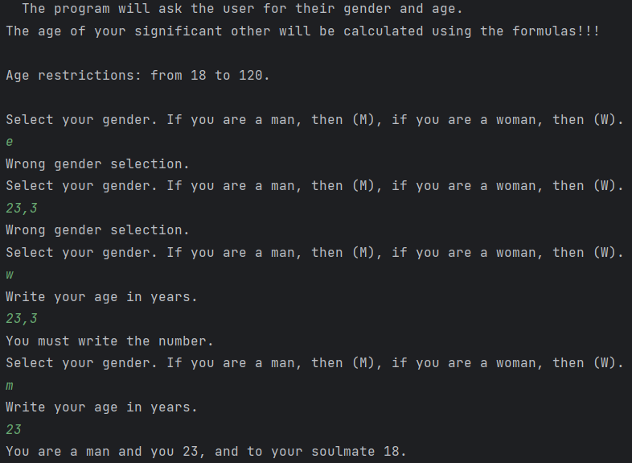

Блок-схема:

