УО «Белорусский государственный университет информатики и радиоэлектроники»

Кафедра ПОИТ

Отчет по лабораторной работе №1.4

по предмету

Основы алгоритмизации и программирования

Вариант 3

Выполнил:

Бетеня К.С.

Проверила:

Данилова Г.В.

Группа 351005

Минск 2023

Задание:

Вычислить А1 + А3 + А5 + ... + А2N-1

Код программы на **Delphi**:

Program Lab4;

Uses

System.SysUtils;

Var

ArrayOfNumbers: Array Of Real;

ArraySize, I, High: Integer;

SumNumb: Real;

IsCorrect: Boolean;

Begin

ArraySize := 0;

SumNumb := 0.0;

IsCorrect := False;

High := 0;

Writeln(' The program calculates the sum of all odd elements entered by the

user.', #10,

'*Please note that the numbering of the entered numbers starts from

zero.*', #10, #10,

'Restrictions: The number of all elements is an integer;', #10,

'Restrictions: Numbers can be any: both integers and reals.', #10);

Repeat

Try

Writeln('How many numbers will you write?');

Readln(ArraySize);

If ArraySize < 1 Then

Writeln('Number should be > 0. Try again.')

Else

IsCorrect := True;

Except

Writeln('Number entered incorrectly.');

End;

Until IsCorrect;

SetLength(ArrayOfNumbers, ArraySize);

High := ArraySize - 1;

IsCorrect := False;

Repeat

Try

For I := 0 To High Do

Begin

Writeln('Write your ', I + 1, ' number.');

Read(ArrayOfNumbers[I]);

End;

IsCorrect := True;

Except

Writeln('Number entered incorrectly.');

End;

Until IsCorrect;

For I := 0 To High Do

Begin

If I Mod 2 <> 0 Then

SumNumb := SumNumb + ArrayOfNumbers[I];

End;

ArrayOfNumbers := Nil;

Writeln('Sum of all odd numbers - ', SumNumb:3:3);

Readln;

Readln;

End.

Код программы на **C++**:

#include <iostream>

int main()

{

int arraySize = 0;

double sumNumb = 0.0;

bool isCorrect = false;

printf(" The program calculates the sum of all odd elements entered by the

user.\n"

"*Please note that the numbering of the entered numbers starts from

zero.*\n\n"

"Restrictions: The number of all elements is an integer;\n"

" Numbers can be any: both integers and reals.\n\n");

do

{

printf("How many numbers will you write?\n");

std::cin >> arraySize;

if (std::cin.get() != '\n')

{

std::cin.clear();

std::cin.ignore(30000, '\n');

printf("Number entered incorrectly. Try again.\n");

}

else if (arraySize < 1)

{

std::cout << "Number should be > 0. Try again.\n";

}

else

{

isCorrect = true;

}

} while (!isCorrect);

double* arrayOfNumbers = new double[arraySize];

do

{

isCorrect = true;

for (int i = 0; i < arraySize; i++)

{

printf("Write your %d number.\n", i + 1);

std::cin >> arrayOfNumbers[i];

if (std::cin.get() != '\n')

{

std::cin.clear();

std::cin.ignore(35000, '\n');

isCorrect = false;

printf("Number entered incorrectly. Try again.\n");

}

}

} while (!isCorrect);

for (int i = 0; i < arraySize; i = i + 2) {

sumNumb = sumNumb + arrayOfNumbers[i];

}

delete[] arrayOfNumbers;

arrayOfNumbers = nullptr;

printf("\nSum of all odd numbers - %.3f", sumNumb);

return 0;

}

Код программы на **Java**:

import java.text.DecimalFormat;  
import java.util.Scanner;  
  
public class lab_4 {  
 public static void main(String[] args){  
 DecimalFormat dF = new DecimalFormat( "0.###" );  
 Scanner in = new Scanner(System.*in*);  
  
 int arraySize = 0;  
 double sumNumb = 0.0;  
 boolean isCorrect = true;  
  
 System.*out*.print("""  
 The program calculates the sum of all odd elements

entered by the user.  
 *Please note that the numbering of the entered numbers

starts from zero.*  
   
 Restrictions: The number of all elements is an integer

and > 0;  
 Numbers can be any: both integers and

reals.  
   
 """);  
  
 do {  
 try {  
 System.*out*.println("How many numbers will you write?");  
 arraySize = Integer.*parseInt*(in.nextLine());  
 if (arraySize < 1)  
 {  
 System.*err*.println("Number should be > 0. Try again.");  
 }  
 else  
 {  
 isCorrect = false;  
 }  
 } catch (NumberFormatException error) {  
 System.*err*.println("Number entered incorrectly. Try again.");  
 }  
 } while (isCorrect);  
  
 double[] arrayOfNumbers = new double[arraySize];  
  
 isCorrect = true;  
 do  
 {  
 try  
 {  
 for (int i = 0; i < arraySize; i++) {  
 System.*out*.printf("Write your %d number.\n", i + 1);  
 arrayOfNumbers[i] = Double.*parseDouble*(in.nextLine());  
 }  
 isCorrect = false;  
 } catch (NumberFormatException error) {  
 System.*err*.println("Number entered incorrectly. Try again.");  
 }  
 } while(isCorrect);  
  
 in.close();  
  
 for (int i = 0; i < arraySize; i = i + 2) {  
 sumNumb = sumNumb + arrayOfNumbers[i];  
 }  
  
 System.*out*.printf("Sum of all odd numbers - %.3f", sumNumb);  
 }  
}

Результат на **Delphi**:

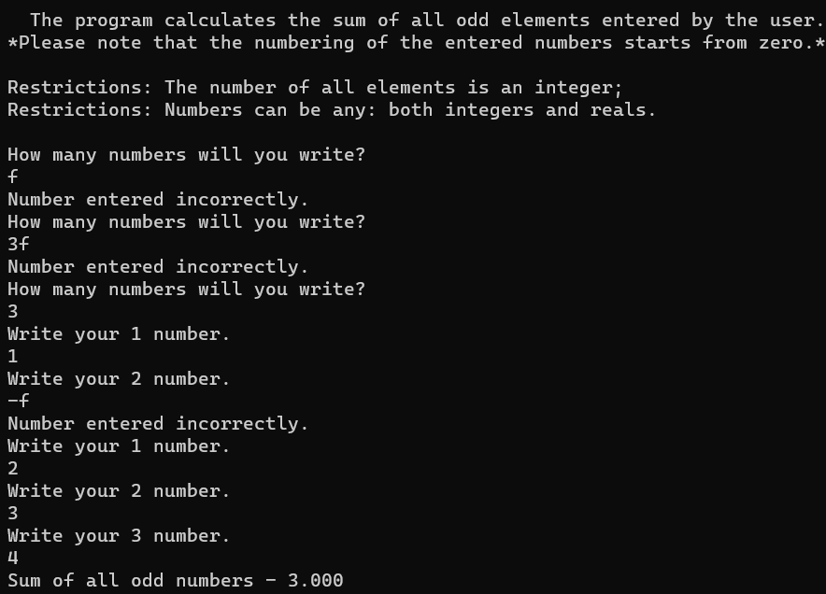

Результат на **C++**:

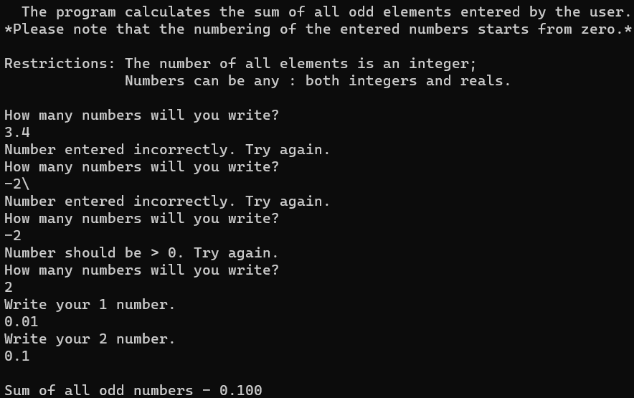

Результат на **Java**:

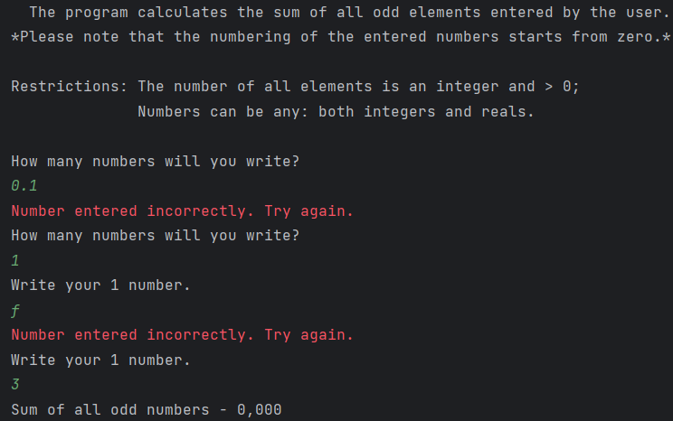

Блок-схема:

