20170910
Отчет по заданию 1.

L3 схема сети.
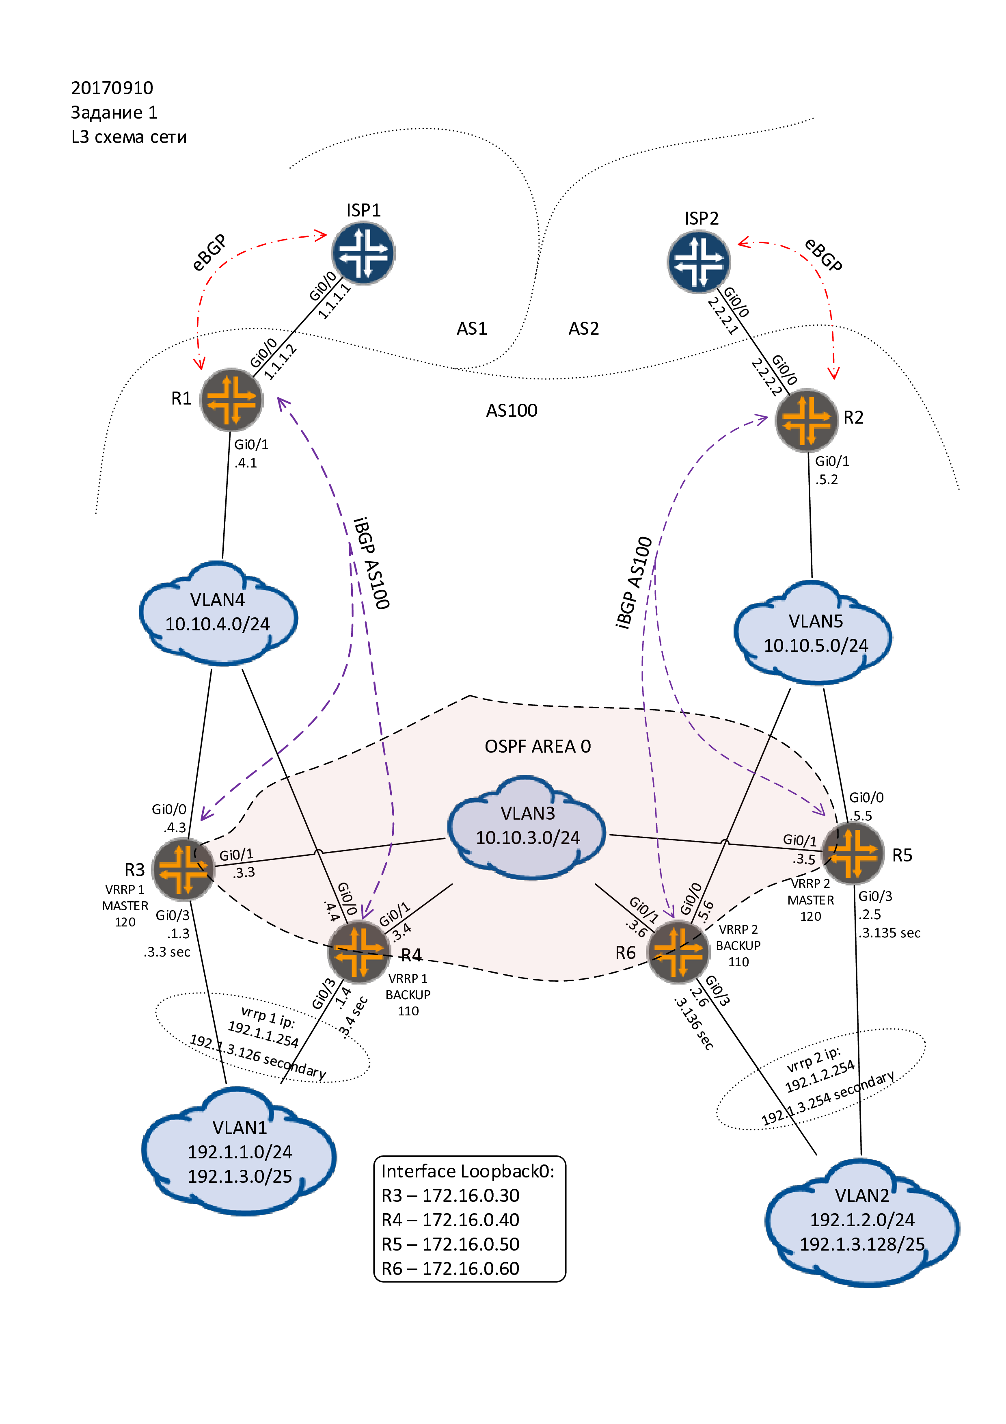

BGP схема
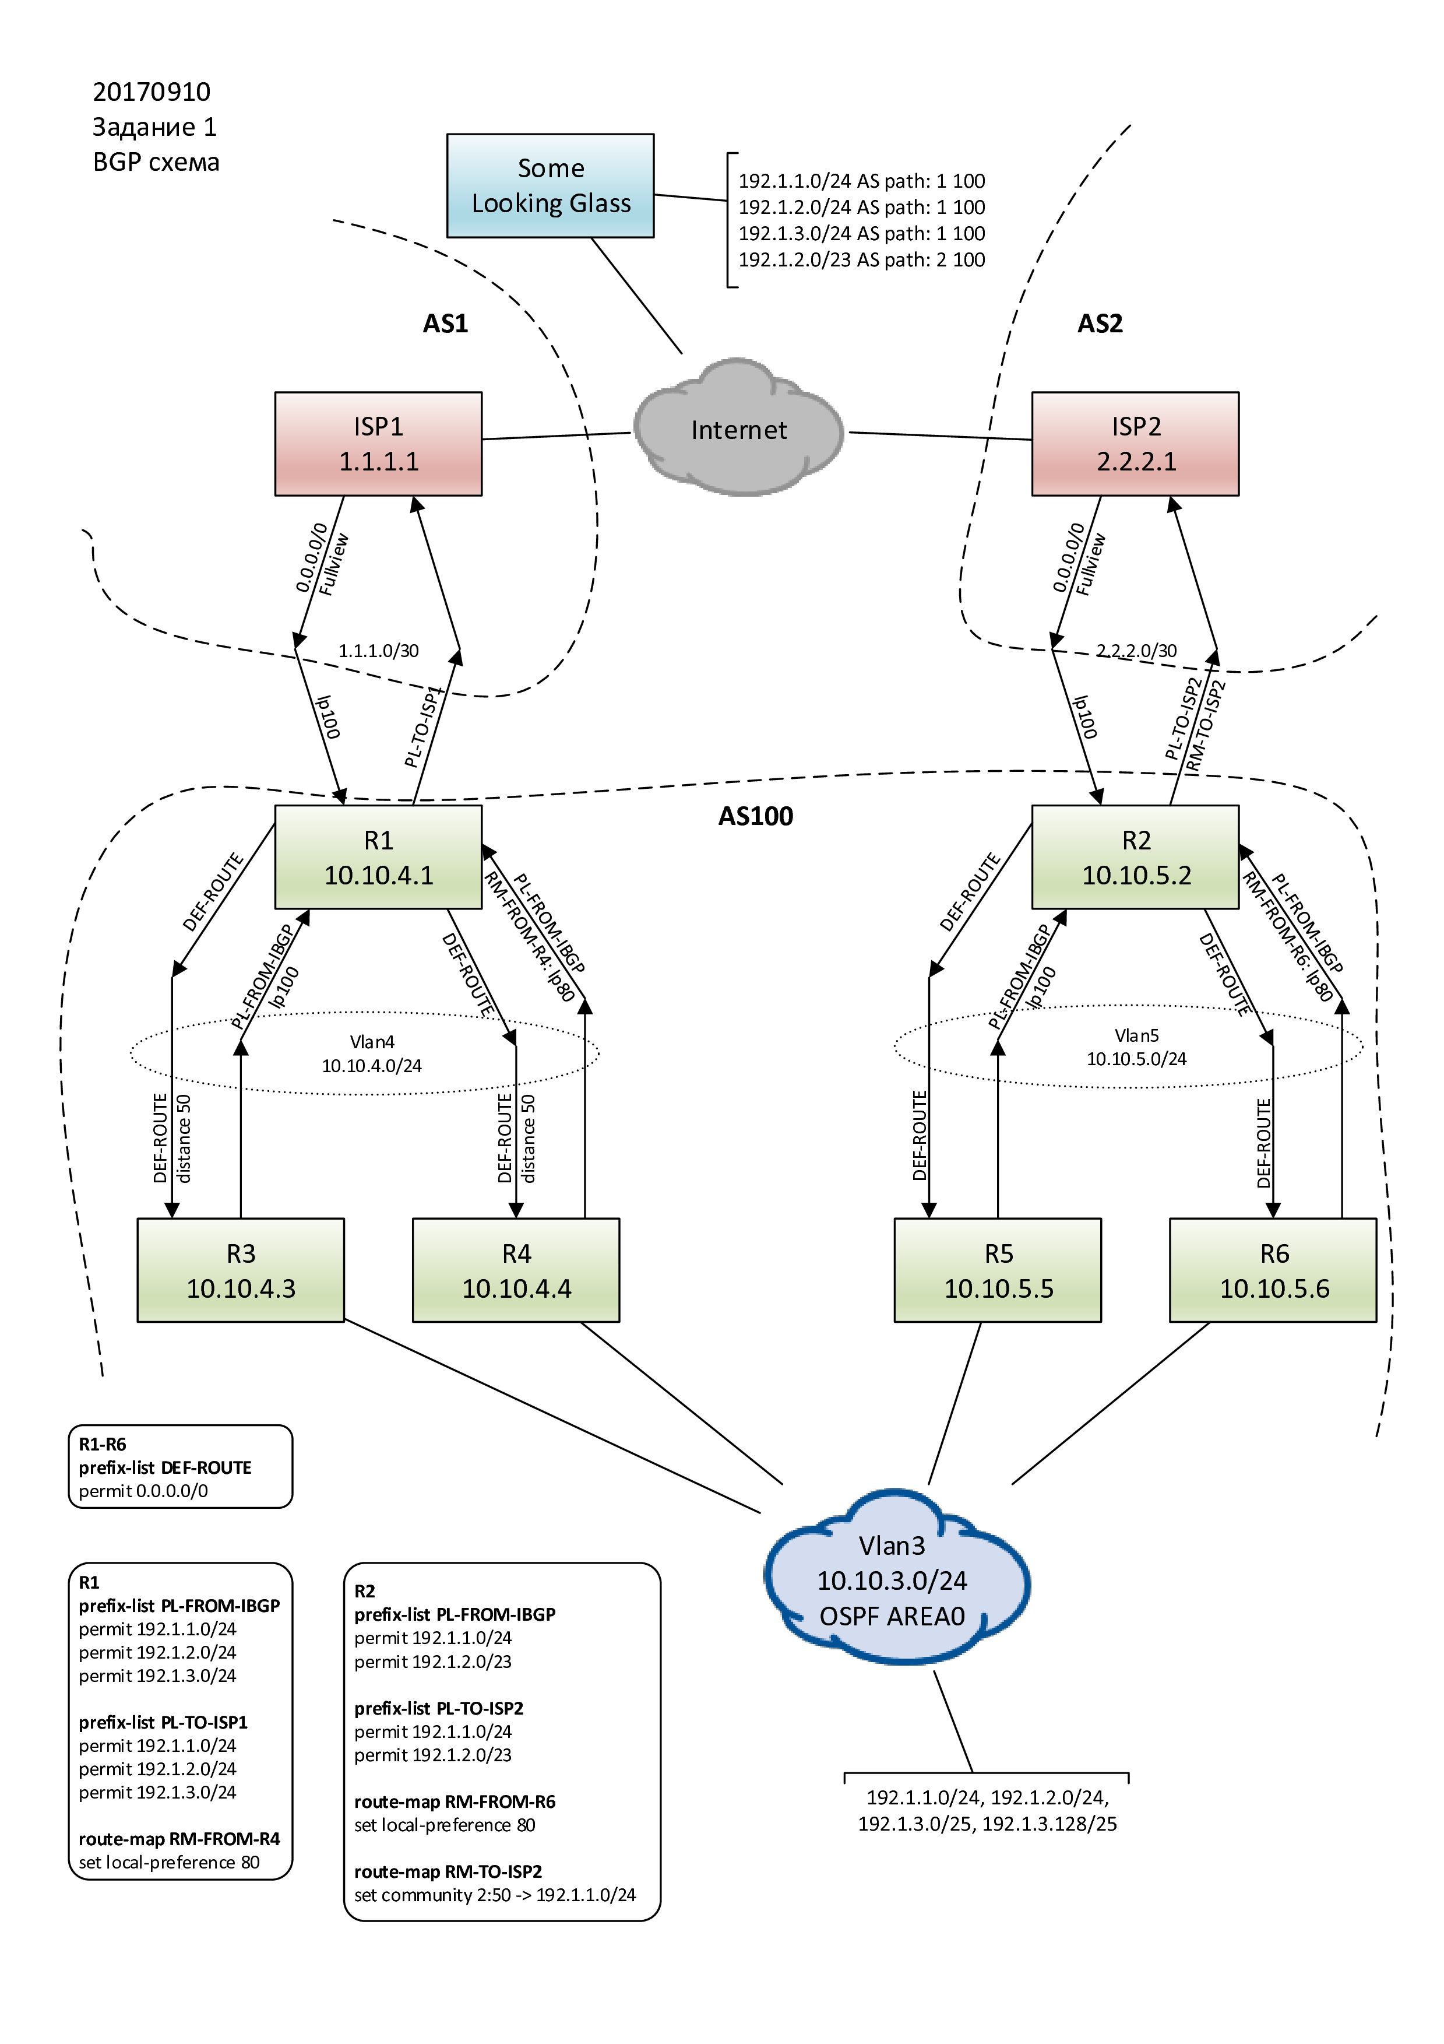

Копцепция

Сети в VLAN1 и VLAN2.
В качестве шлюзов по умолчанию, для клиентов в VLAN1 и VLAN2, выступают пары маршрутизаторов R3-R4 и R5-R6 соответственно. Пары маршрутизаторов объединены по протоколу VRRP и публикуют для клиентов виртуальные ip шлюзов по умолчанию.
R3-R4
R3 – master, R4 – backup
Виртуальные ip – 192.1.1.254 и 192.1.3.126 (secondary)

R5-R6
R5 – master, R6 – backup
Виртуальные ip – 192.1.2.254 и 192.1.3.254 (secondary)

OSPF
OSPF (area 0) работает в VLAN3 (10.10.3.0/24) между четырьмя маршрутизаторами – R3-R6.
Маршрутизаторы R3 и R5 считаются основными, R4 и R6 резервными.

Каждый маршрутизатор анонсит в area 0 сети подключенные к интерфейсу gi0/3.
На резервных R4 и R6 увеличена матрика\стоимость интерфейсов gi0/3 - ip ospf cost 10

Каждый маршрутизатор анонсит в area0 маршрут по умолчанию.
На резервных R4 и R6 увеличена метрика маршрута по умолчанию - default-information originate metric 60\70
На маршрутизаторах R3 и R4, для маршрута по умолчанию, полученному по iBGP от R1, меняется administrative distance c 200 на 50 (distance 50 10.10.4.1 0.0.0.0). Это нужно, что бы перебить маршруты по умолчанию от R5-R6 (ospf AD 110 ).

BGP
iBGP
Поднято 4 iBGP сессии – R1→R3, R1→R4, R2→R5, R2→R6.
От R1 и R2 “вниз” спускаются маршруты по умолчанию полученные от ISP1 и IPS2.

От R3-R6 поднимаются маршруты клиентских сетей, часть из них агрегируются.
На R1 приходят сети 192.1.1.0/24, 192.1.2.0/24, 192.1.3.0/24
(aggregate-address 192.1.3.0 255.255.255.0 summary-only)
На R2 приходят сети 192.1.1.0/24, 192.1.2.0/23
(aggregate-address 192.1.2.0 255.255.254.0 summary-only)

На маршруты, пришедшие от резервных маршрутизаторов R4 и R6, на R1 и R2 ставится
local preference 80.

На R3-R6 настроена редистребьюция connected и ospf маршрутов.
Connected маршруты берутся только от интерфесов gi0/3.
От ospf берутся все маршруты которые потом режутся на R1 и R2.

eBGP
Два стыка, от провайдеров получаем 0.0.0.0/0 и FV.

В ISP1, с R1, анонсим три сети /24 – 192.1.1.0/24, 192.1.2.0/24, 192.1.3.0/24.

В ISP2, с R2, анонсим две сети – 192.1.1.0/24, 192.1.2.0/23.

R2 на анонс 192.1.1.0/24 вешает “backup bgp community” 2:50. Этим комьюнити мы просим ISP2 поставить на анонс local preference 50. После этого анонс 192.1.1.0/24 будет “спать” пока ISP2 видит такой же анонс пришедший через ISP1. Если ISP1 падает, ISP2 начинает анонсить 192.1.1.0/24 в интернет.

Сеть 192.1.2.0/23 анонсим в ISP2 без комьюнити, т.к. анонс менее специфичный, пока все хорошо с ISP1, трафик в него пойти не должен.
Вместе с тем, анонс /23 позволит следить за состоянием ISP2. Если с какого-нить looking glass видим /23, значит ISP2 работает.

Если через ISP2 в /23 будет просачиваться трафик, то можно /23 разбить на два /24 и так же повесить “backup bgp community”.

Конфигурации

R1
hostname R1
!
interface GigabitEthernet0/0
description ISP1/gi0/0
ip address 1.1.1.2 255.255.255.252
no ip redirects
duplex auto
speed auto
media-type rj45
bfd interval 500 min_rx 500 multiplier 3
!
interface GigabitEthernet0/1
description ROUTER-LINKNET-4
ip address 10.10.4.1 255.255.255.0
duplex auto
speed auto
media-type rj45
!
router bgp 100
bgp log-neighbor-changes
neighbor 1.1.1.1 remote-as 1
neighbor 1.1.1.1 description ISP1
neighbor 1.1.1.1 fall-over bfd
neighbor 1.1.1.1 prefix-list PL-TO-ISP1 out
neighbor 10.10.4.3 remote-as 100
neighbor 10.10.4.3 description R3
neighbor 10.10.4.3 next-hop-self
neighbor 10.10.4.3 prefix-list PL-FROM-IBGP in
neighbor 10.10.4.3 prefix-list DEF-ROUTE out
neighbor 10.10.4.4 remote-as 100
neighbor 10.10.4.4 description R4
neighbor 10.10.4.4 next-hop-self
neighbor 10.10.4.4 prefix-list PL-FROM-IBGP in
neighbor 10.10.4.4 prefix-list DEF-ROUTE out
neighbor 10.10.4.4 route-map RM-FROM-R4 in
!
ip forward-protocol nd
!
!
no ip http server
no ip http secure-server
ip route 192.1.1.0 255.255.255.0 Null0 240
ip route 192.1.2.0 255.255.254.0 Null0 240
!
!
ip prefix-list DEF-ROUTE seq 5 permit 0.0.0.0/0
!
ip prefix-list PL-FROM-IBGP seq 5 permit 192.1.1.0/24
ip prefix-list PL-FROM-IBGP seq 10 permit 192.1.2.0/24
ip prefix-list PL-FROM-IBGP seq 15 permit 192.1.3.0/24
!
ip prefix-list PL-TO-ISP1 seq 5 permit 192.1.1.0/24
ip prefix-list PL-TO-ISP1 seq 10 permit 192.1.2.0/24
ip prefix-list PL-TO-ISP1 seq 15 permit 192.1.3.0/24
!
route-map RM-FROM-R4 permit 10
set local-preference 80
!

R2
hostname R2

service password-encryption

no banner exec
no banner incoming
no banner login

interface GigabitEthernet0/0
description ISP2/gi0/0
ip address 2.2.2.2 255.255.255.252
duplex auto
speed auto
media-type rj45
!
interface GigabitEthernet0/1
description ROUTER-LINKNET-5
ip address 10.10.5.2 255.255.255.0
duplex auto
speed auto
media-type rj45
!
interface GigabitEthernet0/2
no ip address
shutdown
duplex auto
speed auto
media-type rj45
!
interface GigabitEthernet0/3
no ip address
shutdown
duplex auto
speed auto
media-type rj45
!
router bgp 100
bgp log-neighbor-changes
neighbor 2.2.2.1 remote-as 2
neighbor 2.2.2.1 description ISP2
neighbor 10.10.5.5 remote-as 100
neighbor 10.10.5.5 description R5
neighbor 10.10.5.6 remote-as 100
neighbor 10.10.5.6 description R6
!
address-family ipv4
neighbor 2.2.2.1 activate
neighbor 2.2.2.1 send-community
neighbor 2.2.2.1 prefix-list PL-TO-ISP2 out
neighbor 2.2.2.1 route-map RM-TO-ISP2 out
neighbor 10.10.5.5 activate
neighbor 10.10.5.5 next-hop-self
neighbor 10.10.5.5 prefix-list PL-FROM-IBGP in
neighbor 10.10.5.5 prefix-list DEF-ROUTE out
neighbor 10.10.5.6 activate
neighbor 10.10.5.6 next-hop-self
neighbor 10.10.5.6 prefix-list PL-FROM-IBGP in
neighbor 10.10.5.6 prefix-list DEF-ROUTE out
neighbor 10.10.5.6 route-map RM-FROM-R6 in
exit-address-family
!
ip forward-protocol nd
!
ip bgp-community new-format
!
no ip http server
no ip http secure-server
ip route 192.1.1.0 255.255.255.0 Null0 240
ip route 192.1.2.0 255.255.254.0 Null0 240
!
!
ip prefix-list DEF-ROUTE seq 5 permit 0.0.0.0/0
!
ip prefix-list PL-FROM-IBGP seq 5 permit 192.1.1.0/24
ip prefix-list PL-FROM-IBGP seq 10 permit 192.1.2.0/23
!
ip prefix-list PL-TO-ISP2 seq 5 permit 192.1.1.0/24
ip prefix-list PL-TO-ISP2 seq 10 permit 192.1.2.0/23
!
ip prefix-list PL-TO-ISP2-W-COMMUNITY seq 5 permit 192.1.1.0/24
!
ip prefix-list PL-TO-ISP2-WO-COMMUNITY seq 5 permit 192.1.2.0/23
!
route-map RM-FROM-R6 permit 10
set local-preference 80
!
route-map RM-TO-ISP2 permit 5
match ip address prefix-list PL-TO-ISP2-WO-COMMUNITY
continue
!
route-map RM-TO-ISP2 permit 10
match ip address prefix-list PL-TO-ISP2-W-COMMUNITY
set community 2:50
!

R3
hostname R3

service password-encryption

no banner exec
no banner incoming
no banner login

interface Loopback0
ip address 172.16.0.30 255.255.255.255
!
interface GigabitEthernet0/0
description ROUTER-LINKNET-4
ip address 10.10.4.3 255.255.255.0
duplex auto
speed auto
media-type rj45
!
interface GigabitEthernet0/1
description ROUTER-LINKNET-3
ip address 10.10.3.3 255.255.255.0
duplex auto
speed auto
media-type rj45
!
interface GigabitEthernet0/2
no ip address
shutdown
duplex auto
speed auto
media-type rj45
!
interface GigabitEthernet0/3
description VLAN1
ip address 192.1.3.3 255.255.255.128 secondary
ip address 192.1.1.3 255.255.255.0
duplex auto
speed auto
media-type rj45
vrrp 1 description VRRP-MASTER-FOR-VLAN1-CUSTOMER-NETS
vrrp 1 ip 192.1.1.254
vrrp 1 ip 192.1.3.126 secondary
vrrp 1 preempt delay minimum 15
vrrp 1 priority 120
vrrp 1 authentication md5 key-string 7 051D141D31015E080A16
!
router ospf 1
router-id 172.16.0.30
passive-interface GigabitEthernet0/3
network 10.10.3.0 0.0.0.255 area 0
network 192.1.1.0 0.0.0.255 area 0
network 192.1.3.0 0.0.0.127 area 0
default-information originate
!
router bgp 100
bgp log-neighbor-changes
bgp redistribute-internal
aggregate-address 192.1.3.0 255.255.255.0 summary-only
redistribute connected route-map CONNECTED-TO-BGP
redistribute ospf 1
neighbor 10.10.4.1 remote-as 100
neighbor 10.10.4.1 description R1
neighbor 10.10.4.1 next-hop-self
neighbor 10.10.4.1 prefix-list DEF-ROUTE in
distance 50 10.10.4.1 0.0.0.0
!
ip forward-protocol nd
!
!
no ip http server
no ip http secure-server
!
!
ip prefix-list CONNECTED-NET seq 5 permit 192.1.1.0/24
ip prefix-list CONNECTED-NET seq 10 permit 192.1.3.0/25
!
ip prefix-list DEF-ROUTE seq 5 permit 0.0.0.0/0
!
route-map CONNECTED-TO-BGP permit 10
match ip address prefix-list CONNECTED-NET
!
!

R4
hostname R4
service password-encryption
interface Loopback0
ip address 172.16.0.40 255.255.255.255
!
interface GigabitEthernet0/0
description ROUTER-LINKNET-4
ip address 10.10.4.4 255.255.255.0
duplex auto
speed auto
media-type rj45
!
interface GigabitEthernet0/1
description ROUTER-LINKNET-3
ip address 10.10.3.4 255.255.255.0
duplex auto
speed auto
media-type rj45
!
interface GigabitEthernet0/2
no ip address
shutdown
duplex auto
speed auto
media-type rj45
!
interface GigabitEthernet0/3
description VLAN1
ip address 192.1.3.4 255.255.255.128 secondary
ip address 192.1.1.4 255.255.255.0
ip ospf cost 10
duplex auto
speed auto
media-type rj45
vrrp 1 description VRRP-BACKUP-FOR-VLAN1-CUSTOMER-NETS
vrrp 1 ip 192.1.1.254
vrrp 1 ip 192.1.3.126 secondary
vrrp 1 preempt delay minimum 15
vrrp 1 priority 110
vrrp 1 authentication md5 key-string 7 0719335E5E4409040401
!
router ospf 1
router-id 172.16.0.40
passive-interface GigabitEthernet0/3
network 10.10.3.0 0.0.0.255 area 0
network 192.1.1.0 0.0.0.255 area 0
network 192.1.3.0 0.0.0.127 area 0
default-information originate metric 60
!
router bgp 100
bgp log-neighbor-changes
bgp redistribute-internal
aggregate-address 192.1.3.0 255.255.255.0 summary-only
redistribute connected route-map CONNECTED-TO-BGP
redistribute ospf 1
neighbor 10.10.4.1 remote-as 100
neighbor 10.10.4.1 description R1
neighbor 10.10.4.1 next-hop-self
neighbor 10.10.4.1 prefix-list DEF-ROUTE in
distance 50 10.10.4.1 0.0.0.0
!
ip forward-protocol nd
!
!
no ip http server
no ip http secure-server
!
!
ip prefix-list CONNECTED-NET seq 5 permit 192.1.1.0/24
ip prefix-list CONNECTED-NET seq 10 permit 192.1.3.0/25
!
ip prefix-list DEF-ROUTE seq 5 permit 0.0.0.0/0
!
route-map CONNECTED-TO-BGP permit 10
match ip address prefix-list CONNECTED-NET

R5
hostname R5

service password-encryption

interface Loopback0
ip address 172.16.0.50 255.255.255.255
!
interface GigabitEthernet0/0
description ROUTER-LINKNET-5
ip address 10.10.5.5 255.255.255.0
duplex auto
speed auto
media-type rj45
!
interface GigabitEthernet0/1
description ROUTER-LINKNET-3
ip address 10.10.3.5 255.255.255.0
duplex auto
speed auto
media-type rj45
!
interface GigabitEthernet0/2
no ip address
shutdown
duplex auto
speed auto
media-type rj45
!
interface GigabitEthernet0/3
description VLAN2
ip address 192.1.3.135 255.255.255.128 secondary
ip address 192.1.2.5 255.255.255.0
duplex auto
speed auto
media-type rj45
vrrp 2 description VRRP-MASTER-FOR-VLAN2-CUSTOMER-NETS
vrrp 2 ip 192.1.2.254
vrrp 2 ip 192.1.3.254 secondary
vrrp 2 preempt delay minimum 15
vrrp 2 priority 120
vrrp 2 authentication md5 key-string 7 095A5C1B09480713181F55
!
router ospf 1
router-id 172.16.0.50
passive-interface GigabitEthernet0/3
network 10.10.3.0 0.0.0.255 area 0
network 192.1.2.0 0.0.0.255 area 0
network 192.1.3.128 0.0.0.127 area 0
default-information originate
!
router bgp 100
bgp log-neighbor-changes
bgp redistribute-internal
aggregate-address 192.1.2.0 255.255.254.0 summary-only
redistribute connected route-map CONNECTED-NET
redistribute ospf 1
neighbor 10.10.5.2 remote-as 100
neighbor 10.10.5.2 description R2
neighbor 10.10.5.2 next-hop-self
neighbor 10.10.5.2 prefix-list DEF-ROUTE in
!
ip forward-protocol nd
!
!
no ip http server
no ip http secure-server
!
!
ip prefix-list CONNECTED-NET seq 5 permit 192.1.2.0/24
ip prefix-list CONNECTED-NET seq 10 permit 192.1.3.128/25
!
ip prefix-list DEF-ROUTE seq 5 permit 0.0.0.0/0
!
route-map CONNECTED-TO-BGP permit 10
match ip address prefix-list CONNECTED-NET
!
!
!

R6
hostname R6

service password-encryption

interface Loopback0
ip address 172.16.0.60 255.255.255.255
!
interface GigabitEthernet0/0
description ROUTER-LINKNET-5
ip address 10.10.5.6 255.255.255.0
duplex auto
speed auto
media-type rj45
!
interface GigabitEthernet0/1
description ROUTER-LINKNET-3
ip address 10.10.3.6 255.255.255.0
duplex auto
speed auto
media-type rj45
!
interface GigabitEthernet0/2
no ip address
shutdown
duplex auto
speed auto
media-type rj45
!
interface GigabitEthernet0/3
description VLAN1
ip address 192.1.3.136 255.255.255.128 secondary
ip address 192.1.2.6 255.255.255.0
ip ospf cost 10
duplex auto
speed auto
media-type rj45
vrrp 2 description VRRP-BACKUP-FOR-VLAN1-CUSTOMER-NETS
vrrp 2 ip 192.1.2.254
vrrp 2 ip 192.1.3.126 secondary
vrrp 2 preempt delay minimum 15
vrrp 2 priority 110
vrrp 2 authentication md5 key-string 7 031249191642314D5D1A48
!
router ospf 1
router-id 172.16.0.60
passive-interface GigabitEthernet0/3
network 10.10.3.0 0.0.0.255 area 0
network 192.1.2.0 0.0.0.255 area 0
network 192.1.3.128 0.0.0.127 area 0
default-information originate metric 70
!
router bgp 100
bgp log-neighbor-changes
bgp redistribute-internal
aggregate-address 192.1.2.0 255.255.254.0 summary-only
redistribute ospf 1
neighbor 10.10.5.2 remote-as 100
neighbor 10.10.5.2 description R2
neighbor 10.10.5.2 next-hop-self
neighbor 10.10.5.2 prefix-list DEF-ROUTE in
!
ip forward-protocol nd
!
!
no ip http server
no ip http secure-server
!
!
ip prefix-list CONNECTED-NET seq 5 permit 192.1.2.0/24
ip prefix-list CONNECTED-NET seq 10 permit 192.1.3.128/25
!
ip prefix-list DEF-ROUTE seq 5 permit 0.0.0.0/0
!
route-map CONNECTED-TO-BGP permit 10
match ip address prefix-list CONNECTED-NET
!

ISP1
hostname R6
service password-encryption

interface GigabitEthernet0/0
description R1/gi0/0
ip address 1.1.1.1 255.255.255.252
no ip redirects
duplex auto
speed auto
media-type rj45
bfd interval 500 min_rx 500 multiplier 3
!
interface GigabitEthernet0/1
no ip address
shutdown
duplex auto
speed auto
media-type rj45
!
router bgp 1
bgp log-neighbor-changes
network 200.0.0.0 mask 255.0.0.0
network 201.0.0.0 mask 255.0.0.0
neighbor 1.1.1.2 remote-as 100
neighbor 1.1.1.2 description R1
neighbor 1.1.1.2 fall-over bfd
neighbor 1.1.1.2 default-originate
!
ip forward-protocol nd
!
!
no ip http server
no ip http secure-server
ip route 200.0.0.0 255.0.0.0 Null0
ip route 201.0.0.0 255.0.0.0 Null0
!

ISP2
service password-encryption
!
hostname R6
interface GigabitEthernet0/0
description R2/gi0/0
ip address 2.2.2.1 255.255.255.252
duplex auto
speed auto
media-type rj45
!
router bgp 2
bgp log-neighbor-changes
network 50.0.0.0
network 51.0.0.0
network 200.0.0.0 mask 255.0.0.0
network 201.0.0.0 mask 255.0.0.0
neighbor 2.2.2.2 remote-as 100
neighbor 2.2.2.2 description R2
neighbor 2.2.2.2 default-originate
neighbor 2.2.2.2 route-map RM-FROM-GORGEOUS-CUSTOMER in
!
ip forward-protocol nd
!
ip bgp-community new-format
ip community-list standard OUR-BACKUP-COMMUNITY permit 2:50
!
no ip http server
no ip http secure-server
ip route 50.0.0.0 255.0.0.0 Null0
ip route 51.0.0.0 255.0.0.0 Null0
ip route 200.0.0.0 255.0.0.0 Null0
ip route 201.0.0.0 255.0.0.0 Null0
!
!
route-map RM-FROM-GORGEOUS-CUSTOMER permit 10
match community OUR-BACKUP-COMMUNITY
set local-preference 50
!
route-map RM-FROM-GORGEOUS-CUSTOMER permit 20
!
!

Выводы команд

ISP1
ISP1#sh ip bgp
BGP table version is 22, local router ID is 1.1.1.1
Status codes: s suppressed, d damped, h history, * valid, > best, i - internal,
r RIB-failure, S Stale, m multipath, b backup-path, f RT-Filter,
x best-external, a additional-path, c RIB-compressed,
Origin codes: i - IGP, e - EGP, ? - incomplete
RPKI validation codes: V valid, I invalid, N Not found

Network Next Hop Metric LocPrf Weight Path
0.0.0.0 0.0.0.0 0 i
*> 192.1.1.0 1.1.1.2 0 100 ?
*> 192.1.2.0 1.1.1.2 0 100 ?
*> 192.1.3.0 1.1.1.2 0 100 i
*> 200.0.0.0/8 0.0.0.0 0 32768 i
*> 201.0.0.0/8 0.0.0.0 0 32768 i

ISP2
ISP2#sh ip bgp
BGP table version is 20, local router ID is 2.2.2.1
Status codes: s suppressed, d damped, h history, * valid, > best, i - internal,
r RIB-failure, S Stale, m multipath, b backup-path, f RT-Filter,
x best-external, a additional-path, c RIB-compressed,
Origin codes: i - IGP, e - EGP, ? - incomplete
RPKI validation codes: V valid, I invalid, N Not found

Network Next Hop Metric LocPrf Weight Path
0.0.0.0 0.0.0.0 0 i
*> 50.0.0.0 0.0.0.0 0 32768 i
*> 51.0.0.0 0.0.0.0 0 32768 i
*> 192.1.1.0 2.2.2.2 50 0 100 ?
*> 192.1.2.0/23 2.2.2.2 0 100 i
*> 200.0.0.0/8 0.0.0.0 0 32768 i
*> 201.0.0.0/8 0.0.0.0 0 32768 I

R1
R1#sh ip bgp
BGP table version is 24, local router ID is 10.10.4.1
Status codes: s suppressed, d damped, h history, * valid, > best, i - internal,
r RIB-failure, S Stale, m multipath, b backup-path, f RT-Filter,
x best-external, a additional-path, c RIB-compressed,
Origin codes: i - IGP, e - EGP, ? - incomplete
RPKI validation codes: V valid, I invalid, N Not found

Network Next Hop Metric LocPrf Weight Path
*> 0.0.0.0 1.1.1.1 0 1 i
* i 192.1.1.0 10.10.4.4 0 80 0 ?
*>i 10.10.4.3 0 100 0 ?
*>i 192.1.2.0 10.10.4.3 2 100 0 ?
* i 10.10.4.4 2 80 0 ?
* i 192.1.3.0 10.10.4.4 0 80 0 i
*>i 10.10.4.3 0 100 0 i
*> 200.0.0.0/8 1.1.1.1 0 0 1 i
*> 201.0.0.0/8 1.1.1.1 0 0 1 i

R1#sh ip ro
R1#sh ip route
Codes: L - local, C - connected, S - static, R - RIP, M - mobile, B - BGP
D - EIGRP, EX - EIGRP external, O - OSPF, IA - OSPF inter area
N1 - OSPF NSSA external type 1, N2 - OSPF NSSA external type 2
E1 - OSPF external type 1, E2 - OSPF external type 2
i - IS-IS, su - IS-IS summary, L1 - IS-IS level-1, L2 - IS-IS level-2
ia - IS-IS inter area, * - candidate default, U - per-user static route
o - ODR, P - periodic downloaded static route, H - NHRP, l - LISP
a - application route
+ - replicated route, % - next hop override, p - overrides from PfR

Gateway of last resort is 1.1.1.1 to network 0.0.0.0

B* 0.0.0.0/0 [20/0] via 1.1.1.1, 04:23:06
1.0.0.0/8 is variably subnetted, 2 subnets, 2 masks
C 1.1.1.0/30 is directly connected, GigabitEthernet0/0
L 1.1.1.2/32 is directly connected, GigabitEthernet0/0
10.0.0.0/8 is variably subnetted, 2 subnets, 2 masks
C 10.10.4.0/24 is directly connected, GigabitEthernet0/1
L 10.10.4.1/32 is directly connected, GigabitEthernet0/1
B 192.1.1.0/24 [200/0] via 10.10.4.3, 04:28:07
S 192.1.2.0/23 is directly connected, Null0
B 192.1.2.0/24 [200/2] via 10.10.4.3, 04:13:03
B 192.1.3.0/24 [200/0] via 10.10.4.3, 04:28:07
B 200.0.0.0/8 [20/0] via 1.1.1.1, 04:23:06
B 201.0.0.0/8 [20/0] via 1.1.1.1, 04:23:06

R2
R2#sh ip bgp
BGP table version is 78, local router ID is 2.2.2.2
Status codes:
...
Network Next Hop Metric LocPrf Weight Path
*> 0.0.0.0 2.2.2.1 0 2 i
*> 50.0.0.0 2.2.2.1 0 0 2 i
*> 51.0.0.0 2.2.2.1 0 0 2 i
* i 192.1.1.0 10.10.5.6 2 80 0 ?
*>i 10.10.5.5 2 100 0 ?
* i 192.1.2.0/23 10.10.5.6 0 80 0 i
*>i 10.10.5.5 0 100 0 i
*> 200.0.0.0/8 2.2.2.1 0 0 2 i
*> 201.0.0.0/8 2.2.2.1 0 0 2 i

R2#sh ip route
Codes: L - local, C - connected, S - static, R - RIP, M - mobile, B - BGP
...
Gateway of last resort is 2.2.2.1 to network 0.0.0.0

B* 0.0.0.0/0 [20/0] via 2.2.2.1, 06:34:58
2.0.0.0/8 is variably subnetted, 2 subnets, 2 masks
C 2.2.2.0/30 is directly connected, GigabitEthernet0/0
L 2.2.2.2/32 is directly connected, GigabitEthernet0/0
10.0.0.0/8 is variably subnetted, 2 subnets, 2 masks
C 10.10.5.0/24 is directly connected, GigabitEthernet0/1
L 10.10.5.2/32 is directly connected, GigabitEthernet0/1
B 50.0.0.0/8 [20/0] via 2.2.2.1, 06:34:58
B 51.0.0.0/8 [20/0] via 2.2.2.1, 06:34:58
B 192.1.1.0/24 [200/2] via 10.10.5.5, 07:24:49
B 192.1.2.0/23 [200/0] via 10.10.5.5, 07:24:49
B 200.0.0.0/8 [20/0] via 2.2.2.1, 06:34:58
B 201.0.0.0/8 [20/0] via 2.2.2.1, 06:34:58

R3
R3#sh ip bgp
BGP table version is 24, local router ID is 172.16.0.30
..
Network Next Hop Metric LocPrf Weight Path
*>i 0.0.0.0 10.10.4.1 0 100 0 1 i
*> 192.1.1.0 0.0.0.0 0 32768 ?
*> 192.1.2.0 10.10.3.5 2 32768 ?
s> 192.1.3.0/25 0.0.0.0 0 32768 ?
*> 192.1.3.0 0.0.0.0 32768 i
s> 192.1.3.128/25 10.10.3.5 2 32768 ?
R3#sh ip rout
R3#sh ip route
Codes: L - local, C - connected, S - static, R - RIP, M - mobile, B - BGP
...
Gateway of last resort is 10.10.4.1 to network 0.0.0.0

B* 0.0.0.0/0 [50/0] via 10.10.4.1, 05:14:34
10.0.0.0/8 is variably subnetted, 4 subnets, 2 masks
C 10.10.3.0/24 is directly connected, GigabitEthernet0/1
L 10.10.3.3/32 is directly connected, GigabitEthernet0/1
C 10.10.4.0/24 is directly connected, GigabitEthernet0/0
L 10.10.4.3/32 is directly connected, GigabitEthernet0/0
172.16.0.0/32 is subnetted, 1 subnets
C 172.16.0.30 is directly connected, Loopback0
192.1.1.0/24 is variably subnetted, 2 subnets, 2 masks
C 192.1.1.0/24 is directly connected, GigabitEthernet0/3
L 192.1.1.3/32 is directly connected, GigabitEthernet0/3
O 192.1.2.0/24 [110/2] via 10.10.3.5, 05:02:30, GigabitEthernet0/1
192.1.3.0/24 is variably subnetted, 4 subnets, 3 masks
B 192.1.3.0/24 [200/0], 08:00:10, Null0
C 192.1.3.0/25 is directly connected, GigabitEthernet0/3
L 192.1.3.3/32 is directly connected, GigabitEthernet0/3
O 192.1.3.128/25 [110/2] via 10.10.3.5, 05:02:30, GigabitEthernet0/1

R4
R4#sh ip bgp
BGP table version is 24, local router ID is 172.16.0.40
...
Network Next Hop Metric LocPrf Weight Path
*>i 0.0.0.0 10.10.4.1 0 100 0 1 i
*> 192.1.1.0 0.0.0.0 0 32768 ?
*> 192.1.2.0 10.10.3.5 2 32768 ?
s> 192.1.3.0/25 0.0.0.0 0 32768 ?
*> 192.1.3.0 0.0.0.0 32768 i
s> 192.1.3.128/25 10.10.3.5 2 32768 ?

R4#sh ip route
Codes: L - local, C - connected, S - static, R - RIP, M - mobile, B - BGP
...
Gateway of last resort is 10.10.4.1 to network 0.0.0.0

B* 0.0.0.0/0 [50/0] via 10.10.4.1, 05:14:25
10.0.0.0/8 is variably subnetted, 4 subnets, 2 masks
C 10.10.3.0/24 is directly connected, GigabitEthernet0/1
L 10.10.3.4/32 is directly connected, GigabitEthernet0/1
C 10.10.4.0/24 is directly connected, GigabitEthernet0/0
L 10.10.4.4/32 is directly connected, GigabitEthernet0/0
172.16.0.0/32 is subnetted, 1 subnets
C 172.16.0.40 is directly connected, Loopback0
192.1.1.0/24 is variably subnetted, 2 subnets, 2 masks
C 192.1.1.0/24 is directly connected, GigabitEthernet0/3
L 192.1.1.4/32 is directly connected, GigabitEthernet0/3
O 192.1.2.0/24 [110/2] via 10.10.3.5, 05:02:29, GigabitEthernet0/1
192.1.3.0/24 is variably subnetted, 4 subnets, 3 masks
B 192.1.3.0/24 [200/0], 07:53:23, Null0
C 192.1.3.0/25 is directly connected, GigabitEthernet0/3
L 192.1.3.4/32 is directly connected, GigabitEthernet0/3
O 192.1.3.128/25 [110/2] via 10.10.3.5, 05:02:29, GigabitEthernet0/1

R5
R5#sh ip bgp
BGP table version is 30, local router ID is 172.16.0.50
Status codes: s suppressed, d damped, h history, * valid, > best, i - internal,
r RIB-failure, S Stale, m multipath, b backup-path, f RT-Filter,
x best-external, a additional-path, c RIB-compressed,
Origin codes: i - IGP, e - EGP, ? - incomplete
RPKI validation codes: V valid, I invalid, N Not found

Network Next Hop Metric LocPrf Weight Path
r>i 0.0.0.0 10.10.5.2 0 100 0 2 i
*> 192.1.1.0 10.10.3.3 2 32768 ?
*> 192.1.2.0/23 0.0.0.0 32768 i
s> 192.1.3.0/25 10.10.3.3 2 32768 ?
R5#
R5#sh ip ro
R5#sh ip route
Codes: L - local, C - connected, S - static, R - RIP, M - mobile, B - BGP
...
Gateway of last resort is 10.10.3.3 to network 0.0.0.0

O*E2 0.0.0.0/0 [110/1] via 10.10.3.3, 05:22:39, GigabitEthernet0/1
10.0.0.0/8 is variably subnetted, 4 subnets, 2 masks
C 10.10.3.0/24 is directly connected, GigabitEthernet0/1
L 10.10.3.5/32 is directly connected, GigabitEthernet0/1
C 10.10.5.0/24 is directly connected, GigabitEthernet0/0
L 10.10.5.5/32 is directly connected, GigabitEthernet0/0
172.16.0.0/32 is subnetted, 1 subnets
C 172.16.0.50 is directly connected, Loopback0
O 192.1.1.0/24 [110/2] via 10.10.3.3, 07:59:56, GigabitEthernet0/1
B 192.1.2.0/23 [200/0], 07:55:04, Null0
192.1.2.0/24 is variably subnetted, 2 subnets, 2 masks
C 192.1.2.0/24 is directly connected, GigabitEthernet0/3
L 192.1.2.5/32 is directly connected, GigabitEthernet0/3
192.1.3.0/24 is variably subnetted, 3 subnets, 2 masks
O 192.1.3.0/25 [110/2] via 10.10.3.3, 07:59:56, GigabitEthernet0/1
C 192.1.3.128/25 is directly connected, GigabitEthernet0/3
L 192.1.3.135/32 is directly connected, GigabitEthernet0/3

R6
R6#sh ip bgp
BGP table version is 23, local router ID is 172.16.0.60
Status codes: s suppressed, d damped, h history, * valid, > best, i - internal,
r RIB-failure, S Stale, m multipath, b backup-path, f RT-Filter,
x best-external, a additional-path, c RIB-compressed,
Origin codes: i - IGP, e - EGP, ? - incomplete
RPKI validation codes: V valid, I invalid, N Not found

Network Next Hop Metric LocPrf Weight Path
r>i 0.0.0.0 10.10.5.2 0 100 0 2 i
*> 192.1.1.0 10.10.3.3 2 32768 ?
*> 192.1.2.0/23 0.0.0.0 32768 i
s> 192.1.3.0/25 10.10.3.3 2 32768 ?

R6#sh ip route
Codes: L - local, C - connected, S - static, R - RIP, M - mobile, B - BGP
...
Gateway of last resort is 10.10.3.3 to network 0.0.0.0

O*E2 0.0.0.0/0 [110/1] via 10.10.3.3, 05:26:51, GigabitEthernet0/1
10.0.0.0/8 is variably subnetted, 4 subnets, 2 masks
C 10.10.3.0/24 is directly connected, GigabitEthernet0/1
L 10.10.3.6/32 is directly connected, GigabitEthernet0/1
C 10.10.5.0/24 is directly connected, GigabitEthernet0/0
L 10.10.5.6/32 is directly connected, GigabitEthernet0/0
172.16.0.0/32 is subnetted, 1 subnets
C 172.16.0.60 is directly connected, Loopback0
O 192.1.1.0/24 [110/2] via 10.10.3.3, 07:59:48, GigabitEthernet0/1
B 192.1.2.0/23 [200/0], 07:54:56, Null0
192.1.2.0/24 is variably subnetted, 2 subnets, 2 masks
C 192.1.2.0/24 is directly connected, GigabitEthernet0/3
L 192.1.2.6/32 is directly connected, GigabitEthernet0/3
192.1.3.0/24 is variably subnetted, 3 subnets, 2 masks
O 192.1.3.0/25 [110/2] via 10.10.3.3, 07:59:48, GigabitEthernet0/1
C 192.1.3.128/25 is directly connected, GigabitEthernet0/3
L 192.1.3.136/32 is directly connected, GigabitEthernet0/3

