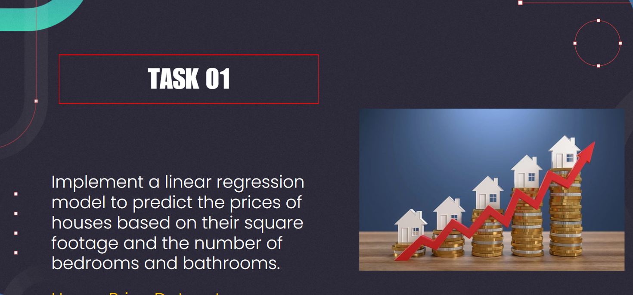

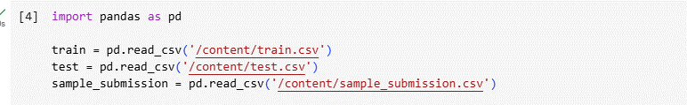

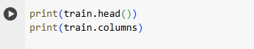

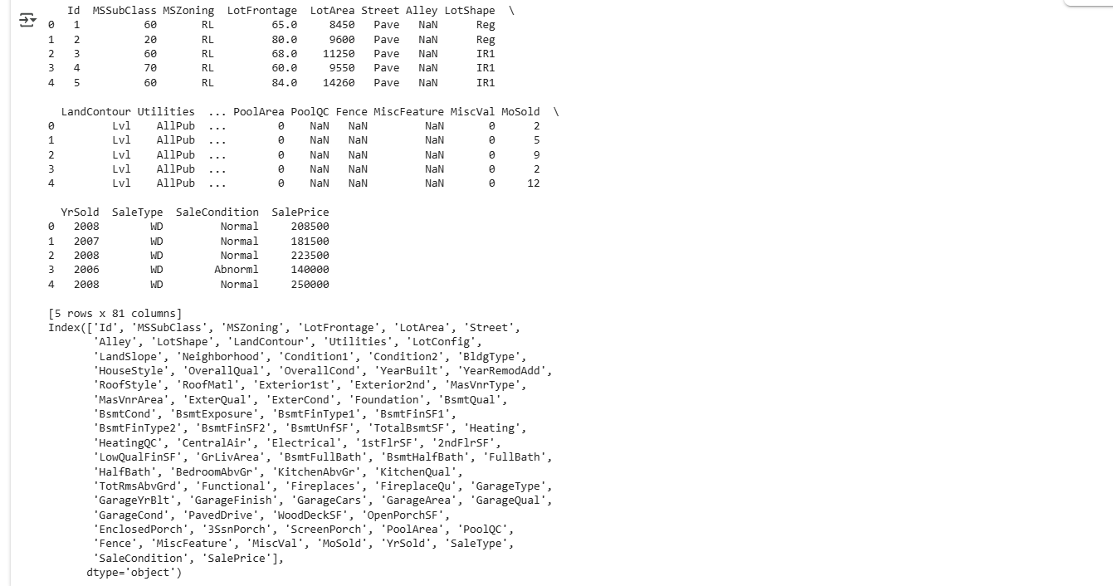

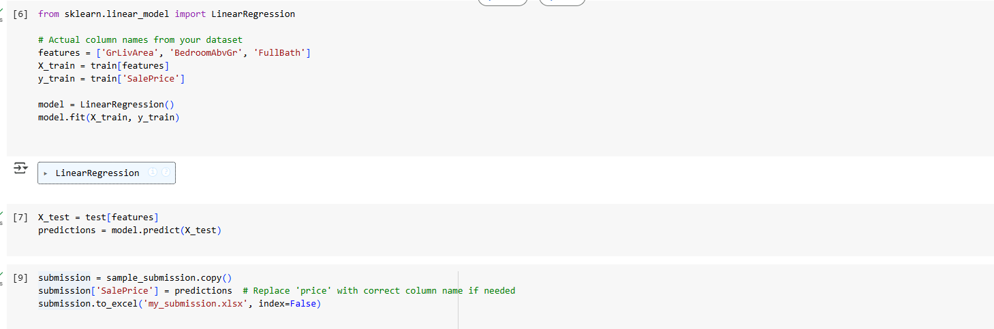

**Inference**

* A simple, interpretable linear model was used.
* Predictions are based on 3 meaningful numerical features.
* This basic model forms a solid starting point but can be improved by:
  + Including more predictive features (e.g., OverallQual, YearBuilt)
  + Handling missing values
  + Feature engineering (e.g., interaction terms)