**SAVEETHA SCHOOL OF ENGINEERING**

**SAVEETHA INSTITUTE OF MEDICAL AND TECHNICAL SCIENCES**

**INSTITUTE OF INFORMATION TECHNOLOGY**

**CSA1555 CLOUD COMPUTING AND BIG DATA ANALYTICS FOR EDUCATION**

1) Demonstrate virtualization by Installing Type-2 Hypervisor in your device, create and configure VM image with a Host Operating system (Either Windows/Linux).

STEP 1:

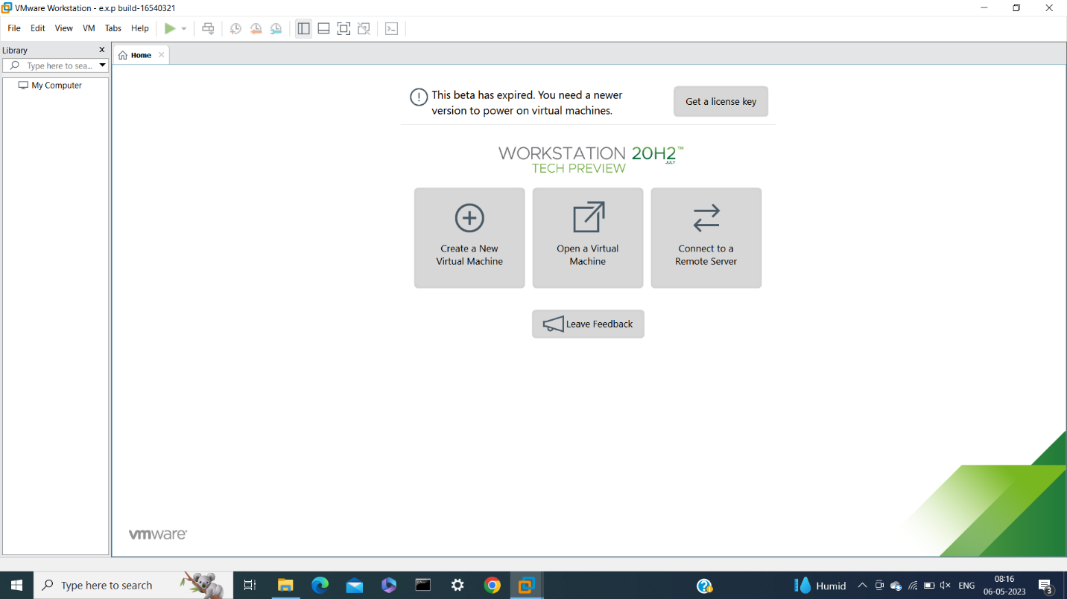

STEP 2:

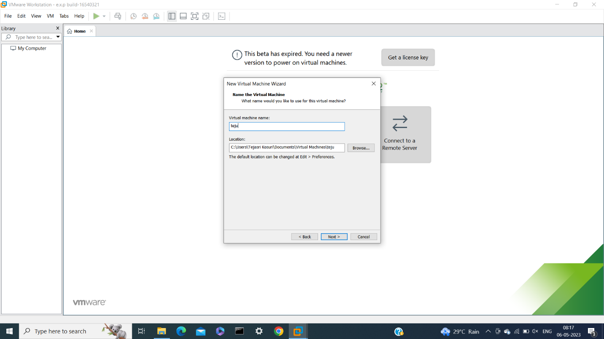

STEP 3:

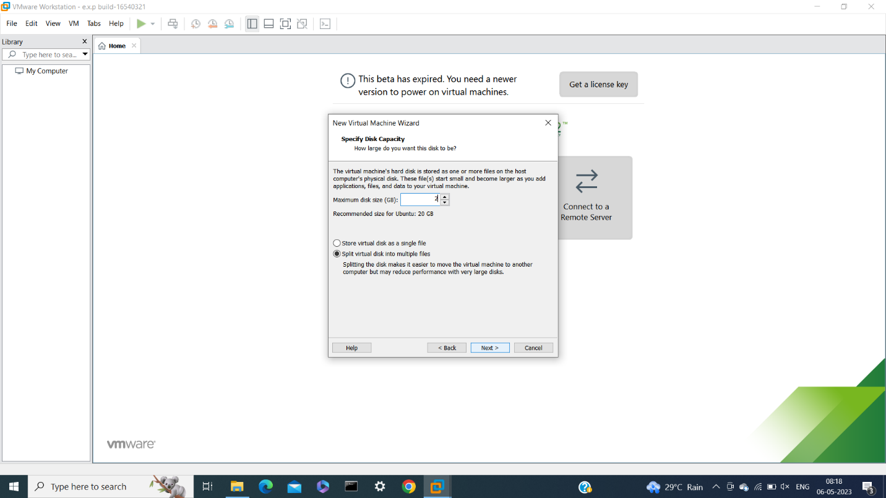

STEP 4:

