**SAVEETHA SCHOOL OF ENGINEERING**

**SAVEETHA INSTITUTE OF MEDICAL AND TECHNICAL SCIENCES**

**INSTITUTE OF INFORMATION TECHNOLOGY**

**CSA1555 CLOUD COMPUTING AND BIG DATA ANALYTICS FOR EDUCATION**

8.Create a Virtual Hard Disk and allocate the storage using VM ware Workstation.

STEP 1:

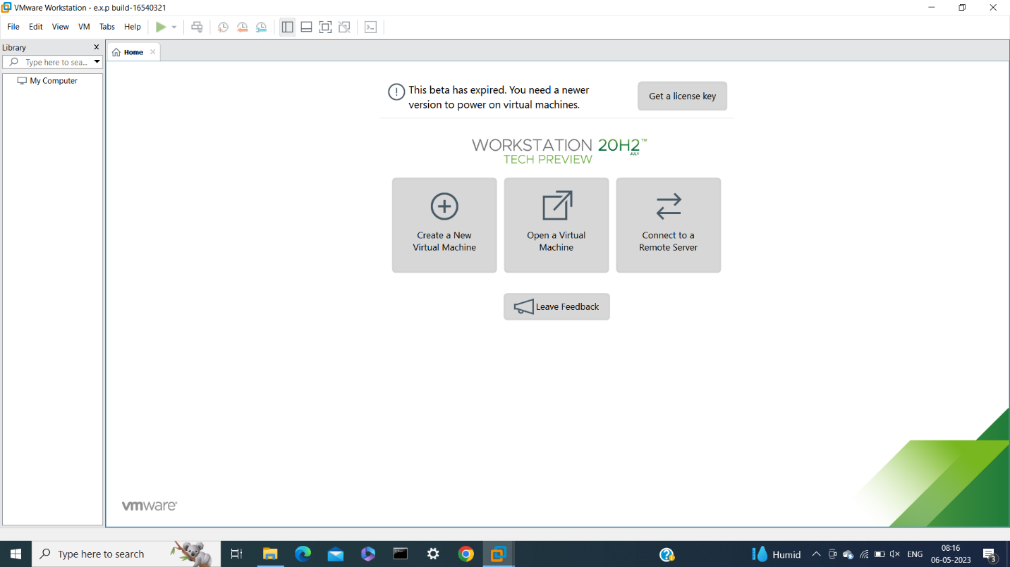

STEP 2:

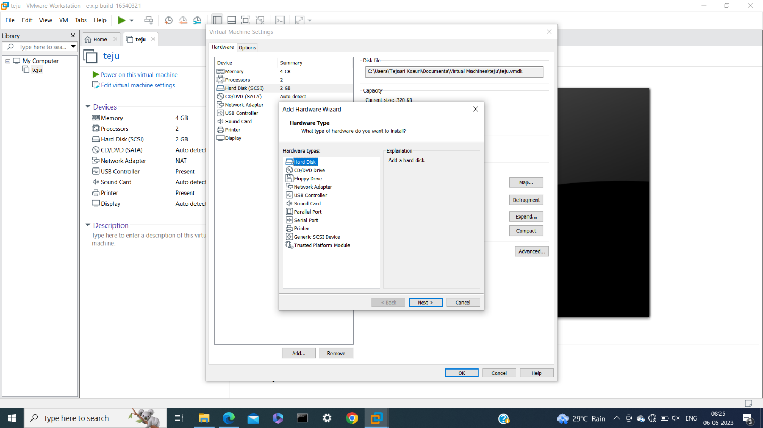

STEP 3:

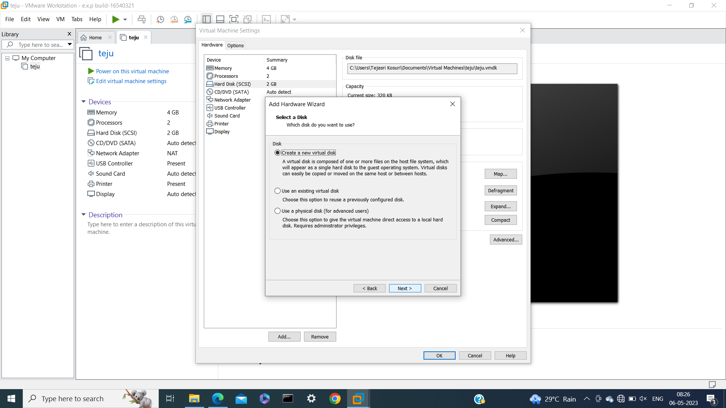

STEP 4:

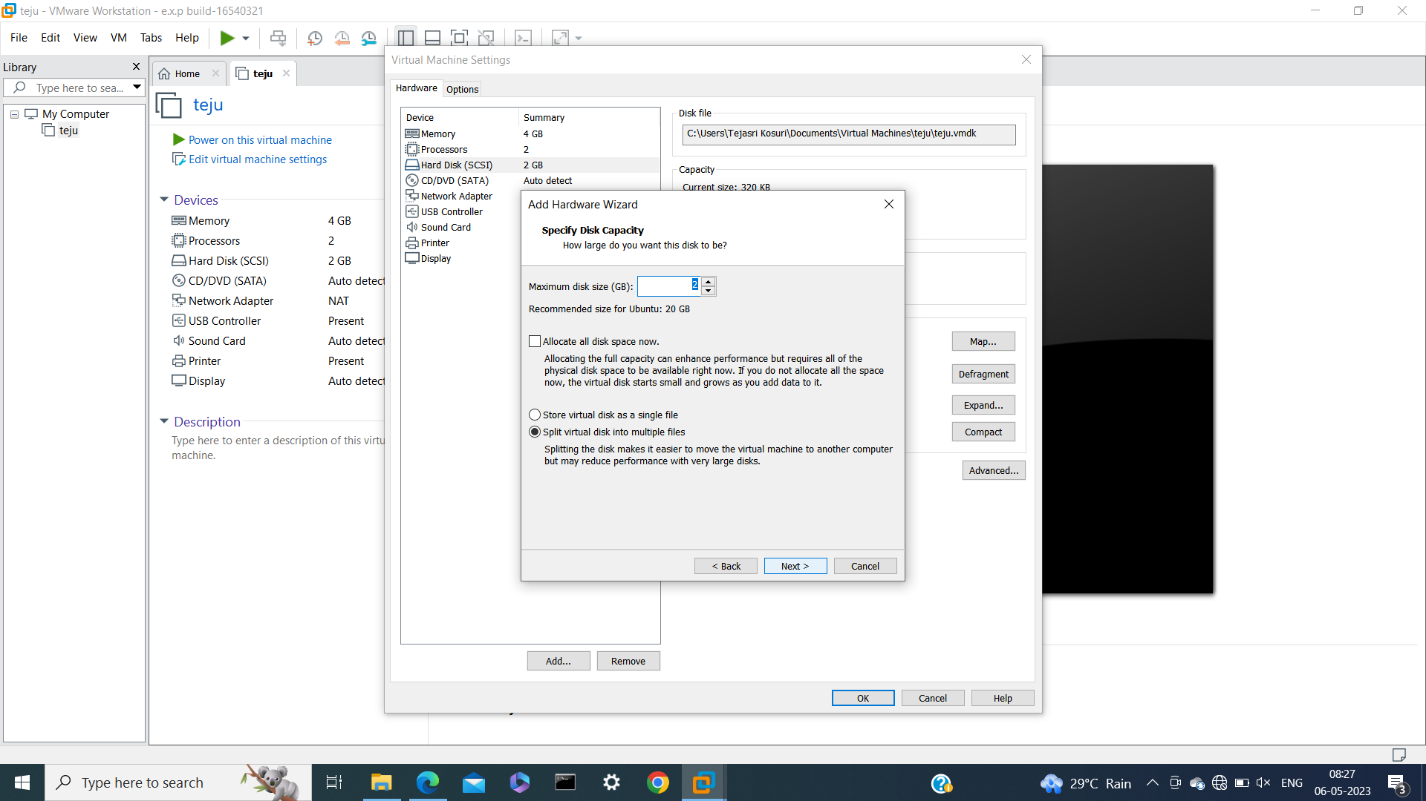

STEP 5:

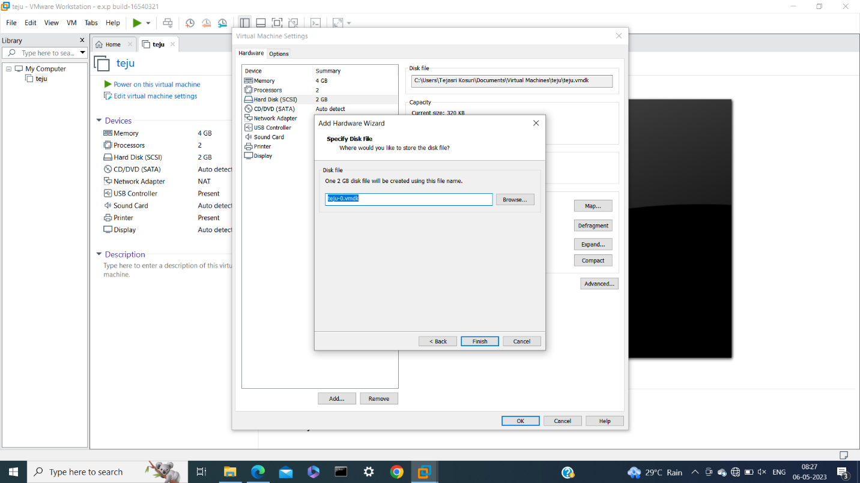

STEP 6:

