Environmental Controller Device

Architecture , Design , Protocol

TABLE OF CONTENTS

Document change history 4
1. Introduction 5
1.1. Purpose and Scope 5
1.2. Open Points 5
1.3. assumptions 5
1.4. Definitions, Acronyms & Abbreviations 5
1.5. References 5
2. TECHNICAL specifications 6
2.1. SYSTEM 6
3. Architecture 7
3.1. BOOTLOADER 7
3.1.1. STATIC VIEW 7
3.1.2. DYNAMIC VIEW 8
3.2. EC Application 9
3.2.1. STATIC VIEW 9
3.2.2. DYNAMIC VIEW 10
3.2.3. SCENARIOS 12
4. Protocol 19
4.1. CMD ACknowledgement 19
4.2. APP_MQTT_PROVISION_INFO 19
4.2.1. Set Request 20
4.2.2. Get Request 22
4.2.3. Erase User Provisioning Request 22
4.3. APP_MQTT_PROFILE_INFO 22
4.3.1. Set Request 22
4.3.2. ApplyRequest 26
4.3.3. Get Request 27
4.3.4. ModifyRequest 27
4.3.5. Erase Request 28
4.3.6. Erase Individual Profile Request 28
4.4. APP_MQTT_GROW_CYCLE_INFO 28
4.4.1. Start Request 29
4.4.2. Stop Request 29
4.5. APP_MQTT_STATUS_INFO 29
4.6. APP_MQTT_FAULT_INFO 31
4.7. APP_MQTT_DEVICE_REQUest 31
4.8. APP_MQTT_FW_UG_REQUEST 32
4.9. APP_MQTT_FW_UG_STATUS 32
Appendix A : - HW RESOURCES 33
Appendix B : - HW PIN ALLOTMENT 34
Appendix C : - MEMory layout 37

Document change history
Date Person Version Reason

21-08-2020 Venu Kosuri 0.1 Initial Release

19-10-2020 Venu Kosuri 0.2 Command protocol between APP & EC added

19-11-2020 Venu Kosuri 0.3 HW Resources added, see Appendix A

25-02-2021 Venu Kosuri 0.4 added Appendix B
added Appendix C
BOOT LOADER architecture details
EC Application architecture details
Scenarios details
19-03-2021 Venu Kosuri 0.5 updated protocol as per new configuration parameter

18-04-2021 Venu Kosuri 0.6 updated protocol as per new json fields of device info , enum value of commands as per code

03-05-2021 Venu Kosuri 0.7 added SMTP info for email functionality, MQTT command acknowledge added.

03-05-2021 Venu Kosuri 0.8 added CO2 protocol params

14-09-2021 Venu Kosuri 0.9 provisioning note added section 4.2.1 update

28-10-2021 Venu Kosuri 0.10 4.9.1.Appendix C update ,
4.9.1.Appendix B update 4.2.1 update for JSON element “time_zone”:
Section 3 update
25-03-2022 Linta 0.11 4.2.3 added (erase provisioning)
4.3.6 added (erase particular profile)
4.2 updated to add new fields to wifi /mqtt to support WPA2, MQTT SSL

27-07-2023 Venu Kosuri 0.12 critical_temp_fault low_temp_state low_humidity_state low_co2_state high_temp_state high_humidity_state high_co2_state, modbus parameters added

Introduction

Purpose and Scope
This document mentions all details of architecture, design & protocol details of environmental controller system.

Open Points
- None

assumptions
- None

Definitions, Acronyms & Abbreviations
Definitions:

Component :- Software module having designated functionality

Acronyms:

Dir : - Directory

Firmware: - Software running EC Hardware

Mobile APP: - Mobile Application communicating with EC

Abbreviations:

EC :-Environmental Controller

HW : - Hardware

I/O :- Input /Output

SW : - Software

References
[EC_product_spec_Vx (Scott)] Specification Document

TECHNICAL specifications
This section describes high level specifications of the environmental controller system for quick reference. Pl see the document [ EC_product_spec_Vx] for detailed requirements .

SYSTEM
EC is environmental controlling device used in green house environments. The different crops required different environmental conditions such as temperature, humidity, light , fertilisation, and pesticide cycles to be maintained to give good yield. EC is programmable device to maintain such environmental conditions for different crops.

The environmental controller at the simplest consists of the 6 device outlet relays plus sensors to monitor temperature , humidity & Co2 .

The basic premise of the controller is a 24 hour recycling timer- The controller will operate according to light and dark cycle parameters in a 24 hour cycle, then start again on a new 24 hour cycle. One 'profile' consists of all the desired user parameters for operating the 6 device outlet relays plus sensors.

The following are top level requirements.

- EC controls six kinds of device outlets to control the environment parameters.
- EC communicates with a mobile application over the internet using wireless LAN technology. The green house is expected to have internet connectivity using the Wifi .
- For different crops there are different environmental profiles. These profile status & configurability is done by Mobile APP. Using this APP, the current status of profiles & their parameters can be read.

- During grow cycle these profiles can be configurable & applied to the grow cycle any time using the APP.

- EC is always powered using live power.

Architecture
EC Firmware is split into two independent entities running separately, loaded at different locations. Pl refer Appendix C for memory organisation.

- Boot Loader
- EC Application

In case of ESP32S2 HW platform, Boot loader component is provided by ESP32S2 SDK . Skip boot loader section 3.1.

BOOTLOADER
Boot Loader is the initial program that gets activated when EC is switched ON. The functionality of the boot loader is to take care of loading new controller application if needed and it releases the control to Controller Application. So it supports use case of firmware upgrade functional feature.

STATIC VIEW

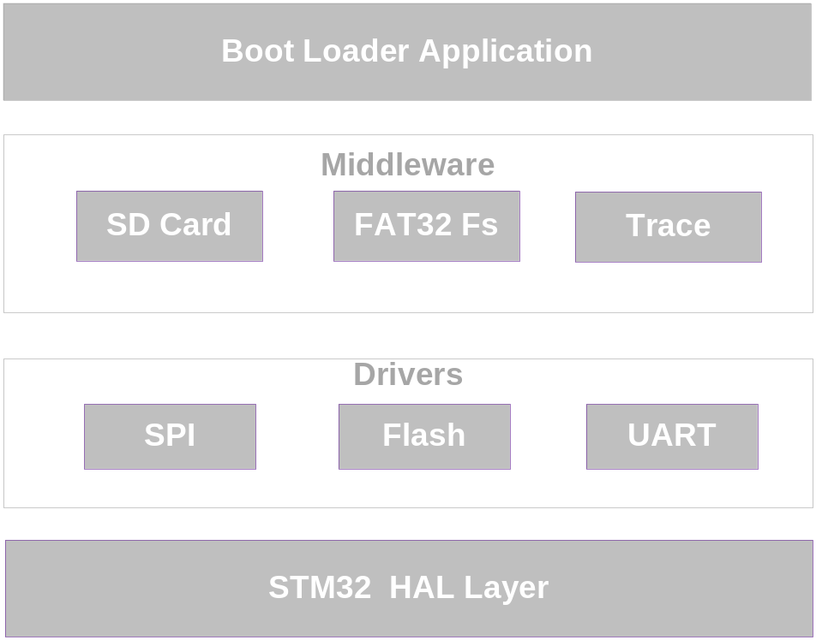

Figure 1

Boot Loader consists of the following components
- Boot Loader application
  - It checks the need for upgrading firmware & relinquishes the control to control application
- SD card
  - It consists of functionality of reading /writing at file /directory level to/from SD card
- FAT32 File System
  - It is FAT32 file system used to access SD card
  - It is open source code module i.e fat_io_lib
- Trace module
  - It has frame work for debug prints , print levels such as DBG , INFO WARN , ERROR etc.. can be controlled
- SPI driver
  - It is to access SD card physically
- FLASH driver
  - It is to access ARM Program Flash for read /write/erase
- UART driver
  - Debug Prints are sent over UART interface
- STM32 HAL Layer
  - Start up code
  - HAL layer to access HW registers , ISRs , drivers
  - Std C libraries

DYNAMIC VIEW
Boot Loader doesn’t have any RTOS or specific scheduler as it implements only one dedicated feature i.e. firmware upgrade. The boot loader works as per the given flow chart. Pl note Boot loader check whether there is EC Application binary present or not in SD card. If it is present, it copies EC application from SD card to program FLASH

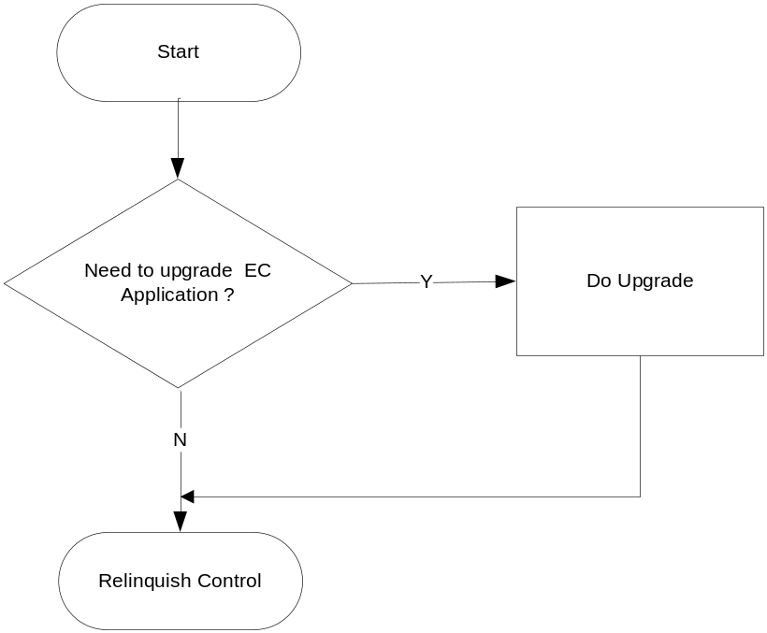
Figure 2

EC Application
This is the actual application implementing all functionality

STATIC VIEW

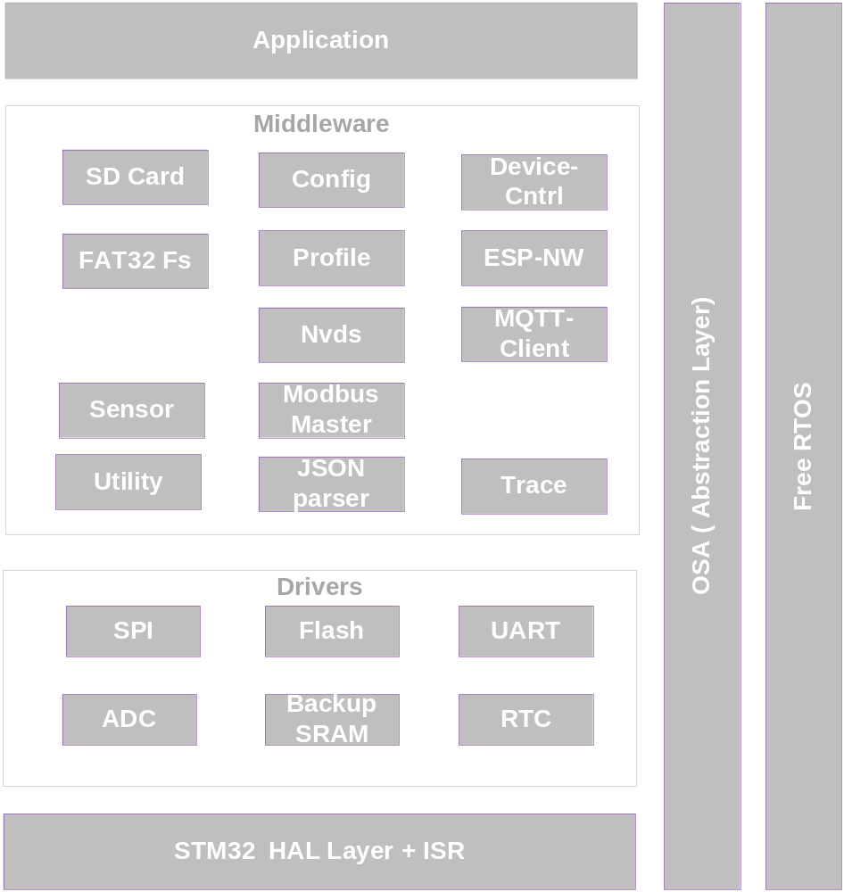

Figure 3

EC Application consists of the following components
- Application
  - It is main control application
- SD card
  - It consists of functionality of reading /writing at file /directory level to/from SD card
- FAT32 File System
  - It is FAT32 file system used to access SD card
  - It is open source code module i.e fat_io_lib
- Trace module
  - It has frame work for debug prints , print levels such as DBG , INFO WARN , ERROR etc.. can be controlled
- Device Cntrl
  - This module takes care of functionality of all device outlets as per device operation states.
- ESP NW
  - It takes care of communication functionality with ESP module to send /receive over Wifi in case of STM32 platform
  - In case of ESP32S2 , it used WIFI API provided by ESP32S2 SDK
- MQTT client
  - MQTT client responsible for MQTT protocol with remote server
  - It uses Paho MQTT open source code in case of STM32 platform .
  - It uses ESP32S2 SDK provided MQTT client
- Modbus Master
  - Implements modbus master protocol
- Sensor
  - To get sensor values such as temp, humidity , Co2 etc ...
- Config + Profile + Nvds
  - To set/get/ user/factory configuration profiles as well as device provisioning details
- FreeRTOS + OSA
  - All FreeRTOS Kernel
  - OSA abstracts all freeRTOS calls.
- SPI driver
  - It is to access SD card physically
- FLASH driver
  - It is to access ARM Program Flash for read /write/erase
- UART driver
  - Debug Prints are sent over UART interface. It is available in STM32 HW only.
- ADC driver
  - To check the Battery voltage
- RTC driver
  - To implement real time clock functionality .
- Backup Sram
  - To read/write to Back up SRAM
- STM32 HAL Layer + ISR( this component is present only on STM32 platform )
  - Start up code
  - HAL layer to access HW registers ,drivers
  - Std C libraries
- ESP32S2 libs ( ESP32S2 provided libraries . )

DYNAMIC VIEW
EC Application uses freeRTOS Kernel along STM32 HAL layer plus HAL ISR frame work. The Application is set up into set of Tasks (or Threads). The following are the tasks in the descending order of priorities.

- Free RTOS Timer Task
- ESP Rx Task . On ESP32S2 platform , This task is Wifi Task provided by SDK.
- MQTT Task ( MQTT client communicator with MQTT server using ESP ). On ESP32S2 platform , This task is MQTT Connection task provided by SDK.
- Application task ( Control Application task )

Free RTOS Timer Task

This is highest priority task implemented by FreeRTOS kernel. This is responsible for all timing events concerned with periodic /a periodic timers. All times are SW timers; no specific HW timers are used. At the expiry of respective SW timer, the call back is executed. The call back function is registered at the time of creating the timer.

ESP Rx Task

This takes care of communication with ESP wifi module. It process all the messages received from ESP wifi module over UART interface. This is also highest priority task.

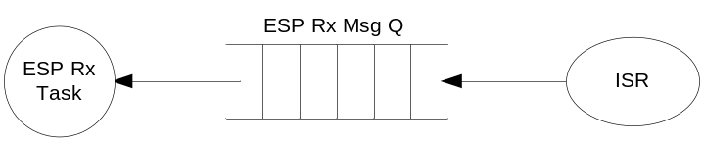
Figure 4

For ESP32S2 ignore the above description. It runs as art of wifi task provided by SDK . It takes care of functionality as Library calls of SDK.

MQTT Task

This takes care of establishing connection & communication with MQTT server.. It processes all the MQTT messages received.

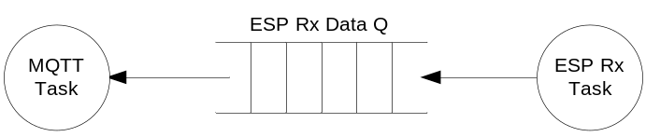
Figure 5

For ESP32S2 ignore the above description. It runs as art of MQTT task provided by SDK . It takes care of functionality as Library calls of SDK.

ApplicationTask

This takes care of functionality of EC i.e. grow cycle start/stop, provisioning, user profile configuration, device outlet control, fault detection & firmware upgrade. This is the lowest priority task.

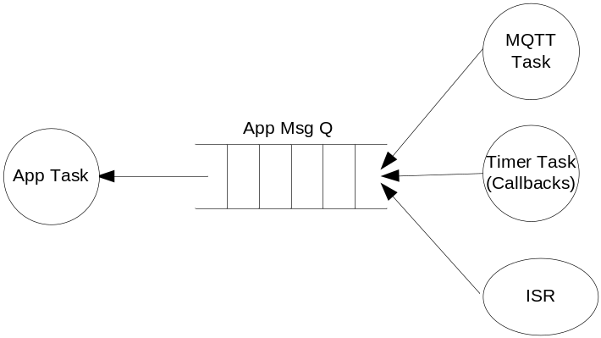
Figure 6

SCENARIOS
This section depicts the scenarios of EC Application. For ESP32S2 platform, In all scenarios ESP ISR is part of ESP WIFI SDK . It is shown explicitly just to ease the understanding.

EC Initialization
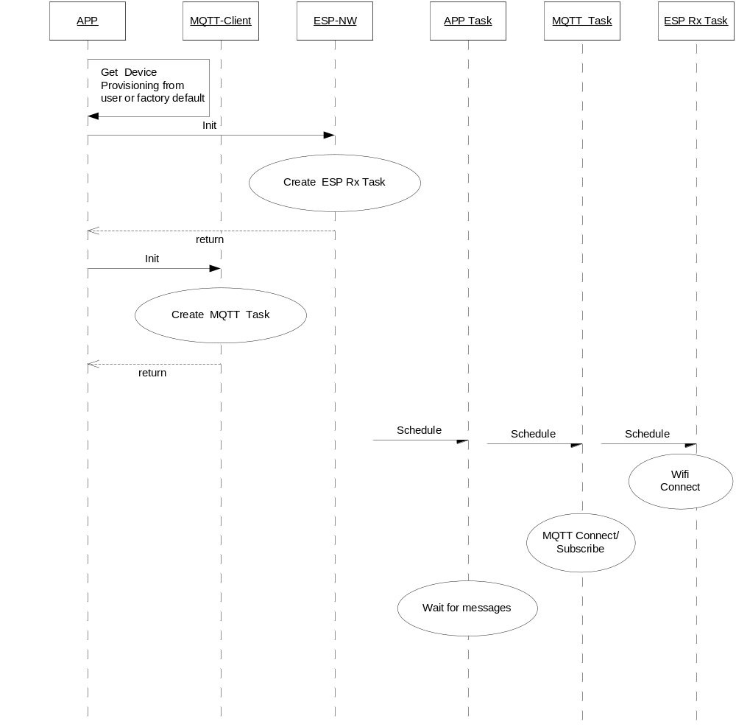

Figure 7

Grow Cycle Start

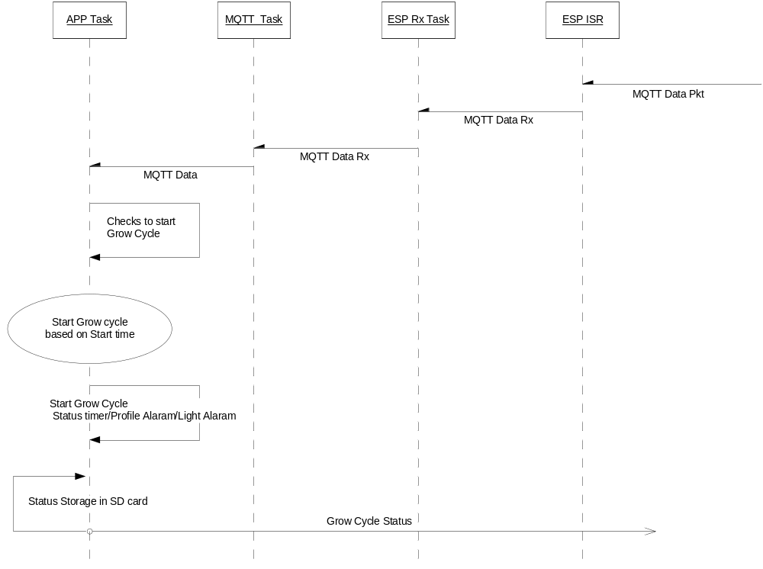
Figure 8

Grow Cycle Stop
Grow cycle stop can happen two ways either from user initiated action or designated number of days of grow cycle expired. Both cases are shown .

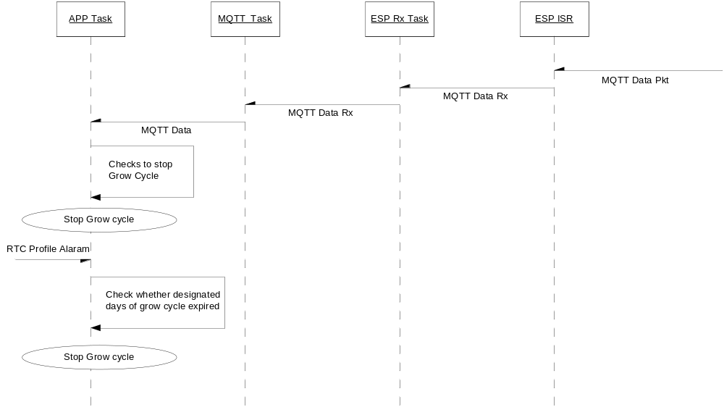
Figure 9

EC Set Provisioning

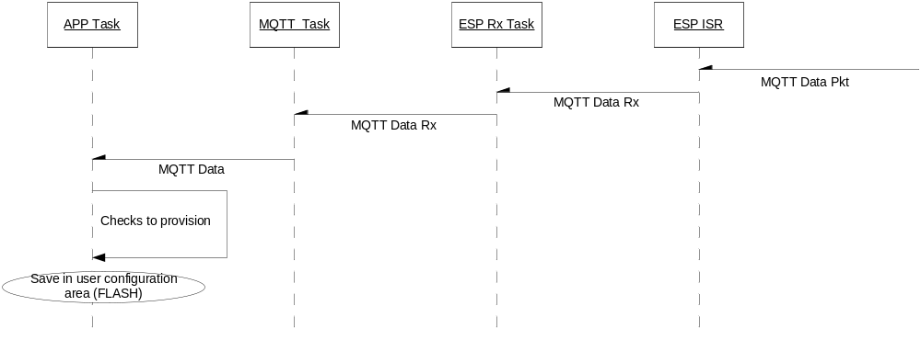
Figure 10

EC Get Provisioning

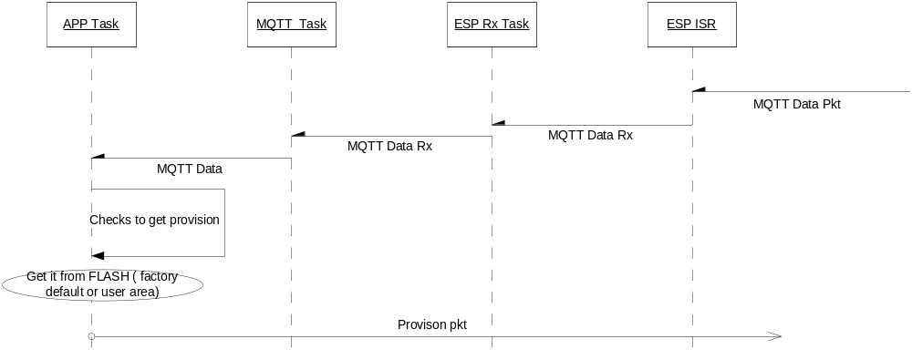
Figure 11

Profile Configuration (SET or APPLY)
Configuring user profile is possible either in grow cycle or non grow cycle. In grow cycle the profile configuration can be applied too. All these possible cases are shown in the diagram.

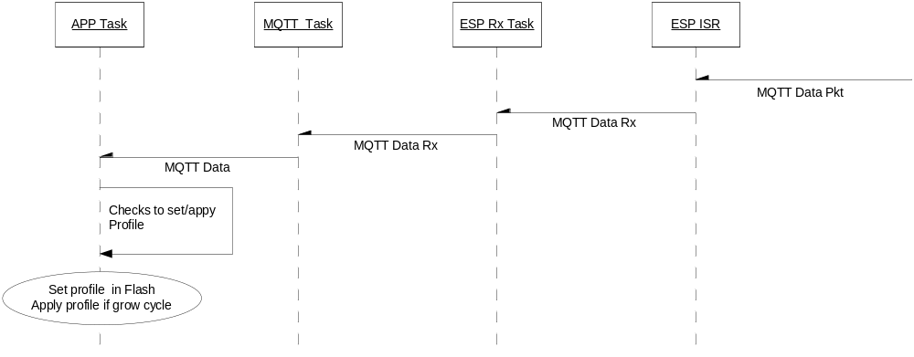
Figure 12

Get Profile

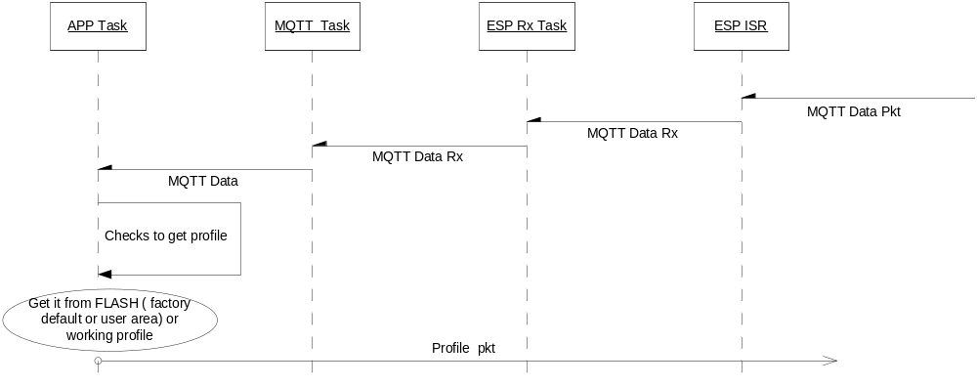
Figure 13

Faults

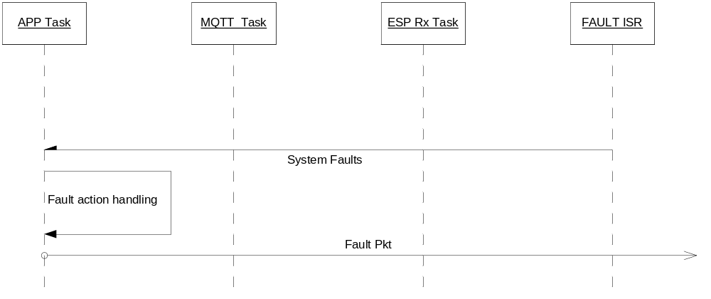
Figure 14

Firmware Upgrade

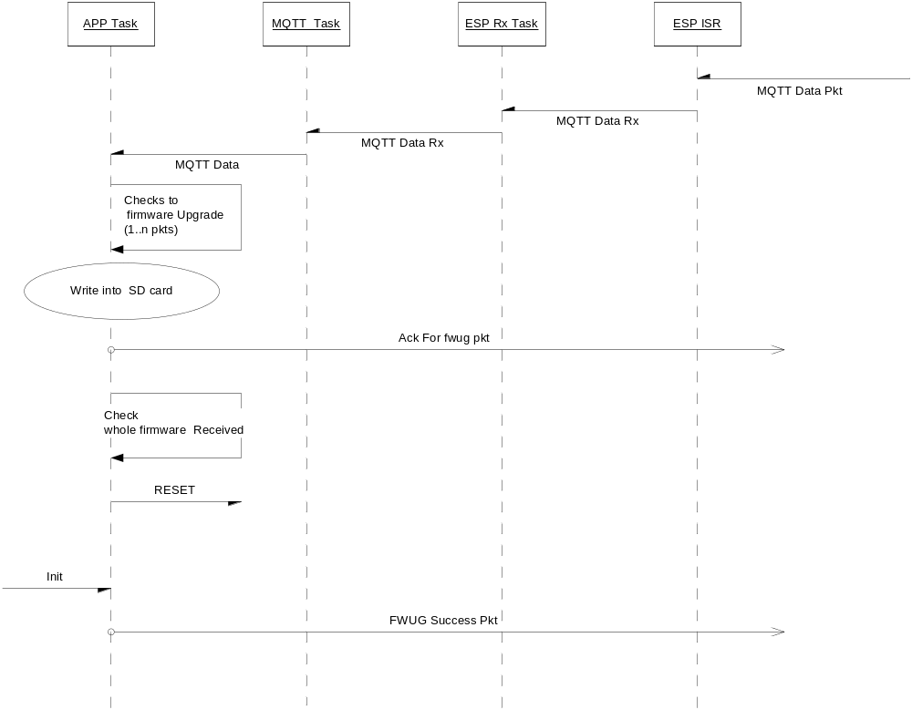
Figure 15

Protocol
This section describes the communication protocol between the mobile APP & EC. As EC is accessible from anywhere using the mobile APP, MQTT protocol is used between mobile APP & EC using third party MQTT Broker ( server ) running on the cloud server.

As per MQTT protocol the communication is established using EC device id & Mobile APP id. These Ids are configured at the time of deployment. These ids help multiple ECs talking to multiple APPs using one cloud server (multiple number of green houses supported)

EC Identification:-

For each EC is identified using the following fields
device_name
device_id
farm_name
greenhouse_id
mobile_app_id

The following commands are exchanged between EC & Mobile Application

typedef enum APP_MQTT_CMD_TYPE
{
APP_MQTT_PROVISION_INFO = 0,
APP_MQTT_PROFILE_INFO,
APP_MQTT_GROW_CYCLE_INFO,
APP_MQTT_STATUS_INFO,
APP_MQTT_FAULT_INFO,
APP_MQTT_DEVICE_REQUEST,
APP_MQTT_FW_UG_REQUEST,
APP_MQTT_FW_UG_STATUS

}APP_MQTT_CMD_TYPE;

All Commands are exchanged as JSON format. The Boolean values takes 1 for true , 0 for false .

Each command reception is acknowledged by EC using following frame format.

CMD ACknowledgement

{"type":"mqtt","device_name":, device_id="", "farm_name"="", "greenhouse_id"="","mobile_app_id"="","ver":"","flag":0,"ack":{"cmd":}}

APP_MQTT_PROVISION_INFO
Purpose:- It is used to set or get the general configuration . If it is set request, the command is given by mobile APP & processed by EC. If it is get request, the command is issued as request with no fields present to EC , EC will respond as response with all the fields .

Set Request

Whenever provisioning is set, EC will get reset immediately to apply the latest provisioning parameters. It is not advised to do provisioning when there is grow cycle is in progress. Whenever it is required to change during grow cycle, stop the grow cycle, apply provisioning & restart the grow cycle.

{"type":"mqtt","device_name":, device_id="", "farm_name"="", "greenhouse_id"="","mobile_app_id"="","ver":"","flag":0,"req":{"cmd":APP_MQTT_GENERAL_INFO,","fields":
[{"action":"set”},
{"wifi_info":{},},
{"mqtt_info":{},},
{"device_info":{},},
{"grow_info":{},},
{"smtp_info":{},},
]}}

The Respective JSON elements :-

Wifi_info
{
"ssid":””,
"passphrase":””
“time_zone”: (-11 to 13) for STM32 board
OR
“time_zone”: "UTC-05:30” for ESP32S2 board, std UTC string format
“wifi_security”:(0:PSK, 1:PEAP, 2:TLS, 3:TTLS),
"eap_identity":””,
"username":””,
"password":””,
"key_password":””,
"ca_cert":””,
"client_cert":””,
"key_cert":””
}
Note:- All the fields may not be present . For e.g. in case of PSK, APP will send ssid, passphrase, in case of PEAP, APP will send ssid, eap_identity, username, password, in case of TLS, APP will send ssid, key_password, ca_cert, client_cert, key_cert, in case of TTLS, APP will send ssid, eap_identity, username, password.

mqtt_info
{
"hostname":””,
"portno":””,
“mqtt_security”:(0:NO_SECURITY, 1:SSL),
"username":””,
"password":””,
"mqtt_ca_cert":””,
"mqtt_client_cert":””,
"mqtt_key_cert":””,
"topic":””,
"qos_type":(0:QOS0,1:QOS1 or 2:QOS2 )
}
Note:- All the fields may not be present . For e.g. in case of NO_SECURITY, APP will send username, password, in case of SSL, APP will send mqtt_ca_cert, mqtt_client_cert, mqtt_key_cert.

device_info
{
"dev_name":””,
"dev_id":,
"fname":””,
"ghouse_id":,
"app_id":
“ver_info”:
“controller_type”:

}

Here “ver_info” is EC firmware version number . This can only be read, not set by mobile APP .

grow_info
{
“measure_unit”: (0:ENGLISH , 1:METRIC)
“clk”: (0:12HR, 1:24HR)
“language”: (0:ENGLISH ,1: KOREAN,2:JAPANESE,3:CHINESE,4:GERMAN,5: OTHERS)
" rpt_lo_tmp":1,"lo_tmp_chk_val":18,
"rpt_hi_tmp":1,"hi_tmp_chk_val":40, “rpt_critical_tmp”:1,”critical_tmp_chk_val”:35,
"rpt_lo_hmdy":1,"lo_hmdy_chk_val":50,
"rpt_hi_hmdy":1,"hi_hmdy_chk_val":80,

"rpt_lo_co2":1,"low_co2_chk_val":800,
"rpt_hi_co2":1,"hi_co2_chk_val":1500,

"rpt_battery_flt":1,
"rpt_frequency_flt":1,
"rpt_emr_fuse_flt":1,
"rpt_sensor_flt":1,
"rpt_rs485_fuse_flt":1,
"light_restrike_tmr ":1,
"light_restrike_dur":"HH:MM:SS"
"dev_hoodvent_nt_finish_delay": "HH:MM:SS",
“battery_voltage”: ,
“batttery_trig_voltage”: ,
“battery_hyst_voltage”: ,
“co2_pva_vent_delay_time”:
“sensor_height”:
}

smtp_info
{
"email_address":””,
"email_password":””,
"smtp_host_name":””,
"smtp_port":,
"smtp_security": 1/0
“to_addresses”:””,
“cc_addresses”:””,
“signature”:””
}

Get Request

{"type":"mqtt","device_name":, device_id="", "farm_name"="", "greenhouse_id"="","mobile_app_id"="","ver":"","flag":0,"req":{"cmd":APP_MQTT_GENERAL_INFO,","fields":
[{"action":"get”,”user_profile”:1/0}
]}}

Get Response ( sent by EC )

{"type":"mqtt","device_name":, device_id="", "farm_name"="", "greenhouse_id"="","mobile_app_id"="","ver":"","flag":0,"res":{"cmd":APP_MQTT_GENERAL_INFO,"fields":
[{"action":"get"},
{"wifi_info":{},},
{"mqtt_info":{},},
{"device_info":{},},
{"grow_info":{},},
{"smtp_info":{},},
]}}

Erase User Provisioning Request

{"type":"mqtt","device_name":, device_id="", "farm_name"="", "greenhouse_id"="","mobile_app_id"="","ver":"","flag":0,"req":{"cmd":APP_MQTT_PROVISION_INFO,","fields":
[{"action":"erase"} ]}}

This command is used to erase user provisioning information.

APP_MQTT_PROFILE_INFO
Purpose:- It is used to set or get the profile configuration . When it is set, the command is given by mobile APP & processed by EC. When it is get, the command is issued as request with no fields present to EC, EC will respond as response with all the fields.

Set Request

{"type":"mqtt","device_name":, device_id="", "farm_name"="", "greenhouse_id"="","mobile_app_id"="","ver":"","flag":0,"req":{"cmd":APP_MQTT_PROFILE_INFO,","fields":
[{"action":"set","profile_no":,”user_profile”:1/0,"to_save":1/0,”apply_now”:1/0,"apply_date":”DD:MM:YYYY”,"apply_time":”HH:MM:SS”}, {"dev_light":{},}, {"dev_hood_vent":{},}, {"dev_circ":{},}, {"dev_vent":{},}, {"dev_fxp1":{}, {"dev_fxp2":{}
]}}

This command is used either to store the profile, store & apply (immediately or later date/time ) or apply without saving the profile in flash . This command can be used before grow cycle to save the profile. It also can be used during the grow cycle to apply dynamic profile changes with (out) saving .

”profile_no” ranges from (1...20).

If APP does not give ”apply_now”, “apply_date” & “apply_time” fields , it is considered not to apply profile .

If APP does not give “apply_date”, it takes same day & apply grow cycle based on the starting time.

If APP does not give “apply_time”, it takes current time & applies grow cycle.

If APP does not give “to_save”, APP will have the profile as local RAM copy. In the event of power shut down, this profile will not be saved. It is always advised to save the profile (user recommendation).

The Respective JSON elements :-

dev_light
{
"state":2(0:suspended 1:forced 2:usual),
"light_cycle":2(0:Always on 1:Always off 2:Normal)
"light_on_time":"HH:MM:SS"
"light_off_time":"HH:MM:SS"
}

dev_hood_vent
{
"state":2(0:suspended 1:forced 2:usual),
"op_mode":0(0:Native 1:Follow 2:Flip 3:Flexi ),
"flexi_mode":0 (0:rpttimer mode 1:Heater 2:Cooler 3:humidifier
4:dehumidifier 5:CO2 6:Leak Mode),
"follow_dev":0(0:light 2:circ 3:vent 4:fxp1
5:fxp2),
“nt_mode_lc":1,
"lc_rpt_tmr_start_delay" :"HH:MM:SS",
"lc_rpt_tmr_on_time" : "HH:MM:SS",
"lc_rpt_tmr_off_time" :" HH:MM:SS ",
"dc_rpt_tmr_start_delay" :"HH:MM:SS",
"dc_rpt_tmr_on_time" :"HH:MM:SS",
"dc_rpt_tmr_off_time" :"HH:MM:SS",
"lc_tmp_up_val":,
"lc_tmp_lo_val":,
"lc_hmdy_up_val":,
"lc_hmdy_lo_val":,
"co2_gen_on_val":,
"co2_gen_off_val":,
"co2_cyl_set_val":,
"co2_source": 0/1,(0: cylinder, 1: generator)
"dc_tmp_up_val":,
"dc_tmp_lo_val":,
"dc_hmdy_up_val":,
"dc_hmdy_lo_val":
"lc_on":,
"dc_on":,
"vent_lockout":

}

Note:- All the fields may not be present . For e.g. in case of heater mode, APP need not send any humidity threshold values. CO2 mode need to be added

dev_circ
{
"state":2(0:suspended 1:forced 2:usual),
"op_mode":0(0:Native 1:Follow 2:Flip 3:Flexi ),
"flexi_mode":0 (0:rpttimer mode 1:Heater 2:Cooler 3:humidifier
4:dehumidifier 5:CO2 6:Leak Mode),
"follow_dev":0(0:light 1:hood vent 3:vent 4:fxp1
5:fxp2),
"nt_mode_lc":1,
"nt_mode_dc_":1,
"nt_lc_start_delay": "HH:MM:SS",
"nt_dc_start_delay": "HH:MM:SS",
"lc_rpt_tmr_start_delay" :"HH:MM:SS",
"lc_rpt_tmr_on_time" : "HH:MM:SS",
"lc_rpt_tmr_off_time" :" HH:MM:SS ",
"dc_rpt_tmr_start_delay" :"HH:MM:SS",
"dc_rpt_tmr_on_time" :"HH:MM:SS",
"dc_rpt_tmr_off_time" :"HH:MM:SS",
"lc_tmp_up_val":,
"lc_tmp_lo_val":,
"lc_hmdy_up_val":,
"lc_hmdy_lo_val":,
"co2_gen_on_val":,
"co2_gen_off_val":,
"co2_cyl_set_val":,
"co2_source": 0/1,(0: cylinder, 1: generator)
"dc_tmp_up_val":,
"dc_tmp_lo_val":,
"dc_hmdy_up_val":,
"dc_hmdy_lo_val":
"lc_on":,
"dc_on":,
"vent_lockout":

}

Note:- All the fields may not be present, for eg in case of heater mode , APP need not send any humidity threshold values

dev_vent
{
"state":2(0:suspended 1:forced 2:usual),
"lc_rpt_tmr":,
"lc_rpt_start_delay" :"HH:MM:SS",
"lc_rpt_on_time" :"HH:MM:SS",
"lc_rpt_off_time" :"HH:MM:SS",
"lc_chk_tmp":,
"lc_tmp_on_val":,
"lc_tmp_off_val":,
"lc_chk_hmdy":,
"lc_hmdy_on_val":,
"lc_hmdy_off_val":,
"dc_rpt_tmr":,
"dc_rpt_start_delay" :"HH:MM:SS",
"dc_rpt_on_time" :"HH:MM:SS",
"dc_rpt_off_time" :"HH:MM:SS",
"dc_chk_tmp":,
"dc_tmp_on_val":,
"dc_tmp_off_val":,
"dc_chk_hmdy":,
"dc_hmdy_on_val":,
"dc_hmdy_off_val":
}
Note:- All the fileds may not be present . for eg in case of humiidty threshold check is not required , APP need not send any humidity threshold values

dev_fxp1
{
"state":2(0:suspended 1:forced 2:usual),
"op_mode":3( 1:Follow 2:Flip 3:Flexi ),
"flexi_mode":0 (0:rpttimer mode 1:Heater 2:Cooler 3:humidifier
4:dehumidifier 5:CO2 6:Leak Mode),
"follow_dev":0(0:light 1:hood vent 2:circ 3:vent ),
"lc_rpt_tmr_start_delay" :"HH:MM:SS",
"lc_rpt_tmr_on_time" : "HH:MM:SS",
"lc_rpt_tmr_off_time" :" HH:MM:SS ",
"dc_rpt_tmr_start_delay" :"HH:MM:SS",
"dc_rpt_tmr_on_time" :"HH:MM:SS",
"dc_rpt_tmr_off_time" :"HH:MM:SS",
"lc_tmp_up_val":,
"lc_tmp_lo_val":,
"lc_hmdy_up_val":,
"lc_hmdy_lo_val":,
"co2_gen_on_val":,
"co2_gen_off_val":,
"co2_cyl_set_val":,
"co2_source": 0/1,(0: cylinder, 1: generator)
"dc_tmp_up_val":,
"dc_tmp_lo_val":,
"dc_hmdy_up_val":,
"dc_hmdy_lo_val":
"lc_on":,
"dc_on":,
"vent_lockout":

}

Note: - no Native mode is there. It does not follow Fxp2 also. All the fields may not be present. For eg in case of heater mode, APP need not send any humidity threshold values.

dev_fxp2
{
"state":2(0:suspended 1:forced 2:usual),
"op_mode":3( 1:Follow 2:Flip 3:Flexi ),
"flexi_mode":0 (0:rpttimer mode 1:Heater 2:Cooler 3:humidifier
4:dehumidifier 5:CO2 6:Leak Mode),
"follow_dev":0(0:light 1:hood vent 2:circ 3:vent ),
"lc_rpt_tmr_start_delay" :"HH:MM:SS",
"lc_rpt_tmr_on_time" : "HH:MM:SS",
"lc_rpt_tmr_off_time" :" HH:MM:SS ",
"dc_rpt_tmr_start_delay" :"HH:MM:SS",
"dc_rpt_tmr_on_time" :"HH:MM:SS",
"dc_rpt_tmr_off_time" :"HH:MM:SS",
"lc_tmp_up_val":,
"lc_tmp_lo_val":,
"lc_hmdy_up_val":,
"lc_hmdy_lo_val":,
"co2_gen_on_val":,
"co2_gen_off_val":,
"co2_cyl_set_val":,
"co2_source": 0/1,(0: cylinder, 1: generator)
"dc_tmp_up_val":,
"dc_tmp_lo_val":,
"dc_hmdy_up_val":,
"dc_hmdy_lo_val":,
"dc_co2_up_val":,
"dc_co2_lo_val":
"lc_on":,
"dc_on":,
"vent_lockout":

}

Note: - no Native mode is there. It does not follow Fxp1 also. All the fields may not be present. For eg in case of heater mode, APP need not send any humidity threshold values.

ApplyRequest

{"type":"mqtt","device_name":, device_id="", "farm_name"="", "greenhouse_id"="","mobile_app_id"="","ver":"","flag":0,"req":{"cmd":APP_MQTT_PROFILE_INFO,","fields":
[{"action":"apply","profile_no":,”user_profile”:1/0,”apply_now”:1/0,"apply_date":”DD:MM:YYYY”,"apply_time":”HH:MM:SS”} ]}}

”profile_no” ranges from (1...20).

This command is used when user intends to use the stored profiles either from factory default or user defined profile set. The user might have configured this profile earlier & want to use. This command is used when the user intends to change the profile any time during the grow cycle period.

Get Request

{"type":"mqtt","device_name":, device_id="", "farm_name"="", "greenhouse_id"="","mobile_app_id"="","ver":"","flag":0,"req":{"cmd":APP_MQTT_PROFILE_INFO,","fields":
[{"action":"get","profile_no":,”is_user_profile”:1/0,”is_working_profile”:1/0}
]}}

”profile_no” ranges from (1...20).

If “user_profile”, the profile is taken from user configured profile list .

If “working_profile”, the profile is taken from the running profile . This is to address the case , user changed the configuration & but not intended to store it permanently in & wants to apply for the running cycle.

Get Response ( sent by EC )

{"type":"mqtt","device_name":, device_id="", "farm_name"="", "greenhouse_id"="","mobile_app_id"="","ver":"","flag":0,"res":{"cmd":APP_MQTT_PROFILE_INFO,","fields":
[{"action":"get","profile_no”:},
{"dev_light":{}},
{"dev_hood_vent":{}},
{"dev_circ":{}},
{"dev_vent":{}},
{"dev_fxp1":{}},
{"dev_fxp2":{}}
]}}

ModifyRequest

{"type":"mqtt","device_name":, device_id="", "farm_name"="", "greenhouse_id"="","mobile_app_id"="","ver":"","flag":0,"req":{"cmd":APP_MQTT_PROFILE_INFO,","fields":
[{"action":"modify","profile_no":,”user_profile”:1/0,"to_save":1/0,”apply_now”:1/0,"apply_date":”DD:MM:YYYY”,"apply_time":”HH:MM:SS”}, {"grow_info":{},}, {"dev_light":{},}, {"dev_hood_vent":{},}, {"dev_circ":{},}, {"dev_vent":{},}, {"dev_fxp1":{}, {"dev_fxp2":{}
]}}

”profile_no” ranges from (1...20).

This command is used when user intends to modify some parameters of the profile. The modified parameters can be stored or not based on the user choice. This profile can be either operational in the current grow cycle or just stored profile.

Modify Response ( sent by EC )

{"type":"mqtt","device_name":, device_id="", "farm_name"="", "greenhouse_id"="","mobile_app_id"="","ver":"","flag":0,"res":{"cmd":APP_MQTT_PROFILE_INFO,","fields":
[{"action":"modify","profile_no”:, ”user_profile”:1/0,"saved_ok”:1/0 }
]}}

Erase Request

{"type":"mqtt","device_name":, device_id="", "farm_name"="", "greenhouse_id"="","mobile_app_id"="","ver":"","flag":0,"req":{"cmd":APP_MQTT_PROFILE_INFO,","fields":
[{"action":"erase"} ]}}

This command is used to erase complete user configuration profiles. This includes erasing of provisioning information also. This is useful feature when the user wants to reconfigure EC with new settings.

Erase Individual Profile Request

{"type":"mqtt","device_name":, device_id="", "farm_name"="", "greenhouse_id"="","mobile_app_id"="","ver":"","flag":0,"req":{"cmd":APP_MQTT_PROFILE_INFO,","fields":
[{"action":"profile_erase","profile_no”:} ]}}

This command is used to erase individual user configuration profiles.

APP_MQTT_GROW_CYCLE_INFO
Purpose:- It is to start or stop the grow cycle. The command is given by mobile APP & processed by EC

Start Request

{"type":"mqtt","device_name":,device_id="","farm_name"="","greenhouse_id"="","mobile_app_id"="","ver":"1.0.0","flag":0,"req":{"cmd":APP_MQTT_GROW_CYCLE_INFO,"fields":[{"action":"start",”grow_name”:””, “status_priod”:, "profile_no":, “user_profile”:1/0,"start_date":”DD/MM/YYYY”,"start_time":”HH:MM:SS”, “total_days”: }]}}
”profile_no” ranges from (1...20).

If APP does not give “start_date” & “start_time” fields , it is considered to start the
grow cycle immediately .

If APP does not give “start_date”, it takes same day & apply grow cycle based on the starting time.

If APP does not give “start_time”, it takes current time & applies grow cycle.

Stop Request

{"type":"mqtt","device_name":,device_id="","farm_name"="","greenhouse_id"="","mobile_app_id"="","ver":"1.0.0","flag":0,"req":{"cmd":APP_MQTT_GROW_CYCLE_INFO,"fields":[{"action":"stop”}]}}

APP_MQTT_STATUS_INFO
Purpose:- It is used to send status information . The status is sent periodically with status period set by the grow cycle info.

{"type":"mqtt","device_name":,device_id="","farm_name"="","greenhouse_id"="","mobile_app_id"="","ver":"","flag":0,"res":{"cmd":APP_MQTT_STATUS_INFO,"fields":
[{"grow_info":{}},
{"light_cycle":{}},
{"dev_config":{}},
{"dev_status":{}},
{"dev_cnt":{}},
{"sensor_data":{}},
{"faults":{}}
]}}

The Respective JSON elements :-

grow_info
{
"grow_name":"",
“total_days”:,
“days_elapsed”: ,
"profile_no":,
“user_profile”:0(0:factory profile , 1 user profile)
“transit_profile_no” :0( 0:no transition , x:apply profile no )
"day_no":,
"week_no":,
"day_cur_week":,
"grow_time":"HH:MM:SS",
"rtc_time":"DD/MM/YYYY HH:MM:SS"
}

light_cycle
{
“cur_cycle”:0(0:dark 1:light),
"lc_duration":"HH:MM:SS",
"elapsed_lc_duration":"HH:MM:SS",
"pending_lc_duration":"HH:MM:SS",
"dc_duration":"HH:MM:SS",
"elapsed_dc_duration":"HH:MM:SS",
"pending_dc_duration":"HH:MM:SS",
}

dev_config
{
"light_cfg": (0:suspended 1:forced 2:usual),
"hood_vent_cfg":,
"circ_cfg":,
"vent_cfg”:,
"fxp1_cfg:,
"fxp2_cfg”:
}

dev_status
{
"light_on": (1:On, 0:Off ),
"hood_vent_on":,
"circ_on": ,
"vent_on": ,
"fxp1_on": ,
"fxp2_on":
}

dev_cnt
{
"light_cnt":
"hood_vent_cnt":,
"circ_cnt": ,
"vent_cnt": ,
"fxp1_cnt": ,
"fxp2_cnt":
}

sensor_data
{
"cur_temp":,
"cur_humidity":,
"cur_co2":,
"max_temp":,
"max_humidity":,
"max_co2":,
"min_temp":,
"min_humidity":,
"min_co2":
“low_temp_state”: 1/0 TRUE/FALSE
“high_temp_state”:
“low_humidity_state”:
“high_humidity_state”:
“low_co2_state”:
“high_co2_state”:
}

faults
{
"backup_battery_fault":(1:Yes ,0:No),
“cur_battery_voltage”:
"ac_power_fault":,
"hot_restrike_fault":,
"emr_fuse_fault":,
"rs485_fuse_fault":,
"sensor_fault":
“critical_temp_fault”:
}

APP_MQTT_FAULT_INFO
Purpose:- It is used to send fault information . It is sent as & when fault occurs.

{"type":"mqtt","device_name":,device_id="","farm_name"="","greenhouse_id"="","mobile_app_id"="","ver":"","flag":0,"res":{"cmd":APP_MQTT_FAULT_INFO,"fields":
[ {"faults":{}}
]}}

faults
{
"backup_battery_fault":(1:Yes ,0:No),
"ac_power_fault":,
"hot_restrike_fault":,
"emr_fuse_f
ault":,
"rs485_fuse_fault":,
"sensor_fault":
“critical_temp_fault”:
}

APP_MQTT_DEVICE_REQUest
Purpose:- It is to suspend or forced or normal operation of the device outlet.

{"type":"mqtt","device_name":,device_id="","farm_name"="","greenhouse_id"="","mobile_app_id"="","ver":"1.0.0","flag":0,"req":{"cmd":APP_MQTT_DEVICE_REQUEST, fields":[{"action":"suspend/forced/normal",”dev[“light”,”hoodvent”,”circ”,”vent”,”fxp1”,”fxp2”]}]}}

If APP does give only devices that are to be affected, need not all devices be present. In case of all devices to be affected, all the devices will be present.

APP_MQTT_FW_UG_REQUEST
Purpose:- It is used to upgrade the firmware of EC . The command is given by mobile APP & processed by EC. This request contain series of packets with an acknowledge coming from EC

FW UG Pkt:-

{"type":"mqtt","device_name":,device_id="","farm_name"="","greenhouse_id"="","mobile_app_id"="","ver":"1.0.0","flag":0,"req":{"cmd":APP_MQTT_FW_UG_REQUEST,”fields":
[{“file_name”:””,"file_size":"", “seq_no“:, “chunk_size”:,”pkt_enc_len”:, “pkt”:} ]
}}

Here pkt is encoded in BASE64 format. The chunk size is taken as 512 bytes. The packet encoded length is BASE64 encoded length.

FW UG Pkt ACK :-

{"type":"mqtt","device_name":,device_id="","farm_name"="","greenhouse_id"="","mobile_app_id"="","ver":"1.0.0","flag":0,"res":{"cmd":APP_MQTT_FW_UG_REQUEST,”fields":[{“is_pkt_ok”:1/0, “seq_no“:}]}}

APP_MQTT_FW_UG_STATUS
Purpose:- It is used to send the status of firmware upgrade of EC . The command is given by by EC & processed by mobile APP.

FW UG Status Pkt:-
{"type":"mqtt","device_name":,device_id="","farm_name"="","greenhouse_id"="","mobile_app_id"="","ver":"1.0.0","flag":0,"res":{"cmd":APP_MQTT_FW_UG_REQUEST,”fields":[{“app_ver”:””, “grow_cycle_restored“:1/0}]}}

: - HW RESOURCES

This section details out all STM32 HW resources used by firmware. USART3 used for printf() on Nucleo board where as USART1 is used on actual HW.

Pin | HW Block | On Nucleo | On Real HW | SW Functionality
PA0 | UART4_TX | MODBUS_TX | MODBUS_TX | sensor MODBUS
PA1 | UART4_RX | MODBUS_RX | MODBUS_RX | sensor MODBUS
PA2 | USART2_TX | EXP32_TX | EXP32_TX | ESP32 interface
PA3 | USART2_RX | EXP32_RX | EXP32_RX | ESP32 interface
PA4 | SPI1_NSS | SPI CS | SPI CS | SD Card
PA5 | SP11_CSK | SPI Clk | SPI Clk | SD Card
PA6 | SP11_MISO | SPI MISO | SPI MISO | SD Card
PA7 | SP11_MOSI | SPI MOSI | SPI MOSI | SD Card
PA8 | GPIO_Output | ESP32 RESET | ESP32 RESET | ESP32 interface
PA9 | USART1_TX |  | DEBUG_PRINT_TX | Printf functionality
PA10 | USART1_RX |  | DEBUG_PRINT_RX | Printf functionality
PA11 | GPIO_EXTI11 | LEAK SENSOR | LEAK SENSOR | Leak mode
PA12 | GPIO_EXTI12 | PANIC KEY | PANIC KEY | Panic mode
PA13 | GPIO_EXTI13 | AC PWR FAULT | AC PWR FAULT
PA14 | GPIO_EXTI14 | EMR FUSE FAULT | EMR FUSE FAULT
PA15 | GPIO_EXTI15 | FUES - RS485 | FUES - RS485
PB0 | ADC1_IN8 | BATT VOLT A/D | BATT VOLT A/D | Back up Battery Measurement
PB1 | GPIO_Output | BATT TEST PULSE | BATT TEST PULSE | Back up Battery Measurement
PB2 | GPIO_Output | LIGHT RELAY | LIGHT RELAY
PB3 | GPIO_Output | HV RELAY | HV RELAY
PB4 | GPIO_Output | CIRC RELAY | CIRC RELAY
PB5 | GPIO_Output | VENT RELAY | VENT RELAY
PB6 | GPIO_Output | FXP1 RELAY | FXP1 RELAY
PB7 | GPIO_Output | FXP2 RELAY | FXP2 RELAY
PB8 | GPIO_Output | LIGHT LED | LIGHT LED
PB9 | GPIO_Output | HV LED | HV LED
PB10 | GPIO_EXTI10 | HOT RE-STRIKE | HOT RE-STRIKE
PB12 | GPIO_Output | CIRC LED | CIRC LED
PB13 | GPIO_Output | VENT LED | VENT LED
PB14 | GPIO_Output | FXP1 LED | FXP1 LED
PB15 | GPIO_Output | FXP2 LED | FXP2 LED
PC13 | GPIO_Output | ESP32_PROG | ESP32_PROG | ESP32 interface
PC14 | GPIO_Output | SENSOR LED | SENSOR LED
PD8 | USART3_TX | DEBUG_PRINT_TX |  | Printf functionality
PD9 | USART3_RX | DEBUG_PRINT_RX |  | Printf functionality

: - HW PIN ALLOTMENT
This section details out all pins on real hardware for STM32

Pin No | Name | Type | Functionality | Designated functionality
1 | VBAT | Power
2 | PC13 | I/O | GPIO_Output | ESP32_PROG
3 | PC14 | I/O | GPIO_Output | SENSOR LED
4 | PC15
5 | PH0
6 | PH1
7 | NRST | Reset
8 | VSSA
9 | VDDA
10 | PA0 |  | UART4_TX | MODBUS_TX
11 | PA1 |  | UART4_RX | MODBUS_RX
12 | PA2 |  | USART2_TX | EXP32_TX
13 | PA3 |  | USART2_RX | EXP32_RX
14 | PA4 |  | SPI1_NSS | SPI CS
15 | PA5 |  | SP11_CSK | SPI Clk
16 | PA6 |  | SP11_MISO | SPI MISO
17 | PA7 |  | SP11_MOSI | SPI MOSI
18 | PB0 |  | ADC1_IN8 | BATT VOLT A/D
19 | PB1 | I/O | GPIO_Output | BATT TEST PULSE
20 | PB2 | I/O | GPIO_Output | LIGHT RELAY
21 | PB10 | I/O | GPIO_EXTI10 | HOT RE-STRIKE
22 | VCAP
23 | VSS
24 | VDD
25 | PB12 | I/O | GPIO_Output | CIRC LED
26 | PB13 | I/O | GPIO_Output | VENT LED
27 | PB14 | I/O | GPIO_Output | FXP1 LED
28 | PB15 | I/O | GPIO_Output | FXP2 LED
29 | PA8 | I/O | GPIO_Output | ESP32_RESET
30 | PA9 |  | USART1_TX | DEBUG_PRINT_TX
31 | PA10 |  | USART1_RX | DEBUG_PRINT_RX
32 | PA11 |  | GPIO_EXTI11 | LEAK SENSOR
33 | PA12 |  | GPIO_EXTI12 | PANIC KEY
34 | PA13 |  | GPIO_EXTI13 | AC PWR FAULT
35 | VSS
36 | VDD
37 | PA14 |  | GPIO_EXTI14 | EMR FUSE FAULT
38 | PA15 |  | GPIO_EXTI15 | FUES - RS485
39 | PB3 | I/O | GPIO_Output | HV RELAY
40 | PB4 | I/O | GPIO_Output | CIRC RELAY
41 | PB5 | I/O | GPIO_Output | VENT RELAY
42 | PB6 | I/O | GPIO_Output | FXP1 RELAY
43 | PB7 | I/O | GPIO_Output | FXP2 RELAY
44 | BOOT0
45 | PB8 | I/O | GPIO_Output | LIGHT LED
46 | PB9 | I/O | GPIO_Output | HV LED
47 | VSS
48 | VDD

The given below are pins for ESP32S2 :-

Label | Pin | Type | FUNCTION
GND | 1, 2, 30, 42, 43, 46-65 |  | GND
3V3 | 3 |  | PWR
IO0 | 4 | I | BOOT_OPTION (GPIO0)
IO1 | 5 | A/D | BATTVOLT_A/D
IO2 | 6 | O | BATT_TEST_PULSE
IO3 | 7 | I | HOT_RE-STRIKE
IO4 | 8 | O | FXP2_RELAY
IO5 | 9 | O | FXP1_RELAY
IO6 | 10 | O | VENT_RELAY
IO7 | 11 | O | CIRC_RELAY
IO8 | 12 | O | HV_RELAY
IO9 | 13 | O | LIGHT_RELAY
IO10 | 14 | I | ACPWR_FAULT
IO11 | 15 |  | NOT USED
IO12 | 16 | UART | MODBUS_ DE_/RE
IO13 | 17 | I | FUSE_RS485
IO14 | 18 |  | PANIC_KEY
IO15 | 19 | OSC | XTAL_32K_P
IO16 | 20 | OSC | XTAL_32K_N
IO17 | 21 | UART1 | MODBUS_TXD
IO18 | 22 | UART1 | MODBUS_RXD
IO19 | 23 | USB | USB_D- (NC)
IO20 | 24 | USB | USB_D+ (NC)
IO21 | 25 |  | FXP2_LED
IO26 | 26 | O | FXP1_LED
NC | 27 | NA | NC
IO33 | 28 | O | VENT_LED
IO34 | 29 | O | SPI_CS
IO35 | 31 | SPI | SPI2_MOSI
IO36 | 32 | SPI | SPI2_SCK
IO37 | 33 | SPI | SPI2_MISO
IO38 | 34 | O | SD_CARD_DETECT
IO39 | 35 | O | CIRC_LED
IO40 | 36 | O | HV_LED
IO41 | 37 | O | LIGHT_LED
IO42 | 38 | NA | SENSOR_LED
TXD0 | 39 | UART0 | DEBUG_TXD
RXD0 | 40 | UART0 | DEBUG_RXD
IO45 | 41 | NA | NC
IO46 | 44 | I | NC
EN | 45 | I | EN

: - MEMory layout
This section details out memory organisation for different boards.

NUCLEO_F439ZI_EVK_BOARD

Total Flash Size: - 2MB
Address Range: - (0x8000000 - 0x80200000)

Boot Loader
Address Range: - (0x8000000 - 0x800FFFF)
Size:- 64KB

Factory Configuration Settings
Address Range: - (0x8010000 - 0x80200000)
Size: - 64KB

User Configuration Settings
Address Range: - (0x8020000 - 0x803FFFFF)
Size: - 64KB

EC Application
Address Range: - (0x8040000 - 0x80 0x08200000)

ESP32S2 Board

Total Flash Size: - 4MB
Address Range: - (0x000000 - 0x400000)

Boot Loader ( part of ESP SDK )
Start Address : - 0x1000
Size:- 32KB

Partition Table ( part of ESP SDK )
Start Address : - 0x8000
Size:- 4KB

NVS ( part of ESP SDK )
Address Range: - 0x9000
Size:- 16KB

OTA Data ( part of ESP SDK, used by Boot Loader , set by Application, mentions where the latest EC running )
Start Address : - 0xD000
Size:- 8KB

Phy Init ( part of ESP SDK, used by Boot Loader , set by Application )
Start Address Range: - 0xF000
Size:- 8KB

EC Application ( factory default )
Start Address : - 0x10000
Size:- 1MB

EC Application OTA1 ( used during Firmware Upgrade )
Start Address : - 0x130000
Size:- 1MB

EC Application OTA2 ( used during Firmware Upgrade )
Start Address : - 0x250000
Size:- 1MB

Factory Configuration Settings (factory profile + certificates)
Address Range: - 0x3CE000
Size: - bottom 200 KB th position from last 1MB

User Configuration Settings
Address Range: - 0x3D6000
Size: - bottom 168 KB th position from last 1MB

