Lappeenrannan teknillinen yliopisto

School of Technology

Sofware Development Skills

Maria Małysa 003005073

LEARNING DIARY

Software Development Skills: Full-Stack MODULE

**LEARNING DIARY**

**15.05.2025**  
I enrolled in the course

Environment Setup.

Installing and connecting applications.

**16.05.2025**

Video:

**“**[**Node.js Crash Course**](https://www.youtube.com/watch?v=32M1al-Y6Ag&ab_channel=TraversyMedia)**”**

Content:

Node.js as an open-source JavaScript runtime.

Usage, advantages.

How Node.js Works.

Making project nodejs-crash-2024, files in repo.

Video:

**“**[**MongoDB Crash Course 2022**](https://www.youtube.com/watch?v=2QQGWYe7IDU&ab_channel=TraversyMedia)**”**

Content:

MongoDB as NoSQL (NotOnly SQL) – document database JSON.

Schema comparison and structure, scaling.

The importance and operation of the program.

I started working with MongoDB and added text file in repo.

Everything worked and here are results after using cmd:

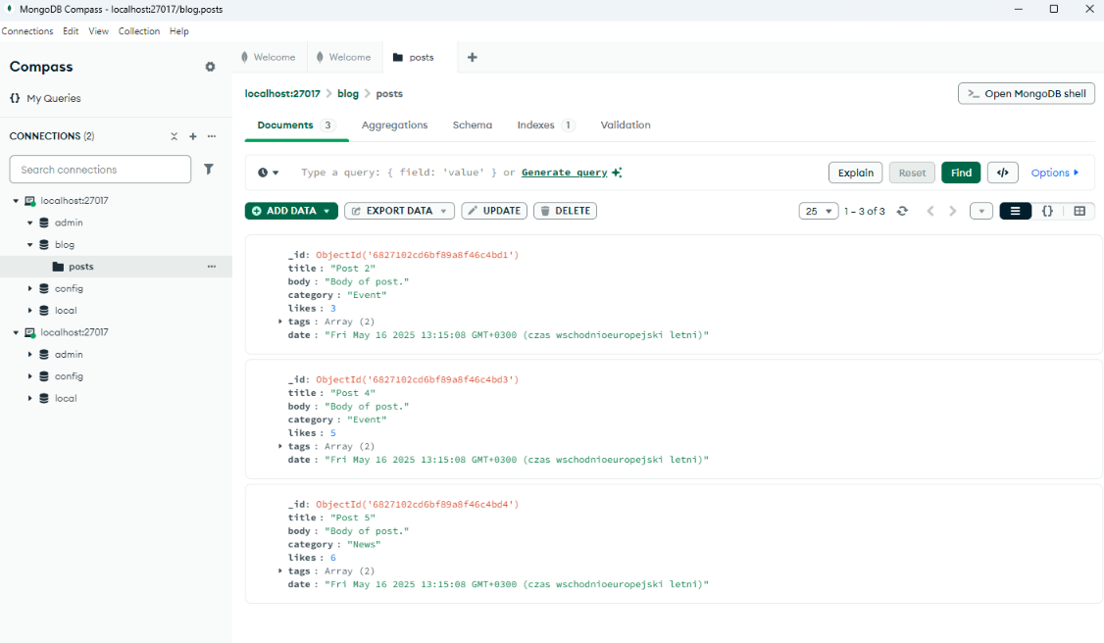

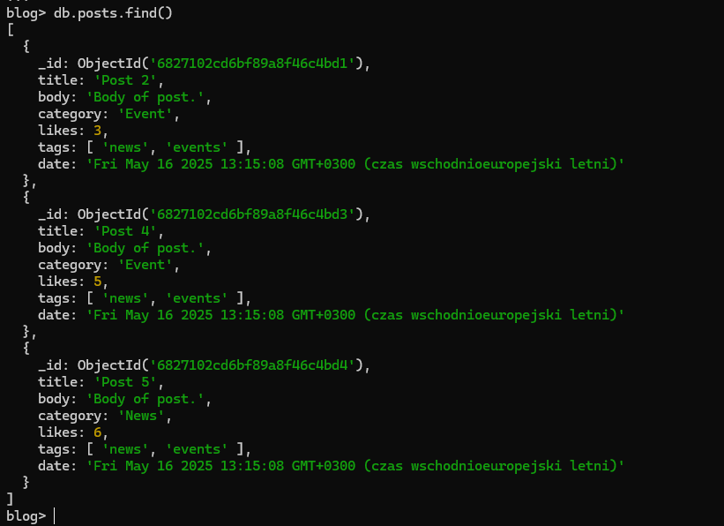

Added new database with sample data:

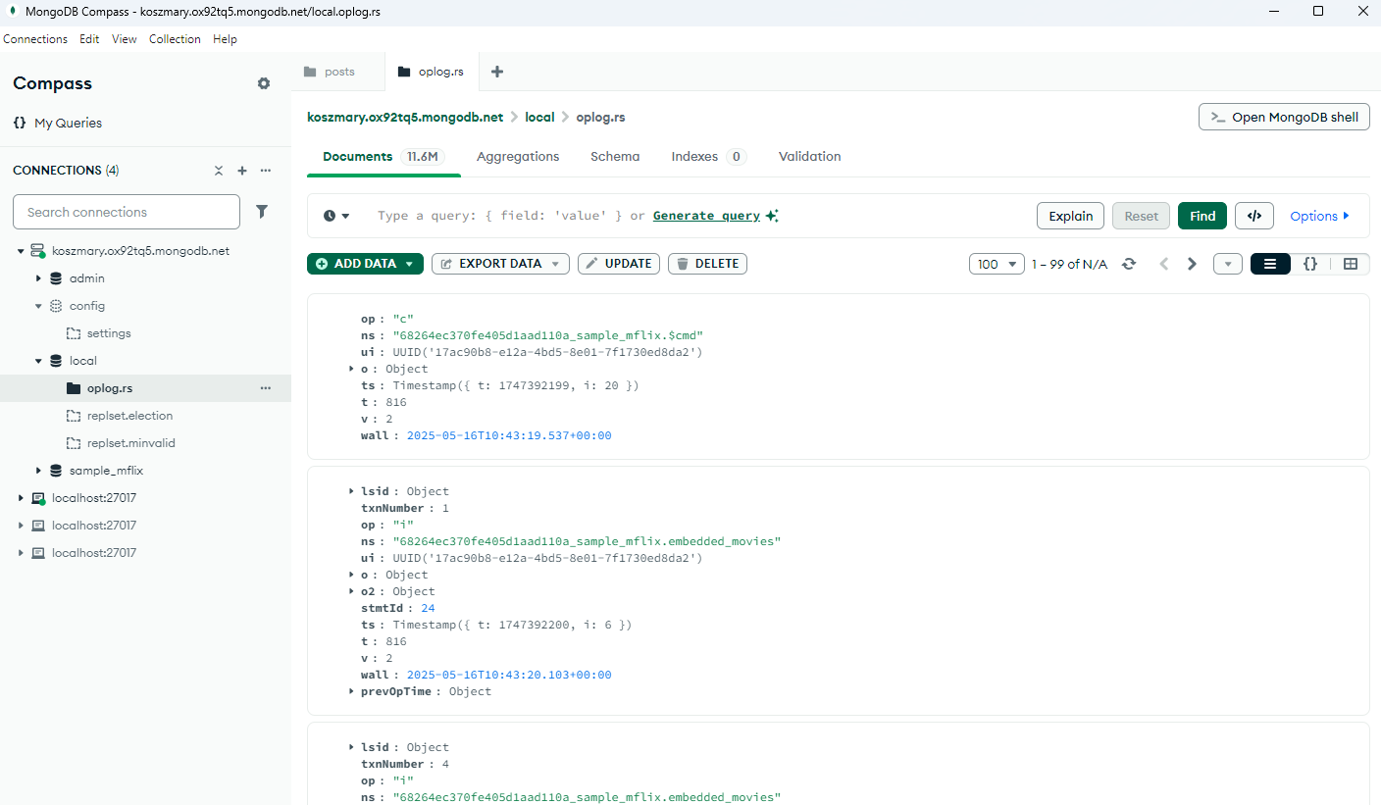

Database in VS:

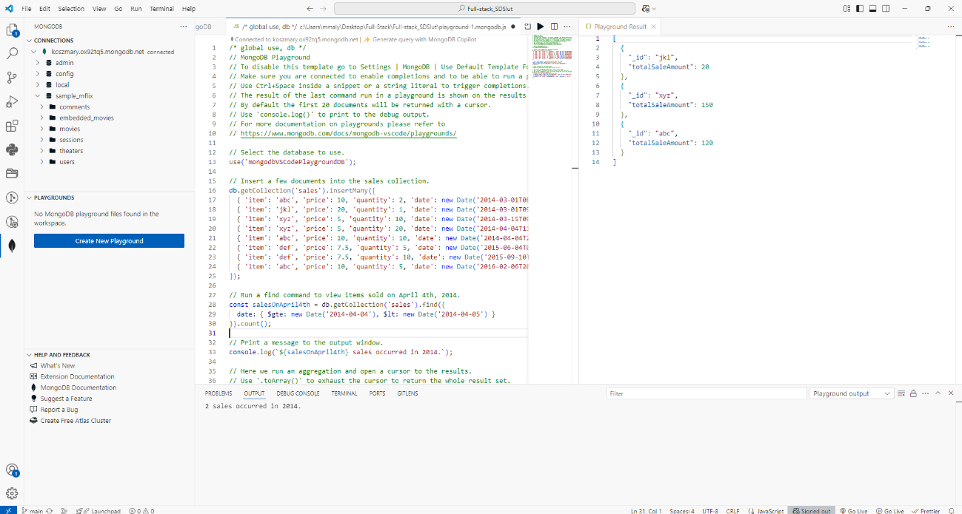

MongoDB

Username: admin

Password: admin

mongosh "mongodb+srv://koszmary.ox92tq5.mongodb.net/" --apiVersion 1 --username admin

**17.05.2025**

Video:

“[**Express Crash Course**](https://www.youtube.com/watch?v=CnH3kAXSrmU)”

Content:

Express as framework for Node.js.

Usage, importance.

Opinionated vs Unopinionated framework.

Making project, files in repo.

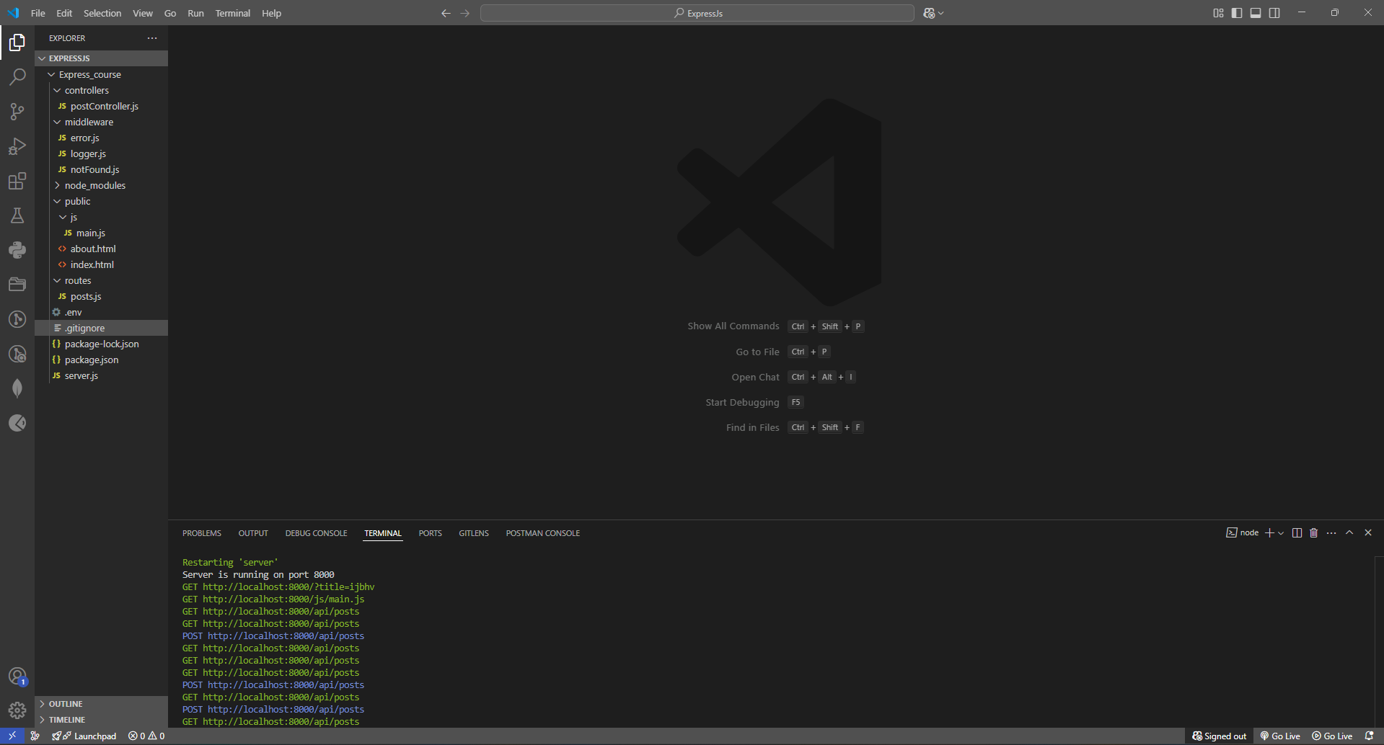

Everything is working properly.

Working localhost:

Get Post

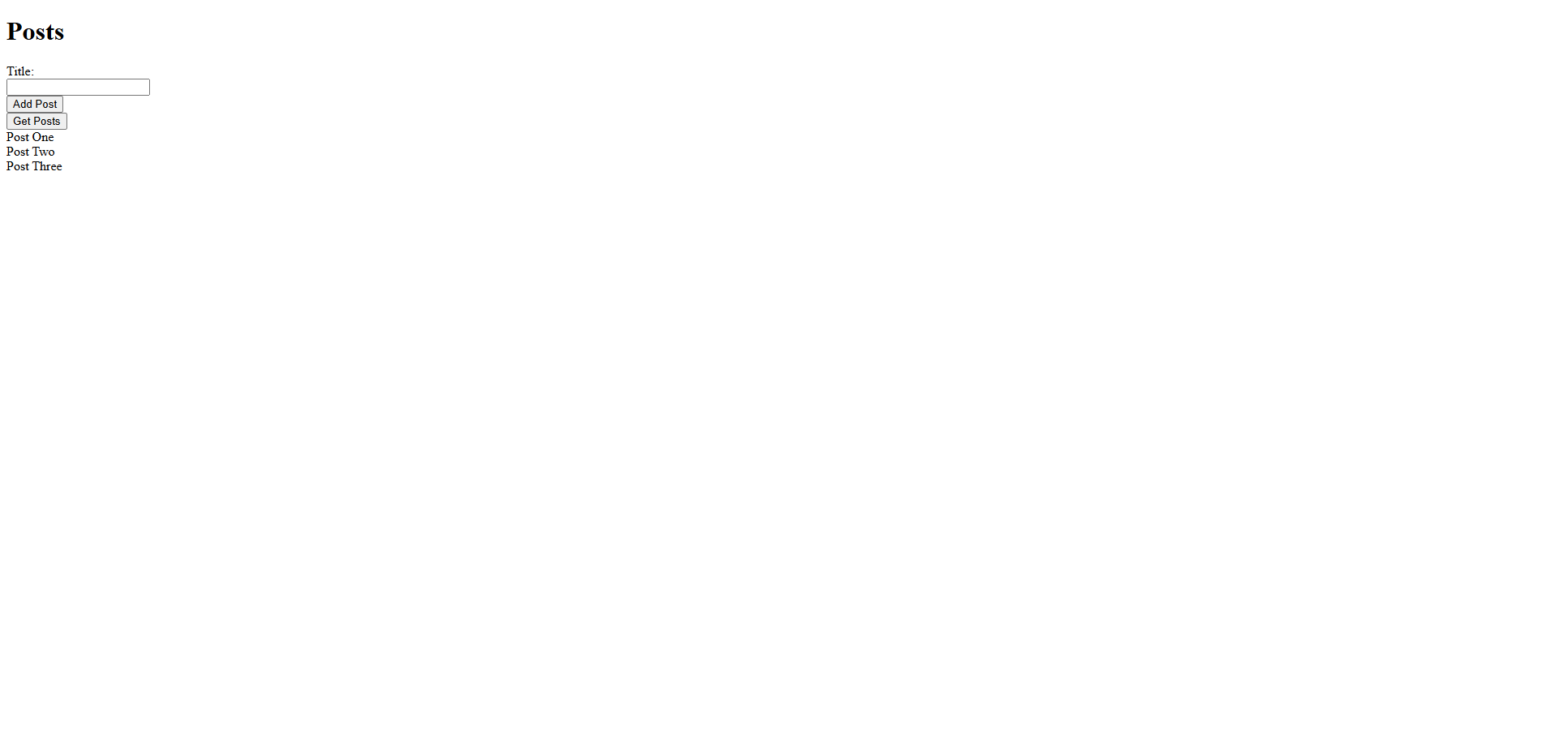

Add Post “Maria”

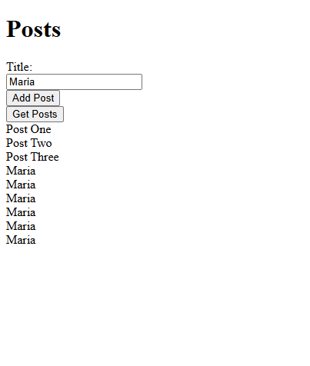

EJS part:

