Lappeenrannan teknillinen yliopisto

Name of your school goes here (School of Business and Management)

Software Development Skills DevOps, Online course

Maria Małysa 003005073

LEARNING DIARY,

Introduction to DevOps MODULE

**LEARNING DIARY**

**20 - 21.05.2025**

# Version Control

Video: <https://youtu.be/w5qcXwKJRf8>

Distributed Version Control and Git

Version Control is a technique to keep track of changes in a file or a set of files allowing to easily switch between the versions.

Types of VCS:

* Local – database
* Centralized - server
* Distributed – mirror

Basics of Git.

Workflow.

Working with files.

Commands.

Committing.

Branches.

Merging.

Advantages of branching.

All feature development is done the dedicated branches instead of the main branch.

Video: <https://youtu.be/hwP7WQkmECE>

Using Git – basic, general overview.

Video: <https://youtu.be/RcfEEQm4GLE>

Basic operations via command lines- Initializing, status view of a repo.

Commiting files.

Video: <https://youtu.be/qBJgxdWFH6A>

Commiting changd files.

Video: <https://youtu.be/fOjqNDzkrk0>

Diferencing two versions of a file.

Video: <https://youtu.be/_-0dPiObPtQ>

Files menagment – renaming, deleting.

Video: <https://youtu.be/kwMEK9eKaP8>

Working with branches – creating, using.

Video: <https://youtu.be/_JTHkmSkvBM>

Merging branch to main one.

Video: <https://youtu.be/qVS2kPAd8ss>

Connecting local repository to an external repository manager.

Video: <https://youtu.be/6d_Sz4Kd1Ks>

GitLab.com – usage, interface.

Video: <https://youtu.be/GpSnehvFX58>

Merge request menagment.

Video: <https://youtu.be/Yn2CRb8n7lM>

Merge conflict – fixing manually.

**21 - 22.05.2025**

# Container Technologies

Video : <https://youtu.be/cm_PoUy4yow>

To execute a software application, two essential components are required:

1. The compiled software output generated from its source code
2. A compatible execution environment for the software

While version control systems effectively manage and coordinate changes to source code (and its resulting build output), they aren't designed to handle the software's runtime environment. This limitation is addressed by containerization technology, which bundles both the application and its required runtime into a single deployable unit.

Key containerization concepts:

* **Image**: An immutable template containing the application and its dependencies
* **Dockerfile**: A configuration file specifying how to construct an image
* **Container**: An active, operational instance created from an image

Core container management tasks include:

* Creating images
* Uploading images to repositories
* Launching container instances

<https://dev.to/dronk6/getting-started-with-docker-docker-playground-28h3>

video: <https://youtu.be/6J9lrgUXroQ>

practice:

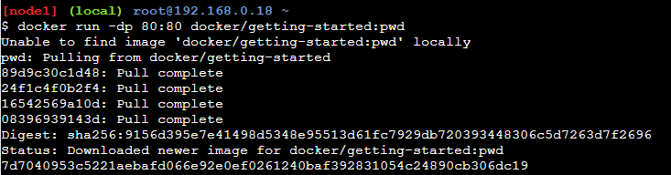

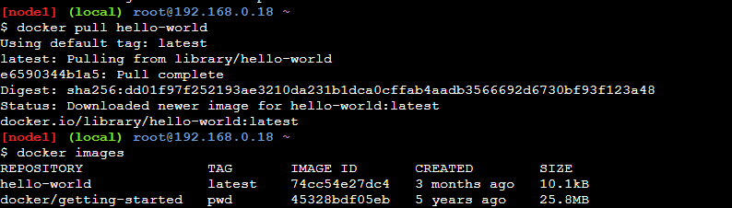

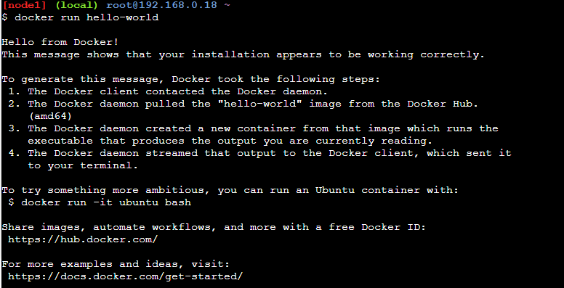

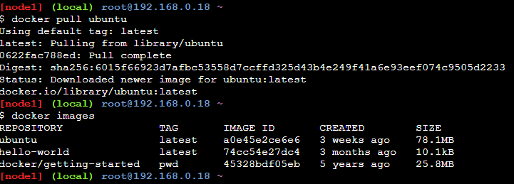

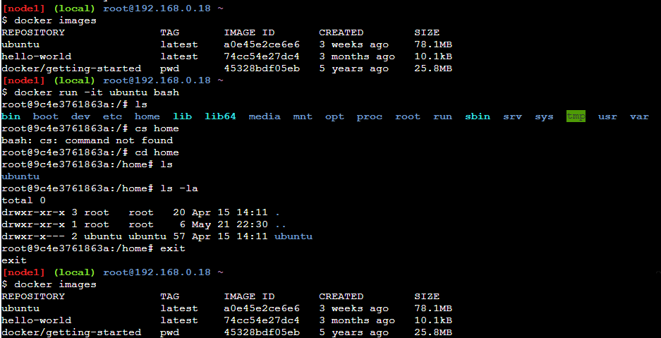

Video: <https://youtu.be/e1PJ_18ut5s>

Creating my own file and building image based on the Dockerfile

docker build -t image_name

docker run image_name

docker ps – working containers

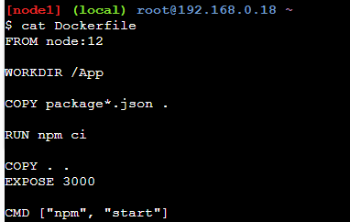

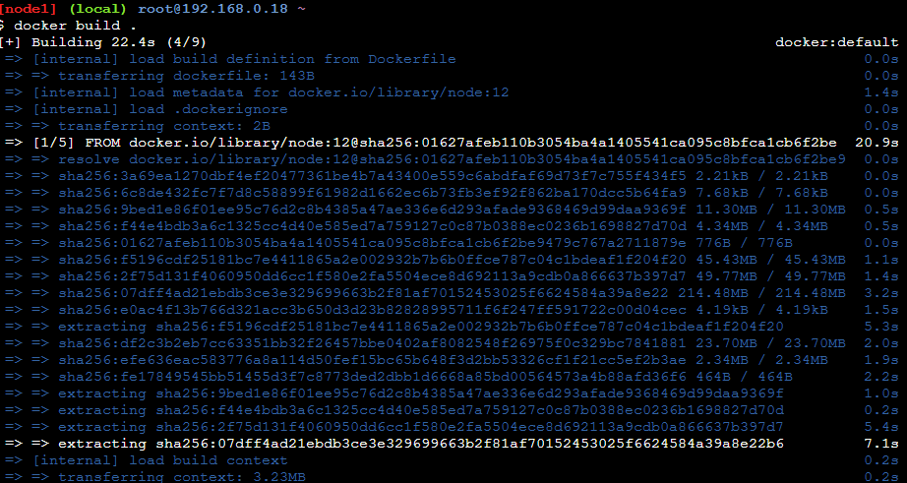

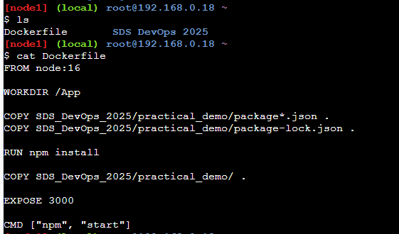

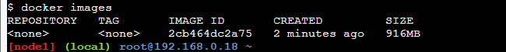

Video: <https://youtu.be/wjnQaMOtwls>

Running container.

Deleting file.

Video: <https://youtu.be/9FDi_IRHo5Y>



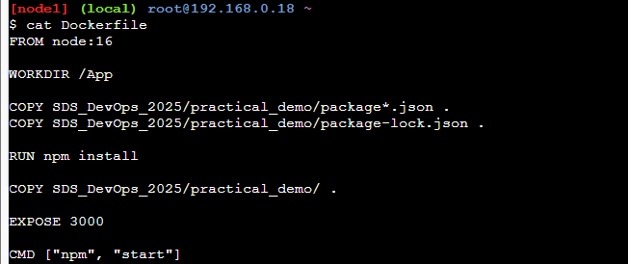

Video: <https://youtu.be/akkni5VpVzY>

Pushing image to external container registry.

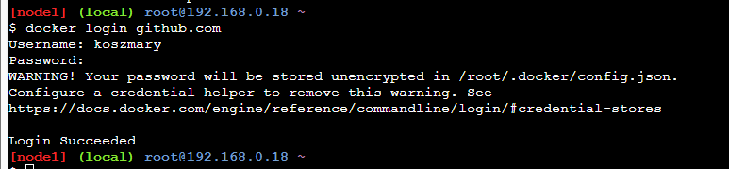

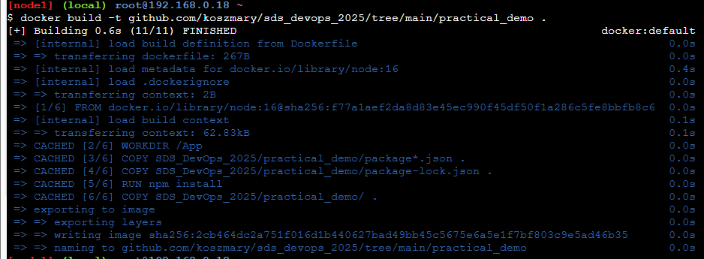

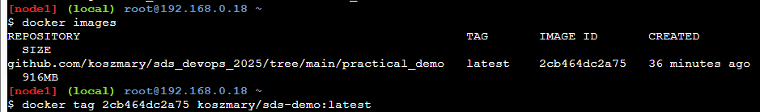

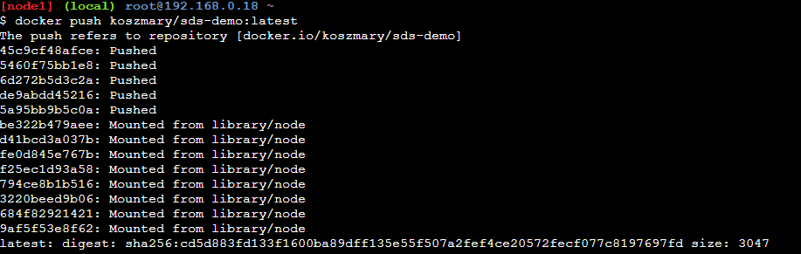

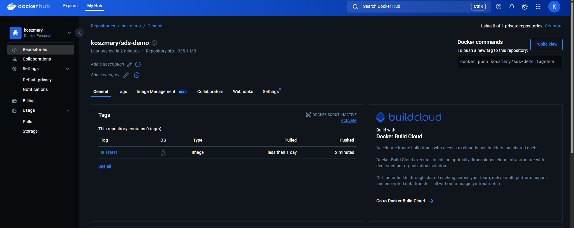

# cloud environments

Video: <https://youtu.be/fxklQ55LwKE>

Cloud services have scalability, reliability, security and dynamic.

Cloud computing is the on-demand delivery of computing services—including servers, storage, databases, networking, software, analytics, and intelligence—over the internet ("the cloud"). Instead of owning physical hardware or running on-premises servers, users access these resources remotely from cloud providers, paying only for what they use.

Key Characteristics of Cloud Computing

1. On-Demand Self-Service
   * Users can provision resources (e.g., virtual machines, storage) automatically without human intervention.
2. Broad Network Access
   * Services are accessible over the internet from any device (laptop, smartphone, etc.).
3. Resource Pooling
   * Cloud providers serve multiple customers using shared physical resources (with security isolation).
4. Rapid Elasticity
   * Resources scale up or down instantly based on demand (e.g., handling traffic spikes).
5. Measured Service
   * Pay-as-you-go pricing (e.g., per hour, per GB of storage).

A cloud refers to remote servers accessed over the internet, along with the software and databases that run on them. Instead of storing data or running applications on your local computer, you use shared computing resources hosted in data centers worldwide.