https://towardsdatascience.com/probability-concepts-explained-probability-distributions-introduction-part-3-4a5db81858dc

a random variable is a variable whose value is the outcome of a random event

A probability distribution is a list of all of the possible outcomes of a random variable along with their corresponding probability values.

When we use a probability function to describe a discrete probability distribution we call it a probability mass function (súlyfüggvény)

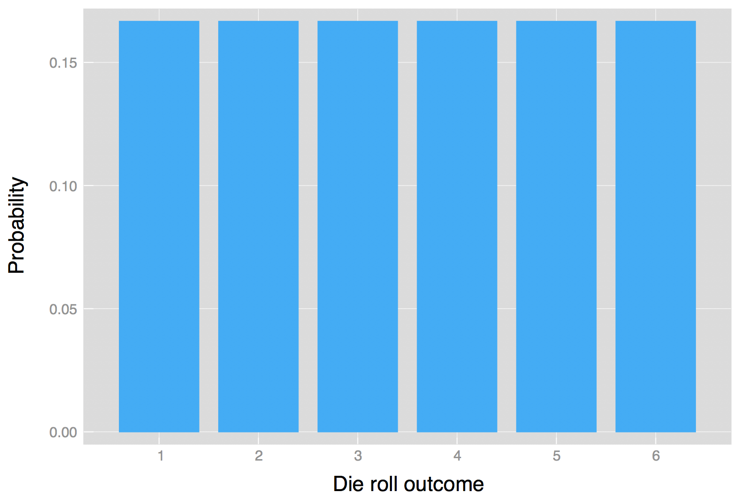

When we use a probability function to describe a continuous probability distribution we call it a probability density function (sűrűséggfüggvény) (commonly abbreviated as pdf).

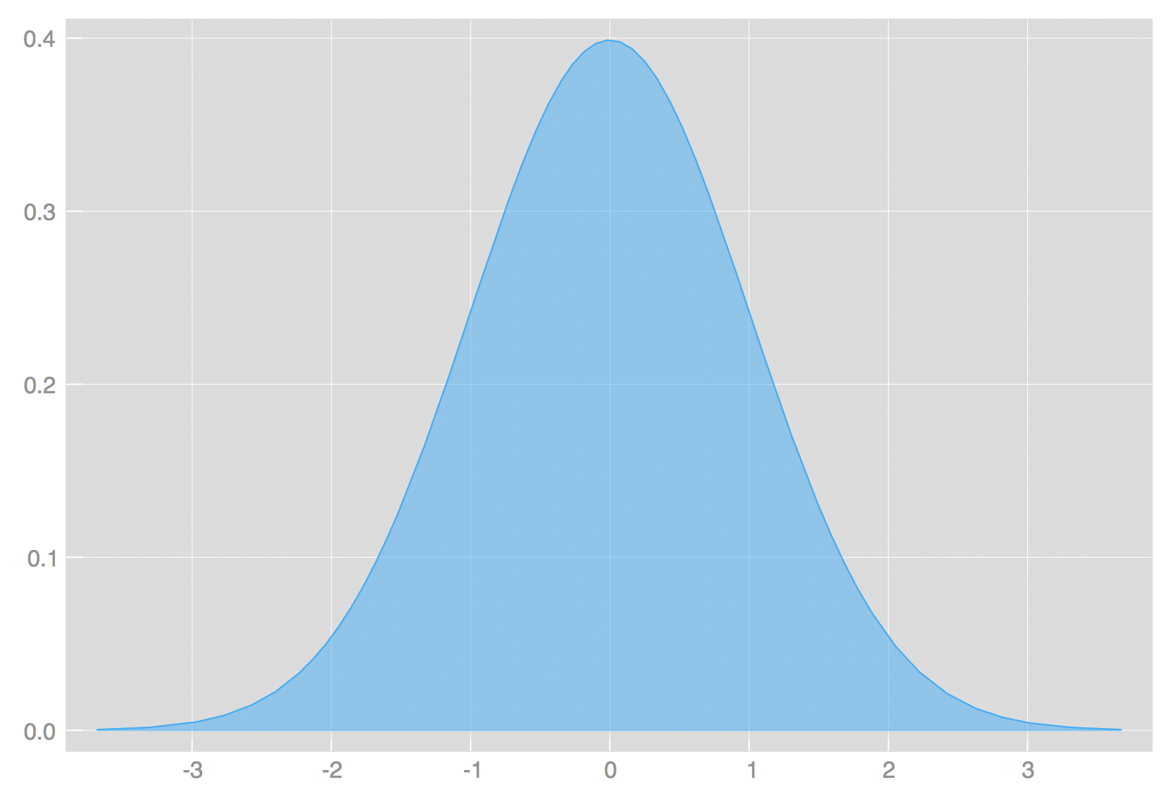

Cumulative distribution function (eloszlásfüggvény)

F(x) = P(x < x)
or
F(x) = P(x <= x)

