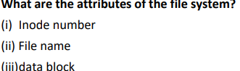
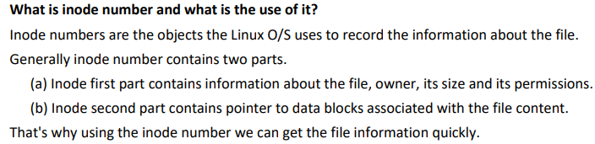
- INode Number:
- Journaling
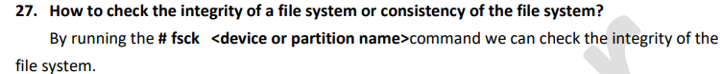
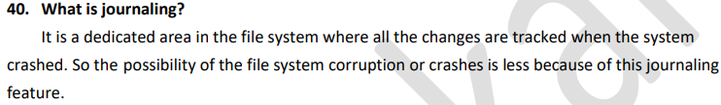
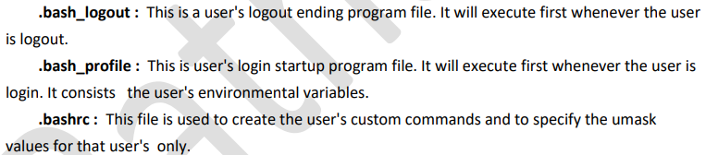
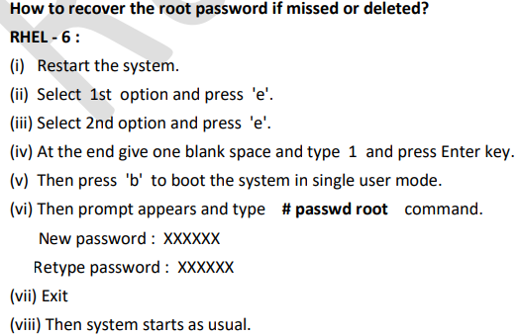
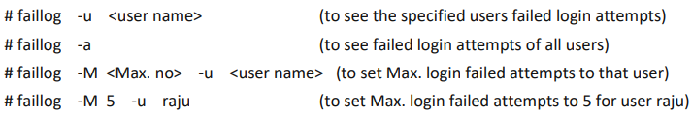
What is the command to check all the open ports of your machine
#nmap localhost
What is the command to check all the open ports of remote machine?
# nmap 32.
What is the command to check all the listening ports and services of your machine?
# netstat –ntulp
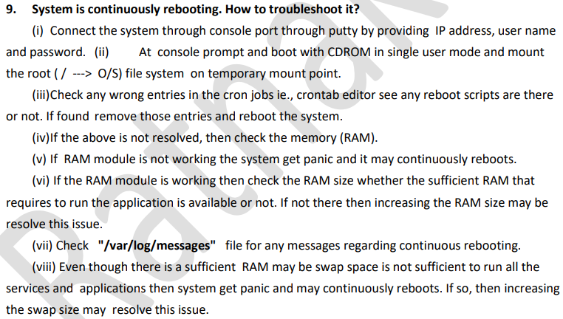
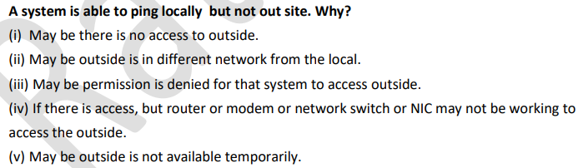
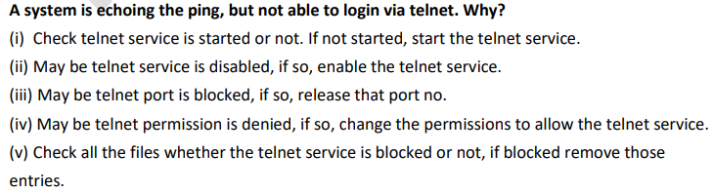
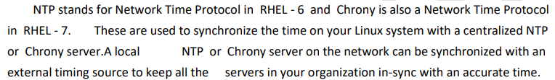

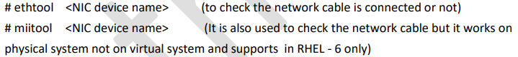
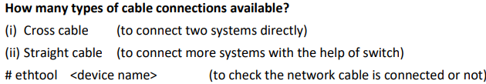
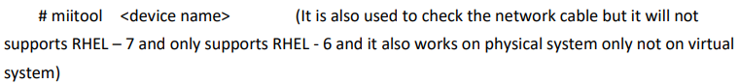
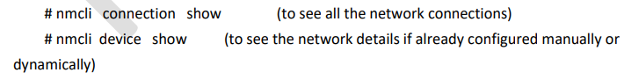
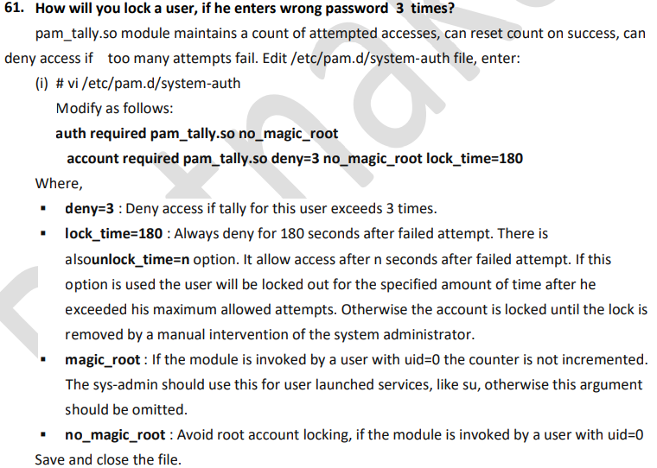
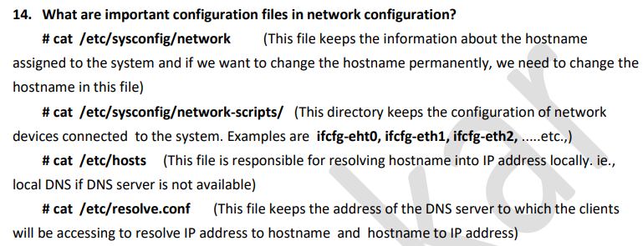
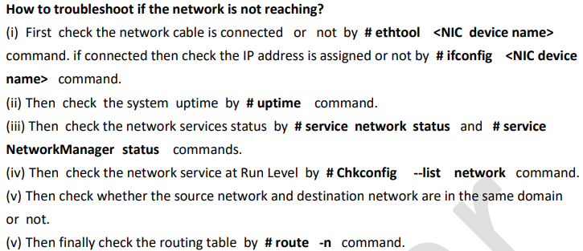
In Linux systems the booting is done in 6 stages. • BIOS • MBR • GRUB • Kernel • Init • Runlevel
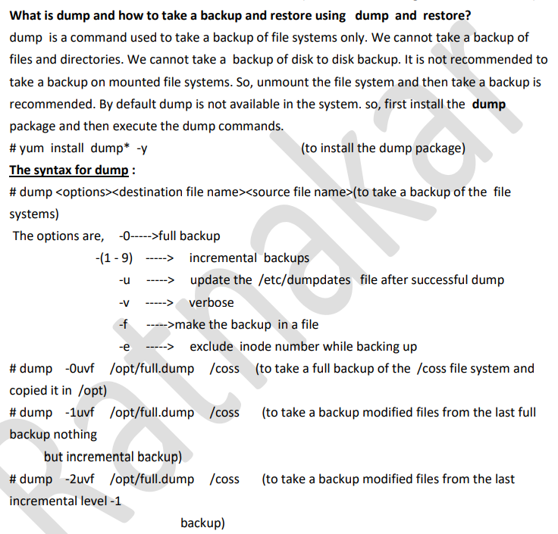
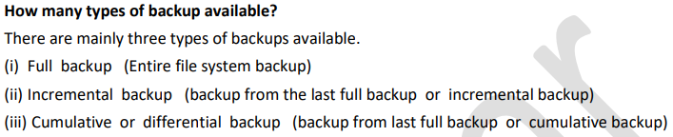
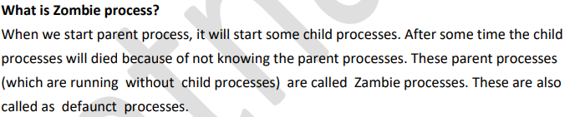
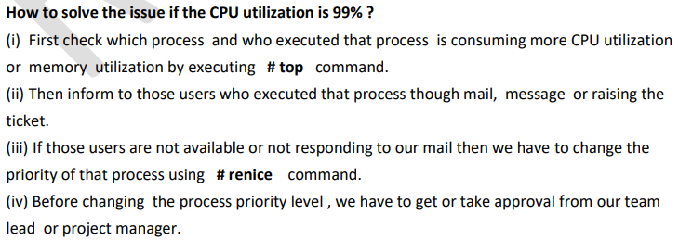
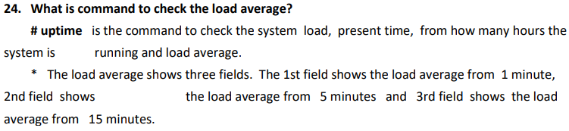

Credentials stored in Jenkins can be used:
- anywhere applicable throughout Jenkins (i.e. global credentials),
- by a specific Pipeline project/item (read more about this in the Handling credentials section of Using a Jenkinsfile),
- by a specific Jenkins user (as is the case for Pipeline projects created in Blue Ocean).
Jenkins can store the following types of credentials:
- Secret text - a token such as an API token (e.g. a GitHub personal access token),
- Username and password - which could be handled as separate components or as a colon separated string in the format username:password (read more about this in Handling credentials),
- Secret file - which is essentially secret content in a file,
- SSH Username with private key - an SSH public/private key pair,
- Certificate - a PKCS#12 certificate file and optional password, or
- Docker Host Certificate Authentication credentials.

Load Statistics
This pages displays graphical data on how busy the Jenkins instance is in terms of the number of concurrent builds and the length of the build queue which gives an idea of how long your builds need to wait before being executed. These statistics can give a good idea of whether extra capacity or extra build nodes is required from an infrastructure perspective.

The agent directive tells jenkins to allocate a workspace and an executor for the pipeline. Without it, the pipeline is not valid and therefore required
# Ignore everything in /jobs
*
# Reinclude all folders in /jobs
!*/
# Ignore everything in the subfolders of /jobs
*/*
# Reinclude config.xml files in the first-level subfolders of /jobs
!*/config.xml

Click Reload Configuration from Disk button in the Jenkins web user interface to force Jenkins to reload configuration from the disk.
Since you can’t delete a file that is currently opened by a program you need to stop all applications accessing the log file. If you are running Ubuntu the applications are Jenkins itself and the rsyslog service.
sudo service jenkins stop
sudo rm /var/log/jenkins/jenkins.log
sudo service rsyslog restart
sudo service jenkins start

Jenkins Shared Libraries
Jenkins shared library is a great way to reuse the pipeline code. You can create libraries of your CI/CD code which can be referenced in your pipeline script. The extended shared libraries will allow you to write custom groovy code for more flexibility.

Jenkins Backup Using Thin Backup Plugin
Jenkins Thin Backup is a popular plugin for backing up Jenkins

In a distributed Jenkins environment, resource utilization of the slaves will be very less when the builds are not quite often. In this scenario, it is better to use ephemeral docker containers as your build slaves for better resource utilization.
As we all know that spinning up a new container takes less than a minute. So, for every build, a new container will get spun up, builds the project and will get destroyed.
Jenkins master connects to the docker host using REST API’s.
So we need to enable the remote API for our docker host
You will need Docker remote API in various situations. Let’s say you are running the docker host on a remote server and you want to connect to it from your laptop. For this scenario, you can use the remote API and connect to it using REST API’s as the docker engine accepts REST requests.

Enable Docker Remote API
All the docker configurations are present in the file/lib/systemd/system/docker.service. In that file, there is an ExecStart parameter.
Open the file/lib/systemd/system/docker.service, search for ExecStart and add values as shown below.
For Ubuntu,
ExecStart=/usr/bin/docker daemon -H fd:// -H tcp://0.0.0.0:4243
For Centos,
ExecStart=/usr/bin/dockerd -H tcp://0.0.0.0:4243 -H unix://
You can test the API using REST client like Postman. If you use the following URL in your REST client, you will get the JSON output in a prettified manner as shown in the image below
Shell Scripting
=============
\ Escape character
Define like this: touch ravi \ Kumar (Treats single name only)
Cd . : Current Directory
Cd ~ : User’s home directory
Cd - : Moving to the previous directory where you are coming from.
Date
Date +%d-%m-%y
Date +%F
Date +%d:%m:%y
Date –r shell Modified time stamp
Touch test{1..10}.txt(creates test1,test2….test10)
Cp -p source dest (preserves the time stamp and everything)
Diff –c file 1 file 2 (displays the exact changes b/n the 2 files)
Diff –y file1 file2 (displays the 2 files side by side to showcase)
Grep file[^2345] grs Not included in to the output,except the 2345
Grep test$ grs Line is ending with the test
Grep ^test grs starting character
Cat /var/log/messages | more (to display the content one by one)Lengthy of text
More messages
Sort –nk2 file (column number is k,to sort the second column in to order)
Sort –r file (Reverse Order)
Df –h | sort –nk2(To display the volume mounted and storage data)2nd column is sorted
Tail –f /var/log/messages (The updating has been displayed)
Tr – Used to convert lower case to upper case and vice versa
Tr a-z A-Z
Tr a-z A-Z < file (as file as a input for the command)
Cat file1 | tr –d A
Cat file2 | tr –d E (delete the E from the current namespace
Echo “12345 are the numbers” | tr –d [:digit:](It deletes the digits from the given text)
Echo “this is the line” | tr [:space:] ‘\t’
It displays the tab space b/n the line

Sed :
Sed ‘s/arkit/tech/2’ file1
It changes the second occurrence of the word in the given string
Sed ‘s/arkit/tech/g’ file1
All occurrences
Sed ‘s/arkit/tech/2g’ file1
Sed ‘s/^\(arkit\)$/#\1/1’ example
Sed –i ‘s/^\(arkit\)$/#\1/1’ example(i-permanently changes the file)
Sed ‘s/https:\/\//www.’ Example
Can comment the particular line number and delete the line number.insert some lines starting of the files and ending of the files, Replacing the specified line.
Sed ‘3 s/arkit/Tech/’ example (Single line)
Sed ‘3,5 s/arkit/Tech/’ example (Multiple lines)
Sed ‘3 d’ example (Deletes third line)
Sed –i ‘3 d’ example(i-permanently changes the file)
AWK:
====
Test manipulation tool,built string functions.
Cat example | awk ‘{print $3,$9}’
Print’s 3rd and 9th columns remaining fields would be eliminated
#!/usr/bin/awk -f
Awk ‘BEGIN {sum=0} {sum=sum+7} END {print sum}’example
Awk –f sumawk example
To print the matched content only!
Awk ‘{ if($3 == “arkit”) print $0;}’ awkexample
Print the entire line
Vmstat:
Tool is used to Reports data about machine processors,swap,IO Utilizations resources,
Linux machine performance monitoring is easy
# Vmstat –a
It displays Process, Memory, Swap, IO, System, and CPU
Vmstat –f Dispalys the forks
Vmstat –m Displays the SWAP info
Vmstta –t Displays time stamp
Vmstat –t 3 10 (every 3 seconds up to 10 lines)
Netstat :
-----------
Is used to create the sockets.To open and listen ports.The port is listening or not.
#netstat –tunlp (Existing port no’s)
#mail -- Verify the mails
&1 Email number will display the content of an Email
Mail is used to send the messages to the different users
Mail –s “Hello world” admin@localhostt (To send an email to admin user)
#echo “testing mail” | Mail –s “Hello world” admin@localhost(Includig the body line)
Mail –s “Hello world” admin@localhost < example
(Including an attachment) Mail –s “Hello world” admin@localhost -a (attachment) example
Mail –s “Hello world” admin@localhost -c(CC) admin@localhost -b(bcc) admin@localhost

Workspaces -- To open the terminals and running the simulations stuff (4 )
Cut
====
Echo “ravi” | cut –b 2 (o/p : a) (Single Byte)
Cut range of bytes
Cut –b 2-4
Cat exam | cut –c 1,4,10 (First, Fourth and 10th character)
Cut – c 10-15
Cut –c 5-(Cuts from 5th character to the line last number)
Cut –d’:’ –f 1 example
Select all fields except the delimited fields
Cut –d’:’ –complement –s f5 if delimiter is there then only used
Cut –d’:’ –s –f1,4,2 --output-delimiter=’$’
Cut –d’:’ –f1-4 –output-delimiter=$’\n’
Each delimiter column in to a separate field
Paste:
====
Merging of the files
Paste file1 file2
Paste –s 1 2 Converts columns in to the single row.
It is joining the lines in the columns
Paste –d, -s 2(Delimiter) (Column no)
Converts columns in to the single row.
Paste –d”#,” –s 2(Column no)
Merging the contents of a different files
Paste –d’\n’ file1 file 2 everything in to line by line
Paste –d’ ’ file1 file 2 | cut –d ‘‘–f 1,2,4,5
SSH – Secure shell
  - Symmetric Algorithms: Secret Key
Use same key for both encryption and decryption
  - Asymmetric Algorithms: Public Key
Use different key for both encryption and decryption
- Known_hosts file
- Authorized _keys file
Ls –ltr (Time stamp)
Scp –rvp source1 destination (It’s copy with the all contents)
Shift --- shifts the parameters from left to right automatically
It is a bash feature
Shift – first parameter shifts to second and second to third like this
Shift 2 switching the 2 positions
Shift 4 switching the next 4 positions
Functions:
========
Functions are used to develop modularity in program. Divide the large script in to multiple tasks
A large program can be split into multiple small modules. Each module performs an specific task. Instead of writing the code over and over again we can write single function and call the function whenever you want and wherever you want throughout the program.
Function name ()
{
}
Name () -- function calling

PYTHON
=======
Used for automation
- Linux automation
- Windows Automation
- Cloud Automation
1. Join(Merge)
a = "hello"
b = ("guys","v","n","m")
print (a.join(b))
2. rsrtip
a = " hello"
print(a)
print (a.lstrip())
3. split
Returns list of substrings
a = [1,2,3,4,5,6,7,8,9]
b = [99,100]
print(a.append(11))
print(a)
print(a.insert(3,34))
print(a)
a.extend(b)
print(a)
b.pop(1)
print(b)

Dir
====
It returns the sorted list of strings containing the names defined by a amodule
import numpy
a = dir(numpy)
print(a)

OS Tasks
=====
import os
os.system("ls") -- executing a shell command

import os

#print(os.getpid()) # returns real process ID of the current process
#print(os.getcwd()) # return current working directory
#os.chdir() # move to differnet directory
#print(os.chmod()) # change the mode of path
#print(os.chown()) #change the owner of file
#print(os.getsize()) #get the size of a file
#print(os.uname()) # prints os information
#print(os.listdir(path)) # list of the entries in the directory given by path
#print(os.path.exists()) # check path exists
#print(os.mkdir(path)) # create directory named path with numeric code
#print(os.remove(path)) # remove delete the path
#print(os.rmdir(path)) # remove directory path
print(os.makedirs(path)) # recursive directory creation function
os.removedirs(path) # remove directories recursively
os.rename(src,dst) # rename the file or dir src to dst

OS.Path
======
Os.path.isdir(path)
Os.path.isfile(path)
Fabric
=====
It is a python library. It’s a command line tool for streamlining the use of SSH for application deployment or system administration tasks
It is used to write and execute the python functions and tasks to automate the interactions with remote servers.
Pip is used to install the python
Pip install fabric
Fab file or fab scripts
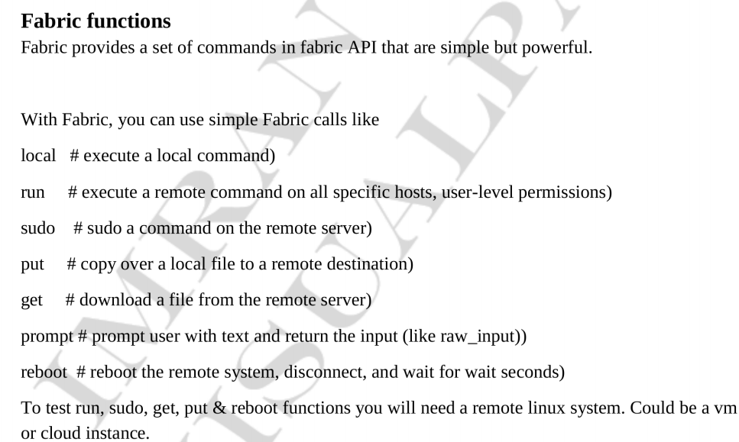
Boto
====
Pip install boto
~/.boto file is used for access and secret key files
Import boto
Conn = boto.connect_s3()
Bucket = s3.create_bucket(‘boto-demo-%s’ % int(time.time()))
Mybucket = conn.get_bucket(‘mybucket’)
Mybucket.lsit()
Conn.delete_bucket(‘mybucket’
Import boto.ec2
Conn = boto.ec2.connect_to_region(“us-west-2”)
Conn.run_instances(key_name,instance_type,Security_groups)
Conn.stop_instances(instances_ids)
Conn.terminate_instances
Import boto.dynamodb2
Dynamodb -- NoSQL DB service.

Python Functions
==============
- Lower
- Upper
- IsUpper
- IsLower
- len
print(x.upper().islower())
print(x.upper().isupper())
print(len(x))
print(x[3]) -- To retrieve the index no of 3rd position
x = "hello world"
print(x.index("e"))
print(x[3])
replace(source,dest) :
print(x.replace("ello","worl"))
print(2) # output is 2
print(2.8908) # 2.8908
print(-2.8907) # -2.8907
print((3 * 4) + 3 - 2 / 3)
print(10 % 3) # remainder is “1”
abs()
pow() -- a = 3
print(pow(a,2))
max()
min()
a = [2,3,4,5,6,7,7]
print(max(a))
print(min(a))
print(len(a))
print(round(3.8907899))
print(round(2.11111))

from math import *

print(floor(2.456777))
print(ceil(3.11))
print(sqrt(2345))

