(vii) Sometimes we will delete file contents not the files to reduce the file sizes. For that we execute the command # cat /dev/null ><file name with path> ie., nullifying the files.

How to extend the root file system which is not on LVM?
By using # gparted command we can extend the root partition, otherwise we cannot extend the file systems which is not on LVM.

Fstab file systems table
The Linux supported file systems are ext2, ext3, ext4, xfs, vfat, cdfs, hdfs, iso9660 ...etc.,
The ext2, ext3, ext4 file systems are widely used in RHEL-6 and xfs file system is introduced on RHEL-7. The vfat file system is used to maintain a common storage between Linux and Windows O/S.
# mount -a to mount the partitions without reboot)
for example: 8e for Linux LVM, 82 for Linux Swap and 83 for Linux normal partition
# fuser -cu <device name> (to check the users who are accessing that partition)
# lsof <device name> (to check the files which are open in that mount point)
# fuser -ck <opened file name with path> (to kill that opened files)
How to see the usage information of mounted partitions?
# df -hT (to see device name, file system type, size, used, available size, use% and mount point)
How to see the size of the file or directory?
# du -h <filename or directory name> (to see the size of the file or all the file sizes in that directory)
# ncdu (to list biggest files and directories, we have to install the ncdu package before executing this)
# mount -l (to list all the mounted partitions along with their labels)
# mount -a (to mount the partitions)
# mount (to verify whether it is mounted or not)
How to know the file system type?
# df -hT (command gives the file system type information)
How to know which file system occupy more space and top 10 file systems?
# df -h <device or partition name> | sort -r | head -10
How to find how many disk are attached to the system?
# fdisk -l (to see how many disk are attached to the system)
# dump2fs <device or partition name> (to check the metadata of the partition and repair the metadata)

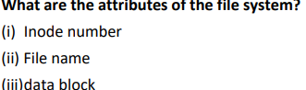
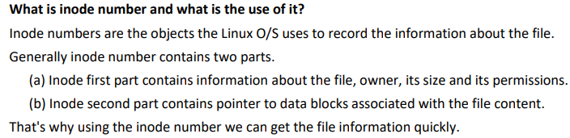
- INode Number:
- Journaling
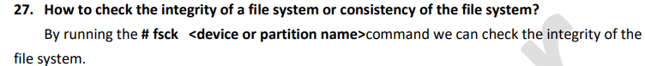
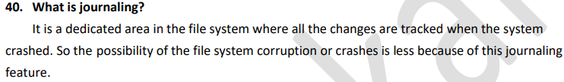
# journalctl -n 5 (to display last five lines of all the log files)
# journalctl -p err (to display all the error messages)
# journalctl -f (to watch journalctl messages continuously)
# journalctl --since<today> or <yesterday> (to see all the journalctl messages since today or yesterday)
# journalctl --since "date" --until "date" (to see the journal messages between the specified two dates)
# journalctl -pid=1 (to see the pid=1 process name)
# auditctl (to see the audit report)
# smartctl -H <hard disk name> (to check the health of the specified hard disk)
# smartctl -i <hard disk name> (to see the information of the specified hard disk)
# smartctl -a <hard disk name> (it gives more information of the specified hard disk)
Using this LVM we can extend or reduce the file systems as per requirement without loss of any data
- Increase the size of the logical volume by # lvextend or # lvresize commands.
- Then finally update the file system by # resize2fs or # xfs_growfs commands.

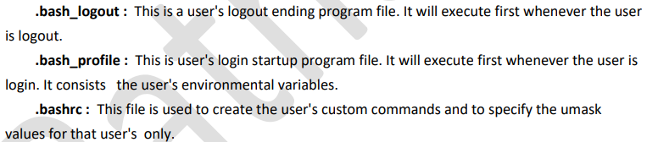
- /etc/login.defs ----> user's login defaults settings information taken from this file.
(i) # id <user name> (It shows the user id group id and user name if that is already created)
How to create the duplicate root user?
# useradd -o -u 0 -g root <user name>
How to recover if the user deleted by mistake?
# pwunconv (It creates the users according /etc/passwd file and deletes the /etc/shadow file)
How add 45 days to the current system date?
# date -d "+ 45 days"
# w (this command gives the login user information like how many users currently login and processes)
# who (to see users who are currently login and on which terminal they login)
# last (see the list of users who are login and logout since the /var/log/wtmp file was created)
# lastb (to see the list of the users who tried as bad logins)
# lastreboot (to see all reboots since the log file was created)
# uptime (to see the information from how long the system is running, how many users login and load average)
* The load average is from 1 sec : 5 secs : 15 secs
# df (to see the mounted partitions, their mount points and amount of disk space)
# du (to see the disk usage of the each file in bytes)
# uname -r (gives the current kernel version)
# last -x (It shows last shutdown date and time)
# last -x grep shutdown (only shutdown time shows ie., grep will filter the 'last -x' command)
# cat /etc/shells or # chsh -l (to see how many shells that are supported by Linux)
# date + %R (to display the time only)
# date + %x (to display the date only)
# whatis <command> (to see the short description of that command)
# whereis <command> (to see the location of that command and location of the document of that command)
# reset (to refresh the terminal)
# whoami (to see the current user name)
# who a mi (to see the current user with full details like login time and others)
# du -sh /etc/ (to see the size of the /etc on the disk in KBs or MBs)
# stat <file name/directory name> (to see the statistics of the file or directory)
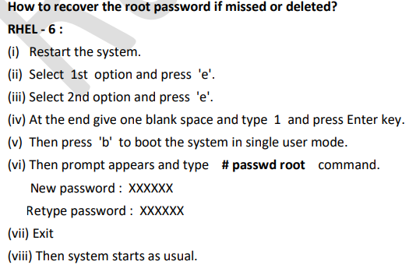
How to restrict the users from login?
(i) By removing (deleting) the user we can restrict the user from login.
(ii) Put the user's hostnames as entries in /etc/hosts.deny file (applying TCP wrappers).
(iii) #passwd -l <user name> (by locking his password we can restrict the users).
50. How to put never expiry to a user?
# passwd -x -1 <user login name>
51. Which one is the default sticky bit directory?
/tmp is the default sticky bit directory.
What is the purpose of the profiles?
(i) Profile is a file to enter some settings about users working environment. ie., we can set user home directory, login shell, path, ...etc.,
Profiles are two types.
(a) Global profile
(b) Local profile
Global profile :
(1) Only root user can set and applicable to all the users.
(2) Only global parameters can entered in this profile.
(3) The location of the global profile is /etc/bashrc
Local profile :
(1) Every user has his/her own profile.
(2) The settings entered in this profile are only for that user.
(3) The location of the profile is .bash_profile (hidden file) in that particular user's home directory.
How will you lock a user, if he enters wrong password 3 times?
pam_tally.so module maintains a count of attempted accesses, can reset count on success, can deny access if too many attempts fail. Edit /etc/pam.d/system-auth file, enter:
auth required pam_tally.so no_magic_root
account required pam_tally.so deny=3 no_magic_root lock_time=180
TCP/IP | UDP
Transmission Control Protocol | User Datagram Protocol
It is connection oriented | It is connection less
Reliable | Non-Reliable
TCP Acknowledgement will be sent / received | No Acknowledgement
Slow communication | Fast communication
Protocol No. for TCP is 6 | Protocol No. for UDP is 17
HTTP, FTP, SMTP, ....etc., uses TCP | DNS, DHCP, ....etc., uses UDP
How to see the no. of failed logins of the users?
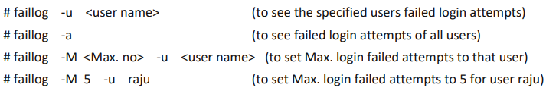
A Gateway is the network point that provides entrance into another network. On the internet a node or stopping point can be either gateway node or a host (end point) node
What is the command to check all the open ports of your machine
#nmap localhost
What is the command to check all the open ports of remote machine?
# nmap 32.
What is the command to check all the listening ports and services of your machine?
# netstat –ntulp
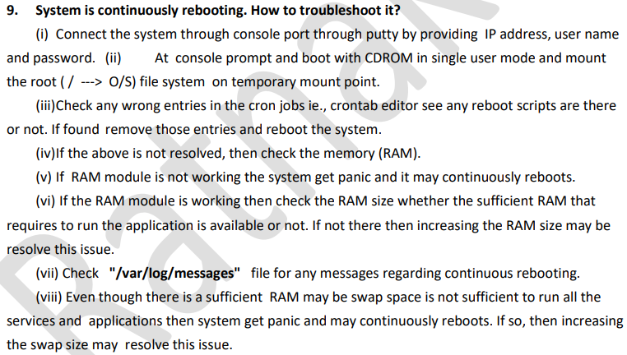
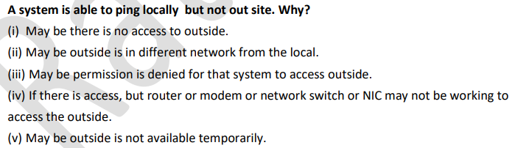
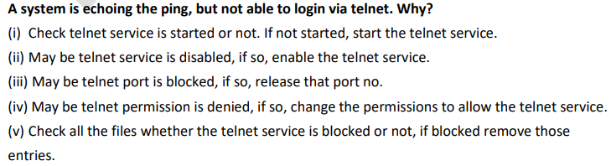
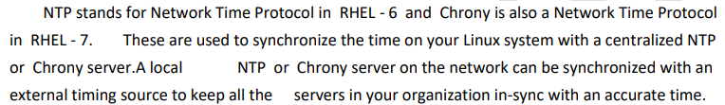
How many types of NIC cards available?
(a) eth0 (1st NIC card)
(b) eth1 (2nd NIC card)
(c) br0 (Bridge -----> used for communication from physical to virtual)
(d) lo (loopback device name and IP address is 127.0.0.1)
# ifconfig (to see all the NIC devices connected to the system)

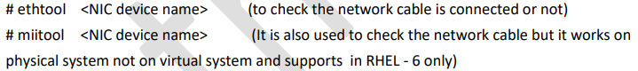
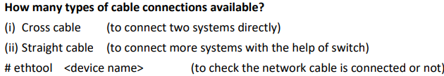
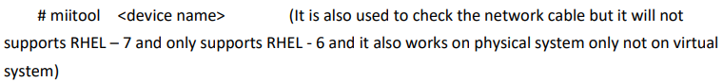
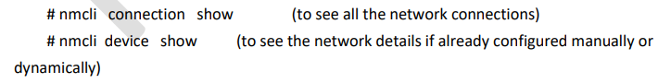
# nmcli connection up "System eth0" (to up the connection)
What is the command to check all the open ports of your machine?
#nmap localhost
What is the command to check all the open ports of remote machine?
# nmap <IP address or hostname of the remote system>
RHEL - 6 | RHEL - 7
/etc/sysconfig/network-scripts is the directory which contains the NIC configuration information. | /etc/sysconfig/network-scripts is the directory which contains the NIC configuration information.
/etc/sysconfig/network-scripts/ifcfg-<device name> is the file which contains the NIC configuration details. | /etc/sysconfig/network-scripts/ifcfg-<device name> is the file which contains the NIC configuration details.
/etc/resolve.conf is the file which contains DNS server IP and domain name location. | /etc/resolve.conf is the file which contains DNS server IP and domain name location.
/etc/sysconfig/network is the hostname configuration file. | /etc/hostname is the hostname configuration file.
/etc/hosts is the file which contains the local DNS server IP address. | /etc/hosts is the file which contains the local DNS server IP address.
What is the command to check all the listening ports and services of your machine?
# netstat -ntulp
33. How can you make a service run automatically after boot?
# chkconfig <service name> on
What are the possible ways to check if your system is listening to port 67?
# nmap localhost | grep 67
# netstat -ntulp | grep 67
# ipcalc -m <IP address) (to find the subnet mask for that specified IP address)
# hostname -i (to see the IP address of the system)
# hostname -d (to check the domain name of the system)
# hostname -s (to check the hostname without domain name)
# netstat -r (to check the default gateway and routing table)
# route (to check the default gateway with routing table)
# ip route (to display the NIC device with default gateway)
# dig or # host or #nslookup (all are used to resolve the name to IP and IP to name)
# nslookup <IP address> (to resolve IP to name)
# nslookup <hostname> (to resolve name to IP)
# host <IP address> (to resolve IP to name)
# host <fully qualified domain name> (to resolve name to IP address)
# dig -x <IP address> (to resolve IP address to name)
# nmcli networking off (to disable all the connections at a time)
# nmcli device status (to display all NIC device connections statuses)
# netstat -ntulp (to check how many open ports are there in local system)
# ss -ntulp ( " " )
# nmap (to check how many open ports are there in remote system)
# tracepath (it displays the routing information)
# route -n (to check the gateway)
# service --status-all (to see the list of all the processes which are currently running)
# chkconfig --list (to list all the services which are running at boo time in RHEL - 6 & 7)
# systemctl list-unit-files (to list all the processes which are running at boot time in RHEL - 7)
# chkconfig --level <service name>
(it will set the service at run level 3 when the system is booting)
# /etc/rc.local (is the last script to be run when the system is booting)
# service --service -all (to see the process ID of all the services)
# netstat -ntulp (to see all the services with port no., status, process ID and all open ports in local system, routing table and NIC device information)
-n -----> port no. (numeric no) -t ----->tcp protocol
-u -----> upd protocol -l -----> port is listening or not
-p -----> display the process ID
# netstat -r (to see all routing table information)

# netstat -i (to see all the NIC cards information)
# nmap (to see the network mapping ie., open ports list on remote system)
Note : By default this command will not available. So, first install the nmap package by # you install nmap -y
# nmap <remote system IP address> (to see all the services which are running in the specified remote system)
# nmap <remote IP 1><remote IP 2><remote IP 3> (to see the running services on specified remote systems)
# nmap 172.25.0.11 - 50 (to see the running service on 172.25.0.11 to 172.25.0.50 systems)
# nmap -p 80 <remote IP>
(to see the http port is running or not on specified remote system)
# nmap -p 80 - 90 <remote IP>
(to see port no's 80 to 90 are running or not on remote systems)
# nmap -sp 172.25.0.0/24 (to see all the systems which are in upstate ie., 172.25.0.1, 172.25.0.2,(where s -- scan & p -- ping) 172.25.0.3, ......upto 172.25.0.254 systems)
# nmap -iL coss (to scan all the IP addresses by reading the coss file)(where -i ----> input, -L ----> list)
# nmap --iflist (to see all the routing table information in the network)
# nmap 172.25.0.10 - 20 --exclude 172.25.0.15 (to scan all the systems from 172.25.0.10 to 172.25.0.20 systems and excluding 172.25.0.15 system)
# nmcli connection show --active (to control the network connections)
# ip link (to check the network connection)
# ping -I eth1 <IP address> (to check the 2nd NIC card connection)
How to check the current run level of the system?
# who -r (to see the present run level of the system)

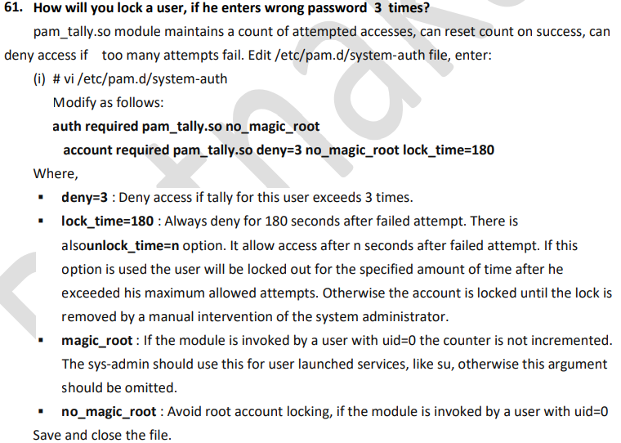
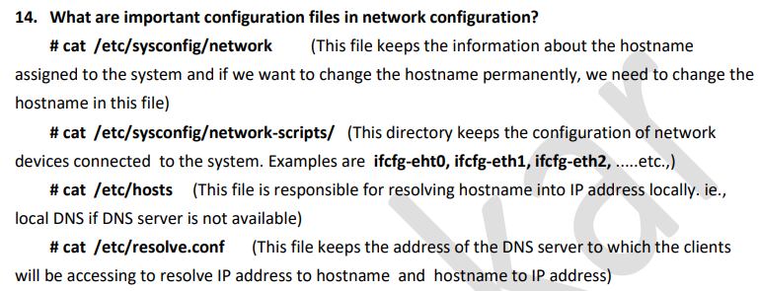
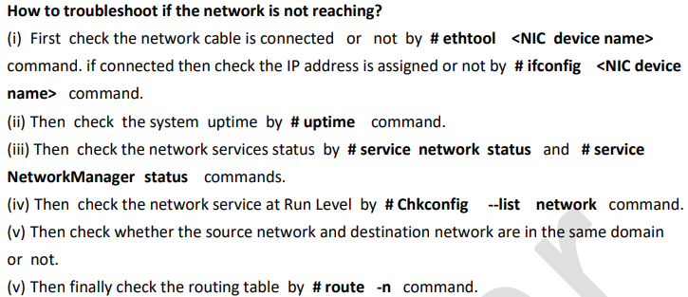
In Linux systems the booting is done in 6 stages. • BIOS • MBR • GRUB • Kernel • Init • Runlevel
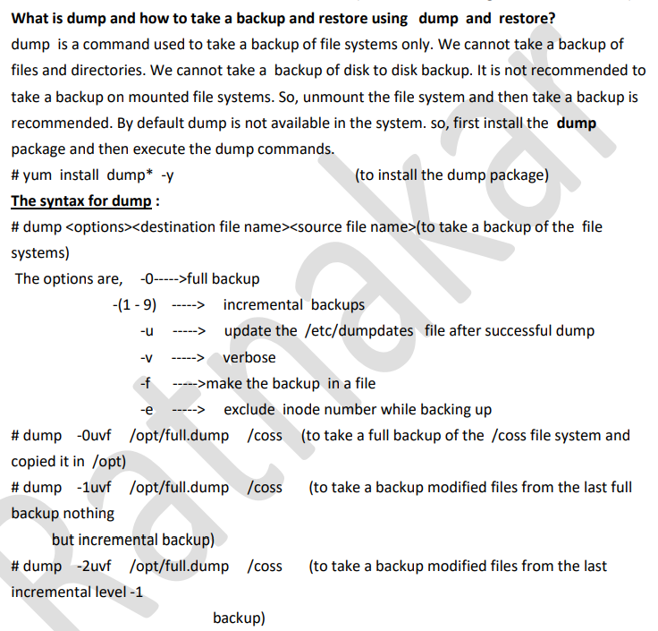
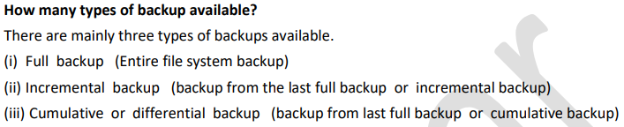
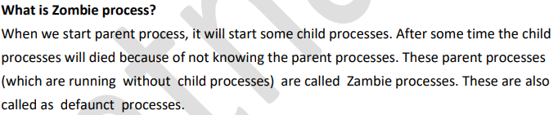
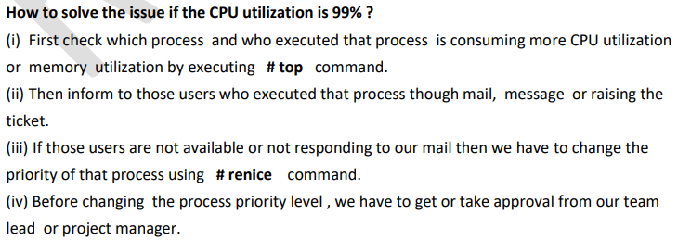
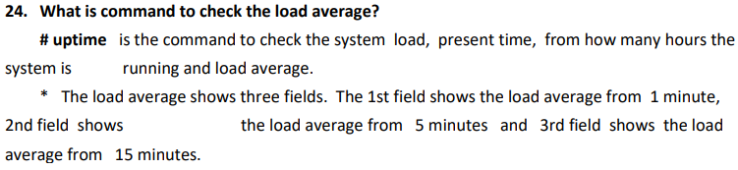
In Linux the default run level is 5 in GUI and 3 in CLI.
What is " wait " and where it is stored?
(i) If there is not enough memory to run the process, then it will wait for free space in memory. That process is called wait.
(ii) wait is stored in buffer like cache memory.
In how many ways we can connect the remote system?
(i) telnet (ii) ssh
(iii) rlogin (iv) rcp
(v) ftp (vi) scp
(vii) sftp (viii) tftp
How allow the specified no. of users to access remote system at a time?
(i) Open the ssh configuration file by # vim /etc/ssh/sshd_config then go to MaxAuthTries line and type as,
MaxAuthTries <no.> (type any numeric value equal to Max. users to allowat a time in place of <no.>,
A system is able to ping locally but not out site. Why?
(i) May be there is no access to outside.
(ii) May be outside is in different network from the local.
(iii) May be permission is denied for that system to access outside.
(iv) If there is access, but router or modem or network switch or NIC may not be working to access the outside.
(v) May be outside is not available temporarily.
# last -x |grep shutdown (to see the date & time of the system's last shutdown)
dump is a command used to take a backup of file systems only. We cannot take a backup of files and directories. We cannot take a backup of disk to disk backup. It is not recommended to take a backup on mounted file systems. So, unmount the file system and then take a backup is recommended. By default dump is not available in the system. so, first install the dump package and then execute the dump commands.
# yum install dump* -y
The options are, -0----->full backup
-(1 - 9) -----> incremental backups
-u -----> update the /etc/dumpdates file after successful dump
-v -----> verbose
-f ----->make the backup in a file
-e -----> exclude inode number while backing up
# restore <options><dump backup file> (to restore the backup contents if that data is lost)
The options are, -f -----> used to specify the dump or backup file
-C -----> used to compare the dump file with original file
-v -----> verbose
-e -----> exclude the inode number
-i -----> restore in interactive mode
How many types of backup available?
There are mainly three types of backups available.
(i) Full backup (Entire file system backup)
(ii) Incremental backup (backup from the last full backup or incremental backup)
(iii) Cumulative or differential backup (backup from last full backup or cumulative backup)
Which file will update when backing up with dump command?
/etc/dumpdates file will be updated when backing up with dump command.
What are the dump devices?
(i) Tape drives
(ii) Disks (local disks)
(iii) Luns (network disks)
"tar" stands for tape archive.
# ps (to see the active process in the system)
# top (It will show a dynamic real-time view of a running system. ie., a summary of processes or threads currently managed by the Linux kernel)
# kill (It sends the specified signal to the specified process or process group)
# pkill (It will send the specified signal to each process instead of listing them on standard output)
# pstree (to show all the running processes as a tree structure. The tree is rooted either pid or init)
# nice (to run a program with modified scheduling priority ie., it runs the process with an adjustable niceness)
# renice (to alter the scheduling priority of one or more running processes)
# pgrep (to list the process id's which matches with the pgrep argument)
Useful # ps commands :
# ps -a (it displays all the terminals processes information)
# ps -au (it displays all the terminals processes information with user names)
# ps -aux
(it displays all the terminals processes information including background processes with user names)
* ? (question mark) if it is appeared at tty column, it indicates that is a background process.
# ps -ef (it displays the total processes information with parent process ID (PPID))
# ps -P <process id> (it displays the process name if we know the process ID (pid))
# pidof<process name> (to see the process ID of the specified process)
# pidof initd (to see the process ID of the initd process)
# pstree (to display the parent and child processes structure in tree format)
# ps -u <user name> (to display all the processes of the specified user)
# ps -u raju (to display all the processes of the user raju)
# ps -G <group name> (to display all the processes that are running by a particular group)
# ps -o pid, comm, %mem, %cpu (to display process id, command, %memory and %cpu utilization nothing but filtering the output)
# ps -Ao pid, comm, %mem, %cpu (to display the same information as above but including some more information)
# ps -o pid, comm, %mem, %cpu |sort -k <no.> -r |head -n 10
(to display which process is utilizingmore memory or cpu in reverse order where -k means field, <no.> means field no. and -r reverse order)
# ps -o pid, comm, %mem, %cpu |sort -k 3 -r |head -n 10 (to display the process which occupies more memory and cpu utilization in reverse order)
# ps -aux |grep firefox (to check whether the firefox is running or not)
# pgrep -U <user name> (to display all the process ID's only for that user)
* To communicate with the processes # kill and # pkill commands are used.
# kill -----> It will kill the processes using PID's.
# pkill -----> It will kill the processes using process names.
* We can also give some signals while using the above commands and we get the signals information by
# kill -l command. This command will list all the signals with no's and there are 64 signals to pass.
* But the most commonly used signals are 1, 9, 15 and 20.
* The default signal is 15 (gracefully) when we not specified any signal.
# kill - <signal><process ID> (to kill the specified process using kill signal)
# kill -9 1291 (to kill the process which has the PID as 1291)
* If we not specified the signal no. then the default signal 15 will effect.
# kill 1291 (to kill the process 1291 with default signal)
# pkill -u <user name> (to kill all the processes of the specified user)
# pkill -u raju (to kill all the processes of the user raju)
# pkill -9 firefox (to kill the firefox process)
* But the most commonly used signals are 1, 9, 15 and 20.
* The default signal is 15 (gracefully) when we not specified any signal.
# kill - <signal><process ID> (to kill the specified process using kill signal)
# kill -9 1291 (to kill the process which has the PID as 1291)
* If we not specified the signal no. then the default signal 15 will effect.
# kill 1291 (to kill the process 1291 with default signal)
# pkill -u <user name> (to kill all the processes of the specified user)
# pkill -u raju (to kill all the processes of the user raju)
# pkill -9 firefox (to kill the firefox process)
What is "sosreport" and how to generate it?
Sosreport is a command in linux (RHEL / CentOS) which collects system configuration and diagnostic information of your linux box like running kernel version, loaded modules, and system and service configuration files.
How to remove the page caches and other caches?
# sysnc ; echo 2 > /proc/sys/vm/drop_caches (to remove the page caches)
# sysnc ; echo 3 > /proc/sys/vm/drop_caches (to remove all types of caches like dent cache, page caches and others)
What is the command to see the complete information on virtual memory?
# vmstat is the command to the complete information on virtual memory like no of processes, memory usage, paging memory, block I/O (input /output), traps, disk and CPU activity.
# vmstat 2 10 (It will give the report for every 2 seconds upto 10 times)
# vmstat -a (to see the active and inactive processes)
# vmstat -d (to see the statistics of the disk used)
What is the command to see the I/O statistics?
# iostat (to see the Input and Output statistics in the Linux system)
* This command is used to monitoring the system input and output statistics and processes transfer rate.
* It is also used to monitor how many kilo bytes read per second and how many kilo bytes read and write, shows CPU load average statistics since the last reboot in first line and most current data is shown in the second line.
How many CPUs are there in the system?
# cat /proc/cpuinfo command will show no. of CPUs, no. of cores, no. of threads, no. of sockets and the CPU architecture, ...etc., information.
# nproc command will give the no. of CPUs present in the system.
# lscpu command will give the information the architecture of the CPU (x86_64 or x86_32), no. of cores, no. of threads, no. of sockets, cache memory sizes (L 1, L 2, L 3, ...etc) , CPU speed and the vendor of the CPU.
What is command to check the load average?
# uptime is the command to check the system load, present time, from how many hours the system is running and load average.
* The load average shows three fields. The 1st field shows the load average from 1 minute, 2nd field shows the load average from 5 minutes and 3rd field shows the load average from 15 minutes.
How to assign or shift the process to the particular CPU?
(i) First install util-linux package by # yum install util-linux -y command.
(ii) Check the specified process is assigned to which processor ie., which CPU by # taskset -p <pid> command.
(iii) Then shift the process to another available CPU by # taskset -cp <cpu -list><pid> command.
How to limit the CPU usage of a linux process?
(a) First install the cpulimit package by # yum install cpulimit -y command.
* This package is not available in normal Linux packages and it is available in EPEL (Extra Packages for Enterprise Linux). So, first we have to enable the EPEL repository in our system by following steps.
(b) # cpulimit -p <PID> -l 10 (to see the CPU usage of that process and limit the CPU usage to 10%)
(c) # cpulimit -e /usr/local/bin/myprog -l 20 (to limit the CPU usage of this command to 20%)
How to capture the network traffic?
# tcpdump is the command to capture and analyze the network traffic. By using this command we can also troubleshoot the network problems.
Examples :
# tcpdump (to capture and analyze the network traffic)
# tcpdump -i eth0 (to capture the network traffic from eth0 continuously and Ctrl + c to exit)
# tcpdump -c 30 -i eth0 (to capture the network traffic from eth0 upto 30 packets only)
# tcpdump -w /root/tcp.pcap -i eth0 (to capture the network traffic from eth0 and write that in /root/tcp.pcap file)
# tcpdump -t t t -r /root/tcp.pcap (to read the contents of the above captured file)
# tcpdump -i eth0 port 22 (to capture the network traffic from eth0 of ssh traffic)
# tcpdump -i eth0 dst 172.25.0.11 and port 22 (to capture the network traffic from 172.25.0.11 system of ssh traffic)
What is SAR utility and how to use it?
SAR stands for System Activity Report. Using SAR we can check the information of CPU usage, memory, swap, I/O, disk I/O, networking and paging. We can get the information of the present status and post status (history using the data) upto last 7 days because HISTORY=7 is there in the configuration file. The log messages are stored in /var/log/sa/sa1, /var/log/sa/sa2, /var/log/sa/sa3, ....etc., (where 1, 2, 3, ....etc., are dates). The SAR configuration is stored in /etc/sysconfig/sysstat file. In this file the HISTORY=7 default option will be there. So, we can change the default 7 days to our required value.
Before using the SAR utility first we should install the SAR utility package by # yum install sysstat* -y command.
# sar -p 2 10 (to see the CPU utilization for every 2 seconds upto 10 times)
# sar -r 2 10 (to see the memory utilization for every 2 seconds upto 10 times)
# sar -S 2 10 (to see the swap utilization for every 2 seconds upto 10 times)
# sar -q 2 10 (to see the load average for every 2 seconds upto 10 times)
# sar -q -f /var/log/sa/sa14 (to check the load average on 14th day of the current month)
# sar -d 2 10 (to see the disk usage for every 2 seconds upto 10 times)
# sar -m 2 10 (to see the power management for every 2 seconds upto 10 times)
# sar -b 2 10 (to see the disk input and output statistics for every 2 seconds upto 10 times)
# nproc (to check how many processors (CPUs) are there in the system)
# iptraf (to monitor the TCP or network traffic statistics in graphical mode)
# iftraf -ng -f eth0 (to see the IP traffic statistics in graphical mode)
# lscpu (to see the no. of CPUs present in the system)
# lsusb (to see the no. of USB devices present in the system)
# lsblk (to see all the partitions or block devices information)
# cat /etc/redhat-release (to see the RHEL version of system)
# dmidecode (to see the complete hardware information of the system)
# dmidecode -t memory (to see the memory information of the system)
# dmidecode -t bios (to see the system's bios information)
# dmidecode -t system (to see the system's information)
# dmidecode -t processor to see the processor's (CPU's) information of the system)
# dmidecode -t 1 (to check the System's Serial No. information)
# dmidecode -t 4 (to see the processor's (CPU's) information)
# dmidecode -t 16 (to check the Max. RAM capacity of the system)
# dmidecode -t 17 (to check how much RAM the system is using)
# pidstat (to monitoring the individual tasks currently being managed by the Linux kernel)
# nfsiostat (to monitor the NFS input and output statistics)
# cifsiostat (to monitor the Samba input and output statistics)
# stat <file name or directory name> (to see the statistics of the file or directory)
# strings <command name> (to read the binary language of the command)
# find / -nouser -o -nogroup (to see the files which are no belongs to any user and any group)
# systemctl -t help (to see the list of systemd objects that are available)
# systemctl -l help (to see the list of unit names)
# systemctl list-dependencies <service name> (to see the dependent services in a tree manner)
# sleep <seconds>& (to run the sleep processes at background)
# jobs (to see the background jobs which were sent by the user)
# fg % < Job ID > (to get back the background job to foreground job)
# Ctrl + z (to stop the process)
# bg % < Job ID > (to restart the process again at background)
Take a backup of the database.
# mysqldump -u root -p <database name>><file name with full path>
How to add mysqld service to IPtables and mariadb service to firewall?
In RHEL - 6 :
# iptables -A INPUT -i eth0 -p tcp -m tcp --deport 3306 -j ACCEPT
# iptables -A OUTPUT -i eth0 -p tcp -m tcp --deport 3306 -j ACCEPT
# service iptables save
# service iptables restart
# chkconfig iptables on
In RHEL - 7 :
# firewall-cmd --permanent --add-port=3306
# firewall-cmd --complete-reload
) Add the log server service to IPtables.
# iptables -A INPUT -p tcp -m tcp --deport 514 -j ACCEPT (to add the incoming port no. to
var/log/messages -----> System and general messages and DHCP log messages.
/var/log/authlog -----> Authentication log messages.
/var/log/secure -----> Security and authentication and user log messages.
/var/log/maillog -----> Mail server log messages.
/var/log/cron -----> Cron jobs log messages.
/var/log/boot.log -----> All booting log messages.
# logger <type any text> (to send that text into /var/log/messages files and to test whether logging service is running or not)
# logrotate (to create the log files with datewise)
* Generally in log messages the fields are,
# logwatch (to monitor the log messages)
IP tables is a command-line firewall utility that uses policy chains to allow or block traffic.
There are four types of firewalls.
(i) Packet firewalls :
- It works atPhysical, Data Link and Network Layers.
- It works fast and efficiently.
- It treats each packet in isolation.
(ii) Statefull firewalls :
- It identifies a packets connection state.
- It maintains packets history in the state tables.
(iii) Application layer firewalls :
- It inspects and filter packets on OSI layer upto Application Layer.
- It identifies if protocols are being misused.
(iv) Proxies firewalls :
- It acts as an intermediary.
- It operates at Application Layer.
- It won't allow direct connections.
- What are the tables maintained by IP tables?
- Normally IP tables maintain 3 tables.
- (i) INPUT table:
- This chain handles all packets that are addressed to your server and also to control the behaviour for incoming connections. For example, if a user attempts to SSH into your PC/server, iptables will attempt to match the IP address and port to a rule in the input chain.
- (ii) OUTPUT table :
- This chain contains rules for traffic created by your server. This chain is used for outgoing connections. For example, if you try to ping google.com, iptables will check its output chain to see what the rules are regarding ping and google.combefore making a decision to allow or deny the connection attempt.
- (iii) FORWARD table :
- This chain is used for incoming connections that aren’t actually being delivered locally. Think of a router – data is always being sent to it but rarely actually destined for the router itself; the data is just forwarded to its target. Unless you’re doing some kind of routing, NATing, or something else on your system that requires forwarding, you won’t even use this chain.This chain is used to deal with traffic destined for other servers that are not created on your server. This chain is basically a way to configure your server to route requests to other machines.
- What are the meanings of REJECT, DROP and ACCEPT ?
- REJECT :
- REJECT means server receives the FTP request from the specified IP address and rejects that request and
- also send the acknowledgement.
- DROP :
- DROP means server receives the FTP requests from the specified IP address and drop the request without sending any acknowledgement.
- ACCEPT :
- ACCEPT means server receives the FTP requests from the specified IP address and allow that system for FTP services.
- /etc/sysconfig/iptables is the configuration file of IP tables.
- # iptables <options><chain> firewall-rule (to execute the IP tables)
- The options are as follows.
- -A -----> Add or append the rule.
- -p -----> Indicates the protocol for that rule (tcp, udp, icmp, ....etc.;).
- -s -----> Indicates the source of the packet (IP address, Network ID or Hostname).
- -d ----->Indicates the destination of the packet.
- -j -----> 'Jump to target' indicates the interface through which the incoming packets are coming through the INPUT , FORWARD and PREROOTING chain.
- -o -----> 'Output Interface' indicates the interface through which the outgoing packets are sent through the INPUT, FORWARD and PREROOTING chain.
- -sport or -source-port -----> Source port for -p tcp or -p udp.
- -dport or -destination-port -----> Destination port for -p tcp or -p udp.
- In how many ways can we protect the network?
- There are 4 ways to protect the network.
- (i) SELinux
- (ii) IP tables
- (iii) Firewalld
- (iv) TCP wrappers
- IP tables and firewalld both are used to protect our systems services from outside. But we can use only one way at a time.
- # service iptables status (to check the IP tables status)
- # service iptables start (to start the IP tables)
- # service iptables stop (to stop the IP tables)
- # service iptables restart (to restart the IP tables)
- # service iptables save (to save the iptable rules permanently)
- # chkconfig iptables on (to enable the iptables at next boot)
- # chkconfig iptables off (to disable the iptables at next boot)
- # iptables -P INPUT DROP (to block the input traffic)
- # iptables -P FORWARD DROP (to block the forward traffic)
- # iptables -p OUTPUT DROP (to block the output traffic)
- (where P is capital letter)
- # iptables -A INPUT -s 9.9.9.9 -j DROP (to block the 9.9.9.9 input traffic)
- # iptables -L (to see the list of the IP tables)
- # iptables -F (to flush the iptable rules nothing but deleting all the rules)
- # iptables -save > /root/iptables (to save all the existing iptables rules as backup copy in /root/iptables file)
- # iptables -F (to delete all iptables rules)
- # iptables -restore < /root/iptables (to restore the IP tables from the backup file)
PING uses the aforementioned ICMP protocol to send out echo requests for responses from a selected host. If the request is received by the tested host, it will reply with an ICMP Echo Reply message.
Ping www.google.com
The command used is PING, followed by the hostname or IP address of the host that you want to test.
The Trace Route test, also known as traceroute and tracert, is a utility that maps the path between the tested hosts. The results are then displayed as a list of hops.
The information provided could be used to identify a weak link along the route. If the test fails at a certain point, the IP address of the last router that responded properly is known, so the problem could then be identified more easily.
The MTR test is combination of the ones above. This test analyses the network connection between two hosts. It first determines the IP address of each of the hops and then sends a sequence of ICMP ECHO requests to each hop, thus providing information about the quality of the link. Below is shown the output from a MTR test using WebSitePulse Free Test Tools.
MyTraceRoot(MTR)

Using PathPing
This network utility is a more advanced version of the Ping tool, which performs a ping to each hop along the route to the destination (unlike Ping, which just pings from the originating device to the destination device). It is extremely useful in diagnosing packet loss, and can help with diagnosing slow speed faults.
Pathping serverip
# stat <file name> (to display the status of a file or file system like absolute path of the files, the no of blocks used by the file, the I/O block size, inode access specifier, access time, time of modification, ....etc)
# mc (it is a powerful text based file manager and it is a directory browsing tool and allows to see thecontents of the archived files, ...etc.;)
What are the tools you are using?
(i) netstat, vmstat, iostat, nmap and top for performance monitoring tools.
(ii) cron and at for job scheduling.
(iii) Remedy tool for ticketing system.
(iv) Veritas Netbackup, Tivoli, .... etc., for backing purpose
(v) Outlook for internal mailing.
What is server hardening?
(i) To checking our system is reaching to standards required by the organization.
(ii) That is minimum password length, minimum size of root partition.
(iii) Minimum free space and password expiry and all other security standards.
Decommission means the process of removing the old system from the production environment and Recommission means the process of putting the new system into the production environment.
Backup is automated though crontab or separate backup tools like Veritas Net backup and Tivoli, ....etc.,
) Sometimes backup failed due to backup port no. 13782 may be not working or in blocked state. It can be checked by # netstat -ntulp | grep 13782 command.
CPU utilization full, how to troubleshoot it?
First check which processes are using more CPU utilization by # top and take a snap shot of that user processes and send the snap shot and inform to that user to kill the unnecessary process.
How to troubleshoot when the system is slow?
(a) System slow means the end users response is slow.
(b) Check the Application file system, CPU utilization, memory utilization and O/S file system utilization.
How to troubleshoot if the node is down?
(a) Check pinging the system. If pinging, then check whether the system is in single user mode or not.
(b) If the system is in single user mode then put the system in multi user mode ie., default run level by confirming with our team whether system is under maintenance or not.
How to troubleshoot if the memory utilization full?
(a) Check how much memory is installed in the system by # dmidecode -t memory command.
(b) Check the memory utilization by # vmstat -v command.
How to replace the failed hard disk?
(a) Check whether the disk is failed or not by # iostat -En | grep -i hard/soft command.
(b) If hard errors are above 20 then we will go for replacement of the disk.
What is the command in sar to monitor NIC devices received/transmitted packets?
# sar -n DEV 1 5
This will show 5 consecutive output each with a time interval of 1 sec for all the ethernet devices
What are the main parameters effect on server performance?
The one of the most important task of any Linux Admin includes performance monitoring which includes a parameter "Load Average" or "CPU Load".
What is load average?
Load Average is the value which represents the load on your system for a specific period of time. Also it can be considered the ratio of the number of active tasks to the number of available CPUs.

43. How to check?
We can use either top or uptime command to view the output of the load average as shown below.
# uptime
00:07:00 up 4 days, 6:14, 1 user, load average: 0.11, 0.14, 0.09
# top
top - 00:07:12 up 4 days, 6:15, 1 user, load average: 0.09, 0.13, 0.09

What do you understand the Load Average?
If the number of active tasks utilizing CPU is less as compared to available CPU cores then the load average can be considered normal but if the no. of active tasks starts increasing with respect to available CPU cores then the load average will start rising.For example,
# uptime
00:43:58 up 212 days, 14:19, 4 users, load average: 6.07, 7.08, 8.07
What is an orphan process?
An orphan process is a process that is still executing, but whose parent has died.
What is the command to take remote of any Linux machine?
# rdesktop
How do you limit maximum connections in your apache server?
Change the below parameter value inside httpd.conf
MaxClients 256
Which command do you use to download a file from ftp or http website using CLI?
# wget path_to_the_file
What is the difference between A record and CNAME record in DNS?
A record :
- It is the Address records also known as host records
- Points to the IP address reflecting the domain
- Used for forward lookup of any domain name
For example:
Our website is configured on 50.63.202.15 IP so the A record of my domain name will point towards that IP.
Every time a query for golinuxhub.com is made the internet will lookup for contents stored on the machine with 50.63.202.15 this IP.
CNAME Record :
- It is short abbreviation for Canonical Name
- Provides an alias name for same hostname
- Helps create subdomains
NOTE: You cannot create a CNAME record for the domain name itself (it should be done with A record)

Credentials stored in Jenkins can be used:
- anywhere applicable throughout Jenkins (i.e. global credentials),
- by a specific Pipeline project/item (read more about this in the Handling credentials section of Using a Jenkinsfile),
- by a specific Jenkins user (as is the case for Pipeline projects created in Blue Ocean).
Jenkins can store the following types of credentials:
- Secret text - a token such as an API token (e.g. a GitHub personal access token),
- Username and password - which could be handled as separate components or as a colon separated string in the format username:password (read more about this in Handling credentials),
- Secret file - which is essentially secret content in a file,
- SSH Username with private key - an SSH public/private key pair,
- Certificate - a PKCS#12 certificate file and optional password, or
- Docker Host Certificate Authentication credentials.

Load Statistics
This pages displays graphical data on how busy the Jenkins instance is in terms of the number of concurrent builds and the length of the build queue which gives an idea of how long your builds need to wait before being executed. These statistics can give a good idea of whether extra capacity or extra build nodes is required from an infrastructure perspective.

The agent directive tells jenkins to allocate a workspace and an executor for the pipeline. Without it, the pipeline is not valid and therefore required
# Ignore everything in /jobs
*
# Reinclude all folders in /jobs
!*/
# Ignore everything in the subfolders of /jobs
*/*
# Reinclude config.xml files in the first-level subfolders of /jobs
!*/config.xml

Click Reload Configuration from Disk button in the Jenkins web user interface to force Jenkins to reload configuration from the disk.
Since you can’t delete a file that is currently opened by a program you need to stop all applications accessing the log file. If you are running Ubuntu the applications are Jenkins itself and the rsyslog service.
sudo service jenkins stop
sudo rm /var/log/jenkins/jenkins.log
sudo service rsyslog restart
sudo service jenkins start

Jenkins Shared Libraries
Jenkins shared library is a great way to reuse the pipeline code. You can create libraries of your CI/CD code which can be referenced in your pipeline script. The extended shared libraries will allow you to write custom groovy code for more flexibility.

Jenkins Backup Using Thin Backup Plugin
Jenkins Thin Backup is a popular plugin for backing up Jenkins

In a distributed Jenkins environment, resource utilization of the slaves will be very less when the builds are not quite often. In this scenario, it is better to use ephemeral docker containers as your build slaves for better resource utilization.
As we all know that spinning up a new container takes less than a minute. So, for every build, a new container will get spun up, builds the project and will get destroyed.
Jenkins master connects to the docker host using REST API’s.
So we need to enable the remote API for our docker host
You will need Docker remote API in various situations. Let’s say you are running the docker host on a remote server and you want to connect to it from your laptop. For this scenario, you can use the remote API and connect to it using REST API’s as the docker engine accepts REST requests.

Enable Docker Remote API
All the docker configurations are present in the file/lib/systemd/system/docker.service. In that file, there is an ExecStart parameter.
Open the file/lib/systemd/system/docker.service, search for ExecStart and add values as shown below.
For Ubuntu,
ExecStart=/usr/bin/docker daemon -H fd:// -H tcp://0.0.0.0:4243
For Centos,
ExecStart=/usr/bin/dockerd -H tcp://0.0.0.0:4243 -H unix://
You can test the API using REST client like Postman. If you use the following URL in your REST client, you will get the JSON output in a prettified manner as shown in the image below
Shell Scripting
=============
\ Escape character
Define like this: touch ravi \ Kumar (Treats single name only)
Cd . : Current Directory
Cd ~ : User’s home directory
Cd - : Moving to the previous directory where you are coming from.
Date
Date +%d-%m-%y
Date +%F
Date +%d:%m:%y
Date –r shell Modified time stamp
Touch test{1..10}.txt(creates test1,test2….test10)
Cp -p source dest (preserves the time stamp and everything)
Diff –c file 1 file 2 (displays the exact changes b/n the 2 files)
Diff –y file1 file2 (displays the 2 files side by side to showcase)
Grep file[^2345] grs Not included in to the output,except the 2345
Grep test$ grs Line is ending with the test
Grep ^test grs starting character
Cat /var/log/messages | more (to display the content one by one)Lengthy of text
More messages
Sort –nk2 file (column number is k,to sort the second column in to order)
Sort –r file (Reverse Order)
Df –h | sort –nk2(To display the volume mounted and storage data)2nd column is sorted
Tail –f /var/log/messages (The updating has been displayed)
Tr – Used to convert lower case to upper case and vice versa
Tr a-z A-Z
Tr a-z A-Z < file (as file as a input for the command)
Cat file1 | tr –d A
Cat file2 | tr –d E (delete the E from the current namespace
Echo “12345 are the numbers” | tr –d [:digit:](It deletes the digits from the given text)
Echo “this is the line” | tr [:space:] ‘\t’
It displays the tab space b/n the line

Sed :
Sed ‘s/arkit/tech/2’ file1
It changes the second occurrence of the word in the given string
Sed ‘s/arkit/tech/g’ file1
All occurrences
Sed ‘s/arkit/tech/2g’ file1
Sed ‘s/^\(arkit\)$/#\1/1’ example
Sed –i ‘s/^\(arkit\)$/#\1/1’ example(i-permanently changes the file)
Sed ‘s/https:\/\//www.’ Example
Can comment the particular line number and delete the line number.insert some lines starting of the files and ending of the files, Replacing the specified line.
Sed ‘3 s/arkit/Tech/’ example (Single line)
Sed ‘3,5 s/arkit/Tech/’ example (Multiple lines)
Sed ‘3 d’ example (Deletes third line)
Sed –i ‘3 d’ example(i-permanently changes the file)
AWK:
====
Test manipulation tool,built string functions.
Cat example | awk ‘{print $3,$9}’
Print’s 3rd and 9th columns remaining fields would be eliminated
#!/usr/bin/awk -f
Awk ‘BEGIN {sum=0} {sum=sum+7} END {print sum}’example
Awk –f sumawk example
To print the matched content only!
Awk ‘{ if($3 == “arkit”) print $0;}’ awkexample
Print the entire line
Vmstat:
Tool is used to Reports data about machine processors,swap,IO Utilizations resources,
Linux machine performance monitoring is easy
# Vmstat –a
It displays Process, Memory, Swap, IO, System, and CPU
Vmstat –f Dispalys the forks
Vmstat –m Displays the SWAP info
Vmstta –t Displays time stamp
Vmstat –t 3 10 (every 3 seconds up to 10 lines)
Netstat :
-----------
Is used to create the sockets.To open and listen ports.The port is listening or not.
#netstat –tunlp (Existing port no’s)
#mail -- Verify the mails
&1 Email number will display the content of an Email
Mail is used to send the messages to the different users
Mail –s “Hello world” admin@localhostt (To send an email to admin user)
#echo “testing mail” | Mail –s “Hello world” admin@localhost(Includig the body line)
Mail –s “Hello world” admin@localhost < example
(Including an attachment) Mail –s “Hello world” admin@localhost -a (attachment) example
Mail –s “Hello world” admin@localhost -c(CC) admin@localhost -b(bcc) admin@localhost

Workspaces -- To open the terminals and running the simulations stuff (4 )
Cut
====
Echo “ravi” | cut –b 2 (o/p : a) (Single Byte)
Cut range of bytes
Cut –b 2-4
Cat exam | cut –c 1,4,10 (First, Fourth and 10th character)
Cut – c 10-15
Cut –c 5-(Cuts from 5th character to the line last number)
Cut –d’:’ –f 1 example
Select all fields except the delimited fields
Cut –d’:’ –complement –s f5 if delimiter is there then only used
Cut –d’:’ –s –f1,4,2 --output-delimiter=’$’
Cut –d’:’ –f1-4 –output-delimiter=$’\n’
Each delimiter column in to a separate field
Paste:
====
Merging of the files
Paste file1 file2
Paste –s 1 2 Converts columns in to the single row.
It is joining the lines in the columns
Paste –d, -s 2(Delimiter) (Column no)
Converts columns in to the single row.
Paste –d”#,” –s 2(Column no)
Merging the contents of a different files
Paste –d’\n’ file1 file 2 everything in to line by line
Paste –d’ ’ file1 file 2 | cut –d ‘‘–f 1,2,4,5
SSH – Secure shell
  - Symmetric Algorithms: Secret Key
Use same key for both encryption and decryption
  - Asymmetric Algorithms: Public Key
Use different key for both encryption and decryption
- Known_hosts file
- Authorized _keys file
Ls –ltr (Time stamp)
Scp –rvp source1 destination (It’s copy with the all contents)
Shift --- shifts the parameters from left to right automatically
It is a bash feature
Shift – first parameter shifts to second and second to third like this
Shift 2 switching the 2 positions
Shift 4 switching the next 4 positions
Functions:
========
Functions are used to develop modularity in program. Divide the large script in to multiple tasks
A large program can be split into multiple small modules. Each module performs an specific task. Instead of writing the code over and over again we can write single function and call the function whenever you want and wherever you want throughout the program.
Function name ()
{
}
Name () -- function calling

PYTHON
=======
Used for automation
- Linux automation
- Windows Automation
- Cloud Automation
1. Join(Merge)
a = "hello"
b = ("guys","v","n","m")
print (a.join(b))
2. rsrtip
a = " hello"
print(a)
print (a.lstrip())
3. split
Returns list of substrings
a = [1,2,3,4,5,6,7,8,9]
b = [99,100]
print(a.append(11))
print(a)
print(a.insert(3,34))
print(a)
a.extend(b)
print(a)
b.pop(1)
print(b)

Dir
====
It returns the sorted list of strings containing the names defined by a amodule
import numpy
a = dir(numpy)
print(a)

OS Tasks
=====
import os
os.system("ls") -- executing a shell command

import os

#print(os.getpid()) # returns real process ID of the current process
#print(os.getcwd()) # return current working directory
#os.chdir() # move to differnet directory
#print(os.chmod()) # change the mode of path
#print(os.chown()) #change the owner of file
#print(os.getsize()) #get the size of a file
#print(os.uname()) # prints os information
#print(os.listdir(path)) # list of the entries in the directory given by path
#print(os.path.exists()) # check path exists
#print(os.mkdir(path)) # create directory named path with numeric code
#print(os.remove(path)) # remove delete the path
#print(os.rmdir(path)) # remove directory path
print(os.makedirs(path)) # recursive directory creation function
os.removedirs(path) # remove directories recursively
os.rename(src,dst) # rename the file or dir src to dst

OS.Path
======
Os.path.isdir(path)
Os.path.isfile(path)
Fabric
=====
It is a python library. It’s a command line tool for streamlining the use of SSH for application deployment or system administration tasks
It is used to write and execute the python functions and tasks to automate the interactions with remote servers.
Pip is used to install the python
Pip install fabric
Fab file or fab scripts
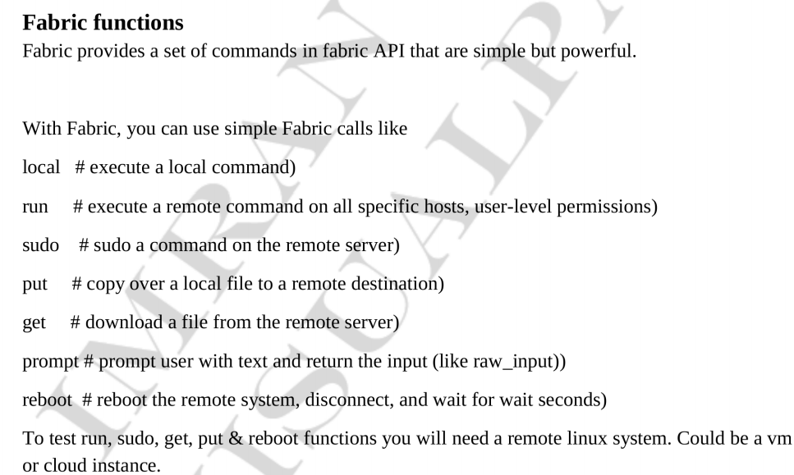
Boto
====
Pip install boto
~/.boto file is used for access and secret key files
Import boto
Conn = boto.connect_s3()
Bucket = s3.create_bucket(‘boto-demo-%s’ % int(time.time()))
Mybucket = conn.get_bucket(‘mybucket’)
Mybucket.lsit()
Conn.delete_bucket(‘mybucket’
Import boto.ec2
Conn = boto.ec2.connect_to_region(“us-west-2”)
Conn.run_instances(key_name,instance_type,Security_groups)
Conn.stop_instances(instances_ids)
Conn.terminate_instances
Import boto.dynamodb2
Dynamodb -- NoSQL DB service.

Python Functions
==============
- Lower
- Upper
- IsUpper
- IsLower
- len
print(x.upper().islower())
print(x.upper().isupper())
print(len(x))
print(x[3]) -- To retrieve the index no of 3rd position
x = "hello world"
print(x.index("e"))
print(x[3])
replace(source,dest) :
print(x.replace("ello","worl"))
print(2) # output is 2
print(2.8908) # 2.8908
print(-2.8907) # -2.8907
print((3 * 4) + 3 - 2 / 3)
print(10 % 3) # remainder is “1”
abs()
pow() -- a = 3
print(pow(a,2))
max()
min()
a = [2,3,4,5,6,7,7]
print(max(a))
print(min(a))
print(len(a))
print(round(3.8907899))
print(round(2.11111))

from math import *

print(floor(2.456777))
print(ceil(3.11))
print(sqrt(2345))

