Continuous Integration, Delivery or Deployment with Jenkins, Docker and Ansible
- CI/CD Environment

We’ll set up Jenkins environment using Vagrant and Ansible.

Vagrant will create a VM with Ubuntu and run the bootstrap.sh script.

#!/bin/bash
echo "Installing Ansible..."
apt-get install -y software-properties-common
apt-add-repository ppa:ansible/ansible
apt-get update
apt-get install -y ansible
cp /vagrant/ansible/ansible.cfg /etc/ansible/ansible.cfg
Two key lines in the Vagrantfile are:
2  3  4 | ...  cd.vm.provision "shell", path: "bootstrap.sh"  cd.vm.provision :shell, inline: 'ansible-playbook /vagrant/ansible/cd.yml -c local'

The only purpose of that script is to install Ansible. Once that is done, Ansible will make sure that Docker is installed and Jenkins process is running

Once bootstrap.sh is executed, Ansible playbook cd.yml is run.
- hosts: localhost
remote_user: vagrant
sudo: yes
roles:
- java
- docker
- registry
- Jenkins

It will run java, docker, registry and jenkins roles.
Java is the Jenkins dependency required for running slaves.
Docker is needed for building and running containers. All the rest will run as Docker processes. There will be no other dependency, package or application that will be installed directly.
Registry role runs Docker Registry. Instead of using the public one in hub.docker.com, we’ll push all our containers to the private registry running on port 5000. Finally, jenkins role is run. This one might require a bit more explanation.

Here’s the list of tasks in the jenkins role.
- name: Directories are present
file: path="{{ item }}" state=directory
with_items: directories

- name: Config files are present
copy: src='{{ item }}' dest='{{ jenkins_directory }}/{{ item }}'
with_items: configs

- name: Plugins are present
get_url: url='https://updates.jenkins-ci.org/{{ item }}' dest='{{ jenkins_directory }}/plugins'
with_items: plugins

- name: Build job directories are present
file: path='{{ jenkins_directory }}/jobs/{{ item }}' state=directory
with_items: jobs

- name: Build jobs are present
template: src=build.xml.j2 dest='{{ jenkins_directory }}/jobs/{{ item }}/config.xml' backup=yes
with_items: jobs

- name: Deployment job directories are present
file: path='{{ jenkins_directory }}/jobs/{{ item }}-deployment' state=directory
with_items: jobs

- name: Deployment jobs are present
template: src=deployment.xml.j2 dest='{{ jenkins_directory }}/jobs/{{ item }}-deployment/config.xml' backup=yes
with_items: jobs

- name: Container is running
docker: name=jenkins image=jenkins ports=8080:8080 volumes=/data/jenkins:/var/jenkins_home

- name: Reload
uri: url=http://localhost:8080/reload method=POST status_code=302
ignore_errors: yes

First we create directories where Jenkins plugins and slaves will reside.
In order to speed up building containers, we’re also creating the directory where ivy files (used by SBT) will be stored on host. That way containers will not need to download all dependencies every time we build Docker containers.

Once directories are created, we copy Jenkins configuration files and few plugins.
Next are Jenkins jobs. Since all jobs are going to do the same thing, we have two templates (build.xml.j2 and deployment.xml.j2) that will be used to create as many jobs as we need.

Finally, once Jenkins job files are in the server, we are making sure that Jenkins container is up and running.

Build.xml.j2

Deployment.xml.j2

Let’s go back to Jenkins job templates. One template is for building and the other one for deployment.
sudo docker build -t 192.168.50.91:5000/{{ item }}-tests docker/tests/
sudo docker push 192.168.50.91:5000/{{ item }}-tests
sudo docker run -t --rm -v $PWD:/source -v /data/.ivy2:/root/.ivy2/cache 192.168.50.91:5000/{{ item }}-tests
sudo docker build -t 192.168.50.91:5000/{{ item }} .
sudo docker push 192.168.50.91:5000/{{ item }}

First we build the test container and push it to the private registry. Then we runs tests. If there are no failures, we’ll build the books-service container and push it to the private registry. From here on, books-service is tested, built and ready to be deployed.

With Docker comes simplicity. If we can assume that each project will have its own tests and application containers, all jobs can do the same thing. Build the test container and run it. If nothing fails, build the application container and push it to the registry. Finally, deploy it. All projects can be exactly the same if we can assume that each of them have their own Docker files. Another advantage is that there’s nothing to be installed on servers (besides Docker). All we need is Docker that will run containers.
- hosts: books-service
remote_user: vagrant
become: yes
roles:
- docker
- books-service
- name: Directory is present
file:
path=/data/books-service/db
state=directory
tags: [books-service]
- name: Latest container is pulled
shell: sudo docker pull 192.168.50.91:5000/books-service
tags: [books-service]
- name: Container is absent
docker_container:
image=192.168.50.91:5000/books-service
name=books-service
state=absent
tags: [books-service]
- name: Container is running
docker_container:
name=books-service
image=192.168.50.91:5000/books-service
ports=9001:8080
volumes=/data/books-service/db:/data/db
state=started
tags: [books-service]

Continuous Deployment: Implementation with Ansible and Docker
Preferable way to work with Ansible is with roles. They describe a set of tasks that should be run in order to setup something. In our case, we’ll have 5 roles described in bdd.yml.
- hosts: all
remote_user: vagrant
sudo: yes
roles:
- etcd
- confd
- docker
- nginx
- bdd

First four roles (etcd, confd, docker and nginx) will make sure that the tools we need for blue-green deployment are present. Docker role
- name: Docker is present
apt: name=docker.io state=present
tags: [docker]
- name: Python-pip is present
apt: name=python-pip state=present
tags: [docker]
- name: Docker-py is present
pip: name=docker-py version=0.4.0 state=present
tags: [docker]
- Pipeline Project Using Gradle
Create a Pipeline project in Jenkins and put the below code in the pipeline script and trigger the build
pipeline {
agent any
stages {
stage(“Checkout”) {
steps {
git url: ‘https://github.com/nidhigupta12/calculator.git’
}
}
stage(“Compile”) {
steps {
sh “./gradlew compileJava”
}
}
stage(“Unit test”) {
steps {
sh “./gradlew test”
}
}
}
}

#!/usr/bin/env groovy

pipeline {

agent {
docker {
image 'node'
args '-u root'
}
}

stages {
stage('Build') {
steps {
echo 'Building...'
sh 'npm install'
}
}
stage('Test') {
steps {
echo 'Testing...'
sh 'npm test'
}
}
}
}

Ansible playbook to provision Azure Web Apps
The below Ansible playbook creates a resource group and a web app on App Service Linux with Java 8 with Tomcat container runtime.
- name: Create Azure VM
hosts: localhost
connection: local
vars:
resource_group: "{{ lookup('env', 'RES_GROUP') }}"
webapp_name: "{{ lookup('env', 'WEB_APP_NAME') }}"
location: eastus
tasks:
- name: Create a resource group
azure_rm_resourcegroup:
name: "{{ resource_group }}"
location: "{{ location }}"
- name: Create a linux web app with java framework
azure_rm_webapp:
resource_group: "{{ resource_group }}"
name: "{{ webapp_name }}"
plan:
resource_group: "{{ resource_group }}"
name: myappplan
is_linux: true
sku: S1
number_of_workers: 1
frameworks:
- name: "java"
version: "8"
settings:
java_container: tomcat
java_container_version: 8.5

Jenkinsfile
Below Jenkinsfile defines 4 tasks as followings.
- Check out source code
- Build
- Call Ansible to provision web app
- Deploy application to created web app
node {
stage('Init') {
checkout scm
}

stage('Build') {
sh '''
cd complete
mvn clean package
mv target/*.war ROOT.war
'''
}

stage('Deploy') {
withCredentials([azureServicePrincipal(credentialsId: env.AZURE_CRED_ID,
subscriptionIdVariable: 'AZURE_SUBSCRIPTION_ID',
clientIdVariable: 'AZURE_CLIENT_ID',
clientSecretVariable: 'AZURE_SECRET',
tenantIdVariable: 'AZURE_TENANT')]) {

ansiblePlaybook installation: 'ansible',
playbook: 'complete/deploy/ansible/webapp.yml'
}

azureWebAppPublish azureCredentialsId: env.AZURE_CRED_ID,
resourceGroup: env.RES_GROUP,
appName: env.WEB_APP_NAME,
filePath: "ROOT.war"
}
}
pipeline {

agent {
// Node setup : minimal centos7, plugged into Jenkins, and
// git config --global http.sslVerify false
// sudo yum -y install https://centos7.iuscommunity.org/ius-release.rpm
// sudo yum -y install python36u python36u-pip python36u-devel git curl gcc
// git config --global http.sslVerify false
// sudo curl -fsSL get.docker.com | bash
label 'Molecule_Slave'
}

stages {

stage ('Get latest code') {
steps {
checkout scm
}
}

stage ('Setup Python virtual environment') {
steps {
sh '''
export HTTP_PROXY=http://10.123.123.123:8080
export HTTPS_PROXY=http://10.123.123.123:8080
pip3.6 install virtualenv
virtualenv virtenv
source virtenv/bin/activate
pip install --upgrade ansible molecule docker
'''
}
}

stage ('Display versions') {
steps {
sh '''
source virtenv/bin/activate
docker -v
python -V
ansible --version
molecule --version
'''
}
}

stage ('Molecule test') {
steps {
sh '''
source virtenv/bin/activate
molecule test
'''
}
}

}

}
node {
stage("Main build") {

checkout scm

docker.image('ruby:2.3.1').inside {

stage("Install Bundler") {
sh "gem install bundler --no-rdoc --no-ri"
}

stage("Use Bundler to install dependencies") {
sh "bundle install"
}

stage("Build package") {
sh "bundle exec rake build:deb"
}

stage("Archive package") {
archive (includes: 'pkg/*.deb')
}

}

}

// Clean up workspace
step([$class: 'WsCleanup'])

}
#!/usr/bin/env groovy

node('master') {

try {

stage('build') {
// Clean workspace
deleteDir()
// Checkout the app at the given commit sha from the webhook
checkout scm
}

stage('test') {
// Run any testing suites
sh "echo 'WE ARE TESTING'"
}

stage('deploy') {
sh "echo 'WE ARE DEPLOYING'"
wrap([$class: 'AnsiColorBuildWrapper', colorMapName: "xterm"]) {
ansibleTower(
towerServer: 'Ansible AWX',
jobTemplate: 'ark',
importTowerLogs: true,
inventory: '',
jobTags: '',
limit: '',
removeColor: false,
verbose: true,
credential: '',
extraVars: ''
)
}
}

} catch(error) {
throw error

} finally {
// Any cleanup operations needed, whether we hit an error or not

}
}
node {

withEnv(["PATH+MAVEN=${tool 'Maven3'}bin"]) {

stage('Checkout') {
def branch = env.gitlabBranch
env.branch = branch
git url: 'http://172.16.42.157/minkowp/start.git', credentialsId: '5693747c-2f45-4557-ada2-a1da9bbfe0af', branch: branch
}

stage('Test') {
def pom = readMavenPom file: 'pom.xml'
print "Build: " + pom.version
env.POM_VERSION = pom.version
sh 'mvn clean test -Dmaven.test.failure.ignore=true'
junit '**/target/surefire-reports/TEST-*.xml'
currentBuild.description = "v${pom.version} (${env.branch})"
}

stage('QA') {
withSonarQubeEnv('sonar') {
sh 'mvn org.sonarsource.scanner.maven:sonar-maven-plugin:3.2:sonar'
}
}

stage('Build') {
def server = Artifactory.server "server1"
def buildInfo = Artifactory.newBuildInfo()
def rtMaven = Artifactory.newMavenBuild()
rtMaven.tool = 'Maven3'
rtMaven.deployer releaseRepo:'libs-release-local', snapshotRepo:'libs-snapshot-local', server: server
rtMaven.resolver releaseRepo:'remote-repos', snapshotRepo:'remote-repos', server: server
rtMaven.run pom: 'pom.xml', goals: 'clean install -Dmaven.test.skip=true', buildInfo: buildInfo
publishBuildInfo server: server, buildInfo: buildInfo
}

stage('Deploy') {
dir('ansible') {
ansiblePlaybook playbook: 'preprod.yml'
}
mail from: 'ci@example.com', to: 'piotr.minkowski@play.pl', subject: "Nowa wersja start: '${env.POM_VERSION}'", body: "Wdrożono nowa wersję start '${env.POM_VERSION}' na środowisku preprodukcyjnym."
}

}
}

How the Jenkinsfile does looks like:
1  2  3  4  5  6  7  8  9  10  11  12  13  14  15  16  17  18  19  20  21  22  23  24  25  26  27  28  29  30  31  32  33  34  35  36  37  38  39  40  41 | node() {  try {  stage ("Get Latest Code") {  checkout scm  sh 'git rev-parse HEAD > .git/commit-id'  }  stage ("Install Application Dependencies") {  sh 'sudo pip install --upgrade ansible==${ANSIBLE_VERSION} molecule==${MOLECULE_VERSION} docker'  }  stage ("Executing Molecule lint") {  sh 'molecule lint'  }  stage ("Executing Molecule create") {  sh 'molecule create'  }  stage ("Executing Molecule converge") {  sh 'molecule converge'  }  stage ("Executing Molecule idemotence") {  sh 'molecule idempotence'  }  stage ("Executing Molecule verify") {  sh 'molecule verify'  }  stage('Tag git'){  def commit_id = readFile('.git/commit-id').trim()  withEnv(["COMMIT_ID=${commit_id}"]){  sh '''#!/bin/bash  if [[ $(git tag | grep ${COMMIT_ID} | wc -l) -eq 1 ]]  then echo "Tag already exists"  else echo "Tag will be created"  git config user.name "jenkins"  git config user.email "jenkins@localhost"  git tag -a $COMMIT_ID -m "Added tagging"  git push --tags  fi  '''  }  }  stage('Start Staging Job') {  def commit_id = readFile('.git/commit-id').trim()  withEnv(["COMMIT_ID=${commit_id}"]){  build job: 'ansible-access-2-staging', wait: false, parameters: [string(name: 'COMMIT_ID', value: "${COMMIT_ID}") ]  }  }  } catch(all) {  currentBuild.result = "FAILURE"  throw err  }  }
node() {
try {
stage ("Get the Code") {
checkout scm: [$class: 'GitSCM', branches: [[name: "refs/tags/${params.COMMIT_ID}"]], extensions: [[$class: 'RelativeTargetDirectory', relativeTargetDir: 'ansible-access']], userRemoteConfigs: [[url: 'ssh://git@192.168.1.206:2222/ansible/access.git']]]
checkout scm: [$class: 'GitSCM', branches: [[name: '*/master']], extensions: [[$class: 'RelativeTargetDirectory', relativeTargetDir: 'environment']], doGenerateSubmoduleConfigurations: false, userRemoteConfigs: [[url: 'ssh://git@192.168.1.206:2222/ansible/environment.git']]]
sh 'pwd > workspace'
}
stage ("Install Application Dependencies") {
sh 'sudo pip install --upgrade ansible==${ANSIBLE_VERSION} testinfra docker'
}
stage ("Execute role on host(s)") {
dir("environment") {
sh "ansible-playbook -i hosts -l staging playbooks/ansible-access.yml"
}
}
stage ("Test Role execution") {
workspace = readFile('workspace').trim()
withEnv(["WORKSPACE_DIR=${workspace}", "MOLECULE_INVENTORY_FILE=${workspace}/environment/hosts"]){
dir("environment/") {
sh "testinfra --connection=ansible --ansible-inventory=hosts --hosts=staging ${WORKSPACE_DIR}/ansible-access/molecule/default/tests/test_default.py --verbose"
}
}
}
stage('Tag git'){
withEnv(["COMMIT_ID=${params.COMMIT_ID}_staging"]){
dir("ansible-access/") {
sh '''#!/bin/bash
if [[ $(git tag | grep "${COMMIT_ID}" | wc -l) -eq 1 ]]
then echo "Tag already exists"
else echo "Tag will be created"
git config user.name "jenkins"
git config user.email "jenkins@localhost"
git tag -a $COMMIT_ID -m "Added tagging"
git push --tags
fi
'''
}
}
}
stage('Start Production Job') {
build job: 'ansible-access-3-production', wait: false, parameters: [string(name: 'COMMIT_ID', value: "${params.COMMIT_ID}") ]
}
} catch(all) {
currentBuild.result = "FAILURE"
throw err
}
}
node() {
try {
stage ("Get the Code") {
checkout scm: [$class: 'GitSCM', branches: [[name: "refs/tags/${params.COMMIT_ID}"]], extensions: [[$class: 'RelativeTargetDirectory', relativeTargetDir: 'ansible-access']], userRemoteConfigs: [[url: 'ssh://git@192.168.1.206:2222/ansible/access.git']]]
checkout scm: [$class: 'GitSCM', branches: [[name: '*/master']], extensions: [[$class: 'RelativeTargetDirectory', relativeTargetDir: 'environment']], doGenerateSubmoduleConfigurations: false, userRemoteConfigs: [[url: 'ssh://git@192.168.1.206:2222/ansible/environment.git']]]
sh 'pwd > workspace'
}
stage ("Install Application Dependencies") {
sh 'sudo pip install --upgrade ansible==${ANSIBLE_VERSION} testinfra docker'
}
stage ("Execute role on host(s)") {
dir("environment") {
sh "ansible-playbook -i hosts -l 'all:!localhost:!staging' playbooks/ansible-access.yml"
}
}
stage ("Test Role execution") {
workspace = readFile('workspace').trim()
withEnv(["WORKSPACE_DIR=${workspace}", "MOLECULE_INVENTORY_FILE=${workspace}/environment/hosts"]){
dir("environment") {
sh "testinfra --connection=ansible --ansible-inventory=hosts --hosts='all:!localhost:!staging' ${WORKSPACE_DIR}/ansible-access/molecule/default/tests/test_default.py --verbose"
}
}
}
stage('Tag git'){
withEnv(["COMMIT_ID=${params.COMMIT_ID}_production"]){
dir("ansible-access") {
sh '''#!/bin/bash
if [[ $(git tag | grep "${COMMIT_ID}" | wc -l) -eq 1 ]]
then echo "Tag already exists"
else echo "Tag will be created"
git config user.name "jenkins"
git config user.email "jenkins@localhost"
git tag -a $COMMIT_ID -m "Added tagging"
git push --tags
fi
'''
}
}
}
} catch(all) {
currentBuild.result = "FAILURE"
throw err
}
}

Continuous Integration and Delivery by Dockerizing a Jenkins Pipeline
- to automatically manage the process of building, testing with the highest coverage, and deploying phases
- Our goal is to ensure our pipeline works well after each code being pushed.
- Code checkout
- Run tests
- Compile the code
- Run Sonarqube analysis on the code
- Create Docker image
- Push the image to Docker Hub
- Pull and run the image

1) Running the Services
the Sonarqube report of our project, we should be able to access Sonarqube from the Jenkins service. Docker composeis the best choice to run services working together. We configure our application services in a yaml file, as below.
docker-compose.yml
version: '3.2'
services:
sonarqube:
build:
context: sonarqube/
ports:
- 9000:9000
- 9092:9092
container_name: sonarqube
jenkins:
build:
context: jenkins/
privileged: true
user: root
ports:
- 8080:8080
- 50000:50000
container_name: jenkins
volumes:
- /tmp/jenkins:/var/jenkins_home #Remember that, the tmp directory is designed to be wiped on system reboot.
- /var/run/docker.sock:/var/run/docker.sock
depends_on:
- sonarqube

The paths of Docker files of the containers are specified at context attribute in the docker-compose file. The content of these files as follows:
sonarqube/Dockerfile
FROM sonarqube:6.7-alpine
jenkins/Dockerfile
FROM jenkins:2.60.3

Execution : docker-compose -f docker-compose.yml up --build

2. GitHub Configuration
define a service on GitHub to call the Jenkins Github webhook because we want to trigger the pipeline. To do this, go to Settings -> Integrations & services. The Jenkins Github plugin should be shown on the list of available services, as below.
After this, we should add a new service by typing the URL of the dockerized Jenkins container along with the /github-webhook/ path.
The next step is to create an SSH key for a Jenkins user and define it as Deploy keys on our GitHub repository.
If everything goes well, the following connection request should return with a success.
ssh git@github.com
One of the seven goals listed above is that we must have the ability to build an image in the Jenkins being dockerized.
/var/run/docker.sock:/var/run/docker.sock
The purpose is to communicate between the Docker Daemon and the Docker Client (we will install it on Jenkins) over the socket. Like the docker client, we also need Maven to compile the application. For the installation of these tools, we need to perform the Maven and Docker Client configurations under Manage Jenkins -> Global Tool Configuration menu.
In this step, we select GitHub hook trigger for GITScm pooling options for an automatic run of the pipeline by Github hookcall.
stage('Initialize'){
def dockerHome = tool 'myDocker'
def mavenHome = tool 'myMaven'
env.PATH = "${dockerHome}/bin:${mavenHome}/bin:${env.PATH}"
}

stage('Push to Docker Registry'){
withCredentials([usernamePassword(credentialsId: 'dockerHubAccount', usernameVariable: 'USERNAME', passwordVariable: 'PASSWORD')]) {
pushToImage(CONTAINER_NAME, CONTAINER_TAG, USERNAME, PASSWORD)
}
}

Sonarqube Configuration
For Sonarqube, we have made the following definitions in the pom.xml file of the project.
<sonar.host.url>http://sonarqube:9000</sonar.host.url>
...
<dependencies>
...
<dependency>
<groupId>org.codehaus.mojo</groupId>
<artifactId>sonar-maven-plugin</artifactId>
<version>2.7.1</version>
<Type>maven-plugin</type>
</dependency>
...
</dependencies>

def CONTAINER_NAME="jenkins-pipeline"
def CONTAINER_TAG="latest"
def DOCKER_HUB_USER="hakdogan"
def HTTP_PORT="8090"
node {
stage('Initialize'){
def dockerHome = tool 'myDocker'
def mavenHome = tool 'myMaven'
env.PATH = "${dockerHome}/bin:${mavenHome}/bin:${env.PATH}"
}
stage('Checkout') {
checkout scm
}
stage('Build'){
sh "mvn clean install"
}
stage('Sonar'){
try {
sh "mvn sonar:sonar"
} catch(error){
echo "The sonar server could not be reached ${error}"
}
}
stage("Image Prune"){
imagePrune(CONTAINER_NAME)
}
stage('Image Build'){
imageBuild(CONTAINER_NAME, CONTAINER_TAG)
}
stage('Push to Docker Registry'){
withCredentials([usernamePassword(credentialsId: 'dockerHubAccount', usernameVariable: 'USERNAME', passwordVariable: 'PASSWORD')]) {
pushToImage(CONTAINER_NAME, CONTAINER_TAG, USERNAME, PASSWORD)
}
}
stage('Run App'){
runApp(CONTAINER_NAME, CONTAINER_TAG, DOCKER_HUB_USER, HTTP_PORT)
}
}
def imagePrune(containerName){
try {
sh "docker image prune -f"
sh "docker stop $containerName"
} catch(error){}
}
def imageBuild(containerName, tag){
sh "docker build -t $containerName:$tag -t $containerName --pull --no-cache ."
echo "Image build complete"
}
def pushToImage(containerName, tag, dockerUser, dockerPassword){
sh "docker login -u $dockerUser -p $dockerPassword"
sh "docker tag $containerName:$tag $dockerUser/$containerName:$tag"
sh "docker push $dockerUser/$containerName:$tag"
echo "Image push complete"
}
def runApp(containerName, tag, dockerHubUser, httpPort){
sh "docker pull $dockerHubUser/$containerName"
sh "docker run -d --rm -p $httpPort:$httpPort --name $containerName $dockerHubUser/$containerName:$tag"
echo "Application started on port: ${httpPort} (http)"
}
POM.XML
=======
<build>
<finalName>${project.artifactId}</finalName>
Run.sh
=====
#!/usr/bin/env bash
docker-compose -f docker-compose.yml up --build

Down.sh
======
#!/usr/bin/env bash
docker-compose -f docker-compose.yml down
docker stop jenkins-pipeline

.Integrating Ansible with Jenkins in a CI/CD process
Ansible for environment provisioning and application deployment in a Continuous Integration/Continuous Delivery (CI/CD) process using a Jenkins Pipeline.
The purpose of using Ansible in the pipeline flow is to reuse roles and Playbooks for provisioning, leaving Jenkins only as a process orchestrator instead of a shell script executor.
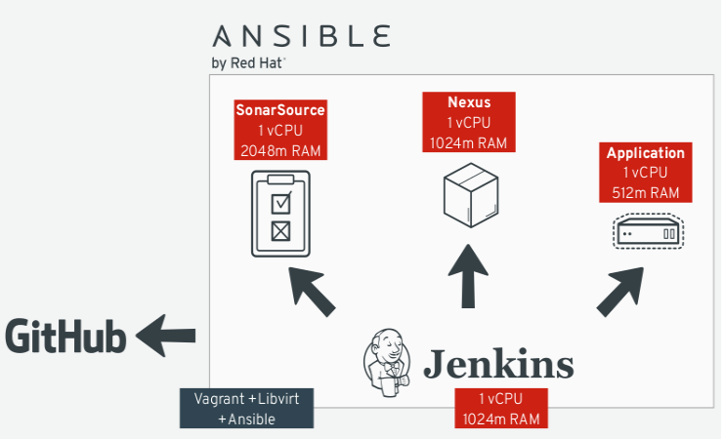
- Github is where our project is hosted and where Jenkins will poll for changes to start the pipeline flow.
- SonarSource is our source code analysis server. If anything goes wrong during the analysis (e.g. not enough unit tests), the flow is interrupted. This step is important to guarantee the source code quality index.
- Nexus is the artifact repository. After a successful compilation, unit tests and quality analyses, the binaries are uploaded into it. Later those binaries will be downloaded by Ansible during the application deployment.
- The Ansible Playbook, which is a YAML file integrated in the application source code, deploys the Spring Boot App on to a CentOS machine.
- Jenkins is our CI/CD process orchestrator. It is responsible to put all the pieces together, resulting in the application successfully deployed in the target machine.
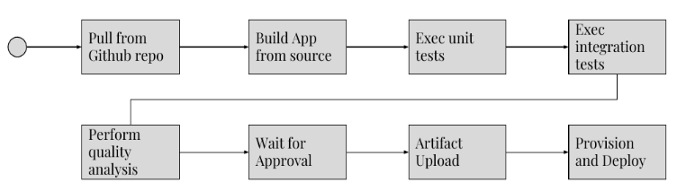
Playbook.yml
==========
---
- name: Install Roles from Galaxy
hosts: localhost
connection: local
become_user: "{{ local_user | default('awx') }}"
become: yes
tasks:
- name: installing ansible-galaxy roles
command: ansible-galaxy install -r requirements.yml --roles-path roles
- name: Install Java
hosts: app_server
become: yes
become_user: root
roles:
- geerlingguy.java
- name: Download Application from Repo
hosts: app_server
tasks:
- get_url:
force: yes
url: "{{ ARTIFACT_URL }}"
dest: "/tmp/{{ APP_NAME }}.war"
- stat:
path: "/tmp/{{ APP_NAME }}.war"
- name: Setup Spring Boot
hosts: app_server
become: yes
become_user: root
roles:
- { role: pellepelster.springboot-role,
spring_boot_file: "{{ APP_NAME }}.war",
spring_boot_file_source: "/tmp/{{ APP_NAME }}.war",
spring_boot_application_id: "{{ APP_NAME }}"
}

---
- name: Deploy Jenkins CI
hosts: jenkins_server
remote_user: vagrant
become: yes

roles:
- geerlingguy.repo-epel
- geerlingguy.jenkins
- geerlingguy.git
- tecris.maven
- geerlingguy.ansible

- name: Deploy Nexus Server
hosts: nexus_server
remote_user: vagrant
become: yes

roles:
- geerlingguy.java
- savoirfairelinux.nexus3-oss

- name: Deploy Sonar Server
hosts: sonar_server
remote_user: vagrant
become: yes

roles:
- wtanaka.unzip
- zanini.sonar

- name: On Premises CentOS
hosts: app_server
remote_user: vagrant
become: yes

roles:
- jenkins-keys-config

Basically, we group the roles that make sense together in order to provide the desired infrastructure. Let’s take a closer look at the Jenkins’ provision:
- name: Deploy Jenkins CI
hosts: jenkins_server
remote_user: vagrant
become: yes

roles:
- geerlingguy.repo-epel
- geerlingguy.jenkins
- geerlingguy.git
- tecris.maven
- geerlingguy.ansible
---
- name: Install Java
hosts: app_server
become: yes
become_user: root
roles:
- geerlingguy.java

- name: Download Application from Repo
hosts: app_server
tasks:
- get_url:
force: yes
url: "{{ lookup('env','ARTIFACT_URL') }}"
dest: "/tmp/{{ lookup('env','APP_NAME') }}.jar"
- stat:
path: "/tmp/{{ lookup('env','APP_NAME') }}.jar"

- name: Setup Spring Boot
hosts: app_server
become: yes
become_user: root
roles:
- { role: pellepelster.springboot-role,
spring_boot_file: "{{ lookup('env','APP_NAME') }}.jar",
spring_boot_file_source: "/tmp/{{ lookup('env','APP_NAME') }}.jar",
spring_boot_application_id: "{{ lookup('env','APP_NAME') }}"
}
Dockerized Pipeline:
===============
def artifactUrl = "http://${NEXUS_URL}/repository/ansible-meetup/${repoPath}/${version}/${pom.artifactId}-${version}.jar"

withEnv(["ARTIFACT_URL=${artifactUrl}", "APP_NAME=${pom.artifactId}"]) {
echo "The URL is ${env.ARTIFACT_URL} and the app name is ${env.APP_NAME}"

// install galaxy roles
sh "ansible-galaxy install -vvv -r provision/requirements.yml -p provision/roles/"

ansiblePlaybook colorized: true,
credentialsId: 'ssh-jenkins',
limit: "${HOST_PROVISION}",
installation: 'ansible',
inventory: 'provision/inventory.ini',
playbook: 'provision/playbook.yml',
sudo: true,
sudoUser: 'jenkins'
}
Pom.Xml
======
<skip>${surefire.skip}</skip>
<version>${jacoco.version}</version>
<nexusUrl>${NEXUS_URL}</nexusUrl>

#!groovy​
// FULL_BUILD -> true/false build parameter to define if we need to run the entire stack for lab purpose only
final FULL_BUILD = params.FULL_BUILD
// HOST_PROVISION -> server to run ansible based on provision/inventory.ini
final HOST_PROVISION = params.HOST_PROVISION
final GIT_URL = 'https://github.com/ricardozanini/soccer-stats.git'
final NEXUS_URL = 'nexus.local:8081'
stage('Build') {
node {
git GIT_URL
withEnv(["PATH+MAVEN=${tool 'm3'}/bin"]) {
if(FULL_BUILD) {
def pom = readMavenPom file: 'pom.xml'
sh "mvn -B versions:set -DnewVersion=${pom.version}-${BUILD_NUMBER}"
sh "mvn -B -Dmaven.test.skip=true clean package"
stash name: "artifact", includes: "target/soccer-stats-*.war"
}
}
}
}
if(FULL_BUILD) {
stage('Unit Tests') {
node {
withEnv(["PATH+MAVEN=${tool 'm3'}/bin"]) {
sh "mvn -B clean test"
stash name: "unit_tests", includes: "target/surefire-reports/**"
}
}
}
}
if(FULL_BUILD) {
stage('Integration Tests') {
node {
withEnv(["PATH+MAVEN=${tool 'm3'}/bin"]) {
sh "mvn -B clean verify -Dsurefire.skip=true"
stash name: 'it_tests', includes: 'target/failsafe-reports/**'
}
}
}
}
if(FULL_BUILD) {
stage('Static Analysis') {
node {
withEnv(["PATH+MAVEN=${tool 'm3'}/bin"]) {
withSonarQubeEnv('sonar'){
unstash 'it_tests'
unstash 'unit_tests'
sh 'mvn sonar:sonar -DskipTests'
}
}
}
}
}
if(FULL_BUILD) {
stage('Approval') {
timeout(time:3, unit:'DAYS') {
input 'Do I have your approval for deployment?'
}
}
}
if(FULL_BUILD) {
stage('Artifact Upload') {
node {
unstash 'artifact'
def pom = readMavenPom file: 'pom.xml'
def file = "${pom.artifactId}-${pom.version}"
def jar = "target/${file}.war"
sh "cp pom.xml ${file}.pom"
nexusArtifactUploader artifacts: [
[artifactId: "${pom.artifactId}", classifier: '', file: "target/${file}.war", type: 'war'],
[artifactId: "${pom.artifactId}", classifier: '', file: "${file}.pom", type: 'pom']
],
credentialsId: 'nexus',
groupId: "${pom.groupId}",
nexusUrl: NEXUS_URL,
nexusVersion: 'nexus3',
protocol: 'http',
repository: 'ansible-meetup',
version: "${pom.version}"
}
}
}
stage('Deploy') {
node {
def pom = readMavenPom file: "pom.xml"
def repoPath = "${pom.groupId}".replace(".", "/") +
"/${pom.artifactId}"
def version = pom.version
if(!FULL_BUILD) { //takes the last version from repo
sh "curl -o metadata.xml -s http://${NEXUS_URL}/repository/ansible-meetup/${repoPath}/maven-metadata.xml"
version = sh script: 'xmllint metadata.xml --xpath "string(//latest)"',
returnStdout: true
}
def artifactUrl = "http://${NEXUS_URL}/repository/ansible-meetup/${repoPath}/${version}/${pom.artifactId}-${version}.war"
withEnv(["ARTIFACT_URL=${artifactUrl}", "APP_NAME=${pom.artifactId}"]) {
echo "The URL is ${env.ARTIFACT_URL} and the app name is ${env.APP_NAME}"
// install galaxy roles
sh "ansible-galaxy install -vvv -r provision/requirements.yml -p provision/roles/"
ansiblePlaybook colorized: true,
credentialsId: 'ssh-jenkins',
limit: "${HOST_PROVISION}",
installation: 'ansible',
inventory: 'provision/inventory.ini',
playbook: 'provision/playbook.yml',
sudo: true,
sudoUser: 'jenkins'
}
}
}
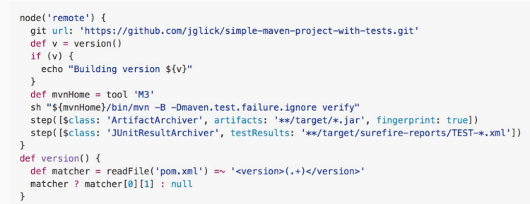
Pipeline is a "new" feature of Jenkins 2.0, but it is based on a plugin which used to be known as Workflow.
It will use the Jenkins REST API to install plugins and change configuration.

Continuous Integration With Ansible Jenkins Git
Summary of desired workflow:
- The Communote team want to turn on mysql query logging on their backend servers, so create a Jira ticket for the task.
- Sam (DevOps) modifies the existing Ansible cnote-mysql-config role.
- Sam commits then pushes this change to the shared remote repository (Git) of Communote infrastructure code.
- The automation pipeline (Jenkins), woken up by a git hook, tests the new code and, if successful, merges the new commit into the producion repository.
- The Jira ticket for the change, containing a full audit trail, is set to completed.
- At some later point, Chris (DevOps) runs the playbook (Ansible Tower) to execute the change on the live servers.

The Private Small Team workflow simply involves a central repository which developers pull the latest code from, and then push back changes using feature branches. Pushing feature branches allows an automated integration pipeline (Jenkins) to test and validate changes, without potentially messing up ‘master’.
Jenkins pipelines are built as code, stored in a repo, and pulled automatically when the job is run. The pseudo-code of our Jenkins pipeline:
#!groovy

node {
stage('Begin') {
// match commit to Jira ticket
// slackSend message: "${JIRA_TICKET}: begin ${pipeline} with ${featurebranch}"
}
stage('Files') {
// for each yml file:
// ansible/yaml lint file
// detect disallowed modules
// detect cleartext passwords
// ...
// add file role to roles_list
// update Jira
}
stage('Roles') {
// for each role:
// unit test role on vm
// add role playbook test to playbook_list
// update Jira
}
stage('Playbooks') {
// for each test_playbook:
// run test_playbook on vm
// update Jira
}
stage('Git Merge Check') {
// git merge feature branch to master
// update Jira
}
stage('Final') {
// Send PR to merge to master
// update Jira
// slackSend message: "${JIRA_TICKET}: ${pipeline} ended successfully with ${featurebranch}"
}
}
Kubernetes is a platform-agnostic container orchestration tool created by Google and heavily supported by the open source community as a project of the Cloud Native Computing Foundation.
Kubernetes is compatible with the majority of CI/CD tools which allows developers run tests, deploy builds in Kubernetes and update applications with no downtime. One of the most popular CI/CD tools now is Jenkins, and this article will focus on configuring a CI/CD pipeline with Jenkins and Helm on Kubernetes.
CI/CD Steps
CI/CD process with Jenkins generally follows the following scheme:
- Checkout Code
- Run Unit Tests
- Dockerize App
- Push dockerized app to Docker Registry
- Use Ansible Playbook to deploy the dockerized app on K8s
https://medium.com/containerum/configuring-ci-cd-on-kubernetes-with-jenkins-89eab7234270

The QA team performs a suite of Integration Testing, Acceptance Testing, and Non-functional Testing (performance, recovery, security, and so on)
Thanks to the support of multiple agent (slave) nodes, it is able to handle the heavy concurrent load
The Jenkins master accepts a build request, but the execution is started at one of the Jenkins Slave (agent) machines. Such an approach provides horizontal scaling of the Jenkins environment.
The application is a simple web service written in Java with the Spring Boot framework. Gradle is used as a build tool and GitHub as the source code repository. Every commit to GitHub automatically triggers the Jenkins build, which uses Gradle to compile Java code, run unit tests, and perform additional checks (code coverage, static code analysis, and so on). After the Jenkins build is completed, a notification is sent to the developers.
Docker Registry: After the Continuous Integration phase, the application is packaged first into a JAR file and then as a Docker image. That image is then pushed to the Docker Registry, which acts as a storage for dockerized applications.
Docker Host: Before performing the acceptance test suite, the application has to be started. Jenkins triggers a Docker Host machine to pull the dockerized application from the Docker Registry and starts it.
Docker Compose: If the complete application consists of more than one Docker container (for example, two web services: Application 1 using Application 2), then Docker Compose helps to run them together.
Cucumber: After the application is started on the Docker Host, Jenkins runs a suite of acceptance tests written in the Cucumber framework.
To run the Docker container on a remote machine, you can use the -H option: docker -H :2375 run hello-world
Docker Engine consists of three components:
Docker Daemon (server) running in the background
Docker Client running as a command tool
REST API

An image is a stateless building block in the Docker world.
Containers are stateful, we can interact with them and make changes to their states, writable, we can do anything we want in its terminal.
Check what has changed in the container comparing it to the ubuntu image:
$ docker diff dee2cb192c6c
Commit the container to the image: $ docker commit dee2cb192c6c ubuntu_with_git
We've just created our first Docker image. Let's list all the images of our Docker host to see if the image is present:
we would like to print Hello to the logs, not to the console, or we may want to have different dependent services during the testing phase and the production phase. One solution would be to prepare a separate Dockerfile for each case; however, there is a better way, environment variables.
If the environment variable is defined both in Dockerfile and as a flag, then the command flag takes precedence
To run a container in the background, we can use the -d (--detach) option. Let's try it with the ubuntu image:
There are two more states we haven't observed yet: paused and restarting.
We need to start the container specifying the port mapping with the -p (--publish) flag:
In order to prevent removing the images with tags (for example, to not remove all the latest images), it's very common to use the dangling parameter:
$ docker rmi $(docker images -f "dangling=true" -q)
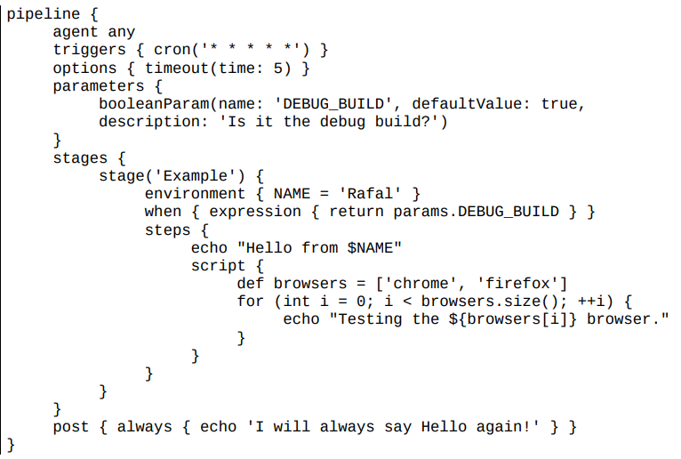
Agent: This specifies where the execution takes place and can define the label to match the equally labeled agents or docker to specify a container
Triggers: This defines automated ways to trigger the pipeline and can use cron to set the time-based scheduling or pollScm to check the repository for changes
Options: This specifies pipeline-specific options, for example, timeout (maximum time of pipeline run) or retry (number of times the pipeline should be rerun after failure)
Environment: This defines a set of key values used as environment variables during the build Parameters: This defines a list of user-input parameters
Stage: This allows for logical grouping of steps
When: This determines whether the stage should be executed depending on the given condition
sh: This executes the shell command; actually, it's possible to define almost any operation using sh custom: Jenkins offers a lot of operations that can be used as steps (for example, echo); many of them are simply wrappers over the sh command used for convenience; plugins can also define their own operations
script: This executes a block of the Groovy-based code that can be used for some non-trivial scenarios, where flow control is needed
1.Commit pipeline:
The most basic Continuous Integration process is called a commit pipeline. This classic phase, as its name says, starts with a commit (or push in Git) to the main repository and results in a report about the build success or failure.

The commit phase works as follows. A developer checks in the code to the repository, the Continuous Integration server detects the change, and the build starts. The most fundamental commit pipeline contains three stages:
Checkout: This stage downloads the source code from the repository
Compile: This stage compiles the source code
Unit test: This stage runs a suite of unit tests
Creating a checkout stage:
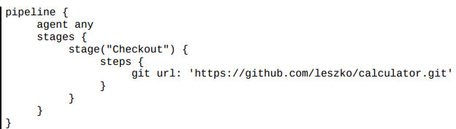
Creating a unit test stage Now, we can add a Unit test stage to the pipeline:
stage("Unit test")
{ steps
{ sh "./gradlew test" }
}
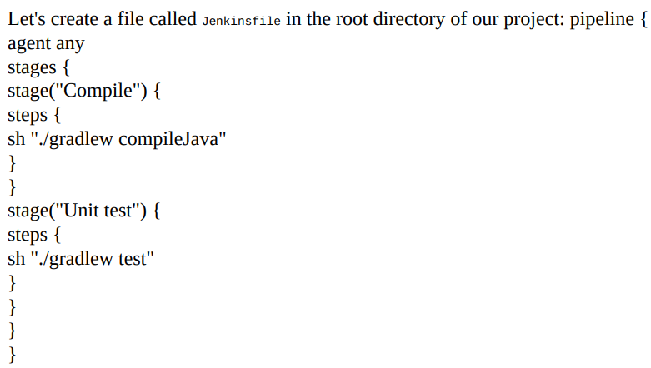
Code quality stages
We can extend the classic three steps of Continuous Integration with additional steps. The most widely used are code coverage and static analysis.
Code coverage :
; however, nobody in your project writes unit tests. It passes all the builds, but it doesn't mean that the code is working as expected. What to do then? How to ensure that the code is tested?
The solution is to add the code coverage tool that runs all tests and verifies which parts of the code have been executed. Then, it creates a report showing not-tested sections. Moreover, we can make the build fail when there is too much untested code.
There are a lot of tools available to perform the test coverage analysis; for Java, the most popular are JaCoCo, Clover, and Cobertura.
Let's use JaCoCo and show how the coverage check works in practice. In order to do this, we need to perform the following steps:
1. Add JaCoCo to the Gradle configuration.
2. Add the code coverage stage to the pipeline.
3. Optionally, publish JaCoCo reports in Jenkins.
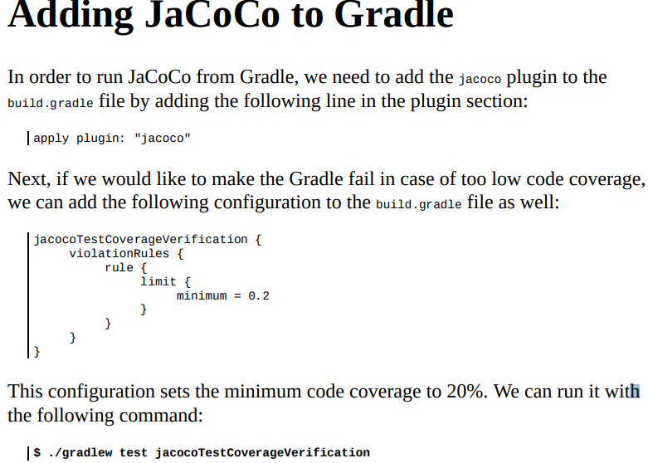
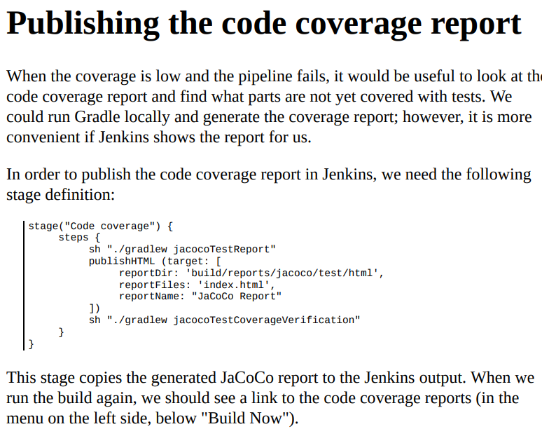
Static code analysis
Your code may work perfectly fine, however, what about the quality of the code itself? How do we ensure it is maintainable and written in a good style?
Static code analysis is an automatic process of checking the code without actually executing it. In most cases, it implies checking a number of rules on the source code
The most popular tools to perform the static analysis on the Java code are Checkstyle, FindBugs, and PMD. Let's look at an example and add the static code analysis stage using Checkstyle. We will do this in three steps:
1. Add the Checkstyle configuration.
2. Add the Checkstyle stage.
3. Optionally, publish the Checkstyle report in Jenkins.
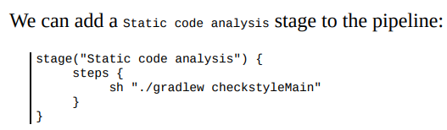
SonarQube
SonarQube is the most widespread source code quality management tool. It supports multiple programming languages and can be treated as an alternative to the code coverage and static code analysis steps we looked at. Actually, it is a separate server that aggregates different code analysis frameworks, such as Checkstyle, FindBugs, and JaCoCo. It has its own dashboards and integrates well with Jenkins.
Instead of adding code quality steps to the pipeline, we can install SonarQube, add plugins there, and add a "sonar" stage to the pipeline. The advantage of this solution is that SonarQube provides a user-friendly web interface to configure rules and show code vulnerabilities.
Triggers and notifications:
So far, we have always built the pipeline manually by clicking on the Build Now button. It works but is not very convenient. All team members would have to remember that after committing to the repository, they need to open Jenkins and start the build. The same works with pipeline monitoring; so far, we manually opened Jenkins and checked the build status. In this section, we will see how to improve the process so that the pipeline would start automatically and, when completed, notify the team members about its status.
Triggers:
An automatic action to start the build is called the pipeline trigger. In Jenkins, there are many options to choose from; however, they all boil down to three types: External Polling SCM (Source Control Management) Scheduled build
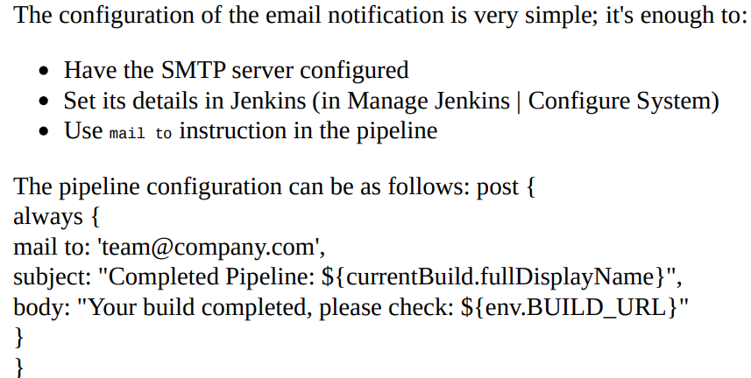
always: Execute regardless of the completion status
changed: Execute only if the pipeline changed its status
failure: Execute only if the pipeline has the failed status
success: Execute only if the pipeline has the success status
unstable: Execute only if the pipeline has the unstable status (usually caused by test failures or code violations)
Team space :
Currently, it's very common to install big screens (also called build radiators) in the team space. Then, when you come to the office, the first thing you see is the current status of the pipeline. Build radiators are considered one of the most effective notification strategies.
Development workflows :
Branching strategies :
Each development workflow implies a different Continuous Integration approach:
A development workflow is the way your team puts the code into the repository.
As a result, each team develops the code in a slightly different manner. We can, however, classify them into three types: trunk-based workflow, branching workflow, and forking workflow.
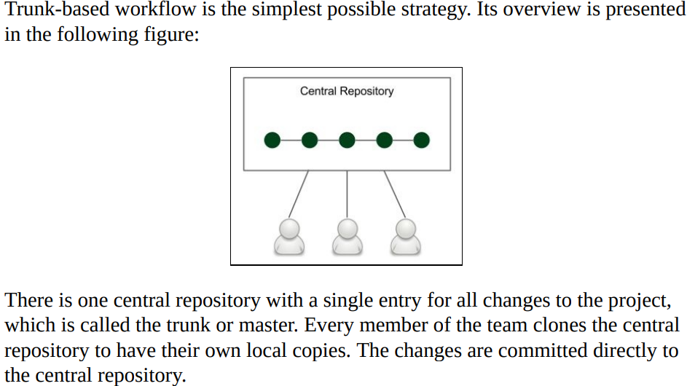
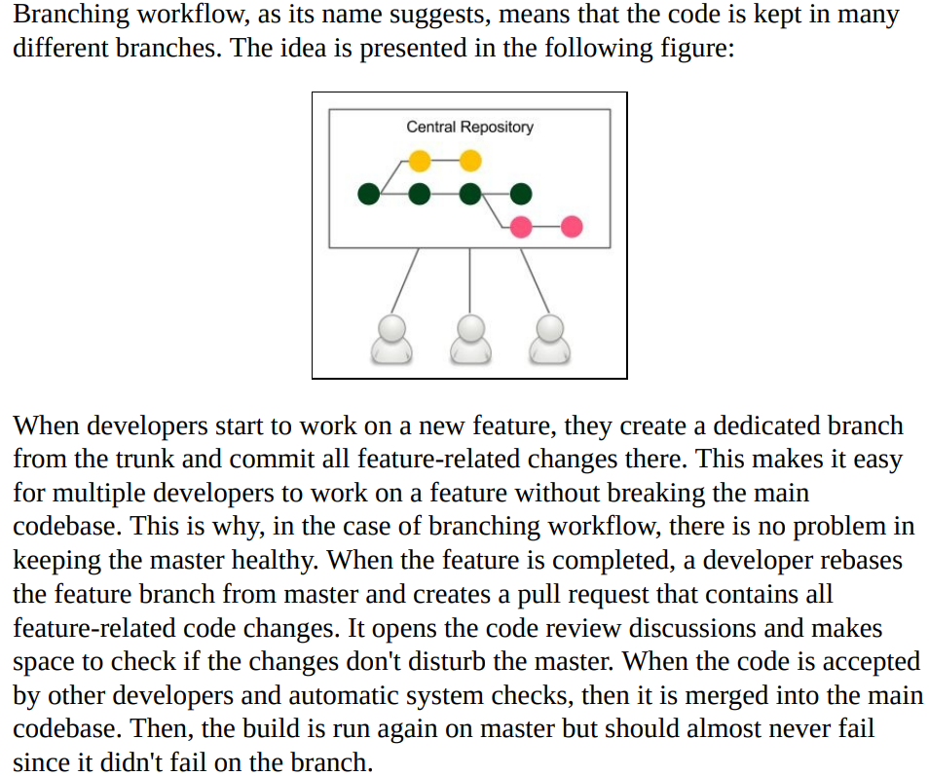

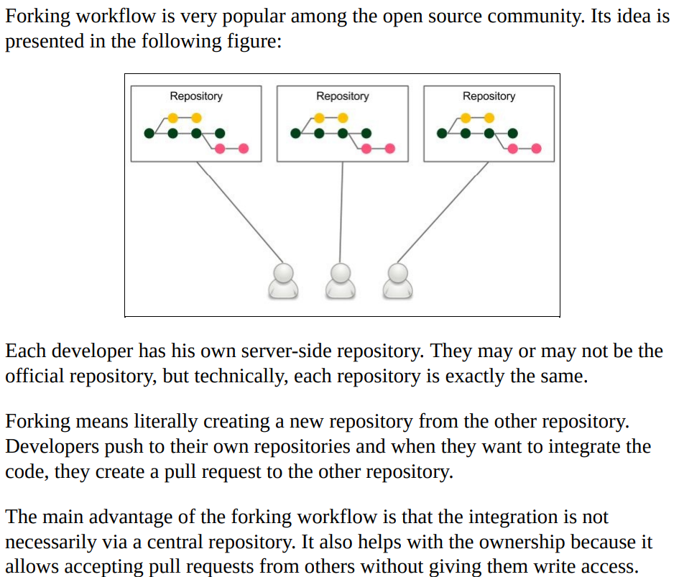
Jenkins Multibranch :
We can create a new branch and see how it works.
Let's create a new branch called feature and push it into the repository: $ git checkout -b feature
$ git push origin feature After a moment, you should see a new branch pipeline automatically created and run:
Now, before merging the feature branch to master, we can check if it's green. This approach should never break the master build.
In the case of GitHub, there is an even better approach, using the GitHub Organization Folder plugin. It automatically creates pipelines with branches and pull requests for all projects.
A very similar approach is to build a pipeline per pull request instead of a pipeline per branch, which gives the same result; the main codebase is always healthy
the prerequisites for Continuous Integration that can be rephrased with the following points:
- Check in regularly:
- Create comprehensive unit tests:
- Keep the process quick:
- Monitor the builds:
2. Automated Acceptance Testing
Acceptance testing is a test performed to determine if the business requirements or contracts are met. Also called UAT (user acceptance testing), end user testing, or beta testing, it is a phase of the development process when software meets the real-world audience.
Automated acceptance tests, however, can be considered difficult due to their specifics:
- User-facing:
- Dependencies integration:
- Environment identity:
- Application identity:
- Relevance and consequences:
Acceptance testing can have multiple meanings; in this book, we treat acceptance testing as a complete integration test from a user perspective, excluding nonfunctional testing, such as performance, load, and recovery.
Artifact repository :
File size:
Versions
Revision mapping:
Packages
Access control:
Clients:
Use cases:
Private Docker registry :
a lot of companies have policies not to store their software outside their own network. In this case, the only option is to install a private Docker registry.
- Installing the Docker registry application
$ docker run -d -p 5000:5000 --restart=always --name registry registry:2
By default, the registry data is stored as a docker volume in the default host filesystem's directory. To change it, you can add -v :/var/lib/registry. Another alternative is to use a volume container.
- Adding a domain certificate
Having the certificates either signed by CA or self-signed, we can move domain.crt and domain.key to the certs directory and start the registry.
$ docker run -d -p 5000:5000 --restart=always --name registry -v `pwd`/certs:/certs -e R
- Adding an access restriction
The command, in addition to setting the certificates, creates the access restriction limited to the users specified in the auth/passwords file.

The process goes as follows:
1. The developer pushes a code change to GitHub.
2. Jenkins detects the change, triggers the build, and checks out the current code.
3. Jenkins executes the commit phase and builds the Docker image.
4. Jenkins pushes the image to Docker registry.
5. Jenkins runs the Docker container in the staging environment.
6. Staging the Docker host needs to pull the image from the Docker registry.
7. Jenkins runs the acceptance test suite against the application running in the staging environment.
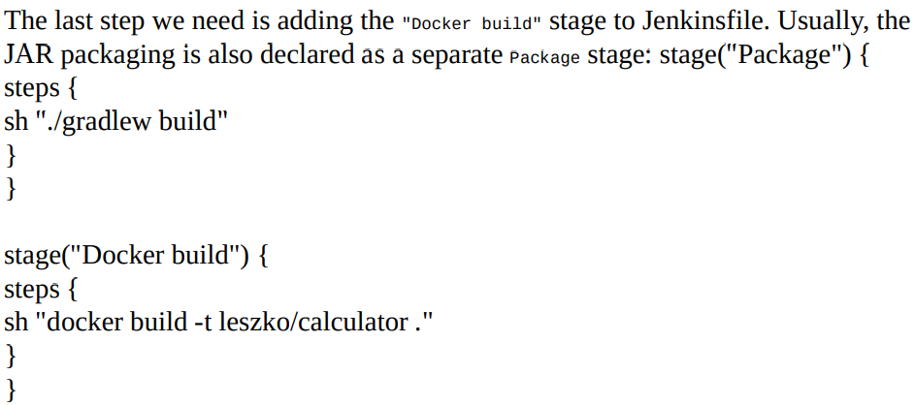
The Docker push stage
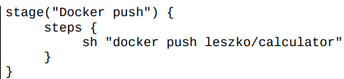
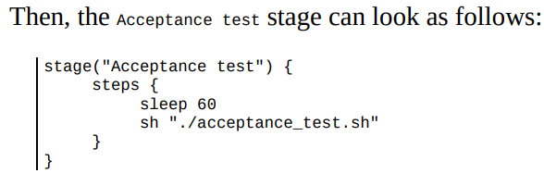

Docker Compose :

Life is easy without dependencies. In real-life, however, almost every application links to a database, cache, messaging system, or another application. In the case of a (micro) service architecture, each service needs a bunch of other services to do its work. The monolithic architecture does not eliminate the issue, an application usually has some dependencies, at least to the database.
Docker Compose is a tool for defining, running, and managing multi-container Docker applications. Services are defined in a configuration file (a YAML format) and can be created and run all together with a single command.
Docker Compose orchestrates containers using standard Docker mechanisms and provides a convenient way to specify the entire environment.
Docker Compose comes with a lot of features, the most interesting are:
1. Building a set of services
2. Launching a set of services together
3. Managing the state of individual services
4. Preserving volume data between runs
5. Scaling services up and down
6. Showing logs of individual services
7. Caching configuration and recreating changed containers between runs
We present the Docker Compose tool starting with the installation process, going through the docker-compose.yml configuration file and the docker-compose command, to end up with the building and scaling features.
The docker-compose.yml file is used to define the configuration for containers, their relations, and runtime properties.
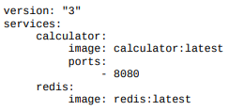
The container links to the redis container, which means that they share the same network and the redis IP address is visible under the redis hostname from inside the calculator container.
If we like a service to be addressed by a different hostname than its service name (for example, by redis-cache apart from redis), then we can create aliases using the links keyword.
The docker-compose command reads the definition file and creates the environment: $ docker-compose up –d
Docker-compose ps
When we're done, we can tear down the environment: $ docker-compose down
let's look at two other Docker Compose features:
- building images and
- scaling containers.
Building images In the preceding example, we had to first build the calculator image using the docker build command, and then it could be specified inside docker-compose.yml. There is also another approach to let Docker Compose build the image. In that case, we need to specify the build property instead of image in the configuration. Let's put the docker-compose.yml file in the calculator project's directory. When Dockerfile and Docker Compose configurations are in the same directory, the former can look as follows: version: "3"
services:
calculator:
build: .
ports: - 8080
redis: image: redis:latest
The docker-compose build command builds the image. We can also ask Docker Compose to build images before running the containers with the use of the
docker-compose --build up command.
- Scaling services
Docker Compose provides the functionality to automatically create multiple instances of the same container. We can either specify the replicas: count parameter inside docker-compose.yml or use the docker-compose scale command
$ docker-compose up -d
$ docker-compose scale calculator=5
Scaling containers is one of the most impressive Docker Compose features. With one command, we can scale up and down the number of clone instances. Docker Compose takes care of cleaning up the containers that are no longer used.
We can check the port on which the calculator service is published:
$ docker-compose port calculator 8080
$ docker-compose exec redis redis-cli
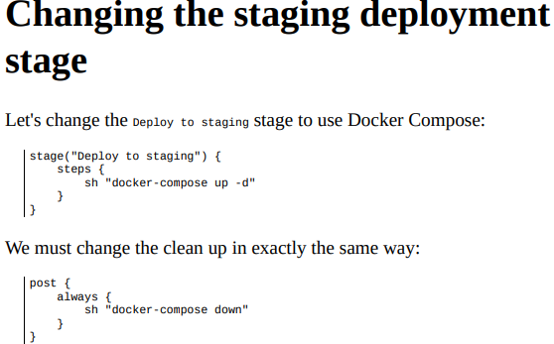
We can check its logs with the following command: $ docker logs acceptance_test_1
we can check the exit code of the container: $ docker wait acceptance_test_1 0
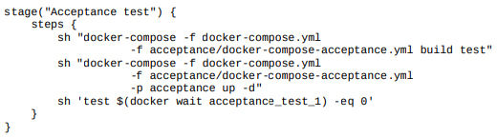
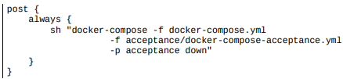
Ansible
---------
Application configuration: This involves software properties that decide how the system works, which are usually expressed in the form of flags or properties files passed to the application,
Infrastructure configuration: This involves server infrastructure and environment configuration, which takes care of the deployment process.
The configuration management tool reads the configuration file and prepares the environment respectively (installs dependent tools and libraries, deploys the applications to multiple instances).

Installing Ansible
Ansible is an open source, agentless automation engine for software provisioning, configuration management, and application deployment.
Its first release was in 2012 and its basic version is free for both, personal and commercial use. The enterprise version, called Ansible Tower, provides GUI management and dashboards, REST API, role-based access control, and some more features. We present the installation process and a description of how it can be used separately as well as together with Docker.
it is also possible to use the username and the password by adding the - -ask-pass option to the Ansible commands.
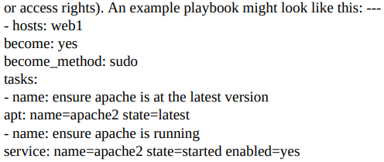
It's also possible to pass the sudo password (if required) by setting the extra variable -e ansible_become_pass=.
It is possible to run tasks in parallel using the -f <num_of_threads> option.
handlers: This specifies the tasks executed when notified
notify: This specifies the handlers that should be executed
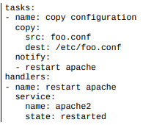
Handlers are executed always at the end of the play and only once, even if triggered by multiple tasks.
We used the copy module, which is smart enough to detect if the file has changed, and then in such a case, make a change on the server.
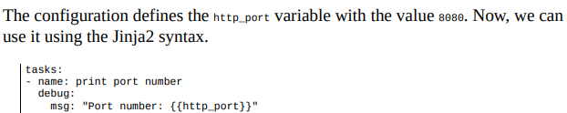
The Jinja2 language allows doing way more than just getting a variable. We can use it to create conditions, loops, and many more.
The debug module prints the message while executing.
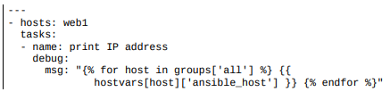
Note that with the use of the Jinja2 language, we can specify the flow control operations inside the Ansible playbook file.
An alternative to the Jinja2 templating language, for the conditionals and loops, is to use the Ansible built-in keywords: when and with_items
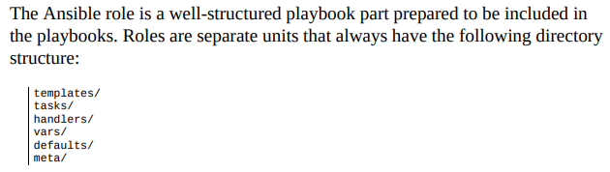
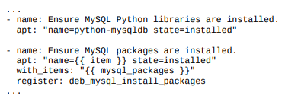
The with_items keyword is used to create a loop over all the items. The when keyword means that the task is executed only under a certain condition.
Ansible Galaxy is to Ansible what Docker Hub is for Docker-it stores common roles, so that they can be reused by others
To install the role from Ansible Galaxy, we can use the ansible-galaxy command.
$ ansible-galaxy install username.role_name
This command automatically downloads the role. In the case of the MySQL example, we could download the role by executing:
$ ansible-galaxy install geerlingguy.mysql
If you need to install a lot of roles at the same time, you can define them in the requirements.yml file and use
ansible-galaxy install -r requirements.yml.
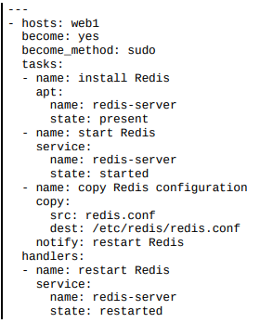
Ansible Docker playbook
There are a few very useful Docker-related modules provided by Ansible: docker_image (build/manage images), docker_container (run containers), docker_image_facts (inspect images), docker_login (log into Docker registry), docker_network (manage Docker networks), and docker_service (manage Docker Compose)
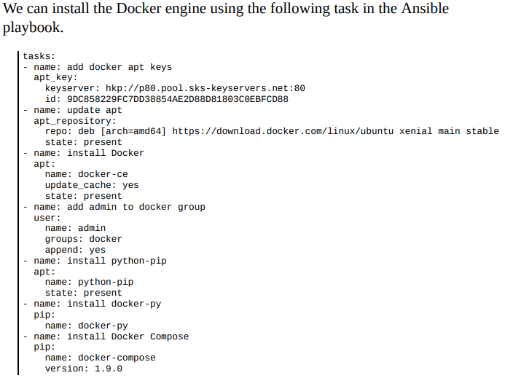
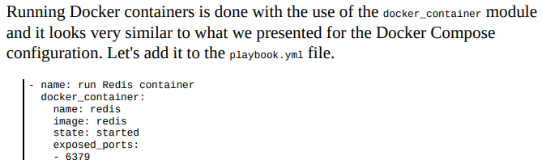
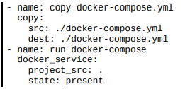
In order to use the timestamp information from Jenkins, you need to install the Build Timestamp Plugin and set the timestamp format in the Jenkins configuration
:${BUILD_TIMESTAMP}
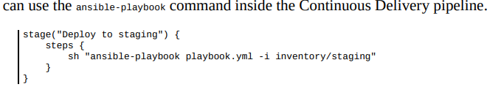
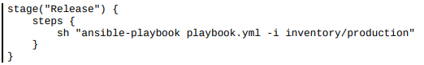
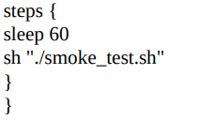
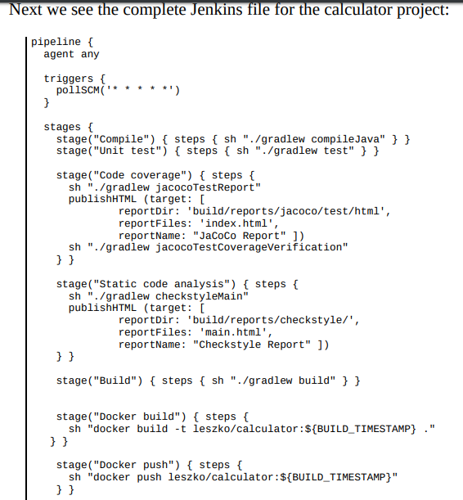

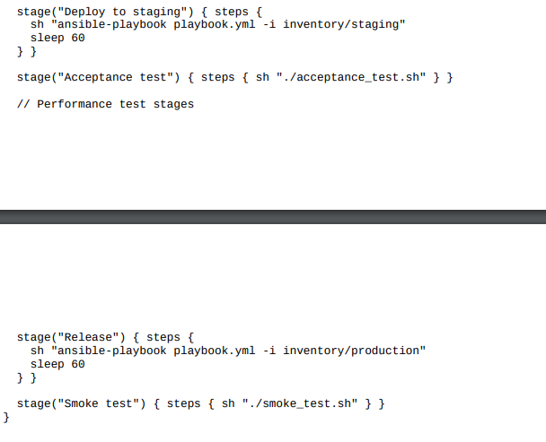
Docker Swarm
---------------------
Docker environment from a single Docker host into a cluster of machines and how to use it all together with Jenkins.
Server clustering:
A server cluster is a set of connected computers that work together in a way that they can be used similarly to a single system.
A user accesses the cluster via a host called the manager, whose interface should be similar to a usual Docker host. Inside the cluster, there are multiple worker nodes that receive tasks, execute them, and notify the manager of their current state. The manager is responsible for the orchestration process, including task dispatching, service discovery, load balancing, and worker failure detection.
The manager can also execute tasks, which is the default configuration in Docker Swarm. However, for large clusters, the manager should be configured for management purposes only.
Docker Swarm is a native clustering system for Docker that turns a set of Docker hosts into one consistent cluster, called a swarm.
Regarding the terminology, in swarm mode, a running image is called a service, as opposed to a container, which is run on a single Docker host. One service runs a specified number of tasks. A task is an atomic scheduling unit of the swarm that holds the information about the container and the command that should be run inside the container. A replica is each container that is run on the node. The number of replicas is the expected number of all containers for the given service.
Docker Swarm features
- Load balancing:
- Dynamic role management:
- Dynamic service scaling:
- Failure recovery:
- Rolling updates:
- Replicated services:
- Global services:
- Security:
In order to set up a Swarm, we need to initialize the manager node. We can do this using the following command on a machine that is supposed to become the manager:
$ docker swarm init
We can check that the Swarm has been created using the docker node command:
$ docker node ls
In order to add a machine to the Swarm, we have to log in to the given machine and execute the following command:
$ docker swarm join \ --token SWMTKN-1-253vezc1pqqgb93c5huc9g3n0hj4p7xik1ziz5c4rsdo3f7iw2-df098e2jpe8uvwe2ohhhcxd6w \ 192.168.0.143:237
Deploying a service
but the Swarm dedicated Docker service command (which is executed on the manager node). Let's start a single tomcat application and give it the name tomcat:
$ Docker service create --replicas 1 --name tomcat tomcat
Let's list the running services: $ docker service ls
The log confirms that the tomcat service is running, and it has one replica (one Docker container is running). We can examine the service even more closely:
$ docker service ps tomcat
If you are interested in the detailed information about a service, you can use the docker service inspect command
If we don't want a task to be executed on the manager node, we can constrain the service with the --constraint node.role==worker option.
The other possibility is to disable the manager completely from executing tasks with
docker node update --availability drain .
2. Scaling Services
-----------------------
When the service is running, we can scale it up or down so that it will be running in many replicas: $ docker service scale tomcat=5
We can check that the service has been scaled: $ docker service ps tomcat
If we want to remove the services, it's enough to execute the following command:
$ docker service rm tomcat
docker service ls
- Publishing ports
Docker services, similar to the containers, have a port forwarding mechanism. We use it by adding the -p : parameter. Here's what starting a service could look like:
$ docker service create --replicas 1 --publish 8080:8080 --name tomcat tomcat
- Rolling updates
Then, how can we provide zerodowntime deployment in a cluster? This is the role of rolling updates.
A rolling update is an automatic method for replacing a service, replica by a replica, in a way that some of the replicas are working all the time. Docker Swarm uses rolling updates by default, and they can be steered with two parameters:
update-delay: Delay between starting one replica and stopping the next one (0 seconds by default)
update-parallelism: Maximum number of replicas updated at the same time (one by default)
- Draining nodes When we need to stop a worker node for maintenance, or we would just like to remove it from the cluster, we can use the Swarm draining node feature
There are two replicas running on the ubuntu-worker2 node. Let's drain that node:
$ docker node update --availability drain ubuntu-worker2
If we would like to get the node back, we can check its availability to active:
$ docker node update --availability active ubuntu-worker2
An alternative method to draining the node would be to execute the docker swarm leave command from the worker. T
Docker Stack is a method to run multiple-linked containers on a Swarm cluster. To understand better how it links Docker Compose with Docker Swarm,
Pods are dynamically built and removed depending on the changing requirements.
They usually take a lot of time, so assuming they are independent and isolated, it makes sense to run them in parallel. In Jenkins, we can parallelize the pipeline on two different levels:
- Parallel steps: Within one stage, parallel processes run on the same agent. This method is simple because all Jenkins workspace-related files are located on one physical machine, however, as always with the vertical scaling, the resources are limited to that single machine.
- Parallel stages: Each stage can be run in parallel on a separate agent machine that provides horizontal scaling of resources. We need to take care of the file transfer between the environments (using the stash Jenkinsfile keyword) if a file created in the previous stage is needed on the other physical machine.
- By the time of writing this book, parallel stages are not available in the declarative pipeline. The feature is supposed to be added in Jenkins Blue Ocean v1.3. In the meantime, the only possibility is to use the deprecated feature in the Groovy-based scripting pipeline
- 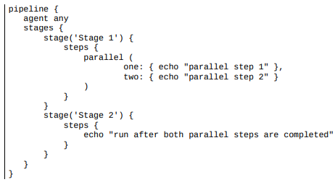
- 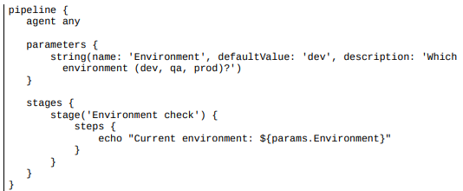
- Blue-green deployment is a technique to reduce the downtime associated with the release. It concerns having two identical production environments, one called green, the other called blue. The blue-green deployment technique works correctly with two assumptions: environment isolation and no orchestrated releases.
This solution gives two significant benefits:
Zero downtime: All the downtime from the user perspective is a moment of changing the load balance switch, which is negligible
Rollback: In order to roll back one version, it's enough to change back the load balance switch blue-green deployment include:
Database: Schema migrations can be tricky in case of a rollback, so it's worth using the patterns presented at the beginning of this chapter
Transactions: Running database transactions must be handed over to the new database Redundant infrastructure/resources: We need to have double the resources

- Building a Continuous Delivery Pipeline Using Jenkins

https://dzone.com/articles/building-a-continuous-delivery-pipeline-using-jenk

Steps Involved in the Demo
- Fetching the code from GitHub
- Compiling the source code
- Unit testing and generating the JUnit test reports
- Packaging the application into a WAR file and deploying it on the Tomcat serve
https://github.com/saurabh0010/game-of-life.git

Step 1 — Compiling the Source Code
New Item : exam
Git : repo
Poll scm : * * * * *
Build : compile
Post-build Actions
Test report XMLs **/target/surefire-reports/*.xml

Step 3 — Creating a WAR File and Deploying on the Tomcat Server

- How To Set Up Continuous Integration Pipelines in Jenkins on Ubuntu 16.04
https://www.digitalocean.com/community/tutorials/how-to-set-up-continuous-integration-pipelines-in-jenkins-on-ubuntu-16-04
https://read.acloud.guru/ci-cd-for-lambda-functions-with-jenkins-1c682a6c8d33
https://code-maze.com/ci-jenkins-docker/
pipeline {
environment {
DOCKER = credentials('docker-hub')
}
agent any
stages {
// Building your Test Images
stage('BUILD') {
parallel {
stage('Express Image') {
steps {
sh 'docker build -f express-image/Dockerfile \
-t nodeapp-dev:trunk .'
}
}
stage('Test-Unit Image') {
steps {
sh 'docker build -f test-image/Dockerfile \
-t test-image:latest .'
}
}
}
post {
failure {
echo 'This build has failed. See logs for details.'
}
}
}
// Performing Software Tests
stage('TEST') {
parallel {
stage('Mocha Tests') {
steps {
sh 'docker run --name nodeapp-dev --network="bridge" -d \
-p 9000:9000 nodeapp-dev:trunk'
sh 'docker run --name test-image -v $PWD:/JUnit --network="bridge" \
--link=nodeapp-dev -d -p 9001:9000 \
test-image:latest'
}
}
stage('Quality Tests') {
steps {
sh 'docker login --username $DOCKER_USR --password $DOCKER_PSW'
sh 'docker tag nodeapp-dev:trunk <DockerHub Username>/nodeapp-dev:latest'
sh 'docker push <DockerHub Username>/nodeapp-dev:latest'
}
}
}
post {
success {
echo 'Build succeeded.'
}
unstable {
echo 'This build returned an unstable status.'
}
failure {
echo 'This build has failed. See logs for details.'
}
}
}
// Deploying your Software
stage('DEPLOY') {
when {
branch 'master' //only run these steps on the master branch
}
steps {
retry(3) {
timeout(time:10, unit: 'MINUTES') {
sh 'docker tag nodeapp-dev:trunk <DockerHub Username>/nodeapp-prod:latest'
sh 'docker push <DockerHub Username>/nodeapp-prod:latest'
sh 'docker save <DockerHub Username>/nodeapp-prod:latest | gzip > nodeapp-prod-golden.tar.gz'
}
}

}
post {
failure {
sh 'docker stop nodeapp-dev test-image'
sh 'docker system prune -f'
deleteDir()
}
}
}
// JUnit reports and artifacts saving
stage('REPORTS') {
steps {
junit 'reports.xml'
archiveArtifacts(artifacts: 'reports.xml', allowEmptyArchive: true)
archiveArtifacts(artifacts: 'nodeapp-prod-golden.tar.gz', allowEmptyArchive: true)
}
}
// Doing containers clean-up to avoid conflicts in future builds
stage('CLEAN-UP') {
steps {
sh 'docker stop nodeapp-dev test-image'
sh 'docker system prune -f'
deleteDir()
}
}
}
}
https://www.linode.com/docs/development/ci/automate-builds-with-jenkins-on-ubuntu/

