WEEK 1 TASK

Data Science Project
Planning & Strategy
A Python-based Fraud Detection Project

Prepared as a conceptual plan — no dataset or model training is required in Week 1.
Planned effort: 32 hours | Proposed duration: 2 weeks at 16 hours/week

Project premise
Design a responsible, measurable workflow that helps an analyst prioritize potentially fraudulent transactions while limiting unnecessary alerts for legitimate customers.

1. Introduction and Project Background
Digital payments and online commerce create large volumes of transactions. A small proportion may be fraudulent, but manually reviewing every transaction is costly and slow. A data science approach can use historical transaction patterns to estimate which transactions deserve closer review. This plan describes a hypothetical fraud-detection project using Python. It is a planning document, not a claim that a trained model or measured business result already exists.

Problem statement
How can a transaction-review team prioritize suspicious transactions using available transaction attributes, while keeping false alarms manageable and treating customer data responsibly?

Motivation and justification
- Prioritization: help analysts focus limited review time on higher-risk transactions.
- Potential loss reduction: earlier identification may reduce losses, subject to validation and operational controls.
- Consistency: use documented evaluation criteria instead of relying only on informal rules.
- Learning value: the project demonstrates the complete Python data science lifecycle from problem definition to communication.

2. Project Objectives and Scope

Objectives
- Define the business problem, stakeholders, assumptions, and measurable success criteria.
- Plan how to obtain an approved, de-identified transaction dataset with a fraud label and a data dictionary.
- Design a reproducible workflow for data validation, cleaning, exploratory analysis, and feature engineering.
- Compare a simple baseline with suitable classification models and evaluate them using metrics appropriate for class imbalance.
- Document privacy, bias, security, and deployment considerations before any operational use.

In scope
- Offline analysis of historical, de-identified transaction records.
- Exploratory data analysis (EDA), data quality checks, feature engineering, and model evaluation planning.
- Candidate models such as logistic regression and tree-based classifiers.
- A report and recommendation for a future controlled pilot, if evidence supports it.

Out of scope
- Real-time payment blocking, production deployment, or automated account suspension.
- Accessing identifiable customer data without authorization or a documented lawful basis.
- Guaranteeing a specific fraud-detection rate or financial saving before experiments are run.
- Building a complete fraud investigation platform or replacing human review.

3. Stakeholders, Assumptions, and Success Measures
Primary stakeholders are the fraud operations lead, data analyst/data scientist, engineering or data-platform team, privacy/security representative, and business owner.

Working assumptions
- A permitted historical dataset can be sourced from an approved internal source or a public educational dataset.
- A target label identifies confirmed fraud or a carefully defined proxy; label quality will be assessed.
- The dataset may be highly imbalanced, so accuracy alone will not be considered sufficient.
- The project is educational and planning-focused during Week 1; all metrics are targets for later testing, not current results.

Proposed success measures
- Data quality: missingness, duplicate rate, invalid values, and label completeness are measured and documented.
- Model quality: precision, recall, F1-score, precision-recall AUC (PR-AUC), and confusion matrix are reported.
- Operational usefulness: estimate how many alerts a team can review at a chosen threshold and measure false-positive burden.
- Governance: data provenance, access restrictions, limitations, and a human-review process are documented.
Initial decision rule: do not select a model on accuracy alone. Choose an operating threshold with stakeholders after considering the cost of missed fraud, the cost of false alerts, and the review team's capacity.

4. Methodology and Strategy

Stage 1 — Problem framing and data requirements
Confirm the intended decision, users, definition of fraud, time horizon, and acceptable alert volume. Define the unit of analysis (one transaction), target label, prediction timing, and information that would genuinely be available at prediction time. Create a data dictionary and a list of prohibited or sensitive fields.

Stage 2 — Data collection and governance
Request an approved dataset from a trusted source. Record provenance, collection period, schema, license or permission, and known limitations. Use de-identified records, least-privilege access, secure storage, and retention rules. Do not use names, full card numbers, passwords, or other direct identifiers as model features.

Stage 3 — Data cleaning and validation
- Check schema, data types, duplicate records, missing values, impossible amounts, inconsistent timestamps, and invalid labels.
- Separate data-quality corrections from assumptions; document each transformation and preserve a reproducible raw-data snapshot where permitted.
- Check whether duplicates or related transactions could leak information across train and test sets.

Stage 4 — Exploratory data analysis (EDA)
- Summarize transaction amount, time, transaction type, channel, and label distribution.
- Inspect missingness, outliers, fraud rates across appropriate groups, and trends over time.
- Visualize class imbalance and investigate suspicious patterns without assuming correlation proves causation.

Stage 5 — Feature engineering and splitting
- Derive only features available at the time a decision would be made, such as transaction amount bands or transaction frequency over a defined look-back window.
- Avoid target leakage: do not use post-investigation outcomes or future transaction information as predictors.
- Prefer a time-based split when future deployment is the goal; otherwise use a stratified split where appropriate. Fit preprocessing only on training data.

Stage 6 — Baseline and candidate models
- Start with a transparent rule-based baseline or logistic regression.
- Compare with a tree-based model such as Random Forest or a gradient-boosted model if the data and project constraints support it.
- Use pipelines for preprocessing and model fitting; address imbalance with class weights or training-only resampling when justified.
- Keep the final test set untouched until model and threshold choices are complete.

Stage 7 — Evaluation and communication
- Report precision, recall, F1-score, PR-AUC, confusion matrix, and the alert volume at candidate thresholds.
- Review false positives and false negatives with stakeholders; inspect performance across relevant groups where lawful and statistically meaningful.
- Document uncertainty, limitations, monitoring needs, and criteria for a controlled pilot with human review.
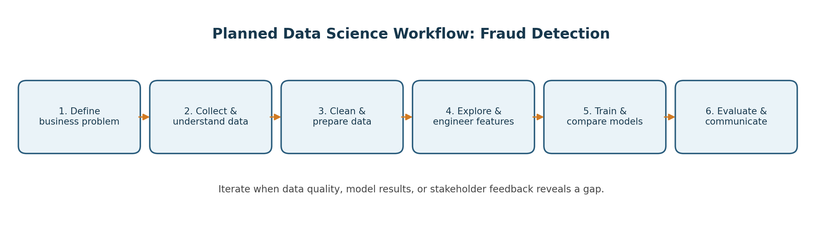
Figure 1. End-to-end workflow planned for the project.

5. Evaluation Strategy
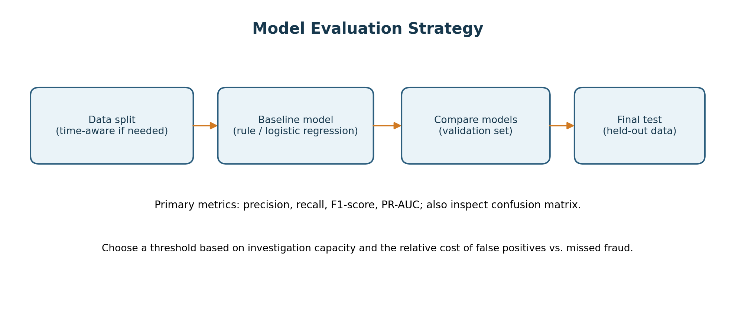
Figure 2. Proposed validation and evaluation sequence.

Why these metrics?
- Precision: among transactions flagged, the proportion that are actually fraudulent; useful for understanding false-alert burden.
- Recall: among fraudulent transactions, the proportion detected; useful for understanding missed fraud.
- F1-score: combines precision and recall into one summary, but does not replace stakeholder-specific cost analysis.
- PR-AUC: summarizes precision-recall trade-offs and is often informative when the positive class is rare.
- Confusion matrix and threshold analysis: make false positives and false negatives concrete for operational decisions.
No numerical performance result is asserted at the planning stage. Targets and acceptable trade-offs should be agreed with stakeholders before model evaluation, then reported honestly with confidence intervals or repeated validation where feasible.

6. Timeline and Work Allocation (32 Hours)
The following schedule allocates 32 hours across planning and design activities. It can be completed over two weeks at approximately 16 hours per week.
Activity | Hours | Deliverable
Problem framing, stakeholders, success metrics | 2 | Written problem statement and metric definitions
Data sourcing plan and data dictionary | 3 | Source options, schema, governance checklist
Data quality and preparation strategy | 5 | Cleaning rules, split strategy, leakage checks
EDA and feature engineering plan | 5 | Analysis questions, visualization plan, candidate features
Baseline and model comparison design | 7 | Model shortlist, pipeline design, validation plan
Evaluation, fairness, and risk review | 5 | Metric plan, risk register, mitigation steps
Documentation and presentation | 5 | Final report, diagrams, review checklist
TOTAL | 32 | Completed Week 1 planning package
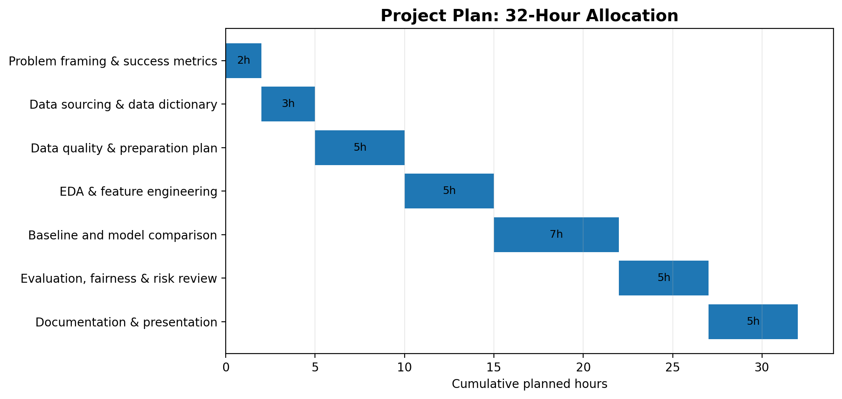
Figure 3. Visual allocation of the 32 planned hours.

7. Tools and Technologies
Tool | Planned use
Python | Main programming language for data preparation, analysis, and modeling.
Jupyter Notebook / VS Code | Exploration, code development, and documentation.
pandas, NumPy | Tabular data manipulation, numerical operations, and validation.
Matplotlib, Seaborn | Charts for class balance, distributions, trends, and error analysis.
scikit-learn | Pipelines, train/test splitting, baseline models, classification metrics, and validation.
Git and GitHub | Version control, change history, and reproducible project collaboration; do not commit sensitive data.
CSV/Parquet and a data dictionary | Documented data interchange and schema, subject to source constraints.
Word / diagrams.net or PowerPoint | Final report and planning diagrams.
Optional tools such as XGBoost may be considered only if installation, licensing, data size, and project constraints make them appropriate.

8. Expected Outcomes and Benefits
- A clearly framed problem statement, scope, stakeholder map, and agreed evaluation criteria.
- A documented data acquisition and governance plan with a data dictionary template.
- A reproducible analysis and modeling blueprint, including leakage prevention and an appropriate validation approach.
- A model evaluation report that explains precision/recall trade-offs and operational alert volume once experiments are performed.
- A recommendation to proceed, revise the approach, or stop based on evidence; a model is not assumed to be successful in advance.

Potential business value
If later testing demonstrates reliable performance and a controlled pilot confirms usefulness, the workflow may help analysts prioritize reviews and improve consistency. Actual savings, fraud reduction, and customer impact must be measured in a pilot; they cannot be guaranteed from a project plan alone.

9. Anticipated Challenges and Mitigation
Challenge | Potential impact | Mitigation
Severe class imbalance | Accuracy may look high even when fraud is missed. | Use precision/recall, PR-AUC, class weights when justified, and threshold analysis.
Noisy or delayed labels | Some fraud cases may be unconfirmed or mislabeled. | Document label definitions, review samples with domain experts, and report uncertainty.
Data leakage | Future or post-investigation information can inflate results. | Define prediction time, use time-aware splits where suitable, and fit transformations only on training data.
False positives | Legitimate customers or transactions may be unnecessarily flagged. | Tune threshold to review capacity, analyze error cases, and retain human review.
Privacy and security | Transaction data may contain sensitive information. | Use approved de-identified data, access controls, secure storage, and retention limits.
Concept drift | Fraud patterns may change over time. | Plan ongoing monitoring, periodic evaluation, and retraining criteria before production.
Bias or uneven performance | Error rates may differ across customer or transaction groups. | Audit lawful, relevant groups, minimize proxy risks, and consult privacy/compliance stakeholders.
Limited time or compute | Advanced models may exceed project constraints. | Start with a baseline, prioritize high-value analysis, and document trade-offs.

10. Risks, Ethics, and Responsible Use
- The system should support, not replace, trained human decision-makers during any pilot.
- Do not automatically decline payments or penalize customers solely because of an unvalidated score.
- Restrict access to data and model outputs; log decisions where appropriate and protect against unauthorized disclosure.
- Communicate model limitations, uncertainty, and possible uneven performance clearly.
- Establish an owner for monitoring, escalation, correction, and rollback before any operational deployment.

11. Conclusion
This plan lays out a structured Python-based approach to a hypothetical fraud-detection problem. It covers business framing, data governance, cleaning, EDA, feature engineering, modeling, evaluation, time allocation, tools, and responsible use. The next phase would be to secure an appropriate dataset, validate the assumptions, implement the workflow, and assess results against pre-agreed criteria. The project should advance only if evidence and stakeholder review support its usefulness.

Appendix A — Initial Project Checklist
☐ Problem statement and stakeholders are agreed.
☐ Target label and prediction timing are clearly defined.
☐ Dataset source, permissions, and privacy constraints are documented.
☐ Data dictionary and quality checks are prepared.
☐ Train/validation/test strategy prevents leakage.
☐ Baseline and candidate models are selected for comparison.
☐ Metrics and threshold trade-offs are agreed before evaluation.
☐ Risk, fairness, security, and monitoring plans are documented.
☐ Final report distinguishes planned targets from measured results.

