Krishna Khandurao Kotalwar 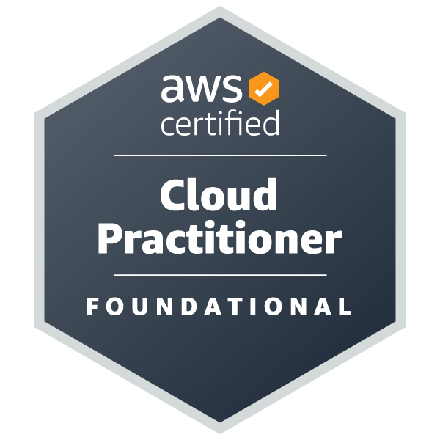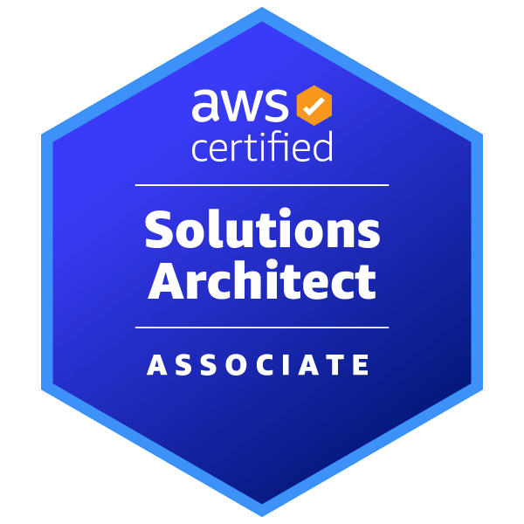

**DevOps Engineer**

📧 [sanketkotalwar@gmail.com](mailto:sanketkotalwar@gmail.com) 

📞 +918983143288 Pune, Maharashtra

[krishna-kotalwar-dev](http://www.linkedin.com/in/krishna-kotalwar-dev)

# Summary

DevOps Engineer with 3.9 years of experience in implementing and managing Cloud-based solutions using AWS Cloud platform within agile environments. Proven ability to collaborate effectively with other teams to design high performance and scalable solutions. Seeking to leverage comprehensive knowledge in cloud infrastructures, networking, security and automation to drive innovation and enhance Operational efficiency with strategic mindset in dynamic organization.

# Experience

# **System Engineer, TCS** *OCT 2020 - Now*

# Project : Takenaka - CDPF

* **AWS Cloud Infrastructure :**

Managed and optimized AWS services including EC2, S3, RDS, Lambda, VPC, Step Function, ECS, EKS , etc.

* + Implemented and maintained AWS CodeCommit, CodePipeline for streamlined CI/CD processes of various applications and services.
  + Ensured the security and compliance of infrastructure and applications.
  + Led the Cost Optimization Activity for AWS infrastructure achieving a significant 50% reduction in costs through the implementation of targeted cost optimization strategies.
* **IoT Core & Fiware Services :** 
  + Developed and deployed IoT solutions using AWS IoT Core, enhancing data collection and device management.
  + Integrated Fiware services for smart applications, contributing to improved interoperability and scalability.
* **Containerization & Orchestration :**
  + Deployed and managed Kubernetes clusters on AWS EKS, facilitating efficient container orchestration and scaling.
  + Automated container deployments, scaling, and operations using Kubernetes and Helm charts.
* **Monitoring & Logging :**
  + Implemented comprehensive monitoring and logging solutions using CloudWatch and other tools.
  + Created custom dashboards and alerts to proactively identify and resolve issues.
  + Monitored and analyzed system performance using CloudWatch, ensuring high availability and reliability.
* **Collaboration & Tools :**
  + Collaborated with cross-functional teams to design and implement infrastructure as code (IaC) using Terraform.
  + Utilized configuration management tools like Ansible to automate server provisioning and configuration.

# Technical Skills

* **Cloud Platforms:** AWS (EC2, S3, RDS, Lambda, VPC, IoT Core, API Gateway, CloudWatch , etc.)
* **DevOps Tools:** CodeCommit, CodePipeline, Kubernetes (EKS), Terraform, CloudFormation, Ansible
* **Monitoring & Logging:** CloudWatch, Prometheus, Grafana
* **Programming & Scripting:** Python, Bash, YAML, JSON
* **Version Control:** Git
* **Collaboration Tools:** JIRA, Slack

# Certifications

* 🔗 [AWS Certified Cloud Practitioner](https://cp.certmetrics.com/amazon/en/public/verify/credential/MGNV69DCXE1Q1P94)
* 🔗 [AWS Certified Solution Architect Associate](https://cp.certmetrics.com/amazon/en/public/verify/credential/ZF3TPJMC411E13GD)
* 🔗 [Edureka DevOps Engineering Training Completion](https://www.edureka.co/certificates/mycertificate/eed4c99b7d09500edc21257db884627f)
* 🔗 [AWS Partner Advanced Tier Training Completion Certificate](https://trainocate.com/certificate/3b22644b-0999-45ad-9d59-4c3d7077a565)

# Achievements

* Got Technical Excellence Award in TCS.
* Achieved “On The Spot Award” 5 times in TCS.

# Education

* Singhad institute of Technology, Pune | B.E. Electronics and Telecommunication *2014-2018*

# Project Profile

| **Name** | IOTF Platform |
| --- | --- |
| **Role** | DevOps Engineer |
| **Client** | Takenaka |
| **Environment** | Languages: Python, Bash, YAML, JSON  Database: RDS, MongoDB..  AWS services : ECS, EKS, Kinesis , EC2, Load Balancer, DynamoDB, Lambda, Cloudwatch, API GW, Cloudfront, etc. |

| **Name** | IoT_Building Communication System (BCS)_usecase |
| --- | --- |
| **Role** | L2 , L3 |
| **Client** | Takenaka |
| **Environment** | Languages: Python , NodeJs  Database: RDS , MongoDB  AWS services : ECS, EKS, Kinesis , EC2, Load Balancer, DynamoDB, Lambda, Cloudwatch, API GW, Cloudfront, etc. |

# Personal Details

* **Strengths :** 
  + Good Team player and good Leadership skills
  + Complete ownership of task responsibility
  + Honest with given work, Learning new things like as new technologies
* **Hobbies :** 
  + Playing Chess
  + Playing Cricket