
Department of CSE

B.Tech. CSE Trimester -5

Roll Number:2520030520
Name: Kota Mohith

Cloud Infrastructure and Services
25CS2206E

LAB RECORD
2026

Experiment-1: b) Enabling Multi-Factor Authentication to Secure Your Access

AIM: To enable Multi-Factor Authentication (MFA) for an AWS account to provide an additional layer of security during the login process.
Description:
Multi-Factor Authentication (MFA) is a simple best practice that adds an extra layer of protection on top of a user's standard credentials (username and password). When MFA is enabled, accessing the AWS Management Console requires the user to provide their password plus an authentication code generated by an approved MFA device (such as a virtual authenticator application or a FIDO-based passkey/security key). Configuring MFA for IAM users limits unauthorized access and enforces security compliance across cloud infrastructure environments.
Prerequisites:
1. An active AWS account.
2. Valid AWS account login credentials.
3. Access to a smartphone for authentication (if using a virtual MFA application) or a supported hardware security key / Passkey device.
Steps:
Part A: Creating an IAM User
1. Open a web browser and navigate to the AWS Management Console.
2. Sign in to the AWS account using the root user credentials.
3. In the AWS Management Console search bar, type IAM and select Identity and Access Management (IAM).
4. From the left navigation pane, select Users.
5. Click Create user.
6. Enter a username (e.g., mk1).
7. Under console access, select 'Provide user access to the AWS Management Console'.
8. Set a custom password or allow AWS to generate an autogenerated password.
9. Select the option requiring the user to create a new password at the next sign-in, if appropriate. Click Next.
10. Under Set permissions, select Attach policies directly.
11. Select AdministratorAccess - AWS managed - job function under policy name and type. Click Next.
12. Review the username and permission details (tags are optional).
13. Click Create user.
14. Note down the IAM user sign-in details and download the .csv credentials file.
15. Sign out of the root account.
Part B: Signing in as an IAM User
1. Open the AWS Management Console sign-in page (or navigate directly using the Console sign-in URL from the downloaded .csv file).
2. Select IAM user as the sign-in type.
3. Enter the AWS account ID (703759331563) or account alias.
4. Enter the newly created IAM username (mk1) and password.
5. If prompted, change the temporary password and set a new password.
6. Verify that you can successfully access the AWS Management Console.
Part C: Enabling Multi-Factor Authentication (MFA)
1. Sign in to the AWS Management Console using the IAM user credentials.
2. Search for IAM in the AWS Management Console search bar and open the IAM dashboard.
3. From the left navigation pane, select Users.
4. Click the newly created IAM username (mk1).
5. Open the Security credentials tab.
6. Locate the Multi-Factor Authentication (MFA) section.
7. Click Assign MFA device.
8. Enter a device name (e.g., MyMac).
9. Select the MFA device type: Passkey or security key (or Authenticator app).
10. Follow the instructions displayed by the browser to create and register the passkey using biometric authentication (Touch ID, device PIN, or security key).
11. Click Continue to complete the registration.
12. Verify that the selected MFA device is displayed as assigned to the IAM user with active status.
Part D: Testing MFA Authentication
1. Sign out of the AWS Management Console.
2. Open the AWS sign-in page and select IAM user sign-in.
3. Enter the AWS account ID (703759331563), IAM username (mk1), and password.
4. When prompted, complete the MFA verification using the registered passkey or security key.
5. Verify that you can successfully log in to the AWS Management Console after completing MFA verification.
Output:
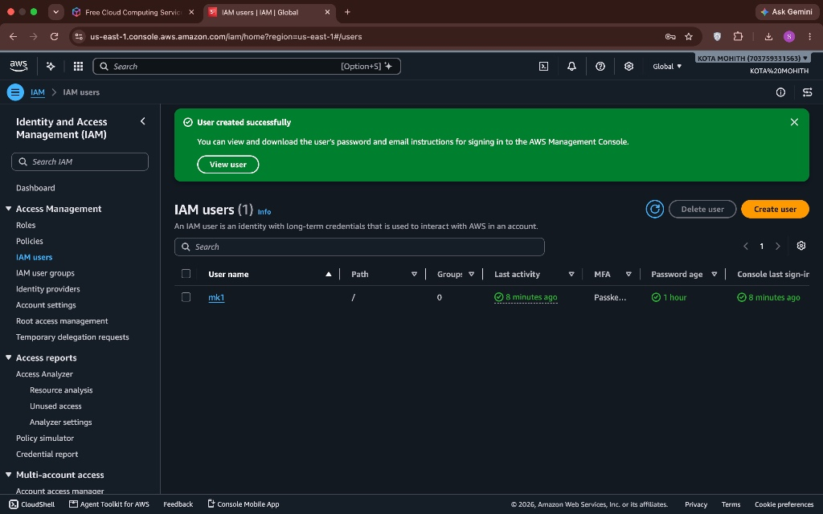
Figure 1: IAM users console showing user mk1 created successfully with console access.
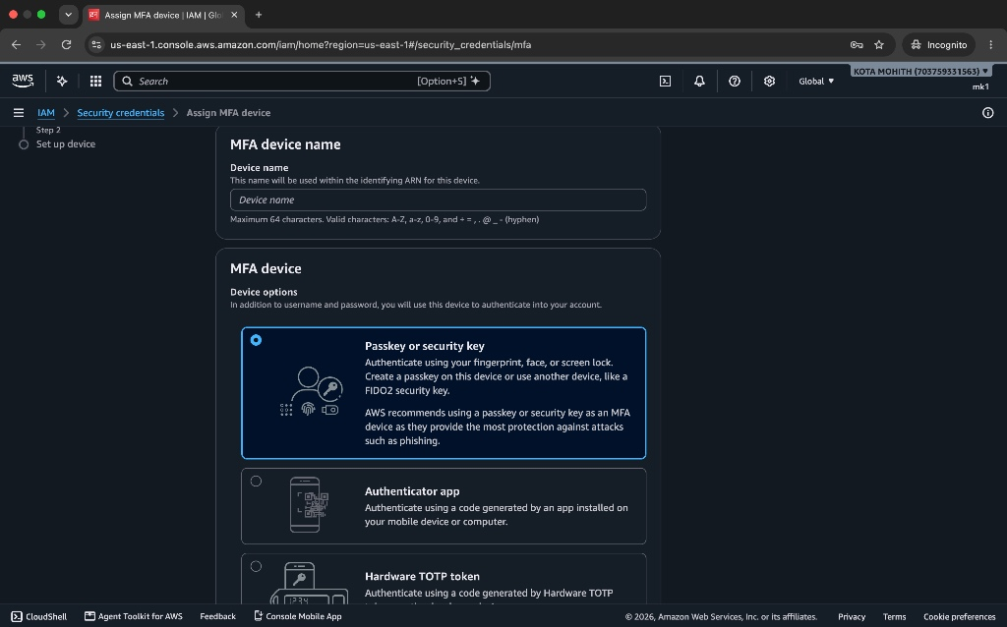
Figure 2: Assign MFA device wizard showing device name input and selection of Passkey or security key.
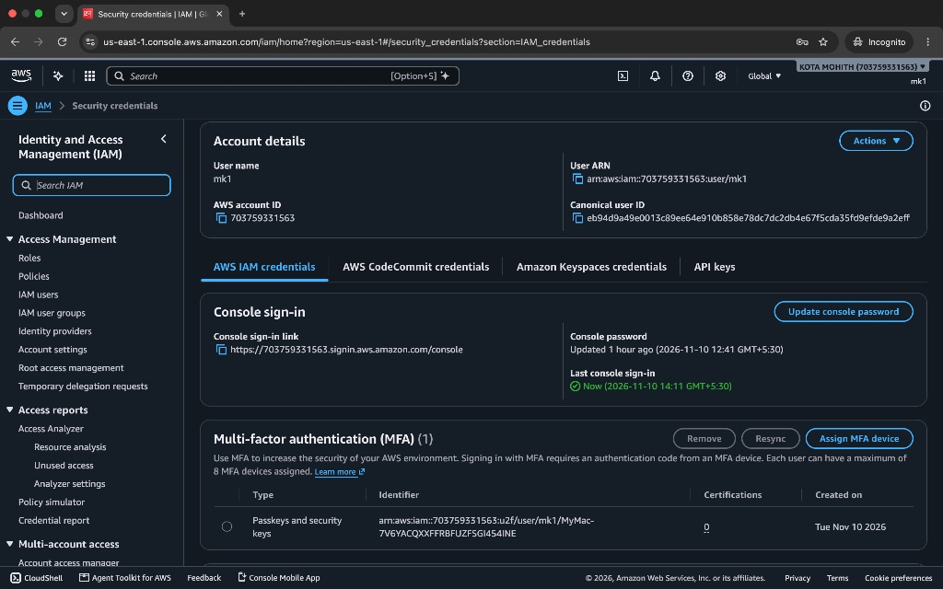
Figure 3: Security credentials tab showing Passkey/Security key MFA device successfully assigned to user mk1.
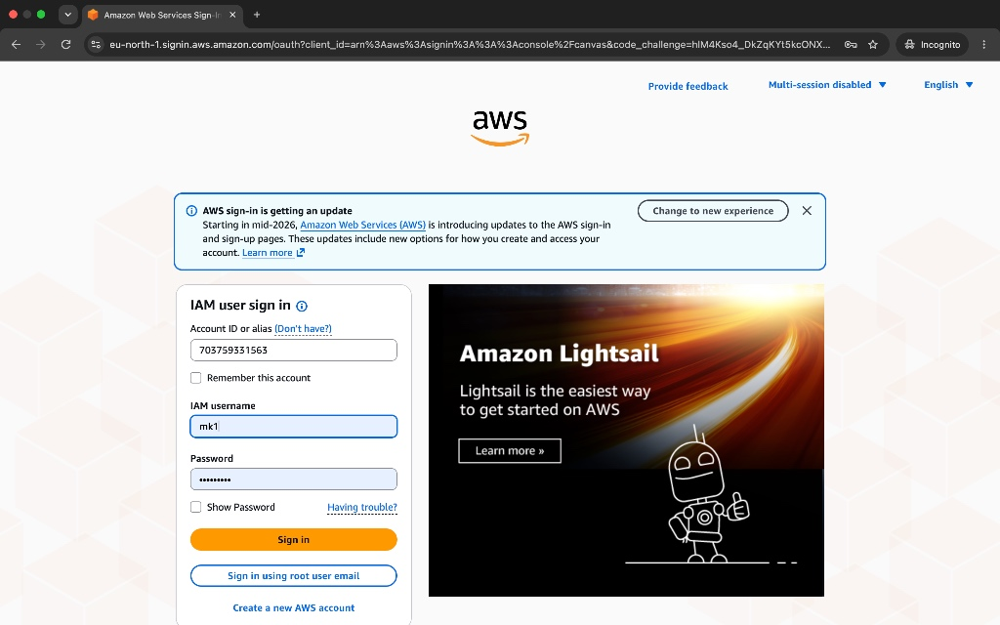
Figure 4: AWS IAM user sign-in screen showing Account ID (703759331563) and username mk1.
Expected Outcome:
1. An IAM user (mk1) is successfully created in AWS.
2. Appropriate permissions (AdministratorAccess) are assigned to the IAM user.
3. Multi-Factor Authentication is successfully enabled for the IAM user.
4. The IAM user can securely access the AWS Management Console using the configured MFA method.

