CLOUD COMPUTING LAB | SKILL 3
Launching an Ubuntu EC2 Instance & Deploying Nginx via User Data
Automated Web Server Provisioning on AWS EC2 & Comparison with Amazon Linux / Apache

Instance Name  Myec2Nginx | AMI / OS  Ubuntu Server 26.04 LTS | Instance Type  t3.micro | Region / AZ  us-east-1 (us-east-1c)
Instance ID  i-0e8f14627d76e75ff | Web Server  Nginx (via User Data) | Public IPv4  54.144.94.247 | Protocol / Port  HTTP (Port 80)
1. Objective
To launch an Amazon EC2 virtual machine running Ubuntu Server 26.04 LTS, automate the installation and startup of the Nginx web server at launch time using an EC2 User Data bash script, verify the deployment by accessing the default Nginx welcome page in a web browser, and record the observed operational differences compared to deploying Apache HTTP Server on Amazon Linux.
2. Step-by-Step Implementation
Step 1: Navigate to the EC2 Service — Log in to the AWS Management Console, confirm the active region is US East (N. Virginia) [us-east-1], type "ec2" into the top search bar, and select EC2 under Services.
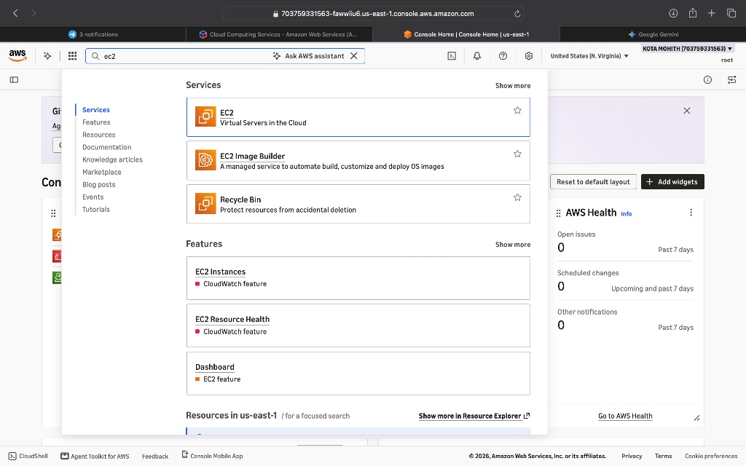
Figure 1: Searching for and selecting the EC2 service in the AWS Management Console.
Step 2: Open the EC2 Instances Dashboard — On the EC2 Instances dashboard, view the current instance list and click the "Launch instances" button to begin configuring a new virtual server.
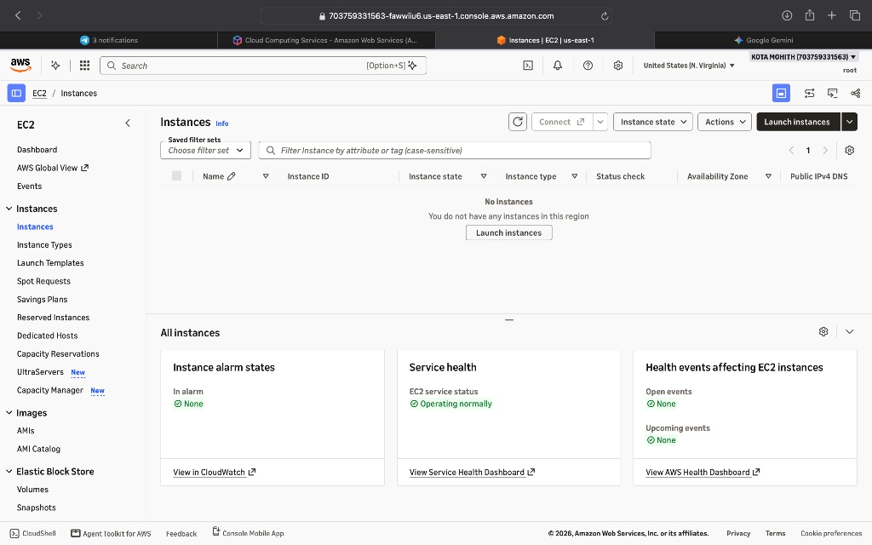
Figure 2: EC2 Instances dashboard prior to launching the new instance.
Step 3: Configure Instance Name and Ubuntu AMI — Under "Name and tags", enter "Myec2Nginx" as the instance name. Under "Application and OS Images (Amazon Machine Image)", select Ubuntu and choose the Free tier eligible Ubuntu Server 26.04 LTS (HVM), SSD Volume Type (64-bit x86) AMI with a t3.micro instance type and a security group allowing HTTP (port 80) traffic.
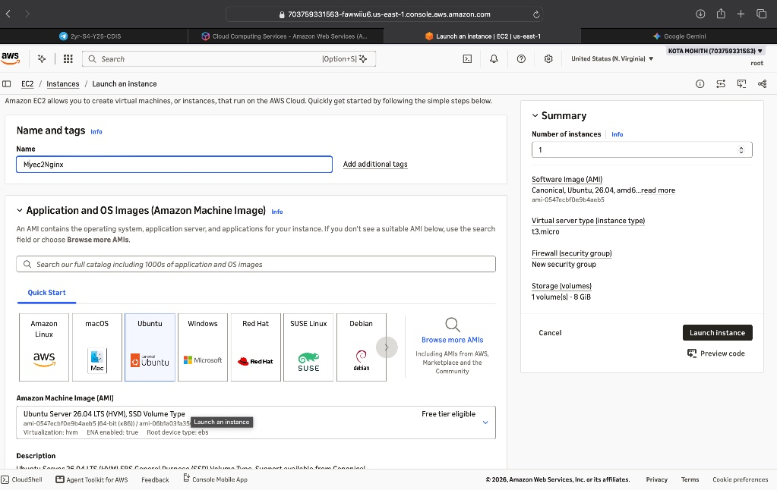
Figure 3: Configuring the instance name (Myec2Nginx), Ubuntu Server 26.04 LTS AMI, and t3.micro instance type.
Step 4: Configure the User Data Script — Expand the "Advanced details" section at the bottom of the launch configuration page and enter the following bash script into the "User data" field so that Nginx is automatically updated, installed, enabled on boot, and started upon launch:
#!/bin/bash
sudo apt update -y
sudo apt install nginx -y
sudo systemctl enable nginx
sudo systemctl start nginx

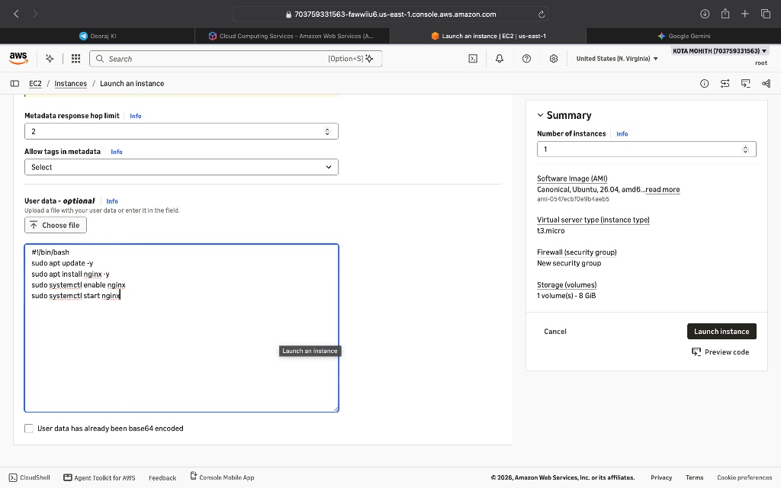
Figure 4: Entering the Nginx installation bash script in the User Data section before clicking Launch instance.
Step 5: Verify Launch Initiation — Click "Launch instance". AWS confirms that the launch of instance ID i-0e8f14627d76e75ff has been successfully initiated.
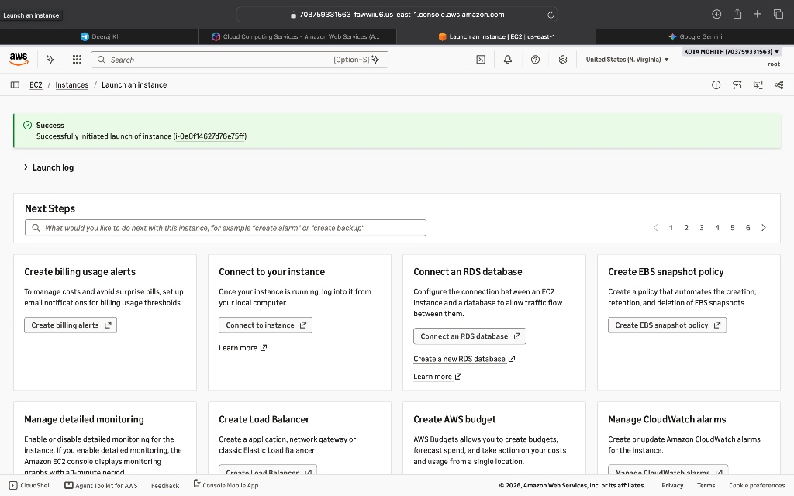
Figure 5: AWS confirmation banner showing successful initiation of instance i-0e8f14627d76e75ff.
Step 6: Confirm Running State & Retrieve Public IP — Return to the EC2 Instances dashboard and wait until the Instance state transitions to "Running". Note the assigned Public IPv4 DNS (ec2-54-144-94-247.compute-1.amazonaws.com) and Public IPv4 address (54.144.94.247).
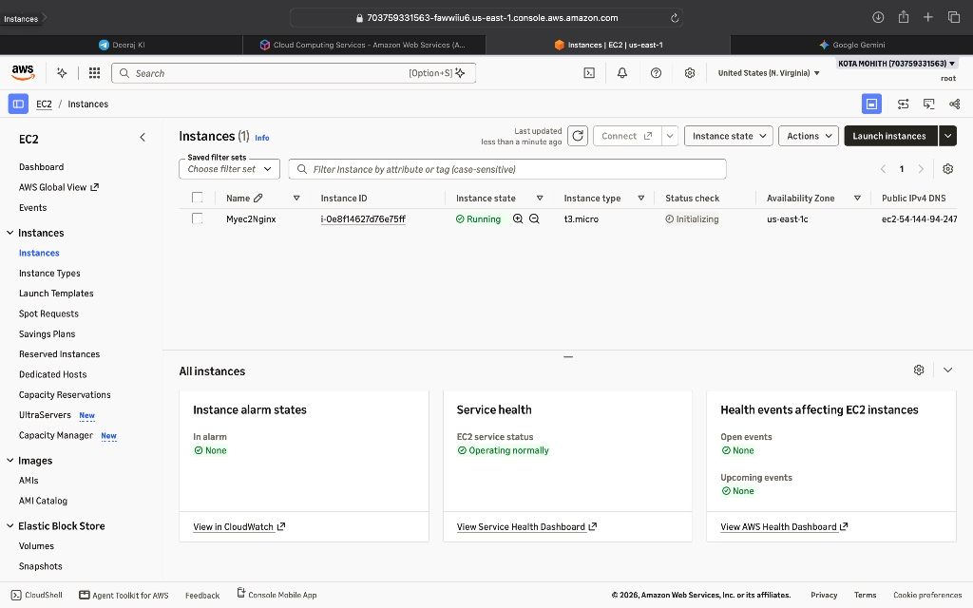
Figure 6: Instance Myec2Nginx in the Running state in availability zone us-east-1c.
Step 7: Verify Nginx Web Server in Browser — Open a web browser and navigate to http://54.144.94.247. The default "Welcome to nginx!" landing page loads immediately, confirming that the User Data script executed properly and HTTP port 80 traffic is permitted.
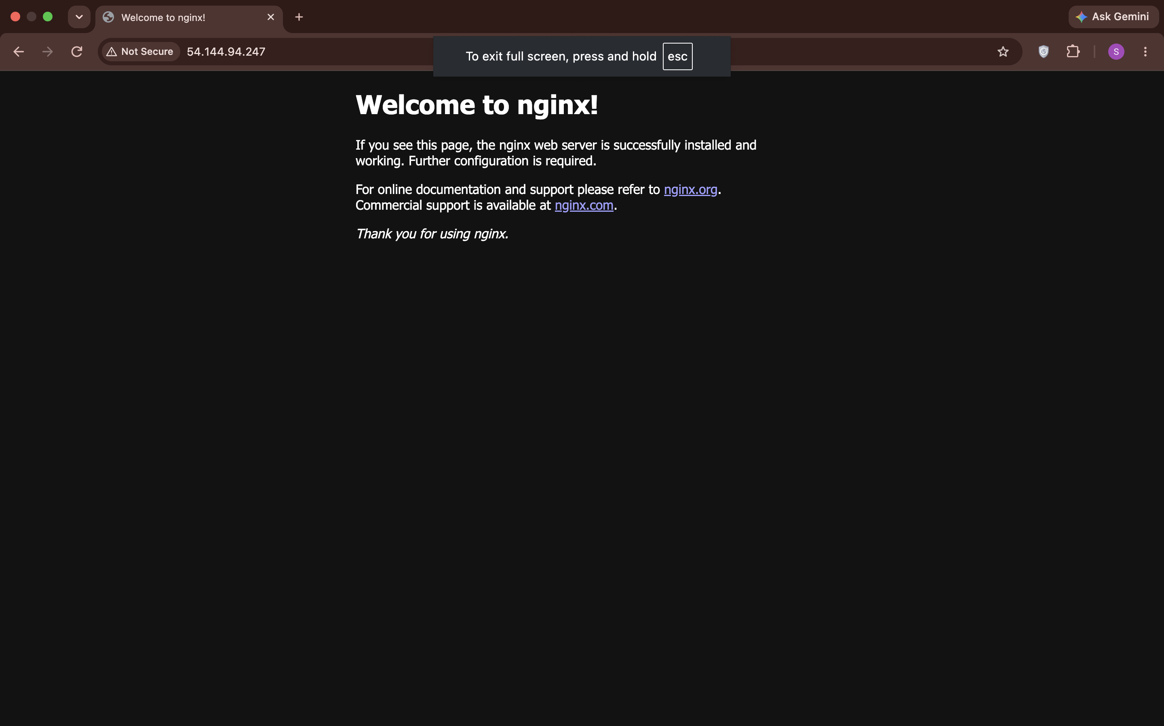
Figure 7: Default Nginx welcome page served at http://54.144.94.247.
3. Observed Differences: Ubuntu + Nginx vs. Amazon Linux + Apache
When provisioning an Ubuntu EC2 instance with Nginx compared to an Amazon Linux EC2 instance with Apache HTTP Server, several key differences in package management, service naming, default behavior, and web root structure are observed:
Parameter / Aspect | Ubuntu + Nginx (This Lab) | Amazon Linux + Apache
Operating System Family | Debian-based Linux (Ubuntu Server 26.04 LTS) | RHEL / Fedora-based Linux (Amazon Linux 2 / AL2023)
Default SSH Username | ubuntu | ec2-user
Package Manager | APT (apt update / apt install) | YUM or DNF (yum update / dnf install)
Web Server Package Name | nginx | httpd (Apache HTTP Server)
Systemd Service Name | nginx (systemctl start/enable nginx) | httpd (systemctl start/enable httpd)
Default Document Root | /var/www/html (serves index.nginx-debian.html by default) | /var/www/html (serves Apache test page or index.html)
Configuration Directory | /etc/nginx/ (nginx.conf & sites-available/sites-enabled) | /etc/httpd/ (conf/httpd.conf & conf.d/)
Post-Install Service State | Ubuntu automatically starts and enables Nginx right after apt install (explicit systemctl commands reinforce reliability). | Amazon Linux leaves httpd stopped and disabled after installation; systemctl start & enable are mandatory.
Architecture & Concurrency | Event-driven, asynchronous, non-blocking worker architecture optimized for high concurrency and static content. | Process/thread-based (MPM prefork/worker/event) architecture.
4. Conclusion
An Ubuntu Server 26.04 LTS EC2 instance (Myec2Nginx) was successfully launched in the us-east-1 region with an automated User Data script that installed and started the Nginx web server on boot. Accessing the instance's public IPv4 address (54.144.94.247) confirmed active HTTP delivery of the default Nginx welcome page, demonstrating how User Data streamlines zero-touch server provisioning across different Linux distributions.

