
Department of CSE

B.Tech. CSE Trimester -5

Roll Number: 2520030520
Name: KOTA MOHITH

Cloud Infrastructure and Services
25CS2206E

LAB RECORD
2026

Experiment - 2

AIM: To configure Multi-Factor Authentication (MFA) using FIDO2 / Passkey on the AWS Root User Account.

Description:
Securing the AWS Root User is the most critical baseline best practice recommended by the AWS Well-Architected Security Pillar and CIS AWS Foundations Benchmark. The root user retains unrestricted administrative access to all resources, billing data, and account configurations. Compromise of root credentials poses catastrophic security and financial risks to the cloud infrastructure.
Multi-Factor Authentication (MFA) adds an essential secondary physical verification layer beyond standard username and password authentication. In this experiment, a hardware-bound FIDO2 passkey / biometric security key ('Mymac') is registered and bound directly to the AWS Root User account, enforcing cryptographic resistance against phishing, session hijacking, and brute-force credential attacks.
Steps:
• Sign in to the AWS Management Console as the Account Root User (Account ID: 703759331563).
• Click on the Account Menu in the top-right console header and navigate to 'Security credentials' (or open IAM > Security credentials).
• In the 'Multi-factor authentication (MFA)' section, click on the 'Assign MFA device' button.
• Under Step 1 ('Select MFA device'), provide an identifiable Device name: 'Mymac'.
• Select the MFA device option: 'Passkey or security key' (FIDO2 authentication using biometric fingerprint / Touch ID, facial recognition, or physical hardware security key).
• Click 'Next' and follow the operating system biometric / security prompt to register and bind the cryptographic passkey to the device.
• Verify that the MFA registration succeeds and review the updated 'My security credentials' console.
• Confirm that under 'Multi-factor authentication (MFA)', 1 active device is displayed with Type 'Passkeys and security keys', matching ARN identifier 'arn:aws:iam::703759331563:u2f/root/Mymac-PHI4FXJ4RFCUXI4IF2SXE4PLEQ', and creation timestamp.
Output:
Figure 1: Selecting MFA Device Option and naming device 'Mymac' (Passkey / FIDO2 Security Key).
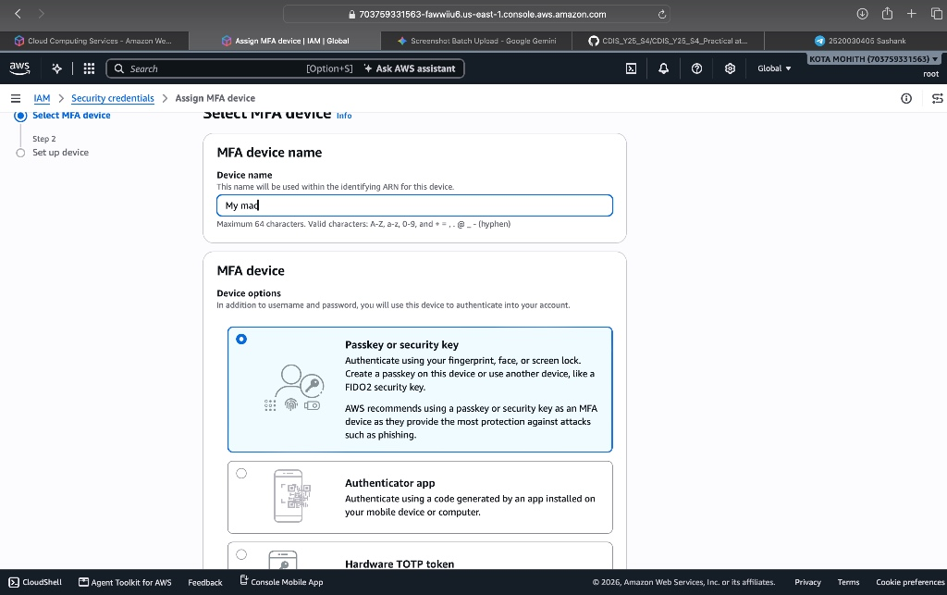
Figure 2: Verified Security Credentials Dashboard showing 1 Active Root MFA device assigned.
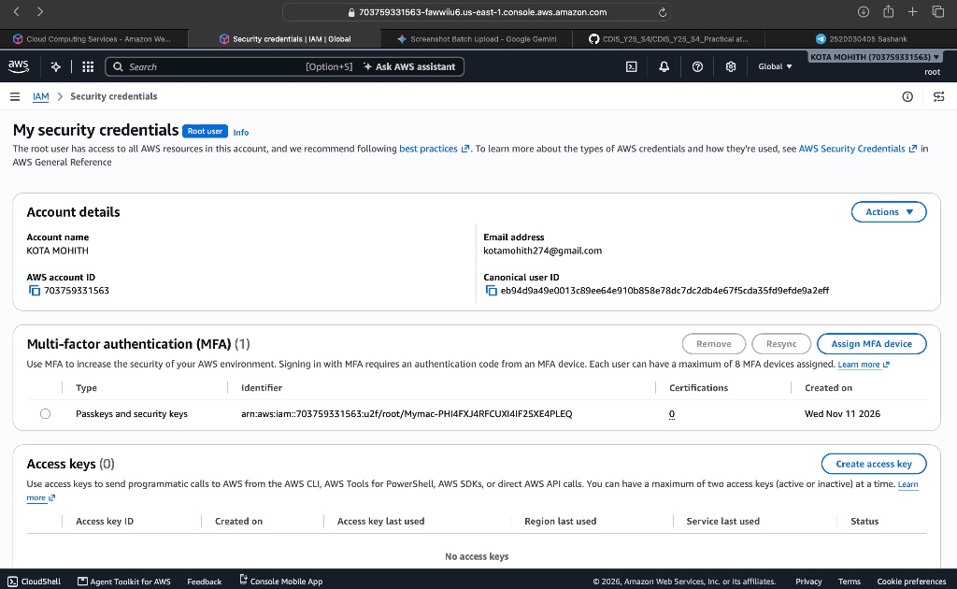
Summary of Root MFA Security Configuration:
Parameter | Configured Value / State
AWS Account Name | KOTA MOHITH
AWS Account ID | 703759331563
Root Account Email | kotamohith274@gmail.com
Canonical User ID | eb94d9a49e0013c89ee64e910b858e78dc7dc2db4e67f5cda35fd9efde9a2eff
MFA Device Name | Mymac
MFA Authentication Type | Passkeys and security keys (FIDO2 / WebAuthn)
MFA Device ARN | arn:aws:iam::703759331563:u2f/root/Mymac-PHI4FXJ4RFCUXI4IF2SXE4PLEQ
Assigned Devices Count | 1 Active MFA Device
Access Keys (Root) | 0 (No long-term access keys present - Best Practice)
Status | Active / Enabled

