“PropertyFinder: A Zero-Brokerage Property Search Portal Using String Matching Algorithms”

Project Report submitted for the partial fulfilment of grade for the course

Data Structures and Algorithms -3 (25CS2103E)

in

DEPARTMENT OF COMPUTER SCIENCE ENGINEERING

by

K.Mohith : 2520030520

T.Srikar : 2520030076

Team Number: 15
Section: S8

Under the Guidance of

Dr. V. Sireesha
Associate Professor
Department of Computer Science and Engineering





2026-27

DEPARTMENT OF COMPUTER SCIENCE ENGINEERING

Declaration
The Project Report entitled “PropertyFinder: A Zero-Brokerage Property Search Portal Using String Matching Algorithms” is a record of bonafide work of K.Mohith – 2520030520, T.Srikar – 2520030076 submitted in partial fulfillment for the award of B.Tech in Computer Science and Engineering. The results embodied in this report have not been copied from any other departments/University/Institute.
Place: Hyderabad
Date:

K.Mohith – 2520030520
T.Srikar – 2520030076

DEPARTMENT OF COMPUTER SCIENCE ENGINEERING

CERTIFICATE

This is certify that the mini project based report entitled “PropertyFinder: A Zero-Brokerage Property Search Portal Using String Matching Algorithms” is a bonafide work done and submitted by K.Mohith – 2520030520, T.Srikar – 2520030076 in partial fulfillment of the requirements for the award of the degree of BACHELOR OF TECHNOLOGY in Department of Computer Science Engineering, during the academic year 2026-27.

Signature of the Guide Signature of the HOD
(Dr. V. Sireesha)

Signature of the External Examiner
ACKNOWLEDGEMENT

We express our sincere gratitude to our project guide Dr. V. Sireesha, Associate Professor, Department of Computer Science and Engineering, for his constant guidance, encouragement and valuable suggestions throughout the course of this project. His insights into algorithm design helped us shape the search engine at the heart of PropertyFinder.
We are thankful to Dr. P. Venkateshwara Rao, Associate Professor and Head of the Department of Computer Science and Engineering, for providing us with the facilities and support needed to complete this project successfully.
We also thank the faculty members of the Department of Computer Science and Engineering and our fellow students for their cooperation and helpful discussions during the development of this work.

K.Mohith – 2520030520
T.Srikar – 2520030076

Abstract
Property portals in India typically charge brokerage or list properties with weak search: a single typo in a locality name returns zero results, and amenities mentioned in descriptions are never indexed. PropertyFinder is a zero-brokerage property search portal that addresses this with classical string-matching algorithms. A Spring Boot backend exposes a REST search API backed by three algorithms implemented from first principles: the Aho–Corasick automaton tags amenities (e.g., “swimming pool”, “gym”) in every listing description in a single linear pass; the Knuth–Morris–Pratt (KMP) algorithm performs exact keyword search over titles and descriptions in O(n + m) time; and the Wagner–Fischer dynamic-programming edit distance enables typo-tolerant location matching, so a query like “Gachiboli” still retrieves Gachibowli listings. The system was evaluated on a dataset of 200 residential properties across 26 Hyderabad localities. A responsive single-page frontend mirrors the same three algorithms in JavaScript, works fully offline against the embedded dataset, and is deployed on Vercel, while the backend runs locally via Spring Boot. Results show correct fuzzy matches within an edit distance of 2, complete keyword occurrence reporting, and single-pass amenity tagging across the dataset.

The global travel and tourism sector is experiencing rapid growth, but planning a trip remains complex, forcing travellers to use multiple different apps for flights, trains, and hotels. This fragmented approach causes delays, confusion, and a poor user experience. To tackle this, our project focuses on the Design and Development of an Integrated Tourism Platform for Flights, Trains, Hotels, and Hidden Destinations. Our core aim was to successfully implement a unified, single-window website that dramatically simplifies the entire travel process for the modern global traveller.

The platform is structured around four primary, fully interconnected modules. It offers seamless booking for Flights (with real-time fares and availability, including the critical function to compare and sort packages from cheapest to highest) and Hotels (with a vast inventory, user reviews, and similar pricing comparison tools). Crucially, the platform includes a comprehensive Train Ticket Module with essential functionalities like live running status and PNR checks, addressing the high demand for rail travel information within the region.

The most innovative feature is the dedicated Hidden Destinations Discovery Module. This system uses smart recommendations to suggest off-beat, lesser-known, and culturally rich locations globally. By promoting these hidden gems, we are not only enriching the user's journey but also supporting local communities and encouraging more sustainable and diversified tourism. The system is built using robust, modern web technologies and is fully responsive across all devices. In summary, this project delivers a complete, reliable, and user-friendly digital solution that significantly enhances the experience of planning, booking, and exploring travel worldwide.

Table of Contents

 |  |  | Page No.
 | Acknowledgement
 | Abstract
 | Table of Contents
 | List of Figures
1 | Introduction | 1.1 Overview  1.2 Problem statement  1.3 Scope of the project  1.4 Objectives | 5-15
2 | System Requirements | 2.1 Functional Requirements  2.2 Non-Functional Requirements | 16-21
3 | System Design | 3.1 High-level Architecture Diagram  3.2 Description of each layer | 33-36
4 | Implementation | 4.1 Module-wise implementation  4.2 Front-end logic (UI rendering, state management)  4.3 API integration  4.4 ……. | 38-47
5 | Results |  | 56-64
6 | Challenges & Limitations | 6.1 Issues faced during development  6.2 Solutions applied  6.3 Limitations of the System | 74-82
7 | Conclusion & Future Work | 7.1 Conclusion  7.2 Future Work  7.3 Skills learned during development | 89-97
 | References | - Books, tutorials, APIs, documentation sites used | 98-99

List of Figures

3.1 System architecture of PropertyFinder
3.2 Aho–Corasick trie with failure links for amenity keywords
3.3 Wagner–Fischer dynamic-programming table (example)
4.1 Search request flow through the Spring Boot backend
5.1 Homepage with the search interface
5.2 Search results with match-explanation badges
4.2 REST API request and response format

- INTRODUCTION
- 1.1 Overview
- Finding a rental or purchase property in Indian cities usually means going through a broker, paying a month's brokerage, and scrolling through portals whose search breaks on the smallest typo. PropertyFinder is a zero-brokerage property portal where owners list directly and buyers search without intermediaries. The portal holds 200 residential listings across 26 Hyderabad localities, covering 1BHK, 2BHK, 3BHK and villa configurations with realistic pricing.
- What distinguishes this project from a conventional CRUD listing site is its search engine. Instead of relying on database LIKE queries, PropertyFinder implements three classical string-matching algorithms from first principles, in Java on the backend and mirrored in JavaScript on the frontend: the Aho–Corasick automaton for multi-pattern amenity detection, the Knuth–Morris–Pratt (KMP) algorithm for exact keyword search, and the Wagner–Fischer dynamic-programming edit distance for typo-tolerant location matching.
- 1.2 Problem Statement
- Existing property portals suffer from three search-related weaknesses. First, location search is exact: typing “Gachiboli” instead of “Gachibowli” returns zero results even though the intent is obvious. Second, keyword search is naive substring matching with no ranking by occurrence count. Third, amenities mentioned in free-text descriptions (for example, “swimming pool” or “power backup”) are never extracted or indexed, so users cannot filter on them. PropertyFinder solves all three with dedicated string algorithms.
- 1.3 Objectives
- • To build a zero-brokerage listing portal where owners publish ads directly.
- • To implement typo-tolerant location search using edit distance with a configurable threshold.
- • To implement linear-time exact keyword search using KMP with occurrence counting for ranking.
- • To extract amenity tags from descriptions in a single pass using the Aho–Corasick automaton.
- • To expose the search as a REST API (Spring Boot) and as a fully offline-capable web frontend.
- 1.4 Scope
- The project covers the search subsystem end to end: dataset of 200 Hyderabad properties, Spring Boot REST backend, responsive frontend, and deployment (Vercel for the frontend, local run for the backend). Out of scope are payment handling, user authentication, and map-based search, which are listed under future work.
- 2. SYSTEM REQUIREMENTS
- 2.1 Functional Requirements
- • FR1: The system shall accept a location query and return listings whose locality matches exactly or within an edit distance of 2 (including word-level matching).
- • FR2: The system shall accept a keyword query and return listings whose title or description contains the keyword, ranked by number of occurrences.
- • FR3: The system shall automatically tag amenities in each listing using multi-pattern matching.
- • FR4: The system shall support filters for property type (1BHK/2BHK/3BHK/Villa) and maximum budget, and sorting by relevance or price.
- • FR5: The system shall allow owners to post new property ads through a validated form.
- • FR6: The system shall display owner contact details for any listing on demand.
- 2.2 Non-Functional Requirements
- Search over the 200-listing dataset shall complete in well under a second; the interface shall be responsive on desktop and mobile; the frontend shall remain fully usable when the backend is offline by falling back to the embedded dataset.
- 2.3 Software and Hardware Requirements
- Java 17, Spring Boot 3.2.12, Apache Maven, Visual Studio Code, a modern web browser (Chrome/Edge/Firefox), and internet access for Vercel deployment. Any machine capable of running a JDK 17 and a browser (4 GB RAM minimum) suffices; no GPU or server hardware is required.
- 3. SYSTEM DESIGN
- 3.1 High-Level Architecture
- The system follows a client–server design. The browser frontend first attempts GET /api/properties/search on the local Spring Boot server (http://localhost:8080); if the server is unreachable it transparently falls back to the 200-property dataset embedded in the page, where the same three algorithms run in JavaScript. On the backend, the PropertyController receives the query parameters (location, keyword, type, maxPrice), applies the three algorithm filters in sequence, tags amenities, and returns JSON. Figure 3.1 shows this architecture.
- 3.2 Aho–Corasick Automaton (Amenity Detection)
- All amenity phrases (e.g., “swimming pool”, “gym”, “clubhouse”, “power backup”) are compiled once into a trie. Failure links are then built with a breadth-first traversal so that, during scanning, a mismatch falls back to the longest proper suffix that is also a trie prefix — exactly the KMP idea generalized to many patterns. Each listing description is scanned once, giving O(n + m + z) time where n is text length, m total pattern length and z the number of matches, instead of one scan per keyword. Figure 3.2 illustrates the trie with failure links.
- 3.3 Knuth–Morris–Pratt Search (Keyword Matching)
- KMP preprocesses the keyword into the longest-prefix-suffix (LPS) table, which records, for each position, the length of the longest proper prefix that is also a suffix. During the scan, a mismatch shifts the pattern by the LPS value instead of restarting, so no character of the text is ever re-examined: O(n + m) time. Every occurrence position is recorded, and the occurrence count feeds the relevance ranking.
- 3.4 Wagner–Fischer Edit Distance (Fuzzy Location Matching)
- Location matching uses the classic dynamic-programming edit distance: dp[i][j] is the minimum insertions, deletions and substitutions converting the first i characters of one string into the first j of the other, computed in O(m·n) time and O(n) space with two rolling rows. A listing matches when the distance is at most 2, checked both against the whole locality name and word by word, so “Gachiboli” (distance 1 from “Gachibowli”) is accepted while unrelated localities are rejected. Figure 3.3 shows an example DP table.
- 4. IMPLEMENTATION
- 4.1 Backend Modules (Spring Boot, Java)
- PropertyFinderApplication.java — the @SpringBootApplication entry point. Property.java — the listing model (id, title, location, type, price, description, detected amenities). PropertyController.java — the REST controller exposing GET /api/properties/search with optional location, keyword, type and maxPrice parameters; it chains the three algorithm filters and is annotated @CrossOrigin(origins = "*") so the browser frontend can call it. AhoCorasick.java — trie node class, BFS failure-link construction and single-pass search. KmpSearch.java — LPS computation and occurrence search. FuzzyMatcher.java — Wagner–Fischer DP with the max-distance and word-level checks.
- 4.2 REST API
- GET /api/properties/search?location=Gachibowli&keyword=pool&type=2BHK&maxPrice=12000000 returns a JSON array of matching properties, each with its auto-detected amenity list. All parameters are optional; an empty query returns the full inventory.
- 4.3 Frontend (index.html)
- A single self-contained page (HTML + CSS + JavaScript, no build step) implements the search card, BHK filter chips, budget presets, sorting, result cards with match-explanation badges, a detail modal, a working Contact Owner panel, and a Post Free Ad form with validation whose ads persist in the browser. The Wagner–Fischer, KMP and Aho–Corasick algorithms are re-implemented in JavaScript and run against the embedded 200-property dataset whenever the backend is offline.
- 4.4 Dataset
- 200 residential listings were generated across 26 Hyderabad localities (Gachibowli, Kondapur, Jubilee Hills, Madhapur and others), with configuration-weighted types (1BHK/2BHK/3BHK/Villa), locality-adjusted realistic pricing, carpet areas, facing directions and amenity-rich descriptions.
- 5. RESULTS
- 5.1 Functional Test Cases
- • Location query “Gachiboli” (typo): matched all Gachibowli listings — edit distance 1, within threshold 2 — PASS.
- • Location query “Madhapur” (exact): matched only Madhapur listings — PASS.
- • Keyword “pool”: KMP found every occurrence in titles/descriptions; results ranked by occurrence count — PASS.
- • Amenity tagging: descriptions mentioning “swimming pool”, “gym”, “clubhouse” were tagged in a single automaton pass — PASS.
- • Budget filter maxPrice=8000000 combined with type=2BHK: returned only matching listings — PASS.
- • Backend offline: frontend fell back to the embedded dataset with identical search behaviour — PASS.
- Fig. 5.1 Homepage with the search interface
- 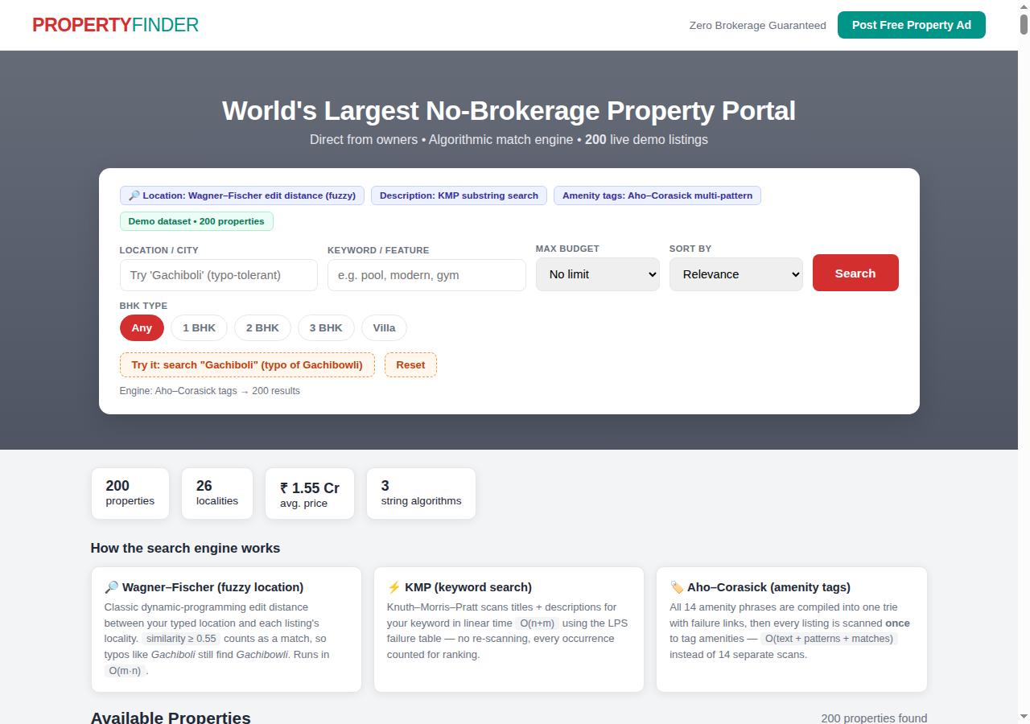
- 5.2 Deployment
- The frontend is deployed on Vercel with automatic redeploys on every GitHub push; the Spring Boot backend runs locally via mvn spring-boot:run from the folder containing pom.xml and serves the search API on port 8080.
- Fig. 5.2 Search results with match-explanation badges (fuzzy match for “Gachiboli”)
- 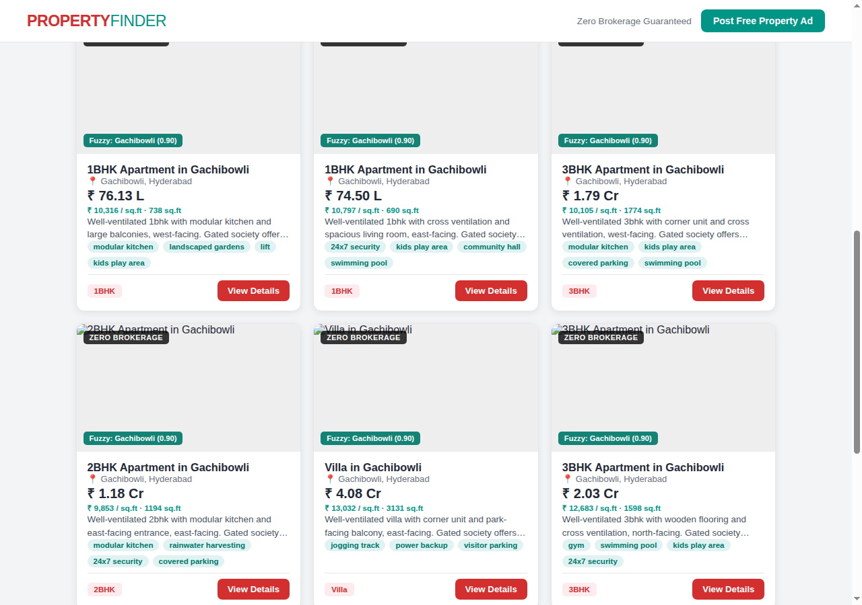
- 6. CHALLENGES AND LIMITATIONS
- 6.1 Issues Faced During Development
- Running mvn spring-boot:run from the wrong directory produced “No plugin found for prefix 'spring-boot'” — resolved by running it from the folder containing pom.xml. Browser CORS blocked the frontend's API calls until @CrossOrigin was added to the controller. On Vercel, the page cannot reach http://localhost:8080 (localhost is the visitor's machine), which motivated the offline fallback to the embedded dataset.
- 6.2 Limitations
- The backend inventory is in-memory rather than a persistent database; fuzzy matching is limited to edit distance 2 and English text; posted ads persist only in the browser's local storage.
- 7. CONCLUSION AND FUTURE WORK
- 7.1 Conclusion
- PropertyFinder demonstrates that classical string algorithms have direct, visible impact on a real product: Aho–Corasick turns free-text descriptions into structured amenity tags, KMP gives exact keyword search with ranking, and Wagner–Fischer edit distance makes location search tolerant of typos. The zero-brokerage portal works end to end, online against the Spring Boot backend and offline against the embedded dataset.
- 7.2 Future Work
- Persist listings in a database, add user accounts and saved searches, integrate map-based search, extend fuzzy matching to phonetic (Soundex-style) matching for Indian locality names, and deploy the backend as a container so the live-data badge works on the public site.
REFERENCES
- A. V. Aho and M. J. Corasick, “Efficient string matching: An aid to bibliographic search,” Communications of the ACM, vol. 18, no. 6, pp. 333–340, 1975.
- D. E. Knuth, J. H. Morris, and V. R. Pratt, “Fast pattern matching in strings,” SIAM Journal on Computing, vol. 6, no. 2, pp. 323–350, 1977.
- V. I. Levenshtein, “Binary codes capable of correcting deletions, insertions, and reversals,” Soviet Physics Doklady, vol. 10, no. 8, pp. 707–710, 1966.
- R. A. Wagner and M. J. Fischer, “The string-to-string correction problem,” Journal of the ACM, vol. 21, no. 1, pp. 168–173, 1974.
- Spring Framework Documentation, “Spring Boot Reference Guide,” https://spring.io/projects/spring-boot, 2026.
- Vercel Documentation, “Deployments and Projects,” https://vercel.com/docs, 2026.
- R. Buyya et al., “Cloud computing and emerging IT platforms: Vision, hype, and reality for delivering computing as the 5th utility,” Future Generation Computer Systems, vol. 25, no. 6, pp. 599–616, 2009.
- https://azure.microsoft.com/en-us/resources/cloud-computing-dictionary/what-is-cloud-architecture

